Form 3
EXAMINATION
121/2 MATHEMATICS
MARKING SCHEME
No
1. | 0.8064 x 1000 x 6.048 x 10000  1.008 x 10000 0.134 x 1000  8 4  80.64 x 6048 9  4008 x 1344  4 2  4 x 9 = 36 | B 1  B 1  A1
2. | -4 (-4 ⅓ )  - 12 3 5  -4 X -8  -4  -8 | B1
3. | Sin (2θ 30⁰) Cos 4θ 0  Sin (20 30⁰) Cos 4θ  A 1 B 1 90⁰  Θ 120⁰  6  =20⁰ | A1  B 1  B1  A 1
4. | Let 52x be U  5^{2X}(5³) 20(5^{2X}) = 625  25U 20U = 625  125  5U = 625  5 5  U = 125  52x 53  2x = 3  X = ³/₂ | B1  B1  A 1
5. | The sum of n sides polygon in degrees (n -2) 180⁰  Angles in quadrilateral add up to 360⁰  5 (x + 4) + 4(x + 5) + 2(x + 10) + (x +20) + 360⁰  (x+20) = 360⁰  12x = 360  X = 30⁰  Interior angles  5(x+4)=170⁰  4(x+5)=140⁰  2(x+10)=40⁰  X+20=10⁰ | A 1  B 1  B 1

 | Exterior angles  180⁰ 170⁰ 10⁰  180⁰ 140⁰ 40⁰  180⁰ 40⁰ 140⁰  180⁰ 10⁰ 170⁰ | B2 for all 4 angles correct  B1 for two three angles correct  No mark for 1 or less correct angles
6. | 140 x 1240 1736  100  Selling price  75 x 1736  100  Ksh 1302 | B 1  B 1  A 1
7. | Co-odinates A are (-1,7)  B are (3,-5)  C are (6,-4)  AB 3 - -1 4  5 7 -12  BC 0 - 3 -3  4 -5 9  4BC -3 -3 AB hence BC parallel to AB.  They share a common point B hence collinear. | B 1  B 1  B 1
8. | 1 man 2 x 1 in 3 days 4 hr a day  4  1 man 2 x 1 in 3 days 1 hr a day  4 4  1 man 2 x 1 x 1 acres in 1 day 1 hr a day  4 4 3  2 x 1 x 1 x 5 x 4 x 3 men  4 4 3  2 x 1 x 1 x 4 days x 3 days  4 4 3  1 man 0.5 acres 4 day in 3 hrs 1 day 5 half  0.5  0.5  10 men | B 1  B 1  A 1
9. | (30cm³)  12  12  108  ASF 108  12  3  LSF ASF 3 V? V = 810  VSF (LSF³) 2  810 27  V1  V1 = 810  27  = 30cm³ | B 1  B 2  A 1

10. | Area of triangle ADB is ¹/₂ x 7 x 125 to 60⁰  7 x 6 sin 60⁰  = 36.37 cm²  b) Area of unshaded sector  60 x 22 x 7 x 7 = 25.6667  360 7  Shaded area 36.37 25.67  10.7 cm² | B1  A1  M1  B1
11. | -7 x X < 3x + 2 2x < 9,x7 4-5  3x+2<4(x 5), 3x + 2 < 4x 20  -x < -22, x > 22  If x > -5 and x > 22  22 | M1  M1  A1
12. | (3.5) 2p √ x  3x -5  (3x 5)95² 4p² x x 3x 5  27x 5² 455² 4p²x  27x5² - 4p²x 455²  X(275² 4p²) 455²  X 455²  275² 4p² | Square both sides  M1  M2  A1
13. | Max val of x 13.45 min 13.35  Max val of y 4.35 min 4.25  Max value of x 13.45 3.1647  Y 4.25  Max value of x 13.35 3.069  Y 4.35  Actual value of x 13.4 3.1163  Y 4.3  Absolute error 3.1642 3.069 0.04785  2  Pere em 0.04785 x 100 0.015355 x 100  3.1163  1.5355% | B1  B1
14. | Gradient of AB is M-1 M- 1  4 2 2  Gradient product is -1  Gradient of second line  Y 5 2x is 2  3 3  m-1 3  2 2  2m -2 = 6  2m = 8  M = 4

15. | Principal p amount 2p  2p p(I + 10)n 2p - p (1+0.1)n  100 p p  2 (1 1)n  Log 2 n log 1.1  N log 2 0.301  Log 1.1 0.0414  N = 7.27  Round upto 8  N = 8 yrs | B1  B1  A1
16. | P(black) and p(brown) or p(brown and p(black)  5 x 3 x 3 x 4  8 x 7 x 8 x 7  15 3  56 14  27  56 | B1  B1  A1

17 | 400km  Nairobi busia  Speed = 120 km/hr  Distance = 400 km  Time = 400  - = 3hrs 20min  8.30 + 3 hrs 20min  11: 50 a.m  b) at 8.30 am distance covered by bus  ½ x 80 = 40km  Distance left = 360 km  Speed = 2000km/hr  Time = 360 = 1 hr 48 min  200  They met at 8.30 + 1 hr 48min  10.18 am  c) 8 – 10.18 is 2 hrs 18min  Distance = 2 x 80 + 18 x 80  60  160 + 24  184km from Nairobi.  d) Car arrived in Nairobi after 3 hrs 20 min  bus travelled at a time of  3hrs 20 min + 30 min  = 3hrs 50 min  Dist = 3 x 80 = 50 x 80  60  = 240 + 66 ¹/₃  = 93¹/₃km  Distance from Busia is 93¹/₃ km | M1  A1  B1  B1  M1  A1  M1  A1  M1  A1

18 | ABC  Y - = -x drawn  A¹B¹C¹ draw (rotated)  A¹¹B¹¹C¹¹ draw ( translated)  A¹¹¹B¹¹¹C¹¹¹ Enlarged  A^{1v} ( 2,6) B^{1v} (0,0) C^{1v} (-6,2) | B1  B1  B2  B2  B2  B1
19 | 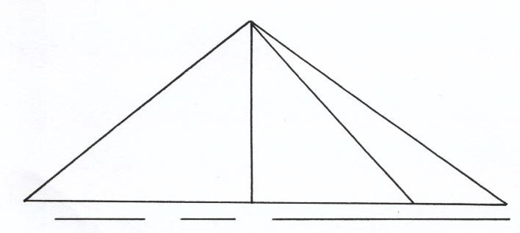  x² + x² = (56 -2x)²  2x² = 4 x² – 224x + 3136  2x²- 224 x + 3136 = 0  X² – 112x + 1568 = 0  X ( x –16) – 98 (x – 16) = 0  (x-16) ( x – 98) =0  X = 16 or 98  Height = 16 cm  Tan θ = 16 = 0.4575  35  = 24.57º  b) ST = √16² + 35²  = √1481  = 38.48  c) Muximum distance  = 35 ± 16  = 51 | M1  M1  M1  A1  M1  A1  M1  A1  M1  A1
20 | a) 50,00 + 6 x 62 5000 + 10000 x 250  100  50,000 + 37500 + 25,000  = 112,5000  b) i) 12000 x 2.5 + 0.06x + 50,000 = 134 000  30,00 + 50,000 + 0.06x = 134 000  0.06x = 134 000 – 80 000  0.06x = 54000  0.06 0.06  x = 900,000 | M1  M1  A1  M1  M1  M1  A1
56 -2x
x
x
S
R
35
O
35
S

 | ii) increase = 900 000 – 625 000  = 275,000  % increase = 275 000 x 100  625 000  = 44 % | M1  M1  A1
21 | Distance covered in 90 min  Bl P = 540km  Q = 360 km  Scale 1 cm = 10 000 000 cm  1 cm rep 100 km  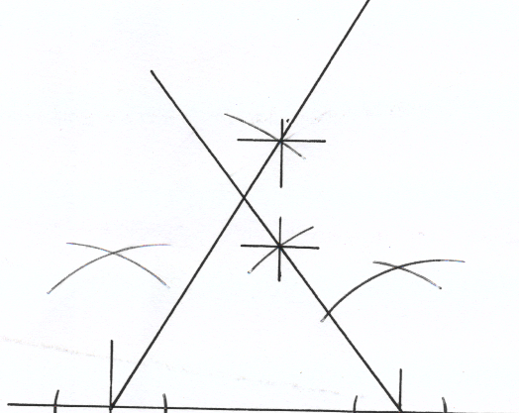  30  B  A  Distance btwn plane 2,1 cm ± 0.1  b  2 10 ± 10  Bearing of plane Q from plane P  185 ± 1º | B1  B1  B1  B1  B1  B1  B1  B1  B2 | For A & B 5cm  030º & 5.4 to P  315º & 3.6 to Q  Completed diagram
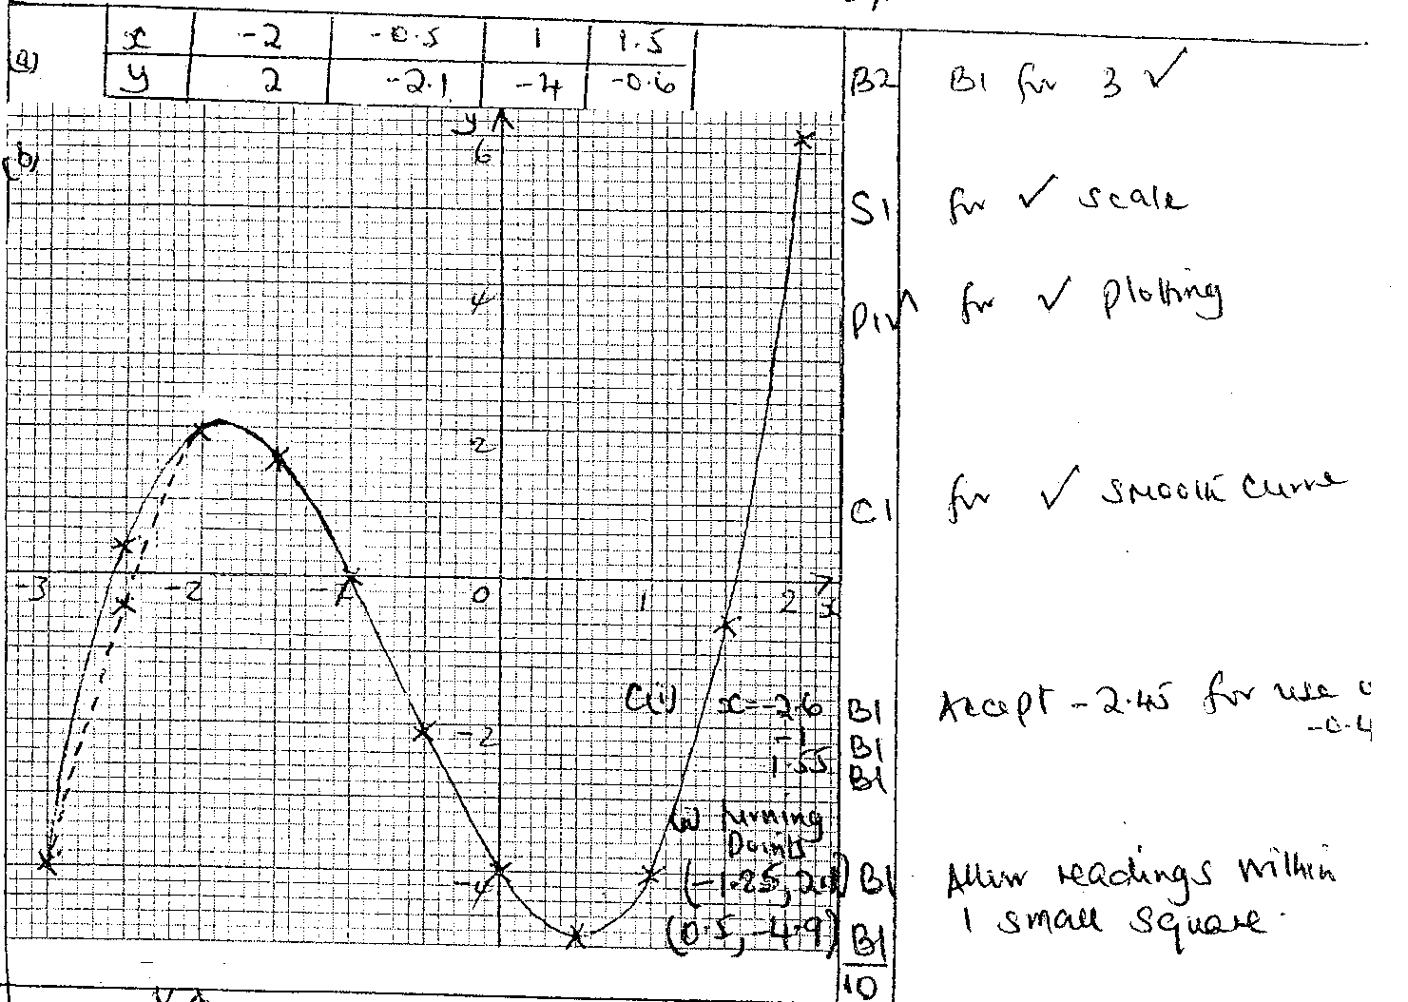  23 | a. x -4 -3 -2 -1 0 1 2  y -12 0 0 -6 -12 -12 0  c.x=-3.9,x=0.9,x=1.8
24. | a) ACC = 15 – 0  20  = 0.75m/s²  b) Dece = 0 – 15  20  = - 0.75  c) Area = 1 x 20 x 15  2  = 150ml  d) Area = 20 x 15  = 300m  e) Area = 1 ( 30 + 60) X 15  2  = 675m | M1  A1  M1  A1  M1  A1  M1  A1  M1  A1

