**231/3 –**

**BIOLOGY PAPER 3 –**

**FORM THREE 2018**

**MARKING SCHEME**

|  |  |  |  |
| --- | --- | --- | --- |
| **FOOD SUBSTANCE** | **PROCEDURE** | **OBSERVATION** | **CONCLUSION** |
| Proteins | * Put 2cm3 of food sample D into a test tube. * Add sodium hydroxide solution * Add copper sulphate solution and shake; | No colour change / blue colour of copper sulphate persists / retains / maintains; | Proteins / absent / Absence of proteins; |
| Non-reducing Sugar | * Put 2cm3 of food sample D into a test tube. * Add dil. Hydrochloric acid, boil and cool; * Add sodium hydrogen carbonate until the fizzing stops; * Add Benedict’s solution and boil; | Colour changes from Blue to green / yellow orange and brown. Acc Redbrown / if only one colour is mentioned. | Non-reducing sugar(s) present; Rej. Reducing sugar(s); present after hydrolysis. |
| Starch | * Put 2cm3 of food sample D into a test tube. * Add iodine solution and shake | Coour changes to blue black / blue-black / blue / black; | Starch present |

1. (i) (a) Dichotyledonae;

(ii) - Network venation / net veined leaves;

- Presence of leaf petiole / leaf stalk;

- Broad leaf;

(iii) Insect;

(iv) - Brightly coloured petals to attract insects;

- Large and conspicuous;

- Scented;

- Has landing platform for insects;

- Anthers are firmly attached to the filament;

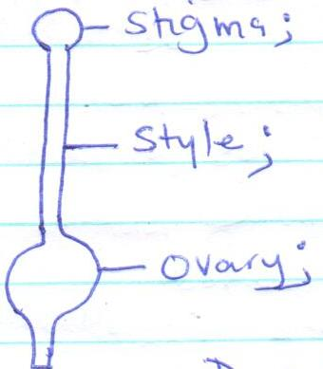(v)

1. (a)

|  |  |
| --- | --- |
| **K** | **M** |
| * Has 3 pairs of legs * Has 3 body parts * Has wings * Has antennae | * Has 4 pairs of legs; * Has 2 body parts; * Lack wings; * Lack antennae; |

1. (i) Phylum - Arthropoda;

Reasons: - Jointed appendages;

* Segmented body ; -Presence of exoskeleton;
* Bilaterally symmetrical;

1. Class - Arachnida

Reasons: - has 4 pairs of legs;

* body divided into two parts;
* lack antennae;

1. exoskeleton;
2. (i) Pisces;
3. (ii) - Presence of fins;

- Presence of scales;

- Presence of lateral line;