**AA-14**

**FORM TWO HOME SCIENCE**

1. Name **three** surfaces on which clothes can be ironed (3mks)

………………………………………………………………………………………………………

………………………………………………………………………………………………………

………………………………………………………………………………………………………

2. a) Outline **four** general rules for making seams. (4mks)

………………………………………………………………………………………………………

………………………………………………………………………………………………………

………………………………………………………………………………………………………

………………………………………………………………………………………………………

b) Discuss **five** points that influence the choice of a seam. (10mks)

………………………………………………………………………………………………………

………………………………………………………………………………………………………

………………………………………………………………………………………………………

………………………………………………………………………………………………………

3. a) Mention **three** types of drainage system. (3mks)

………………………………………………………………………………………………………

………………………………………………………………………………………………………

………………………………………………………………………………………………………

b) Give **four** reasons for keeping the drainage systems clean. (4mks)

………………………………………………………………………………………………………

………………………………………………………………………………………………………

………………………………………………………………………………………………………

………………………………………………………………………………………………………

4. Discuss the cleaning action of a detergent. (6mks)

………………………………………………………………………………………………………

………………………………………………………………………………………………………

………………………………………………………………………………………………………

………………………………………………………………………………………………………

………………………………………………………………………………………………………

………………………………………………………………………………………………………

5. Name **four** categories under which clothes are sorted out. (2mks)

………………………………………………………………………………………………………

………………………………………………………………………………………………………

………………………………………………………………………………………………………

………………………………………………………………………………………………………

6. State **two** precaution to take when using grease solvents. (2mks)

………………………………………………………………………………………………………

………………………………………………………………………………………………………

7. Give **two** uses of mangles. (2mks)

………………………………………………………………………………………………………

………………………………………………………………………………………………………

8. Identify **two** practices that would help prevent loss of colour during laundry. (2mks)

………………………………………………………………………………………………………

………………………………………………………………………………………………………

9. Name **four** communicable diseases.

………………………………………………………………………………………………………

………………………………………………………………………………………………………

………………………………………………………………………………………………………

………………………………………………………………………………………………………

………………………………………………………………………………………………………

10. State the use of each of the following;

a) Water seal. (1mk)

………………………………………………………………………………………………………

b) U or S – bend or bottle trap.

………………………………………………………………………………………………………

11. Write down **four** sanitary practices one needs to acquire. (4mks)

………………………………………………………………………………………………………

………………………………………………………………………………………………………

………………………………………………………………………………………………………

………………………………………………………………………………………………………

12. Give **three** reasons which make plastic more popular than metals in making laundry

equipment. (3mks)

………………………………………………………………………………………………………

………………………………………………………………………………………………………

………………………………………………………………………………………………………

13. State **three** factors to consist or when choosing storage equipment for laundry work. (3mks)

………………………………………………………………………………………………………

………………………………………………………………………………………………………

………………………………………………………………………………………………………

14. Give **two** qualities of good pegs fro hanging clothes. (2mks)

………………………………………………………………………………………………………

………………………………………………………………………………………………………

15. Explain how you can work out a machine fell seam. (2mks)

………………………………………………………………………………………………………

………………………………………………………………………………………………………

16. State advantages of using a commercial pattern. (2mks)

………………………………………………………………………………………………………

………………………………………………………………………………………………………

17. Give **two** reasons for airing clothes after ironing them. (2mks)

………………………………………………………………………………………………………

………………………………………………………………………………………………………

18. Identify the following pattern makings.

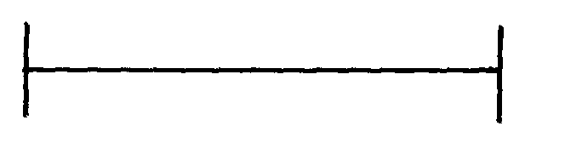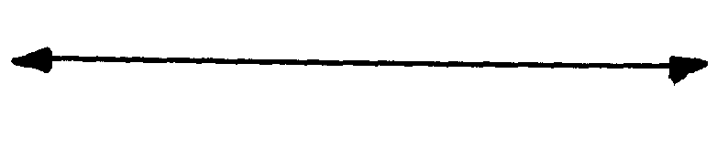

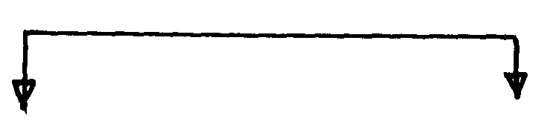

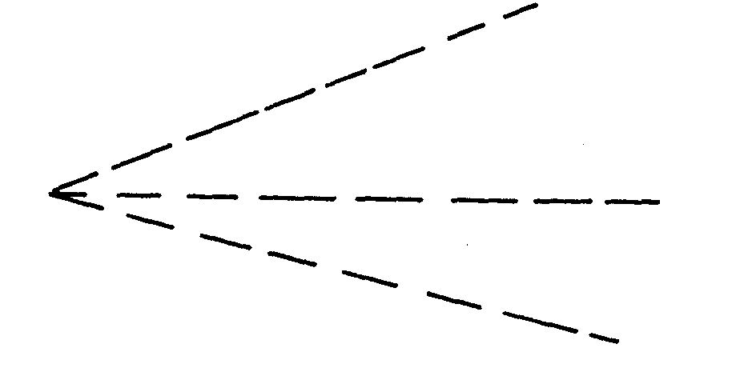



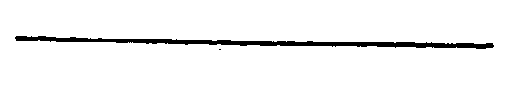

19. State **four** methods of transferring pattern makings (4mks)

………………………………………………………………………………………………………

………………………………………………………………………………………………………

………………………………………………………………………………………………………

………………………………………………………………………………………………………

20. Define the following terms. (5mks)

a) Consumer

………………………………………………………………………………………………………

………………………………………………………………………………………………………

b) Nutrition.

………………………………………………………………………………………………………

………………………………………………………………………………………………………

c) Food

………………………………………………………………………………………………………

………………………………………………………………………………………………………

d) Goods

………………………………………………………………………………………………………

………………………………………………………………………………………………………

e) Food nutrients.

………………………………………………………………………………………………………

………………………………………………………………………………………………………

21. Differentiate between.

a) Informative and competitive advertising. (2mks)

………………………………………………………………………………………………………

………………………………………………………………………………………………………

………………………………………………………………………………………………………

b) Electronic media and print media. (2mks)

………………………………………………………………………………………………………

………………………………………………………………………………………………………

………………………………………………………………………………………………………

22. List **four** equipments that are used fro drying garments. (2mks)

………………………………………………………………………………………………………

………………………………………………………………………………………………………

………………………………………………………………………………………………………

………………………………………………………………………………………………………

23. Give **four** advantages of using ironing board instead of a table. (4mks)

………………………………………………………………………………………………………

………………………………………………………………………………………………………

………………………………………………………………………………………………………

………………………………………………………………………………………………………

24. State **five** uses of fabric conditioner. (5mks)

………………………………………………………………………………………………………

………………………………………………………………………………………………………

………………………………………………………………………………………………………

………………………………………………………………………………………………………

………………………………………………………………………………………………………

25. Identify effects of laundry processes on woolen fibres. (3mks)

………………………………………………………………………………………………………

………………………………………………………………………………………………………

………………………………………………………………………………………………………

26. Give **two** reasons why French seam is commonly used on children garments. (2mks)

………………………………………………………………………………………………………

………………………………………………………………………………………………………

27. Mention **two** uses of bleaches in the laundry work. (2mks)

………………………………………………………………………………………………………

………………………………………………………………………………………………………