AA-14
FORM ONE MATHEMATICS
MARKING SCHEME

1. | (a) (i) thousand.  (ii) 3 x 1000 = 3000  (b)  4 7 3 6 4 5  Hundred Thousand Ten Thousand Thousand Hundred Tens ones  Four hundred and seventy three thousands, six hundred and forty five. | B 1  B1  B1  B1
 |  | 4mks
2. | N 3 + 12 ÷ 4 x 7  4 7 7 3  3  3 + 12 x 3  4 7 4  3 + 9 = 21 + 36  4 4 28  = 57  28  D 10 – 5 x 2  7 8 3  80 – 35 x 2  56 3  15  1  45 X 2 = 15  56 3 28  28  19  - 57 ÷ 15 = 57 X 28  28 28 28 15  5  = 19  5  = 4  3  5 | B1  B1  M1  A1
 |  | 4mks
3 | 7b + 4p = 207  5b + 5p = 165  35b + 20p = 1035  20b + 20p = 660  15b = 375  b = 25  5p = 165 – 125  = 40   p = 8 | B1  M1  M1  A1 | One eq.  Elimination for substitution  For both values.
 |  | 4mks
4 | - 4 + 108 - 24 = 80 = 5  8 x 2 16 | B1  B1  B1 | BODMAS  SIMPLIFY 80/16
 |  | 3mks
5 | Total amount = ( 50 x 80,000 ) + 120,000  = ( 4,000,000 + 120,000  = sh. 4,120,000  Amount for each child  = 4120000 – 520000  6  = sh. 600,000 | M1  A1  M1  A1
 |  | 4mks
6. | 60 = 2² X 3² X 5  90 = 2² X 3² X 5  180 = 2² X 3 x 5  G.C.D = 2 x3 x5  = 30  Greatest vessels = 30 litres. | B1  M1  B1
 |  | 3mks
7. | L.C.M of 6 and 8  6 = 2 x 3  8 = 2 x 2 x 2  G.C.D = 2  L.C.M = product of all factors  G.C.D  = ( 2 X3 ) ( 2 X2 X 2 )  2  = 3 X 8  = 24 Minutes | M1  A1 | Alternative  2 6 8  2 3 4  2 3 2  3 3 1  1 1  LCM = 2³x3 M1  = 24 minutes A1
 |  | 2mks
8. | Let x = 0.1515…  100 x = 15.1515….  x = 0.1515  99x = 15  x= 15  99  = 5  33 | M1  A1
 |  | 2mks
9 | 6 (x + 1) + 6 2x + 1 = 9 x 6  2 3  3 ( x + 1 ) + 2 ( 2x + 1 ) = 54  3x +3+ 4x + 2 = 54  7x = 54 – 5  7x = 49  x= 7 | B1  M1  M1  A1 | Multiply L.C.M  Collecting like terms.
 |  | 4mks
10 | xº = ( 180º- 130º) = 50º  alternate angles  yº = ( 130 – 70 ) 60º  opposite interrior angles | B1  B1
 |  | 2mks
11. | Area of triangles  = ½ X 6 X 12 X 2  = 72 cm²  Area of rectangles  = 8 x 12 x 2  = 192 cm²  Area of a square (base)  = 12 x 12  = 144  S.A = 72 + 192 +144  = 408 cm² | M1  M1  A1
 |  | 3mks
12. | 3 (2) + 2 ( 3) + 2 ( 2²) – 6 (3)  4(2) – 2 ( 3)  6 + 6 +8 – 18  8 -6  = 1 | M1  M1  A1
 |  | 3mks
13. | A:B A : B  2(3:2) = (6 :4)  B : C B: C  1(4:1) (4 :5)  A:B:C = 6:4:5 | M1  A1
 |  | 2mks
14. | Perimeter of semicicle + permieter of rectangular part  2 X 22 X 35 + 2 (100)  7  = 220m + 200m  = 420m  Distance covered = 25 x 420  = 10500m  1km = 1000m  x = 10500m  = 10500  10000  = 10.5 km | M1  M1  A1  B1
 |  | 4mks
15. | No. of use Dollars = 30,000  79  = $ 379.75 | M1  A1
 |  | 2mks
16. | x + 24 = 4x – 30  3x = 54  x = 18   QP R = 42   PQR = 42   QP R = 84 | B1  B1  B1
 |  | 3mks
17 | a)  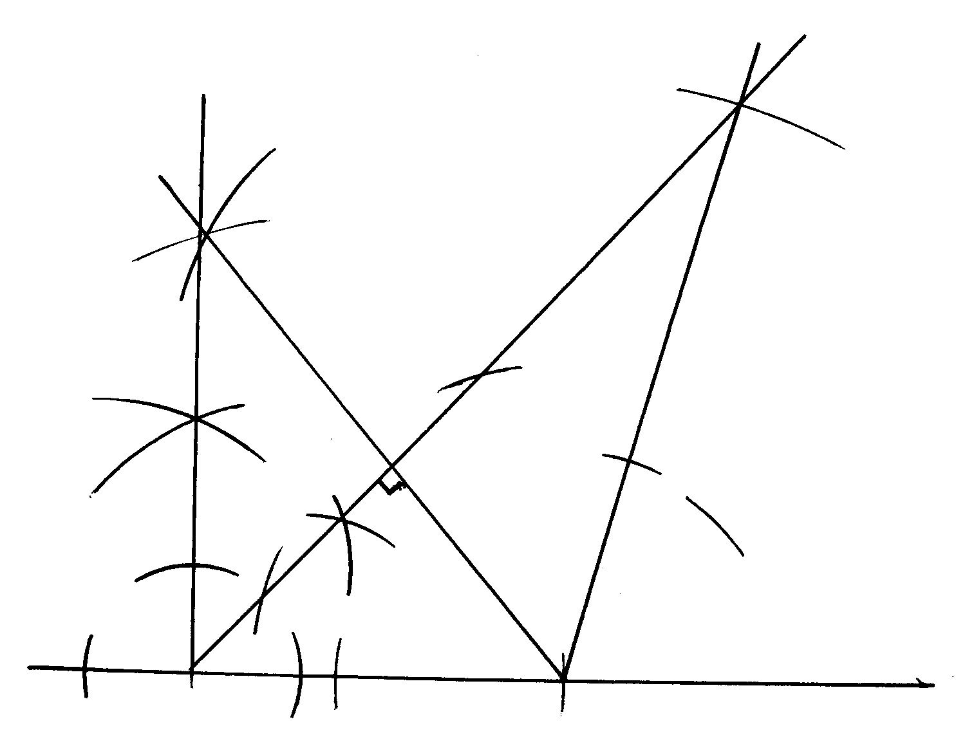  b) PR = 10.8 ± 0.1  45  S  P  Q  R   PQR = 109 ± 1º  c) (i) QS = 3.5 ± 0.1  (ii) Area = ½ x 3.5 x 10.8   18.9 cm² | B 1  B1  B1  B1  B1  B1  B1  M1  A1 | R
 |  | 10mks
18. | (a) (i) 5148 = 2 x 2 x 3 x 3 x 11x 13  = 2² x 3² x 11 x 13  (ii) 6084 = 2 x 2 x 3 x 3 x13 x 13  2² X 3² x 13²  (b) (i) (5148)²  6084  = (2² x 3² x 11 x 13)²  2² x 3² x 13²  = 2⁴ x 3⁴ x11² x 13²  2 x 3 x 13  = 2³ x 3² x 11² x13  ii H.C.F = 2² X 3² X 13  L.C.M = 2² x 3² x 11 X 13² | M1  A 1  M1  M1  M1  A1  B1  B1
 |  | 10mks
19. | a) (i) volume = 3.142 x 5² x 10m³  = 785.5 x 1000li  = 785500litre  (ii) Time taken to fill the tank = 785500  29 x 3600  = 7hrs 30min.  Time the tank is full = 2030 + 7.30  = 2800 – 2400  = 4.00am  b) No. of days = 785,500  250,000  = 3days | M1  M1  A1  M1  A1  M1  A1  M1  M1  A1 | for calculation
 |  | 10mks
20 | 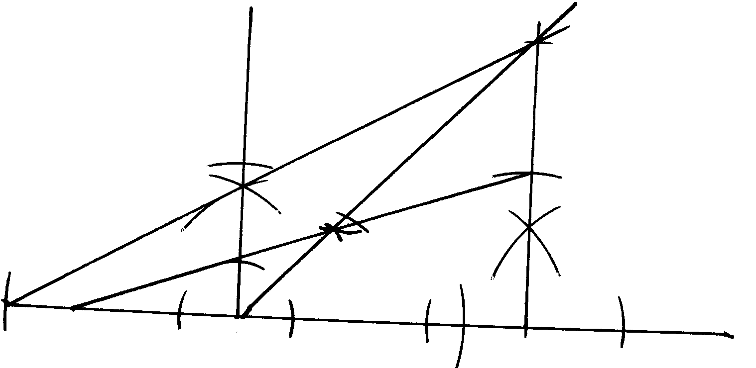  1 cm = 1m  B  - L of evaluent = 80º or 30º  5 cm  B  A  - 5.2 ± 0.1m  (b) Distence of Lorry = 7.5 ± 0.1 | B1  B1  B1  B1  B1 | For locating A  For locating B  For L 45 drawn  Locations top
21 | - Fraction for maize and beans = ½ + ¹/₅ = ⁷/₁₀  A  Remainder = 1 – 7 = 3  10 10   Fraction for grazing = 1 of 3 = 1  3 10 10  Remainder = 2 or 1  - 5  Hence fraction for Hort. = 1  5  Land fro grazing = 10 ha = 1 of whole land.  10   whole land is 10 x 10 = 100 ha  Hence land used for horti = 1 x 100ha  5  = 20ha | B1  B1  M1  A1
 | - Total number of shares = 6  Wife’s share = 1 x 2,116,800  6  = sh. 352,800  Son’s share = 3 x 2,116,800  6  = sh. 1058,000  Son finally got.  = 1058,000 + ½ of sh. 352,800  = 105800 + 176,400  = sh. 1,234,800 | M1  A1  M1  A1  M1  A1
 |  | 10mks
22. | a) let selling price = 100 %  Agent’s commision = 7 ½ %  Owner eceived =100 – 7 ½ = 92 ½ %   92 ½ % = 222000  1% = 22200 ÷ 2 x 100  185  Agent received = sh 240,000 | B1  M1  A1
 | b) Rono received sh. 222000 incuring a loss of 25 %  Rono received 75% of the price he had paid   75 % = 222,000/=  1% = 222,000  75   100% = 222,000 x 100  75  Rono paid = sh. 296,000 | M1  A1
 | c) Take price of new car = 100 %  Rono paid ( 100-26) = 74 % of new   74 % = sh 296,000  1% = 296,000  74  100 % = 296,000 x 100  74  Price of new car = sh. 400,000  b) Amount Rono received = sh 222,000  price of new car = sh. 400,000   required % age = 222 000 x 100  400000  = 55.5 % | B1  M1  M1  M1  A1
 |  | 10mks
23. | 2x – y = 3  x -4 -2 0 3 5 7 8  Y -7 -3 3 11 13  Points (-2,-7) (0,-3) (3,3) (7,11) (8,13)  x -2 0 2 4 6 8 10  Y= 3x – 4 2 -5 1 4 7 10  Points (-2,5) (2,1) (4,4) (6,7) (8,10)  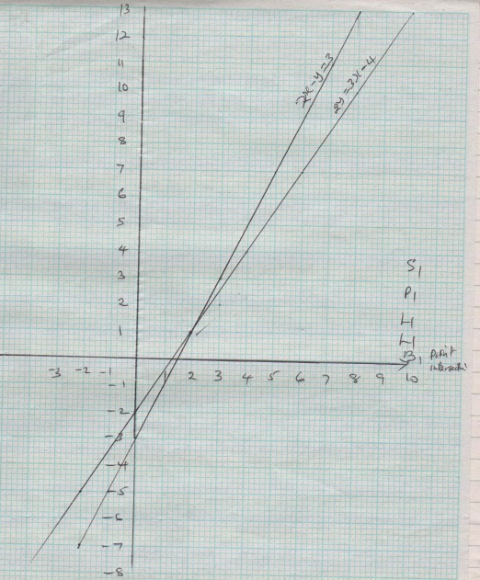  (e) ( 2,1)  (d) P ( 1 ½ ,0)  Q (0,-3) | B1  B1  B1  B1  B1
24 | (i) 2325 – 2015 = 3hr 10mi  0640 – 0310 = 3hr 30mi  2100 – 0820 = 12hrs 40 mi  3415 – 22 55 = 11hr 20min  Travelling time = 6hrs 40 + 24  = 30hrs 40 min  (ii) 2710 – 23 25 = 3hr 45 min  0820 – 0640 = 1 hr 40min  2255 – 21000 = 1hrmin  Stoppage time = 3hrs 45 + 3 hr 35m  = 7hrs 20min  (iii) time for whole journey  30 hrs 40min + 7hrs 20 min  = 38hrs  b) distance = 60 x 3  = 2280km. | M1  M1  A1  M1  M1  A1  M1  A1  M1  A1 | Alter  3415 – 2015= 14hrs  Plus 24hrs  38hrs

