NATIONAL EXAMAINATION 2017
Form 4 Physics paper 1 Marking schemes

SECTION A (25 MARKS]

1. A vernier calipers was used to measure the length of the side of a dice. A section of the vernier calipers is shown in Figure l. Determine the reading on the instrument. (lmrk)
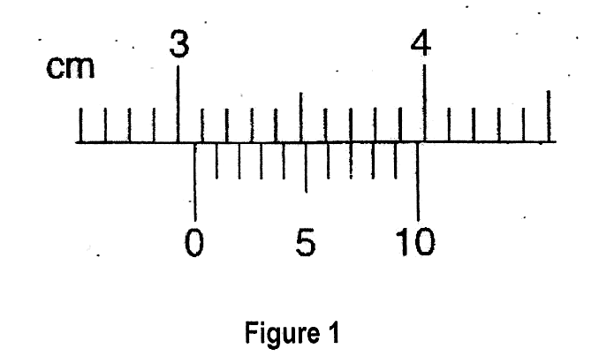

Reading = 3.0 + 0.07 = 3.07cm

2. Two samples of bromine vapor are allowed to diffuse separately under different conditions, one in a vacuum and the other in air. State with reasons the conditions in which bromine will diffuse faster
(2mrks)
Bromine in vacuum diffuses faster. There are no particles that woll slow down the motion of the gas molecules in a vacuum.

3. The Figure 2 below shows a circuit where a battery of e.m.f. 4.5V, switches A and B, two capacitors C₁ = 0.6μF and C₂ = 1.0μF and a voltmeter are connected.

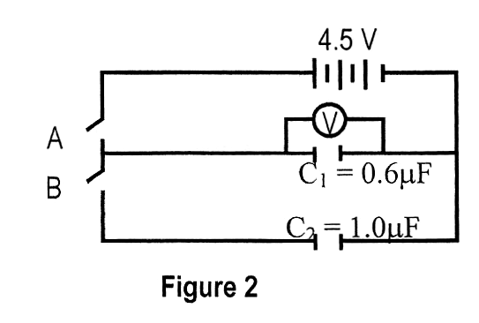

(a) Determine the charge on C₁ when switch A is closed and switch B is open. (2mrks)
Q = V₁V
= 0.6 x 10⁻⁶ x 4.5
= 2.7Μc

(b) Determine the effective capacitance when both switches are closed (2mrks)
C₁ = C₁ + C₂ = (0.6 + 1.0) X 106 = 1.6μF

4. State Newton’s first law of motion (1 mrks)
A body remains in its state of rest or uniform motion in a straight line unless compelled to do otherwise by an externally applied force.

5. Give two reasons why optic fibers are preferred over copper cables in telecommunication (2mrks)
They have a larger carrying capacity, No loss of energy during transmission,
Immune to electromagnetic interference, information cannot be intercepted or tapped, they are not bulky

6. Transformers cannot work with d.c current. Explain. (1 mrk)
d.c current buids up from a zero to maximum thus doesn’t cause continuous changein magnetic flux.

7. A uniform meter rule of mass 0.4kg has an iron mass fixed at the 20cm mark is balanced when pivoted at the 35cm mark by an attractive force due to a magnet fixed on a bench below the mass as shown in Figure 3 below. Determine the attractive force due to the magnet given that the iron has a mass of
200g. (3marks)

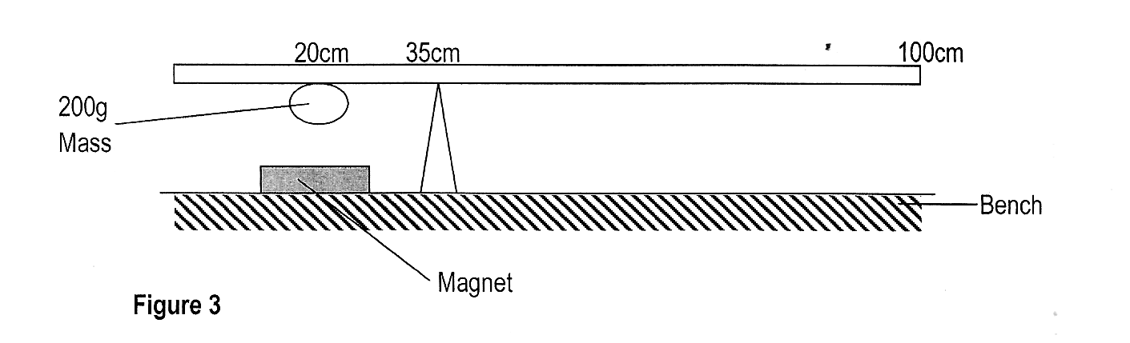
Sum of clockwise moments = sum of anticlockwise moments
Let downward force on 200g mass be F
4 x 0.15 = F x 0.15
F = 4 x 0.15/0.15
F = 4N; attractive force = 4 – 2(weight of 200g mass) = 2N

8. (a) state Fleming’s left hand rule (1 mrk)
If the left hand is held such that the thumb, the first finger and the second finger are held mutually perpendicular to each other, the first finger pointing towards the direction of field, the second finger current, the thumb will points towards the direction of motion.

(b) Figure 4 below shows a conductor in a magnetic field. Given that the field is out of the paper, indicate on the diagram the direction of the resultant force on the conductor. (lmrk)

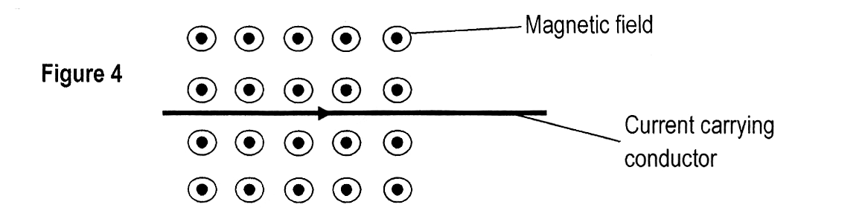

9. State any one condition for the interference of waves to occur. (1 mrk)
Source of wave must be coherent (same frequency and constant phase)

10. State and explain one advantage of fitting wide tires on vehicles that move on earth surface such astractors. (2mrks)
It avoids sinking of the vehicle. The pressure the vehicle exert is reduced due to increased area of contact.
11. Two identical plastic containers were painted one dull black and the other silvery. They were partiallyfilled with equal amount of water and completely sealed then left in the sun for some time.

(a) State the observation that was made after sometime. (lmrk)
The container painted dull black bulges more than the one painted silvery

(b) Explain the above observation (2mrks)
The dull surface absorbs more radiant heat, heating the air in the container to expand more while the silvery surface being a poor absorber will cause less heat thus less expansion.

12. The graph below shows the relationship of force against extension of a certain helical spring made of steel. Use it to answer the questions that follow.

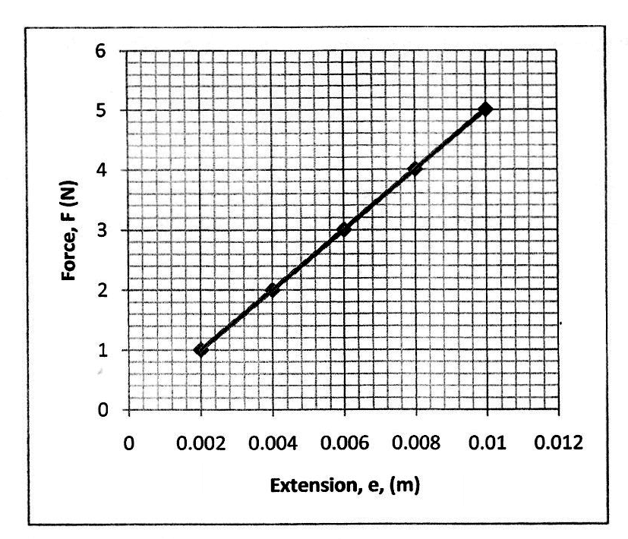

(a) Calculate the spring constant (3mrks)
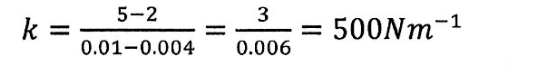

(b) State one factor that affects the spring constant obtained in (a) above (lmrk)
Diameter of the spring, thickness of the wire, number of coils on the spring

SECTION B (55 MARKS)
13. (a) A defective eye focuses a near object as shown in Figure 6 below.

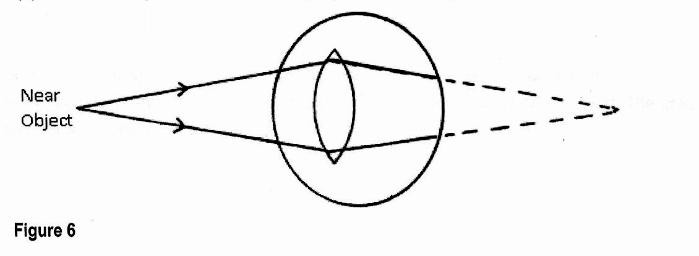

(i) State the defect. (l mrk)
Long sightedness/ hypermetropia

(ii) Suggest a suitable lens that can be used to correct the defect. (lmrk)
Use of a convex lens

(b) (i) A real image, half the size of the object is formed by a lens. If the distance between the object and the image is 450mm. Determine the focal length of the lens. (3mrks)
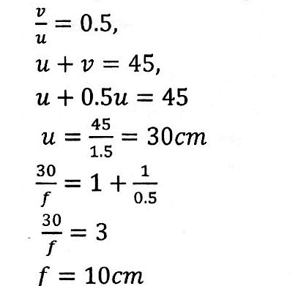

(c) Figure 7 below shows a virtual image formed by a convex lens. Complete the ray diagram toshow the position of the object. (3mrks)

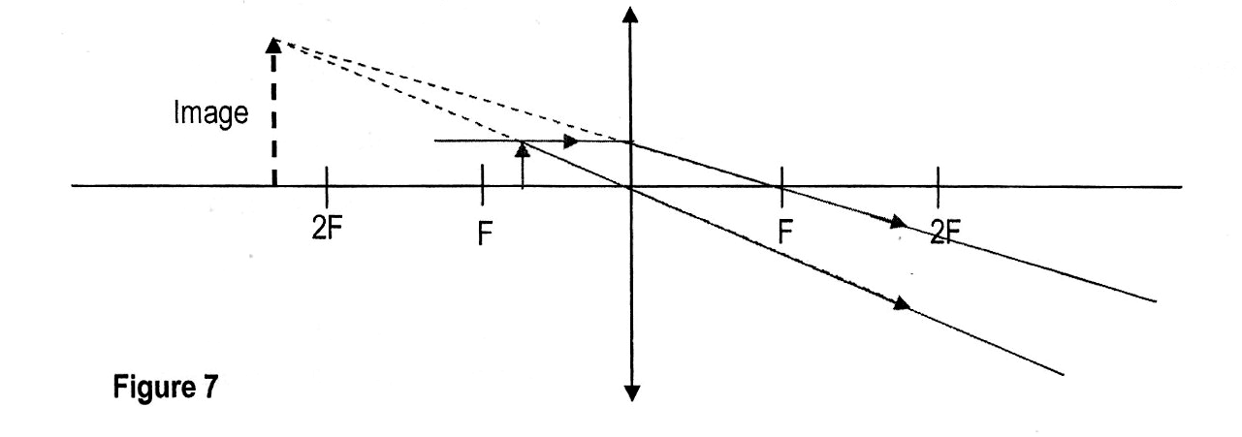

14. (a) Figure 8 shows a hydraulic lift used to raise a load ‘L’. The effort applied is 160N at the end of the lever 36cm long and pivoted at the other end. The plunger is 6cm from the pivot. The area of the plunger A is 4cm² and that of piston B is 400cm².

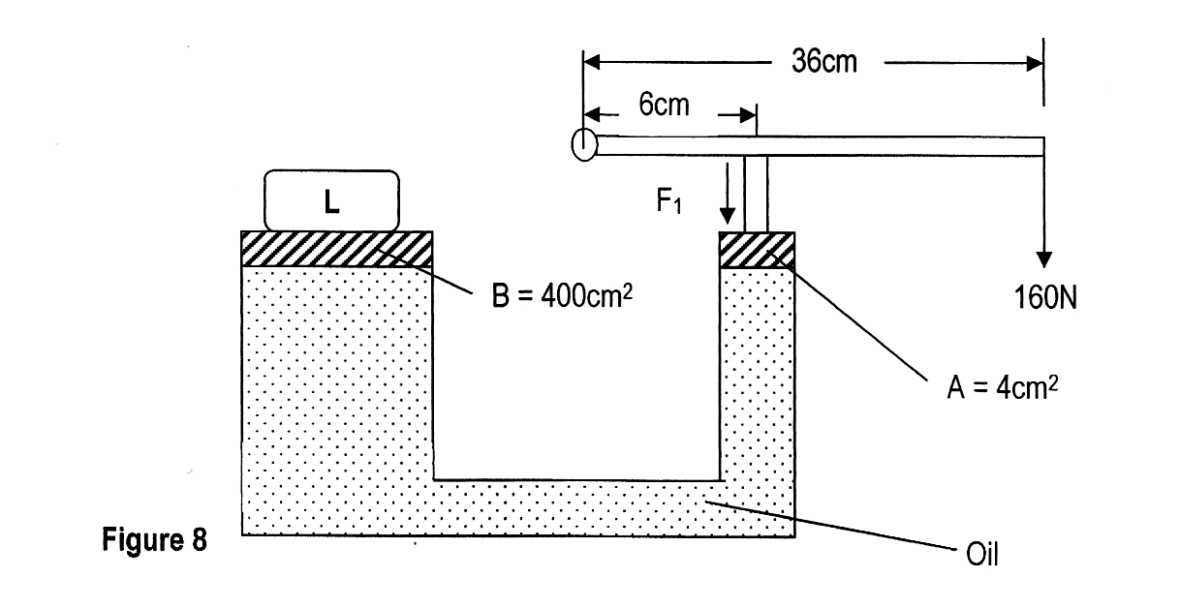

Determine:
(i) The value of force Fl extended by the plunger on oil. (2mrks)

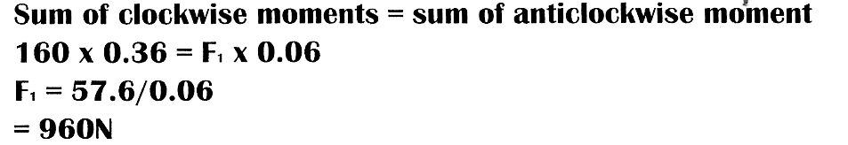

(i) The value of the load L (2mrks)
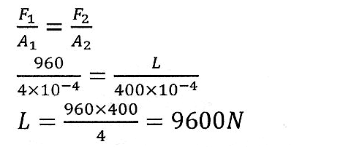

(iii) The velocity ratio of the lever. (2mrks)
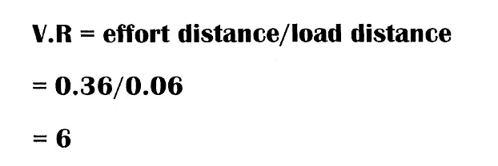

(iv) The velocity ratio of the hydraulic lift (2mrks)
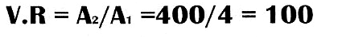

(v) Combined velocity ratio of the system (2mrks)

(vi)Efficiency of the system (2mrks)
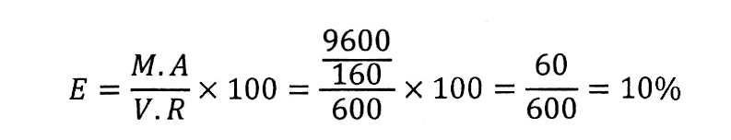

15. a) Figure 9 below shows a faulty set up used to investigate a certain gas law.

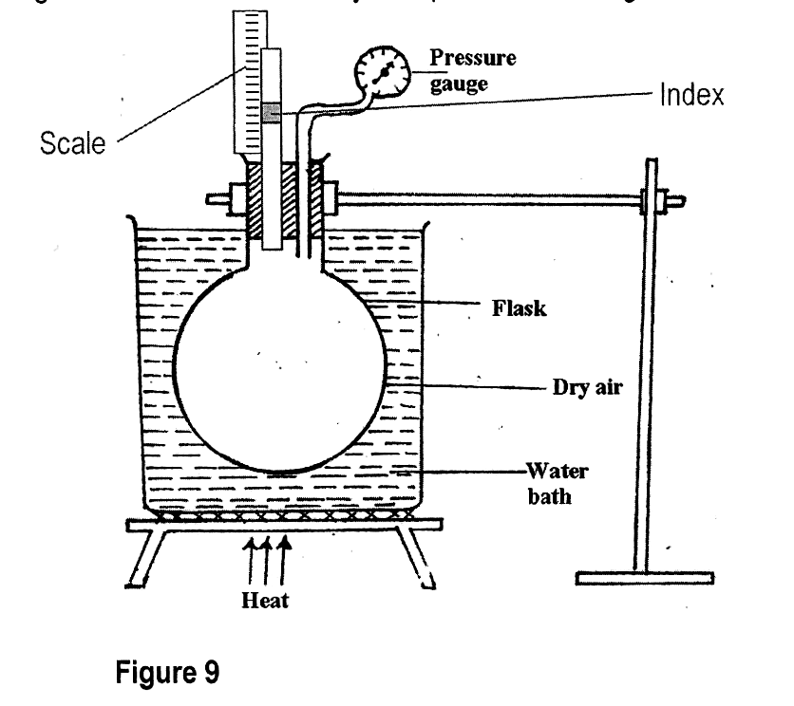

(i) On the diagram, show the missing part required for the set up to be functional. (l mrk)

(ii) State the law being investigated. (l mrk)
Boyle’s law

(iii) The volume of a gas at a pressure of 1.0 kPa is 12m³. If the container isdepressurised to 0.8 kPa. Determine the new volume given that the temperaturewas kept constant. (3mrks)
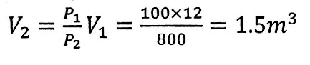

(b) State ONE difference between boiling and evaporation. (lmrk)
- Boiling takes place at a fixed temperature while evaporation takes
- Place at any temperature
- Boiling takes place throughout the liquid while evaporation takes
- Place at the surface of the liquid
- Decrease in atmospheric pressure lowers the boiling point but
- Increases the rate of evaporation.

(c) 200g of a solid was uniformly heated by a 0.2 kW heater for sometime. The graph in Figure l0 below shows how the temperature of the solid changed with time.

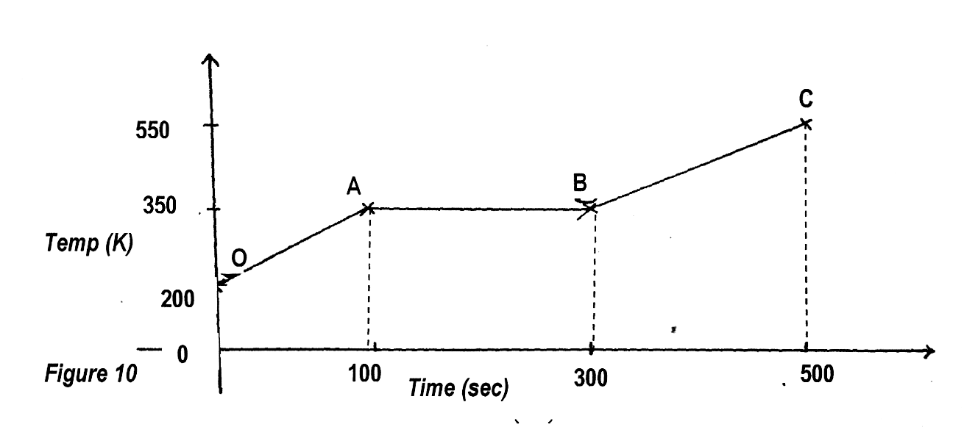

(i) Explain what is happening between
(I)OandA (lmrk)
The solid expands with rise in temperature

(II) A and B (lmrk)
Body is melting

(ii) Calculate the specific heat capacity of the solid. (3mrks)

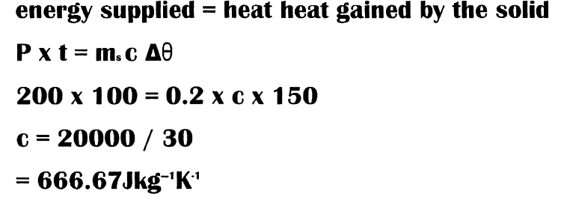

16, (i) State the law off floatation. (l mrk)
A floating body displaces its own weight of the fluid in which it floats

- Figure 11 below shows a floating object of volume 40,000 cm³ and mass l0g. It is held as shown in water of density 1 ,25g/cm³ by a light cable at the bottom so that 3/4 of the volume of the object is below the water surface, take g =10N/kg (Assume that up thrust due to air is negligible)

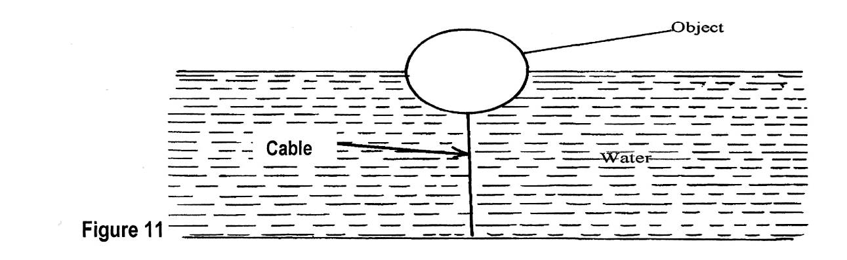

(i) Calculate the volume of the object under water. (2mrks)
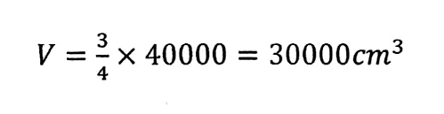
(ii) State the volume of water displaced by the object. (1 mrk)
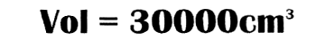

(iii) Calculate the weight of water displaced. (2mrks)
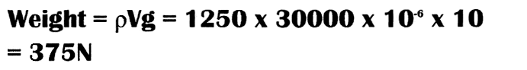

(iv) Determine the tension in the cable (2mrks)
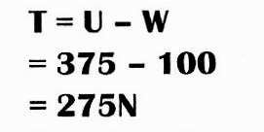

17. (a) Explain why a body moving with a uniform velocity in a circular path is said to be accelerating
(l mrk)
The instantaneous velocities on the circle keep changing with time.

- An object of mass 0.5 kg is attached to one end of a light in extensible string and whirled up in a vertical circle of radius 1m and centre 0 as shown in Figure 12. (Take g = 10N/kg)

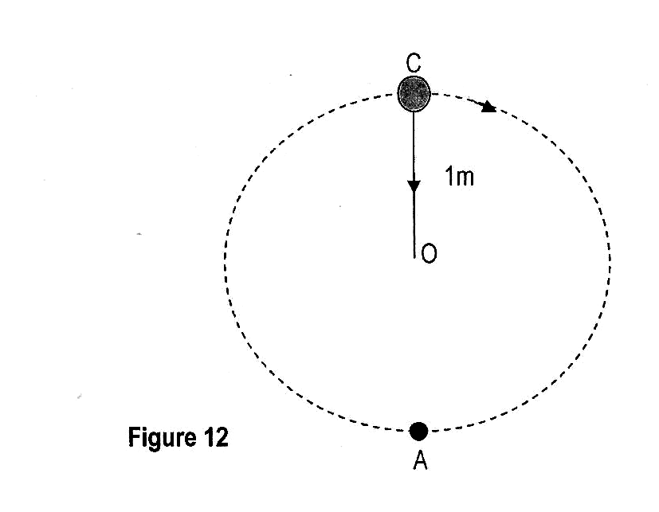

(i) If the tension on the string when the object is at the lowers point A is13.ON. Calculate the velocity v of the object. (3 mrks)
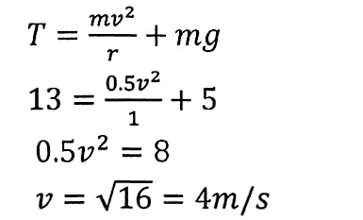

(ii) Tension on the string when the object is at the highest point C of thecircle. (3mrks)
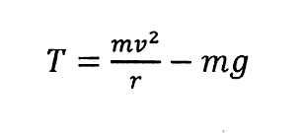
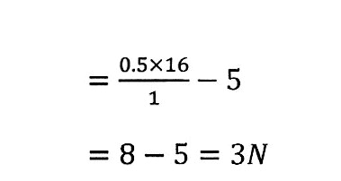
(iii) If the string was to break when the object is at the lowest point A of the path determine how far the object moves horizontally before it hits the ground which is 0.4m below point A. (3mrks)
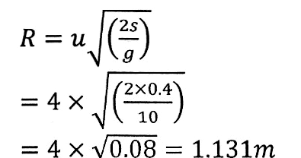

18. Figure 13 below shows how a student set up a circuit using 3 identical bulbs X, Y and Z each rated
“12V, 2.0A”

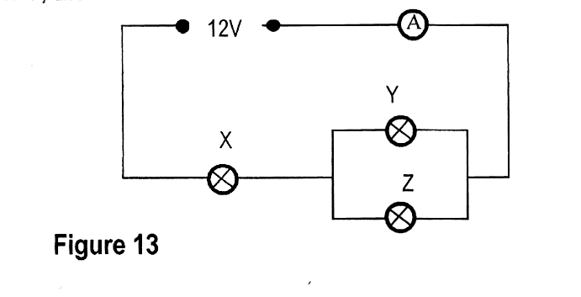

(a) When operating normally, calculate the resistance of one of the bulbs (2 mrks)
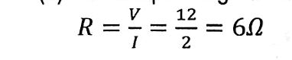

(b) Calculate the effective resistance of the three bulbs, (2 mrks)
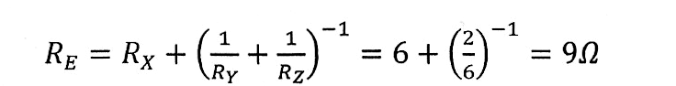

(c) Determine what the ammeter reading will be (2 mrks)

