PHYSICS PAPER 3

MARKING SCHEME
Question 1
(b) d = 1cm (1 mk)

(f)
$$x(\text{cm})$$ | 50 | 40 | 35 | 30 | 25 | 20
y(cm) | 12.5 | 13.33 | 14 | 15 | 16.6 | 20
h(cm) | 0.25 | 0.3 | 0.4 | 0.5 | 0.7 | 1.0
M=$dh$ | 0.25 | 0.3 | 0.4 | 0.5 | 0.7 | 1.0
(5 mks)
g(i)
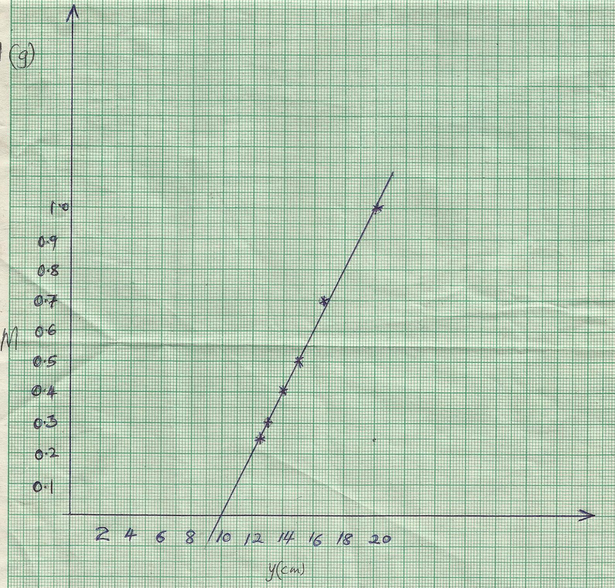
Axes 1 marks
Scale 1 mark
Plotting 2 marks
Line 1 mark

Gradient = 1 – 0.25 = 0.1
20 – 12.5

(ii) Slope, s of the graph.
Slope= $s = \frac{0\text{.}\text{66}−0\text{.}3}{\text{16}\text{.}6−\text{13}\text{.}2}$=0.105 (3 mks)
(h)$M = \frac{v}{p} − 1$$p = \frac{1}{s}=9\text{.}4 ±1\text{.}0\text{cm}$ 1 1
Part B
J (i)
u₁ =10.5 cm (1mk)
(ii)
u₂ = 77.5cm (1mk)

iii) $\begin{aligned}x = u_{2} − u_{1} \\ = \text{87}\text{.}5−\text{10}\text{.}5=\text{77}\text{cm}\end{aligned}$ 1

iv) $f = \frac{L^{2} − x^{2}}{4L}$, $f = \frac{{\text{100}}^{2} − {\text{77}}^{2}}{4x\text{100}}$=10.1775cm 1

2 (i) V=…0.2V……………… I=…0.1A…………… (1 mark)
ii)

L(cm) | 80 | 60 | 40 | 20 | 0 |  | 3mks  3mks  2mks
Ammeter reading I (A) | 0.15 | 0.2 | 0.2 | 0.25 | 0.3 | +0.1 | 3mks  3mks  2mks
Voltmeter reading V (v) | 0.3 | 0.4 | 0.6 | 1.2 | 2.4 | +0.1 | 3mks  3mks  2mks
$R = \frac{V}{I}$$\left(Ω\right)$ | 2 | 2 | 3 | 4.8 | 8 |  | 3mks  3mks  2mks
8marks
(iii)
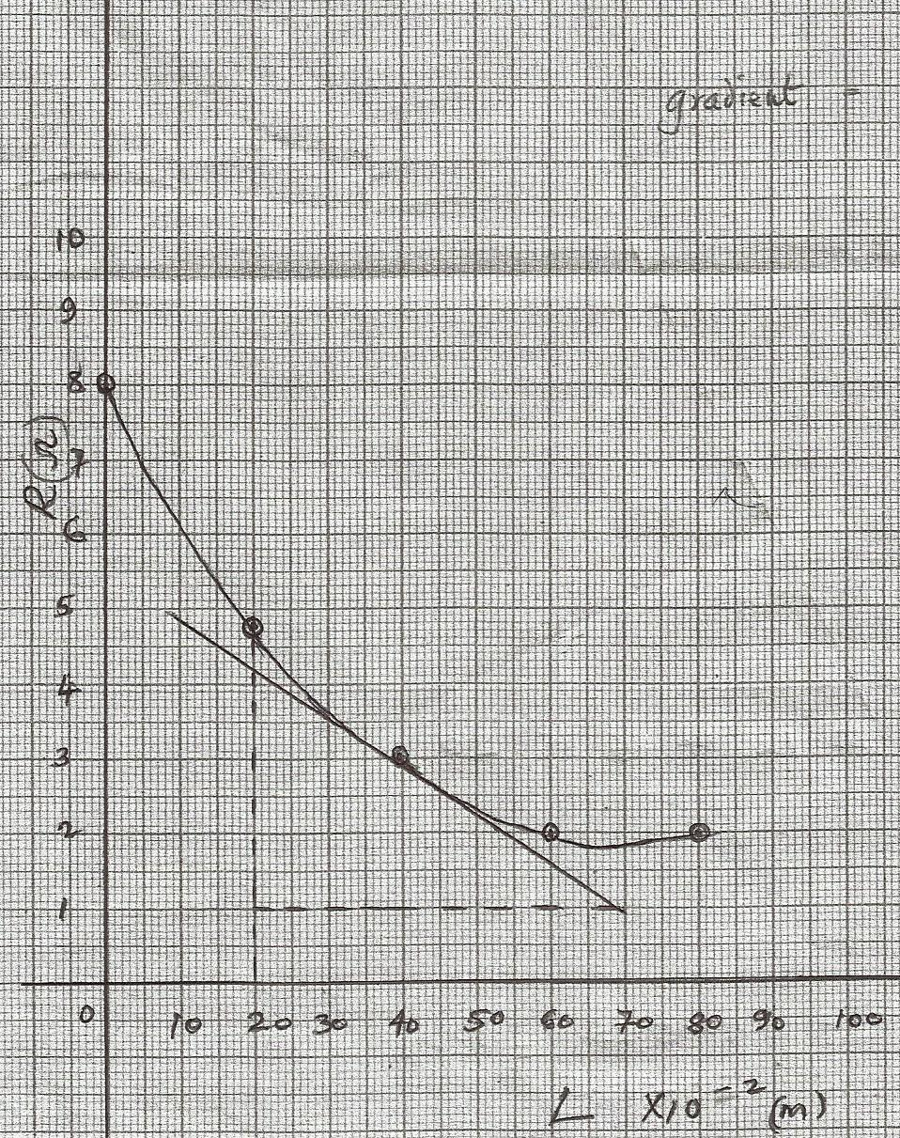
Axes 1 mark
Scale 1 mark
Plotting 2 marks
Line 1 mark

Gradient = ΔR = 4.2 – 1
ΔL 0.2 – 0.7
= -6.4

Iv)Slopes at Y=40. (3mks)

$g = \frac{ΔR}{ΔL}=$$\frac{4\text{.}2−1}{0\text{.}2−0\text{.}7}=−6\text{.}7$

(v) D = …………………m 1
p = 0.5 $\left(\frac{D^{2}}{s}\right)$ at Y=40cm substitution 1evaluation 1

