PHYSICS 2
PRE – MOCK 2017
MARKING SCHEME

No | Answers | Remarks
1 | White paper is not smooth√ therefore light reflected by the paper is to different directions (diffused reflection) therefore, no image seems to form √ | ½  ½
2 | (a) Y- Amplitude √α  (b) X-wavelength λ | 1  1
3 | Conditions necessary for sound production  Vibrations or oscillations√  Material medium √  Energy | Any two correct
4 | X-carbon rod √  Y- act as a negative terminal  (also involved in the reaction to produce the e.m.f and gets eaten away with time | 1  1  1  1
5. | Suspend the magnet√ freely, away from a magnetic material. The magnet rest facing north –south earth’s magnetic field. The N-pole points in the earth’s north pole (geographical) | Suspend freely  1  1
6. | Distance = 100+100=200m  Time = $\frac{\text{dis}\text{tan}\text{ce}}{\text{speed}}=\frac{S}{V}=\frac{\text{200}m}{\text{330}m/s}=0\text{.}\text{6061}s$
7. | Let R be effect resistance  $\frac{1}{R}=\frac{1}{8}+\frac{1}{7}=\frac{7+8}{\text{56}}=\frac{\text{15}}{\text{56}}$√1  ∴R= 56/15 n√1 =3.73η√1
8 | 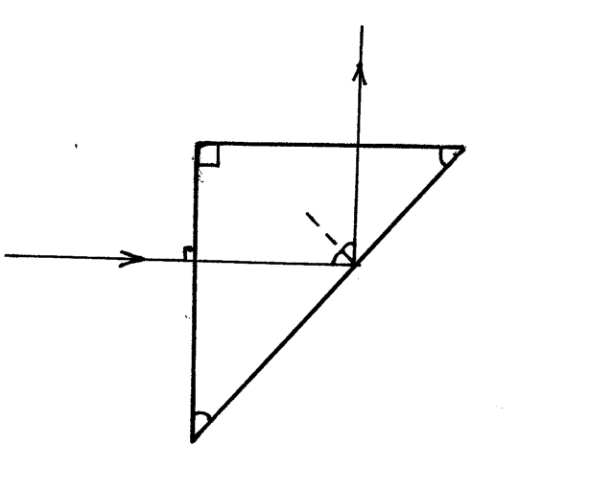  45  45  90º  45  45 | Light at 90º to the prism
9. | A driver in front will see the word ambulance (AMBULANCE) due to lateral inversion of mirrors hence give way√1
10. | 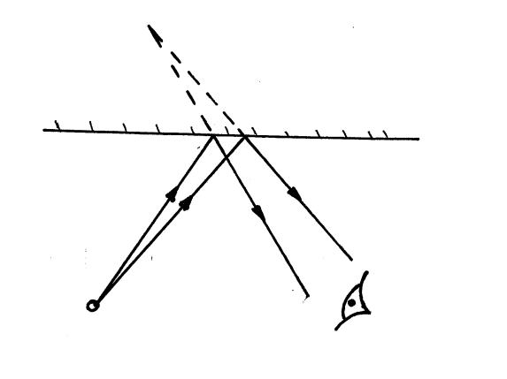  Eye  √1  √1  √1 | For the rays and where they meet
11 | 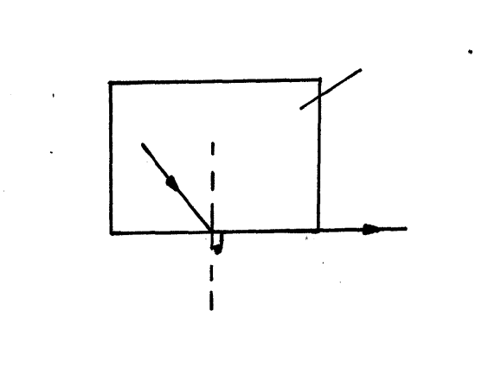  90º  C  Glass (more dense )  C-critical angle √1 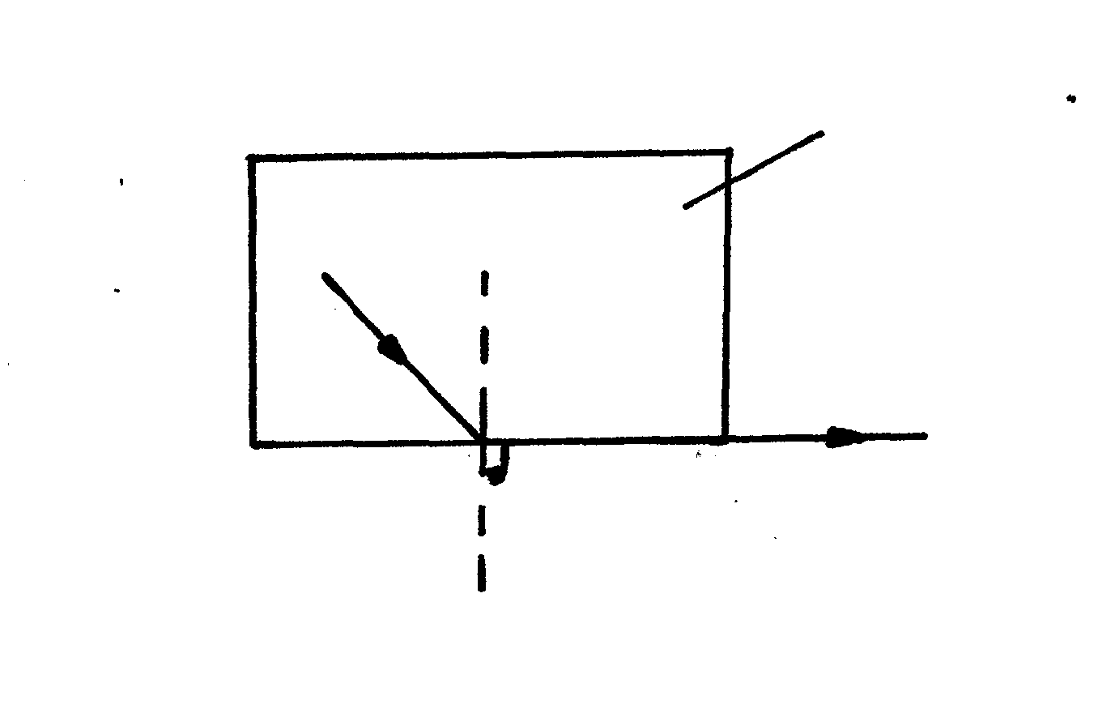Glass (more dense )  Air (less dense)√1  i  i>c  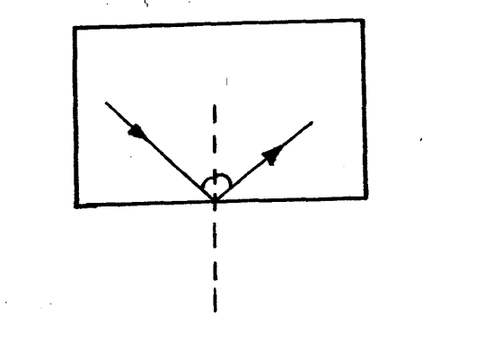  r
12. | (a)  √3  (a) Radio waves have the longest wavelength√  They less energetic and less penetrative  (c) The ionosphere is able to reflect radio waves to the receive and good reception  (d)f= 3x10⁸ m/s = 200,000m  1500m  =2x 10⁵m | For all in correct order  Any one mark
  Radio waves | Micro waves | Infra-red | visible | Ultra-violet | x-rays | Gamma rays
13 | (i)  (ii) Refer to graph A-1  S-1  P-2  L-2  (iii) The y-intercept is 10x10⁻²  f = 1 or 1  y-intercept x-intercept | For 1 mark for  getting the recipri  1 mark for ident inter
  1/u | 0.050 | 0.040 | 0.033 | 0.025 | 0.200 | 0.014
  1/v | 0.050 | 0.050 | 0.667 | 0.075 | 0.08 | 0.086√3
14 | 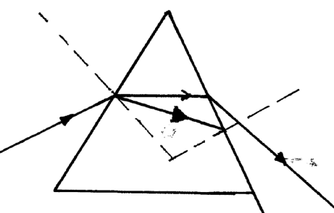  60º  ө  r  C  Refractive index = 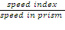√1  =3x10⁸m/s  1.88x10⁸m/s √1  =1.5958√1  (b) As indicated on the diagram  n= 1 = sin C = 1/n = 1/1.5957 =0.6266  sin C  =38.8º  (c) refractive index = sin i= 1.595 = sin ө  Sin r sin 21.2  =sin ө= 1.597x0.3616  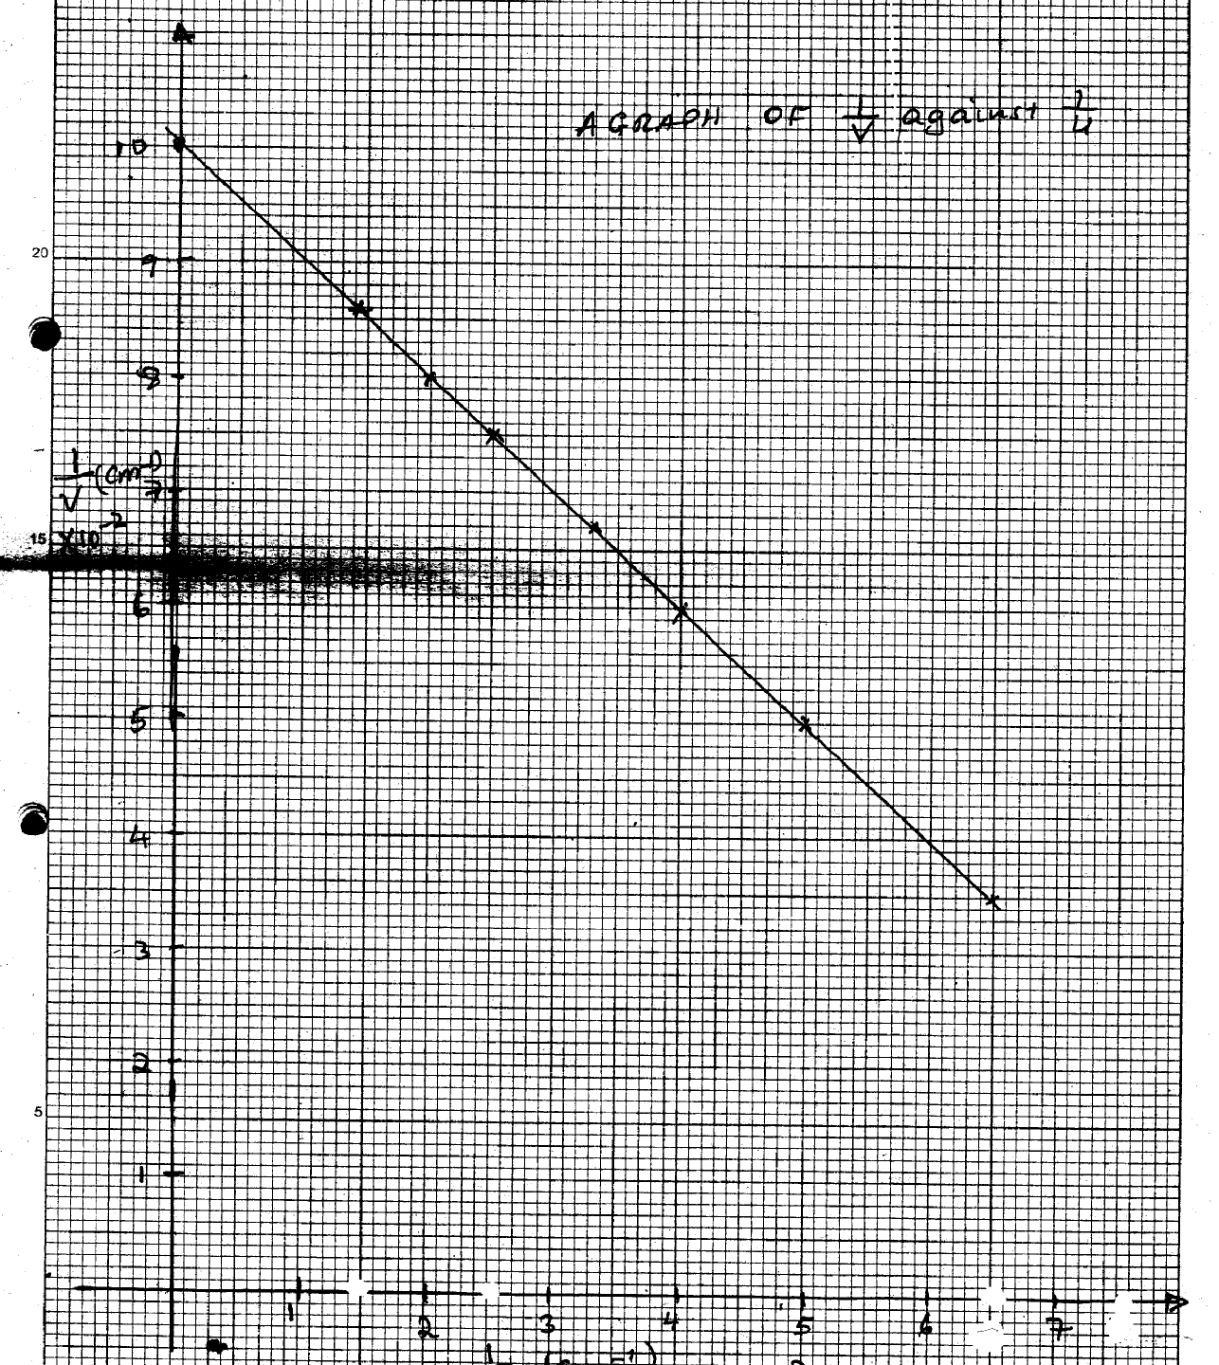  i/v (cm-1) x 10⁻²  Sin ө = 0.577  Ө=sin ⁻¹ 0.577 = 35.2º  (d) As indicated on the diagram  Follow the indication of diagram
15. | Heat lost by the heater = heat gained by water  MC∆ө=p.t  c= p.t = 90 x 15x60  mx ∆ө 2x(30-10)  =81000J  20  =4050Jkg⁻¹K⁻¹  (b) effective capacitance = 3 x 10⁻⁶f+2x10⁻⁶f  =5x 10⁻⁶f√1  Q=VC V = ^{Q}/_{C}= 1x 10⁻⁴  5x 10⁻⁶  =20V  (c) largest wavelength when the frequency is lowest  C=λf  Λ=^{c}/_{f}√1=330m/s  30Hz  =11m√1  (d) (i) Initially the polythene rod and cloth have same amount of charge √1  -when rubbed polythene acquire some of the charge (negative) from cloth hence excess negative charge √1  The cloth remain with excess positive charge hence positively charged  (ii) The brass is good conductor hence it quickly conduct the acquired charge through the hand which is also a good conductor of the charge hence it cannot be charged | Good conductor  Getting or discharges immediately
16. | (a)  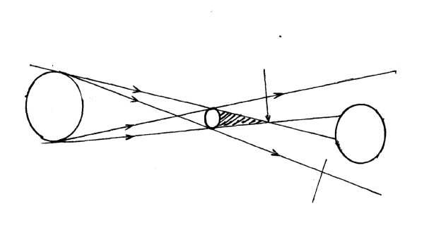  (b)  moon √  Partial darkness √  Tip of umbra √  Sun √  (c) u=15cm, f=6cm V=?  ¹/_{f}= ¹/_{u}+ ¹/_{v}= ¹/₆= ¹/15+¹/v√1  ¹/₆- ¹/₁₅= 1/v 15-6 = 9  90 90  ∴V= 90= 10cm  9√1  (i) the image is 10cm from the concave mirror on the same side as object  Magn = image distance  Obj. dist  = 10cm  15cm√1  =0.667√1  Image is real  Inverted  Same side as the object | 1 rays  1 tip before earth  1 for correct positions
  pinhole | Lens camera
  (i) The image is always similar to the object  (ii) It can be larger same size or smaller | (i) Image can be distorted  (ii) is always smaller than the object

