NATIONAL EXAMINATIONS COUNCIL
FORM 4 GEOGRAPHY PAPER 1 MARKING SCHEME

I Physical requirements of maize
- Cool to high temperature 18 — 27c
- At least 200 4tost days
- Moderate to high rainfall 630 — 1200 mm
- Deep well drained loam soils
- Undulating land/gentle sloping land
- A dry sunny season during harvesting Any 4*1 4 marks

2a.
- Lake Victoria
- LakeNaivasha
- LakeBaringo

b. Trawling method
- It involves dragging a cone-shaped bag over the sea bed behind the boat trawler
- Trawl method is used to a catch fish in the open water away from the shore using large ships! boats known as trawlers.
- The trawl net which is bag shaped is attached to the trawler.
- The mouth is kept open by other boards! head beams.
- The upper part of the trawl is kept a float while the bottom part is held down by weights
- The trawl net is dragged along the sea bottom by the trawler to trap fish.
- After sufficient fish is caught the net is hauled into the trawler Any 4*1 4 marks

3a. National park is where wildlife is kept and there is no human activity 2 marks Game reserve is a place where wildlife is kept and there is limited human activity 2 marks

b.
- Tsavo West
- Tsavo East
- KisiteMpungutiMarineNational Park
- MombasaMarineNational Park
- MalindiMarineNational Park
- ShimbaHillsNational Park

4. Importance of domestic tourism
- Makes people aware of their environment country
- People are able to appreciate their cultural heritage
- Local people make use of the hotel facilitates that are underutilized during the low seasons.
- “Creates more employment opportunities
- More circulation is increased in the economy Any 4*1 4 marks

5. Problems facing irrigation farming
- Siltation of canals pipes
- High rate of evaporation
- Salinasation of the soil
- Clogging up of water canals by weeds
- Problems of water borne diseases e.g. bilharzias/ malaria.
- Fluctuating of water level during the dry seasons.
- Delayed payment of the produce that have been sold
- Mismanagement of irrigation scheme
- Inadequate capital to buy the farm inputs Any 4*1 4 marks

SECTION B
6a On graph paper

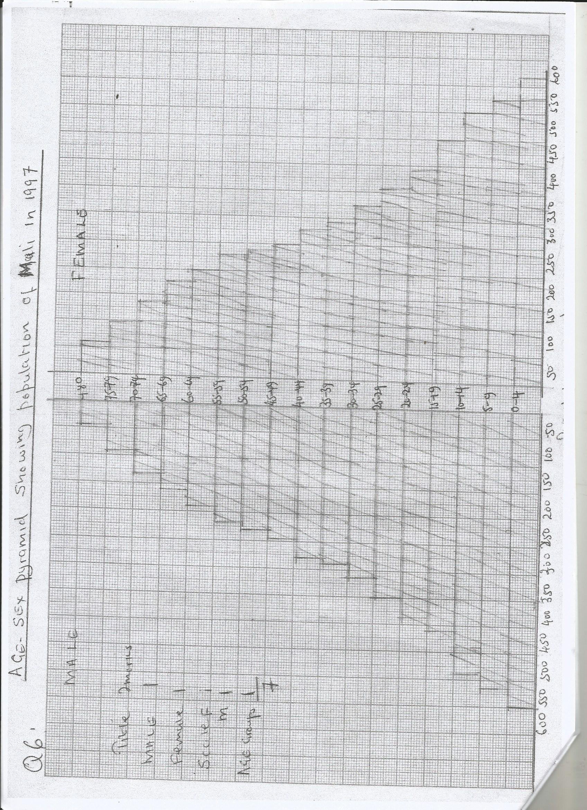

b(i) Disadvantages
- Difficult to maintain uniform size of the dot.
- Dots are place over the map ignoring areas where there no settlements
- If a widely scale is chosen they may be too crowded making interpretation difficult Any 3*1 3 marks

(ii) Importance of conserving wildlife
- Wildlife attract tourists thus earning the country foreign exchange.
- Game ranching. Animals like antelope provide meat rich in protein
- Scientific studies. Wildlife can be studied on their natural habitat and this help on management and conservation
- Preservation of genetic resource for the future generation
- Trees provide cheap source of wood fuel
- Wildlife also provide

c. Problems facing wildlife
- Long period of drought most animals die due to lack of water! pasture.
- Wildlife face extinction due to poachers
- Frequent forest fires that destroy vegetation
- There is competition of land between wildlife and human
- There could be incidences of pest that destroy vegetation
- Diseases would affect wildlife
- Too many wildlife in one area resulting to overgrazing.

7a(i) Non-renewable sources of energy
- Oil petroleum
- Coal
- Natural gas
- uranium Any3 x l 3marks

(ii) Advantages of solar energy
- It is cheap to
- It is environment friendly! clean
- Can be found anywhere Any 2*1 2 marks

b. Economic factors that influence seven forks project
- The area has low population hence the cost of resettling people is low.
- There is high demand for electricity for industrial! domestic use.
- There was need for water to carry out irrigation to increase food production
- There was need for self sufficiency in HEP to avoid over reliance from imported power in Uganda
- There was need for power to encourage industrialization thus create employment.

c(i) Benefits of the Geothermal project

- Geothermal project has increased power production thus saving foreign exchange.
- V’ Cost of electricity for the consumers
- V There is improved transport e.g. roads as these areas have become for accessible.
- Geysers and steam gets are major tourists attraction sites this earnings the country foreign exchange
Any 6*1 6 marks
8a. Industrialization
- Refers to the process through which non-industrialized countries become industrialized by establishing manufacturing industries with an aim of converting raw materials both minerals and agriculture.
b(i) Factors that influence location of industries
- Availability of raw materials that are in the processing industry.
- Availability of power that is in running the engine.
- Adequate capital for construction of infrastructure.
- Skilled! unskilledlabour to work in the industry.
- Availability of markets where the goods can be sold.
- Availability of water for cleaning raw materials.
- Government policy. Government may encourage or discourage the location of industries in an area.
- Availability of raw materials, some raw materials are bulky industries are located near the source.

b. Factors that led to rapid car manufacturing in Japan
- Advanced technology or automation, this has led to efficient and increased car production
- Japan produces fuel- saving vehicles this creates a high demand in external market.
- Availability of market locally and internationally encouraging to produce more,
- Japan has well sheltered natural harbours which are favoured of development of parts which make importation of raw materials and exportation of cars easier.
- Technical oriented education policy has made Japan to manufacture cars.
- Japan has large population which creates a large market.
- Japan has a rugged landscape which discourages development of agriculture and hence industries as alternative land use.
- Japan has highly developed sources of power which encouraged the growth of industries.
- Japan has adequate capital from the fishing industry to invest in the industry.
- The strategic position of Japan in relation to other countries encourage trade thus promoting production of vehicles Any 4*2 8 marks

c. (i) Tertiary industry
- Banking
- Insurance
- Printing
- Publishing
- Transport Any 3*1 3 marks

(ii)
- When industries are concentrated in one place problem of pollution arises i.e. water! air! land pollution.
- There are shortage of houses leading to development of slums.
- Many young people move to the urban areas to work in the industries leading to low production in agriculture.
- Some industries may be closed down leading to unemployment.

