CHEMISTRY PP2
MARKING SCHEME FOR FORM 4 PAPER 2

1. (a) Fractional distillation
(b) (i) Cracking – is the braking of long-chain alkane molecules into shorter alkanes and an alkene by
heating or use of catalyst.
(ii) - Heat or temperature 400ºC – 700ºC
- Silica /SiO₂ or Catalyst – silica /SiO₂
- Aluminium oxide Al₂O₃
(iii) C₁₀H_{22 (l)} → C₅H₁₂ + C₅H_{10 (g)}

(iv)
H HHH
| | |
C = C – C – C – C – H
| | | |
H HHHH Pent-1-ene
H HHH
| | |
C = C – C – C – H OR
| |
H HH
H - C - H
|
H 2-methyl but- 1-ene
H HHH
| | |
H C = C – C – C – C – H
| | | |
H HHHH Pent-2-ene
H HH
| |
C = C – C – C – H
| |
H HHH
H–C ⁻H
|
H 3-methylbut-1-ene
H HH
| |
H - C = C – C – C – H
| |
H Hk
^{H - C - H}
|
H 2-methylbut-2-ene
Any two;drawing 1mknaming 1mk

(v) Shake a sample with;Bromine C₅H₁₂ does not decolourise, C₅H₁₀decolouriseOR. – Acidified Potassium chromate (VI) with C₅H₁₂ the orange colour does not change but with C₅H₁₀ the orange colour changes to green OR Burn a sample of C₅H₁₂ burns with a non-luminous flame; while C₅H₁₀ burns with luminous

2. A. (i) (a) Carbon (IV) oxide or CO₂

(b) KOH _{(aq)} + CO2 _{(g)} KHCO_{3 (aq)} ;
Wrong balanced = 0
State symbols wrong or missing ;

(ii) Oxygen gas or O_{2 (g)} or oxygen (O₂) gas;
(iii) Nitrogen gas or N_{2 (g)} or nitrogen (N₂) gas. ;

B. (i) Moles of nitrogen = 1.54 = 0.11
14

Moles of oxygen = 3.53 = 0.22
16

(ii) N O
Mole ratio 0.11 = 1; 0.22 = 2;
0.11 0.11
Simplest formula NO₂;

(iii) Compound has low melting and boiling points √1 because it has a
Weak Van der wall forces;

3. (a) Hydrogen gas;
b) To provide a larger surface area over which the gas dissolves in water. ;
c) - From electrolysis of aqueous sulphuric (VI) acid;
- From electrolysis of brine
- From cracking of alkanes
- A by-product of petroleum industry (any 1mk)
(d) H_{2 (g)} + Cl_{2 (g)} →2HCl _{(g)};
(e) Allow small amounts of hydrogen through a jet to burn with excess chlorine gas.;
(f) Na₂CO_{3 (aq)} + 2HCl _{(aq)} →NaCl_{(aq)} + N₂O + CO_{2(g)}
Moles of HCl = 0.1 x 25
1000 = 0.0025
Moles of Na₂CO₃ = ½ x 0.0025
= 0.00125
Molarity of Na₂CO₃ = 1000 x 0.0012
20
= 0.0625M;

Mass of NaCl = 8.4 – 6.625 = 1.775
% NaCl = 1.775 x 100
8.4 = 21.13%

(g)Uses of HCl acid
- Removing rust from iron/decaying of iron before galvanizing and other metals before electroplating.
- Sewage treatment
- Making dyes
- Manufacture silver chloride used on photographic films
4. (a) (i) K;
(ii) J or C;
(iii) Group 4, period i.e. below S in the grid
(iv) J and U are in the same period and across the period the nuclear charge increases hence nuclear
charge of U is greater than that of J hence it pulls the outermost electron more strongly reducing the radius.
(v) Y – is better conductor because it has more delocalized electrons. OR Y- has 3 delocalized
electrons while A how one delocalized electron.
(vi) TheB.p of the elements increases down the group. This is because the intermolecular forces of attraction increase down the group with increase in the size of the molecules.
(b) K and N; because they are in the same group or loses 2 electrons / some number of electrons in
the outer energy levels.
(c) L, because its ionic radius is bigger tendency to donate its electron is high.
(d) M, because its ionic radius is bigger than atomic radius so its tendency to donate it s electron is high.

5.
a) Reaction would stop immediately; due to the formation of insoluble CaSO₄;
b) i) - By using anhydrous copper (II) sulphate which turns from white to blue;
- By using anhydrous cobalt chloride paper which turns from blue to pink;

- By measuring its boiling point - 100°C
Density - 1 g/cm³

c) Zn_{(s)} + H₂SO_{4 (aq)}ZnSO_{4 (aq)} + H_{2(g)}
1 mol 1 mol
Moles of H₂ = 480 = 0.02 mol
24000
∴ Moles of H₂ SO₄ = 0.02 mol
0.02 mol 100 cm ³
? 1000 cm ³
= 0.02 x 1000 = 0.2M
100

- – Burning sulphur in oxygen;
Burning metal sulphides in oxygen;

- Vanadium (V) oxide;

- It is cheap; it is not easily poisoned by impurities;

K – Concentrated sulphuric acid;

L – Water;

- 2SO_{2(g)} + O_{2(g)} 2SO_{3(g)}

- H₂SO_{4(l)} + SO_{3(g)} H₂S₂O_{7(l))}

- H₂S₂O_{7(l))} + H₂O_{(l)} 2H₂SO_{4(l)}

- Manufacture of fertilizers
- Manufacture of detergents
- Manufacture of plastics
- Manufacture of dyes and paints any two points 2mks

- a) i) I : Reagent : KMnO_{7;}
Condition: room temperature;
II: Reagent: Hydrogen;
Condition: Nickel / 200 º C;

ii) A CH₂CH_{2n}

B - CH₂BrCH₂Br;

C - CH₃CH₂Br;

Gas D - Carbon (IV) oxide;

Liquid E – Water;

8 I) a)
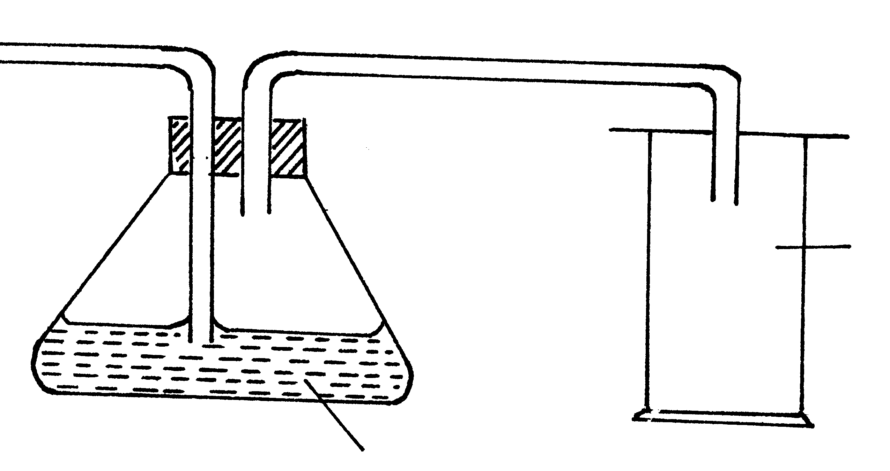

CO ₂

Conc H₂ SO₄

Passing through drying agent;and collection;
- Dilute hydrochloric acid// Hcl (aq);
- 2HCl _{(aq)} + CaCO_{3 (s)} CaCl_{2 (aq)} + CO _{2 (g)} + H₂ O _{(l)};
- It forms insoluble lead (II) chloride which coats the carbonate hence preventing further contact with the acid;

II)
- PbO (s) + CO (g) Pb(s) + CO₂ (g);
- Lead (II) oxide turns from red the grey beads;
- NaoH_{(aq)} // Sodium hydroxide// solution or;
KOH _{(aq)} //potassium hydroxide
Function is to absorb the carbon (IV) oxide produced;
d) CO is poisonous therefore should not escape to the atmosphere;

