NATIONAL EXAMINATIONS COUNCIL
FORM 4 BUSINESS STUDIES PAPER 2 MID TERM 22017
MARKING SCHEME

1. (a) Describe five factors considered when choosing a means of communication. (l0mks)
- Cost of the means — A cost effective means should be selected by the sender.
- Distance between the sender and the receiver for example telephone are preferred for a long distance communication.
- Need for confidentiality means face to face offer room to ascertain the environment around you.
- Urgency/Speed, means like telephone is fast over long distances
- Need for evidence written communication would appropriate when evidence is required.
- Desired impression
- Reliability of the means: the sender should use a means that provides the assurance of reaching the intended recipient.
- Accuracy of the means (any 5 x 2 10)

(b) Explain five problems associated with the output approach in computation of National income. (l0mks)

- Unavailability/inaccuracy of output figure due to poor records especially in the private sector
- Deciding on the goods/services to include since there can exist illegal activities
- Valuation of output in the subsistence sector since no prices are attached to them.
- Valuation of unsold stock whether to assign them historical price or market price. Lack of qualified personnel who can be used to collect the data
- Double counting where it may be difficult to distinguish between intermediate and final output.
(any 5 x 2 = 10)

2. (a) Describe five principles of public expenditure. (l0mks)

- Sanctions
Public expenditure must be approved by the relevant authority.
- Maximum social benefit
Should be incurred in a way that majority of the people are able to reap maximum benefit out of it.
- Adaptability
Should be flexible enough to meet the prevailing economic situation
- Economy
Should be incurred in the most economical way by avoiding any possible waste.
- Proper financial management

Maintenanceof proper records which should also be audited /The government should be accountable / transparent (any 5 x 2 = 10)

(b Explain five advantages of open office layout to an organization. (l0mks)
- Easy supervision of staff since they are in the same room hence reducing wastage of property.
- Low cost of establishment/maintenance due to less partitions
- Easy location of worker since they are working in the same room.
- Faster flow of work due less movement of workers
- Easy sharing of equipment/facilities thus a firm can save on the cost of buying the same equipment.
- Enhances team work / togetherness as workers are able to consult easily.
- Discourages absenteeism due to close supervision of workers.
- Saving of floor space due to less partitions. (any 5 x 2 = 10)

3. (a) Highlight five circumstances under which an insurance company would compensate in eventof loss.
(l0mks)
- When the insured has insurable interest in the property as he will suffer any financial loss
- When the insured disclosed all the relevant facts on the subject matter.
- If the loss is not deliberately instigated
- If the insurance company is solvent hence can meet its financial obligation
- If the insured makes claim within the stipulated time
- If the insured follows the laid down procedures when claiming compensation.(any 5 x 2 = 10)

(b) Explain five reasons for taxation in an economy.
- To collect revenue: which is used in providing goods and service. (l0 mks)
- Protection of local infant industries by taxing imported goods more hence consumers would prefer local goods since due to their low prices.
- Discourage consumption of demerit products e.g. beer and cigarettes.
- To reduce income disparity by taxing the rich and using the finance for the benefit of the poor.
- Correct balance payment deficit — by levying more taxes on imports.
- Control inflation since it will reduce money supply by reducing disposable income
- Help locate/relocate businesses: High taxes on businesses in urban areas make entrepreneurs to relocate to rural areas. (any 5 x 2 = 10)

4. (a) Explain five benefits that accrue to a seller who uses personal selling. (l0mks)
- Gives the seller an opportunity to explain the details
- The seller is able to provide immediate feedback clear doubts raised by customers
- The seller may be able to have direct personal contacts with the buyers thus can correct any misconception(about the product.)
- He can secure immediate orders thus increasing the sales
- Gives room for persuasion/convincing the buyer leading to impromptu purchases by the buyer.
- Enables the seller to have goods tested/examined by the buyer (any 5 x 2 = 10)

(b) The following information was extracted from the books of Karanja Stores on 3Pt December 2011.

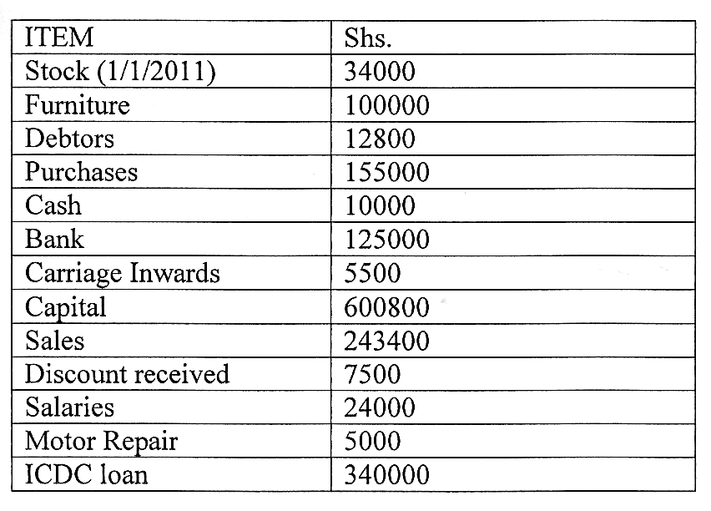

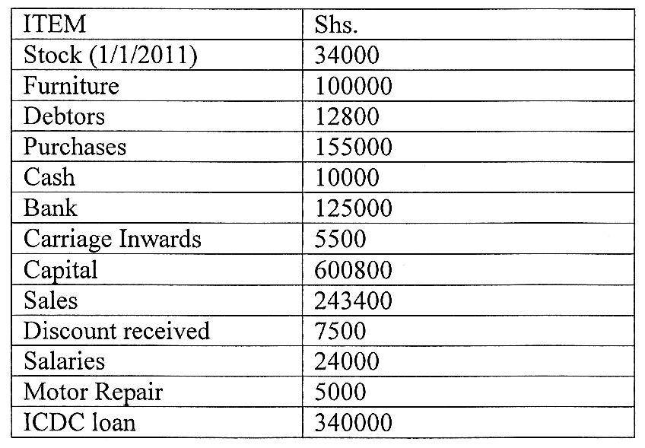
Prepare:
a) Trading, profit and loss account for the year ended 3 l December,2009
b) Balance Sheet as at 31 December 2011. (12mks)

KARANJA STORES
Dr Trading, profit and loss account for the period year ended 31/12/2011 Cr

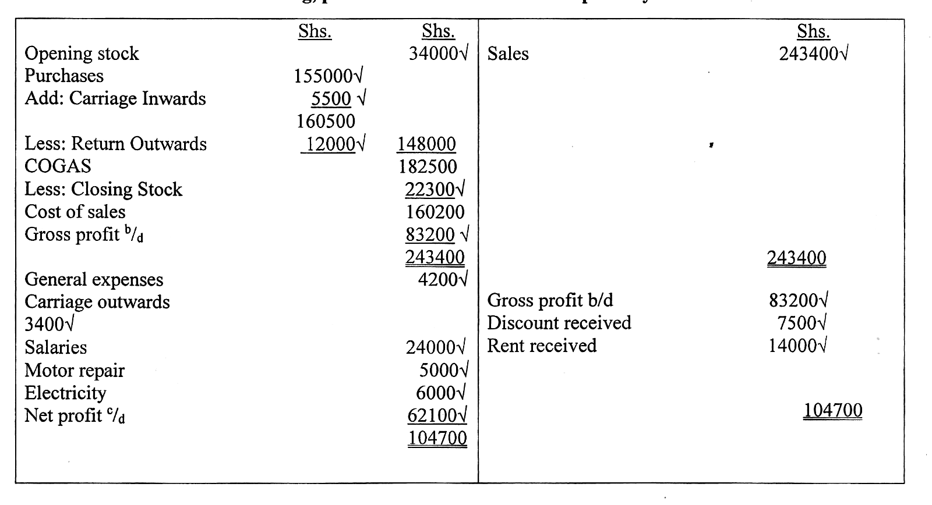

KARANJA STORES
BALANCE SHEET
AS AT 31/12/2011

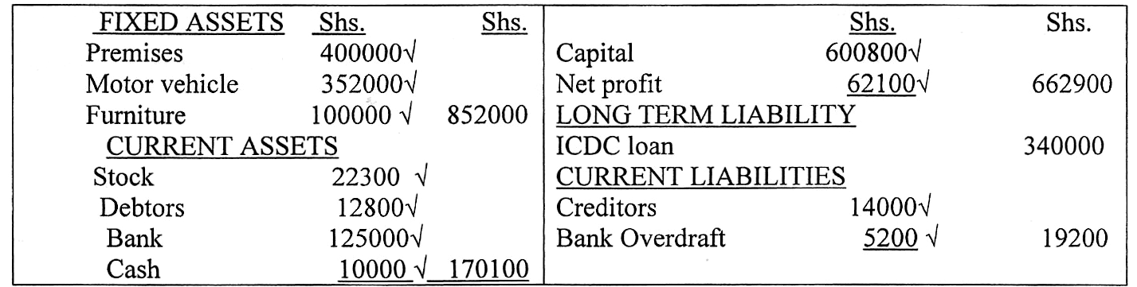
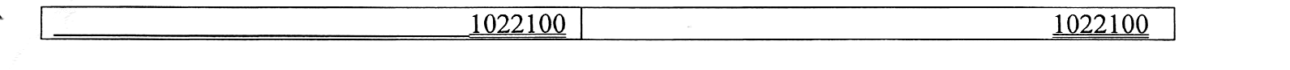

5. (a) Explain five negative effects of over population to a country. (l0mks)
- Landlessness / land fragmentation due to a lot of pressure on land.
- Low quality of service such as education, housing and health because demand is more than the resources can cope with
- May lead to balance of payment deficit as a country may import more than it exports
- Low rate of industrialization as most resources are consumed/less investments.
- Environmental degradation due to over exploitation of resources
- May lead to increase in social evils/ crime rate due to increased unemployment
- May lead to unemployment because the job opportunities available cannot match the increasing population.
- Low savings due to low incomes which may hinder investment.
- Inflationary tendencies because demand for goods and services outstrip supply(any 5 x 2 = 10)

(b) Give five differences between private and public limited companies

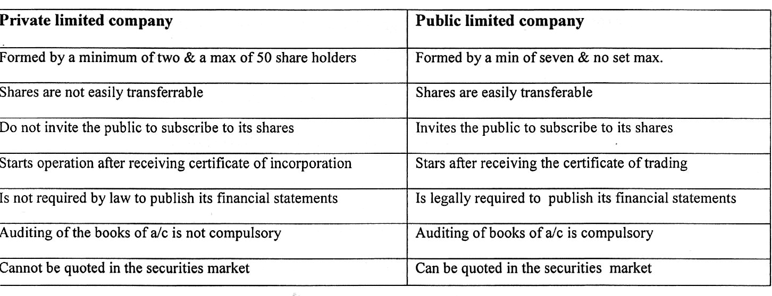

6. (a) Explain five benefits a consumer who buys goods from a departmental store would enjoy. (l0mks)
- Access to specialized goods from relevant departments/shopsince each shop stocks/sells particular type of goods
- Personal attention to customers as they can access to relevant staff
- Access to auxiliary/after sales services which may be readily available within the store
- One can save time by shopping under one roof
- Prices of goods are relatively low enabling a customer to save/buy more goods
- Use of credit/debit cards thus relieving the customers the need/bother of carrying cash to
- Access to new products/information — which he may not be aware of.

(bJagongo enterprises had the following balances as at 3 1St December 2012:

Shs.
Stock 15000
Cash at bank 20000
Cash in hand 6500
Debtors 3400
Creditors 2500

The following transactions took place during the first week of January 2013:-

Jan 2: Bought stock by cash Kshs.2000
3: Sold goods on credit Kshs.3 000
4: Received a cheque of Kshs. 1800 from a debtor.
4: Deposited Kshs.600 into the bank account from the cash till.
5: A debtor returned goods worth shs.500
5: Sold goods for cash Ksh. 1200
6: Bought goods Kshs.4500 on credit
6:: The owner took cash Shs. 1000 to pay his child school fees

Required:-Prepare the ledger accounts to record the above transactions. (10 mks)

