NATIONAL EXAMINATIONS COUNCIL
FORM 4 BUSINESS STUDIES PAPER 1 MID TERM 22017
MARKING SCHEME

1. Characteristics of goods (4 mks)
- Arc tangible
- Can be stored
- Quality can he standardized
- Can change possession
- Can change in quality over time

2. Factors that make up a healthy business environment. (4mks)
- Reliable/efficient legal system
- Favorable government policy/low taxes/increased subsidy
- Availability of market
- Availability of auxiliary services
- Political goodwill
- Improved technology
- Favorable socio cultural factors
- Availability of finance

3. Types of partnership. (4mks)
- General partnership
- Limited partnership
- Temporary partnership
- Permanent partnership
- Trading partnership
- Non trading partnership

4. The following show a shift in demand curve.

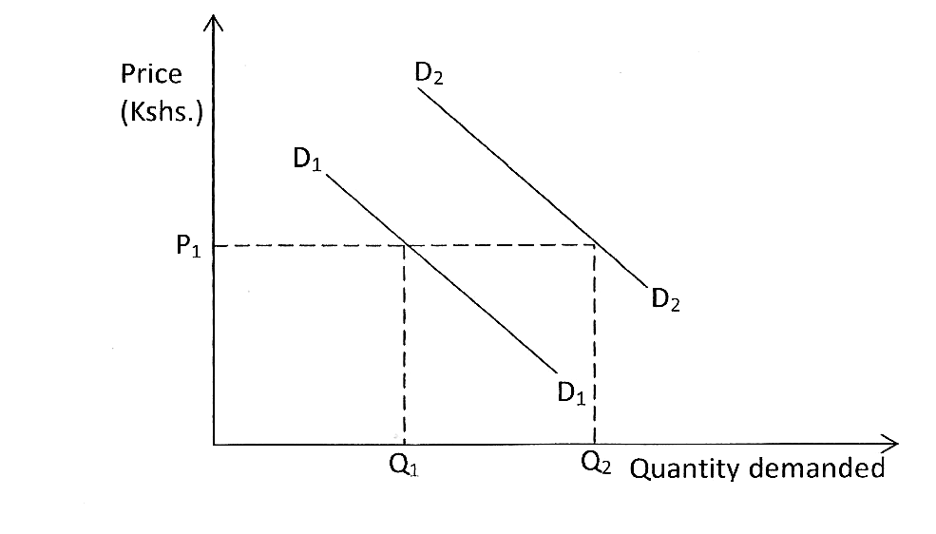

Factors that will lead to the shift of demand curve from D1 to D2. (4mks)
- Rise in income.
- Rise in population.
- Fall in price of complimentary products.
- Rise in the price of substitute goods
- Favorable change in taste/fashion toward the product.
- Favorable government directive on consumption of product.
- Expectation of future rise in price

5. Characteristics of a multiple shop. (4mks)
- Branches are run by branch managers
- They deal in the same line of products
- They have similar shop fronts
- They sell products at uniform prices in all the branches
- Product promotion is coordinated from the head office.
- They are owned by one firm

6. Ledgers in which the following accounts are recorded. (4mks)

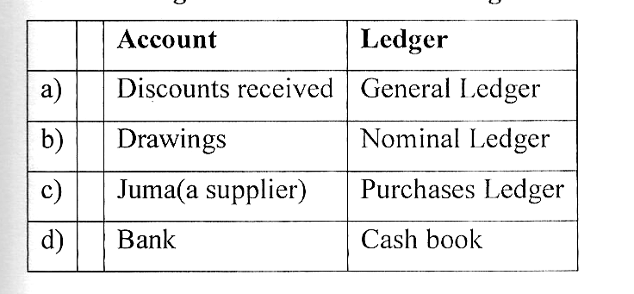

7. Circumstances under which a banker’s cheque may be used (4mks)
- When debtors financial status in a doubt
- When there is fear of delay in payment
- When the amount involved is large
- In ease the traders deals in different currencies

8. Sources of Monopoly power (4mks)
  - Control of a strategic factor of production:
  - Legal restrictions:
  - Sole ownership of a given technology
  - Sole ownership of production rights i.e. patent
  - v. High initial capital: which other firms might not be able to raise.
  - vi. Where a group of firms merge/amalgamate; thus controlling the market of their product
  - vii. The market can be small that can only he served by one firm, a new firm coming in will lead to losses.
  - viii. Restrictive practices; i.e. the tendency to lower their prices to bare minimum to keep off competitors

9. Reasons why sonic county governments in Kenya find it difficult to provide public utility
- Lack of adequate finance
- ii) Poor management skills
- Political interference / wrangle
- iv)Embezzlement of funds
- Lack of a working plan.

10. Procedure of acquiring an insurance policy. (5mks)
- A person wishing to acquire a policy must fill in the form
- The insurance company then accesses the applicant and then calculates thepremium to be paid by theinsured
- The insured then pays the first premium to the insurer/ insurance company
- The insured then issues a cover note to the insured to show that the contract is now on
- Then finally the insured is issued with a policy document

11. Sources of business idea. (4mks)
- News papers / magazines
- Shows and exhibitions
- Hobbies
- Spotting gaps in the market
- Vocational training / experience
- Survey
- Listening to what people say

12. Assumptions of a two sector economy. (3mks)
- There arc only two sectors/players (i.e. households and firms)
- Households spend all their incomes on goods and services produced by firms
- Firms spend all their revenues on payment of factors of production
- No government intervention
- The economy is closed i.e. no Foreign trade

13. Advantages of sending parcels using courier firms. (4mks)
- Speed /fast delivery
- Safety/Security
- Direct / can provide door to door delivery
- Proofofdelivery
- Proof/evidence of sending

14. Characteristics of Money. (4mks)
- It should he generally acceptable
- It should be portable / easy to carry
- It should be durable / long lasting
- It should be divisible into smaller units
- It should be homogenous
- 0 It should he limited in supply
- It should he easily recognized
- The material used in making notes and coins should be easy to east into required shape

15. Reasons that account for the popularity of small scale retails in Kenya. (4mks)
- they require little capital to start
- have few legal formalities during formation
- are highly flexible /may change from one form to another depending in profitable
- low government taxes-enabling them earn high profits
- have low risks/losses
- 0 have ready market-most of them located in densely populated areas/close to the customers
- have permanent market due to consumer loyalty brought about by close contact with customers
- sell fast moving goods hence no dead stock

16. Use the balance sheet equation to fill the missing figures in the table below (4mks)

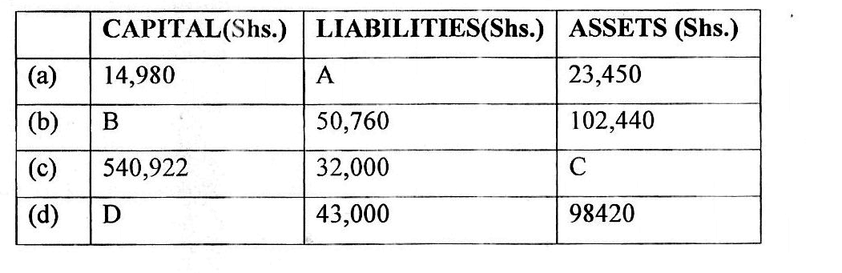
A = Shs. 8,470
B = Shs. 51,680
C = Shs. 572,922
D = Shs. 55,420

17. Factors that would hinder a warehouse from functioning effectively. (4mks)
- If its location is not suitable for client/if it is not accessible to users
- Lack of proper communication network
- Poor transport system.
- if it lacks appropriate handling facilities
- If it is not spacious enough to allow easy movement
- If it doesn’t have well trained personnel
- If it doesn’t keep proper records for movement of goods

18. Errors in a trial balance although present it would still balance. (4mks)
- Errors of original entry
- Errors of total commission
- Errors of complete reversal of entries
- Compensating errors

19. Implications of an ageing population in a country. (4mks)
- Low labour supply/shortage of labour/manpower
- High dependency burden
- Strains on the availability resource to cater for the welfare of the aged e.g. health and homes for the aged
- Underdevelopment where some resources are not fully exploited
- Low standards of living/low per capita income
- Production of consumer goods to meet need of the agents at the expense of producer goods
- Less progressive growth of the economy-as old people tend to be conservative/resistant to change
- Reduced labour mobility

20. The following information was extracted from Asuna traders on 31 December 2009
Rate of stock turnover 5 times
Markup 25%
Cost of sales 60,000
Closing stock 8,000

Required:
i) Net sales (2mks)
ii) Average stock (2mks)
iii) Opening stock (1mks)

Working:

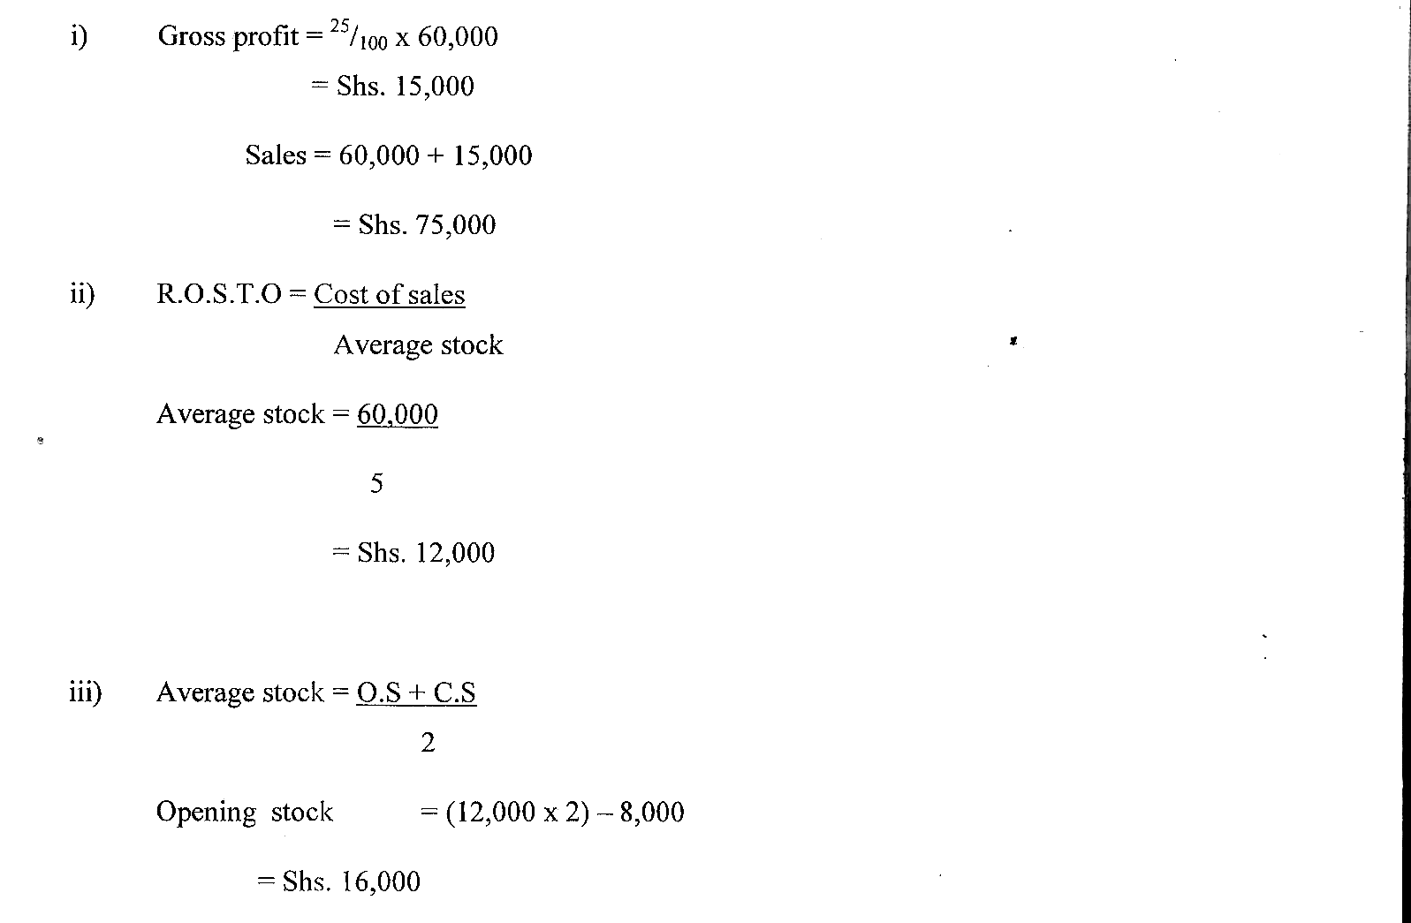

21. Duties of a company’s secretary. (4mks)
- Provide legal advice
- Writing minutes of board meetings
- Maintains confidential records of the organization
- Maintains and updates organizations legal registers
- Ensures compliance by the organization with legislation or law
- Preparation of contracts, leases and other legal documents
- Interprets law and legal notices to the directors

22. Show how the following transactions may affect the items of balance sheet, stating whether it isan increase, decrease or no effect (4mks)

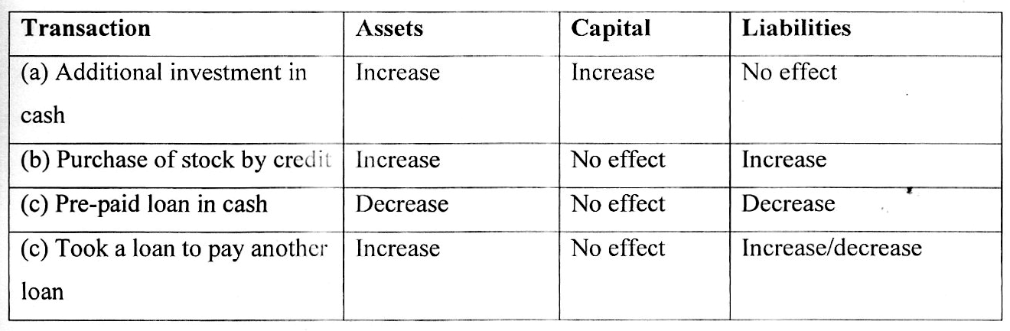

23. How each of the following utilities are created. (4mks)
- Form utility-industrial processing/manufacturing
- Possession utility-exchange/trade
- Time utility-warehousing/storage (4x 1 =4mks)

24. Circumstances under which it would be advisable for a manufacturer to sell directly to consumers
- Where the commodity is perishable
- Where the commodity is a service
- Where the use of the commodity requires demonstration
- Where the quantity of the commodity is small
- Where technical advice is required
- 0 Where immediate feed hack is required
- Where the law requires so

25. Causes of unemployment cut in Kenya. (4mks)
- Rapid Population growth
- Inappropriate education system
- Inappropriate methods of production
- Seasonality in production
- Lack of capital for investment
- Low demand for good and services
- Rural-Urban Migration

