KCSE PREMOCK2017
MARKING SCHEME –BIO P3

- a) 5(b) Leaves with more than 3 leaflets (2mks)
7(b) Bipinnate leaves

IDENTITY STEPS FOLLOWED (4mks)
b) P Bidensbiloba 1b, 5a, 6a
Q Hibiscus 1a, 2b, 4b
T Papilionaceae 1b, 5b, 7a, 8a
U Rose 1b, 5b, 7a, 8b
2. a)

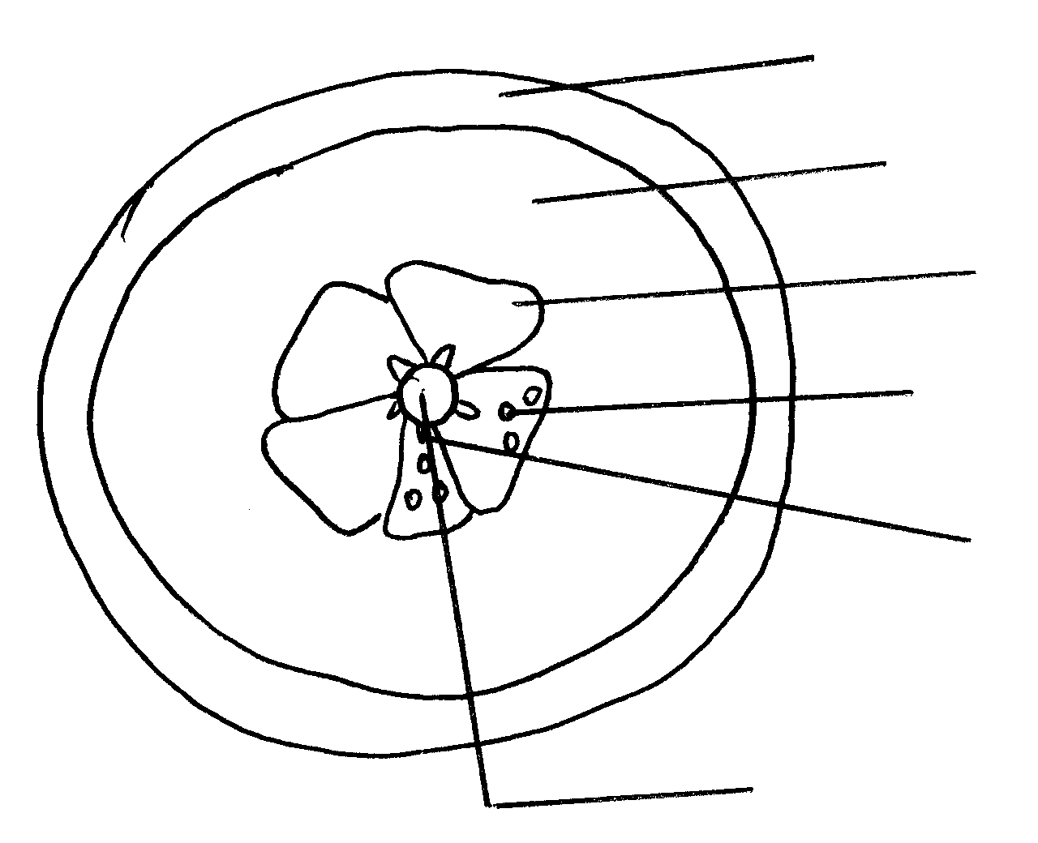
Epicarp /Exocarp;

Mesocarp;

Endocarp;

Juice -sacs

Seed

placenta

Drawing – 1mk
Accuracy – 1mk
Lablling – ⁶/₂ = 3mks
Magnification = 1mk
Total = 6mks

- A berry / Hesperidium;
- i) Animal Dispersal
ii) – Succulent endocarp / juicy endocarp;
- Seeds resistant to digestions ;
- Scented ;
- Bright colouredexocarp;
- i) Animal
ii) -Fleshy/ juicy pericarp to attract the animal
- Brightly colouredepicarp to attract the animal
- Indigestible seed coats to avoid digestion by enzymes

e)
Food substance | Procedure | Observation | Conclusion
Vit . C (Ascorbic Acid) | - Put 2cm³ given vol. of DCPIP in test –tube.  - Add juice / test substance | DCPIP decolourised | - Vit C present
Reducing sugar | - Put test substance in t.tube  - Add Benedict soln;  - Boil ; | - Colour changes to yellow / orange / red.  - | - Reducing sugar present
Proteins | To the juice add sodium Hydroxide  Solution then copper (II) sulphate  Solution | -Blue colour is retained | Absence of proteins

f) i) Absences of Ascorbic acid in the juice
ii) Boiling destroys vitamin c

3. a) A – Renal vein
B – Ureter
C – Kidney pelvis
D – Cortex
b) – Has numerous mitochondria to provide energy for active transport
- has microvilli in the inner lining to increase surface area for reabsorption of substances
- Highly vascularised for transport of reabsorbed substances
- Has a thin epithelium for rapid diffusion of substances
c) on the diagram to show loop of henle
d) – Osmoregulation
- Regulation of pH
e) The distal convoluted tubules and collecting duct will be less permeable to water therefore less rebsorption of water leading to production of large volume of urine that is dilute

