FORM 4
BIOLOGY PP2
MARKING SCHEMES

1. (a) (i) Autecology is the ecological study of a single species.
(ii) Synecology is the ecological study of many species.

(b) A — fresh water or aquatic.
B — habitat with adequate rainfall, moderate temperature and humidity or tropical rain forest.
C — desert/arid/semi-arid/dry area.

(c) • Sunken stomata
• Few stomata on the upper surface
• Reduced pore size
• Hairs around the stomata
•Small leaves/scaly leaves

2.
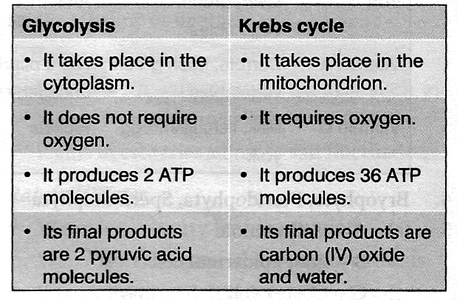
(b) • It synthesizes large molecules such as protein and polysaccharides.
• It is needed for growth and development.
• It is important for movement (musclecontraction).
• It is necessary for cell division (DNAreplication).
• It provides energy for active transport.
• It secretes cell products.
• It is needed in the transmission of impulses.

(c) Cells should be provided with the following:
• A respiratory substrate
• Oxygen for respiration
• Optimum temperature for respiratory enzymes
• Constant removal of waste products.

3. (a) (i) Phytoplankton
(ii)Hawk
(b) Phytoplankton Snails Hawk
(c) • Zooplankton would increase due to decreasedpredation.
• Water snails would decrease due to lack offood (competition).
(d) • The oil prevents dissolving of oxygen in water;hence fish die due to suffocation.
• Oil clogs fish gills and hampers respiration.
(e) • Domestic waste and sewage
• Silting
• Industrial effluent
• Agricultural chemicals

4. (a) Class monocotyledonae because it has:
• a pith at the centre
• xylem and phloem arranged alternately in aring around the pith
• a cylindrical xylem (not star-shaped as in dicotyledonae).
(b) A — epidermis
B — cortex
C – endodermis
D – pericycle

(c) • B (cortex)
- It is a packing tissue.
- It is used for storage of food.
- It is used for active transport of minerals.
- It is a support tissue when the cells are turgid.

• C (endodermis)
- It is a selective barrier to regulate the passage of substances from the soil through the root hair cells to the xylem.
- It is used for the storage of starch.

• E(xylem)
- It conducts water and mineral salts from the roots to the leaves.

6. (a) Graph of the dry weight of the endosperm, embryo and the total dry weight against time.
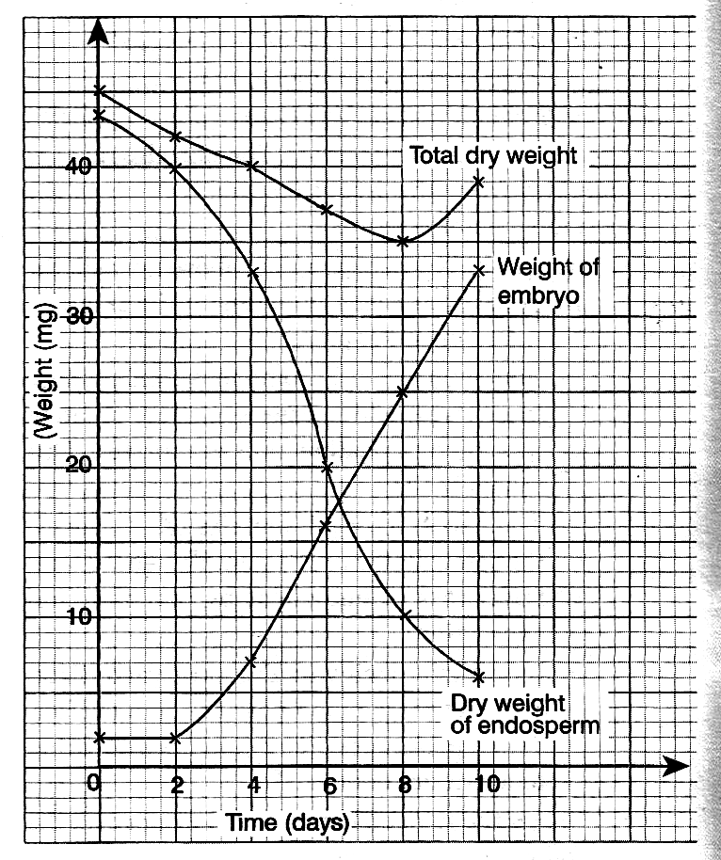

(b) 38.5mg ± 0.5
(c) (i) There was hydrolysis of starch into simple sugar which was used for respiration to provide energy for the growing embryo.
(ii) Raw materials are synthesized and protoplasm produces new tissues, bringing about growth of the embryo.
(iii) The rate of respiration was higher than thatof synthesis of materials for growth in the
embryo.
(iv) Firstleavesstartedcarryingoutphotosynthesis,thus increasing the protoplasm.

(d) Factors within the seed
• Impermeable seed coat.
• Presence of abscisic acid (ABA) or germinatinginhibitors.
• Embryo not fully developed.
• Absence of hormones or enzymes thatstimulate germination.

Factors outside the seed
• Unfavourable temperature
• Absence of light
• Lack of oxygen
• Lack of water
(e) Characteristics ofmeristematic cells
• They have a dense cytoplasm.
• They are small.
• They have thin cell walls.
• They do not have sap vacuoles.
• They do not have chloroplasts.
6.
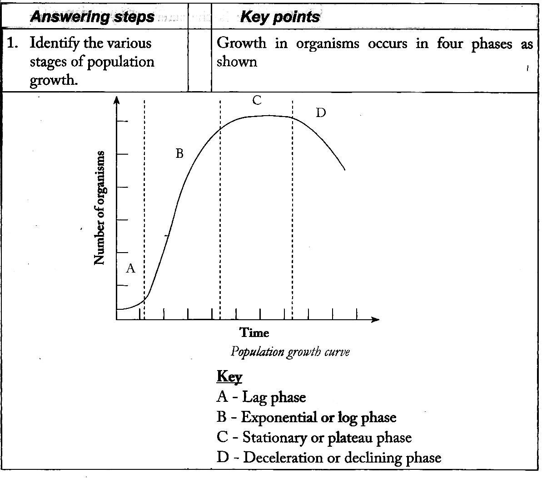
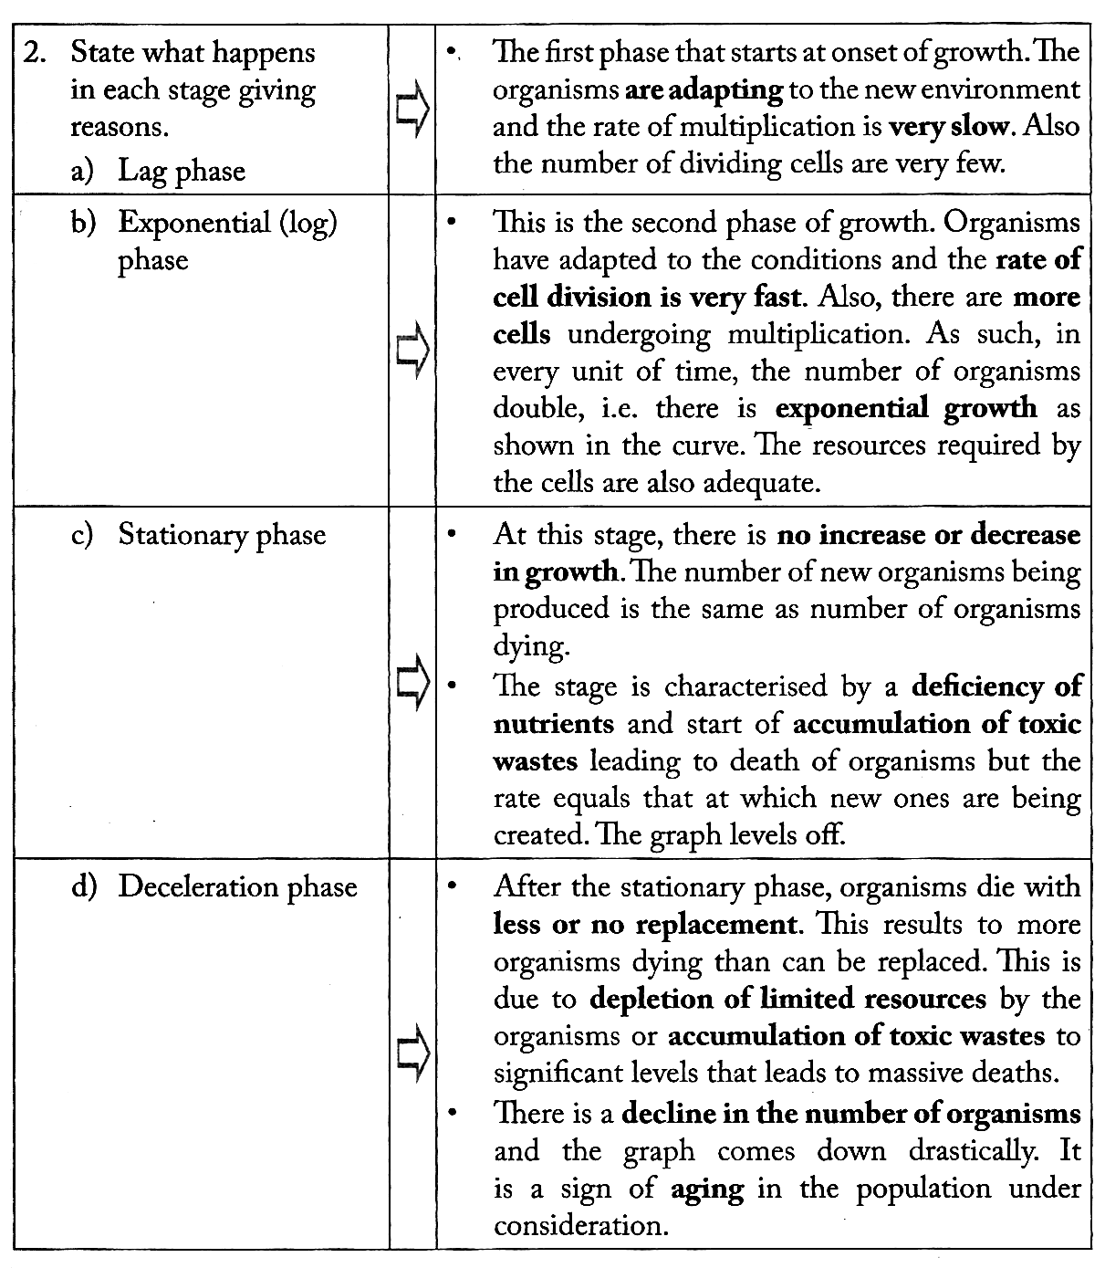

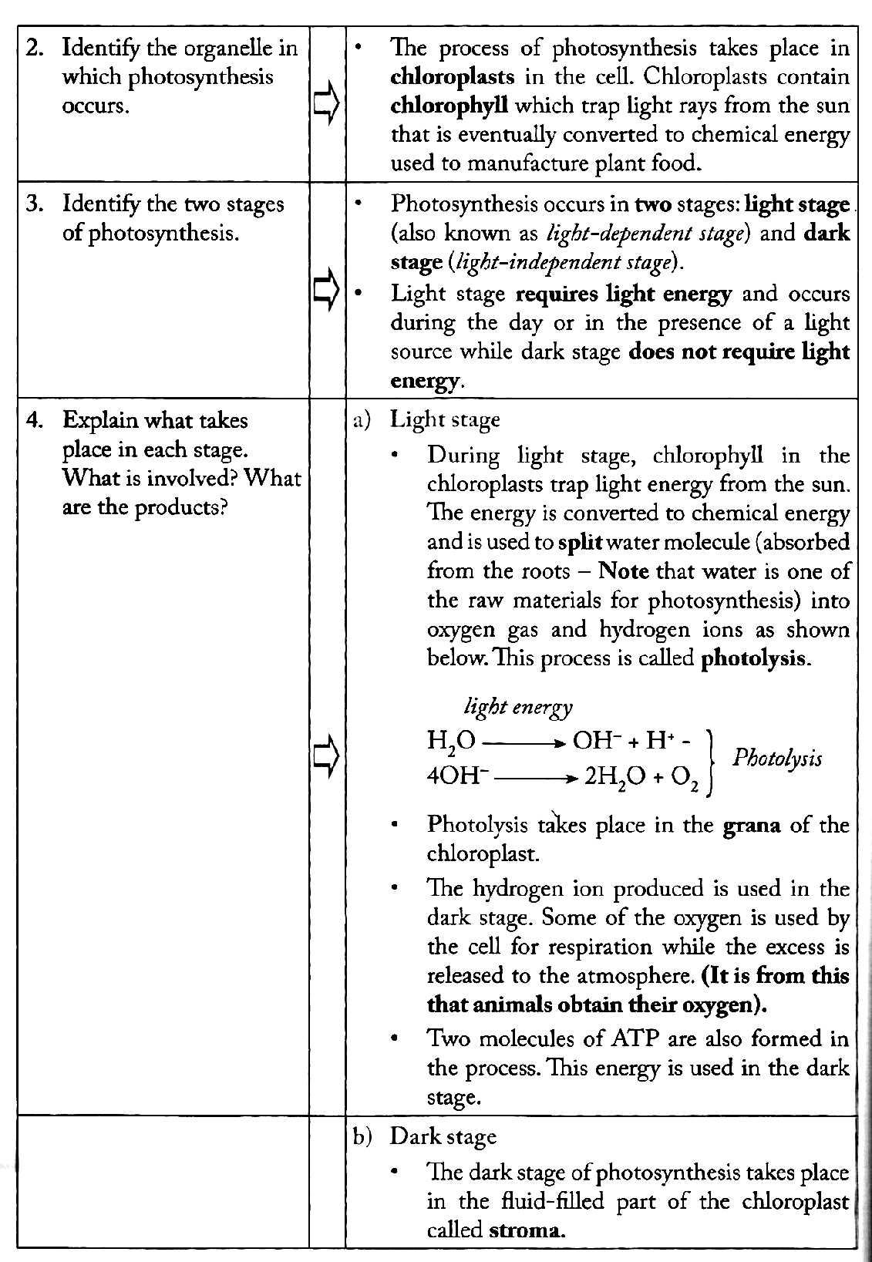
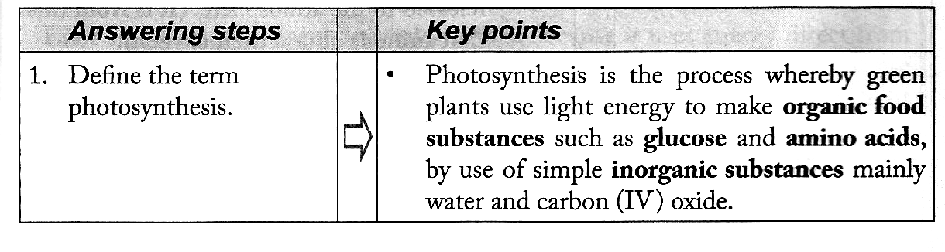
7.
