FORM 4
BIOLOGY P1
MARKING SCHEMES

1. (a) Fermentation or anaerobic respiration.
(b) - It is used in the brewing industry to make alcohol.
- It is used in baking Breads.

2. (a) Lignin
(b) Phloem tissue

3. (a) Magnifying the image of the specimen.
(b) Bringing the image into focus and magnifying it.

4. • Absorption of water from the soil by root hairs.
• Movement of water from root hair vacuoles tothe xylem through the cortex cells.
• Turgidity in plant cells to help support the plant.
• Opening and closing of stomata.
• Feeding in insectivorous plants.

5. (a) • They contain haemoglobin which has a high affinity for oxygen.
• Their lack of a nucleus increases the surface area for packaging of haemoglobin.
• They are small, hence can squeeze into the small capillaries.
•They are numerous to increase the surface area for efficient transport of oxygen.
• They have a biconcave shape to increase the surface area for packaging haemoglobin.

(b) Carbon (II) oxide combines with haemoglobin to form a stable compound, carboxyhaemoglobin. This makes haemoglobin unavailable to combine with oxygen and the oxygen is thus not transported to the tissues by the red blood cells.

6. (a) (a) • It leads to loss of water vapour, causingdehydration.
• It leads to loss of heat, causing hypothermia.
(b) It allows gases to diffuse in solution form.

7. Adaptations of seeds to dispersal by wind
• They are small and light and can, thus, be carried away easily by wind.
• They have hair-like structures or floss to increase buoyancy in the air.
• They develop wing-like extensions to increase surface area for increased buoyancy in the air.

8. (a) Gill

(b)
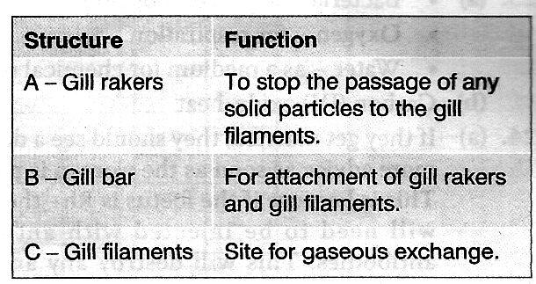

9. (a) • To show that carbon (IV) oxide is producedwhen food burns.
• To show that water is produced when food burns.
(b) • The lime water forms a white precipitate due to the presence of carbon (IV) oxide produced when food burns.
• The blue cobalt (II) chloride turns pink due to the presence of water produced when food burns.

10.(a) Smooth ER — It produces and transports lipids.
(b) Nucleus:
• It contains DNA material for inheritance.
• It synthesizes RNA.
• It is involved in cell division.
• It controls all the activities of the cell.

11. (a) A — Pseudopodium
B — Food vacuole
(b) Phagocytosis
(c) White blood cells or granulocytes

12. (a)
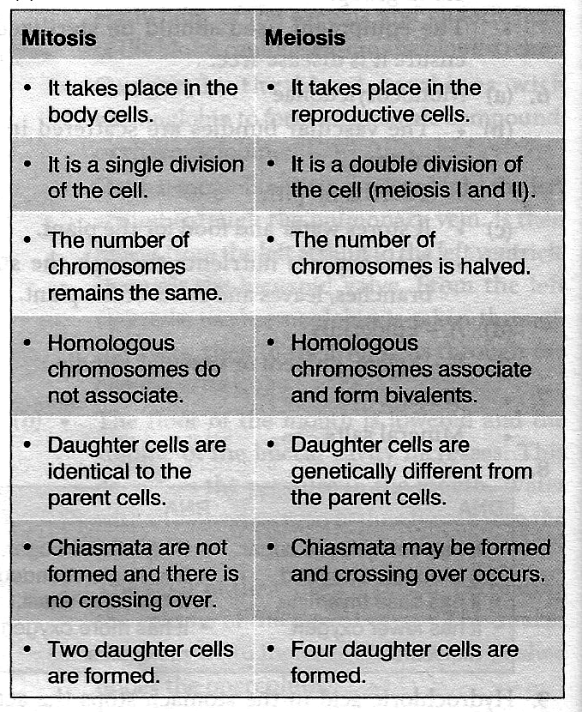

(b) • The DNA replicates.
• The cell organelles replicate.
• The cell builds up a store of energy (ATP) tocarry out the division.

13. (a) A — testa/seed coat
B — cotyledon
(b) C — hypocotyl. It elongates to push the cotyledons above the ground.
(c) It stores the food necessary for germination.

14. Mammalia
• They have aclosed circulatory system.
• They have pigmented blood / have red blood cells.

Insecta
• They have an open Circulatory system.
• They have no pigmented blood/no red blood cells.

15. - It leads to hybrid vigour, such as higher yields.
- It leads to increased resistance to diseases.
- It leads to increased chances of survival.
- It is a source of variations.

16. (a) Malnutrition or lack of enough food
(b) Lack of vitamin C in the diet.

17. (a) They are brightly coloured to attract animals.
(b) They have a sweet scent to attract animals.
(c) They are succulent, juicy and edible.
(d) They have hooks for attachment to the body of animals.
(e) Their seeds are resistant to digestion.

18.(a) They used objective lenses with different magnification power. Student A used a higher magnification power, which reduced the field of view, while student B used a lower magnification power, which gave a wider field of view.
(b) Eye piece x10 and objective x20.

19. (a) Desert, semi-desert or arid habitat
(b) (i) It has a succulent or fleshy stem to store water.
(ii) It has a thick cuticle to reduce transpiration.
(iii) Its leaves are reduced to thorns to reduce transpiration.

20. (i) Mammalia
(ii) Aves
(iii) Reptilia

21. (a) • Quadrat method
• Line transect method
• Belt transect method
• Capture-recapture method
• Census (Direct counting) method
• Aerial photography method
(b) A — polar regions or cold regions
B — hot deserts or dry regions

22. (a) An enzyme regulates chemical reactions.
(b) Temperature — enzymes work best at an optimum temperature, below which they are inactivated and above which they are denatured.
pH — enzymes work best at an optimum pH, above or below which they are denatured.

23. (a) It produces energy or ATP for the functioning of the body.
(b) Glycolysis

24. (a) Increase in oxygen concentration increases the number of fish and a decrease in oxygen concentration decreases the number of fish. Fish use oxygen for respiration and low oxygen concentration can lead to the death of fish.
(b) • Through aquatic plants carrying out photosynthesis and giving out oxygen.
• Waves and currents facilitate the dissolving of atmospheric oxygen in the water.

25. • Phylum — Arthropoda because of the following:
- It has jointed legs.
- Its body is divided into distinct parts.
- Its body is covered by an exoskeleton.

• Class — Arachnida because of the following:
- It has four pairs of jointed legs.
- Its body is divided into cephalothorax andabdomen.

26. (a) Deamination
(b) It regulates controls the amount of amino acids/control excess amino acids in the body.

27. (a) Glucagon
(b) ADH (Anti-diuretic hormone)

28. - Through clearing bushes around residential areas and draining stagnant water to get rid of the mosquito breeding sites.
- sleeping under treated mosquito nets to avoid mosquito bites.

