FORM 4 MID TERM 2 2017
AGRICULTURE P2 MARKING SCHEMES

- symptoms of attack by Taenia saginata:
  - Pot bellied;
  - The
  - Presence of proglottides in animal droppings;
  - Anaemia;
  - Emaciation/Loss of body condition;
  - Indigestion/constipation.

- Factors that may predispose an animal to a certain disease:
• Skin colour of animal.
• Species of the animal.
• Breed of the animal.
• Age of the animal.
• Sex of the animal.
• Housing.
• Stocking rate.
• Environmental factors.

- The functions of the tools and equipment listed below are:
  - Strip cup : For testing mastitis
  - Bolus gun:For administration of tablet drugs orally.
  - Mortise gauge:For making two parallel markings.

- Differences between cross breeding and upgrading:
  - Cross breeding is the mating of animals from two different breeds.
  - Upgrading is the continuous breeding of descendants of a local damand a pure breed sire of high quality to obtain high-grade offspring.

5. Why farmers keep livestock healthy:
• To keep animals safe as healthy animals will not spread diseases to either animals or human beings.
• To maintain high productivity.
• To increase growth rate as healthy animals grow well and fast enough.
• Because good health gives animals a longer economic and productive life.
• To improve quality of products as healthy animals produce good quality products and consequently command a high market value.
• To reduce production cost because the farmer spends less money on disease treatment.

6. Distinguishing features between the following:
(a) Kenya white and Californian white.
(i) Kenya white is white all over the body while Californian white is white with black nose sometimes
Legs and tail are also black.
(ii) Kenya white has pink eyes while California white does not.
(b)Large white and Landrace
(i) Large white has a slightly dished snout while landrace has a straight snout.

(ii)Large white has erect ears while landrace has long drooping ears

(iii)Large white has strong back legs while landrace has weak hind legs.

7. Signs of heat in rabbits:
(i) It becomes restless and tries to contact another rabbit in theadjacent hutch
(ii)The external genitalia becomes swollen.
(iii)It rubs itself against the walls and food containers
(iv) It throws itself on its sides
(v) When mounted it bends its tail up over the back.

8. Reasons why breeding stock should be selected:
(i) To increase yield of milk, eggs, meat.
(ii) To produce better quality carcass.
(iii) To improve resistance against diseases.
(iv) To improve adaptability of the animal.

9.Signs of attack by external parasites in livestock:
(i)Anaemia
(ii)Irritation/scratching
(iii)Loss of hair.
(iv)Sores/wounds on the skin.
(v)Presence of the parasites on the body of the animal

10. Two instances when sheep shearing should be done
(i) As from 8 months of age because it has fully developed wool fibres
(ii)During dry seasons when ambient temperatures are high.
11. (a) Tape worms:
(i) Cattle.
(ii) Pigs.

(b) Liver flukes:
Water snail/mud snail/Lymnea spp.

12.(a) G — Liver fluke (Fasciolassp)
H — Roundworms (Ascansssp)
J — tapeworms (Taemassp)

(b) Internal/eudo – parasites
(c) G — found in the bile duct/gall bladder/liver
I — found attached on the walls of small intestine
(d) G — Water/mud snail (Limnoleatruncatula)
J — Cattle/sheep/goats and pig

13.(a) (i) Identification of livestock
(ii) Q — Ear notching R — Ear tagging

(b) (i) R — Less injurious than Q to the animal.
Its also flexible

(ii)

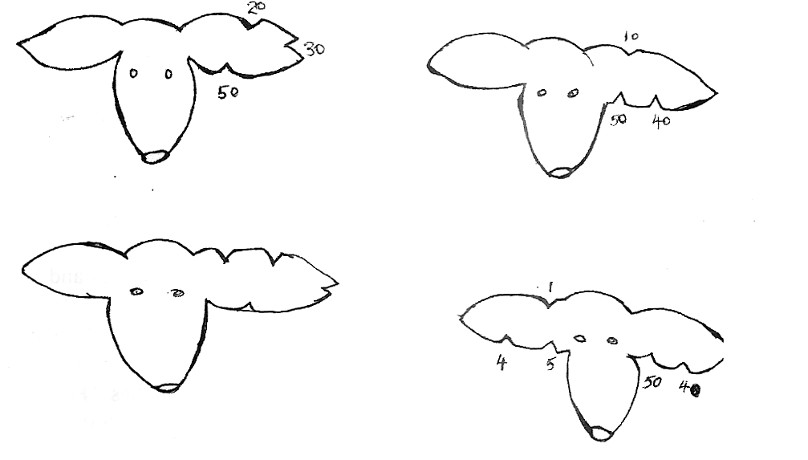
(iii) Identify lost and found animals
Record on farm activities regarding health, feeding, breeding etc
Discourage theft of livestock

14. (a) Tools used in constructing a barbed wire fence.
(i) Fencing hammer.
(ii) Pliers.
(iii) Wire strainer.
(iv) Soil auger.
(v) Tape measure.
(vi) Ramming rods.
(vii) Panga.
(viii) Mallet.
(ix) Wood chisel/drill/auger bit.

(b) Procedure of putting up a barbed wire fence:

(i) Clear the fence line.
(ii) Measure and mark points where to dig holes.
(iii) Dig holes to appropriate depths/ 60 cm for ordinary posts and 75-90cm for corner and gate posts.
(iv) Place corner posts and gate posts first.
(v) Place treated posts in the holes in an upright position.
(vi) Mix concrete of 1:3:5 and place it in the hole.
(vii) Place struts on the corner/gate posts.
(viii) Nail wire onto the posts with fencing staples while stretching using a wire strainer
(ix) Fix the lower strand of wire first and use it as a guide to fix the next upto the required number
(x) Place droppers.

15. The process of constructing a fish pond:
(i).Dimensions are determined after site selection.
- The depth should be a minimum of 50-60 cm to control weeds.
- The maximum depth is 100-120 cm beyond so that the fish do not use the water in fertile ponds.
- Construct a sloping dyke of 2 m or 3 m horizontal for every meter increase in height.
- The freeboard (the distance between water level and the top of the dykes), should be about
30 cm - 50 cm.
- The length and width of a pond is determined mainly by the topography.

(ii)Soil types:
- Avoid soil with too much clay like black cotton soil because the dykes crack and leak, the soil is easily eroded by wave action.
- Avoid soil with too much sand and stones because the dykes leaks.
- The best soil contains about 25% clay or the soil which does not crack in the sun on drying.
- Leaner or wider dykes are used to overcome soil type weaknesses.
.

(iii)Other considerations in the construction.
- Provide for rain water wash off.
- Pile extra soil to the dykes to increase their slope.
- Plant grass to control erosion and strengthen the dykes.
- Site the pond near the main farm house
- Ensure that water flows slowly through the pond.
(iv)Construction materials include.
- Bamboo.
- Stones to line the inlet canals
- Feeds sack,baskets or perforated tins and plastic containers may be used as screens.

16. Factors considered in siting farm structures
(i) Topography: Most structures require a relatively level site. A slop site might require leveling which is expensive
(ii)Direction of prevailing wind:
- Foul smells from some structures e.g. pig sty, latrines, etc. necessitate that the structures be located on the leeward side of the homestead
- Windbreaks may be erected to protect structures from strong winds.
(iii) Soil type: Farm structures should be sited on unproductive soils which are firm and well drained.
(iv) Nearness to utilities such as electric power lines, main roads and water sources. This minimizes
Installation costs.
(v) Accessibility: The structure should be easy to reach from most parts of the farm. This easens transportation of farm inputs and produces to and from the farm respectively.
(vi) Security: The structures should be safe from predators, thieves and trespassers.
(vii) Farmers tastes and preferences: Some farmers prefer to locate the homestead on positions of panoramic view.
(viii) Future expansion: There should be space for expansion.
ix) Relationship between the structures: Structures with related uses should be constructed close to each otherso as to save on time andlabour.
(x) Direction of the sun: Structures should be aligned in a North- South direction to allow more sun light into thehouse.

17.(a) The procedure of harvesting honey:
(i) Dress properly/wear protective clothing.
(ii) Have a smoker and hive tool/knife.
(iii) Blow smoke around the hive and later through the entrance holes.
(iv) Lower the hive to the ground.
(v) Remove the hive top cover.
(vi) Lift the bars individually and inspect the combs. If white, it contains honey and if dark it has brood.
(vii) Cut the white combs leaving 2 - 3 cm still attached to the bars.
(viii) Place the cut combs in clean non-metal containers.
(ix) Replace the bars/place bars with brood.
(x) After harvesting, return the cover on top of the hive.
(x) Return the hive to the posts.

(b) Extraction of honey from combs using the heat method described:
(i) Heat some water in a sufuria.
(ii) Put honey combs in an enamel basin or any other iron free container.
(iii) Put the container with honey combs on the boiling water.
(iv) Heat the water until most of the honey melts.
(v) Separate the melted honey from the combs by straining through a muslin cloth.
(vi) Keep honey in a container to cool down.
(vii) Remove the wax layer that may have formed on the surface of the honey.

(c)Factors affecting the quality of honey:
(i) Type of plants from which the nectar was obtained.
(ii) Maturity stage of honey at the time of harvesting.
(iii) Method of harvesting.
(iv) Method of processing honey.

.

.
.

