MARKING SCHEMES:
FORM 2 MID TERM 2
MATHEMATICS

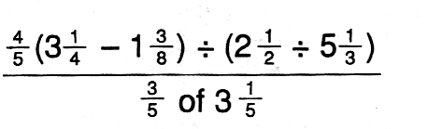
- (3 marks)

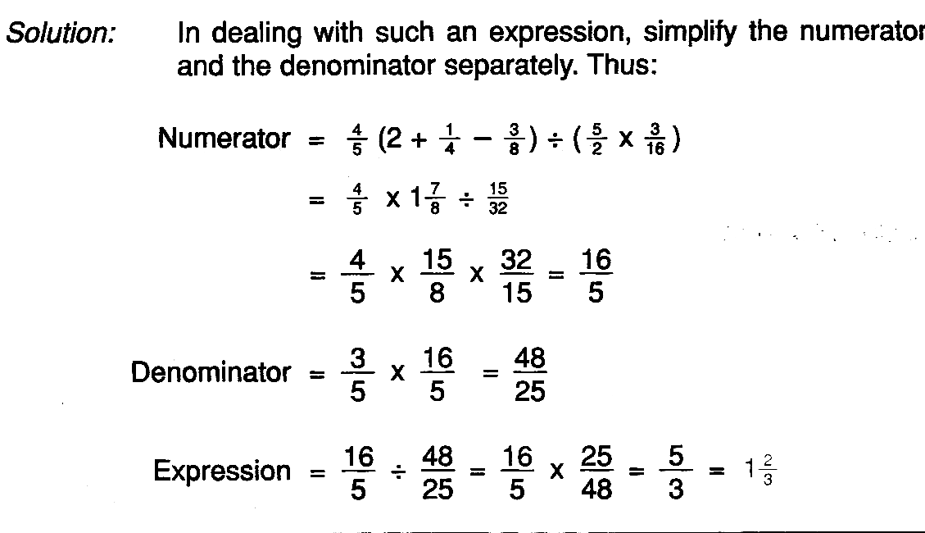

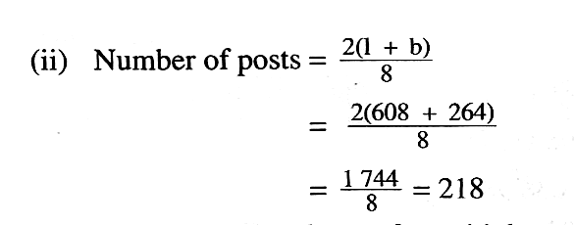
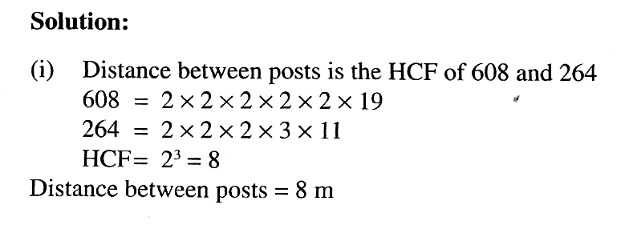
- . (2 marks)

(2 marks)

- (4 marks)

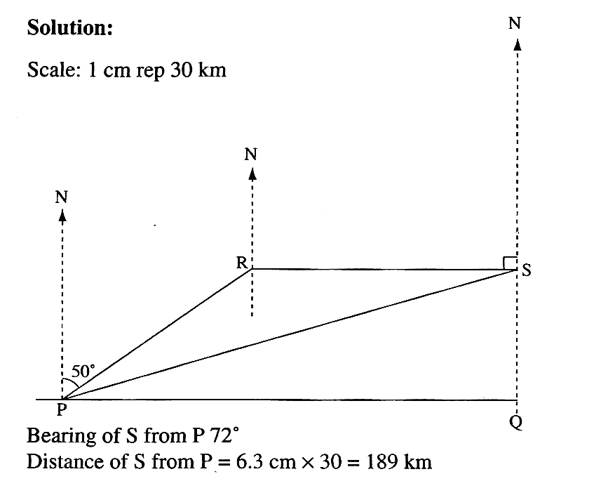

- (3 marks)
$\begin{aligned}=\frac{4a\left(c−4a\right)−b\left(c−4a\right)}{c−4a}+4 \\ =\frac{\left(4a−b\right)\left(c−4a\right)}{c−4a}+4 \\ =4a−b+4\end{aligned}$

- (4 marks)
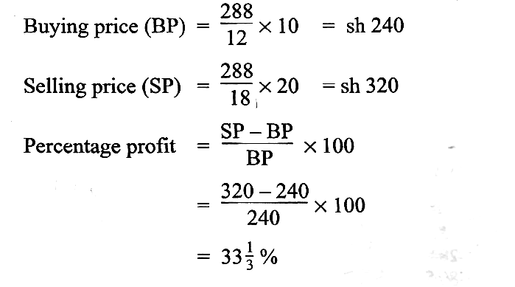

- (3 marks)

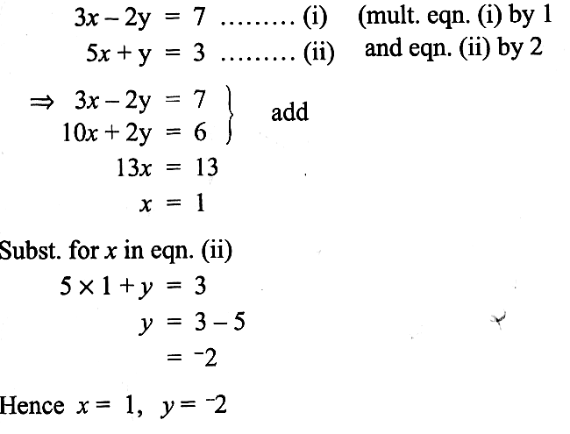

- .
(a) In what ratio did it decrease? (1 mark)

$$\text{120}:\text{150}⇒4:5$$

(b)
(2 marks)
$\begin{aligned}\text{new} \text{width}=\frac{4}{5}×\text{140}\text{cm} \\ =\text{112}\text{cm}\end{aligned}$

- Given the following currency exchange rate, calculate to 3 significant figures the number of dollars that can be exchanged for 25 Sterling pounds.
1 US dollar ($) = Ksh 76.85
1 Sterling pound (£) = Ksh 115.30
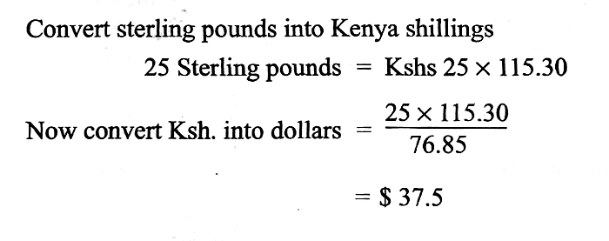

- .
(4 marks)
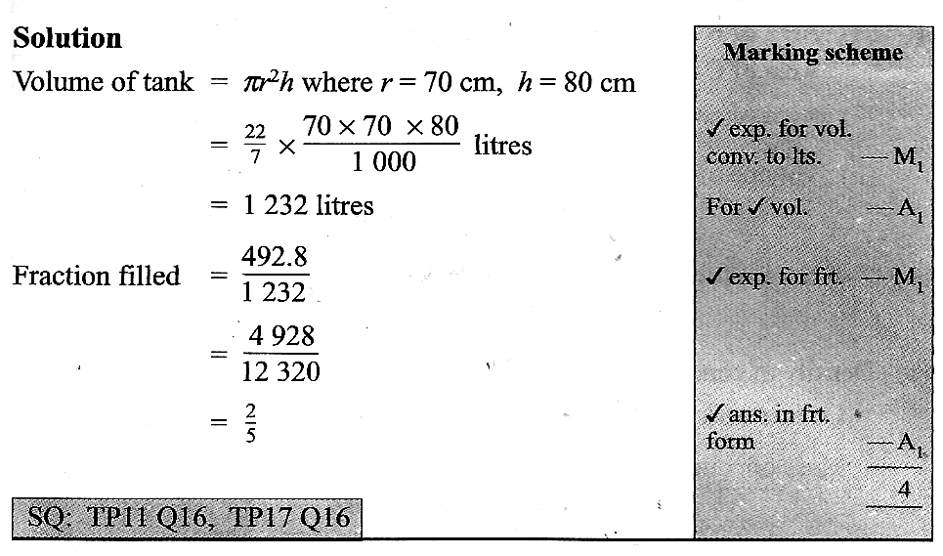

- . (3 marks)
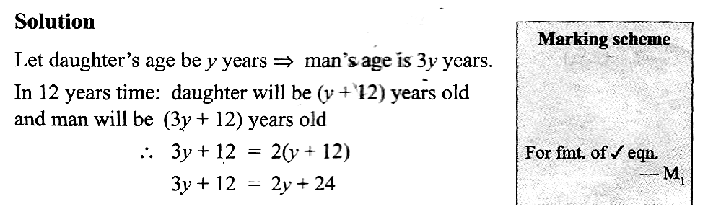
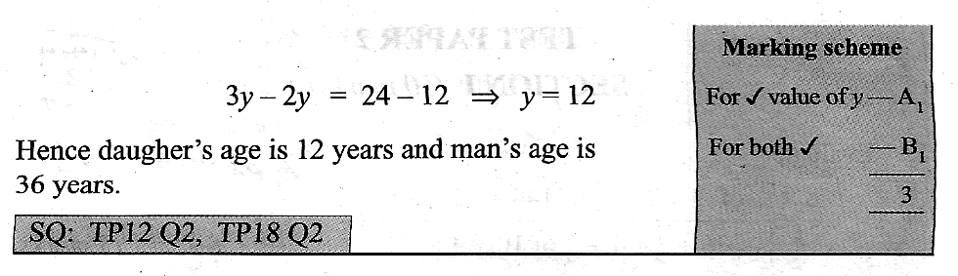

- . (3 marks)

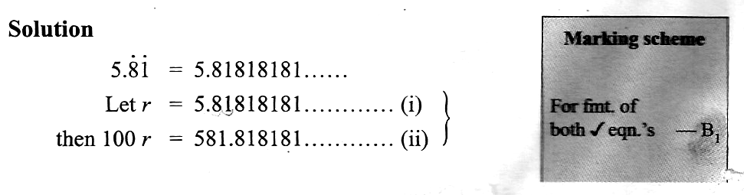
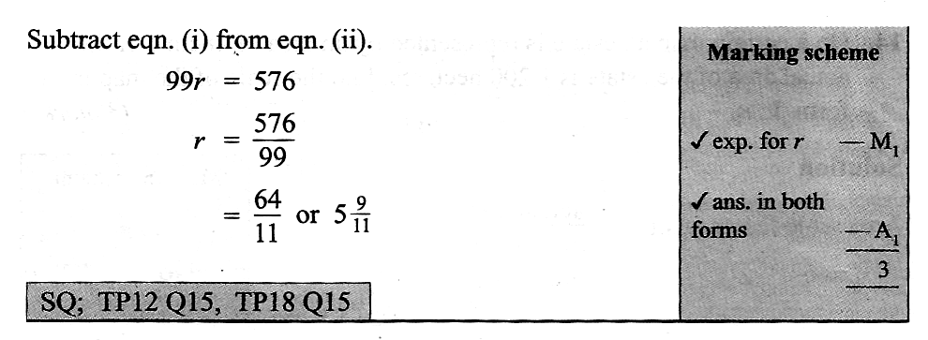

- . (3 marks)

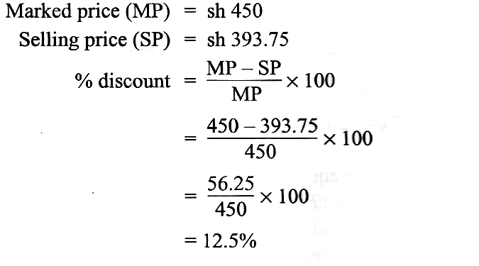

- . (3 marks)

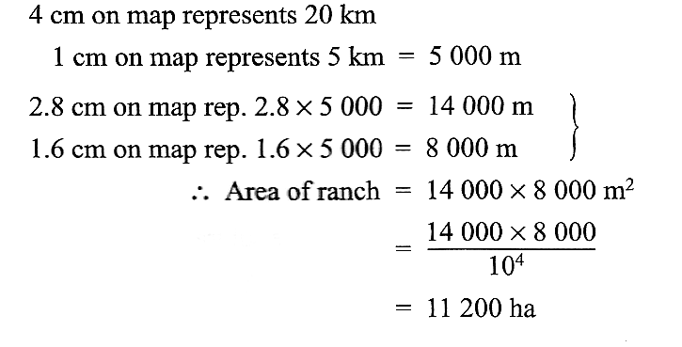

- . (3 marks)

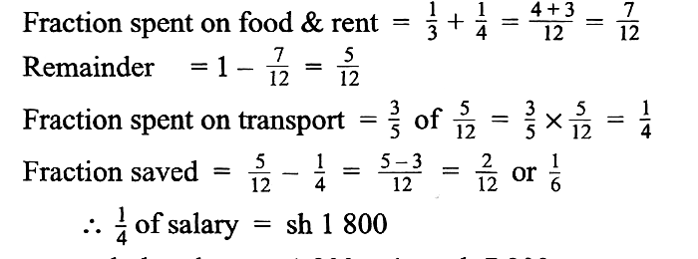

- . (4 marks)
$\begin{aligned}\text{base} \text{Area}=\frac{\text{22}}{7}×\text{14}×\text{14}×\frac{1}{2}×2+\text{40}×\text{28} \\ =\text{1736}{\text{cm}}^{2} \\ \text{curved} \text{surface} \text{area}=\left(\frac{\text{22}}{7}×\text{28} ×\frac{1}{2}+\text{40}+\frac{\text{22}}{7}×\text{28} ×\frac{1}{2}+\text{40}\right)×\text{30} \\ =\text{5040}{\text{cm}}^{2} \\ \text{total} \text{area}=\text{1736}+\text{5040}+\text{1736}=\text{8512}{\text{cm}}^{2} \\ \text{Metal} \text{needed}=\frac{\text{110}}{\text{100}}×\text{8512}=\text{9363}\text{.}2{\text{cm}}^{2}\end{aligned}$

- .

(a) $\text{angle} \text{PTR}=\text{15}+\text{20}=\text{35}°$ ( 2 marks)

(b) ( 2 marks)
$\begin{aligned}∠\text{20}+\text{90}\text{+∠}\text{QYP}+(\text{180}−\text{35})=\text{360} \\ ∠\text{QYP}=\text{105}°\end{aligned}$
- (a) (4 marks)
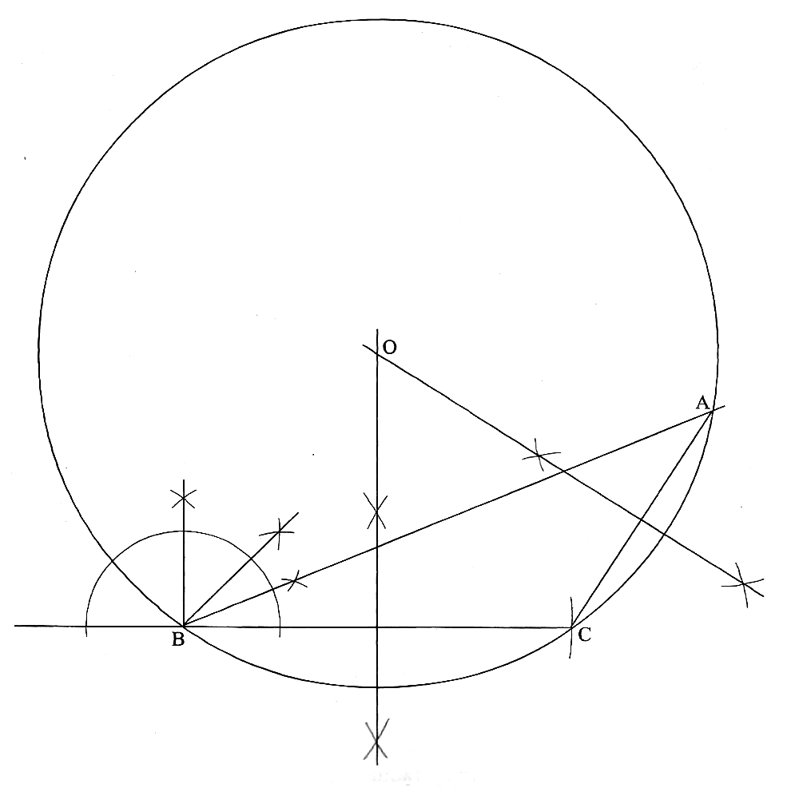

(b) (2 marks)
$$\begin{aligned}\text{AC}=4\text{.}1\text{cm}±0\text{.}1\text{cm} \\ ∠\text{ACB}=\text{122}°±1°\end{aligned}$$
(c) Construct a circle that passes through A, B and C. (3 marks)

(d) What is the radius of this circle? (1 mark)

$\text{radius}=5\text{.}2±0\text{.}1\text{cm}$

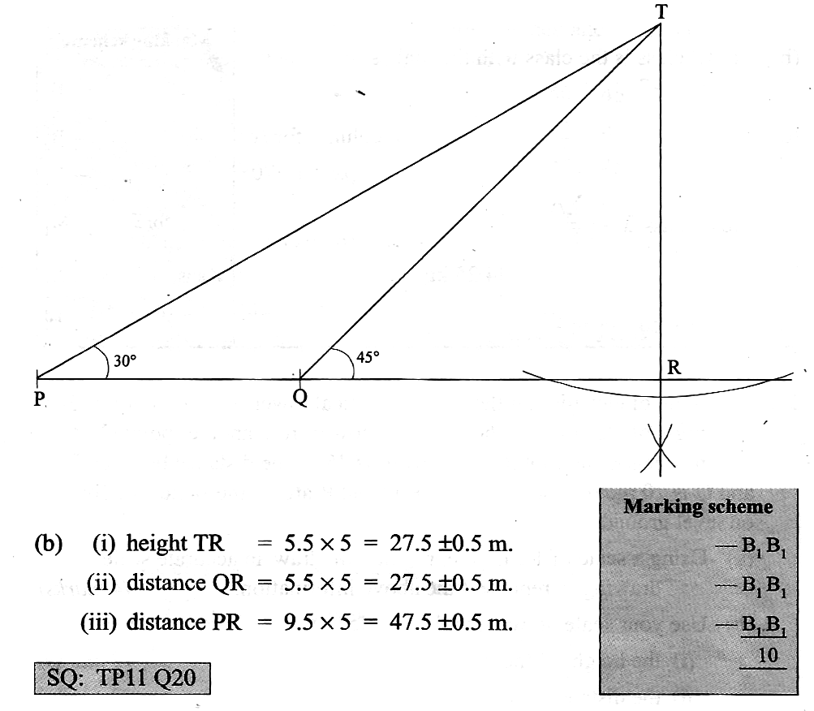
- .(a) (4 marks)

(2 marks)

(2 marks) (2 marks)
- . (a) . (3 marks)

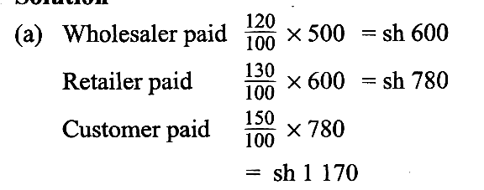

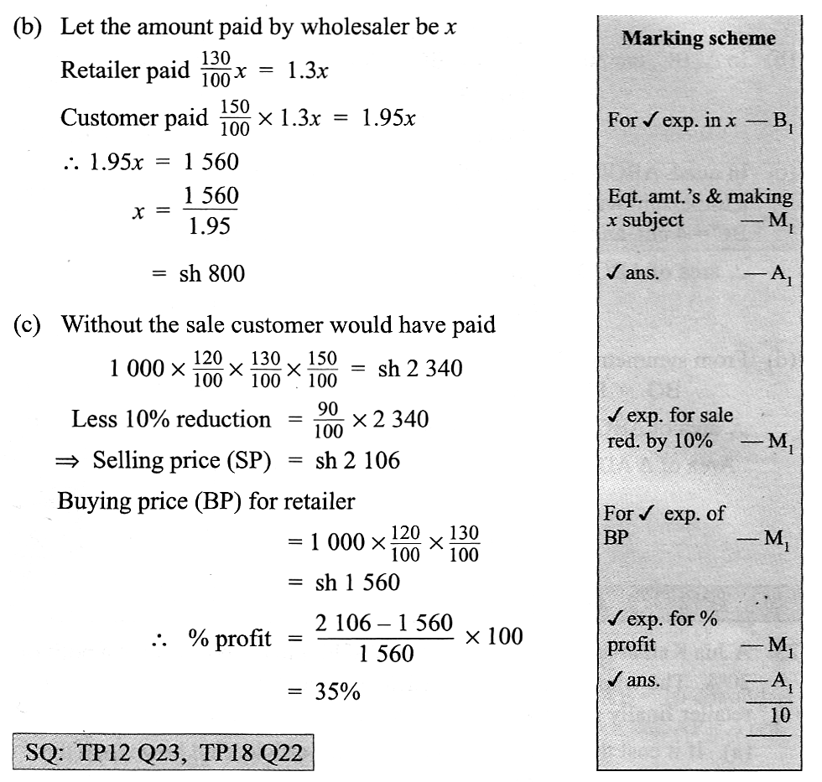
(3 marks)

(4 marks)

- . (a). (5 marks)
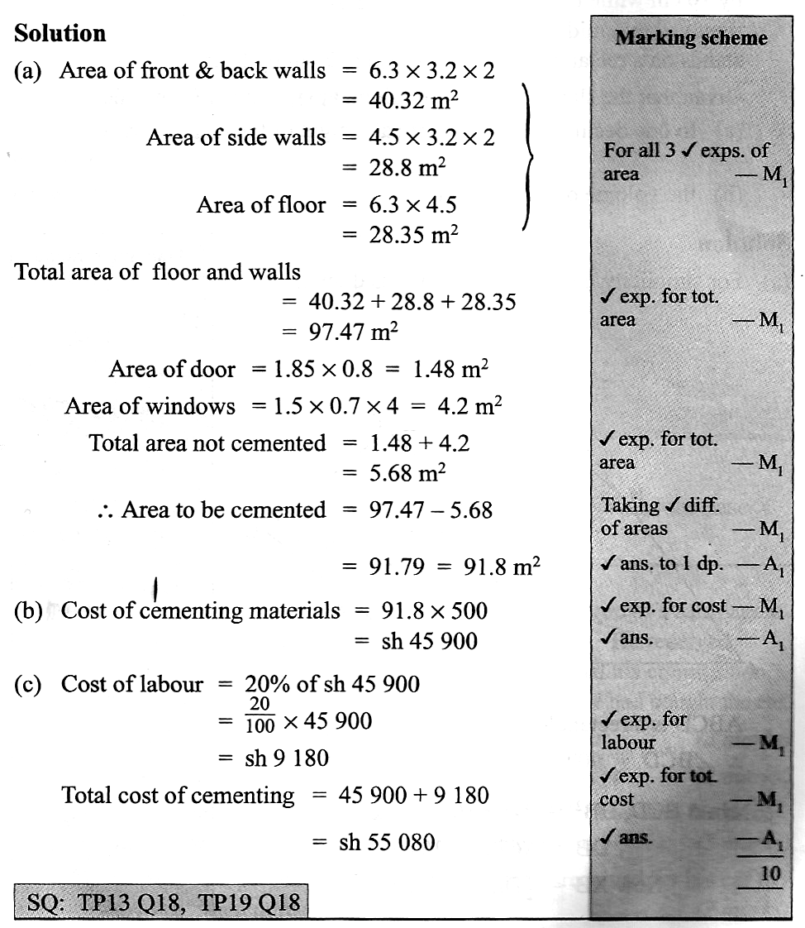

(2 marks)

(3 marks)

- (4 marks)
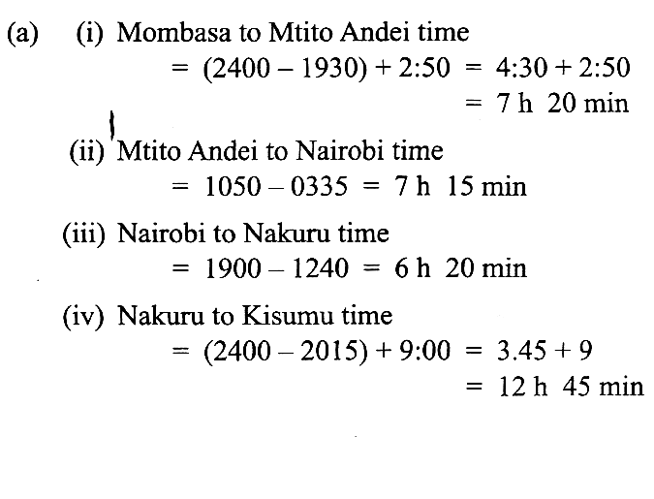

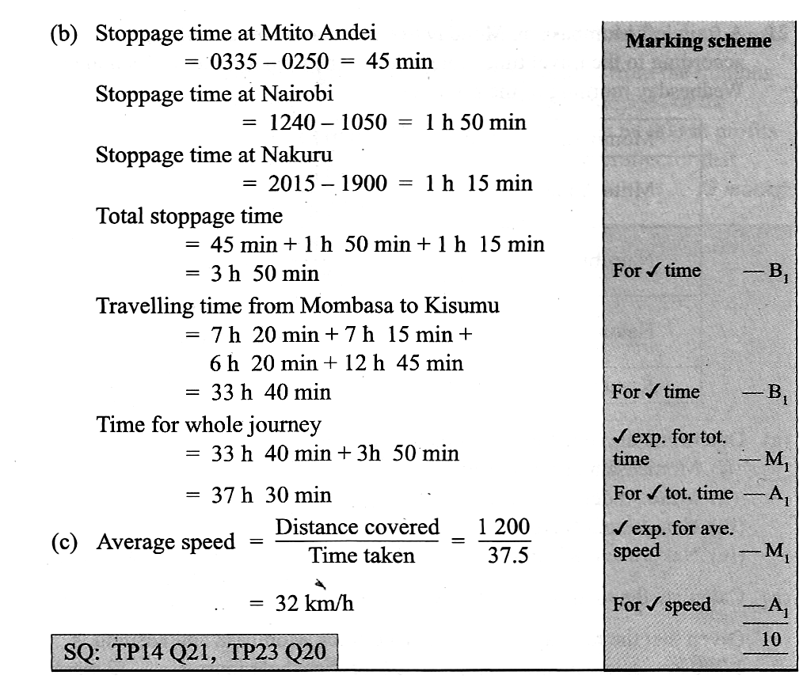
(b) Calculate the total time for the whole journey. (4 marks)

(2 marks)

- . (2 marks)
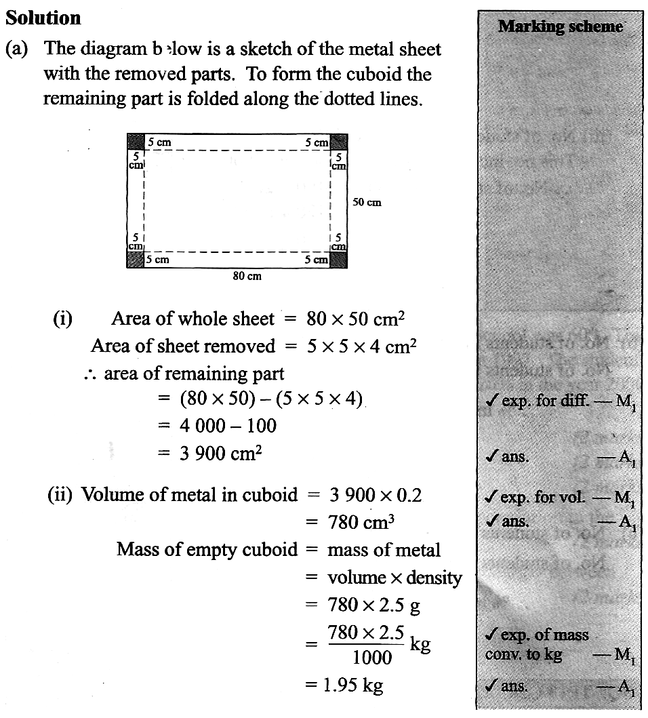

(4 marks)

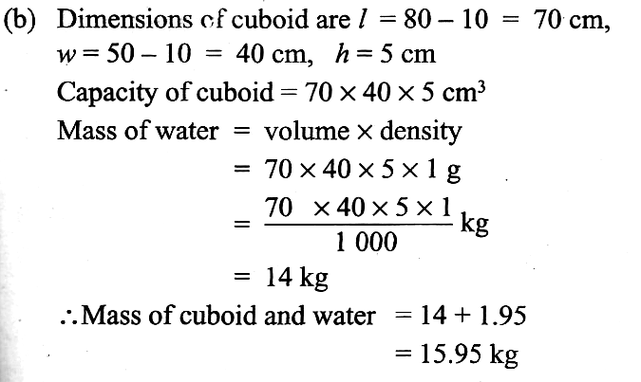
(4 marks)

- .
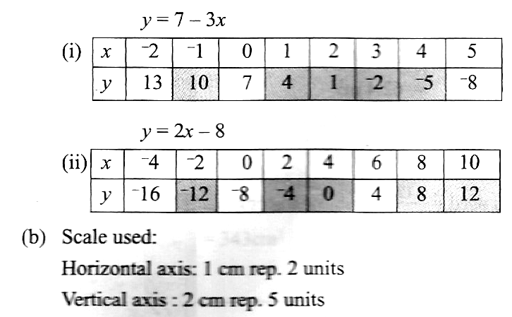

(4 marks)

(c) Both graphs are straight lines (1 mark)
(d) x =3 ,y = -2 (1 mark)

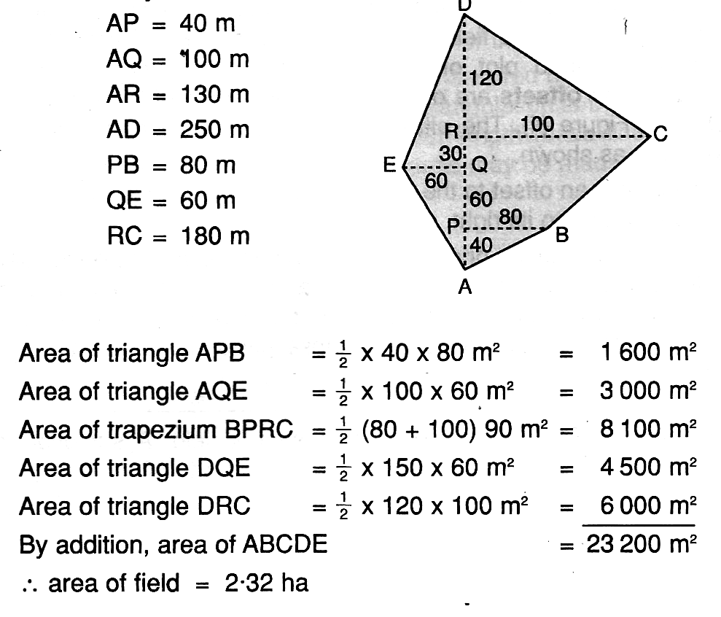

(10 marks)

