FORM 2
EOGRAPHY MARKING SCHEME

1 a). Earth movement occurs within the rocks of the earth’s crust due to tectonic forces.
1*2 2 marks

b. Effects of horizontal earth movement
- -Stretching
- -Shortening
- - Shearing/tearing any 1*3 3 marks

c Magma movement
- -Weak line occurs in the sima rocks.
- Magma moves through that line of weakness and invades the rocks of the earth crust.
- Magma occupies space within the crusted rocks.
- -This makes the displaced crystal rocks to move away vertically / horizontally.
- If the movement of the rocks is vertical the land becomes uplifted and the surface bulges.
- -If the crystal rocks moves side ways away from intruding magma horizontal earth movements are experienced. Any 4*1 4 marks

d. Tension
-Compression force

2a. Plate tectonics theory
- The earth’s lithosphere (sial and sima) is a series of semi-rigid blocks called tectonic plates
- The plates are separated from one another by distinct boundaries.
- Keep moving relative to each other on the underlying partly molten layer of the upper mantle.
- The cause of the movement is due to convection current.
- A long the boundaries the plates that move either away from each other! away from each other! past each other.
- These movements trigger earthquakes / vulcanicity.
- Where plates move away from each other creates an extension boundary where they move towards each other they form compression boundary / destructive boundary.
- When an oceanic plate meets the continental plate the oceanic plate sink below the continental plate in a movement called subduction.
- Sediments in the sea floor may be compressed to form mountains.
- When two oceanic collide there is subduction, resulting into formation of trench
- Sometimes the plate may move past each other. Any 5 * 1

3a. Anticline
Syncline

b. Rolling plains
- Intermontane plateau
- Ridge and valley landscape

c. Significance of Fold Mountains.
- Fold Mountain receive high rainfall on leeward side encouraging growth of forests.
- Forms source of rivers which provide water for domestic / industrial / generation of hep and irrigation.
- In the Northern hemisphere the south facing slope are warmer encouraging agriculture.
- In the process of folding valuable minerals are brought to the surface.
- The mountain landscape provides an unique scenery which attract tourists e.g. the Swiss alps.
- Fold Mountains act as protective barriers during the war. Any 5*1 5 marks

4a. Reverse Fault
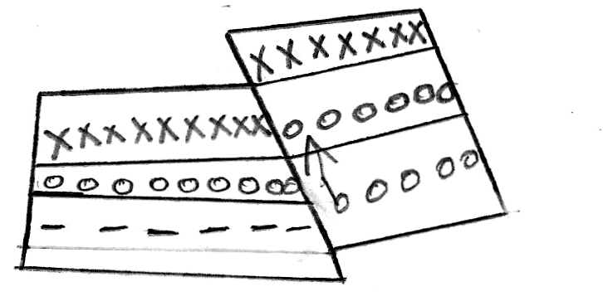The side block pushed over the middle block

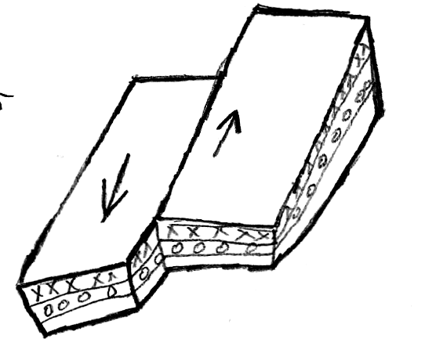The land slide against each other.

5a. Main sections of the Rift Valley
- The Ethiopian Rift system
- The Gregory Rift Valley
- The Western rift Valley
- The Malawi Rift Valley.

b. Rhine Rift Valley
Benue Rift Valley

6a. How the Rift Valley was formed through anticlinal arching
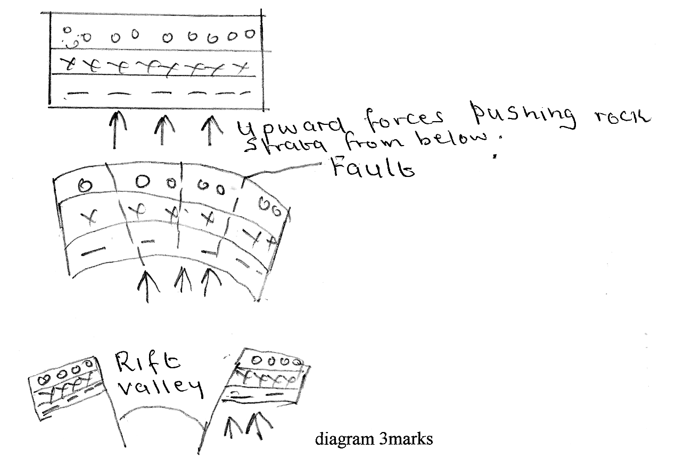

Explanation
- Vertical forces push the earth crust upwards making it to arch. causes a lot of stress at the crest of the anticline.
- Continued upward push
- Upward arching could lead to development of series of cracks! faults.
- If more upward force is exerted the outermost blocks will be pushed much higher than the middle block.
- The middle block will form the floor of the Rift valley. any 4*1 4 marks

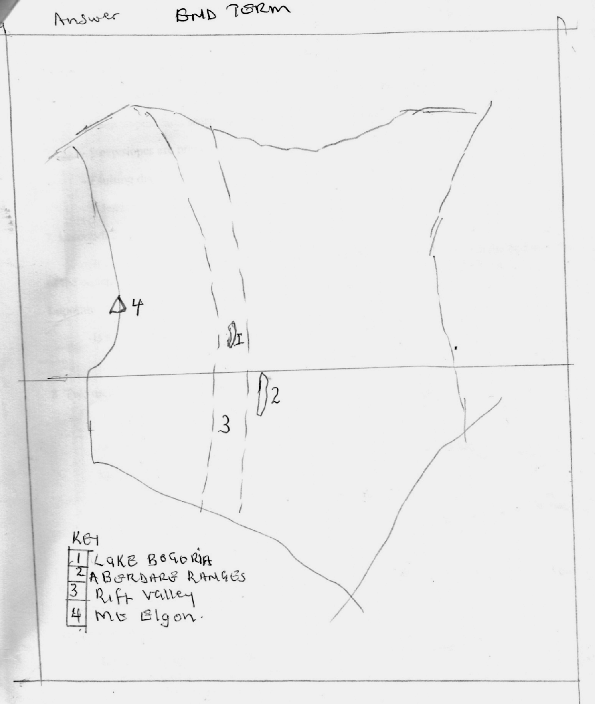

b. Negative effects of faulting
- Fault scarps make it difficult and expensive to construct roads and railways through the slope.
- Steep slopes / fault scarps hinder agriculture / settlement.
- Steep slopes are prone to landscape which are dangerous to life.
- Faulting disrupts and destroys forms of transport such roads / railways / pipelines.
- It leads to tremor earthquakes that may be destructive.

7. Laccolith destructive
- It is doomed shaped igneous intrusion with a flat floor which lies between the bedding plane of the country rock 1*2 2 marks

Lopolith
- Is a very large saucer shaped mass of igneous intrusion. 1*2 2 marks

8. Two escarpments found in Kenya.
- Kikuyu escarpment
- Nguruman escarpment
- -Mau escarpment
- -Tugen escarpment
- Sondu - Kendu escarpment any 2*1 2 marks

9. Magma is the molten rock found inside the earth’s crust while lava is the molten rock found on the surface of the earth.

10. Formation of acid lava dome
- Ii is dome-shaped volcanic hill made up of acidic intermediate lava
- Magma pushes its way to the surface through a vent.
- On reaching the surface the magma is no longer explosive.
- The lava does not flow for a long distance since it is viscous
- It accumulates around the vent and hardens quickly on its outer surface.
- A steep sided dome with convex side is formed by eruption.

11. - If an eruption occurs the magma is unable to reaven the surface is covered with solidified.
- Magma pushes the hardened outer layers of the dome outwards.
- This increases the height of the dome while its width increases slightly. Any 5*1

11. Craters found in Kenya
- Menengai
- Longonot

12. Mofette
This is a crack on the earth surface from where carbon IV Oxide is emitted.

Solfatara
It is vent through which sulphur dioxide gases are emitted from the ground.

Dormant Volcano
This is a volcano which was active but become inactive but can erupt anytime.

b. Muhavura Uganda
Mt. Kenya Kenya
Ngorongoro Tanzania

13. a - Lava flow
b. - Secondary cone
c. - Vent
d. - Crust

14. Volcanic lava especially basalt weather to give rise fertile soils that are good for farming
- Volcanic features e.g. craters, geysers are major tourists attraction sites
- Volcanicity has resulted to formation of valuable minerals.
- Geysers e.g. in Ol Karia a source of geothermal power.
- Volcanic mountains receive heavy rainfall on the windward since thus encourages settlement / farming.
- Volcanic mountains form catchments areas which source of rivers that provide water for irrigation /industrial/ domestic help generation.
- Many varieties of volcano rocks are used in building e.g. trachytes, phonolites etc.
- Fishing is carried out in some crater lakes e.g. Lake Katwe in Uganda.
- Hot springs are used as spas. Any 5*1 5 marks

15a. Epicentre

b. Vulcanicity
- Magma movement within the earth’s crust can cause tremors due to crusted rocks displaced suddenly.
- A sudden eruption of molten magma under oceans can cause earth tremors.
- Violent volcanic explosion! violent emissions of volcanic gasses can shake or shake rocks.
Any 3*1 3 marks

Gravitative Pressure
- The crustal rocks are overlying the hollow! void through which the volcano erupts.
- The rocks are under pressure from the force of gravity which is pushing them inwards.
- The rocks eventually sink due to pressure causing the ground to shake. 3*1 3 marks

16a. Types of waves
- Primary waves
- Secondary waves
- Surface longitudinal waves

b. Effects on Coastal regions
- Parts of the sea floor can be raised! Lowered & Coastal regions can be raised or lowered.
- Sometimes can cause huge waves called tsunamis.
- Can cause destruction of property / loss of lives Any 2*1 2 marks

