FORM 2
BUSINESS STUDIES, MID TERM 2 017
MARKING SCHEME

1. Outline four advantages of sole proprietorship form of business. (4mks)
- Requires small capital to start
- Decision making is faster.
- The owner enjoys all profits earned.
- Easy to form due to few legal requirements
- Flexible in terms of business activities
- The owner enjoys business secrets

2. Describe the following factors that make up the external business environment. (4mks)
- Economic factors - Factors that affect the consumer’s ability to buy goods / services
- Demographic factors - Factors affecting the population e.g. size, density age and sex distribution, birth and death rates etc.
- Socio-cultural factors - Peoples beliefs /attitudes / lifestyles which affect the consumers purchasing patterns
- Technological factors - Refers to the levels of know-how / application of scientific knowledge! tools I equipment in production

3. Highlight four services offered by retailers to consumers. (4mks)
- Variety of goods
- Advice / information about use of goods
- Avail goods at convenient location
- Break bulk
- Offer discount
- Offer credit facilities
- Accumulate bulk

4. Mention four benefits of office machines to an organization. (4mks)
- Saves on labour
- Time saving since they are faster thus
- Are more accurate
- The final product is more presentable
- Enhances uniformity of the output
- Helps in ensuring control thereby reducing fraud

5. State four roles of an entrepreneur in production. (4mks)
- Identifies viable business opportunities
- Provides guidelines on how production should be organized! Take/place/Coordinate
- Provides the capital necessary to carry on production
- Hires and rewards all other factors of production
- Bears all the risks/incurs losses/enjoys all profits
- Decides how/Where/when/what to invest the business
- Provides/Avails/assembles/marshals other factors of production

6. Fill the blanks marked A, B, C and D (4mks)

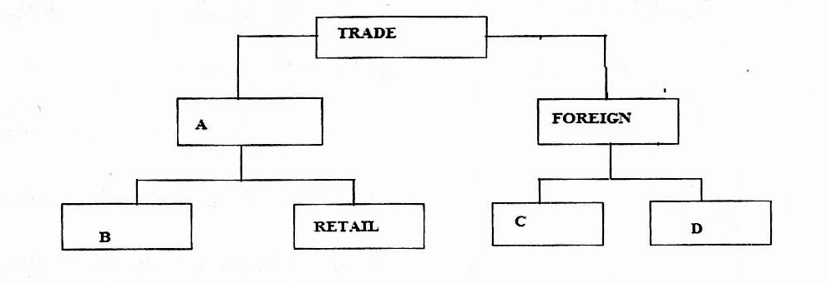

ii. B wholesale trade
iii. C import trade
- D export trade

7. Give the provisions of the partnership act of 1963 regarding: (4mks)
- Profits and losses:
Profits and losses are to be shared equal.
- Admission of new partner:
A new partner can only be admitted on consent of all partners
- Salary to any partner
No salaries are paid to any partner
- Contribution of capital
Partners are entitled to equal capital

8. Outline four trends in office management. (4mks)
- Performance contracting
- Introduction of CCTVs to monitor the activities
- Adoption of landscaped office plans to replace the enclosed plans.
- Offices are located outside the town CBD
- Introduction of public relations department
- Electronic staff log in and out system
- Use of communication and information technology

9. Give four roles played by the stock exchange market in Kenya. (4mks)
- Facilitates the buying and selling of shares amongst the citizens.
- Mobilizing saving
- Indicator of the companies’ performance.
- Promote managerial practices as companies
- Ensures protection of investors’ interest
- Providing useful information to investors on the shares to buy through the mass media
- Assist companies to raise capital by creating an environment through which such companies issue new shares to the public (IPO)
- Creation of employment e.g. brokers, agents
- Raising revenue for our the government e.g. taxes, license fees and rent and rates
- Fixing of prices i.e. to determine the equilibrium price (true market value) of the securities.
- Measure of a country’s economic progress

10. State four benefits of hire purchase selling to a trader. (4mks)
- Seller enjoys a higher sales turn over
- Seller enjoys higher profits due to interest on hire purchase sales
- Seller can re-possess item in case of default in payments
- Capital from down payments enables the seller to continue in trading

11. Outline four roles of ethics in business operation. (4mks)
- Encourages good working relationship among workers
- Ensures fair competition in business
- Encourages good working relationship between employer and employee.
- Ensure rights of individual workers are upheld
- Ensure appropriate professional relationship between professionals and clients
- Help workers protect and uphold good image of business organization
- Help in protection of environment
- Help workers develop proper skills and right attitudes towards their work
- Helps in avoiding consumer exploitation

12. Outline four ways by which an institution can improve the performance of its workers. (4mks)
- Introduce them to advance technology.
- Set performance contracts.
- Regular review of salary / fringe benefits.
- Give yearly bonuses to hardworking employees.
- Regular communication with employees.

13. List any four documents used in home trade that originates from the seller.
- A catalogue
- Quotation
- Price list
- Acknowledgement note
- Packing note
- Advice note
- An invoice
- Receipt
- Statement of account

14. Outline four characteristics of services. (4mks)
- Are intangible
- Cannot be stored
- Quality cannot be standardized
- Inseparable from the provider

15. List four disciplines that form business studies. (4mks)
- Commerce
- Accounting
- Economics
- Entrepreneurship
- Office practice

16. Outline four features of cooperative societies. (4mks)
- Formed by a minimum of ten persons with no set maximum
- Members are entitled to one vote each
- Are managed by an elected management committee
- Have perpetual life
- Are governed under the cooperative Acts / by laws made by members
- Membership is open and voluntary
- Enjoy limited liability status

17. State four circumstances under which a proforma invoice may be used. (4mks)
- When the seller requests the buyer to make payment of goods before delivery
- When the seller doesn’t want to give out goods on credit
- When the importer of goods want to get customs clearance before the goods are sent
- When the seller wants to show the buyer the amount he/she would have to pay for if he/she buys goods on approval
- When the seller employs agents to sell goods for him/her.

18. Outline four reasons why choices are important in the satisfaction of human wants. (4mks)
- Wants are unlimited while resources are limited
- Some wants are more urgent than others
- There are wide varieties that satisfy the same wants
- Commodities differ in quality and other features
- Some wants are recurrent.
- Human wants are competitive

19. Give four functions of an office in an organization. (4mks)
- Receive information from external and internal sources for the organization such as letters, telephone calls
- Distributes information by passing it to the relevant persons / departments for necessary action.
- Reproduction of documents
- Receive / attend visitors by giving direction on required information
- Mailing.
- Safeguarding / controlling they organizations property.
- Filing of documents

20. Give four reasons why a consumer may prefer buying from a super market. (4mks)
- Goods are offered at relative low/fair prices.
- Customers can buy a variety of goods under one roof! less movement.
- They offer quality goods to the customers.
- Easier to shop since they accept credit cards/plastic money
- They at times offer after sale services to the customers e.g. Packaging.
- One can choose the displayed goods hence time saving.
- Goods bears price tags/no bargaining/saves time.
- Operate on self-service basis hence easy budgeting.

21. Give four characteristics of indirect production. (4mks)
- Enhances specialization.
- Production of surplus goods
- Better quality goods produced
- Exchange of goods leading to trade
- Encourages innovation and invention

22. State four ways in which natural resources may be of benefit to a country.
- Their exploitation creates employment
- Provides raw materials for industries
- They are used to generate income for a country! foreign exchange earnings
- They are of food to the populace.

23. Outline four types of business activities. (4mks)
- Extraction
- Processing of raw materials
- Manufacturing
- Distribution of goods
- Trade
- Provision of services

24. List four factors that constitute the internal environment of a business. (4mks)
- Physical resources
- Financial resources.
- Hi. Human resources
- Business culture
- The owner(s)
- Business structure

25. Outline four disadvantages of public corporations. (4mks)
- May suffer inefficient management due to political appointees
- Political interference in the operations
- Suffer from diseconomies of scale
- Some operate as monopolies therefore may exploit the consumers

