BIOLOGY FORM 2
MARKING SCHEMES 2017

1. Below is a diagram representing a longitudinal section of a human tooth.

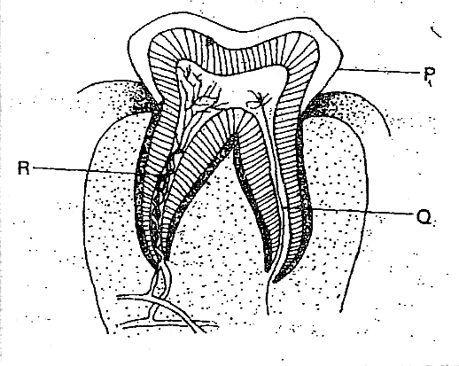

a) Name the type of tooth.
Molar

b) Give a reason for your answer in (a) above
Have two roots
Broad surface
Ridged with cusps

c) Name structures P, Q, and R and give their functions. (6 marks)
P - Enamel
Function protect the inner parts form bacterial infection; provide hard biting surface
Q - Nerve fiber
Function Detects heat, cold & pain
R - Blood capillaries
Function provide nutrients & Oxygen o the living tissues; remove waste products;

d) State four ways of keeping teeth healthy. (4 marks)
i) Regular brushing / cleaning
ii) Avoid eating too much sugary foods
iii) Eating hard foods like carrots
iv) Eating diet rich in calcium, phosphorous and regular visit to the which dentists for check-up.

2. The diagram below shows circulation of blood in a mamma.

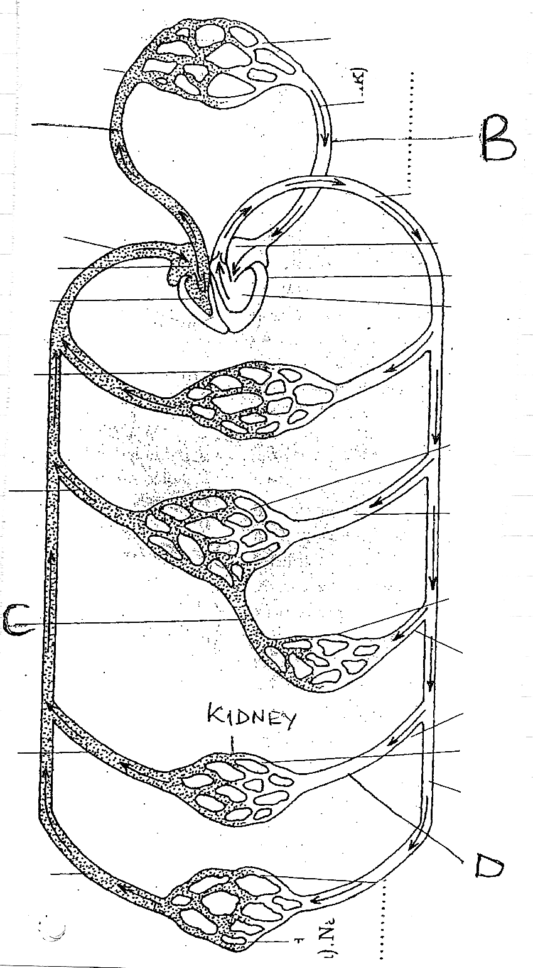
a) Name the type of circulation represented above (1mk)
Double circulation

b) Give reason for your answer (1mk)
Blood flows into the heart twice for every complete circulation

c) Name the blood vessel labeled A,B,C,D (4mks)
A - pulmonary artery
B - pulmonary vein
C - hepatic portal vein
D - renal artery

d)State two roles of blood capillaries (2mks)
i) Exchange of nutrients and works between tissues and blood
ii) Formation of tissue fluid

e)Name other two types of blood vessels beside capillaries (2mks)
i) Arteries
ii) Veins

f) State two functional differences between the blood vessels you have named above (2mks)
i) Arteries transport oxygenated blood except pulmonary artery while veins transport deoxygenated blood except pulmonary vein
ii) In arteries blood flows rapidly under pressure while in veins it flows smoothly and slowly under low pressure

g) State two roles of the red blood cells (2mks)
i) Transport of oxygen
ii) Transport of carbon iv oxide

h) Name the three types of immunity (3mks)
- Natural immunity /innate immunity
- Naturally acquired immunity
- Artificially acquired immunity

3. i) What is gaseous exchange? (1mks)
The process by which the respiratory gases (oxygen and carbon iv oxide) are passed across the respiratory surface

ii) Name the mineral element and vitamin required for blood clotting (2mks)
Mineral element - calcium ion(ca²⁺⁾
Vitamin - k

4. The diagram below represents a transverse section of a plant part

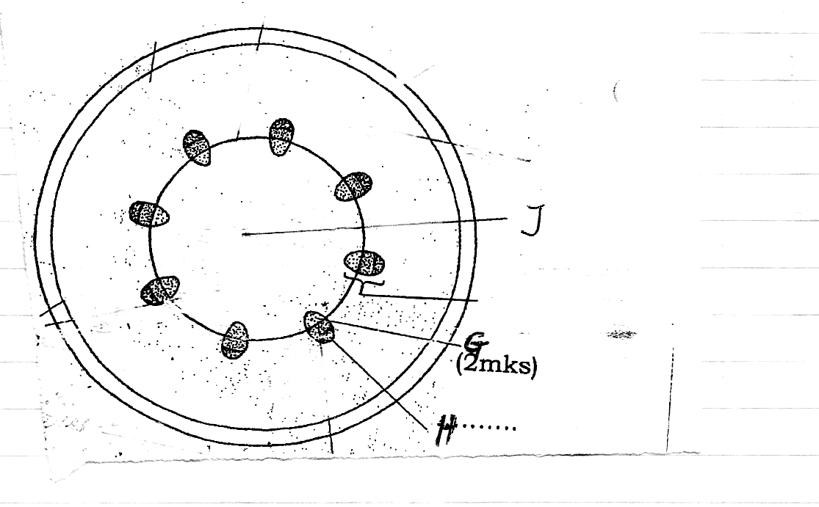
a) Identify the class from which it is obtained (1mk)
Dicotyledonae

b) Name parts G and H (2mks)
G - xylem
H - schlerenchyma

c) Give one role of J (1mks)
Stores water and food substance

d) Name the three types of transpiration (3mks)
  - Stomatal
  - Cuticular
  - Lenticular

e) Give one difference between xylem vessels and xylem trancheids (2mks)
Trancheids have tapering/chisel-shaped ends with perforated cross walls while vessels cross walls disintegrate to form a hallow tube with no tapering

f) Name the strengthening material in vessels (1mks)
Lignin

5) The diagram below shows an organelle in plants
a)Identify the organelle (1mks)
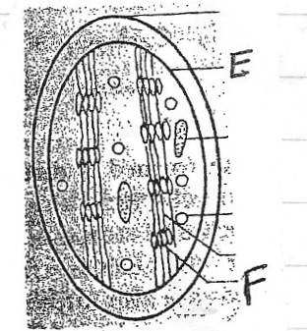

Chloroplast

b)Name the parts E and F (2mks)
E - Inner membrane
F -Granum

c) Give one role of part E (1mks)
Bind the internal pigments and molecules

d) Name two requirements for photosynthesis (2mks)
i) Light
ii) Carbon (iv) oxide
iii) Water

e) Explain what happens during the light stage of photosynthesis.
Cholorophyll molecules absorb light energy; which is used to split water molecules (photolysis); into oxygen and hydrogen atoms; some energy from light is used to from A.T.P, oxygen is released.

6. Discuss the factors that affect rate of enzyme action.
i) Temperature; enzymes work best within a narrow range of temperatures, high temperatures denature enzymes while low temperature inactivates them;
ii) PH; enzymes work best at a given PH (ophmum PH), majority work best at a PH close to 7 while some work best in acidic or alkaline medium.
iii) Specificity; enzymes are specific in nature i.e. a particular enzyme will only act on a particular substrate;
iv) Substrate concentration and enzyme concentration; rate of reaction increases with increase in substrate concentration till all the active sites in enzymes become the limiting factor;
v) enzyme inhibitors; competitive inhibitors shows down the reaction as they compete for the active sites while non-competitive prevents enzymes from interacting with the substrate i.e. stops the reaction processes.

7. Discuss the forces involved in the absorption and transport of water and mineral salts. (10 marks)
i) Transpiration pull; as water vaporizes from spongy mesophyll cells into sub-stomach air spaces, osmotic pressure of the spongy mesophyll increases; it then draw water form surrounding cells which in turn take water form the xylem vessels;

ii) cohesion and adhesion force; water molecules attract one another thus sticking together, as the same time its attracted to walls of xylem vessels; this maintains a thin but high columns of water in xylem vessels up the plant;

iii) capillarity; This is the rise of water column n the xylem vessels because the vessels are narrow; and there is attracting force between walls of the xylem and water;

iv) Root pressure; This is the force in the roots that pushes water up the stem; this is due to active pumping of water across the endodermis to xylem vessels.

