SOCIAL STUDIES SCHEME OF WORK CLASS 8

Available Online:
Schools Net Kenya Consultancy
P.O. Box 8076 – 00200 Nairobi, Kenya | Tel: +254202319748
E-mail: infosnkenya@gmail.com | www.schoolsnetkenya.com

Our Lives Today: Social Studies Standard Eight Schemes of Work: Term One
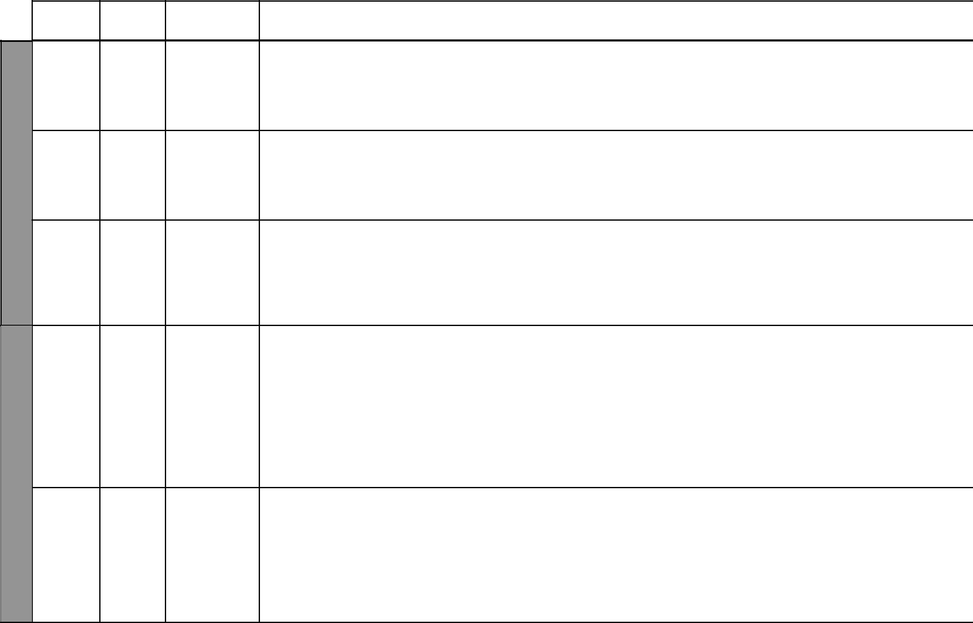

LESSON TOPIC SUB-TOPICS

1 | Map | Symbols
 | reading

2 & 3 | Map | Area
1 | reading
WEEK | reading
4 & 5 | Map | Distance
 | reading

1 | Map | Direction
 | reading

WEEK 2 | Map | Colour and
2 & 3 | Map | Colour and
 | reading | Scales

OBJECTIVES | TEACHING/LEARNING |  | TEACHING/LEARNING |  | REFERENCES | REMARKS
 |  | ACTIVITIES |  | RESOURCES
By the end of the lesson, | - | Identifying symbols | • | Sketch maps | Our Lives Today
the learner should be | - | Using symbols to read | • | Chart with symbols in | SST Pupil’s Book 8
able to identify and use |  | and interpret a map |  | the Pupil’s Book | page 2 – 4
symbols to read and | - | Observing simple maps |  |  | SST Teacher’s Guide
interpret a map | - | Drawing symbols |  |  | pages 1 – 3
By the end of the lesson, | - | Calculating area | • | Sketch maps | Our Lives Today
the learner should be able | - | Working out examples on | • | Shapes in the Pupil’s | SST Pupil’s Book 8
to calculate the area of a |  | the chalkboard |  | Book | pages 4 – 6
given region |  |  |  |  | SST Teacher’s Guide
 |  |  |  |  | pages 1 – 2
By the end of the lesson, | - | Identifying types of scales | • | Measuring rod | Our Lives Today
the learner should be able | - | Measuring distances | • | Sketch maps in the | SST Pupil’s Book 8
to: |  | represented on the map |  | Pupil’s Book | pages 6 – 9
(i) Identify types of scales | - | Measuring simple | • | Local environment | SST Teacher’s
(ii) Measure distances |  | distances in the classroom |  | (classroom block, field | Guide pages 1 – 3
represented on a map |  | and compound |  | etc)
By the end of the lesson, | - | Making improvised | • | Chart showing compass | Our Lives Today
the learner should be able |  | compasses |  | points | SST Pupil’s Book 8
to describe directions | - | Describing direction of |  |  | pages 9 – 10
of places using compass |  | places using compass |  |  | SST Teacher’s Guide
points |  | points |  |  | pages 1– 2
 | - | Observing a chart
 | - | Showing compass points
 | - | Giving direction to
 |  | various objects in our
 |  | school
By the end of the lesson, | - | Identifying various colours | • | Map showing various | Our Lives Today
the learner should be able |  | on a map |  | colours | SST Pupil’s Book 8
to: | - | Explaining the meaning of | • Tables in the Pupil’s |  | pages 10 – 12
(i) Identify various |  | various colours on a map |  | Book | SST Teacher’s Guide
conventional colours | - | Asking and answering |  |  | pages 1 – 3
used on a map |  | questions
(ii) Identify types of | - | Studying the table in the
scales |  | Pupil’s Book
 |  | 1 |  | For use with Our Lives Today Standard Eight

LESSON TOPIC

4 & 5 | Physical
 | features

WEEK 2

- Climate

2 – 4 | Climate

WEEK 3

- Climate

Our Lives Today: Social Studies Standard Eight

Schemes of Work

Term 1

SUB-TOPICS | OBJECTIVES | TEACHING/LEARNING |  | TEACHING/LEARNING |  | REFERENCES | REMARKS
 |  |  | ACTIVITIES |  | RESOURCES
Effects of | By the end of the lesson, | - | Explaining the effects | • | Local environment | Our Lives Today
physical | the learner should be able |  | of physical features on | • Pictures in the Pupil’s |  | SST Pupil’s Book 8
features | to explain the effects of |  | human activities |  | Book | pages 13 – 16
on human | different physical features | - | Identifying physical |  |  | SST Teacher’s Guide
activities | on human activities |  | features in the locality |  |  | pages 4 – 5
 |  | - | Describing how the
 |  |  | features have influenced
 |  |  | the activities of local people
 |  | - Observing pictures in the
 |  |  | Pupil’s Book
Traditional | By the end of the lesson, | - | Naming and describing | • | Information from local | Our Lives Today
methods | the learner should be able |  | traditional methods of |  | people | SST Pupil’s Book 8
of weather | to name and describe |  | weather observation. | • Pictures in the Pupil’s |  | pages 17 – 18
observation | traditional methods of | - | Asking and answering oral |  | Book | SST Teacher’s Guide
 | weather observation |  | questions | • | Local environment | pages 5 – 6
 |  | - | Assignments
 |  | - | Observing pictures
Modern | By the end of the lesson, | - | Observing elements of | • | Weather chart | Our Lives Today
weather | the learner should be able |  | weather and instruments | • | Instruments for | SST Pupil’s Book 8
observation, | to observe, measure and |  | used |  | measuring weather | pages 18 – 23
recording and | record weather elements | - | Measuring and recording | • Pictures in the Pupil’s |  | SST Teacher’s Guide
measurement |  |  | elements of weather |  | Book | pages 6 – 7
 |  | - | Asking and answering | • Diagrams in the Pupil’s
 |  |  | questions |  | Book
 |  | - | Drawing a weather chart | • | Weather station
 |  | - | Observing pictures and
 |  |  | diagrams in the Pupil’s
 |  |  | Book
Factors | By the end of the lesson, | - | Identifying and describing | • | Local environment | Our Lives Today
influencing | the learner should be able |  | factors influencing | • Pictures in the Pupil’s |  | SST Pupil’s Book 8
climate change | to identify and describe |  | climatic changes |  | Book | pages 23 – 24
climate change | to identify and describe | - | Explaining climate changes |  | Book | pages 23 – 24
 | factors influencing | - | Explaining climate changes |  |  | SST Teacher’s Guide
 | factors influencing | - | Asking and answering oral |  |  | SST Teacher’s Guide
 | climatic changes |  | questions |  |  | pages 8 – 9
 |  | - | Listing the factors
 |  |  | influencing climatic
 |  |  | changes
 |  |  | 2 |  | For use with Our Lives Today Standard Eight

Our Lives Today: Social Studies Standard Eight

Schemes of Work

Term 1

WEEK 4

LESSON | TOPIC | SUB-TOPICS | OBJECTIVES | TEACHING/LEARNING |  | TEACHING/LEARNING | REFERENCES | REMARKS
 |  |  |  |  | ACTIVITIES | RESOURCES
1 | Climate | Impact of | By the end of the lesson, | - | Identifying impact of | • Local environment | Our Lives Today
 |  | climate change | the learner should be able |  | climatic changes | • Map in the Pupil’s Book | SST Pupil’s Book 8
 |  | on human | to explain the impact | - | Explaining impacts of |  | pages 25 – 26
 |  | activities | of climatic changes on |  | climatic changes on |  | SST Teacher’s Guide
 |  |  | human activities |  | human activities |  | pages 9 – 10
 |  |  |  | - Asking and answering oral
 |  |  |  |  | questions
 |  |  |  | - Assignment in the Pupil’s
 |  |  |  |  | Book
2 – 3 | Evolution | The Stone Age | By the end of the lesson, | - | Tracing the evolution and | • Pictures of Early Man in | Our Lives Today
 | of Early |  | the learner should be able |  | development of Early Man | the Pupil’s Book | SST Pupil’s Book 8
 | Man |  | to trace the evolution and | - | Discussing the evolution of | • Table in the Pupil’s Book | pages 28 – 29
 |  |  | development of Early Man |  | Early Man |  | SST Teacher’s Guide
 |  |  |  | - | Asking and answering |  | pages 10 – 12
 |  |  |  |  | questions
 |  |  |  | - | Taking notes
4 | Evolution | Prehistoric | By the end of the lesson, | - | Naming the prehistoric | • Map showing prehistoric | Our Lives Today
 | of Early | sites in Eastern | the learner should be able |  | sites in East Africa | sites | SST Pupil’s Book 8
 | Man | Africa | to name the prehistoric | - | Observing a map showing |  | pages 29 – 30
 |  |  | sites in Eastern Africa |  | prehistoric sites |  | SST Teacher’s Guide
 |  |  |  | - | Drawing a map showing |  | pages 10 – 12
 |  |  |  |  | prehistoric sites
 |  |  |  | - | Listing prehistoric sites
5 | Types of | Rural-urban | By the end of the lesson, | - | Stating reasons for rural- | • Pictures in the Pupil’s | Our Lives Today
 | migrations | migration | the learner should be |  | urban migration | Book | SST Pupil’s Book 8
 |  |  | able to state reasons for | - | Discussing rural-urban | • Resource person | pages 31 – 32
 |  |  | migration from rural to |  | migration |  | SST Teacher’s Guide
 |  |  | urban centres | - | Taking notes |  | pages 12 – 14
 |  |  |  | - | Observing pictures


₃ For use with Our Lives Today Standard Eight

WEEK 5

WEEK 6
Our Lives Today: Social Studies Standard Eight

Schemes of Work

Term 1
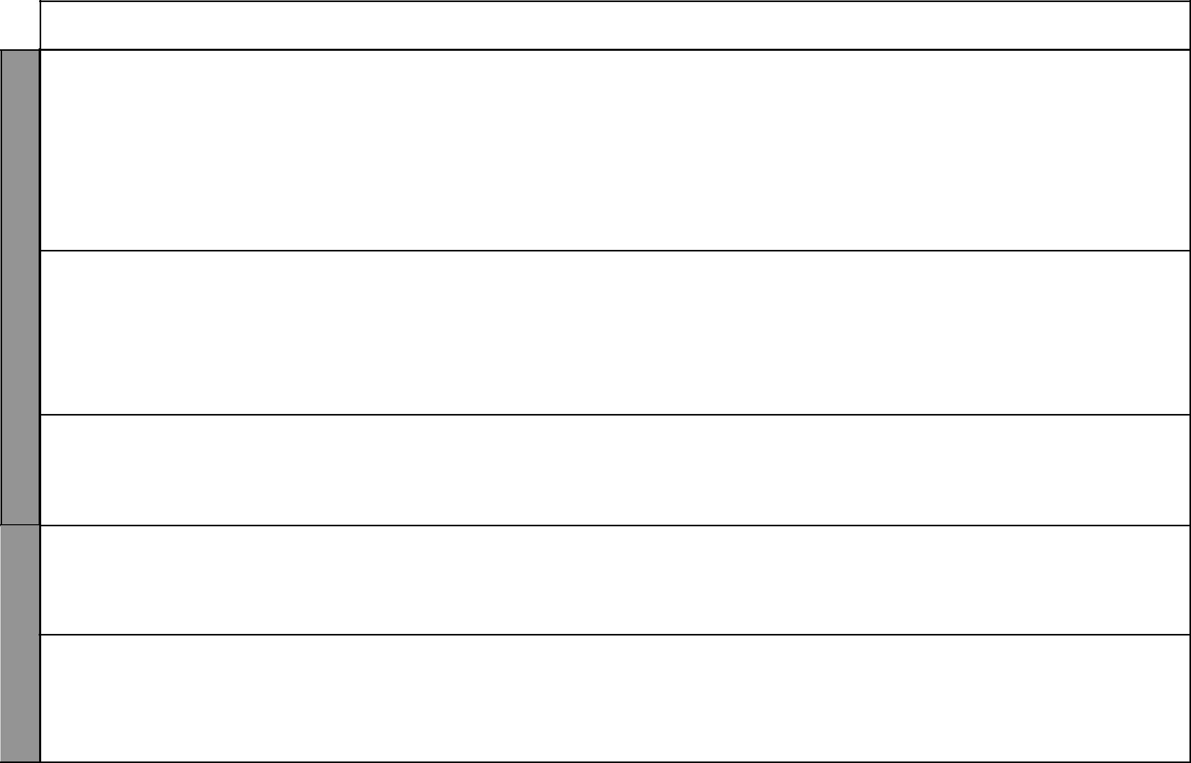
LESSON | TOPIC | SUB-TOPICS | OBJECTIVES | TEACHING/LEARNING |  | TEACHING/LEARNING |  | REFERENCES | REMARKS
 |  |  |  |  | ACTIVITIES |  | RESOURCES
1 & 2 | Types of | (i) Rural-rural | By the end of the lesson, | - | Explaining rural-rural | • Pictures in the Pupil’s |  | Our Lives Today
 | migrations | (ii) Urban- | the learner should be |  | migration |  | Book | SST Pupil’s Book 8
 |  | urban | able to state reasons for | - | Explaining urban to | • | Newspaper cuttings | pages 32 – 36
 |  | (iii) Urban-rural | rural to rural, urban to |  | urban migration | • | Local environment | SST Teacher’s Guide
 |  |  | urban and urban to rural | - | Stating reasons for all the | • | Resource person | pages 12 – 14
 |  |  | migrations |  | above forms of migration
 |  |  |  | - Observing pictures in the
 |  |  |  |  | Pupil’s Book
 |  |  |  | - | Asking and answering
 |  |  |  |  | oral questions
3 & 4 | Types of | Migrations into | By the end of the lesson, | - | Tracing migrations to | • Pictures in the Pupil’s |  | Our Lives Today
 | migrations | and from Kenya | the learner should be |  | and from Kenya |  | Book | SST Pupil’s Book 8
 |  |  | able to state reasons for | - | Observing a map | • | Local environment | pages 36 – 38
 |  |  | migrations into and from |  | showing migration routes |  |  | SST Teacher’s Guide
 |  |  | Kenya | - | Drawing a map showing |  |  | pages 12 – 14
 |  |  |  |  | migration routes
 |  |  |  | - Observing pictures in the
 |  |  |  |  | Pupil’s Book
5 | Types of | Effects of | By the end of the lesson, | - | Narrating a story about a | • Pictures in the Pupil’s |  | Our Lives Today
 | Migrations | migrations | the learner should be |  | character’s experience in |  | Book | SST Pupil’s Book 8
 |  |  | able to state the effects of |  | town | • | Resource person | pages 38 – 40
 |  |  | migrations | - | Dramatization | • | Local environment | SST Teacher’s Guide
 |  |  |  | - | Observing pictures |  |  | pages 13 – 14
1 | Factors | Factors | By the end of the lesson, | - | Identifying factors that | • Pictures in the Pupil’s |  | Our Lives Today
 | influencing | leading to slow | the learner should be able |  | lead to slow population |  | Book | SST Pupil’s Book 8
 | population | population | to identify the factors that |  | growth | • | Resource person | pages 41 – 42
 | growth | growth | lead to slow population | - | Asking and answering | • | Local environment | SST Teacher’s Guide
 |  |  | growth |  | oral questions |  |  | pages 15 –17
2 | Factors | Factors leading | By the end of the lesson, | - | Explaining factors that | • | Local environment | Our Lives Today
 | influencing | to rapid | the learner should be |  | lead to fast population | • | Variety of pictures | SST Pupil’s Book 8
 | population | population | able to identify factors |  | growth | • | Resource person | pages 42 – 44
 | growth | growth | that lead to fast influence | - | Asking oral questions |  |  | SST Teacher’s Guide
 |  |  | population growth | - | Taking notes |  |  | pages 16 – 17

₄ For use with Our Lives Today Standard Eight

Our Lives Today: Social Studies Standard Eight

Schemes of Work

Term 1


WEEK 6

WEEK 7

LESSON | TOPIC | SUB-TOPICS |  | OBJECTIVES | TEACHING/LEARNING |  | TEACHING/LEARNING |  | REFERENCES | REMARKS
 |  |  |  |  |  | ACTIVITIES |  | RESOURCES
3 | Factors | Problems of | By the end of the lesson, |  | - | Identifying problems | • | Pictures in the Pupil’s | Our Lives Today
 | influencing | population | the learner should be able |  |  | of slow and rapid |  | Book | SST Pupil’s Book 8
 | population | growth | to: |  |  | population growth | • | Local environment | pages 44 – 46
 | growth |  | (i) | Identify and explain | - | Asking and answering | • | Resource person | SST Teacher’s Guide
 |  |  |  | problems of slow |  | oral questions |  |  | pages 17 – 18
 |  |  |  | population growth | - | Taking notes
 |  |  | (ii) | Identify and explain
 |  |  |  | problems of rapid
 |  |  |  | population growth
4 | Ways of | Ways of | By the end of the lesson, |  | - | Explaining ways | • | Pictures in the Pupil’s | Our Lives Today
 | managing | managing slow | the learner should be |  |  | of managing slow |  | Book | SST Pupil’s Book 8
 | population | population | able to identify ways of |  |  | population growth | • | Local environment | pages 46 – 47
 | growth | growth | managing slow population |  | - | Asking and answering |  |  | SST Teacher’s Guide
 |  |  | growth |  |  | questions |  |  | pages 18 – 19
 |  |  |  |  | - | Dramatization
5 | Ways of | Ways of | By the end of the lesson, |  | - | Explaining ways | • | Pictures in the Pupil’s | Our Lives Today
 | managing | managing rapid | the learner should be |  |  | of managing rapid |  | Book | SST Pupil’s Book 8
 | population | population | able to explain ways of |  |  | population growth | • | Local environment | pages 47 – 48
 | growth | growth | managing rapid population |  | - | Asking and answering |  |  | SST Teacher’s Guide
 |  |  | growth |  |  | oral questions |  |  | page 19
 |  |  |  |  | - | Dramatization
1 | The | The population | By the end of the lesson, |  | - | Describing the structure | • | Table of population | Our Lives Today
 | population | of Kenya | the learner should be able |  |  | and composition of the | • | Census data of 1999 in | SST Pupil’s Book 8
 | of Kenya |  | to describe the structure |  |  | population in Kenya |  | the Pupil’s Book | pages 48 – 49
 |  |  | and composition of the |  | - | Observing a chart | • | Population pyramids | SST Teacher’s Guide
 |  |  | population of Kenya |  | - | Asking and answering |  |  | pages 19 – 21
 |  |  |  |  |  | questions |  |  | Atlas
 |  |  |  |  | - Studying the table in the
 |  |  |  |  |  | Pupil’s Book
 |  |  |  |  | - | Constructing population
 |  |  |  |  |  | pyramids

₅ For use with Our Lives Today Standard Eight

Our Lives Today: Social Studies Standard Eight

Schemes of Work

Term 1

 | LESSON | TOPIC | SUB-TOPICS | OBJECTIVES | TEACHING/LEARNING |  | TEACHING/LEARNING |  | REFERENCES | REMARKS
 |  |  |  |  |  | ACTIVITIES |  | RESOURCES
 | 2 | The | Comparisons | By the end of the lesson, | - | Comparing the Kenyan | • Table in the Pupil’s Book |  | Our Lives Today
 |  | population | between the | the learner should be able |  | population with that of | • | Population pyramid | SST Pupil’s Book 8
 |  | of Kenya | population | to compare the population |  | Germany and India |  |  | pages 49 – 50
 |  |  | of Kenya, | of Kenya with that of | - | Asking and answering |  |  | SST Teacher’s Guide
 |  |  | Germany and | Germany and India |  | oral questions in the |  |  | pages 19 – 21
 |  |  | India |  |  | Pupil’s Book |  |  | Atlas
 |  |  |  |  | - | Studying the table
 |  |  |  |  | - | Constructing population
 |  |  |  |  |  | pyramids
 | 3 | The | How schools | By the end of the lesson, | - | Explaining how schools | • Pictures in the Pupil’s |  | Our Lives Today
7 |  | school | are managed | the learner should be able |  | are managed |  | Book | SST Pupil’s Book 8
7 |  |  |  | to explain how schools are | - | Asking and answering | • | Resource person e.g. | pages 52 – 53
WEEK |  |  |  | managed |  | oral questions |  | Headteacher or PTA | SST Teacher’s Guide
WEEK |  |  |  |  | - | Observing pictures |  | member | pages 22 – 24
WEEK |  |  |  |  | - | Drawing charts showing
WEEK |  |  |  |  |  | hierarchy of school
 |  |  |  |  |  | administration
 | 4 | The | The role of | By the end of the lesson, | - | Explaining the role | • Pictures in the Pupil’s |  | Our Lives Today
 |  | school | pupils in school | the learner should be |  | of pupils in school |  | Book | SST Pupil’s Book 8
 |  |  | management | able to explain the |  | management | • | Resource person | pages 53 – 54
 |  |  |  | role of pupils in school | - | Asking and answering | • | Discussion among pupils | SST Teacher’s Guide
 |  |  |  | management |  | questions |  |  | pages 23 – 24
 |  |  |  |  | - | Observing pictures
 | 5 | The | The role of the | By the end of the lesson, | - | Explaining the role of the | • Pictures in the Pupil’s |  | Our Lives Today
 |  | school | school in society | the learner should be able |  | school in the society |  | Book | SST Pupil’s Book 8
 |  |  |  | to explain the role of the | - | Asking and answering | • | Resource person | pages 54 – 55
 |  |  |  | school in the society |  | oral questions | • | Class discussions | SST Teacher’s Guide
 |  |  |  |  | - | Observing pictures |  |  | pages 23 – 24
8 | 1 | The family | Different | By the end of the lesson | - | Identifying and | • Pictures in the Pupil’s |  | Our Lives Today
8 |  |  | marriage | the learner should be able |  | appreciating different |  | Book | SST Pupil’s Book 8
WEEK |  |  | marriage | the learner should be able |  | appreciating different |  | Book | SST Pupil’s Book 8
WEEK |  |  | systems | to identify and appreciate |  | marriage systems | • | Local environment | pages 55 – 57
WEEK |  |  |  | different marriage systems | - | Asking and answering | • | Learner’s own | SST Teacher’s Guide
WEEK |  |  |  |  |  | oral questions |  | experiences | pages 24 – 25

₆ For use with Our Lives Today Standard Eight

Our Lives Today: Social Studies Standard Eight

Schemes of Work

Term 1

WEEK 8

LESSON | TOPIC | SUB-TOPICS | OBJECTIVES | TEACHING/LEARNING |  | TEACHING/LEARNING |  | REFERENCES | REMARKS
 |  |  |  |  | ACTIVITIES |  | RESOURCES
2 | The family | Rights and | By the end of the lesson, | - | Identifying the rights and | • Table in the Pupil’s Book |  | Our Lives Today
 |  | responsibilities | the learner should |  | obligations of individuals | • | Learner’s own | SST Pupil’s Book 8
 |  | in marriage | be able to appreciate |  | within the family and |  | experiences | pages 57 – 59
 |  |  | and respect the rights |  | society |  |  | SST Teacher’s Guide
 |  |  | and obligations of an | - | Asking and answering |  |  | pages 25– 26
 |  |  | individual within the |  | oral questions
 |  |  | family and society | - | Making notes
 |  |  |  | - | Observing the table
3 | The family | Succession and | By the end of the lesson, | - | Explaining succession | • Pictures in the Pupil’s |  | Our Lives Today
 |  | inheritance | the learner should be |  | and inheritance of family |  | Book | SST Pupil’s Book 8
 |  |  | able to: |  | property | • | Resource person | pages 59 – 60
 |  |  | (i) Explain succession | - | Identifying types of |  |  | SST Teacher’s Guide
 |  |  | and inheritance of |  | inheritance |  |  | pages 27 – 28
 |  |  | family property | - | Asking and answering
 |  |  | (ii) Appreciate |  | oral questions
 |  |  | succession and | - | Observing pictures
 |  |  | inheritance of family | - | Dramatization
 |  |  | wealth
4 | Agriculture | Traditional | By the end of the lesson | - | Displaying various tools | • | Local environment | Our Lives Today
 |  | forms of | the learner should be | - | Identifying traditional | • | Nature/Science corner | SST Pupil’s Book 8
 |  | agriculture | able to describe the |  | forms of agriculture | • | Curiosity chart | pages 62 – 63
 |  |  | traditional forms of | - | Describing the traditional | • | Traditional farming tools | SST Teacher’s Guide
 |  |  | agriculture |  | forms of agriculture |  |  | pages 28 – 30
 |  |  |  | - | Asking and answering
 |  |  |  |  | questions
 |  |  |  | - | Identifying some
 |  |  |  |  | traditional tools
5 | Agriculture | Traditional | By the end of the lesson, | - | Naming subsistence | • | Crops | Our Lives Today
 |  | agriculture | the learner should be |  | crops grown in traditional | • | Nature/Science corner | SST Pupil’s Book 8
 |  |  | able to name subsistence | - | agriculture | • | Curiosity chart | page 63
 |  |  | crops grown in | - | Asking and answering |  |  | SST Teacher’s Guide
 |  |  | crops grown in |  | oral questions |  |  | SST Teacher’s Guide
 |  |  | traditional agriculture |  | oral questions |  |  | pages 28 – 30
 |  |  | traditional agriculture | - | Discussing subsistence |  |  | pages 28 – 30
 |  |  |  |  | farming
 |  |  |  | - | Identifying and displaying
 |  |  |  |  | specimen crops


₇ For use with Our Lives Today Standard Eight

LESSON TOPIC

- Agriculture

9
WEEK | 2 & 3 | Agriculture

4 & 5 | Agriculture

- Agriculture

WEEK 10

Our Lives Today: Social Studies Standard Eight

Schemes of Work

Term 1

SUB-TOPICS |  | OBJECTIVES | TEACHING/LEARNING |  | TEACHING/LEARNING |  | REFERENCES | REMARKS
 |  |  |  | ACTIVITIES |  | RESOURCES
Traditional | By the end of the lesson, |  | - | Demonstrations | • | Picture showing | Our Lives Today
methods of | the learner should be able |  | - | Stating the farming |  | traditional farming tools | SST Pupil’s Book 8
farming and | to: |  |  | methods used in | • | Samples of traditional | page 63
storing food | (i) | State the farming |  | traditional agriculture |  | food storage equipment | SST Teacher’s Guide
 |  | methods used in | - | Asking and answering |  | e.g. calabashes, gourds | pages 28 – 30
 |  | traditional agriculture |  | oral questions |  | and pots
 | (ii) | Explain ways of | - | Stating food storage
 |  | storing food in |  | methods
 |  | traditional society | - | Explaining the farming
 |  |  |  | methods
 |  |  | - | Modelling/constructing
 |  |  |  | food stores
Settler farming | By the end of the lesson, |  | - | Identifying areas where | • | Map showing where | Our Lives Today
in Kenya | the learner should be able |  |  | settler farming was |  | settler farming was | SST Pupil’s Book 8
 | to: |  |  | practised |  | practised in the Pupil’s | pages 64 – 65
 | (i) | Identify the areas | - | Observing a map showing |  | Book | SST Teacher’s Guide
 |  | where settler farming |  | where settler farming was | • | Relevant pictures | pages 30 – 32
 |  | was practised |  | practised
 | (ii) Describe the methods |  | - | Describing methods of
 |  | of farming in settler |  | settler farming
 |  | agriculture
Effects of | By the end of the lesson, |  | - | Explaining the effects of | • Pictures in the Pupil’s |  | Our Lives Today
settler farming | the learner should be able |  |  | settler farming |  | Book | SST Pupil’s Book 8
in Kenya | to explain the effects of |  | - | Observing a map showing |  |  | pages 65 – 67
 | settler farming in Kenya |  |  | settler farming |  |  | SST Teacher’s Guide
 |  |  | - | Taking notes |  |  | pages 30 – 32
Settlement | By the end of the lesson, |  | - | Stating reasons for | • Map in the Pupil’s Book |  | Our Lives Today
schemes in | the learner should be |  |  | the establishment of |  |  | SST Pupil’s Book 8
Kenya: | able to state reasons for |  |  | settlement schemes |  |  | pages 67 – 68
Reasons | the establishment of |  | - | Asking and answering |  |  | SST Teacher’s Guide
for their | settlement schemes in |  |  | questions orally |  |  | pages 32 – 34
establishment | Kenya |  | - Observing a map showing
establishment |  |  |  | settlement schemes
 |  |  | - Drawing a map of Kenya
 |  |  |  | showing settlement
 |  |  |  | schemes
 |  |  |  | 8 |  | For use with Our Lives Today Standard Eight

Our Lives Today: Social Studies Standard Eight

Schemes of Work

Term 1

 | LESSON | TOPIC | SUB-TOPICS |  | OBJECTIVES | TEACHING/LEARNING |  | TEACHING/LEARNING |  | REFERENCES | REMARKS
 |  |  |  |  |  |  | ACTIVITIES |  | RESOURCES
 | 2 | Agriculture | Settlement | By the end of the lesson, |  | - | Identifying settlement | • Map in the Pupil’s Book |  | Our Lives Today
 |  |  | Schemes in | the learner should be able |  |  | schemes |  |  | SST Pupil’s Book 8
 |  |  | Kenya: | to identify settlement |  | - Observing a map showing |  |  |  | pages 68 – 69
 |  |  | Distribution | schemes in Kenya |  |  | settlement schemes |  |  | SST Teacher’s Guide
 |  |  | of settlement |  |  |  |  |  |  | pages 32– 34
 |  |  | schemes in
 |  |  | Kenya
10 | 3 | Agriculture | Settlement | By the end of the lesson, |  | - Stating the benefits of |  | • | Resource person | Our Lives Today
10 |  |  | Schemes in | the learner should be |  |  | settlement schemes |  |  | SST Pupil’s Book 8
10 |  |  | Kenya: | able to state benefits and |  | - | Identifying problems |  |  | pages 69 – 70
WEEK |  |  |  |  |  |  |  |  |  | pages 69 – 70
WEEK |  |  | Benefits and | problems of settlement |  |  | facing settlement |  |  | SST Teacher’s Guide
WEEK |  |  | problems of | schemes |  |  | schemes |  |  | pages 32 –34
WEEK |  |  | settlement |  |  | - | Asking and answering
WEEK |  |  | schemes |  |  |  | questions
 |  |  |  |  |  | - | Writing main points
 | 4 & 5 | Agriculture | Irrigation | By the end of the lesson, |  | - Naming the crops grown |  | • Real crops of rice |  | Our Lives Today
 |  |  | farming: Mwea, | the learners should be able |  |  | in the irrigation schemes |  | onions, chillies etc. | SST Pupil’s Book 8
 |  |  | Perkerra, and | to: |  | - | Identifying some crops | • | Pictures showing | pages 70 – 72
 |  |  | Ahero Irrigation | (i) | Name the crops |  | found in the locality |  | irrigation schemes and | SST Teacher’s Guide
 |  |  | Schemes |  | grown in the irrigation | - | Asking and answering |  | methods of irrigation | pages 34 – 36
 |  |  |  |  | schemes |  | questions | • | Curiosity chart
 |  |  |  | (ii) | Describe the irrigation | - Observing a map showing
 |  |  |  |  | methods used in the |  | the irrigation schemes
 |  |  |  |  | different irrigation | - | Drawing a map
 |  |  |  |  | schemes
11 | 1 | Agriculture | Irrigation | By the end of the lesson, |  | - | Stating the contribution | • | Resource persons | Our Lives Today
11 |  |  | farming: | the learner should be able |  |  | by irrigation schemes to | • | Learner’s own | SST Pupil’s Book 8
11 |  |  | Mwea, Perkerra | to state the contribution of |  |  | the economy |  | experiences | page 72
WEEK |  |  | Mwea, Perkerra |  |  |  | the economy |  | experiences | page 72
WEEK |  |  | and Ahero | the irrigation schemes to |  | - | Asking and answering | • | Local environment | SST Teacher’s Guide
WEEK |  |  | Irrigation | the economy |  |  | questions |  |  | pages 34 – 36
WEEK |  |  | Schemes |  |  | - | Taking notes

₉ For use with Our Lives Today Standard Eight

LESSON TOPIC

- Agriculture

11 | 3 | Agriculture
WEEK | 3 | Agriculture
 | 4 & 5 | Agriculture

1 | Agriculture

WEEK 12 | Agriculture
2 & 3 | Agriculture

Our Lives Today: Social Studies Standard Eight

Schemes of Work

Term 1
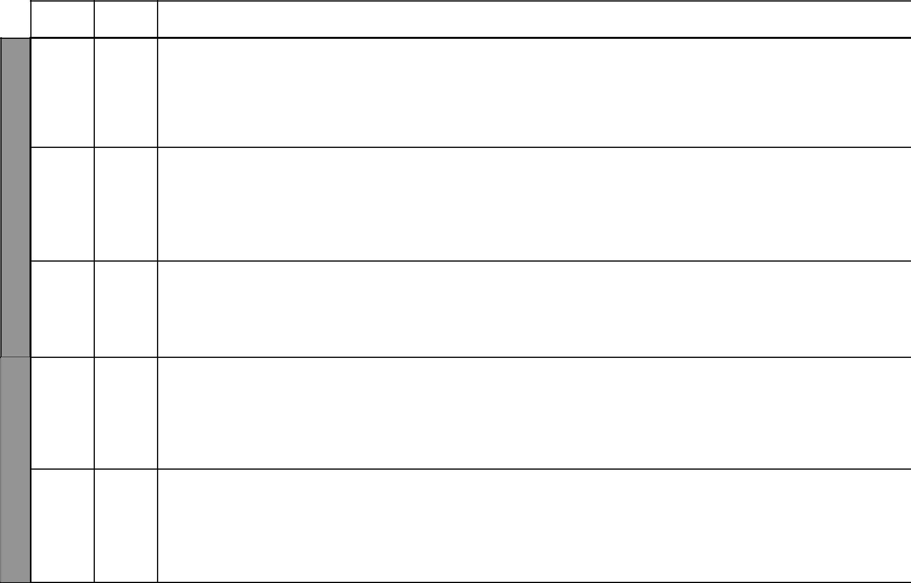
SUB-TOPICS | OBJECTIVES | TEACHING/LEARNING |  | TEACHING/LEARNING |  | REFERENCES | REMARKS
 |  |  | ACTIVITIES |  | RESOURCES
Irrigation | By the end of the lesson, | - | Explaining problems | • | Resource person | Our Lives Today
farming: | the learner should be able |  | facing irrigation farming | • | Learner’s own | SST Pupil’s Book 8
Mwea, | to explain problems facing |  | in Kenya |  | experiences | page 73
Perkerra | irrigation farming in Kenya | - | Asking and answering | • | Local environment | SST Teacher’s Guide
and Ahero |  |  | oral questions |  |  | pages 34 – 36
Irrigation |  | - | Discussing the problems
Schemes |  |  | facing irrigation farming
Horticultural | By the end of the lesson, | - | Explaining the meaning | • | Real crops | Our Lives Today
farming: | the learner should be able |  | of horticulture | • | Pictures in textbook | SST Pupil’s Book 8
Types of crops | to explain the meaning | - | Asking and answering | • | Newspaper cuttings | page 74
grown | of horticulture and crops |  | oral questions |  |  | SST Teacher’s Guide
 | grown | - | Writing notes |  |  | pages 36 – 38
 |  | - | Observing some
 |  |  | horticultural crops
Horticulture: | By the end of the lesson, | - | Stating the contribution | • | Local environment | Our Lives Today
Contribution | the learner should be able |  | of horticulture farming to | • | Resource person | SST Pupil’s Book 8
to the economy | to state the contribution of |  | the economy |  |  | pages 74 – 75
 | horticulture farming to the | - | Asking and answering |  |  | SST Teacher’s Guide
 | economy |  | oral questions |  |  | pages 30 – 38
 |  | - | Writing main points
Horticulture: | By the end of the lesson, | - | Stating the problems | • Map showing areas of |  | Our Lives Today
Problems | the learner should be |  | facing horticulture |  | horticulture farming | SST Pupil’s Book 8
facing | able to state the problems |  | farming in Kenya |  |  | page 75
horticultural | facing horticulture farming | - | Asking and answering |  |  | SST Teacher’s Guide
farming in | in Kenya |  | oral questions |  |  | pages 36 – 38
Kenya |  | - | Observing a map
 |  | - | Drawing a map
Horticulture | By the end of the lesson, | - | Comparing horticulture | • | Real crops | Our Lives Today
Comparison | the learner should be able |  | farming in Kenya and the | • Atlas with emphasis on |  | SST Pupil’s Book 8
of horticulture | to compare horticulture | - | Netherlands |  | location of Netherlands | page 76
farming in | farming in Kenya and the | - | Asking and answering |  | and its neighbours | SST Teacher’s Guide
farming in | farming in Kenya and the |  | oral questions |  | and its neighbours | SST Teacher’s Guide
Kenya and the | Netherlands |  | oral questions | • Table in the Pupil’s |  | pages 36 – 38
Kenya and the | Netherlands | - | Observing horticulture |  |  | pages 36 – 38
Netherlands |  | - | Observing horticulture |  | Book
Netherlands |  |  | crops in the |  | Book
 |  |  | neighbourhood
 |  |  | 10 |  | For use with Our Lives Today Standard Eight

Our Lives Today: Social Studies Standard Eight

Schemes of Work

Term 1
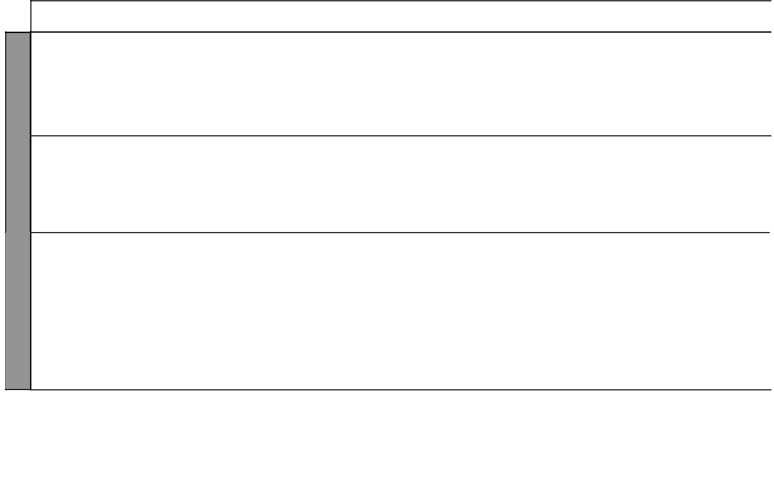

WEEK 12

WEEK 13

LESSON | TOPIC | SUB-TOPICS | OBJECTIVES | TEACHING/LEARNING |  | TEACHING/LEARNING |  | REFERENCES | REMARKS
 |  |  |  |  | ACTIVITIES |  | RESOURCES
4 | Agriculture | Fish farming in | By the end of the lesson, | - | Identifying fish farming | • | Map showing fish | Our Lives Today
 |  | Kenya | the learner should be able |  | areas in Kenya |  | farming areas | SST Pupil’s Book 8
 |  |  | to: | - Drawing a map showing |  |  |  | pages 77 – 78
 |  |  | (i) Identify fish farming |  | fish farming areas |  |  | SST Teacher’s Guide
 |  |  | areas in Kenya | - | Observing a map |  |  | pages 38 – 40
 |  |  | (ii) State the types of fish | - Listing fish farming areas
 |  |  | kept | - Giving examples of fish
 |  |  |  |  | kept
5 | Agriculture | Fish farming | By the end of the lesson, | - | Comparing fish farming | • Table in the Pupil’s |  | Our Lives Today
 |  | Comparison | the learner should be able |  | in Kenya and Japan |  | Book | SST Pupil’s Book 8
 |  | of fish farming | to compare fish farming in | - | Asking and answering |  |  | page 78
 |  | in Kenya and | Kenya and Japan |  | oral questions |  |  | SST Teacher’s Guide
 |  | Japan |  | - | Writing main points |  |  | pages 38 – 40
 |  |  |  | - Studying the table in the
 |  |  |  |  | Pupil’s Book
1 – 3 | Revision | Revision | By the end of the lesson, | - | Revising the work | • | Maps | Our Lives Today
 |  |  | the learner should be able |  | covered | • | Pupil’s Book | SST Pupil’s Book 8
 |  |  | to answer questions on | - | Observing maps |  |  | pages 2 – 80
 |  |  | the work covered | - | Observing charts |  |  | SST Teacher’s Guide
 |  |  |  | - | Asking and answering |  |  | pages 1– 40
 |  |  |  |  | oral questions
4 & 5 | Exams | Exams | By the end of the lesson, | - | Writing the test | • | Question papers | Our Lives Today
 |  |  | the learner should be able | - | Revising the test |  |  | SST Pupil’s Book 8
 |  |  | to answer questions based |  |  |  |  | pages 2 – 80
 |  |  | on the work covered |  |  |  |  | SST Teacher’s Guide
 |  |  |  |  |  |  |  | pages 1 – 40

₁₁ For use with Our Lives Today Standard Eight

Our Lives Today: Social Studies Standard Eight Schemes of Work: Term Two


LESSON | TOPIC | SUB-TOPICS | OBJECTIVES
1 | Mining | Distribution | By the end of the lesson,
 |  | of minerals in | the learner should be able
 |  | Kenya | to locate the distribution
 |  |  | of the minerals in Kenya

 | 2 | Mining | Extraction and | By the end of the lesson,
 |  |  | uses of minerals | the learner should be able
 |  |  |  | to:
 |  |  |  | (i) | Describe ways of
 |  |  |  |  | extracting minerals
 |  |  |  | (ii) | State uses of soda ash
WEEK 1 |  |  |  |  | and fluospar
WEEK 1 | 3 | Mining | Extraction and | By the end of the lesson,
 |  |  | uses of minerals | the learner should be able
 |  |  |  | to:
 |  |  |  | (i) | Describe ways of
 |  |  |  |  | extracting limestone,
 |  |  |  |  | diatomite and
 |  |  |  |  | gemstones
 |  |  |  | (ii) | State uses of
 |  |  |  |  | limestone, diatomite
 |  |  |  |  | and gemstones
 | 4 | Mining | Extraction and | By the end of the lesson,
 |  |  | uses of minerals | the learner should be able
 |  |  |  | to:
 |  |  |  | (i) | Describe ways of
 |  |  |  |  | extracting sand,
 |  |  |  |  | marble and salt
 |  |  |  | (ii) | State uses of sand,
 |  |  |  |  | marble and salt

TEACHING/LEARNING |  | TEACHING/LEARNING |  | REFERENCES REMARKS
 | ACTIVITIES |  | RESOURCES
- | Locating the distribution | • | Map showing mineral | Our Lives Today
 | of minerals |  | distribution | SST Pupil’s Book 8
- Drawing a map showing |  | • Diagram in the Pupil’s |  | pages 80 – 81
 | the distribution of |  | Book | SST Teacher’s Guide
 | minerals |  |  | pages 41 – 44
- | Observing a map
 | showing the distribution
 | of minerals
- | Describing ways of | • | Diagrams showing ways | Our Lives Today
 | extracting minerals |  | of extracting minerals | SST Pupil’s Book 8
- | Discussing mineral | • Pictures in the Pupil’s |  | pages 81 – 82
 | extraction |  | Book | SST Teacher’s Guide
- | Drawing diagrams | • | Atlas | pages 41 – 44
 | showing extraction of
 | minerals

- Observing the diagrams and pictures

- Stating uses of minerals

- | Describing ways of | • | Items made from | Our Lives Today
 | extraction |  | limestone and diatomite | SST Pupil’s Book 8
- | Describing uses of | • | Atlas | pages 83 – 84
 | minerals |  |  | SST Teacher’s Guide
- Listing uses of minerals |  |  |  | pages 41 – 44

- Taking notes

- Observing pictures

- | Describing ways of | • Various items made from | Our Lives Today
 | extraction | sand e.g. glass | SST Pupil’s Book 8
- Listing uses of the |  |  | pages 84 – 85
 | minerals |  | SST Teacher’s Guide
- | Asking and answering |  | pages 41 – 44
 | questions
- | Taking notes
 | 12 | For use with Our Lives Today Standard Eight

Our Lives Today: Social Studies Standard Eight

Schemes of Work

Term 2


WEEK 1

WEEK 2

LESSON | TOPIC | SUB-TOPICS |  | OBJECTIVES | TEACHING/LEARNING |  | TEACHING/LEARNING |  | REFERENCES | REMARKS
 |  |  |  |  |  | ACTIVITIES |  | RESOURCES
5 | Mining | (i) Problems | By the end of the lesson, |  | - | Listing problems | • | Local environment | Our Lives Today
 |  | associated | the learner should be able |  |  | associated with mining | • Pictures in the Pupil’s |  | SST Pupil’s Book 8
 |  | with mining | to: |  | - | Stating the effects |  | Book | pages 85 – 87
 |  | (ii) Effects of | (i) | State the problems |  | of mining on the |  |  | SST Teacher’s Guide
 |  | mining |  | associated with |  | environment |  |  | pages 41 – 44
 |  | on the |  | mining | - | Stating the contribution
 |  | environment | (ii) | State the effects |  | of minerals to the
 |  | (iii) Contribution |  | of mining on the |  | economy
 |  | of minerals |  | environment | - | Asking and answering
 |  | to the | (iii) State the contribution |  |  | questions
 |  | economy |  | of minerals to the
 |  |  |  | economy
1 | Forestry | Distribution of | By the end of the lesson, |  | - | Identifying and locating | • | Map showing forested | Our Lives Today
 |  | forests in Kenya | the learner should be able |  |  | forests in Kenya |  | areas | SST Pupil’s Book 8
 |  |  | to identify and locate |  | - | Observing a map showing | • | Local environment | pages 88 – 89
 |  |  | forests in Kenya |  |  | forests in Kenya | • Table in the Pupil’s |  | SST Teacher’s Guide
 |  |  |  |  | - | Drawing a map showing |  | Book | pages 44 – 48
 |  |  |  |  |  | forests in Kenya
 |  |  |  |  | - Observing the table in the
 |  |  |  |  |  | Pupil’s Book
 |  |  |  |  | - | Identifying items made
 |  |  |  |  |  | from wood
2 & 3 | Forestry | Problems facing | By the end of the lesson, |  | - | Explaining problems | • | Resource person | Our Lives Today
 |  | forests in Kenya | the learner should be able |  |  | facing forests in Kenya |  |  | SST Pupil’s Book 8
 |  |  | to explain the problems |  | - | Asking and answering |  |  | page 90
 |  |  | facing forests in Kenya |  |  | oral questions |  |  | SST Teacher’s Guide
 |  |  |  |  |  |  |  |  | pages 44– 48
4 | Forestry | Deforestation | By the end of the lesson, |  | - | Stating the effects of | • Picture in the Pupil’s |  | Our Lives Today
 |  |  | the learner should be |  |  | deforestation in Kenya |  | Book | SST Pupil’s Book 8
 |  |  | able to state effects of |  | - Writing down the effects |  | • | Local environment | pages 90 – 91
 |  |  |  |  |  | of deforestation | • | Local environment | pages 90 – 91
 |  |  | deforestation in Kenya |  |  | of deforestation |  |  | SST Teacher’s Guide
 |  |  |  |  | - | Asking and answering |  |  | SST Teacher’s Guide
 |  |  |  |  | - | Asking and answering |  |  | pages 44 – 48
 |  |  |  |  |  | questions |  |  | pages 44 – 48
 |  |  |  |  | - Giving local examples of
 |  |  |  |  |  | those effects

₁₃ For use with Our Lives Today Standard Eight

WEEK 2

WEEK 3
Our Lives Today: Social Studies Standard Eight

Schemes of Work

Term 2
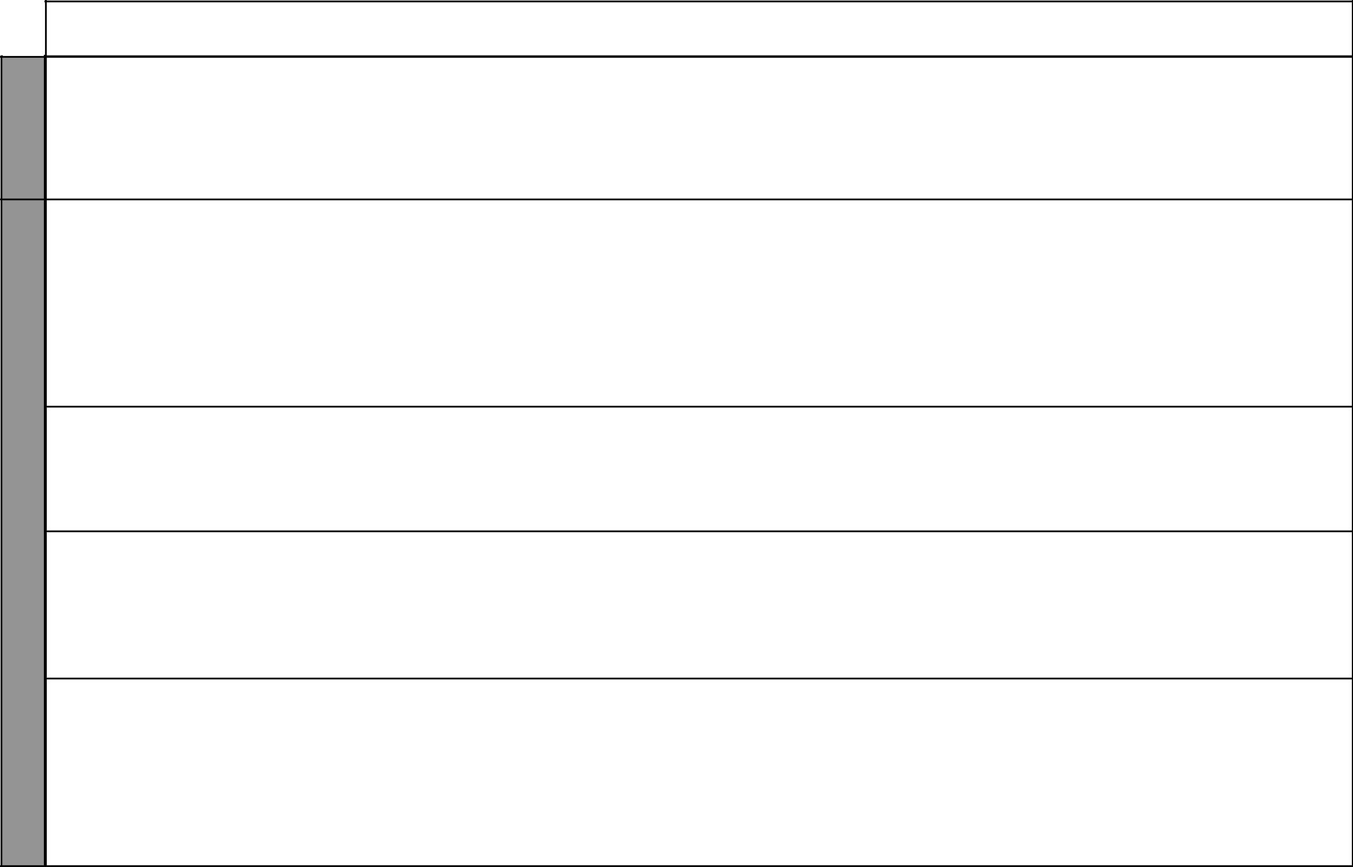
LESSON | TOPIC | SUB-TOPICS | OBJECTIVES | TEACHING/LEARNING |  | TEACHING/LEARNING |  | REFERENCES | REMARKS
 |  |  |  |  | ACTIVITIES |  | RESOURCES
5 | Forestry | Forest | By the end of the lesson, | - | Explaining how forests | • Pictures in the Pupil’s |  | Our Lives Today
 |  | conservation | the learner should |  | are being conserved |  | Book | SST Pupil’s Book 8
 |  | measures | be able to explain | - | Taking notes |  |  | pages 91 – 93
 |  |  | how forests are being | - Observing pictures in the |  |  |  | SST Teacher’s Guide
 |  |  | conserved and the need |  | Pupil’s Book |  |  | pages 44 – 48
 |  |  | for conservation | - | Planting trees
1 | Soils | Distribution of | By the end of the lesson, | - | Identifying and locating | • | Map showing distribution | Our Lives Today
 |  | soils in Kenya | the learner should be |  | the major soil types in |  | of soils | SST Pupil’s Book 8
 |  |  | able to identify and |  | Kenya |  |  | pages 94 – 95
 |  |  | locate the major soil | - | Observing soil types |  |  | SST Teachers Guide
 |  |  | types in Kenya | - | Asking and answering |  |  | pages 48 – 52
 |  |  |  |  | questions
 |  |  |  | - Observing the map in the
 |  |  |  |  | Pupil’s Book
2 | Soils | Uses of soil | By the end of the lesson, | - Stating the uses of soil |  | • Bricks, pots, mud houses |  | Our Lives Today
 |  |  | the learner should be | - | Asking and answering | • | Local environment | SST Pupil’s Book 8
 |  |  | able to state the uses of |  | questions |  |  | page 96
 |  |  | soils | - | Observing real samples |  |  | SST Teacher’s Guide
 |  |  |  |  | made from different soils |  |  | pages 48 – 52
3 & 4 | Soils | Soil erosion | By the end of the lesson, | - Stating the types of soil |  | • | Soil samples | Our Lives Today
 |  |  | the learner should be |  | erosion | • Pictures in the Pupil’s |  | SST Pupil’s Book 8
 |  |  | able to state types of soil | - | Asking and answering |  | Book | pages 96 – 97
 |  |  | erosion |  | questions | • | Relevant posters | SST Teacher’s Guide
 |  |  |  | - Visiting sites of soil |  |  |  | pages 48 – 52
 |  |  |  |  | erosion
5 | Soils | Causes and | By the end of the lesson, | - Stating causes of soil |  | • | Local environment | Our Lives Today
 |  | effects of soil | the learner should be |  | erosion in Kenya | • | Different pictures | SST Pupil’s Book 8
 |  | erosion | able to state the causes | - Stating effects of soil |  | • | Relevant posters | page 98
 |  |  | and effects of soil erosion |  | erosion |  |  | SST Teacher’s Guide
 |  |  | in Kenya | - | Discussing soil erosion |  |  | pages 48 – 52
 |  |  |  | - | Asking and answering
 |  |  |  |  | questions

₁₄ For use with Our Lives Today Standard Eight

Our Lives Today: Social Studies Standard Eight

Schemes of Work

Term 2
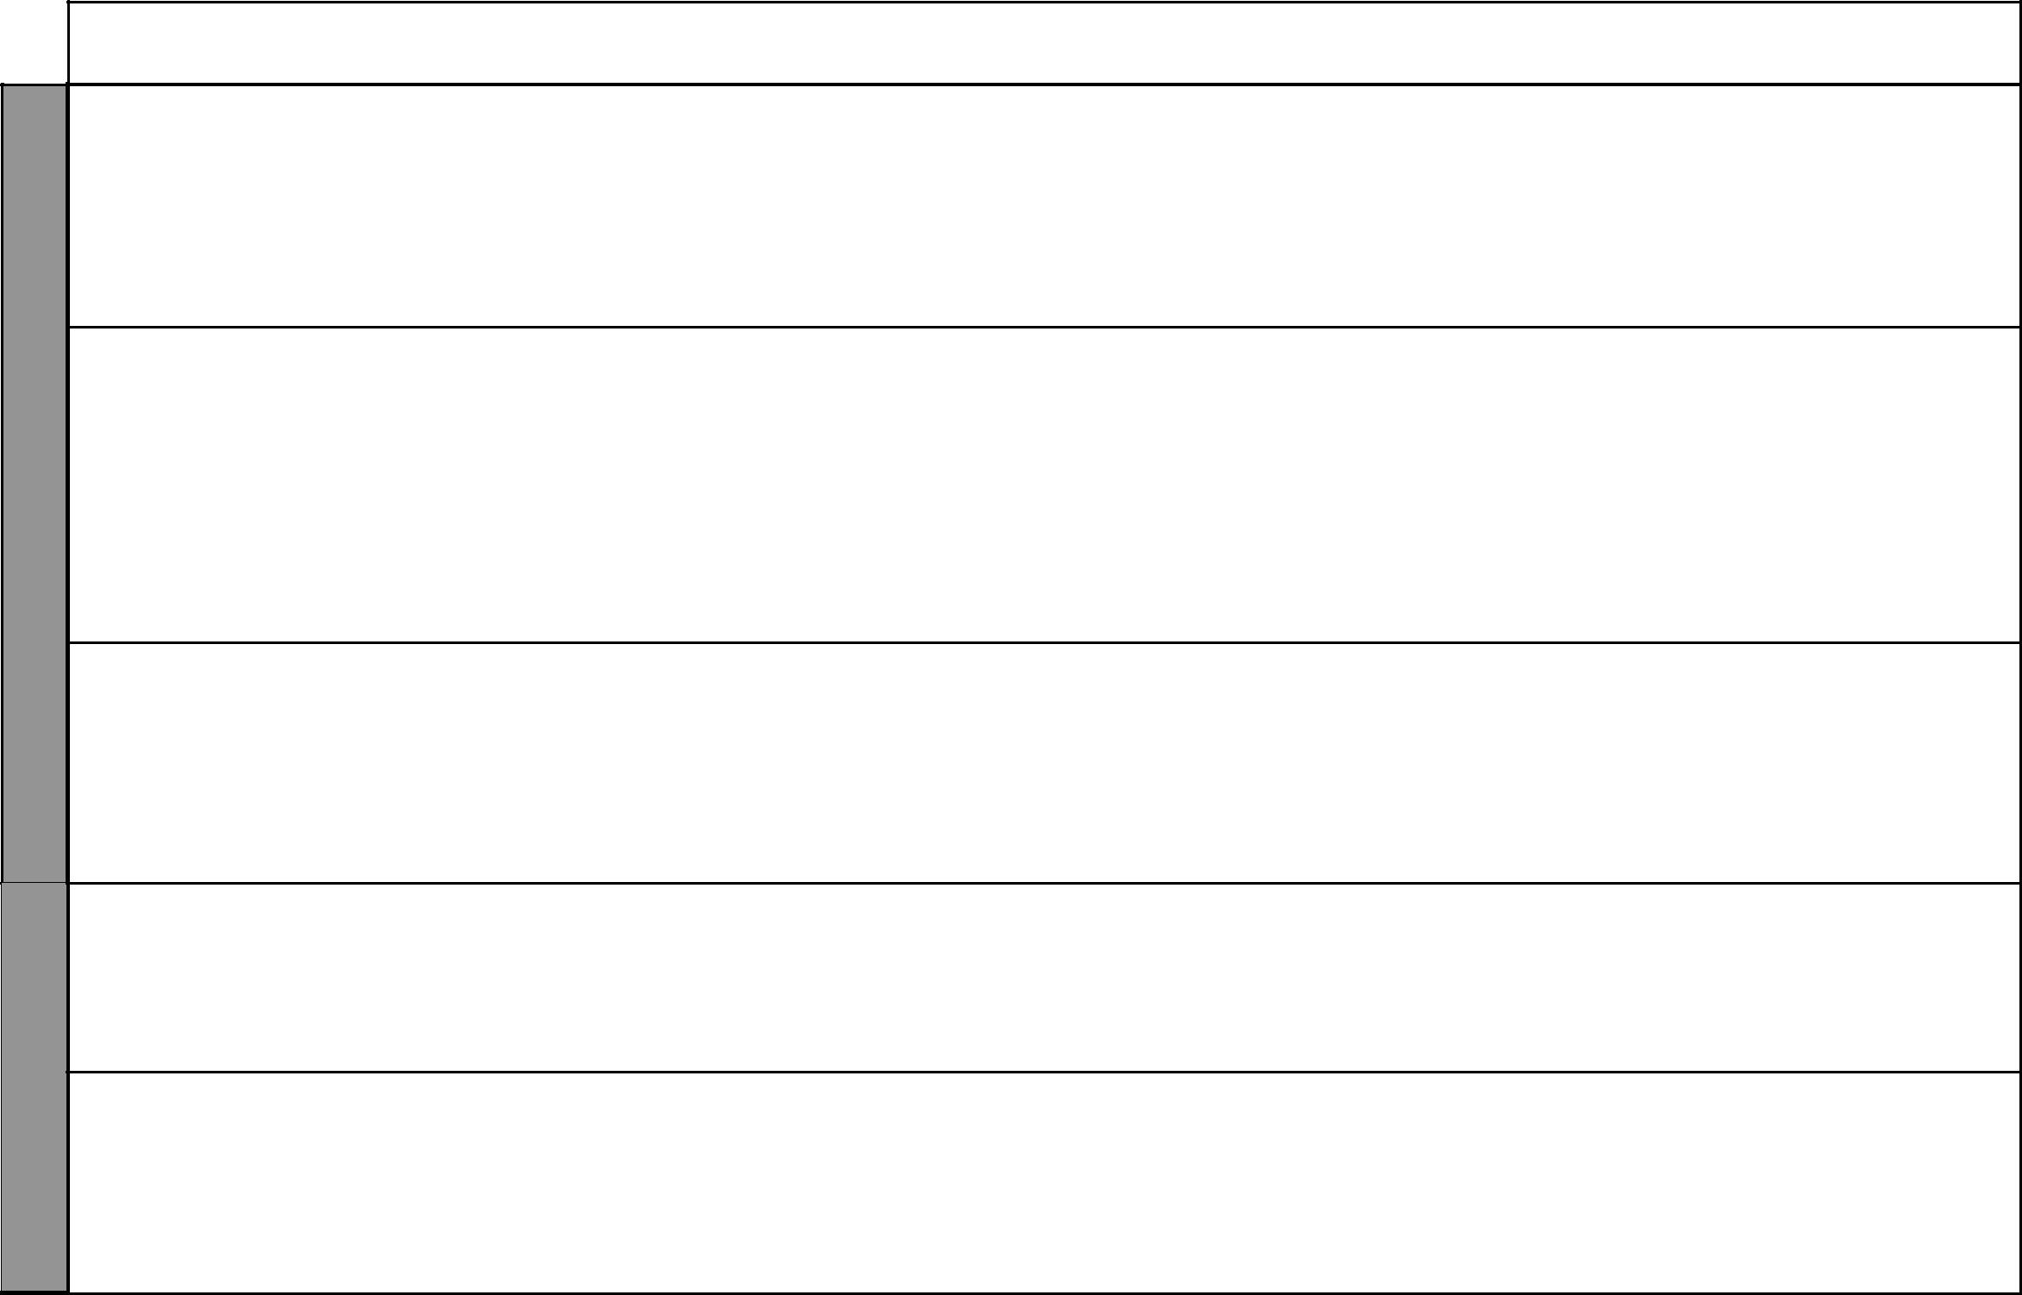

WEEK 4

WEEK 5

LESSON | TOPIC | SUB-TOPICS | OBJECTIVES | TEACHING/LEARNING |  | TEACHING/LEARNING |  | REFERENCES | REMARKS
 |  |  |  |  | ACTIVITIES |  | RESOURCES
1 & 2 | Soils | Soil | By the end of the lesson, | - | Identifying the soil | • Pictures in the Pupil’s |  | Our Lives Today
 |  | conservation | the learner should be |  | conservation measures |  | Book | SST Pupil’s Book 8
 |  | measures | able to identify and | - | Describing soil | • | Local environment | pages 99 – 100
 |  |  | describe soil conservation |  | conservation measures | • Talking to local farmers |  | SST Teacher’s Guide
 |  |  | measures | - | Asking and answering |  |  | pages 48 – 52
 |  |  |  |  | questions
 |  |  |  | - | Demonstrations
3 & 4 | Wildlife | Major game | By the end of the lesson, | - | Visit to a park | • | Map showing major | Our Lives Today
 | and | parks | the learner should be able | - | Naming and locating |  | game parks | SST Pupil’s Book 8
 | tourism |  | to name and locate major |  | major game parks |  |  | page 102
 |  |  | game parks | - | Observing a map showing |  |  | SST Teacher’s Guide
 |  |  |  |  | game parks |  |  | pages 52 – 54
 |  |  |  | - Drawing a map showing
 |  |  |  |  | major game parks
 |  |  |  | - Making models of game
 |  |  |  |  | parks
5 | Wildlife | Importance of | By the end of the lesson, | - | Stating the importance of | • | Government records/ | Our Lives Today
 | and | wildlife | the learner should be able |  | wildlife |  | statistics | SST Pupil’s Book 8
 | tourism |  | to state the importance of | - | Discussing the | • | Resource person | page 103
 |  |  | wildlife |  | importance of wildlife |  |  | SST Teacher’s Guide
 |  |  |  | - | Asking and answering |  |  | pages 52 – 54
 |  |  |  |  | questions
 |  |  |  | - | Writing notes
1 & 2 | Wildlife | Problems | By the end of the lesson, | - | Identifying problems | • | Resource person | Our Lives Today
 | and | facing wildlife | the learner should be |  | facing wildlife |  |  | SST Pupil’s Book 8
 | tourism |  | able to identify problems | - | Asking and answering |  |  | pages 103 – 104
 |  |  | facing wildlife |  | questions |  |  | SST Teacher’s Guide
 |  |  |  | - | Writing notes |  |  | pages 52 – 54
3 | Wildlife | Wildlife | By the end of the lesson, | - | Explaining how wildlife is | • Pictures in the Pupil’s |  | Our Lives Today
 | and | conservation | the learner should be able |  | being conserved |  | Book | SST Pupil’s Book 8
 | tourism | measures | to explain how wildlife is | - | Discussing wildlife | • | Resource person | pages 104 – 105
 |  |  | being conserved |  | conservation |  |  | SST Teacher’s Guide
 |  |  |  | - | Asking and answering |  |  | pages 52 – 54
 |  |  |  |  | questions

₁₅ For use with Our Lives Today Standard Eight

 |  |  | LESSON | TOPIC | SUB-TOPICS
 |  |  |  | Wildlife | Major tourist
 |  | 4 & 5 |  | Wildlife | Major tourist
 | 5 |  |  | and | attractions
 | 5 |  |  | tourism
 | WEEK |  |  | tourism
 |  |  |  | Wildlife | Importance of
1 |  |  |  | Wildlife | Importance of
 |  |  |  | and | tourism
 |  |  |  | tourism

 | 2 | Wildlife |  | Problems facing
 |  | and |  | tourism
6 |  |  | tourism
WEEK
3 |  |  | Industries |  | Factors
 |  |  |  |  | influencing
 |  |  |  |  | the location of
 |  |  |  |  | industries
4 & 5 |  |  | Industries |  | Types of
 |  |  |  |  | industries

Our Lives Today: Social Studies Standard Eight

Schemes of Work

Term 2

OBJECTIVES | TEACHING/LEARNING |  | TEACHING/LEARNING |  | REFERENCES | REMARKS
 |  | ACTIVITIES |  | RESOURCES
By the end of the lesson, | - | Identifying major tourist | • | Chart showing major | Our Lives Today
the learner should be able |  | attractions |  | tourist attractions | SST Pupil’s Book 8
to identify major tourist | - | Observing a map showing | • Pictures in the Pupil’s |  | pages 105 – 106
attractions |  | major tourist attractions |  | Book | SST Teacher’s Guide
 | - | Identifying animals in |  |  | pages 54 – 56
 |  | pictures
 | - Studying the table in the
 |  | Pupil’s Book
By the end of the lesson, | - | Stating the importance of | • | Local environment | Our Lives Today
the learner should be able |  | tourism in Kenya | • | Relevant charts | SST Pupil’s Book 8
to state the importance of | - | Discussing the | • Business people in the |  | page 107
tourism in Kenya |  | importance of tourism |  | tourism sector | SST Teacher’s Guide
 | - | Asking and answering |  |  | pages 54 – 56
 |  | questions
 | - | Taking notes
By the end of the lesson, | - | Identifying the main | • | Local environment | Our Lives Today
the learner should be |  | problems facing tourism | • | Relevant charts | SST Pupil’s Book 8
able to identify the main | - | Discussing the problems | • | Local reports | pages 107 – 108
problems facing tourism | - | Asking and answering |  |  | SST Teacher’s Guide
 |  | questions |  |  | pages 54 – 56
 | - | Taking notes
By the end of the lesson, | - | Explaining and listing | • Pictures in the Pupil’s |  | Our Lives Today
the learner should be |  | factors influencing |  | Book | SST Pupil’s Book 8
able to explain factors |  | industrial location | • | Resource person | pages 110 – 111
influencing location of | - | Writing down main | • | Local environment | SST Teacher’s Guide
industries |  | factors |  |  | pages 56 – 58
 | - | Taking notes
By the end of the lesson, | - | Naming and listing types | • Table in the Pupil’s Book |  | Our Lives Today
the learner should be able |  | of industries |  |  | SST Pupil’s Book 8
to: | - | Giving examples of the |  |  | pages 112 – 113
(i) Name types of |  | types of industries |  |  | SST Teacher’s Guide
(i) Name types of | - | Asking and answering |  |  | SST Teacher’s Guide
industries | - | Asking and answering |  |  | pages 56 – 58
industries |  | questions |  |  | pages 56 – 58
(ii) Give examples of the |  | questions
(ii) Give examples of the | - Studying the table in the
types of industries
types of industries |  | Pupil’s Book
 |  | 16 |  | For use with Our Lives Today Standard Eight

Our Lives Today: Social Studies Standard Eight

Schemes of Work

Term 2
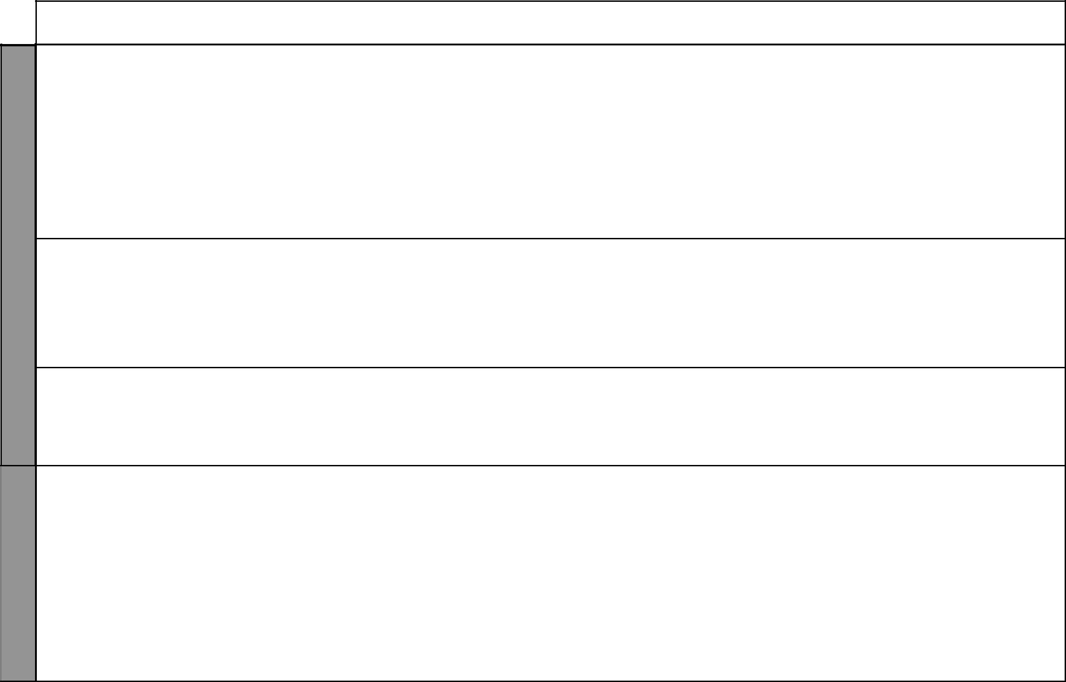

WEEK 7

WEEK 8

LESSON | TOPIC | SUB-TOPICS | OBJECTIVES | TEACHING/LEARNING |  | TEACHING/LEARNING |  | REFERENCES | REMARKS
 |  |  |  |  | ACTIVITIES |  | RESOURCES
1 – 3 | Industries | Jua kali | By the end of the lesson, | - | Identifying reasons for | • Items made by Jua kali |  | Our Lives Today
 |  | industries | the learner should be |  | establishing Jua kali |  | industries | SST Pupil’s Book 8
 |  |  | able to: |  | industries | • Pictures in the Pupil’s |  | pages 113 – 115
 |  |  | (i) Identify the reasons | - Explaining benefits of Jua |  |  | Book | SST Teacher’s Guide
 |  |  | for establishing Jua |  | kali industries | • | Local environment | pages 58 – 59
 |  |  | kali industries | - | Highlighting problems | • | Jua kali artisans
 |  |  | (ii) State benefits of Jua |  | experienced by Jua kali
 |  |  | kali industries |  | industries
 |  |  | (iii) Highlight problems | - Visiting local Jua kali
 |  |  | experienced by Jua |  | sites
 |  |  | kali industries
4 | Industries | Importance | By the end of the lesson, | - | Explaining the | • | Various items produced | Our Lives Today
 |  | of industries | the learner should be |  | contribution of the |  | in industries | SST Pupil’s Book 8
 |  | and their | able to explain the |  | industries to the | • | Relevant charts | pages 115 – 116
 |  | contribution | importance of industries |  | economy | • | Resource person | SST Teacher’s Guide
 |  | to the | and their contribution to | - | Asking and answering |  |  | pages 59 – 61
 |  | economy | the economy |  | questions
5 | Industries | Problems | By the end of the lesson, | - | Explaining and listing | • | Resource person | Our Lives Today
 |  | facing | the learner should be |  | problems facing | • | Newspaper reports | SST Pupil’s Book 8
 |  | industries | able to explain problems |  | industries |  |  | page 116
 |  |  | facing industries | - Visiting an industry in |  |  |  | SST Teacher’s Guide
 |  |  |  |  | the locality |  |  | pages 59 – 61
1 | Industries | Effects of | By the end of the lesson, | - | Explaining the impact | • | Local environment | Our Lives Today
 |  | industries | the learner should be |  | of industries on the | • Pictures in the Pupil’s |  | SST Pupil’s Book 8
 |  | on the | able to explain the |  | environment |  | Book | page 117
 |  | environment | impact of industries on | - | Asking and answering | • | Newspaper reports | SST Teacher’s Guide
 |  |  | the environment |  | questions |  |  | pages 59 – 61
 |  |  |  | - Writing down the main
 |  |  |  |  | impact of industries on
 |  |  |  |  | the environment

₁₇ For use with Our Lives Today Standard Eight

 | LESSON | TOPIC | SUB-TOPICS
 | 2 | Urban- | Factors
 |  | ization | influencing
 |  |  | the growth of
 |  |  | towns
8 | 3 – 4 | Urban- | Functions of
WEEK |  | ization | major towns in
WEEK |  |  | Kenya
 | 5 | Urban- | Functions of
 |  | ization | major towns in
 |  |  | Kenya
 | 1 | Urban- | Problems
 |  | ization | facing urban
 |  |  | centres
9
WEEK | 2 | Urban- | Attempts
WEEK |  | ization | made to solve
 |  |  | problems in
 |  |  | urban areas

Our Lives Today: Social Studies Standard Eight

Schemes of Work

Term 2
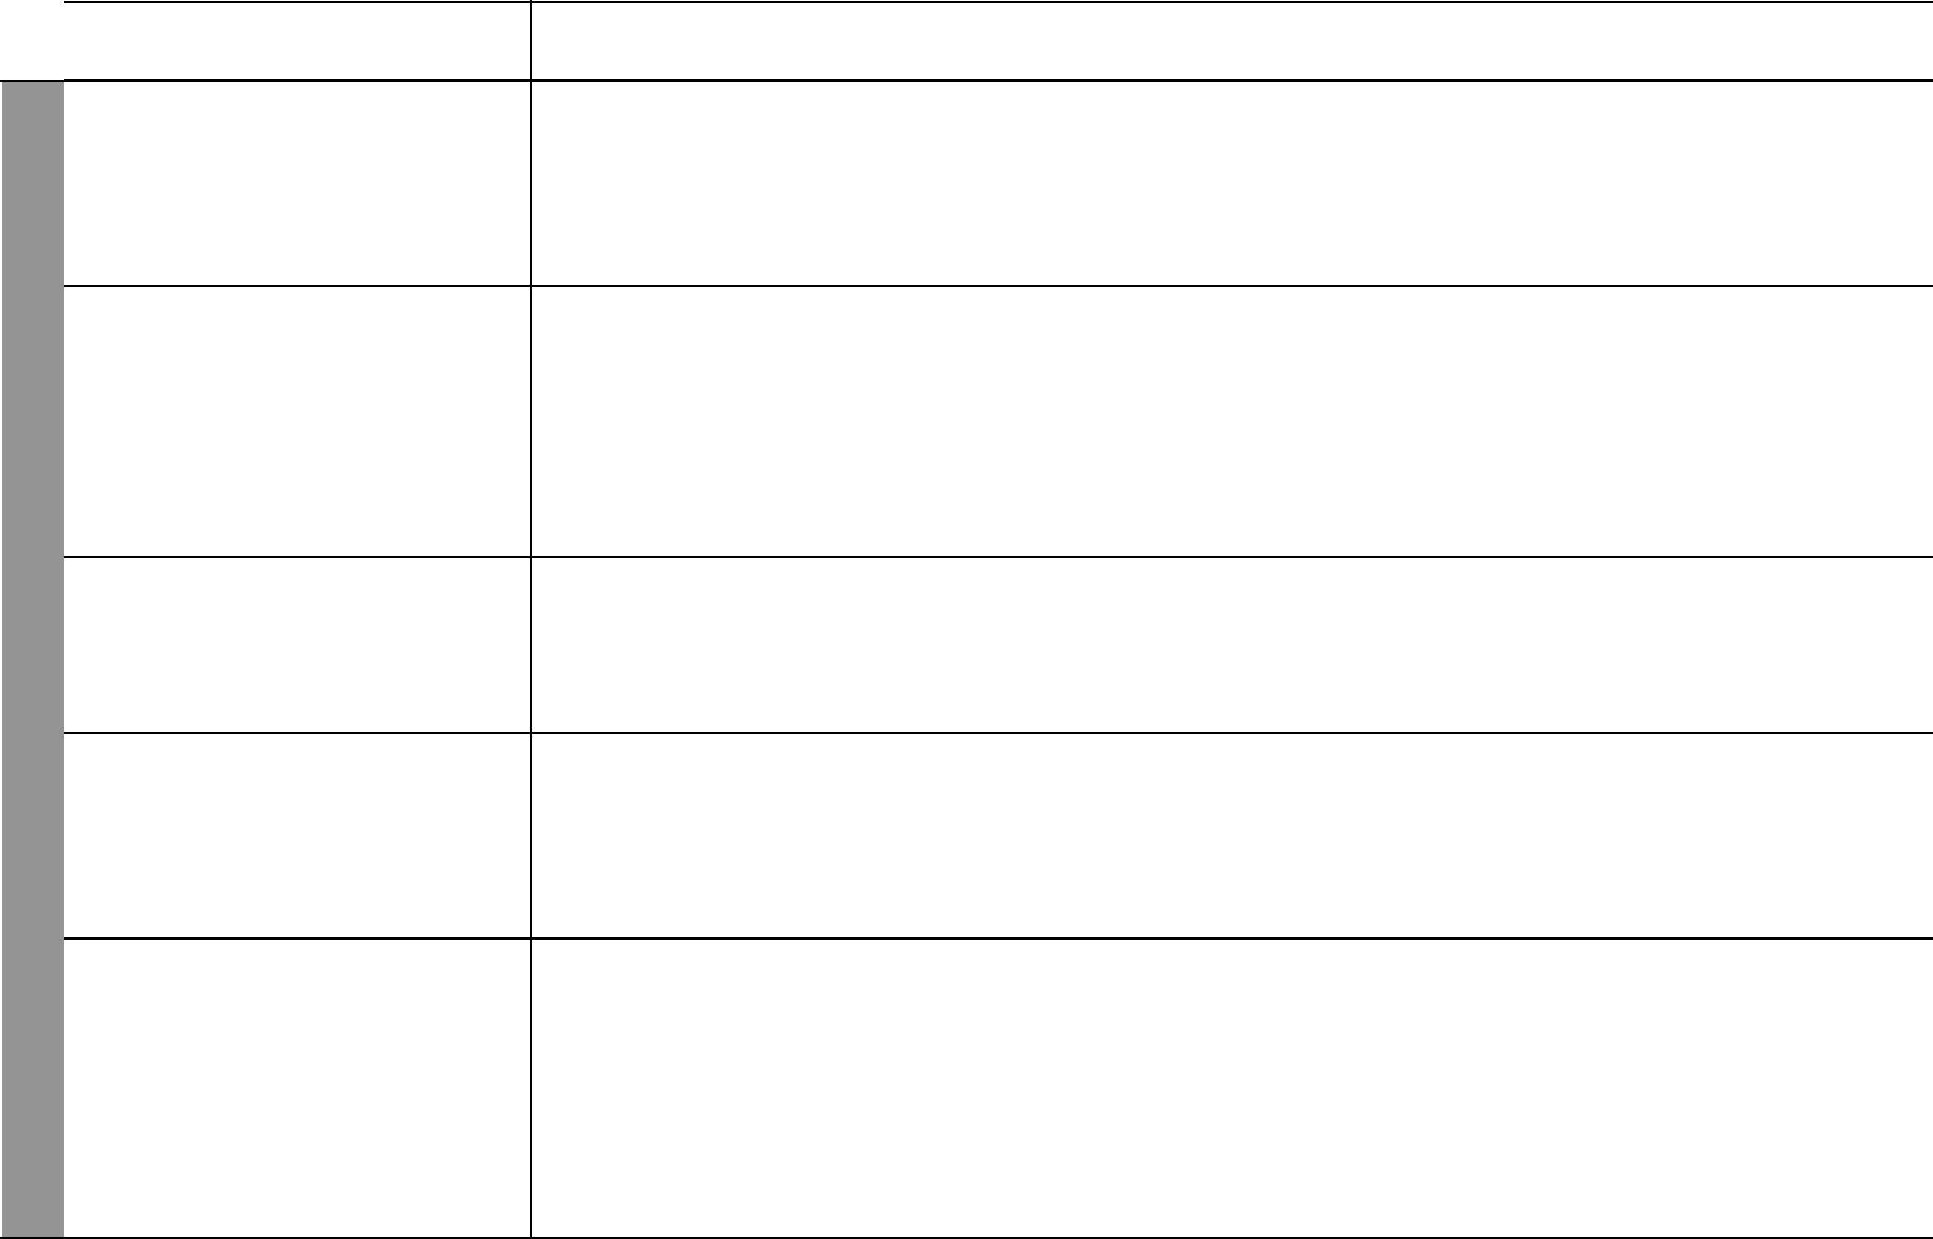
OBJECTIVES | TEACHING/LEARNING |  | TEACHING/LEARNING |  | REFERENCES | REMARKS
 |  | ACTIVITIES |  | RESOURCES
By the end of the lesson, | - | Explaining factors | • | Local environment | Our Lives Today
the learner should be |  | influencing growth of |  |  | SST Pupil’s Book 8
able to explain factors |  | towns |  |  | page 119
influencing growth of | - | Asking and answering |  |  | SST Teacher’s Guide
towns |  | questions orally |  |  | pages 61– 64
 | - | Naming various towns
By the end of the lesson, | - | Locating major towns in | • | Map showing major | Our Lives Today
the learner should be able |  | Kenya |  | towns | SST Pupil’s Book 8
to: | - | Identifying the functions | • | Local environment | pages 120 – 125
(i) Locate the major towns |  | of major towns in Kenya | • | Relevant pictures | SST Teacher’s Guide
in Kenya | - | Drawing a map showing |  |  | pages 61 – 64
(ii) Identify the functions |  | major towns
of the major towns in
Kenya
By the end of the lesson, | - | Locating major towns in | • | Map showing major | Our Lives Today
the learner should be able |  | Kenya |  | towns | SST Pupil’s Book 8
to identify the functions of | - | Describing the functions | • | Relevant pictures | pages 120 – 125
major towns in Kenya |  | of major towns in Kenya | • | Local environment | SST Teacher’s Guide
 |  |  |  |  | pages 61 – 64
By the end of the lesson, | - | Identifying problems | • | Local environment | Our Lives Today
the learner should be able |  | facing urban centres | • Pictures in the Pupil’s |  | SST Pupil’s Book 8
to identify problems facing | - | Listing problems facing |  | Book | pages 125 – 126
urban centres |  | urban centres | • | Newspaper photographs/ | SST Teacher’s Guide
 | - | Asking and answering |  | cuttings | pages 61 – 64
 |  | questions | • | Resource person
By the end of the lesson, | - | Explaining the attempts | • Pictures in the Pupil’s |  | Our Lives Today
the learner should be able |  | being made to solve |  | Book | SST Pupil’s Book 8
to: |  | problems facing urban | • | Resource person | pages 126 – 127
(i) Explain the attempts |  | centres |  |  | SST Teacher’s Guide
being made to solve | - | Asking and answering |  |  | pages 61 – 64
problems facing urban | - | Asking and answering |  |  | pages 61 – 64
problems facing urban |  | oral questions
centres |  | oral questions
centres | - Observing pictures in the
(ii) List the attempts being
(ii) List the attempts being |  | Pupil’s Book
made to solve problems |  | Pupil’s Book
facing urban centres
 |  | 18 |  | For use with Our Lives Today Standard Eight

Our Lives Today: Social Studies Standard Eight

Schemes of Work

Term 2
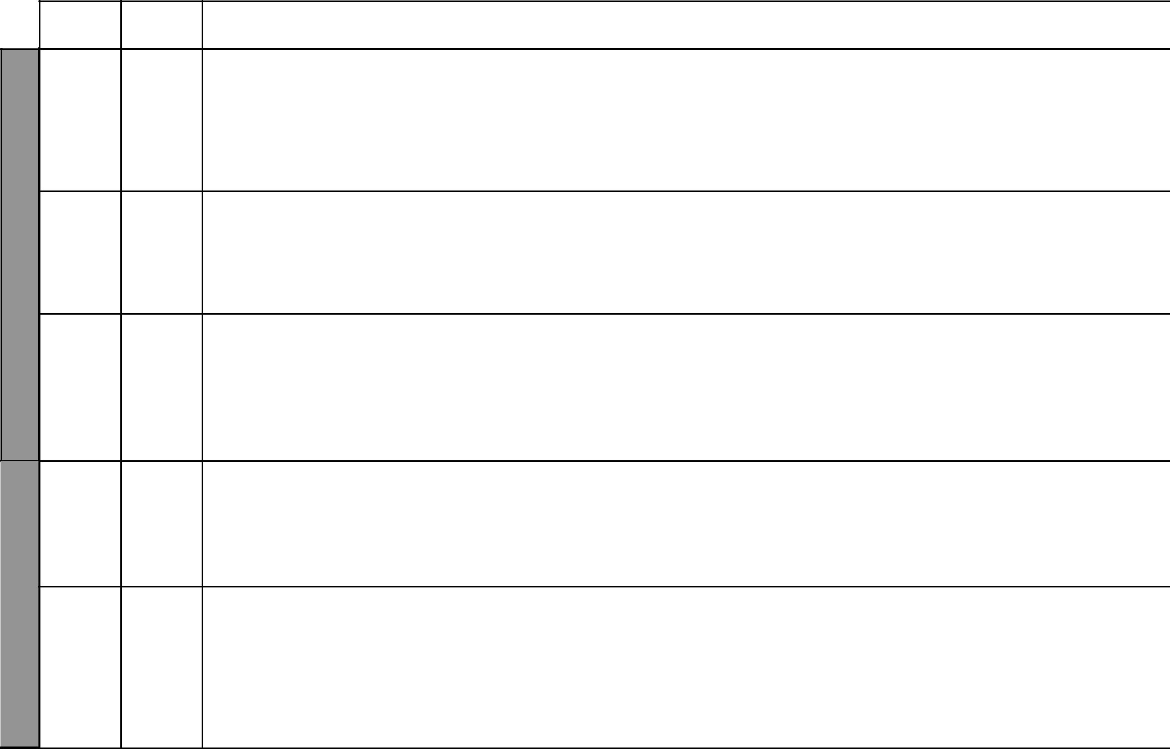

LESSON TOPIC

- Co-opera tive societies

9 | 4 | Co-opera
WEEK | 4 | Co-opera
WEEK |  | tive
WEEK |  | societies
 | 5 | Co-opera
 |  | tive
 |  | societies

 | 1 | Co-opera
 |  | tive
 |  | societies
10
WEEK | 2 – 5 | Transport
WEEK |  | and
WEEK |  | commu-
 |  | nication

SUB-TOPICS | OBJECTIVES | TEACHING/LEARNING |  | TEACHING/LEARNING |  | REFERENCES | REMARKS
 |  |  | ACTIVITIES |  | RESOURCES
Types of | By the end the lesson, the | - | Identifying types of | • | Relevant posters | Our Lives Today
agricultural | learner should be able to |  | agricultural co-operatives | • | Pictures | SST Pupil’s Book 8
co-operatives | identify types of agricultural | - | Listing types of | • | Local examples | pages 128 – 129
 | co-operatives and their |  | agricultural co-operatives |  |  | SST Teacher’s Guide
 | functions | - | Asking and answering |  |  | pages 64– 66
 |  |  | oral questions
 |  | - | Taking notes
Functions of | By the end of the lesson, | - | Explaining the functions | • | Chart showing functions | Our Lives Today
agricultural | the learner should be able |  | of agricultural co- |  | of co-operatives | SST Pupil’s Book 8
co-operatives | to explain the functions of |  | operatives | • | Relevant pictures | page 129
 | agricultural co-operatives | - | Asking and answering |  |  | SST Teacher’s Guide
 |  |  | oral questions |  |  | pages 64 – 66
 |  | - Noting down main points
Benefits from | By the end of the lesson, | - | Stating benefits from | • | Local co-operatives | Our Lives Today
agricultural | the learner should be able |  | agricultural co-operatives | • | Learner’s own | SST Pupil’s Book 8
co-operatives | to state benefits from | - | Asking and answering |  | experiences | pages 129 – 130
 | agricultural co-operatives |  | oral questions |  |  | SST Teacher’s Guide
 |  | - | Writing down main |  |  | pages 64 – 66
 |  |  | points
 |  | - | Group discussions
Challenges | By the end of the lesson, | - | Explaining problems | • | Learner’s own | Our Lives Today
facing | the learner should be able |  | facing agricultural co- |  | experiences | SST Pupil’s Book 8
agricultural | to explain the problems |  | operatives | • | Resource person | page 130
co-operatives | facing agricultural co- | - | Asking and answering |  |  | SST Teacher’s Guide
 | operatives |  | questions |  |  | pages 64 – 66
 |  | - | Discussing the problems
Forms and | By the end of the lesson, | - | Identifying forms and | • Map in the Pupil’s Book |  | Our Lives Today
functions | the learner should be able |  | functions of transport | • Pictures in the Pupil’s |  | SST Pupil’s Book 8
of transport | to: |  | systems |  | Book | pages 132 – 136
systems | (i) Identify forms and | - Observing the map and |  |  |  | SST Teacher’s Guide
systems | (i) Identify forms and |  | pictures in the Pupil’s |  |  | SST Teacher’s Guide
 | functions of transport |  | pictures in the Pupil’s |  |  | pages 66 – 71
 | functions of transport |  | Book |  |  | pages 66 – 71
 | systems |  | Book
 | systems | - | Taking notes
 | (ii) Draw a map showing | - | Taking notes
 | (ii) Draw a map showing | - | Drawing a map showing
 | major transport systems | - | Drawing a map showing
 |  |  | the transport systems
 |  |  | 19 |  | For use with Our Lives Today Standard Eight

WEEK 11

WEEK 12
Our Lives Today: Social Studies Standard Eight

Schemes of Work

Term 2
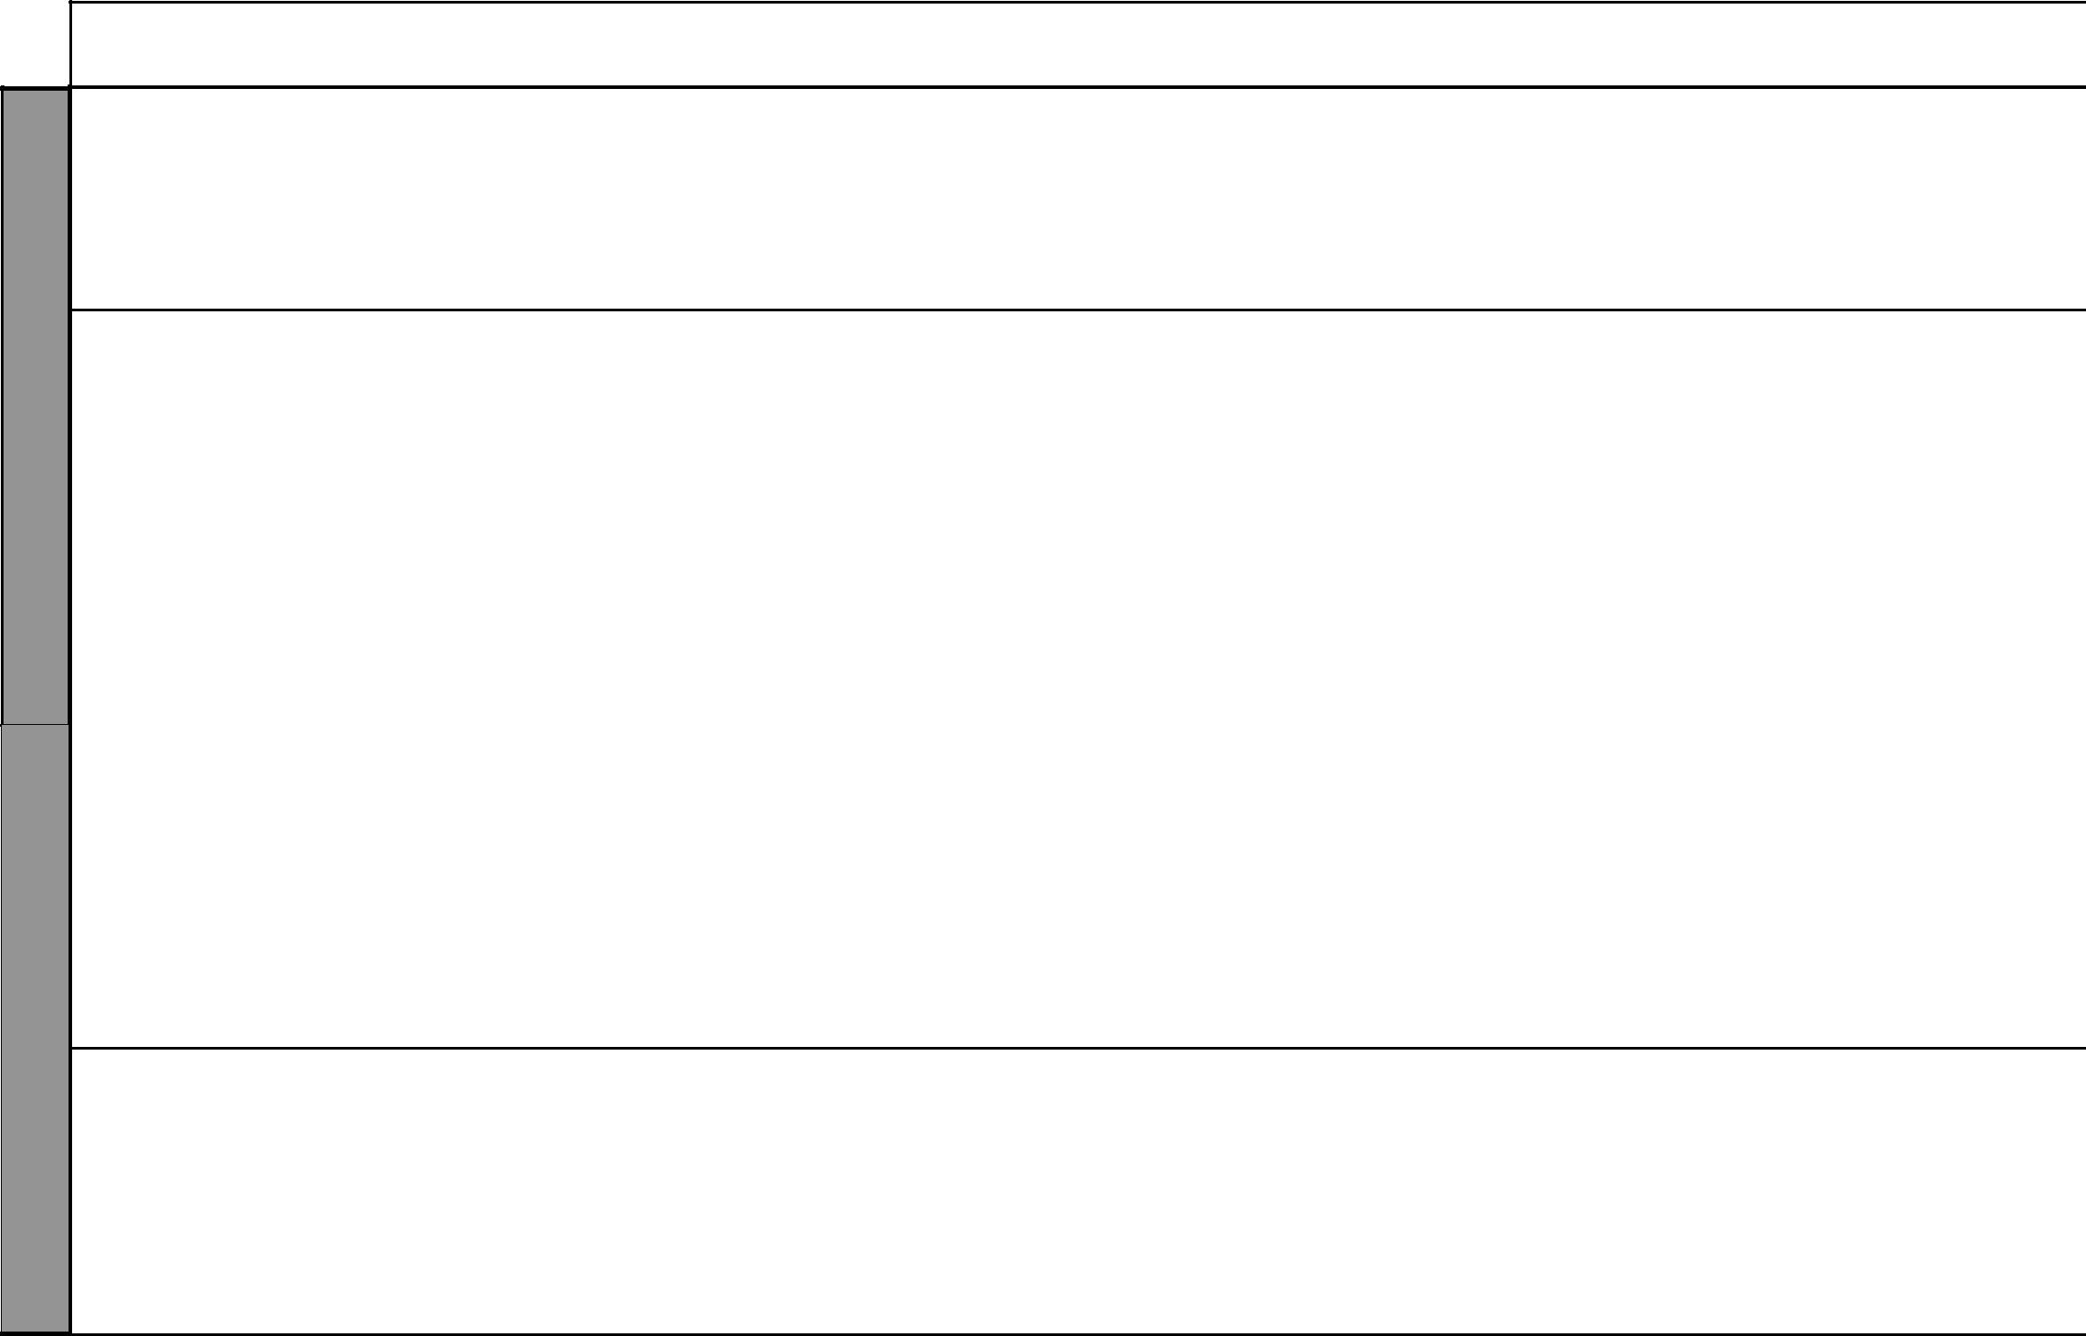
LESSON | TOPIC | SUB-TOPICS | OBJECTIVES | TEACHING/LEARNING |  | TEACHING/LEARNING |  | REFERENCES | REMARKS
 |  |  |  |  | ACTIVITIES |  | RESOURCES
1 & 2 | Transport | Problems | By the end of the lesson, | - | Describing problems | • Table in the Pupil’s |  | Our Lives Today
 | and | facing | the learner should be able |  | facing transport systems |  | Book | SST Pupil’s Book 8
 | commu- | transport | to identify problems facing | - | Asking and answering |  |  | pages 137 – 138
 | nication | systems | transport systems |  | questions |  |  | SST Teacher’s Guide
 |  |  |  | - Studying the table in the |  |  |  | pages 66 –71
 |  |  |  |  | Pupil’s Book
3, 4 & 5 | Transport | Road safety | By the end of the lesson, | - | Identifying major road | • Chart showing road signs |  | Our Lives Today
 | and |  | the learner should be able |  | signs | • Picture in the Pupil’s |  | SST Pupil’s Book 8
 | commu- |  | to: | - Explaining causes of road |  |  | Book | pages 138 – 143
 | nication |  | (i) Identify major road |  | accidents | • | Resource person | SST Teacher’s Guide
 |  |  | signs | - | Suggesting ways of | • | Newspaper cuttings | pages 66 – 71
 |  |  | (ii) Explain causes of |  | preventing road accidents | • | Curiosity chart | Kenya Red Cross
 |  |  | accidents | - | Demonstrate First aid |  |  | manual
 |  |  | (iii) Suggest ways of |  | skills
 |  |  | preventing road | - | Drawing road signs
 |  |  | accidents
 |  |  | (iv) Demonstrate First aid
 |  |  | skills
1 & 2 | Transport | Forms and | By the end of the lesson, | - | Identifying forms of | • | Pictures | Our Lives Today
 | and | functions of | the learner should be able |  | communication systems | • | Realia (phones, radio, | SST Pupil’s Book 8
 | commu- | communication | to: | - | Stating functions of |  | TV, newspapers etc) | pages 145 – 147
 | nication | systems | (i) Identify forms of |  | communication systems |  |  | SST Teacher’s Guide
 |  |  | communication | - | Asking and answering |  |  | pages 67 – 71
 |  |  | systems |  | questions
 |  |  | (ii) State functions of
 |  |  | communication
 |  |  | systems
3 | Transport | Problems | By the end of the lesson, | - | Identifying problems | • | Realia (phones, booths | Our Lives Today
 | and | facing | the learner should be able |  | facing communication |  | etc) | SST Pupil’s Book 8
 | commu- | communication | to identify problems facing |  | systems | • | Resource person | pages 147 – 148
 | nication | systems | communication systems | - | Asking and answering |  |  | SST Teacher’s Guide
 |  |  |  |  | questions |  |  | pages 67 – 71

₂₀ For use with Our Lives Today Standard Eight

Our Lives Today: Social Studies Standard Eight

Schemes of Work

Term 2
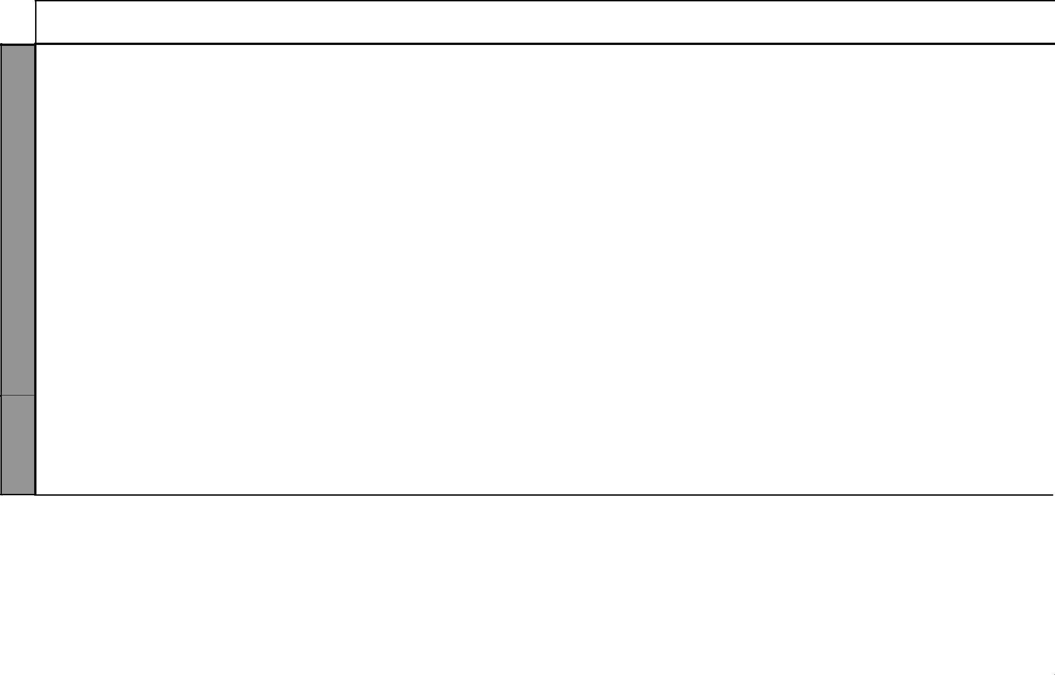

WEEK 13

WEEK 14

LESSON | TOPIC | SUB-TOPICS | OBJECTIVES | TEACHING/LEARNING |  | TEACHING/LEARNING |  | REFERENCES | REMARKS
 |  |  |  |  | ACTIVITIES |  | RESOURCES
4 & 5 | Trade | Role of | By the end of the lesson, | - Identifying the role of |  | • | Learner’s own | Our Lives Today
 |  | government in | the learner should be able |  | government in trade |  | experiences | SST Pupil’s Book 8
 |  | trade | to identify and appreciate | - Discussing the role of |  | • | Resource person | pages 148 – 150
 |  |  | the role of government in |  | government in trade | • | Newspaper reports | SST Teacher’s Guide
 |  |  | trade | - | Asking and answering |  |  | pages 71 – 73
 |  |  |  |  | questions
1 & 2 | Trade | Exports and | By the end of the lesson, | - | Identifying exports from | • Table in Pupil’s Book |  | Our Lives Today
 |  | imports of | the learner should be able |  | Kenya | • | Resource person | SST Pupil’s Book 8
 |  | Kenya | to: | - | Identifying imports to |  |  | pages 150 – 151
 |  |  | (i) Identify exports from |  | Kenya |  |  | SST Teacher’s Guide
 |  |  | Kenya | - | Asking and answering |  |  | pages 71 – 73
 |  |  | (ii) Identify imports to |  | questions
 |  |  | Kenya
3 – 5 | Trade | Importance of | By the end of the lesson, | - | Group discussions | • | Learner’s own | Our Lives Today
 |  | trade | the learner should be able | - | Asking and answering |  | experiences | SST Pupil’s Book 8
 |  |  | to explain the importance |  | questions | • | Resource person | page 151
 |  |  | of trade |  |  |  |  | SST Teacher’s Guide
 |  |  |  |  |  |  |  | pages 71– 73
1 – 5 | Revision | Revision and | By the end of the lesson, | - | Writing the exam | • | Question papers | Our Lives Today
 | and exams | exams | the learner should be able | - | Revising the exam |  |  | SST Pupil’s Book 8
 |  |  | to answer questions based |  |  |  |  | pages 80 – 157
 |  |  | on the work covered |  |  |  |  | SST Teacher’s Guide
 |  |  |  |  |  |  |  | pages 41 – 73

₂₁ For use with Our Lives Today Standard Eight

Our Lives Today: Social Studies Standard Eight Schemes of Work: Term Three
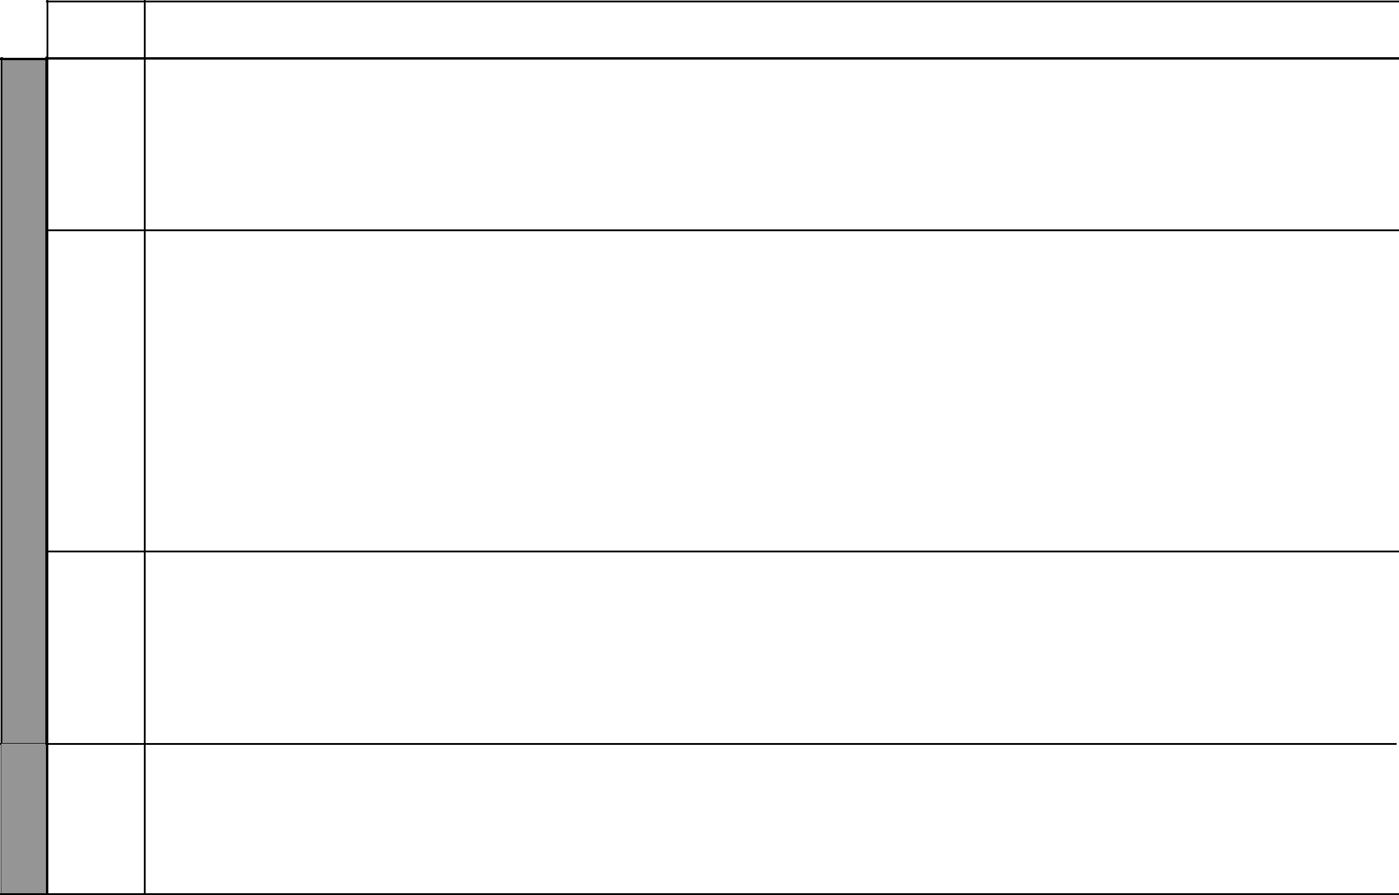

LESSON

1

2 – 4

WEEK 1

5

1

WEEK 2

TOPIC | SUB-TOPICS | OBJECTIVES | TEACHING/LEARNING |  | TEACHING/LEARNING |  | REFERENCES | REMARKS
 |  |  |  | ACTIVITIES |  | RESOURCES
Early | Early political | By the end of the lesson, | - | Identifying early political | • | List of political | Our Lives Today
political | associations in | the learner should be able |  | associations in Kenya up |  | associations | SST Pupil’s Book 8
associations | Kenya | to identify early political |  | to 1939 |  |  | page 158
in Kenya |  | associations in Kenya up | - | Asking and answering |  |  | SST Teacher’s Guide
 |  | to 1939 |  | oral questions |  |  | pages 73 –74
 |  |  | - | Explaining the political
 |  |  |  | associations
Early | Young Kikuyu | By the end of the lesson, | - | Describing the role | • | Relevant pictures | Our Lives Today
political | Association | the learner should be able |  | played by selected early | • | Resource person | SST Pupil’s Book 8
associations | (YKA) | to: |  | political associations |  |  | pages 158 – 162
in Kenya | Kikuyu Central | (i) Describe the role |  | in the struggle for |  |  | SST Teacher’s Guide
 | Association | played by selected early |  | independence |  |  | pages 73 – 74
 | (KCA) | political associations | - | Discussing the political
 | Kavirondo Tax | in the struggle for |  | association
 | Payers Welfare | independence | - | Asking and answering
 | Association | (ii) Appreciate the role |  | questions
 | (KTWA) | of the early political | - | Taking notes
 | The East | associations to Kenya’s
 | African | political development
 | Association
 | (EAA)
The | Nomination | By the end of the lesson, | - | Identifying African | • | Pictures of African | Our Lives Today
Legislative | and election | the learner should be |  | members to LegCo |  | LegCo members | SST Pupil’s Book 8
Council | of African | able to identify African | - | Asking and answering |  |  | page 163
(LegCo) | members to the | members to the LegCo |  | questions |  |  | SST Teacher’s Guide
 | LegCo |  | - | Observing pictures |  |  | pages 75 – 76
 |  |  | - Writing down names of
 |  |  |  | African LegCo members
The | The role of the | By the end of the lesson, | - | Explaining the role of | • | Relevant pictures | Our Lives Today
Legislative | LegCo in the | the learner should be |  | political parties in the |  |  | SST Pupil’s Book 8
Council | struggle for | able to explain the role of |  | struggle for independence |  |  | page 164
(LegCo) | independence | LegCo in the struggle for | - | Asking and answering |  |  | SST Teacher’s Guide
 |  | independence |  | questions |  |  | pages 75 – 76
 |  |  | - | Taking notes
 |  |  |  | 22 |  | For use with Our Lives Today Standard Eight

Our Lives Today: Social Studies Standard Eight

Schemes of Work

Term 3

WEEK 2

LESSON | TOPIC | SUB-TOPICS | OBJECTIVES | TEACHING/LEARNING |  | TEACHING/LEARNING |  | REFERENCES | REMARKS
 |  |  |  |  | ACTIVITIES |  | RESOURCES
2 | Struggle for | The Second | By the end of the lesson, | - Identifying the effects of |  | • Pictures of the Second |  | Our Lives Today
 | independence | World War | the learner should be able |  | 2nd World War on the |  | World War | SST Pupil’s Book 8
 | in Kenya | (1939 – 1945) | to identify the effects of |  | struggle for independence |  |  | pages 165 – 166
 |  |  | 2nd World War on the | - | Asking and answering |  |  | SST Teacher’s Guide
 |  |  | struggle for independence |  | questions orally |  |  | pages 76 – 77
 |  |  |  | - Writing down the main
 |  |  |  |  | points
3 | Struggle for | Kenya African | By the end of the lesson, | - | Asking and answering | • | Pictures of prominent | Our Lives Today
 | independence | Study Union, | the learner should be able |  | questions |  | African leaders | SST Pupil’s Book 8
 | in Kenya: | Kenya Africa | to: | - | Naming members |  |  | pages 166 – 167
 | Political | Union | (i) Name founder |  | of different political |  |  | SST Teacher’s Guide
 | associations |  | members of political |  | associations and |  |  | pages 76 – 77
 | and |  | associations and |  | movements
 | movements |  | movements | - Explaining the role of
 | after 1945 |  | (ii) Explain the role of |  | political associations and
 |  |  | political associations |  | movements
 |  |  | and movements | - | Taking notes
 |  |  | in the struggle for
 |  |  | independence
4 & 5 | Struggle for | The Mau Mau | By the end of the lesson, | - | Naming members | • | Relevant pictures | Our Lives Today
 | independence | Movement | the learner should be able |  | of different political |  |  | SST Pupil’s Book 8
 | in Kenya: | Kenya African | to: |  | associations and |  |  | pages 167 – 170
 | Political | National | (i) Name founder |  | movements |  |  | SST Teacher’s Guide
 | associations | Union | members of political | - Explaining the role of |  |  |  | pages 76 – 77
 | and | KADU | associations and |  | political associations and
 | movements | APP | movements |  | movements
 | up to 1945 |  | (ii) Explain the role of | - | Asking and answering
 |  |  | political associations |  | questions
 |  |  | and movements
 |  |  | in the struggle for
 |  |  | independence


₂₃ For use with Our Lives Today Standard Eight

WEEK 3

WEEK 4
Our Lives Today: Social Studies Standard Eight

Schemes of Work

Term 3

LESSON | TOPIC | SUB-TOPICS | OBJECTIVES | TEACHING/LEARNING |  | TEACHING/LEARNING | REFERENCES | REMARKS
 |  |  |  |  | ACTIVITIES | RESOURCES
1 | Events | Events | By the end of the lesson, | - | Describing the events | • Pictures in the Pupil’s | Our Lives Today
 | leading to | leading to | the learner should be able |  | leading to attainment of | Book | SST Pupil’s Book 8
 | independence | independence | to describe the events |  | independence in Kenya |  | pages 170 – 171
 |  |  | that led to attainment of | - | Asking and answering |  | SST Teacher’s Guide
 |  |  | independence |  | questions orally |  | pages 77 – 79
 |  |  |  | - Observing pictures in the
 |  |  |  |  | Pupil’s Book
 |  |  |  | - | Listing the events
2 | Attainment of | Kenya | By the end of the lesson, | - | Explaining how Kenya | • Pictures in the Pupil’s | Our Lives Today
 | independence | becomes a | the learner should be able |  | became independent | Book | SST Pupil’s Book 8
 |  | republic | to explain how Kenya got | - | Explaining how Kenya |  | pages 171 – 172
 |  |  | Madaraka and became a |  | became a republic |  | SST Teacher’s Guide
 |  |  | Republic | - | Asking and answering |  | pages 77 – 79
 |  |  |  |  | questions
 |  |  |  | - Observing pictures in the
 |  |  |  |  | Pupil’s Book
3 – 5 | Major political | Major political | By the end of the lesson, | - | Identifying major political | • Resource person | Our Lives Today
 | events and | events and | the learner should be able |  | events |  | SST Pupil’s Book 8
 | developments | developments | to identify major political | - | Identifying major political |  | pages 174 – 176
 | in Kenya since | since | developments and events |  | developments |  | SST Teacher’s Guide
 | 1963 | independence | since 1963 | - | Asking and answering |  | pages 79 – 81
 |  |  |  |  | oral questions
1 – 4 | Life and | - Mzee Jomo | By the end of the lesson, | - | Describing the life | • Pictures in the Pupil’s | Our Lives Today
 | contributions | Kenyatta | the learner should be able |  | and contributions of | Book | SST Pupil’s Book 8
 | of prominent | - Daniel Arap | to describe the life and |  | prominent leaders in | • Resource person | pages 177 – 182
 | Kenyans | Moi | contributions of prominent |  | Kenya |  | SST Teacher’s Guide
 |  | - Oginga | leaders in Kenya | - | Asking and answering |  | pages 81 – 82
 |  | Odinga |  |  | oral questions
 |  |  |  | - Observing pictures in the
 |  |  |  |  | Pupil’s Book
 |  |  |  | - Writing down a summary
 |  |  |  | - | Dramatization
 |  |  |  | - | Story telling

₂₄ For use with Our Lives Today Standard Eight

Our Lives Today: Social Studies Standard Eight

Schemes of Work

Term 3

 | LESSON | TOPIC | SUB-TOPICS |  | OBJECTIVES | TEACHING/LEARNING |  | TEACHING/LEARNING |  | REFERENCES REMARKS
 |  |  |  |  |  |  | ACTIVITIES |  | RESOURCES
5 |  | International | United Nations | By the end of the lesson, |  | - | Describing the formation | • | Resource person | Our Lives Today
 |  | co-operation | (UN) | the learner should be able |  |  | of UN | • | Relevant pictures | SST Pupil’s Book 8
4 |  |  |  | to: |  | - | Identifying agencies and |  |  | pages 183 – 185
4 |  |  |  | (i) | Describe formation of |  | functions of UN |  |  | SST Teacher’s Guide
WEEK |  |  |  | (i) | Describe formation of |  | functions of UN
 |  |  |  |  | UN | - | Asking and answering |  |  | pages 83 – 84
 |  |  |  | (ii) Identify the agencies |  |  | questions
 |  |  |  |  | and functions of the | - | Observing pictures
 |  |  |  |  | UN | - Listing the agencies of
 |  |  |  |  |  |  | the UN
 | 1 – 3 | International | Achievements, | By the end of the lesson, |  | - | Stating the achievements | • | Relevant pictures | Our Lives Today
 |  | co-operation | failures and | the learner should be able |  |  | of the UN | • Picture in the Pupil’s |  | SST Pupil’s Book 8
 |  |  | problems facing | to: |  | - Stating the failures of the |  |  | Book | pages 185 – 187
 |  |  | the UN | (i) | Highlight the |  | UN |  |  | SST Teacher’s Guide
 |  |  |  |  | achievements of the | - | Explaining problems |  |  | pages 83 – 84
 |  |  |  |  | UN |  | facing UN

- State failures of the UN

- Explain problems facing the UN

4 – 5 | International | The | By the end of the lesson, |  | - | Describing the formation | • Map of the world in the | Our Lives Today
5 | co-operation | Commonwealth | the learner should be able |  |  | of the Commonwealth | Pupil’s Book showing | SST Pupil’s Book 8
WEEK |  |  | to: |  | - Stating the functions of |  | member states of the | pages 187 – 190
WEEK |  |  | (i) | Describe the formation |  | the Commonwealth | Commonwealth | SST Teacher’s Guide
WEEK |  |  |  | of the Commonwealth | - | Giving their |  | pages 84 – 89
WEEK |  |  | (ii) State the functions of |  |  | achievements
 |  |  |  | the Commonwealth | - Stating the failures of the
 |  |  | (iii) Describe the |  |  | Commonwealth
 |  |  |  | achievements of the | - | Giving the
 |  |  |  | Commonwealth |  | problems facing the
 |  |  | (iv) Identify failures of the |  |  | Commonwealth
 |  |  |  | Commonwealth | - Observing a map in the
 |  |  | (v) | State problems facing |  | Pupil’s Book
 |  |  |  | the Commonwealth

₂₅ For use with Our Lives Today Standard Eight

WEEK 6

WEEK 7
Our Lives Today: Social Studies Standard Eight

Schemes of Work

Term 3
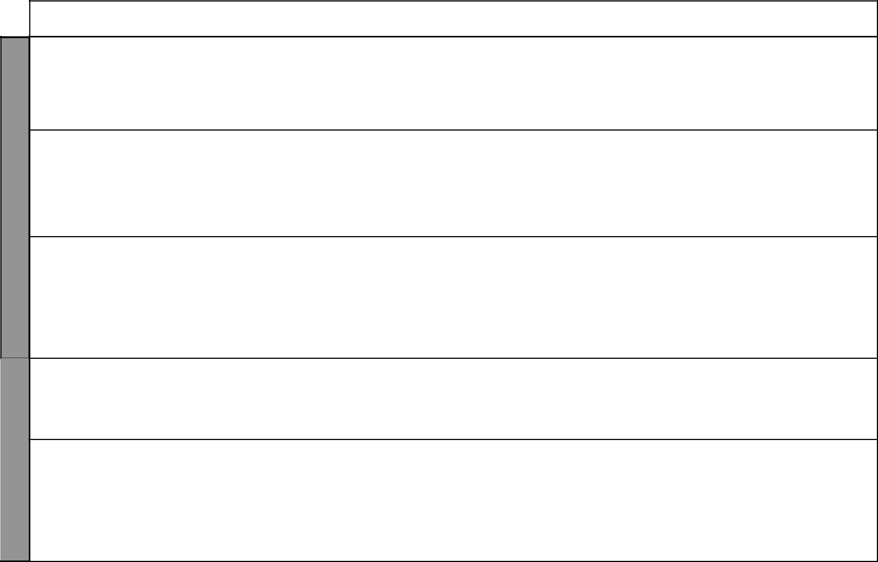
LESSON | TOPIC | SUB-TOPICS | OBJECTIVES | TEACHING/LEARNING |  | TEACHING/LEARNING |  | REFERENCES | REMARKS
 |  |  |  |  | ACTIVITIES |  | RESOURCES
1 & 2 | Citizenship | Importance | By the end of the lesson, | - | Explaining the importance | • Pictures in the Pupil’s |  | Our Lives Today
 |  | of good | the learner should be able |  | of good citizenship |  | Book | SST Pupil’s Book 8
 |  | citizenship | to explain the importance | - | Asking and answering | • | Class discussions | pages 194 – 196
 |  |  | of good citizenship |  | questions |  |  | SST Teacher’s Guide
 |  |  |  | - | Observing pictures in the |  |  | pages 89 – 91
 |  |  |  |  | Pupil’s Book
3 | Citizenship | Loss of Kenyan | By the end of the lesson, | - | Explaining conditions | • | Resource person | Our Lives Today
 |  | citizenship | the learner should be |  | under which one can lose |  |  | SST Pupil’s Book 8
 |  |  | able to explain conditions |  | his/her citizenship |  |  | page 196
 |  |  | under which one can lose | - | Asking and answering |  |  | SST Teacher’s Guide
 |  |  | his/her citizenship |  | questions |  |  | pages 89 – 91
 |  |  |  | - | Discussing loss of
 |  |  |  |  | citizenship
4 & 5 | Democracy | Types of | By the end of the lesson, | - | Stating types of | • Pictures in the Pupil’s |  | Our Lives Today
 | and human | democracy | the learner should be |  | democracy |  | Book | SST Pupil’s Book 8
 | rights |  | able to state types of | - | Asking and answering |  |  | pages 198 – 199
 |  |  | democracy |  | questions |  |  | SST Teacher’s Guide
 |  |  |  | - | Listing types of |  |  | pages 91 – 93
 |  |  |  |  | democracy
 |  |  |  | - | Observing pictures
 |  |  |  | - | Dramatization
1 | Democracy | Main political | By the end of the lesson, | - | Identifying political | • Pictures in the Pupil’s |  | Our Lives Today
 | and human | parties in | the learner should be able |  | parties in Kenya and their |  | Book | SST Pupil’s Book 8
 | rights | Kenya and | to identify political parties |  | policies |  |  | pages 200 – 203
 |  | their policies | in Kenya and their policies | - | Asking and answering |  |  | SST Teacher’s Guide
 |  |  |  |  | questions |  |  | pages 93 – 95
2 | Democracy | Roles of | By the end of the lesson, | - | Identifying the role of | • | Relevant posters | Our Lives Today
 | and human | political parties | the learner should be able |  | political parties in a | • | Resource person | SST Pupil’s Book 8
 | rights | in a democracy | to: |  | democracy |  |  | pages 203 – 204
 |  | and benefits of | (i) Identify the role of | - | Asking and answering |  |  | SST Teacher’s Guide
 |  | democracy | political parties in a |  | questions |  |  | pages 93 – 95
 |  |  | democracy | - | Illustrating the benefits of
 |  |  | (ii) State the benefits of |  | democracy
 |  |  | democracy | - | Dramatization

₂₆ For use with Our Lives Today Standard Eight

Our Lives Today: Social Studies Standard Eight

Schemes of Work

Term 3


WEEK 7

WEEK 8

LESSON | TOPIC | SUB-TOPICS | OBJECTIVES | TEACHING/LEARNING |  | TEACHING/LEARNING |  | REFERENCES | REMARKS
 |  |  |  |  | ACTIVITIES |  | RESOURCES
3 – 4 | Democracy | The Bill of | By the end of the lesson, | - | Stating human rights | • | Local environment | Our Lives Today
 | and human | Rights | the learner should be able | - | Listing Bill of Human | • | Learner’s own | SST Pupil’s Book 8
 | rights |  | to state human rights |  | Rights |  | experiences | pages 204 – 206
 |  |  | and appreciate the Bill of |  |  | • | Resource person | SST Teacher’s Guide
 |  |  | Rights |  |  |  |  | pages 95 – 97
5 | Law, | Symbols of | By the end of the lesson, | - | Identifying symbols of | • | National flag | Our Lives Today
 | peace and | national unity | the learner should be able |  | national unity | • | Court of arms | SST Pupil’s Book 8
 | reconciliation |  | to identify symbols of | - | Asking and answering | • | National anthem | pages 208 – 210
 |  |  | national unity |  | questions |  |  | SST Teacher’s Guide
 |  |  |  | - | Listing the symbols of |  |  | pages 97 – 99
 |  |  |  |  | national unity
 |  |  |  | - | Taking notes
 |  |  |  | - | Assignments
1 | Law, | Factors that | By the end of the lesson, | - | Stating factors that | • Pictures in the Pupil’s |  | Our Lives Today
 | peace and | promote | the learner should be |  | promote national unity |  | Book | SST Pupil’s Book 8
 | reconciliation | national unity | able to state factors that | - | Asking and answering |  |  | pages 210 – 212
 |  |  | promote national unity |  | oral questions |  |  | SST Teacher’s Guide
 |  |  |  | - | Observing pictures in the |  |  | pages 99 – 100
 |  |  |  |  | Pupil’s Book
 |  |  |  | - Writing down a summary
2 | Law, | Importance of | By the end of the lesson, | - | Explaining the | • | Class discussions | Our Lives Today
 | peace and | national unity | the learner should be able |  | importance of national |  |  | SST Pupil’s Book 8
 | reconciliation |  | to explain the importance |  | unity |  |  | pages 212 – 213
 |  |  | of national unity | - | Discussing national unity |  |  | SST Teacher’s Guide
 |  |  |  | - | Asking and answering |  |  | pages 100 – 101
 |  |  |  |  | questions orally
 |  |  |  | - | Writing down main
 |  |  |  |  | points
3 | Law, | Factors | By the end of the lesson, | - | Identifying factors | • | Class discussions | Our Lives Today
 | peace and | undermining | the learner should be |  | undermining national |  |  | SST Pupil’s Book 8
 | reconciliation | national unity | able to identify factors |  | unity |  |  | pages 213 – 214
 |  |  | undermining national | - | Asking and answering |  |  | SST Teacher’s Guide
 |  |  | unity |  | oral questions |  |  | pages 101 – 103
 |  |  |  | - | Demonstrations

₂₇ For use with Our Lives Today Standard Eight

WEEK 8

WEEK 9
Our Lives Today: Social Studies Standard Eight

Schemes of Work

Term 3
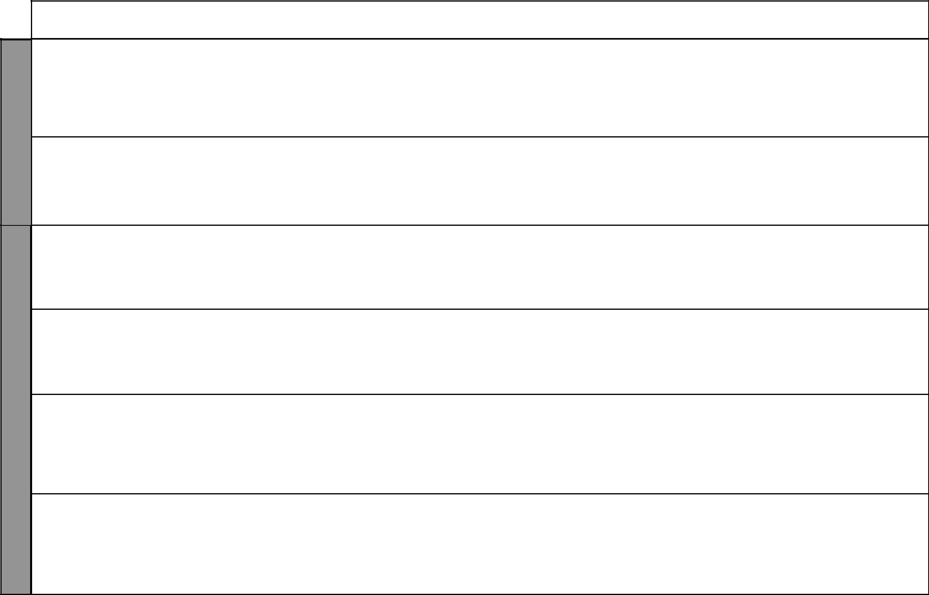
LESSON | TOPIC | SUB-TOPICS | OBJECTIVES | TEACHING/LEARNING |  | TEACHING/LEARNING |  | REFERENCES | REMARKS
 |  |  |  |  | ACTIVITIES |  | RESOURCES
4 | The | The | By the end of the lesson, | - Discussing the process of |  | • | Resource person | Our Lives Today
 | government | Constitution | the learner should be able |  | making, amending and |  |  | SST Pupil’s Book 8
 | of Kenya | of Kenya | to describe the process |  | reviewing of the Kenyan |  |  | pages 216 – 218
 |  |  | of making, amending |  | Constitution |  |  | SST Teacher’s Guide
 |  |  | and reviewing Kenya’s | - | Asking and answering |  |  | pages 103 – 104
 |  |  | Constitution |  | questions
5 | The | Formation of a | By the end of the lesson, | - Explaining the process of |  | • | Resource person | Our Lives Today
 | government | government | the learner should be able |  | forming a government |  |  | SST Pupil’s Book 8
 | of Kenya |  | to explain the process of | - | Asking and answering |  |  | page 218
 |  |  | forming a government |  | questions |  |  | SST Teacher’s Guide
 |  |  |  |  |  |  |  | page 105
1 | The | Loss of | By the end of the lesson, | - Explaining how one may |  | • | Resource person | Our Lives Today
 | government | parliamentary | the learner should be able |  | lose a seat in parliament |  |  | SST Pupil’s Book 8
 | of Kenya | seat | to explain how one may | - | Asking and answering |  |  | page 219
 |  |  | lose a seat in parliament |  | questions |  |  | SST Teacher’s Guide
 |  |  |  |  |  |  |  | pages 106 –107
2 | The | Conducting | By the end of the lesson, | - Describing the process of |  | • | Relevant posters | Our Lives Today
 | government | national | the learner should be able |  | national elections | • | Resource person | SST Pupil’s Book 8
 | of Kenya | elections | to describe the process of | - Discussing the process of |  |  |  | page 219 – 220
 |  |  | national elections |  | national elections |  |  | SST Teacher’s Guide
 |  |  |  |  |  |  |  | pages 106 – 107
3 | The | Participation | By the end of the lesson, | - | Stating ways of | • | Relevant pictures | Our Lives Today
 | government | of citizens in | the learner should be |  | participation in | • | Newspaper cuttings | SST Pupil’s Book 8
 | of Kenya | government | able to state ways of |  | government and civic life |  |  | pages 220 – 221
 |  | and civic life | participating in government |  |  |  |  | SST Teacher’s Guide
 |  |  | and civic life and the |  |  |  |  | pages 107 – 108
 |  |  | importance of taking part
4 | The | The arms | By the end of the lesson, | - | Describing the | • | Resource person | Our Lives Today
 | government | of the | the learner should be able |  | composition and function | • | Newspaper reports | SST Pupil’s Book 8
 | of Kenya | government: | to describe the composition |  | of cabinet and civil |  |  | pages 222 – 224
 |  | The Executive | and function of the cabinet |  | servants |  |  | SST Teacher’s Guide
 |  |  | and civil servants | - | Identifying composition |  |  | pages 108 – 113
 |  |  |  |  | and functions of cabinet

₂₈ For use with Our Lives Today Standard Eight

Our Lives Today: Social Studies Standard Eight

Schemes of Work

Term 3
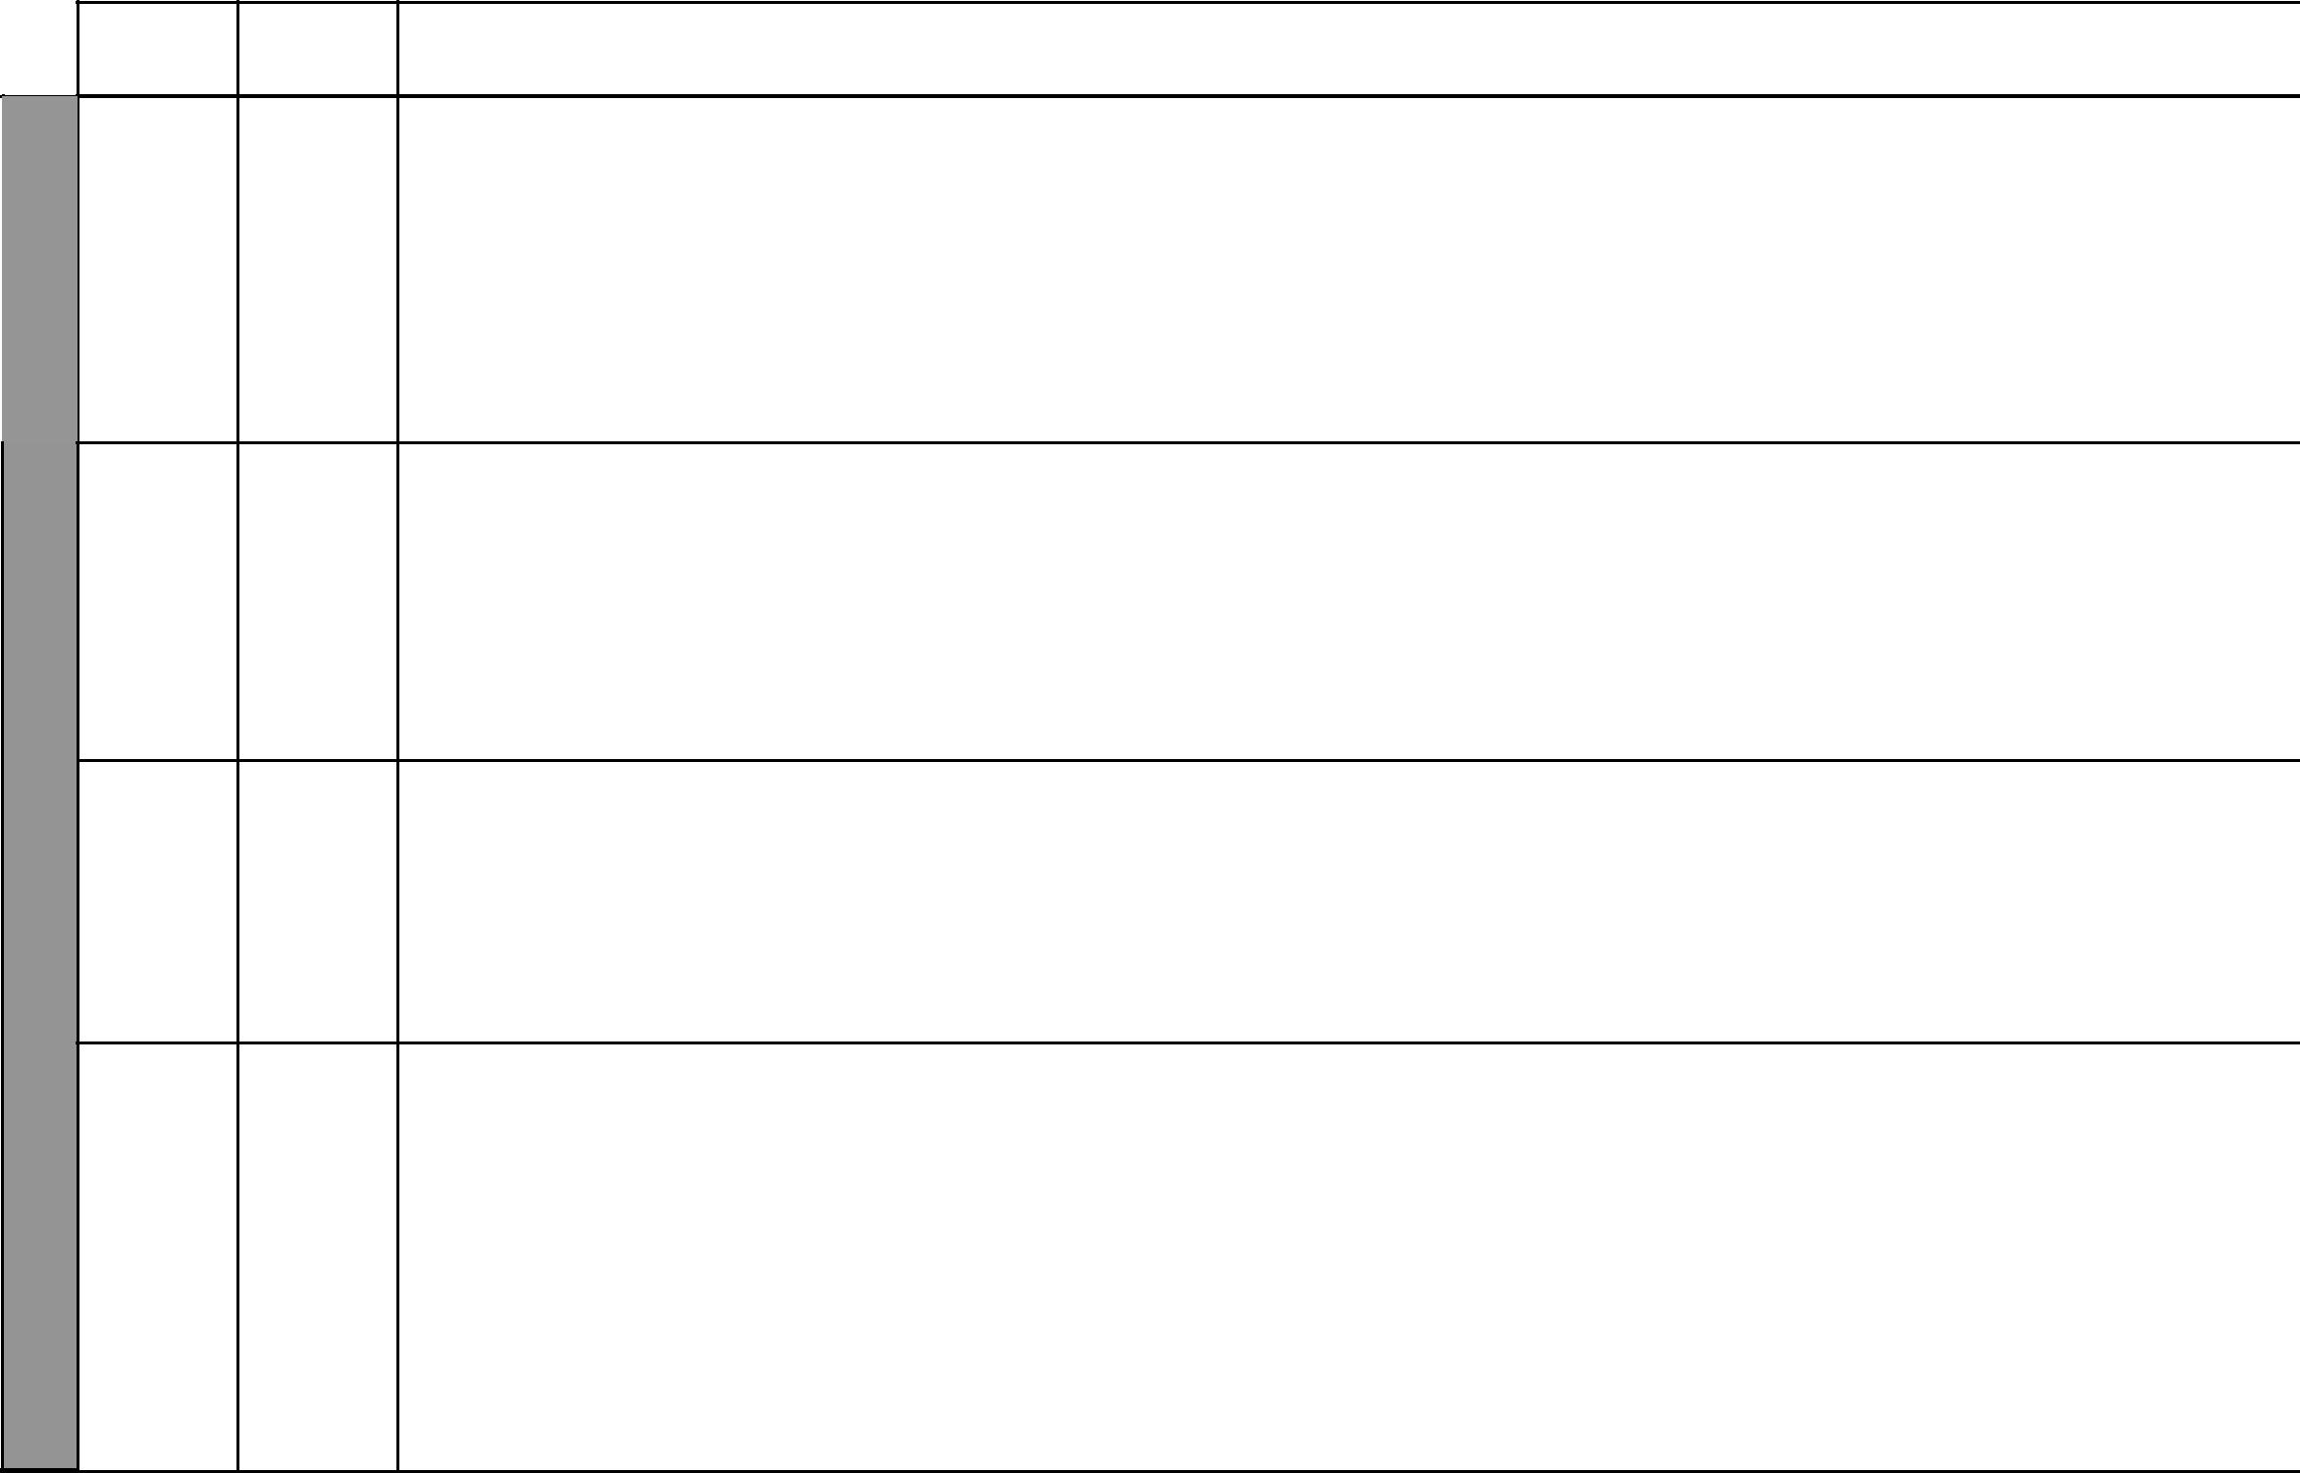

LESSON TOPIC

 | 5 | The
 |  | government
9 |  | of Kenya
WEEK
 |  | The
1 |  | The
 |  | government
 |  | of Kenya

10 | 2 | The
10 |  | government
WEEK |  | of Kenya
 | 3 & 4 | The
 |  | government
 |  | of Kenya

SUB-TOPICS |  | OBJECTIVES | TEACHING/LEARNING |  | TEACHING/LEARNING |  | REFERENCES | REMARKS
 |  |  |  | ACTIVITIES |  | RESOURCES
The arms of | By the end of the lesson, |  | - | Naming the officials of | • | Relevant pictures | Our Lives Today
government: | the learner should be able |  |  | the legislature | • | Resource person | SST Pupil’s Book 8
The Legislature | to: |  | - | Describing the process of |  |  | pages 225 – 226
 | (i) | Name officials of the |  | legislation |  |  | SST Teacher’s Guide
 |  | Legislature | - | Stating the functions of |  |  | pages 108 – 113
 | (ii) Describe process of |  |  | parliament
 |  | legislation
 | (iii) State the functions of
 |  | parliament
The arms of | By the end of the lesson, |  | - | Describing the Judicial | • | Relevant pictures | Our Lives Today
government: | the learner should be able |  |  | system | • | Resource person | SST Pupil’s Book 8
The Judiciary | to: |  |  |  |  |  | pages 227 – 228
 | (i) | Describe the Judicial |  |  |  |  | SST Teacher’s Guide
 |  | system |  |  |  |  | pages 108 – 113
 | (ii) | Appreciate the need for
 |  | an independent Judicial
 |  | system
Sources of | By the end of the lesson, the |  | - | Listing sources of | • | Illustrations | Our Lives Today
government | learner should be able to: |  |  | government revenue | • | Government publications | SST Pupil’s Book 8
revenue and | (i) | List sources of | - | Discussing sources of |  |  | pages 229 –230
forms of |  | government revenue |  | government revenue |  |  | SST Teacher’s Guide
expenditure | (ii) Explain how the |  | - | Explaining how the |  |  | pages 113 – 114
 |  | government spends its |  | government spends its
 |  | money |  | money
Local | By the end of the lesson, the |  | - | Naming types of local | • Pictures in the Pupil’s |  | Our Lives Today
authorities | learner should be able to: |  |  | authorities |  | Book | SST Pupil’s Book 8
 | (i) | Name types of local | - | Describing the process |  |  | pages 231 – 234
 |  | authorities | - | Describing the process |  |  | pages 231 – 234
 |  | authorities |  | of election of local |  |  | SST Teacher’s Guide
 | (ii) | Describe the process of |  | of election of local |  |  | SST Teacher’s Guide
 | (ii) | Describe the process of |  | authorities |  |  | pages 114 – 116
 |  | election of officials in |  | authorities |  |  | pages 114 – 116
 |  | election of officials in | - | Explaining the
 |  | local authorities | - | Explaining the
 |  | local authorities |  | relationship between the
 | (iii) Identify functions of |  |  | relationship between the
 |  | local authorities |  | government and local
 | (iv) Explain the relationship |  |  | authorities
 |  | between the | - | Observing pictures in the
 |  | government and local |  | Pupil’s Book
 |  | authorities
 |  |  |  | 29 |  | For use with Our Lives Today Standard Eight

WEEK 11 WEEK 10
Our Lives Today: Social Studies Standard Eight

Schemes of Work

Term 3
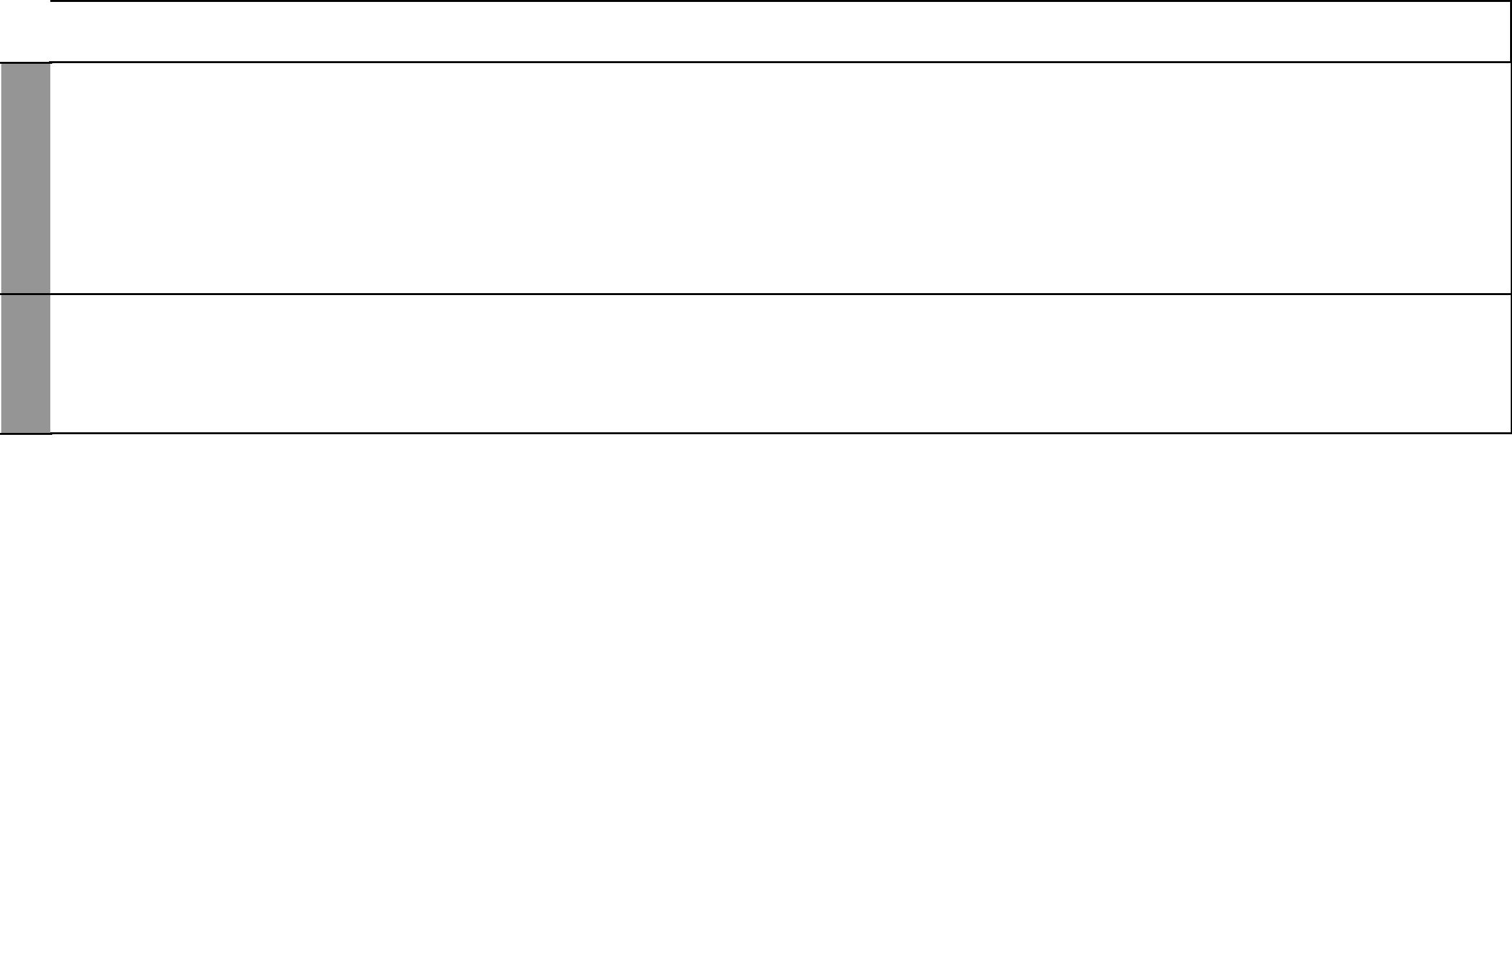
LESSON | TOPIC | SUB-TOPICS | OBJECTIVES | TEACHING/LEARNING | TEACHING/LEARNING | REFERENCES | REMARKS
 |  |  |  | ACTIVITIES | RESOURCES
5 | The | National | By the end of the lesson, | - Identifying organs of | • Pictures showing | Our Lives Today
 | government | defence | the learner should be able | National defence | Kenyan soldiers | SST Pupil’s Book 8
 | of Kenya |  | to: | - Explaining the role of |  | pages 234 – 237
 |  |  | (i) Identify organs of | National defence in |  | SST Teacher’s Guide
 |  |  | National defence | maintaining law and |  | pages 116 – 117
 |  |  | (ii) Explain the role of | order
 |  |  | National defence in
 |  |  | maintaining law and
 |  |  | order
1 – 5 | Revision | Revision and | By the end of the lesson, | - Revising and writing the |  | Our Lives Today
 | and exams | exams | the learner should be | exam |  | SST Pupil’s Book 8
 |  |  | able to revise the work |  |  | pages
 |  |  | covered and write the |  |  | SST Teacher’s Guide
 |  |  | National Exam |  |  | pages 73 – 117

₃₀ For use with Our Lives Today Standard Eight

