SOCIAL STUDIES SCHEME OF WORK CLASS 6

Available Online:
Schools Net Kenya Consultancy
P.O. Box 8076 – 00200 Nairobi, Kenya | Tel: +254202319748
E-mail: infosnkenya@gmail.com | www.schoolsnetkenya.com

Our Lives Today: Social Studies Schemes of Work for Standard Six: Term One

WEEK 1

WEEK 2

LESSON | TOPIC | SUB-TOPIC | OBJECTIVES | TEACHING/LEARNING | LEARNING/TEACHING | REMARKS
 |  |  |  | ACTIVITIES | RESOURCES
1 | East | Countries neigh- | • The learners should be able to name | • Naming the countries | Our Lives Today SST Book 6 page 2
 | Africa: The | bouring Kenya | the countries neighbouring Kenya. | neighbouring Kenya | • Map of Kenya
 | physical |  | • The learners should be able to locate | • Locating them on the map of | • Wall map
 | environ- |  | those countries on the map of | Eastern Africa
 | ment |  | East Africa. | • Drawing the map of East Africa
2 to 4 |  | Map reading and | The learners should be able to: | • Define the term scale | Our Lives Today SST Book 6
 |  | interpretation | • interpret the use of scale on the map. | • Name types of scales | pages 3–5
 |  |  | • read the map using colours and other | • Measure distance on the map | • Pictures in the Pupil’s Book
 |  |  | map symbols. | • Convert scales | page 4
 |  |  | • describe direction using a compass. | • Identify different colours used on | • Map on page 4
 |  |  |  | the map | • Magnetic compass
 |  |  |  | • Use colours to read a map
 |  |  |  | • Interpret other map symbols
 |  |  |  | • Draw 16 points compass
 |  |  |  | • Tell directions using a compass
5 & 1 |  | Longitudes | The learners should be able to | • Defining the terms longitudes and | Our Lives Today SST Book 6
 |  | and latitudes | interpret the position of East Africa | latitudes | pages 5–6
 |  |  | using longitudes and latitudes. | • Telling the position of East | pages 5–6
 |  |  | using longitudes and latitudes. | • Telling the position of East | • Map of East Africa
 |  |  |  | Africa using longitudes and | • Map of East Africa
 |  |  |  | Africa using longitudes and | • Globe
 |  |  |  | latitudes | • Globe
 |  |  |  | latitudes | • Wall map
 |  |  |  | • Observing a globe and other diagrams | • Wall map
2 & 3 |  | Position, size and | The learners should be able to: | • Stating the size of East Africa | Our Lives Today SST Book 6
 |  | shape of East | • state the size of East African countries. | • Giving the position, size and | pages 7–8
 |  | Africa | • give position and shape of East Africa. | shape of the countries | • Map of East Africa
 |  |  | • draw a map of East Africa. | • Observing the map of East Africa
 |  |  |  | • Writing notes on East Africa
4 & 5 |  | Physical formations | The learners should be able to: | • Defining the term physical features | Our Lives Today SST Book 6 page 9
 |  | in East Africa | • name the major physical features of | • Naming the physical feature | • Pictures of mountains and
 |  |  | East Africa. | • Locating them on the map | lakes
 |  |  | • locate them on map of East Africa. | • Writing notes on physical
 |  |  |  | features
 |  |  |  | • Drawing the map


₁ For use with Our Lives Today Standard Six

Our Lives Today: Social Studies Standard Six

Schemes of Work

Term 1

 | LESSON | TOPIC | SUB-TOPIC | OBJECTIVES | TEACHING/LEARNING | LEARNING/TEACHING | REMARKS
 |  |  |  |  | ACTIVITIES | RESOURCES
 | 1 | Physical | Formation of the | The learners should be able to describe | Define the term Rift Valley | Our Lives Today SST Book 6
 |  | environ- | Rift Valley | the formation of the Rift Valley. | • Observe the pictures of Rift Valley | pages 10–11
 |  | ment |  |  | • Locating it on the map of | • Diagrams in the Pupil’s
 |  |  |  |  | East Africa | Books page 11
 |  |  |  |  | • Draw diagrams of the Rift Valley | • Chart showing the formation
 |  |  |  |  |  | of the Rift Valley
 | 2 & 3 |  | Formation of | The learners should be able to: | • Define block mountains and | Our Lives Today SST Book 6
 |  |  | mountains and | • describe the formation of block | volcanic mountains | pages 11–12
 |  |  | mountains and | • describe the formation of block | volcanic mountains | • Diagrams in the Pupil’s Book
 |  |  | plateaus | mountains. | • Describe the formation of the | • Diagrams in the Pupil’s Book
3 |  |  | plateaus | mountains. | • Describe the formation of the | pages 11–12
3 |  |  |  | • describe the formation of volcanic | mountains | pages 11–12
WEEK |  |  |  | • describe the formation of volcanic | mountains | pages 11–12
WEEK |  |  |  | • describe the formation of volcanic | mountains | • Chalkboard pictures
WEEK |  |  |  | mountains. | • Illustrate how these mountains | • Chalkboard pictures
WEEK |  |  |  |  | are formed giving examples
WEEK |  |  |  |  | of each
WEEK |  |  |  |  | • Illustrate in diagrams
 |  |  |  |  | • Write notes on mountains
 |  |  |  |  | • Define the term plateau
 | 4 |  | Importance of | The learners should be able to state the | • Discusing the importance of the | Our Lives Today SST Book 6
 |  |  | physical features | importance of physical features. | physical features | pages 12–13
 |  |  |  |  | • Taking notes
 |  |  |  |  | • Asking and answering questions
 | 5 |  | Relief regions | The learners should be able to: | • Define the term relief | Our Lives Today SST Book 6
 |  |  | • Plains | • identify relief regions. | • Identify and name relief regions | pages 13–15
 |  |  | • Plateaus | • locate the relief regions on the map. | • Locate them on the map | • Map of East Africa
 |  |  | • Highlands | • describe the characteristics of each | • Describe the characteristics of | • Pictures in the Pupil’s Book
 |  |  | • L. Victoria Basin | relief region. | each region
 |  |  | • Rift Valley |  | • Draw the map showing the regions
 |  |  |  |  | • Write notes on the regions
 | 1 to 4 | Climate | Climatic regions | The learners should be able to: | • Identifying the climate regions | Our Lives Today SST Book 6
4 |  |  | of East Africa i.e. | • identify the climatic regions of | • Locating them on the map | pages 16–19
4 |  |  | Equatorial, Modi- | Eastern Africa. | • Observing a map | • Map showing climatic zones
WEEK
WEEK |  |  | fied equatorial, | Eastern Africa. | • Describing the characteristics of | in the Pupil’s Book page 16
WEEK |  |  | fied equatorial, | • describe the characteristics of each | • Describing the characteristics of | in the Pupil’s Book page 16
WEEK |  |  | Tropical, | • describe the characteristics of each | each type | • Rainfall chart
WEEK |  |  | Tropical, | region. | each type | • Rainfall chart
WEEK |  |  | Subtropical, | region. | • Writing notes on climatic regions
WEEK |  |  | Subtropical, | • draw a map showing climatic regions. | • Writing notes on climatic regions
WEEK |  |  | Coastal, Desert | • draw a map showing climatic regions. | • Writing notes on climatic regions
 |  |  | Coastal, Desert |  | • Drawing the map of climatic
 |  |  | and Semi-Desert |  | regions
 |  |  |  | 2 |  | For use with Our Lives Today Standard Six
Our Lives Today: Social Studies Standard Six

Schemes of Work

Term 1
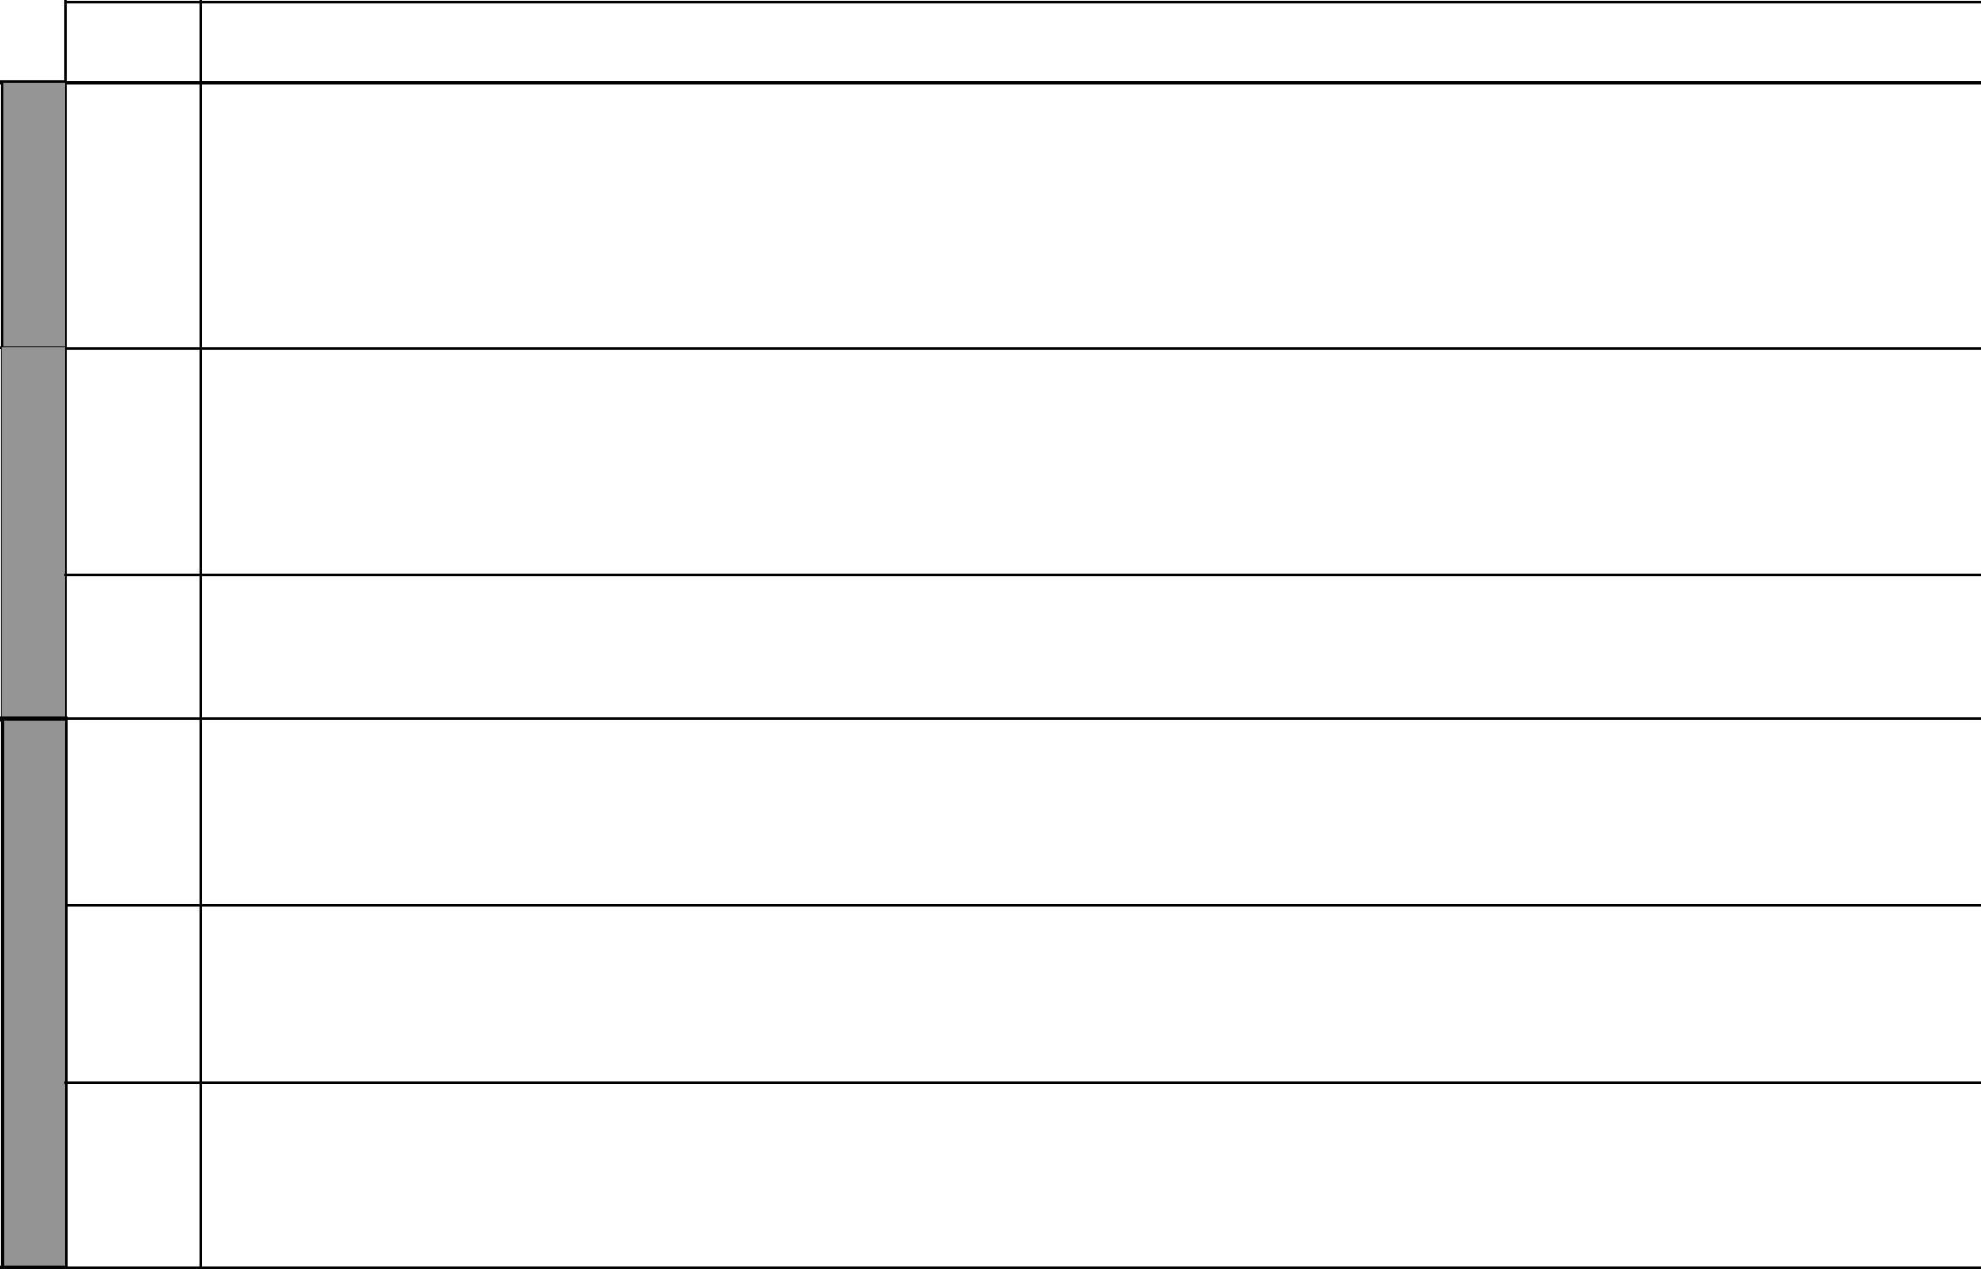

LESSON

5

WEEK 4

1 to 4

WEEK 5

5

1

6
WEEK | 2

3 to 5

TOPIC | SUB-TOPIC | OBJECTIVES | TEACHING/LEARNING | LEARNING/TEACHING | REMARKS
 |  |  | ACTIVITIES | RESOURCES
Climate | Factors influencing | The learners should be able to: | • Name the factors | Our Lives Today SST Book 6 pages
 | climate | • name the factors affecting climate. | • Describe how each factor | 20–25
 | • Latitude | • describe how these factors affect | mentioned affects climate | • Map showing wind
 | • Altitude | climate. | • Observe diagrams | movements
 | • Nearness to large |  | • Draw illustrations | • Diagrams of land and sea breezes
 | bodies of water |  | • Explain land and sea breezes | • Map in Pupil’s Book page 24
 | • Winds |  | • Write notes on the same | • Pictures in Pupil’s Book
 |  |  |  | pages 22–23
 | Weather | The learners should be able to: | • Identify weather instruments | Our Lives Today SST Book 6 page
 | instruments | • identify and name measuring | • Name them | 25
 | instruments | • identify and name measuring | • Name them | • Weather instruments
 | • Barometer | instruments for weather. | • State elements of the weather | • Weather instruments
 | • Barometer | instruments for weather. | • State elements of the weather | • Weather charts
 | • Anemometer | • draw weather instruments. | • Draw weather instruments | • Weather charts
 | • Anemometer | • draw weather instruments. | • Draw weather instruments | • Diagrams in the Pupil’s Book
 |  | • record weather using simple diagrams. | • Record weather using | • Diagrams in the Pupil’s Book
 |  | • record weather using simple diagrams. | • Record weather using | page 25
 |  |  | instruments | page 25
 | How climate | The learners should be able to explain | • Identify human activities | Our Lives Today SST Book 6
 | influences human | how climate influences human activities. | • Discuss how the climate affects | pages 26–27
 | activities |  | each activity | • Pictures in Pupil’s Book
 |  |  | • Write notes | page 27
 | Factors influencing | The learners should be able to: | • Identify the factors influencing | Our Lives Today SST Book 6
 | climate | • identify the factors influencing climate | climate change | pages 27–28
 | • Desertification | change. | • Discuss how they affect climate | • Pictures in Pupil’s Book
 | • Deforestation | • describe those factors, e.g. | • Write notes | page 28
 | • Waste gases | desertification, deforestation etc.
 | Impact of climate | The learners should be able to explain | • Identifying the effects of climate | Our Lives Today SST Book 6
 | change on human | the impact of climatic changes on | change | page 29
 | activities | human activities. | • Discussing how human activities
 |  |  | are affected by climate change
 |  |  | • Taking notes
Vegetation | Types of vegetation | The learners should be able to: | • Define the term vegetation | Our Lives Today SST Book 6
 | • Tropical rain | • identify and name the type of | • Name the types of vegetation | pages 31–34
 | • forest | vegetation. | • Describe the characteristics of | • Pictures in the Pupil’s Book
 | • Mangrove | • describe each type of vegetation. | each | pages 32–33
 |  | • state the uses of each vegetation type. | • State the uses of the vegetation | • Map on page 31 Pupil’s Book
 |  | 3 |  | For use with Our Lives Today Standard Six

WEEK 6

WEEK 7

WEEK 8
Our Lives Today: Social Studies Standard Six

Schemes of Work

Term 1
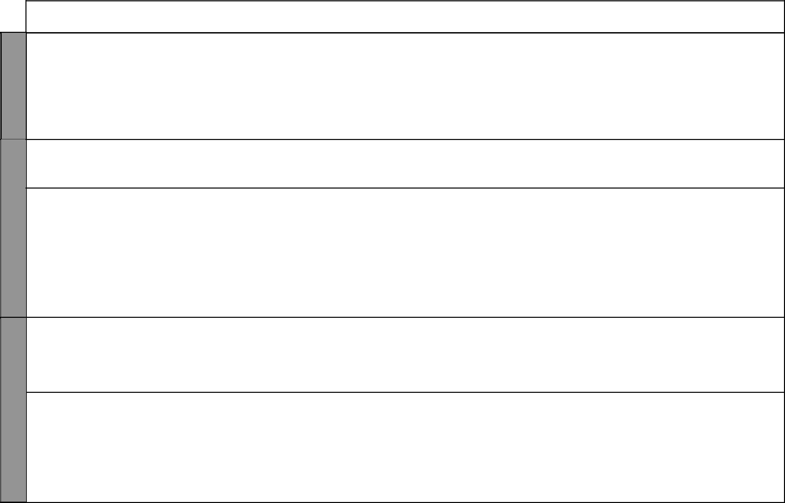
LESSON | TOPIC | SUB-TOPIC | OBJECTIVES | TEACHING/LEARNING | LEARNING/TEACHING | REMARKS
 |  |  |  | ACTIVITIES | RESOURCES
 | Vegetation | • Papyrus swamp | The learners should be able to: | • Defining the term vegetation | Our Lives Today SST Book 6
 |  | • Woodland | • identify various types of vegetation | • Describing various types of | pages 31–34
 |  | • Savannah grass | • locate them on the map | vegetation found in the region | Our Lives Today SST Book 6
 |  | land |  | • Observing pictures of vegetation | Our Lives Today SST Book 6
 |  | • Desert and semi |  | • Writing notes | pages 21–23
 |  | desert |  |  | • Map of Eastern Africa
 |  | • Mountain |  |  | showing vegetation
1 |  | Factors influenc- | The learners should be able to state the | • Stating and explaining the factors | Our Lives Today SST Book 6
 |  | ing vegetation | factors influencing vegetation | influencing vegetation distribution | pages 34–35
 |  | distribution | distribution. | • Taking notes
2 to 5 | People | Major language | The learners should be able to: | • Define the term language groups | Our Lives Today SST Book 6
 | and popu- | groups | • identify the people of Eastern Africa. | • Name the language groups | pages 37–40
 | lation | • Bantus | • classify the people of Eastern Africa | • Classify the people of Eastern | • Language table on page 37
 |  | • Nilotes | into Bantu, Cushites and Nilotes. | Africa | • Map of Eastern Africa
 |  | • Cushites | • describe the characteristics of each | • Draw classification table | showing settlement areas
 |  |  | group. | • Observe a map
 |  |  | • draw a map of Eastern Africa | • Describe the characteristics of
 |  |  | showing settlement areas. | Bantus, Nilotes and Cushites
 |  |  |  | • Draw a map of Eastern Africa
 |  |  |  | • Write notes
1 to 3 |  | Migration and | The learners should be able to: | • Explaining the reasons for | Our Lives Today SST Book 6
 |  | settlement | • explain the reasons for migration. | migration and settlement | pages 36–40
 |  |  | • trace migration routes and settlement. | • Observing migration map
 |  |  | • locate places of origin of East African | • Tracing routes of migration
 |  |  | people. | • Identifying places of origin
4 & 5 |  | Factors that influ- | The learners should be able to: | • Define the term population | Our Lives Today SST Book 6
 |  | ence population | • identify the factors influencing | distribution | pages 42–45
 |  | distribution | population distribution. | • Identify the factors | • Map of population
 |  |  | • describe population distribution. | • Observe map and population | distribution
 |  |  |  | distribution
 |  |  |  | • Describe the distribution
 |  |  |  | • Identify areas of high
 |  |  |  | population and low population

₄ For use with Our Lives Today Standard Six

Our Lives Today: Social Studies Standard Six

Schemes of Work

Term 1
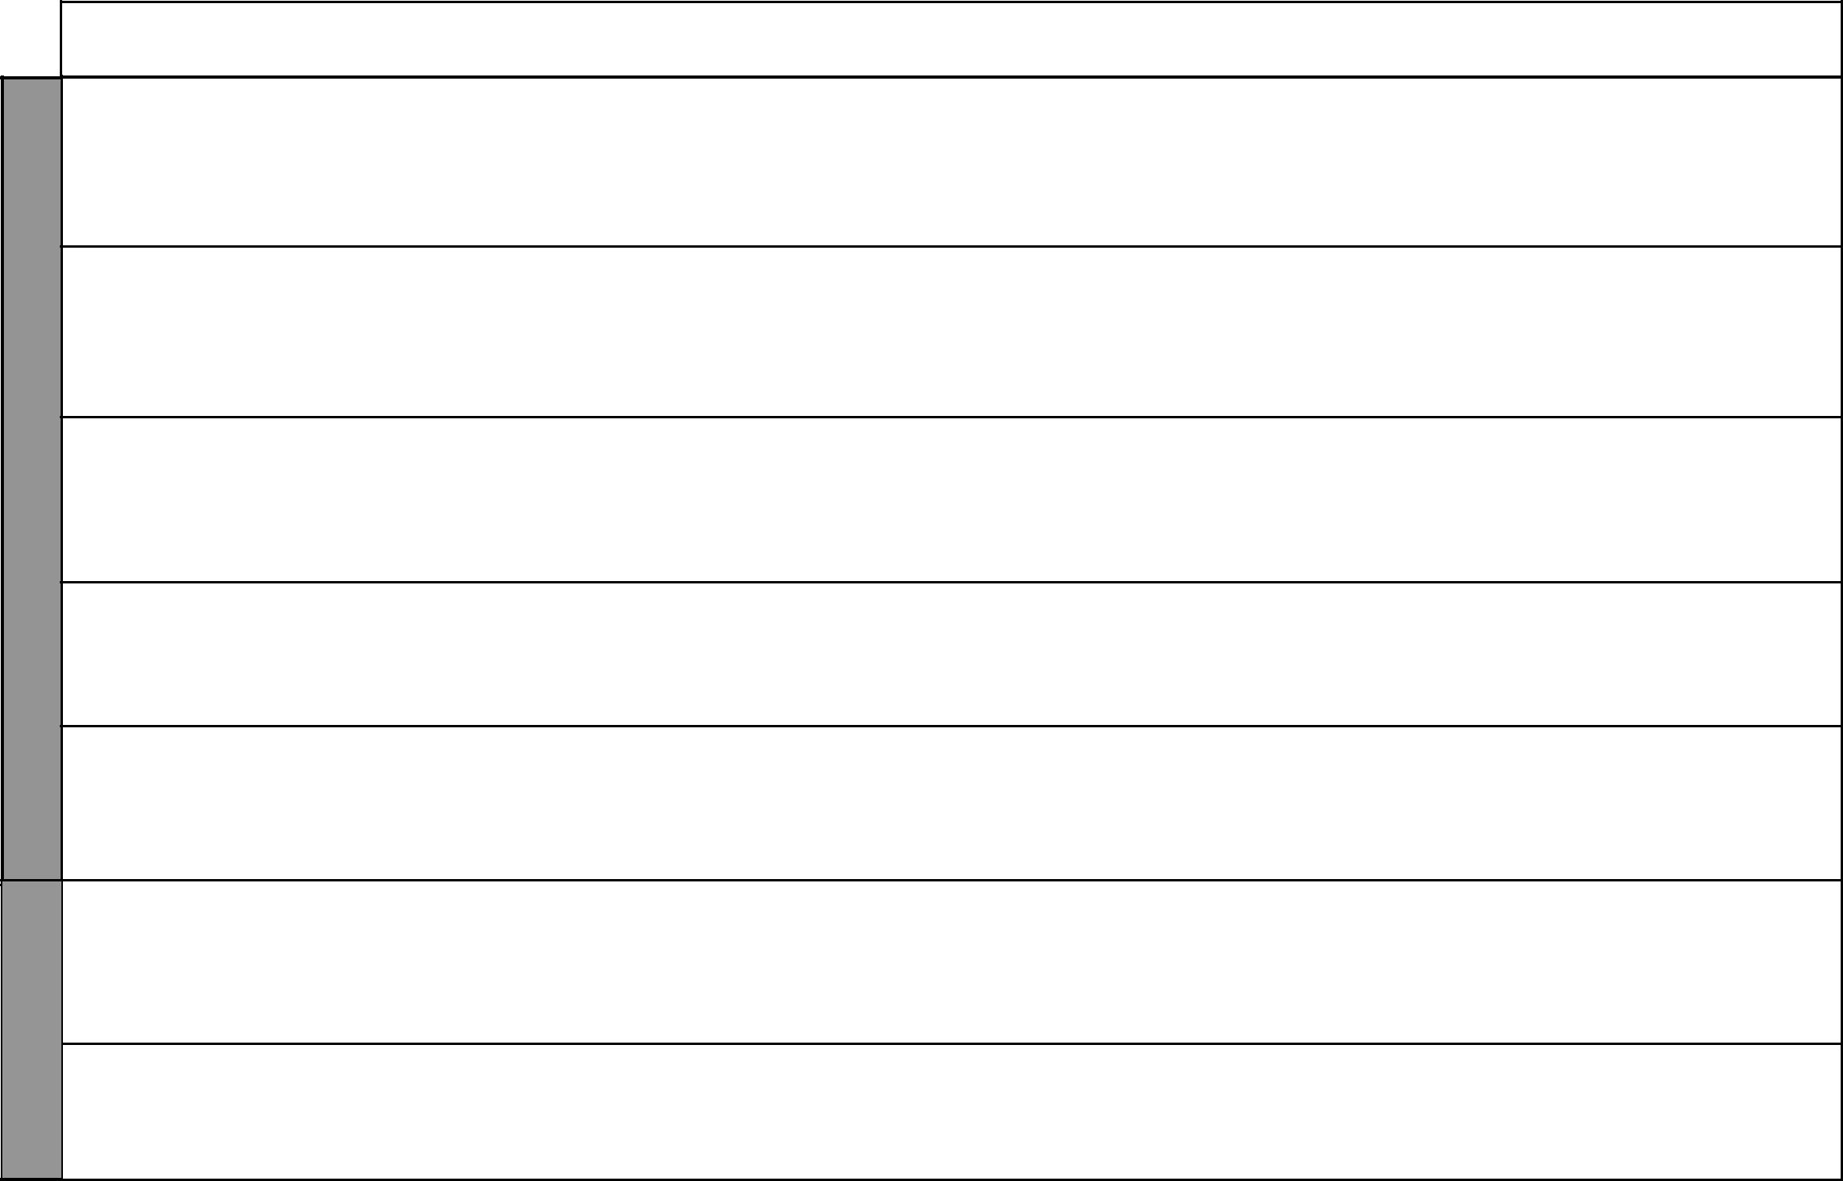

WEEK 9

WEEK 10

LESSON | TOPIC | SUB-TOPIC | OBJECTIVES |  | TEACHING/LEARNING | LEARNING/TEACHING | REMARKS
 |  |  |  |  | ACTIVITIES | RESOURCES
1 | People and | Factors that | The learners should be able to: |  | • Explaining the term population | Our Lives Today SST Book 6
 | population | influence | • identify the factors influencing |  | growth | pages 45–46
 |  | population growth | population distribution. |  | • Identifying and explaining factors | • Picture in the Pupil’s Book
 |  |  | • describe population distribution. |  | for population growth | page 46
 |  |  |  |  | • Taking notes
2 |  | Impact of rapid | The learners should be able to explain |  | • Discussing the effects of rapid | Our Lives Today SST Book 6
 |  | population growth | the effects of rapid population growth. |  | population growth | pages 46–47
 |  |  |  |  | • Answering and asking questions on | • Pictures on page 47
 |  |  |  |  | population
 |  |  |  |  | • Writing notes
3 | Social | History of the | The learners should be able to: |  | • Define the term school | Our Lives Today SST Book 6
 | rela- | school | • define the term school. |  | • Explain what other social | pages 48–49
 | tions and |  | • describe the history of the school. |  | institutions are
 | cultural |  |  |  | • Describe the history of the
 | activities |  |  |  | school
4 |  | School routine | The learners should | be able to describe | • Define the term school routine | Our Lives Today SST Book 6
 |  |  | the school routine. |  | • Describe what happens in school | page 50
 |  |  |  |  | • State the importance of the school
 |  |  |  |  | routine
5 |  | Role of the school | The learners should | be able to describe | • Naming the functions of the school | Our Lives Today SST Book 6
 |  | in terms of | the role of the school in community |  | • Describing the role of the school in | pages 51–52
 |  | community | development. |  | community development | • Pictures in the Pupil’s Book
 |  | development |  |  | • Writing notes | pages 51–52
1 to 3 |  | The family | The learners should be able to: |  | • Define the term family | Our Lives Today SST Book 6
 |  | (Needs of the | • identify the needs of the family members. |  | • Name types of families | pages 52–53
 |  | family) | • state the roles of family members. |  | • Identify family needs
 |  |  | • identify family members |  | • State the roles of family members
 |  |  | responsibilities. |  | • Describe family responsibilities
4 & 5 |  | The clan system | The learners should be able to: |  | • Define the term clan | Our Lives Today SST Book 6
4 & 5 |  | and functions | • explain how a clan is formed. |  | • Explain how a clan is formed | pages 54–55
 |  | and functions |  |  | • Identify clan members | pages 54–55
 |  |  | • name clan functions. |  | • Identify clan members | • Learners’ experiences
 |  |  |  |  | • Name the functions of the clan | • Learners’ experiences
 |  |  |  |  | • Name the functions of the clan | • Local environment
 |  |  |  |  | • Write notes | • Local environment

₅ For use with Our Lives Today Standard Six

Our Lives Today: Social Studies Standard Six

Schemes of Work

Term 1

 |  | LESSON | TOPIC | SUB-TOPIC | OBJECTIVES | TEACHING/LEARNING | LEARNING/TEACHING | REMARKS
 |  |  |  |  |  | ACTIVITIES | RESOURCES
 |  | 1 and 2 | Resources | Agriculture | The learners should be able to: | • Define the term cash crop farming | Our Lives Today SST Book 6
 |  |  | and | (Cash crop farm- | • state the conditions for the growth of | • Give examples of cash crops | pages 55–58
 |  |  | economic | ing, i.e coffee | coffee. | • Identify coffee growing areas in | • Pictures of coffee
 |  |  | activities | growing in Kenya | • explain how coffee is grown in | Kenya and Ethiopia | • Map on page 57
 |  |  |  | and Ethiopia) | Kenyan and Ethiopia. | • Name coffee varieties | • Local environment
 |  |  |  |  | • state the economic importance of | • State conditions for growth
 |  |  |  |  | coffee to Kenya and Ethiopia. | • Describe coffee growing in
 |  |  |  |  |  | Kenya and Ethiopia
 |  |  |  |  |  | • Discuss its importance
 |  | 3 and 4 |  | Maize growing in | The learners should be able to: | • Describe how maize is grown | Our Lives Today SST Book 6
 | 11 |  |  | Kenya and | • state the condition necessary for the | • Discuss conditions for growth | pages 59–60
 | 11 |  |  | Tanzania | growth of maize. | • Identify maize varieties | • Pictures of maize
 | 11 |  |  |  | • explain how maize is grown in | • Identify where maize is grown
 | WEEK |  |  |  | • explain how maize is grown in | • Identify where maize is grown
 | WEEK |  |  |  | Kenyan and Tanzania. | • Discuss economic importance
 | WEEK |  |  |  | • discuss the economic importance of | of maize
 | WEEK |  |  |  | maize.
 |  | 5 |  | Banana grow- | The learners should be able to: | • Naming banana varieties | Our Lives Today SST Book 6
 |  |  |  | ing in Kenya and | • state the conditions necessary for the | • stating the conditions necessary for | pages 61–62
 |  |  |  | Uganda | growth of bananas. | growth | • Pictures of banana
 |  |  |  |  | • describe banana growing in Kenya | • Describing banana growing in | • Local environment
 |  |  |  |  | and Uganda. | Kenya and Uganda
 |  |  |  |  | • identify the contribution of bananas to | • Discussing the importance to the
 |  |  |  |  | the economy. | economy
 |  |  |  |  |  | • Taking notes
 | 13 |  | Revision |  | The learners should be able to revise | • Asking and answering questions | • Test papers/Written
 | & |  | and |  | the work covered during the term and | • Exam | questions
 | WEEKS 12 |  | Exam |  | answer questions set on that work. |  | • Writing materials

₆ For use with Our Lives Today Standard Six

Our Lives Today: Social Studies Schemes of Work for Standard Six: Term Two


WEEK 5 WEEK 4 WEEKWEEK3 1WEEK 2

LESSON TOPIC | SUB-TOPIC | OBJECTIVES | TEACHING/LEARNING | LEARNING/TEACHING | REMARKS
LESSON TOPIC | SUB-TOPIC | OBJECTIVES | ACTIVITIES | RESOURCES | REMARKS
Resources | Sisal growing | The learners should be able to | • Naming sisal varieties | Our Lives Today SST Book 6 page 63
and | in Kenya and | describe sisal growing in Kenya | • Identifying areas where it is grown | • Picture of sisal
economic | Tanzania | and Tanzania. | • Describing the conditions necessary | • Map on page 57 of the Pupil’s Book
activities |  |  | for growth
activities |  |  | • Naming uses
1 |  |  | • Describing how it is grown
1 |  |  | • Discussing its contribution to the
& |  |  | economy
2 |  |  | • Observing pictures of sisal
 |  |  | • Taking notes

Sugarcane | The learners should be able to: |  | • Identifying sugarcane growing areas | Our Lives Today SST Book 6 pages 64–65
Sugarcane |  |  | • Identifying conditions for growth | • Map on page 57
growing in | 1. | describe the conditions | • Identifying conditions for growth | • Map on page 57
growing in | 1. | describe the conditions | • Describing the economic importance
Kenya and |  | necessary for growth. | • Describing the economic importance
Kenya and |  | necessary for growth. | • Taking notes
Sudan | 2. | describe sugarcane growth
 |  | in Kenya and Sudan.
3 | 3. | State the economic
to |  | importance of sugarcane
to |  | growing.
5 |  | growing.

₇ For use with Our Lives Today Standard Six

WEEKWEEK5WEEK3 4 WEEK 3 WEEK 2

 |  |  |  | Our Lives Today: Social Studies Standard Six
 |  |  |  | Schemes of Work
 |  |  |  |  | Term 2
LESSON TOPIC | SUB-TOPIC | OBJECTIVES | TEACHING/LEARNING | LEARNING/TEACHING | REMARKS
LESSON TOPIC | SUB-TOPIC | OBJECTIVES | ACTIVITIES | RESOURCES | REMARKS
Resources | Beef Farming | The learners should be able to: | • Define the term beef farming | Our Lives Today SST Book 6 pages 66–68
and | in Kenya & | • identify areas where beef | • Identify areas where it is practised | • Picture of beef cattle
Economic | Tanzania | farming is carried out in | • Name types of beef cattle | • Map of East Africa showing beef areas
Activities |  | Kenya and Tanzania. | • State conditions suitable for beef farming | • Local environment
Activities |  | Kenya and Tanzania. | • Discuss problems
 |  | • state the problems facing | • Discuss problems
 |  | • state the problems facing | • Discuss the contribution to the
1 |  | beef farming in Kenya and | • Discuss the contribution to the
1 |  | beef farming in Kenya and | economy
to |  | Tanzania. | economy
to |  | Tanzania. | • Taking notes
to |  | • explain the importance of | • Taking notes
3 |  | • explain the importance of | • Observe Maps
3 |  | beef farming. | • Observe Maps


 | Pastoralism in | The learners should be able to: | • Define the term pastoralism | Our Lives Today SST Book 6 pages 69–70
 | Pastoralism in | The learners should be able to: | • Identify areas where it is practised | • Pictures of pastoralism
 | Kenya and | • identify areas where | • Identify areas where it is practised | • Pictures of pastoralism
 | Kenya and | • identify areas where | • State the conditions favouring pastoralism | • Map of East Africa showing
4 | Uganda | pastoralism is practised | • State the conditions favouring pastoralism | • Map of East Africa showing
4 | Uganda | pastoralism is practised | • Describe how pastoralism takes place | pastoral areas
4 |  | • describe how pastoralism | • Describe how pastoralism takes place | pastoral areas
& |  | • describe how pastoralism | • Name pastoral communities
& |  | takes place. | • Name pastoral communities
5 |  | takes place.

 | Factors that | The learners should be able to: - | • Stating factors influencing pastoralism | Our Lives Today SST Book 6 pages 69–71
 | influence | • state the factors influencing | • Discussing the problems | • Pictures of various social activities
 | influence | • state the factors influencing | • Stating developments
1 | pastoralism | pastoralism. | • Stating developments
1 | pastoralism | pastoralism. | • Observing a map
1 |  | • State the problem facing | • Observing a map
to |  | • State the problem facing | • Taking notes
to |  | Pastoralism. | • Taking notes
3 |  | Pastoralism.
3 |  | • state the developments taking
 |  | place in pastoral areas.

₈ For use with Our Lives Today Standard Six

Our Lives Today: Social Studies Standard Six

Schemes of Work

Term 2


WEEK 5 WEEK4 4 WEEK 3 WEEK 2 WEEK 3

LESSON TOPIC | SUB-TOPIC | OBJECTIVES | TEACHING/LEARNING | LEARNING/TEACHING | REMARKS
LESSON TOPIC | SUB-TOPIC | OBJECTIVES | ACTIVITIES | RESOURCES | REMARKS
Resources | Mining: | The learners should be able to: | • Define the terms mining and minerals | Our Lives Today SST Book 6 page 73
and | Copper in | • identify the location of copper & | • Identify areas where it is practised | • Map of East Africa showing minerals
Economic | Uganda | mines in Uganda. | • Describe how it is mined | • Diagram of mining methods
Activities |  | • describe how it is mined. | • Explain the uses of copper
Activities |  | • describe how it is mined. | • State the contribution to the economy
 |  | • explain the uses of copper. | • State the contribution to the economy
 |  | • explain the uses of copper. | • Observe map
4 |  | • state the contribution of the | • Observe map
4 |  | • state the contribution of the | • Taking notes
& |  | mineral to the economy. | • Taking notes
5

Diamonds in | The learners should be able to: | • Naming diamond mines | Our Lives Today SST Book 6 pages 74–75
Diamonds in | The learners should be able to: | • Describing methods of mining | • Pictures of mining methods
Tanzania | • identify diamond mines in | • Describing methods of mining | • Pictures of mining methods
Tanzania | • identify diamond mines in | • Drawing illustrations | • Map of East Africa showing
1 | Tanzania. | • Drawing illustrations | • Map of East Africa showing
1 | Tanzania. | • Explaining the uses of diamond | mineral areas
1 | • describe how diamond is mined. | • Explaining the uses of diamond | mineral areas
& | • describe how diamond is mined. | • Stating the contribution to the economy
2 | • state the contribution of the | • Taking notes
2 | mineral to the economy. | • Taking notes

Salt in Kenya | The learners should be able to: | • Name salt mines in Kenya | Our Lives Today SST Book 6 pages 72–73
 | • identify the location of salt | • Describe how it is mined | • Map of East Africa showing
 | • identify the location of salt | • Explain the uses of salt | major mineral areas
3 | mines in Kenya. | • Explain the uses of salt | major mineral areas
3 | mines in Kenya. | • State the contribution to the economy | • Pictures of methods of mining
3 | • describe how salt is mined. | • State the contribution to the economy | • Pictures of methods of mining
& | • describe how salt is mined. | • Taking notes
& | • explain the uses of salt. | • Taking notes
4 | • explain the uses of salt. | • Draw a map of mineral areas
4 | • state the contribution of salt to | • Draw a map of mineral areas
 | the economy.

₉ For use with Our Lives Today Standard Six

WEEK 5 WEEK 4WEEKWEEK5 3 WEEK 2 WEEK 4

 |  |  |  |  | Our Lives Today: Social Studies Standard Six
 |  |  |  |  |  | Schemes of Work
 |  |  |  |  |  | Term 2
LESSON TOPIC |  | SUB-TOPIC | OBJECTIVES | TEACHING/LEARNING | LEARNING/TEACHING | REMARKS
 |  | SUB-TOPIC | OBJECTIVES | ACTIVITIES | RESOURCES | REMARKS
 | Resources | Problems | The learners should be able to | • Discussing the problems associated | Our Lives Today SST Book 6 page 75
 | and | associated with | state problems associated to | to mining | • Pictures on mining
5 | economic | mining | mining in East Africa. | • Observing pictures
5 | activities |  |  | • Taking notes


 | The learners should be able to: | • | Describing the effects of mining on | Our Lives Today SST Book 6 page 76
Effects of | • describe the effects of mining | • | Describing the effects of mining on | Our Lives Today SST Book 6 page 76
Effects of | • describe the effects of mining |  | the environment
mining on the | on the environment. | • | Suggesting possible conservation
environment | • suggest conservation measures |  | measures for the environment
1 | that should be taken. | • | Taking notes
&
2

 | Forestry | The learners should be able to: | • Defining the term forestry |  | Our Lives Today SST Book 6 pages 77-78
 | (Distribution | • locate major forests in | • | Naming major forests | • Map of East Africa showing
3 | of forests in | East Africa. | • | Locating the forests on the map | major Forests
 | Eastern Africa) | • draw the map of East Africa | • Drawing the map showing forests
 |  | and indicate forests | • | Taking notes
4 | Importance of | The learners should be able to | • | Stating the importance of forests | • Pictures of sawmilling
4 | forests | state the importance of forests. | • | Explaining the contribution to
 |  |  |  | the economy
 |  |  | • | Naming forests

₁₀ For use with Our Lives Today Standard Six

Our Lives Today: Social Studies Standard Six

Schemes of Work

Term 2


WEEKWEEK5WEEK7 4 WEEKWEEK3WEEK6 2 WEEK 5

LESSON TOPIC |  | SUB-TOPIC | OBJECTIVES | TEACHING/LEARNING | LEARNING/TEACHING | REMARKS
 |  | SUB-TOPIC | OBJECTIVES | ACTIVITIES | RESOURCES | REMARKS
 | Resources | Problems | The learners should be able to: | • Describing the problems | Our Lives Today SST Book 6 pages 78–79
 | and | facing forests | • describe the problems | • Suggesting conservation measures | • Pictures of forest destruction
5 | economic | and | facing forests in East Africa. | • Observing pictures of forest destruction
5 | activities | conservation | • suggest conservation | • Taking notes
 |  | measures | measures.
 |  | Fishing: Inland | The learners should be able to: | • Define the terms fishing and fisheries | Our Lives Today SST Book 6 pages 80–82
 |  | fishing in | • identify inland fishing | • Name inland fishing grounds | • Map of East Africa showing fishing
 |  | Kenya, | grounds in East Africa. | • Locate major fishing grounds | grounds
 |  | Uganda and | • name main fishing | • Name types of fish caught | • Pictures of fishing vessels
1 |  | Tanzania | grounds in East Africa. | • Draw a map of East Africa and locate | • Pictures of types of fish
1 |  |  | • identify the types of fish | fishing grounds | • Pictures of fishing methods
to |  |  | caught.
4

Problems | The learners should be able to: | • Explaining the problems of inland fishing | Our Lives Today SST Book 6 pages 82–83
facing fishing | • explain the problems facing | • Stating problems of sea fishing | • Pictures of water hyacinth
in East Africa | inland fishing in Kenya. | • Taking notes
5 | • state the problems facing sea
5 | fishing in East Africa.
& | fishing in East Africa.
1

₁₁ For use with Our Lives Today Standard Six

WEEK 5 WEEK 4 WEEKWEEK3 7 WEEK 2

 |  |  |  |  | Our Lives Today: Social Studies Standard Six
 |  |  |  |  | Schemes of Work
 |  |  |  |  |  | Term 2
LESSON TOPIC |  | SUB-TOPIC | OBJECTIVES | TEACHING/LEARNING | LEARNING/TEACHING | REMARKS
 |  | SUB-TOPIC | OBJECTIVES | ACTIVITIES | RESOURCES | REMARKS
 | Resources | Contribution | The learners should be able to | • Discussing the importance of fishing to | Our Lives Today SST Book 6 page 83
 | and | of fishing to | state the contribution of fishing | the economy | • Pictures on page 83 in the Pupil’s Book
2 | economic | the economy | to the economy. | • Taking notes
2 | activities
 | Trade and | Factors | The learners should be able to | • Defining the term trade | Our Lives Today SST Book 6 pages 84–85
 | industry | influencing | identify the factors influencing | • Classifying trade, i.e. local, internal export | • Pictures of people trading
 |  | trade | trade in the region. | and import
3 |  |  |  | • Explaining the factors influencing trade


Forms of trade | The learners should be able to: | • Naming forms of trade | Our Lives Today SST Book 6 pages 85–86
and items of | • name forms of trade and | • Explaining each | • Local environment
trade | explain each. | • Naming the items of trade | • Pictures of people in the market
4 | • name the items of trade. | • Differentiating between modern trade
 |  | and traditional trade

Imports to and | The learners should be able to: | • Defining the terms import and | Our Lives Today SST Book 6 pages 86–87
exports from | • explain export and import | export trade | • Tables in the Pupil’s Book pages 86–87
the region | trade. | • Naming exports from the region | • Chart showing imports and exports
5 | • name exports from and imports | • Naming imports to the region
5 | to the region | • Drawing import/export table

₁₂ For use with Our Lives Today Standard Six

Our Lives Today: Social Studies Standard Six

Schemes of Work

Term 2

EEKW5 9 WEEK 4 WEEK 3WEEKWEEK8 2

LESSON | TOPIC | SUB-TOPIC | OBJECTIVES | TEACHING/LEARNING | LEARNING/TEACHING | REMARKS
 |  |  |  | ACTIVITIES | RESOURCES | REMARKS
 | Trade and | Benefits of | The learners should be able to | • Explaining the benefits of trade in | Our Lives Today SST Book 6 page 88
1 | industry | trade | state the benefits of trade in the | the region
1 |  |  | region. | • Taking notes
 |  | Problems | The learners should be able to | • Discuss the problems of trade | Our Lives Today SST Book 6 pages 87–88
 |  | facing trade | list the problems facing trade in | • Do a written exercise
2 |  |  | the region.
 |  | Industries: | The learners should be able to | • Define the term industry | Our Lives Today SST Book 6 pages 89–90
3 |  | Industrial | explain industrial development in | • Explain how industries developed in | • Map of East Africa on page 90
3 |  | development in | the region. | the region
 |  | the region
 |  | Importance of | The learners should be able to | • Describing the importance of industries in | Our Lives Today SST Book 6 page 91
 |  | industries | identify the importance of | the region | Our Lives Today SST Book 6 page 91
 |  | industries | identify the importance of | the region | • Pictures of people working in the
 |  |  | industries. | • Taking notes | • Pictures of people working in the
4 |  |  | industries. | • Taking notes | industries
 |  | Problems | The learners should be able to | • Stating problems facing industries | Our Lives Today SST Book 6 pages 91–92
5 |  | facing | state the problems facing | • Taking notes
5 |  | industries | industries.
 |  | Impact of | The learners should be able to | Explaining the effects of industries on the | Our Lives Today SST Book 6 page 92
 |  | industries | explain the impact of industries | environment | Our Lives Today SST Book 6 page 92
 |  | industries | explain the impact of industries | environment | • Local environment
1 |  | on the | on the environment. |  | • Local environment
 |  | environment
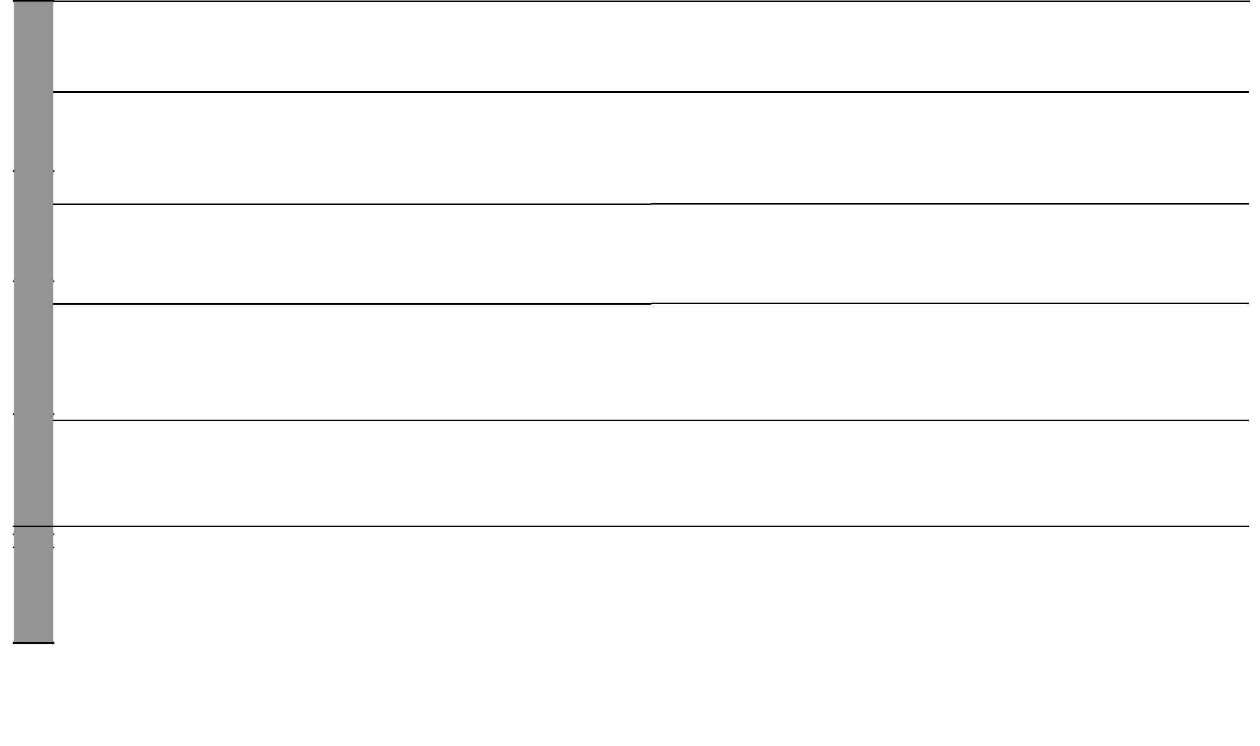

₁₃ For use with Our Lives Today Standard Six

WEEK 5 WEEK 410 WEEK 3 WEEK WEEK2 9

 |  |  |  | Our Lives Today: Social Studies Standard Six
 |  |  |  |  | Schemes of Work
 |  |  |  |  | Term 2
LESSON TOPIC | SUB-TOPIC | OBJECTIVES | TEACHING/LEARNING | LEARNING/TEACHING | REMARKS
LESSON TOPIC | SUB-TOPIC | OBJECTIVES | ACTIVITIES | RESOURCES | REMARKS
Trade and | • Transport and | The learners should be able to: | • Defining the term transport | Our Lives Today SST Book 6 pages
industry | communications | • define the term transport. | • Naming forms of transport | 93–101
 |  | • explain the development of a | • Describing the development of transport | • Pictures of transport network
 | • Development | transport system in the | i.e. railway, water, road and air transport | • Map of Eastern Africa showing
 | • Development | transport system in the | • Naming the advantages and disadvantages | transport network
 | of forms of | region. | • Naming the advantages and disadvantages | transport network
 | of forms of | region. | of each
 | transport | • explain the problems facing | of each
 | transport | • explain the problems facing | • Stating the problems facing the transport
2 |  | transport in Eastern Africa. | • Stating the problems facing the transport
2 |  | transport in Eastern Africa. | network
to |  |  | • Taking notes
5


 | Communication The learners should be able to: | • Defining the term communication | Our Lives Today SST Book 6 pages
 | • define the term communication. | • Identifying the traditional methods of | 101-103
 | • explain the development of a | communication | • Map of modern communication
 | communication network in | • Identifying modern methods | • Pictures of forms of communication
 | Eastern Africa. | • Explaining the development of
 | Eastern Africa. | communication
 | • explain the problems facing | communication
 | • explain the problems facing | • Discussing the advantages and
1 | communication. | • Discussing the advantages and
1 | communication. | disadvantages of each form
to |  | • Stating problems
4 |  | • Taking notes

₁₄ For use with Our Lives Today Standard Six

Our Lives Today: Social Studies Standard Six

Schemes of Work

Term 2

WEEK 10

WEEK 5 WEEK 4WEEKWEEK11 3 WEEK 2

LESSON | TOPIC | SUB-TOPIC |  | OBJECTIVES | TEACHING/LEARNING | LEARNING/TEACHING | REMARKS
LESSON | TOPIC | SUB-TOPIC |  | OBJECTIVES | ACTIVITIES | RESOURCES | REMARKS
 | Trade and | Benefits of | The learners should be able to |  | • Discussing the benefits of improved | Our Lives Today SST Book 6 page 103
 | industry | improved | identify the benefits of improved |  | transport and communication | • Pictures
5 |  | transport and | transport and communication. |  | • Doing a written Continuous Assesment
5 |  | communication |  |  | Test
 | Wildlife | Wildlife and | The learners should be able to: |  | • Defining the term wildlife | Our Lives Today SST Book 6 page 104
 | and | tourism: | • locate major parks in |  | • Naming game parks and game resorts | • Pictures of wildlife
 | tourism | Location of | East Africa. |  | • Locating the parks on the map | • Map of East Africa showing major
 | tourism | Location of |  |  | • Observing the map | wildlife areas
1 |  | major | • draw the map of East Africa |  | • Observing the map | wildlife areas
1 |  | major |  |  | • Drawing the map showing major parks
 |  | game parks | indicating major parks. |  | • Drawing the map showing major parks
 |  | Wildlife | The learners should be able to |  | • Discussing wildlife conservation measures | Our Lives Today SST Book 6 page 105
 |  | conservation | identify the wildlife conservation |  | • Naming the conservation measures | • Pictures of wildlife
2 |  | measures | measures being carried out. |  | • Taking notes | • Map of East Africa
 |  | Benefits of | The learners should be able to: |  | • Defining the term tourism | Our Lives Today SST Book 6 pages
 |  | tourism | (i) | define tourism. | • Identifying the main tourist attractions | Our Lives Today SST Book 6 pages
 |  |  |  |  |  | 105–106
 |  |  | (ii) | identify tourist attractions. | • Stating the benefits of tourism | 105–106
3 |  |  | (ii) | identify tourist attractions. | • Stating the benefits of tourism | • Pictures in the Pupil’s Book page 106
3 |  |  | (iii) state the benefits of tourism. |  | • Taking notes | • Pictures in the Pupil’s Book page 106
&
4
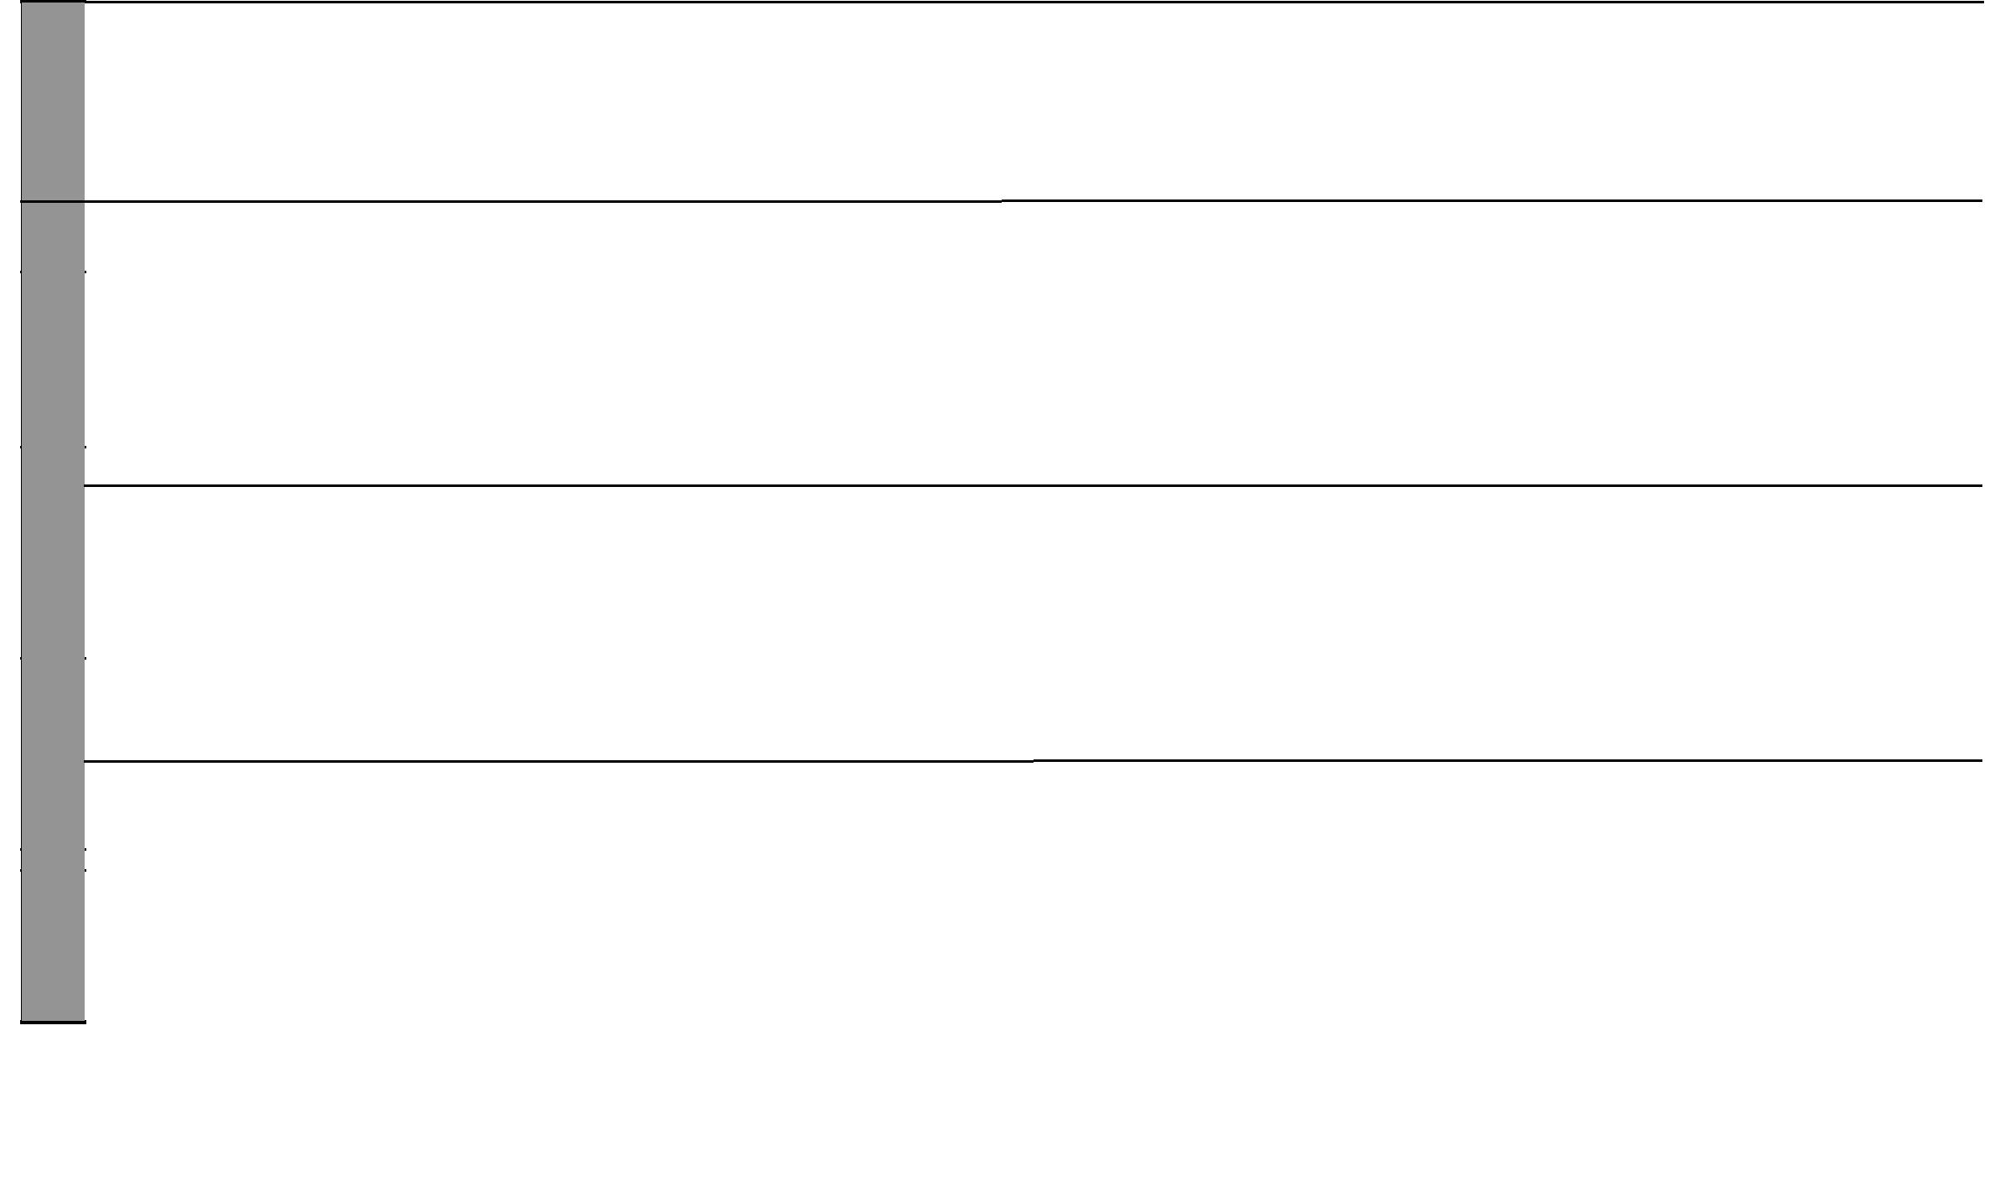

₁₅ For use with Our Lives Today Standard Six

WEEK 11

WEEK5 13WEEK 4 WEEKWEEK3 12WEEK 2

 |  |  |  |  | Our Lives Today: Social Studies Standard Six
 |  |  |  |  |  | Schemes of Work
 |  |  |  |  |  |  | Term 2
LESSON | TOPIC | SUB-TOPIC | OBJECTIVES | TEACHING/LEARNING | LEARNING/TEACHING |  | REMARKS
 |  |  |  | ACTIVITIES | RESOURCES |  | REMARKS
 | Wildlife | Problems | The learners should be able to | • Identifying the problems of tourism | Our Lives Today SST Book 6 page 108
 | and | facing tourism | state the problems facing tourism | • Asking and answering questions
5 | tourism |  | in East Africa. | • Taking notes
 |  | Possible | The learners should be able to | • Identify the remedies | Our Lives Today SST Book 6 page 109
1 |  | solutions to | discuss possible solutions to the | • Discuss each suggestion
1 |  | the problems | problems of tourism.
 |  | facing tourism
 | Urban- | Major towns: | The learners should be able to: | • Define urbanization | Our Lives Today SST Book 6 pages
 |  |  |  |  | 112–115
 | ization | Nairobi, | • state the functions of major | • State the reasons for the growth of | 112–115
 |  |  |  |  | • Pictures of towns in the Pupil’s Book
 |  | Mombasa, | towns in Eastern Africa. | mentioned towns | • Pictures of towns in the Pupil’s Book
 |  | Mombasa, | towns in Eastern Africa. | mentioned towns | • Local environment
 |  | Kampala, | • locate major towns in | • State the functions of the mentioned towns | • Local environment
2 |  | Kampala, | • locate major towns in |  | • Map showing major towns
2 |  | Jinja, | Eastern Africa. |  | • Map showing major towns
to |  | Jinja, | Eastern Africa.
to |  | Dar-se-salaam | • state the reasons for their
5 |  | and | growth.
 |  | Addis Ababa
 |  | Problems | The learners should be able to: | • Describe the problems | Our Lives Today SST Book 6 pages
 |  | Problems | The learners should be able to: | • Describe the problems | 115–117
 |  | facing urban | • identify the problems facing | • Suggest efforts to solve the problems | 115–117
1 |  | facing urban | • identify the problems facing | • Suggest efforts to solve the problems | • Map showing major towns of Africa
1 |  | centres and | towns. | • Fill in blank spaces | • Map showing major towns of Africa
& |  | centres and | towns. | • Observe a map of East Africa
& |  | efforts made to | • suggest the efforts made to | • Observe a map of East Africa
2 |  | solve the | solve the problems.
 |  | problems
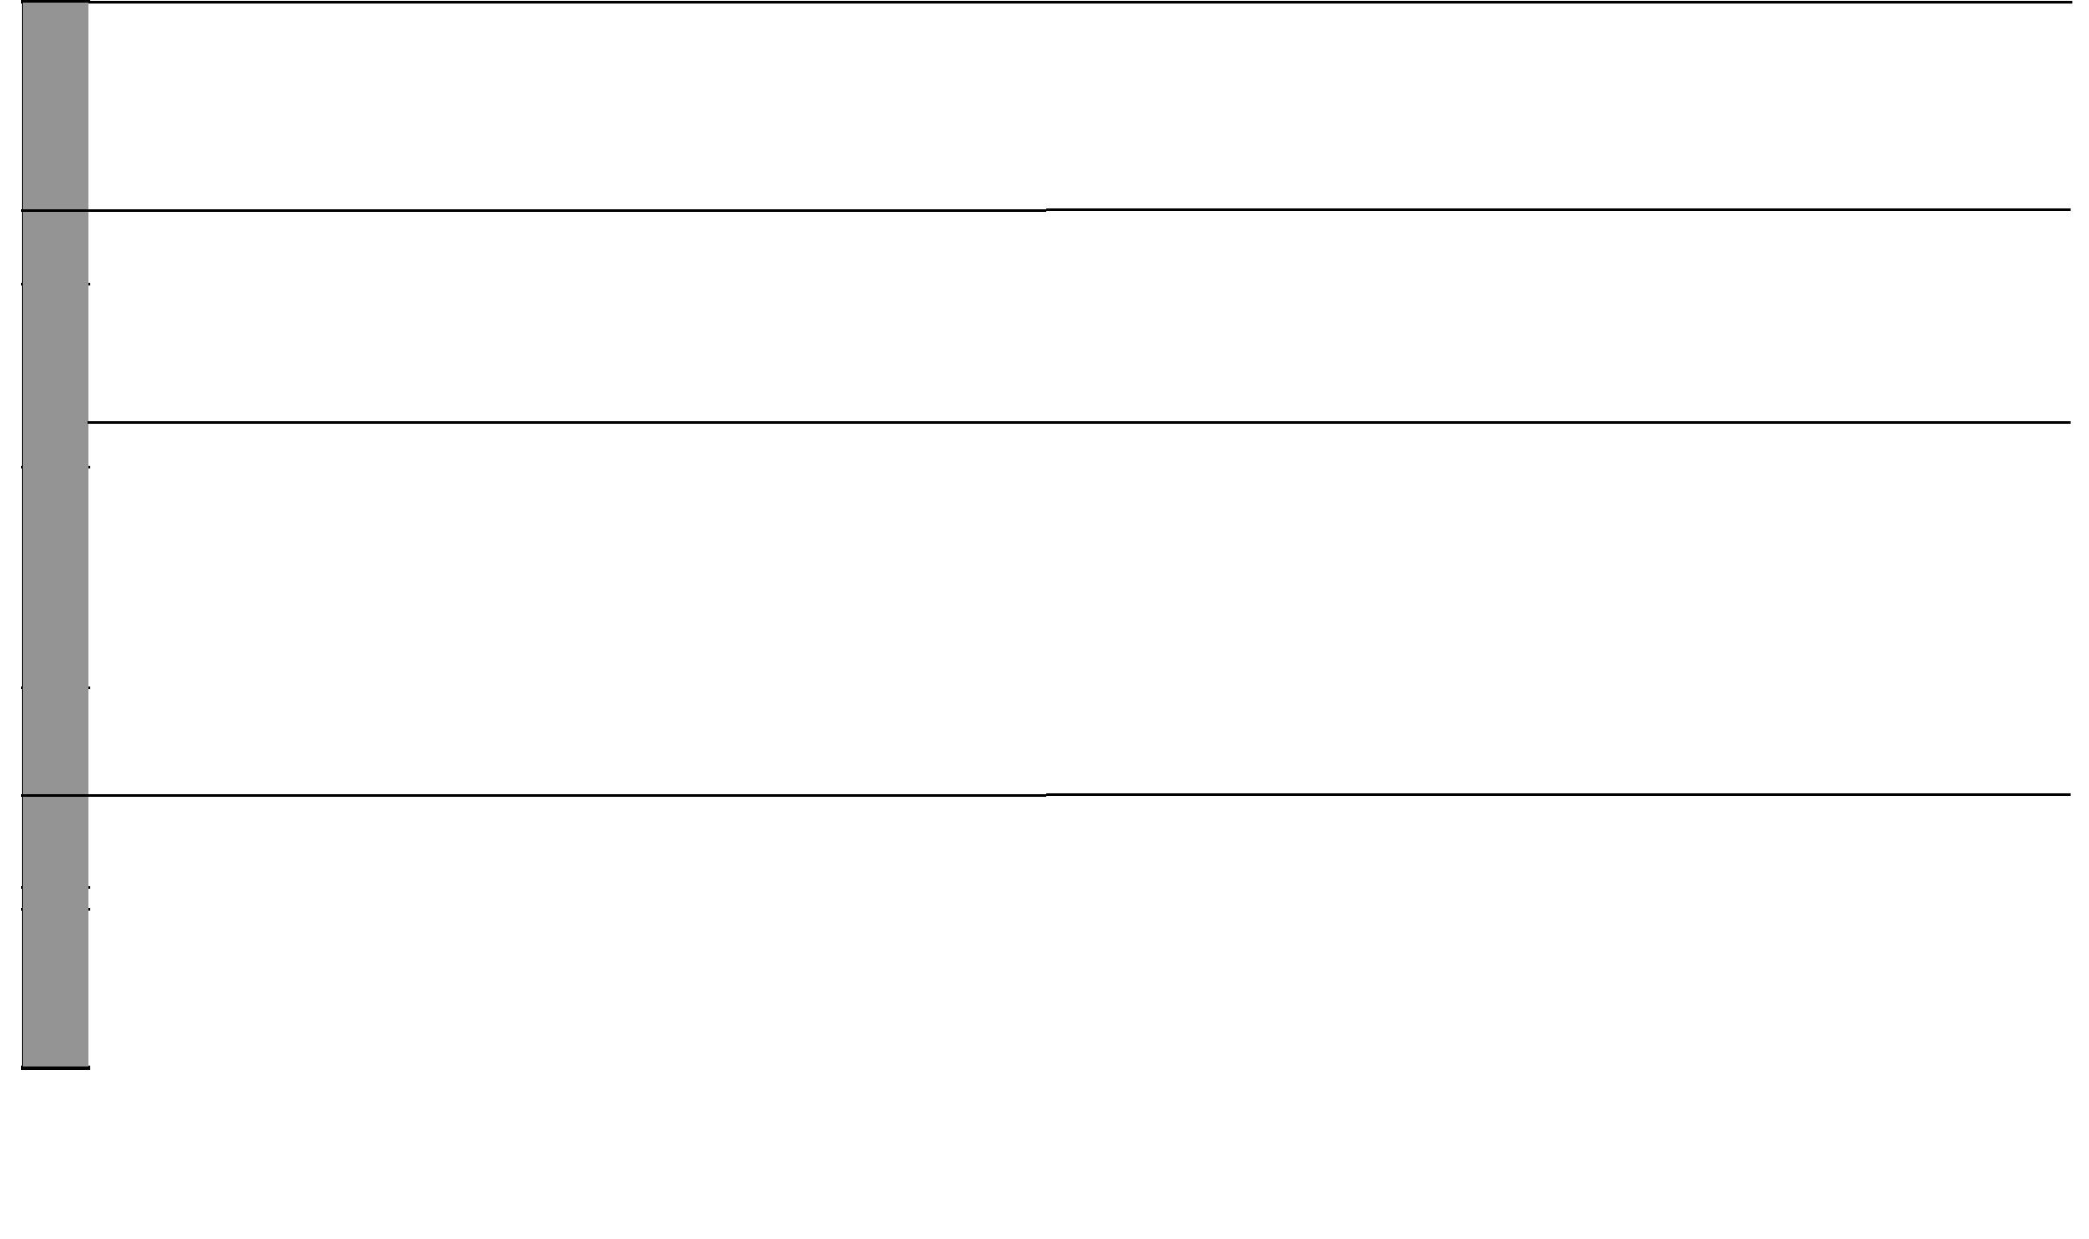

₁₆ For use with Our Lives Today Standard Six

Our Lives Today: Social Studies Standard Six

Schemes of Work

Term 2


WEEKWEEKS2 13 & 14

LESSON TOPIC SUB-TOPIC | OBJECTIVES | TEACHING/LEARNING | LEARNING/TEACHING | REMARKS
LESSON TOPIC SUB-TOPIC | OBJECTIVES | ACTIVITIES | RESOURCES | REMARKS
Revision | The learners should be able to | • Asking and answering questions | • Question papers/Written questions
and | revise the work covered during | • Exam | • Writing materials
Exams | the term and answer questions
 | set on it.

3 to 5

₁₇ For use with Our Lives Today Standard Six


Our Lives Today: Social Studies Schemes of Work for Standard Six: Term Three

WEEK 1

WEEK 2

LESSON | TOPIC | SUB-TOPIC | OBJECTIVES | TEACHING/LEARNING | LEARNING/TEACHING | REMARKS
 |  |  |  | ACTIVITIES | RESOURCES
1 & 2 | Political | Traditional forms | The learners should be able to: | • Locating Buganda Kingdom on | Our Lives Today SST Book 6
 | develop- | of government | • describe the traditional form of | the map of Eastern Africa | pages 118–121
 | ments and | • Buganda | government in Buganda. | • Describing the Buganda | • Map of East Africa
 | systems |  | • state the reasons for the rise of | government i.e. organization | • Chart showing the hierarchy
 |  |  | Buganda Kingdom. | • Stating the reasons for the rise of | of power in Buganda
 |  |  |  | the kingdom
 |  |  |  | • Taking notes
3 to 5 |  | • Nyamwezi | The learners should be able to: | • Locating the Nyamwezi on the | Our Lives Today SST Book 6 pages
 |  |  | • describe the Nyamwezi traditional | map of Eastern Africa | 121–122
 |  |  | form of government. | • Naming Nyamwezi leaders | • Map of East Africa
 |  |  | • state the reasons for the rise. | • Describing the political
 |  |  | • explain the role of the traditional | organization
 |  |  | form of government in society. | • Stating reasons for the rise of the
 |  |  |  | Nyamwezi
 |  |  |  | • Taking notes
1 & 2 |  | Early visitors to | The learners should be able to: | • Naming the visitors | Our Lives Today SST Book 6 pages
 |  | Eastern Africa | • name the visitors to the coast of | • Identifying their origin | 122–124
 |  | (Explorers, | East Africa. | • Stating reasons for their coming | • Chart showing visitors
 |  | Traders | • identify their origin. | • Explaining their effects | • Pictures of churches and
 |  | Missionaries) | • state the reasons for their coming. | • Taking notes | mosques
 |  |  | • explain their effects. |  | • Pictures of Fort Jesus
3 to 5 |  | Establishment of | The learners should be able to: | • Defining the terms partition and | Our Lives Today SST Book 6
 |  | colonial rule | • define scramble and partition. | scrambling | pages 125–127
 |  |  | • state the reasons why the Europeans | • Describing the scramble for and | • Map of East Africa on
 |  |  | scrambled for and partitioned | partition of Eastern Africa | page 126 of Pupil’s Book
 |  |  | scrambled for and partitioned | • Naming the countries involved | page 126 of Pupil’s Book
 |  |  | Eastern Africa. | • Naming the countries involved | • Wall map
 |  |  | Eastern Africa. | • Explaining the reasons for the | • Wall map
 |  |  | • describe the scramble for and | • Explaining the reasons for the
 |  |  | • describe the scramble for and | scramble and partition of
 |  |  | partition of Eastern Africa. | scramble and partition of
 |  |  | partition of Eastern Africa. | Eastern Africa
 |  |  |  | • Describing the establishment of
 |  |  |  | colonial rule
 |  |  |  | • Taking notes


₁₈ For use with Our Lives Today Standard Six

Our Lives Today: Social Studies Standard Six

Schemes of Work

Term 3

WEEK 3

WEEK 4

LESSON | TOPIC | SUB-TOPIC | OBJECTIVES | TEACHING/LEARNING | LEARNING/TEACHING | REMARKS
 |  |  |  | ACTIVITIES | RESOURCES
1 & 2 | Political | Colonial systems | The learners should be able to: | • Naming colonial masters | Our Lives Today SST Book 6
 | develop- | of administration | • name the countries that colonised | • Describing the British system of | pages 129–130
 | ments | • Germany in | Kenya and Tanganyika. | administration | • Map of East Africa
 | ments | • Germany in | Kenya and Tanganyika. | • Describing the German system of | • Map of East Africa
 | and systems | Tanganyika | • describe the colonial system of | administration
 |  | • Britain in Kenya | administration in Kenya and | • Stating the reasons why the
 |  |  | Tanganyika. | British used that system of
 |  |  |  | administration
 |  |  |  | • Stating the reasons why the
 |  |  |  | Germans used that system of
 |  |  |  | administration
3 to 5 |  | African response | The learners should be able to: | • Naming the types of response | Our Lives Today SST Book 6
 |  | to colonial rule | • name 2 types of African response to | • Defining resistance | pages 130–131
 |  | • Kabaka Mwanga | colonial rule. | • Defining the response of Kabaka | • Map of East Africa
 |  | • Maji Maji | • describe the response of: | Mwanga
 |  | Uprising | (i) Kabaka Mwanga | • Describing the response of the
 |  |  | (ii) the Maji Maji uprising | Maji Maji
 |  |  | • name communities involved in Maji | • Naming the communities involved
 |  |  | Maji uprising | in the Maji Maji uprising
 |  |  | • state the reasons why the Kabaka | • Stating reasons why they resisted
 |  |  | Mwanga and the Maji Maji resisted. | • Explaining the results
 |  |  | • explain the effects of resistance. | • Taking notes
1 to 3 |  | Collaboration | The learners should be able to: | • Defining the term collaboration | Our Lives Today SST Book 6
 |  | • Kabaka Mutesa 1 | • define the term collaboration. | • Describing the response of | pages 133–134
 |  | • Karuri wa Gakure | • describe the response of Kabaka | Kabaka Mutesa 1 to colonial rule | • Map of East Africa
 |  |  | Mutesa 1 to colonial rule. | • Describing the response of Karuri
 |  |  | • describe the response of Karuri | wa Gakure
 |  |  | wa Gakure. | • State the reasons for collaboration
 |  |  | • State the reasons for collaboration. | • Explaining the results
 |  |  | • explain the results. | • Explaining the importance of
 |  |  | • explain the importance of African | African response
 |  |  | response.
4 & 5 |  | Struggle for | The learners should be able to | • Describing the struggle for | Our Lives Today SST Book 6
 |  | independence | • Describe the struggle for | independence in Tanzania | pages 135–136
 |  |  | independence in Tanzania. | • Naming the organizations involved
 |  |  |  | in the struggle


₁₉ For use with Our Lives Today Standard Six

WEEK 4

WEEK 5

WEEK 6
Our Lives Today: Social Studies Standard Six

Schemes of Work

Term 3
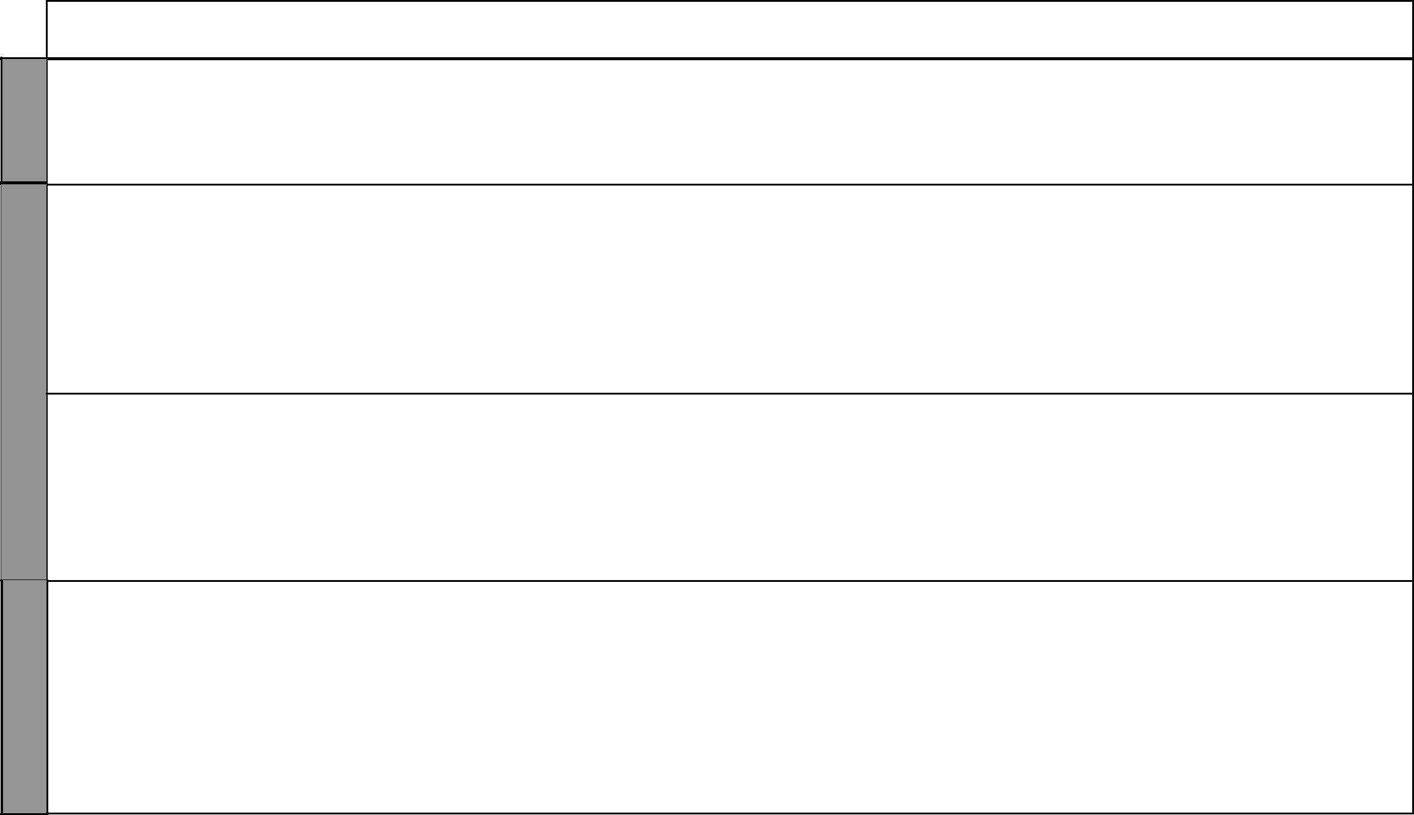
LESSON | TOPIC | SUB-TOPIC | OBJECTIVES | TEACHING/LEARNING | LEARNING/TEACHING | REMARKS
 |  |  |  | ACTIVITIES | RESOURCES
4 & 5 | Political | Struggle for | • explain the importance of the efforts | • Stating events in the involved in | Our Lives Today SST Book 6 page
 | develop- | independence | made in the struggle for independence. | the struggle | 137
 | ments |  |  | • Explaining why it was important to
 | and sys- |  |  | struggle
 | tems |  |  | • Taking notes
1 to 3 |  | Life and contribu- | The learners should be able to: | • Identifying the countries ruled by | Our Lives Today SST Book 6
 |  | tion of prominent | • describe the life & contribution of: | Haile Sellassie and Julius Nyerere | pages 138–139
 |  | heroes | (i) Haile Sellassie. | • Explaining the life and | • Pictures of Haile Sellassie
 |  | • Haile Sellasie | (ii) Julius Nyerere. | contribution of Haile Sellassie and | and Julius Nyerere
 |  | • Julius Nyerere | • explain the importance of their | Julius Nyerere for independence
 |  |  | contribution. | • Explaining the importance of their
 |  |  |  | contribution
 |  |  |  | • Taking notes
4 & 5 |  | Present systems of | The learners should be able to: | • Describing the system of | Our Lives Today SST Book 6
 |  | government | • describe the present systems in: | government in Uganda | pages 139–141
 |  |  | (i) Uganda. | • Describing the system of | • Comparison chart
 |  |  | (ii) Kenya. | government in Kenya | • Map of East Africa
 |  |  | • compare the two systems of | • Comparing the two systems of
 |  |  | government. | government
 |  |  |  | • Taking notes
1 to 5 |  | Regional | The learners should be able to: | • Defining the term regional bodies | Our Lives Today SST Book 6
 |  | co-operation | • explain the formation | • Naming the regional bodies in the | pages 141–145
 |  | • EAC | i. EAC. | East African region
 |  | • IGAD | ii. IGAD. | • Explaining the objectives of
 |  | • COMESA | iii. COMESA. | EAQC, IGAD and COMESA
 |  |  | • identify objectives of EAC, IGAD, | • Naming member countries of
 |  |  | COMESA. | each
 |  |  | • identify member countries of each. | • Explaining the problems of each
 |  |  | • state the problems facing EAC, | • Taking notes
 |  |  | IGAD and COMESA.

₂₀ For use with Our Lives Today Standard Six

Our Lives Today: Social Studies Standard Six

Schemes of Work

Term 3
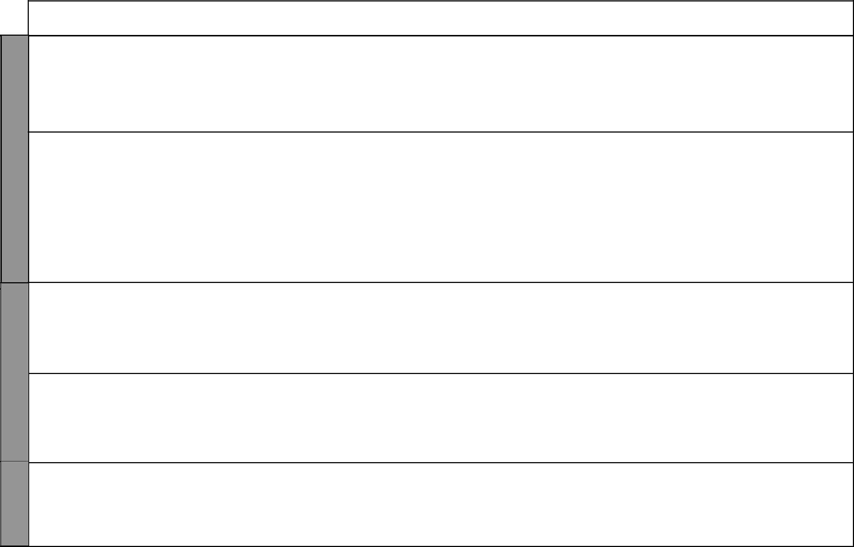

WEEK 7

WEEK 8

WEEK 9

LESSON | TOPIC | SUB-TOPIC | OBJECTIVES | TEACHING/LEARNING | LEARNING/TEACHING | REMARKS
 |  |  |  | ACTIVITIES | RESOURCES
1 to 3 | Citizen- | • Roles of citizens | The learners should be able to: | • Defining the term citizenship | Our Lives Today SST Book 6
 | ship | in government | • define citizenship. | • Stating the role of citizens in | pages 146–147
 |  | and civic life | • state their role in the government and | government and civic life
 |  | • Importance of | explain. | • Identifying the importance of
 |  | good citizenship | • identify the importance of good | good relations in society
 |  |  | relationship in society. | • Taking notes
4 & 5 | Democracy | • Types of | The learners should be able to: | • Defining forms of democracy and | Our Lives Today SST Book 6
 | and | democracy and | • identify types of human rights. | human rights | pages 148–149
 | Human | human rights | • define human rights and democracy. | • Naming and classifying human
 | Rights |  | • explain the importance of | rights
 |  | • Abuse of human | human rights. | • Explaining the importance of
 |  | rights | • identify areas where human rights | human rights
 |  |  | are abused. | • Identifying areas where human
 |  |  | • suggest methods of protecting | right are abused
 |  |  | human rights. | • Suggesting how human rights
 |  |  |  | should be protected
1 & 2 | Law, peace | Factors promoting | The learners should be able to: | • Defining the terms peace, law and | Our Lives Today SST Book 6
 | and | peace | • identify the factors promoting peace | reconciliation | pages 150–151
 | reconcilia- |  | in society. | • Identifying the factors promoting | • Pictures of people working
 | tion |  | • state the factors undermining peace. | peace in society
 | tion |  | • state the factors undermining peace. | • Stating the factors undermining
 |  |  | • explain the importance of peace in | • Stating the factors undermining
 |  |  | • explain the importance of peace in | peace
 |  |  | society. | peace
 |  |  | society. | • Explaining the importance of peace
3 & 5 | The Kenya | The Kenya | The learners should be able to | • Defining the term constitution | Our Lives Today SST Book 6
 |  |  |  |  | pages 152–153
 | govern- | constitution | • state the major elements of the Kenya | • Stating the elements of the Kenya | pages 152–153
 | ment |  | constitution. | constitution
 |  |  | • describe the importance of the Kenya | • Describing the importance of the
 |  |  | constitution. | Kenya constitution
 |  |  |  | • Taking notes
1 |  | Electoral process | The learners should be able to | • Defining the term elections | Our Lives Today SST Book 6
1 |  | Electoral process | The learners should be able to | • Defining the term elections | pages 153–155
 |  |  | • state the requirements of candidates | • Stating the requirements of | pages 153–155
 |  |  | in national elections. | candidates in national elections
 |  |  | • describe the electoral process. | • Describing the electoral process

₂₁ For use with Our Lives Today Standard Six

WEEK 9

WEEK 10

WEEKS 11 & 12
Our Lives Today: Social Studies Standard Six

Schemes of Work

Term 3
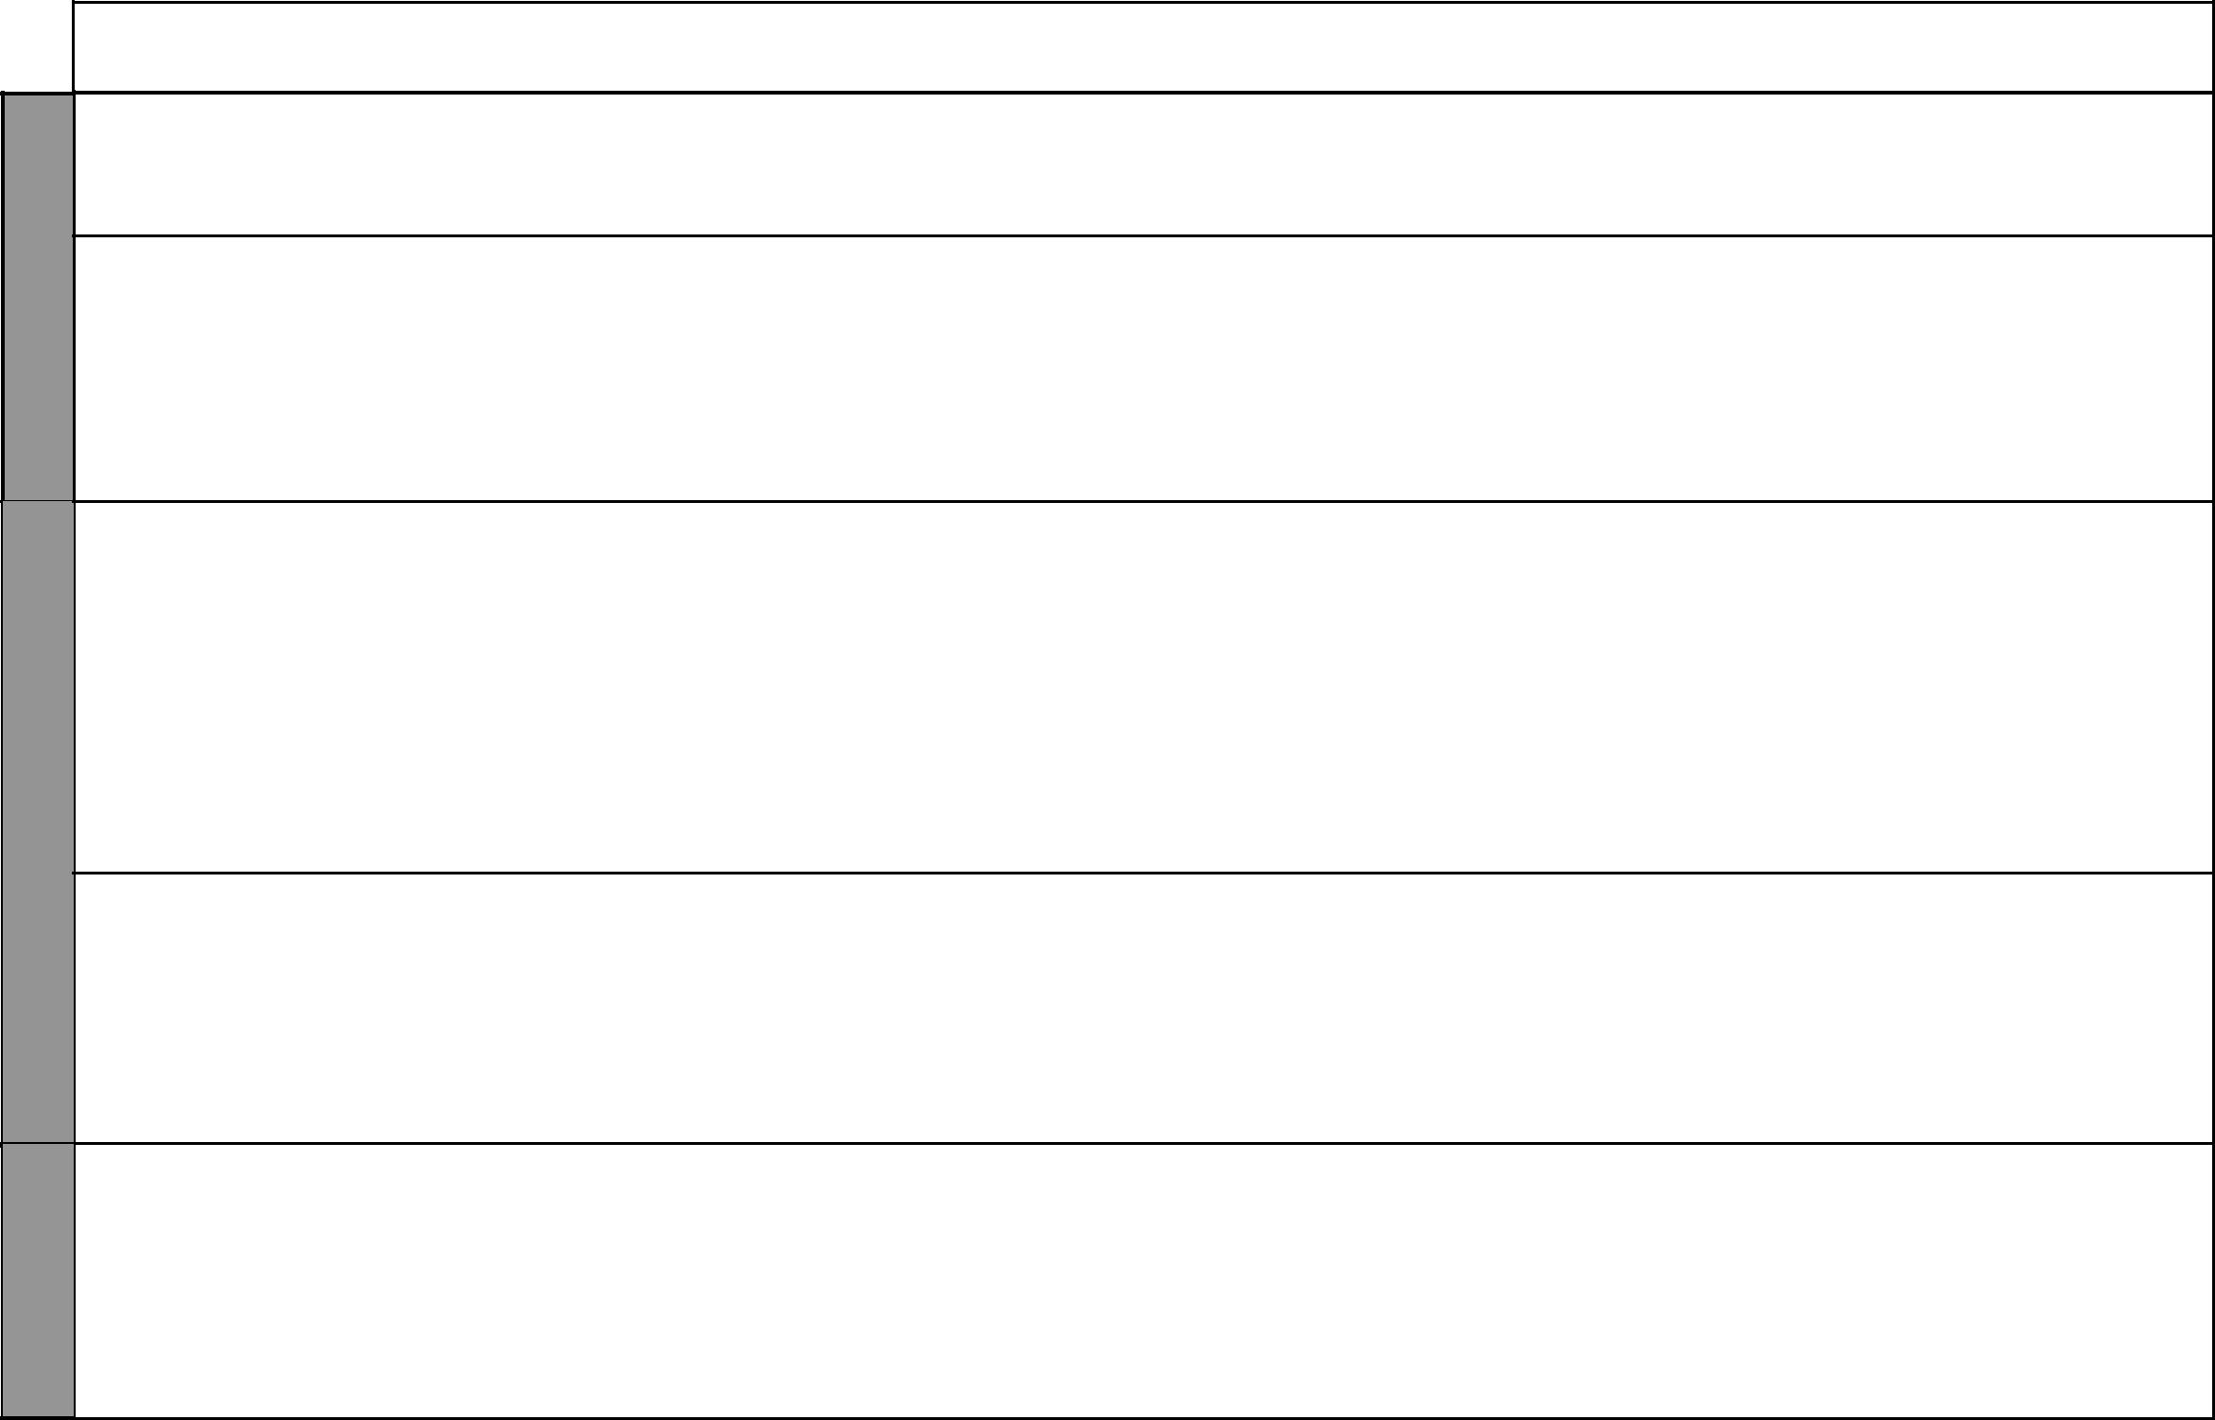
LESSON | TOPIC | SUB-TOPIC | OBJECTIVES | TEACHING/LEARNING | LEARNING/TEACHING | REMARKS
 |  |  |  | ACTIVITIES | RESOURCES
 | The Kenya |  | • explain the role of the Electoral | • Explaining the role of ECK in | • Pictures of ballot boxes,
 | govern- |  | Commission of Kenya in conducting | conducting election | voter cards
 | ment |  | elections. | • Taking notes | • Picture in the Pupil’s Book
2 to 5 |  | Formation of | The learners should be able to | • Defining the term elections | Our Lives Today SST Book 6
 |  | government | • describe how a government is formed | • Stating the requirements of | pages 156–158
 |  | • Three arms of | in Kenya. | candidates in national elections | • Chart showing the structure
 |  | government | • describe the composition of: | • Describing the electoral process | of Judiciary
 |  |  | i. Executive. | • Explaining the role of the ECK in | • Pictures of Parliament in
 |  |  | ii. Legislature. | conducting elections | session
 |  |  | iii. Judiciary. | • Taking notes
1 to 3 |  | Local Authorities | The learners should be able to: | • Defining the term local Authorities | Our Lives Today SST Book 6
 |  |  | • state types of Local Authorities. | • Naming the officers of local | pages 159–160
 |  |  | • explain how elections are conducted | authorities
 |  |  | • explain how elections are conducted | • Stating the types of Local
 |  |  | to elect officers in Local Authorities. | • Stating the types of Local
 |  |  | to elect officers in Local Authorities. | Authorities
 |  |  | • state the functions of Local | Authorities
 |  |  | • state the functions of Local | • Explaining how elections are
 |  |  | Authorities. | • Explaining how elections are
 |  |  | Authorities. | conducted for officers of Local
 |  |  |  | Authorities
 |  |  |  | • Stating the functions of Local
 |  |  |  | Authorities
 |  |  |  | • Taking notes
4 & 5 |  | National | The learners should be able to: | • Defining the national philosophies | • Our Lives Today SST Book 6
 |  | philosophies | • identify national philosophies | • Naming the national philosophies | pages 161–163
 |  | • Harambee | • explain the objectives of: | • Explaining the objectives of: | • Teacher’s own collection
 |  | • African Socialism | i. Harambee. | i. Harambee
 |  | • Nyayoism | ii. African socialism. | ii. Nyayoism
 |  |  | iii. Nyayoism. | iii. African socialism
 |  |  |  | • Taking notes
 |  |  | The learners should be able to revise | • Asking and answering questions | • Question papers/Written
 | Revision |  | the work covered during the term and | • Exams | questions
 | and |  | answer questions set on it. |  | • Writing materials
 | Exam

₂₂ For use with Our Lives Today Standard Six

