SOCIAL STUDIES SCHEME OF WORK CLASS 4

Available Online:
Schools Net Kenya Consultancy
P.O. Box 8076 – 00200 Nairobi, Kenya | Tel: +254202319748
E-mail: infosnkenya@gmail.com | www.schoolsnetkenya.com

Our Lives Today: Social Studies Standard Four Schemes of Work: Term One

WEEK 1

WEEK 2

 | LESSON | TOPIC | SUB-TOPICS |  | OBJECTIVES |  | TEACHING/LEARNING | TEACHING/LEARNING |  | REFERENCES | REMARKS
 |  |  |  |  |  |  | ACTIVITIES |  | RESOURCES
 | 1 | The physical | The eight | By the end of the lesson, the |  | - | Observing a compass | • | Real/improvised | Our Lives Today
 |  | environment | compass points | learner should be able to:- |  | - | Naming the eight compass |  | compass | SST Pupil’s Book 4
 |  |  |  | (i) | Name the eight |  | points |  |  | pages 2 – 3
 |  |  |  |  | compass points | - | Constructing the 8-point
 |  |  |  | (ii) | Use the eight compass |  | compass
 |  |  |  |  | points to describe the | - | Asking and answering
 |  |  |  |  | position of places |  | questions
 |  |  |  |  |  | - | Note taking
 | 2 – 5 | The physical | Position, size | By the end of the lesson, the |  | - | Observing a map of Kenya | • Map of Kenya showing |  | Our Lives Today
 |  | environment | and shape of | learner should be able to:- |  |  | and identifying the province |  | all provinces | SST Pupil’s Book 4
 |  |  | our province | (i) | Describe the position | - | Estimating the size of the | • | Chart showing the | pages 4 – 19
 |  |  |  |  | of their province |  | province |  | province
 |  |  |  | (ii) | Estimate the size of | - | Asking and answering
 |  |  |  |  | the province |  | questions
 |  |  |  | (iii) Draw the map of the |  | - | Drawing the map of the
 |  |  |  |  | province |  | province
 |  |  |  |  |  | - Making model of the province
 |  |  |  |  |  | - | Note taking
 | 1 – 2 | The physical | Districts | By the end of the lesson, the |  | - | Naming the districts in their | • A sketch map of our |  | Our Lives Today
 |  | environment | making up our | learner should be able to:- |  |  | province |  | province showing the | SST Pupil’s Book 4
 |  |  | province | (i) | Name the districts in | - | Observing a map of our |  | districts | pages 5 – 19
 |  |  |  |  | their province |  | province and identifying the
 |  |  |  |  |  |  | various districts
 |  |  |  |  |  | - | Asking and answering
 |  |  |  |  |  |  | questions
 |  |  |  |  |  | - | Note taking
 | 3 – 5 | The physical | Physical | By the end of the lesson, the |  | - | Observing a map of their | • A sketch map of our |  | Our Lives Today
 |  | environment | features:- | learner should be able to:- |  |  | province and identifying the |  | province showing the | SST Pupil’s Book 4
 |  |  | Importance | (i) | Identify and locate the |  | various physical features |  | main physical features | pages 20 – 54
 |  |  | of physical |  | major physical features | - | Discussing the importance of
 |  |  | features |  | in the province |  | physical features
 |  |  |  | (ii) | Appreciate the | - | Asking and answering
 |  |  |  |  | importance of physical |  | questions
 |  |  |  |  | features


1 For use with Our Lives Today Standard Four

WEEK 3

WEEK 4

WEEK 5
Our Lives Today: Social Studies Standard Four

Schemes of Work

Term 1
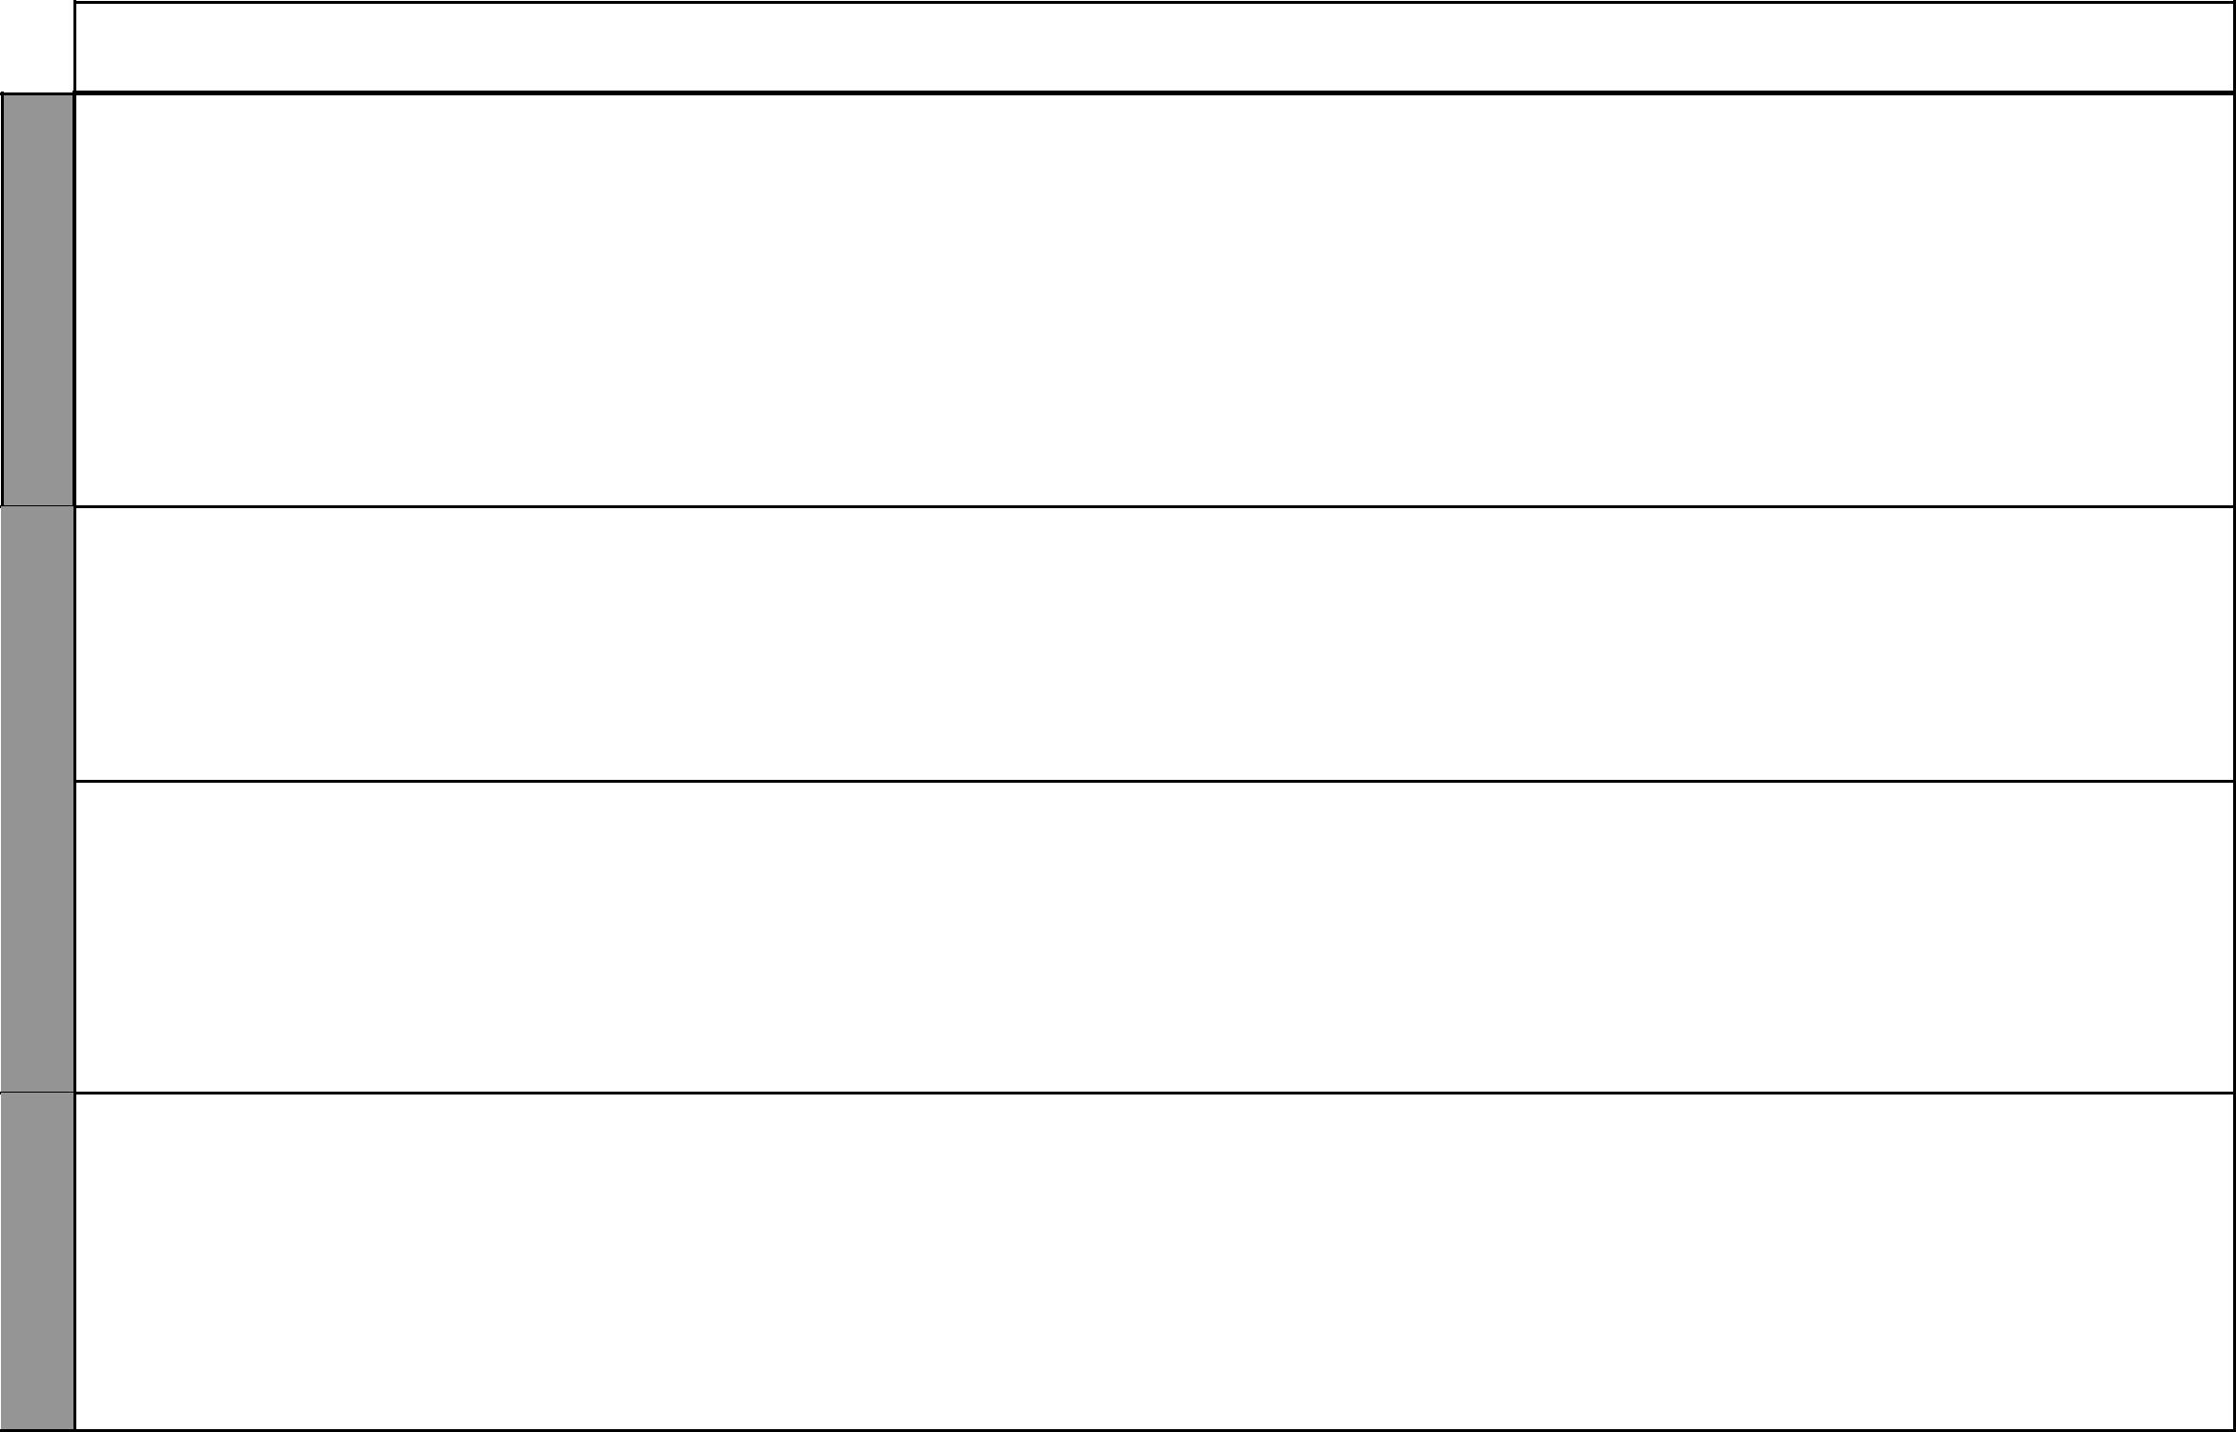
LESSON | TOPIC | SUB-TOPICS | OBJECTIVES |  | TEACHING/LEARNING | TEACHING/LEARNING |  | REFERENCES | REMARKS
 |  |  |  |  | ACTIVITIES |  | RESOURCES
1 – 5 | The physical | Vegetation | By the end of the lesson, the | - | Observing a map of their | • A map showing the |  | Our Lives Today
 | environment |  | learner should be able to: |  | province showing the main |  | physical features | SST Pupil’s Book 4
 |  |  | (i) Identify the main |  | vegetation type | • A sketch map of our |  | pages 55 – 74
 |  |  | vegetation in the | - | Identifying the vegetation |  | province showing where
 |  |  | province |  | types |  | different vegetation lies
 |  |  | (ii) State the importance | - | Discussing the importance of | • | A chart listing
 |  |  | of vegetation |  | various types of vegetation |  | the importance of
 |  |  |  | - | Asking and answering |  | vegetation
 |  |  |  |  | questions | • Cut-out pictures on soil
 |  |  |  |  |  |  | erosion
 |  |  |  |  |  | • | Local environment
1 |  |  | By the end of the lesson, the | - | Defining the term weather | • A chart showing the |  | Our Lives Today
1 | The physical | Elements of | learner should be able to: | - | Stating the various elements |  | elements of weather | SST Pupil’s Book 4
 | environment | weather | (i) Define weather |  | of weather | • Pictures in the Pupil’s |  | pages 75 – 76
 |  |  | (ii) Identify and list down | - | Discussing the elements of |  | Book
 |  |  | the main elements of |  | weather | • | Local environment
 |  |  | weather | - | Asking and answering
 |  |  |  |  | questions
2 – 5 | The physical | Instruments | By the end of the lesson, the | - | Naming the weather- | • A chart with different |  | Our Lives Today
 | environment | used to | learner should be able to: |  | measuring instruments |  | weather-measuring | SST Pupil’s Book 4
 |  | measure | (i) Name the various | - | Identifying the instruments |  | instruments | pages 76 – 78
 |  | weather | weather instruments | - | Discussing the use of each of | • Pictures in the Pupil’s
 |  |  | (ii) Explain what each of |  | the instruments |  | Book
 |  |  | the instruments is used | - | Drawing the weather | • | Real weather-measuring
 |  |  | to measure |  | instruments |  | apparatus
 |  |  |  | - Visiting a weather station
1 – 4 | The physical | Weather | By the end of the lesson, the | - | Observing various elements of | • A chart showing simple |  | Our Lives Today
 | environment | records and | learner should be able to: |  | weather |  | drawn weather records | SST Pupil’s Book 4
 |  | weather chart | (i) Observe, measure | - | Measuring the elements of | • | Weather measuring | pages 79 – 81
 |  |  | and record various |  | weather using the appropriate |  | instruments
 |  |  | elements of weather |  | instruments
 |  |  | (ii) Make simple records | - | Recording the elements of
 |  |  | of weather |  | weather
 |  |  | (iii) Make simple weather | - | Making simple records and
 |  |  | charts |  | charts of weather

2 For use with Our Lives Today Standard Four

Our Lives Today: Social Studies Standard Four

Schemes of Work

Term 1

WEEK 5

WEEK 6

WEEK 8 WEEK 7

LESSON | TOPIC | SUB-TOPICS |  | OBJECTIVES |  | TEACHING/LEARNING | TEACHING/LEARNING |  | REFERENCES | REMARKS
 |  |  |  |  |  | ACTIVITIES |  | RESOURCES
5 | The physical | Influence | By the end of the lesson, the |  | - | Discussing how weather | • | Cut-out pictures showing | Our Lives Today
 | environment | of weather | learner should be able to: |  |  | influences human activities |  | floods and destruction of | SST Pupil’s Book 4
 |  | on human | (i) | State how weather | - | Asking and answering |  | trees | pages 82 – 84
 |  | activities |  | influences human |  | questions | • Pictures in the Pupil’s
 |  |  |  | activities |  |  |  | Book
 |  |  |  |  |  |  | • | Local environment
1 | People and | Main language | By the end of the lesson, the |  | - | Stating the various language | • Cut-out pictures of a |  | Our Lives Today
 | population | groups | learner should be able to:- |  |  | groups |  | meeting or gathering | SST Pupil’s Book 4
 |  |  | (i) | Identify the main | - | Discussing the language |  | during a national day | page 86
 |  |  |  | language groups in the |  | groups
 |  |  |  | province | - | Asking and answering written
 |  |  |  |  |  | questions
 |  |  |  |  | - Asking and answering oral
 |  |  |  |  |  | questions
2 – 5 | People and | The districts in | By the end of the lesson, the |  | - | Naming the areas occupied by | • A sketch map of our |  | Our Lives Today
 | population | which language | learner should be able to: |  |  | different language groups |  | province showing the | SST Pupil’s Book 4
 |  | groups are | (i) | Identify the settlement | - | Observing a map of our |  | districts and places where | pages 87 – 95
 |  | found |  | areas of the language |  | province and identifying |  | language groups are
 |  |  |  | groups |  | various settlement areas |  | settled
 |  |  |  |  | - Asking and answering oral
 |  |  |  |  |  | questions
 |  |  |  |  | - | Taking notes
1 – 5 | People and | Population | By the end of the lesson, the |  | - | Discussing about the | • | Map showing population | Our Lives Today
 | population | distribution in | learner should be able to: |  |  | population distribution in the |  | distribution | SST Pupil’s Book 4
 |  | the province | (i) | Identify the districts |  | province | • A sketch map of our |  | pages 95 – 99
 |  |  |  | where the language | - | Asking and answering |  | province showing the
 |  |  |  | groups in the province |  | questions |  | population distribution
 |  |  |  | are found
1 – 5 | People and | Factors | By the end of the lesson, the |  | - | Naming some of the factors | • A chart showing the main |  | Our Lives Today
 | population | influencing | learner should be able to: |  |  | that influence population |  | factors that influence | SST Pupil’s Book 4
 |  | population | (i) | Identify the factors |  | distribution |  | population distribution | pages 99 – 102
 |  | distribution |  | that influence | - | Explaining the above factors | • | Local environment
 |  |  |  | population | - Asking and answering questions
 |  |  |  | population | - | Note taking
 |  |  |  | distribution | - | Note taking
 |  |  |  | distribution | - | Story telling


3 For use with Our Lives Today Standard Four

WEEK 9

WEEK 10
Our Lives Today: Social Studies Standard Four

Schemes of Work

Term 1

LESSON | TOPIC | SUB-TOPICS | OBJECTIVES |  | TEACHING/LEARNING | TEACHING/LEARNING |  | REFERENCES | REMARKS
 |  |  |  |  | ACTIVITIES |  | RESOURCES
1 | People and | Great names in | By the end of the lesson, the | - | Naming examples of great | • Pictures in the Pupil’s |  | Our Lives Today
 | population | the province | learner should be able to: |  | people in the society |  | Book 4 | SST Pupil’s Book 4
 |  |  | (i) Identify the great | - | Discussing these great names | • | Resource person | pages 103 – 115
 |  |  | names in the province |  | in the society
 |  |  |  | - | Observing pictures
 |  |  |  | - | Story telling
2 – 5 | People and | Contribution | By the end of the lesson, the | - | Stating the contribution of the | • A chart listing the main |  | Our Lives Today
 | population | of the great | learner should be able to: |  | great names in the province |  | contribution of the great | SST Pupil’s Book 4
 |  | people | (i) State the contribution | - | Discussing the contribution of |  | people in our province | pages 103 – 115
 |  |  | of the great names in |  | the great names | • | Resource person
 |  |  | the province | - | Asking and answering
 |  |  | (ii) Appreciate the |  | questions
 |  |  | contribution of the | - | Note taking
 |  |  | great names in the
 |  |  | society
1 | Social | Moral laws | By the end of the lesson, the | - | Stating the cultural activities | • Pictures of some cultural |  | Our Lives Today
 | relations |  | learner should be able to: |  | among different people in our |  | activities in the Pupil’s | SST Pupil’s Book 4
 | and cultural |  | (i) Identify the moral laws |  | province |  | Book 4 | page 116
 | activities |  | in the society | - | Stating the social relations | • | Resource person
 |  |  | (ii) Explain how moral |  | among the people of our
 |  |  | laws were used in |  | province
 |  |  | moulding the society
2 | Social | Moral laws | By the end of the lesson, the | - | Explaining how moral laws | • A chart listing some of |  | Our Lives Today
 | relations |  | learner should be able to: |  | were used in the society |  | the moral laws of the | SST Pupil’s Book 4
 | and cultural |  | (i) Explain how moral | - | Explaining the importance of |  | people of our province | pages 116 – 118
 | activities |  | laws were used in |  | morals in the society | • | Resource person
 |  |  | moulding the society | - | Asking and answering
 |  |  | (ii) Appreciate the |  | questions
 |  |  | importance of moral
 |  |  | laws in the society


4 For use with Our Lives Today Standard Four

Our Lives Today: Social Studies Standard Four

Schemes of Work

Term 1
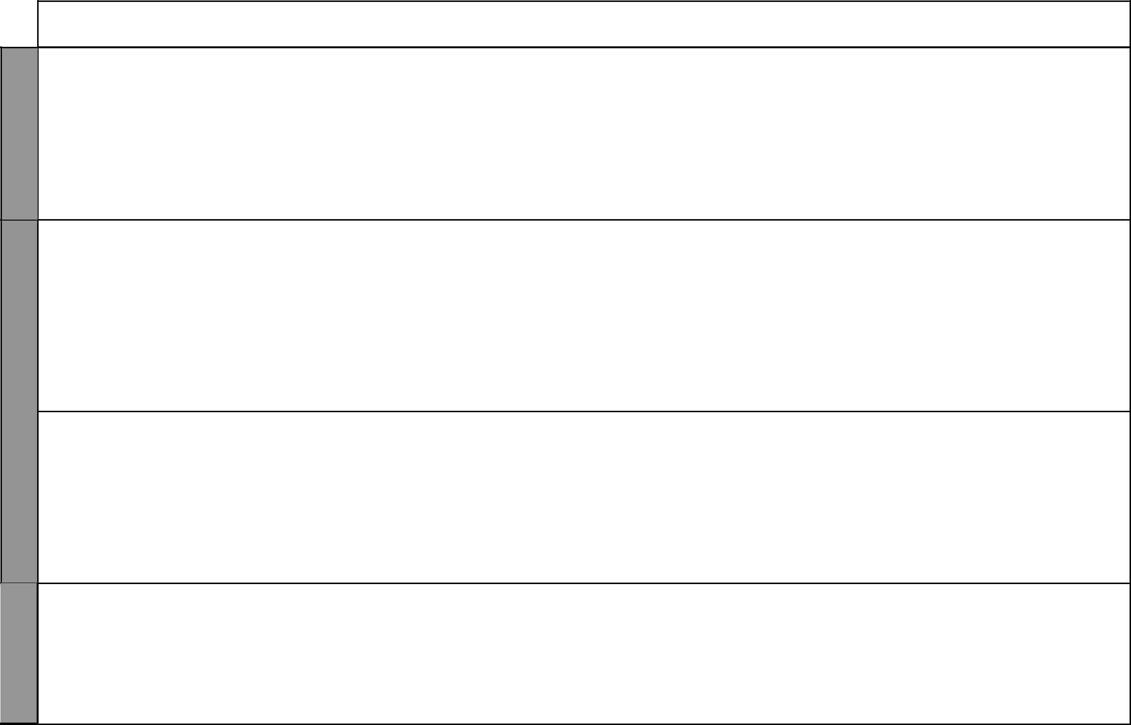

WEEK 10

WEEK 11

WEEK 12

LESSON | TOPIC | SUB-TOPICS |  | OBJECTIVES |  | TEACHING/LEARNING | TEACHING/LEARNING |  | REFERENCES | REMARKS
 |  |  |  |  |  | ACTIVITIES |  | RESOURCES
3 – 5 | Social | Culture in our | By the end of the lesson, the |  | - Defining the term culture |  | • | Pictures showing | Our Lives Today
 | relations | province | learner should be able to: |  | - Stating the various aspects of |  |  | activities | SST Pupil’s Book 4
 | and cultural |  | (i) | Define the term |  | culture | • Dances of some of our |  | pages 118 – 130
 | activities |  |  | culture | - Discussing various aspects of |  |  | people in our provinces
 |  |  | (ii) | State the various |  | our culture | • Cultural items found in
 |  |  |  | aspects of culture | - | Observing some cultural |  | the area
 |  |  | (iii) Describe the culture |  |  | activities/items of the people
 |  |  |  | of the people in the | - | Drawing some items
 |  |  |  | province
1 – 3 | Social | Ceremonies and | By the end of the lesson, the |  | - | Naming the various | • | Cut-out pictures | Our Lives Today
 | relations | festivals | learner should be able to: |  |  | ceremonies and festivals |  | showing some of the | SST Pupil’s Book 4
 | and cultural |  | (i) | Identify the various | - | Discussing the above |  | ceremonies performed | pages 131 – 137
 | activities |  |  | ceremonies and |  | ceremonies and festivals |  | among the people of our
 |  |  |  | festivals held in the | - | Asking and answering |  | province
 |  |  |  | province |  | questions | • Pictures in the Pupil’s
 |  |  | (ii) | Appreciate the rate | - | Taking notes |  | Book
 |  |  |  | of the ceremonies
 |  |  |  | and festivals in the
 |  |  |  | community
4 – 5 | Social | Traditional | By the end of the lesson, the |  | - Giving examples of medicine |  | • Cut out pictures of some |  | Our Lives Today
 | relations | medicine people | learner should be able to: |  |  | people in our society |  | of some of our tradition | SST Pupil’s Book 4
 | and cultural |  | (i) | Name examples of | - Discussing the work of the |  |  | medicine people | pages 137 – 139
 | activities |  |  | medicine people in the |  | medicine people in our society | • | Resource person
 |  |  |  | province | - Giving the equivalents of the |  | • Samples of herbs used
 |  |  | (ii) | Identify and appreciate |  | medicine people in our current |  | by the traditional
 |  |  |  | the role played by the |  | society |  | medicine people
 |  |  |  | traditional medicine
 |  |  |  | people
1 – 2 | Social | Traditional | By the end of the lesson, the |  | - Naming examples of prophets |  | • | Cut-out pictures | Our Lives Today
 | relations | prophets and | learner should be able to: |  |  | and rain makers in our society |  | showing some of our | SST Pupil’s Book 4
 | and cultural | rain makers | (i) | Name examples of | - Discussing the work of the |  |  | traditional Prophets and | pages 140 – 142
 | activities |  |  | prophets and rain |  | prophets and rain makers |  | rain makers
 | activities |  |  | makers in their society |  | prophets and rain makers |  | rain makers
 |  |  | (ii) | makers in their society | - | Asking and answering | • | Resource persons
 |  |  | (ii) | Identify and appreciate |  | questions
 |  |  |  | the role played by these |  | questions
 |  |  |  | the role played by these | - | Taking notes
 |  |  |  | people

5 For use with Our Lives Today Standard Four

WEEK 12

WEEK 13
Our Lives Today: Social Studies Standard Four

Schemes of Work

Term 1
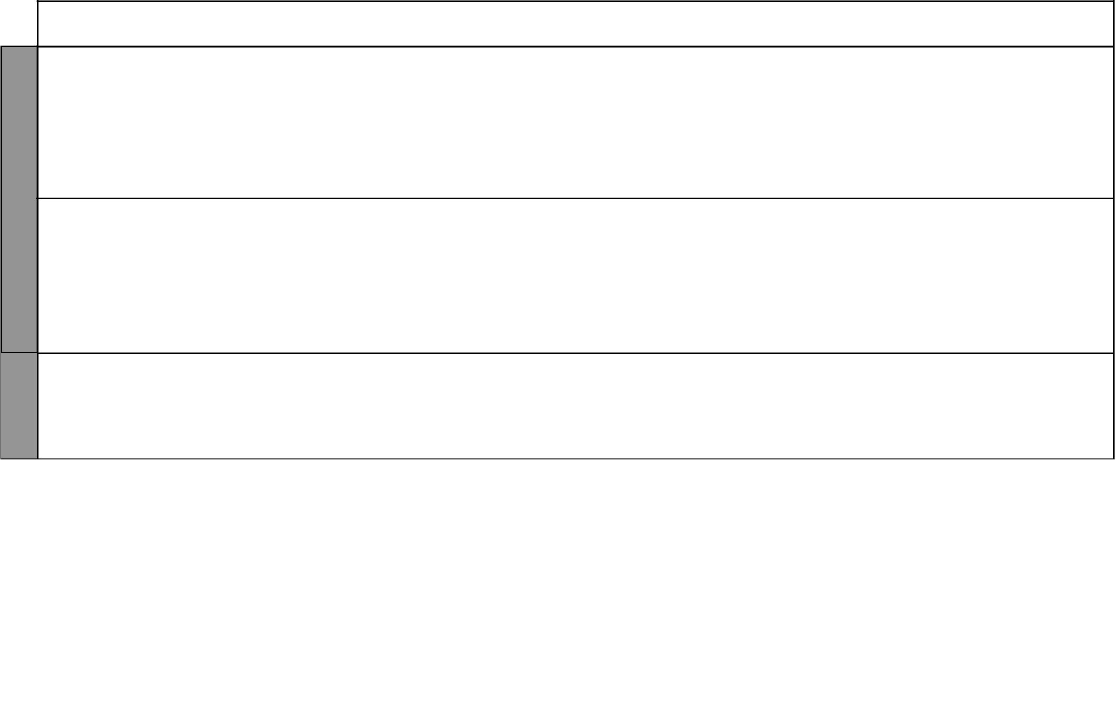
LESSON | TOPIC | SUB-TOPICS | OBJECTIVES |  | TEACHING/LEARNING | TEACHING/LEARNING |  | REFERENCES | REMARKS
 |  |  |  |  | ACTIVITIES |  | RESOURCES
3 | Social | Working | By the end of the lesson, the | - Discussing the various types |  | • | Pictures showing people | Our Lives Today
 | relations | together for the | learner should be able to: |  | of work that people can do |  | working together | SST Pupil’s Book 4
 | and cultural | benefit of the | (i) State the importance |  | together in a community | • Picture in the Pupil’s |  | pages 143 – 144
 | activities | community | of working together | - Explaining the benefits of |  |  | Book
 |  |  | for the benefit of the |  | working together
 |  |  | community | - | Taking notes
 |  |  | (ii) Give examples shared
 |  |  | activities
4 – 5 | Social | The family | By the end of the lesson, | - Naming types of families |  | • | Local environment | Our Lives Today
 | relations |  | the learner should be able | - | Asking and answering | • | Illustrations in the | SST Pupil’s Book 4
 | and cultural |  | to: |  | questions |  | Pupil’s Book | pages 145 – 149
 | activities |  | (i) State types of families | - Drawing the family tree
 |  |  | (ii) Draw the family tree | - Dramatizing roles of family
 |  |  | (iii) Identify the roles and |  | members
 |  |  | responsibilities of
 |  |  | family members
1 – 5 | Revision and | Revision and | By the end of the lesson, | - | Writing the test | • | Question papers | Our Lives Today
 | exams | exams | the learner should be able | - | Reviewing the test |  |  | SST Pupil’s Book 4
 |  |  | to answer questions based
 |  |  | on the work covered

6 For use with Our Lives Today Standard Four

Our Lives Today: Social Studies Standard Four Schemes of Work: Term Two

 |  | LESSON | TOPIC | SUB-TOPICS | OBJECTIVES |  | TEACHING/LEARNING | TEACHING/LEARNING | REFERENCES | REMARKS
 |  |  |  |  |  |  | ACTIVITIES | RESOURCES
 | 1 | 1 – 5 | Resources | Agriculture: | By the end of the lesson, the | - Naming examples of food |  | • Sketch map of our | Our Lives Today
 | 1 |  | and | The main cash | learner should be able to: |  | crops grown in the province | province showing main | SST Pupil’s Book 4
 | WEEK |  | and | The main cash | learner should be able to: |  | crops grown in the province | province showing main | SST Pupil’s Book 4
 | WEEK |  | economic | and food crops | (i) Name the cash crops | - Stating the places where they |  | areas of different cash | pages 150 – 157
 |  |  | activities |  | and food crops in the |  | are grown | crops and food crops
 |  |  |  |  | province | - Observing a map of our
 |  |  |  |  | (ii) State where the crops |  | province
 |  |  |  |  | are grown | - | Taking notes
 |  | 1 – 2 | Resources | Agriculture: | By the end of the lesson, the | - Stating the uses of various |  | • A chart listing the main | Our Lives Today
 |  |  | and | Uses of crops | learner should be able to: |  | food crops grown in the | cash crops and food | SST Pupil’s Book 4
 |  |  | economic |  | (i) State the uses of the |  | province | crops in our province | pages 157 – 158
 |  |  | activities |  | crops grown in the | - | Asking and answering | • Real crops such as
 |  |  |  |  | province |  | questions | coffee, tea and cotton
 | 2 | 3 | Resources | Agriculture: | By the end of the lesson, the | - Stating the importance of |  | • Real cash crops such as, | Our Lives Today
 | 2 |  | and | Contribution | learner should be able to: |  | growing food crops and cash | cotton, coffee, tea etc. | SST Pupil’s Book 4
 | WEEK |  | and | Contribution | learner should be able to: |  | growing food crops and cash | cotton, coffee, tea etc. | SST Pupil’s Book 4
 | WEEK |  | economic | of crops to the | (i) Outline the |  | crops |  | pages 158 – 159
 |  |  | activities | economy | contribution of the | - | Asking and answering
 |  |  |  |  | crops to the economy |  | questions
 |  | 4 – 5 | Resources | Agriculture: | By the end of the lesson, the | - Identifying areas where beef |  | • Map of the province | Our Lives Today
 |  |  | and | Beef farming | learner should be able to: |  | farming is practised | showing areas of beef | SST Pupil’s Book 4
 |  |  | economic |  | (i) Identify areas where | - Drawing a map showing beef |  | farming | pages 159 – 161
 |  |  | activities |  | beef farming is |  | farming areas
 |  |  |  |  | practised
 |  |  |  |  | (ii) State the importance
 |  |  |  |  | of beef farming
 |  | 1 – 2 | Resources | Agriculture: | By the end of the lesson, the | - Stating places where dairy |  | • A sketch map of our | Our Lives Today
 |  |  | and | Dairy farming | learner should be able to: |  | farming is done in the | province showing areas | SST Pupil’s Book 4
 |  |  | economic |  | (i) Identify areas where |  | province | where dairy farming is | pages 161 – 162
 | 3 |  | activities |  | dairy farming is | - | Discussing about dairy | practised
 | WEEK |  |  |  | practised in our |  | farming
 | WEEK |  |  |  | province | - Discussing a map showing
 |  |  |  |  | (ii) State the importance |  | dairy farming areas
 |  |  |  |  | of dairy farming

7 For use with Our Lives Today Standard Four

WEEK 3

WEEK 4

WEEK 5
Our Lives Today: Social Studies Standard Four

Schemes of Work

Term 2
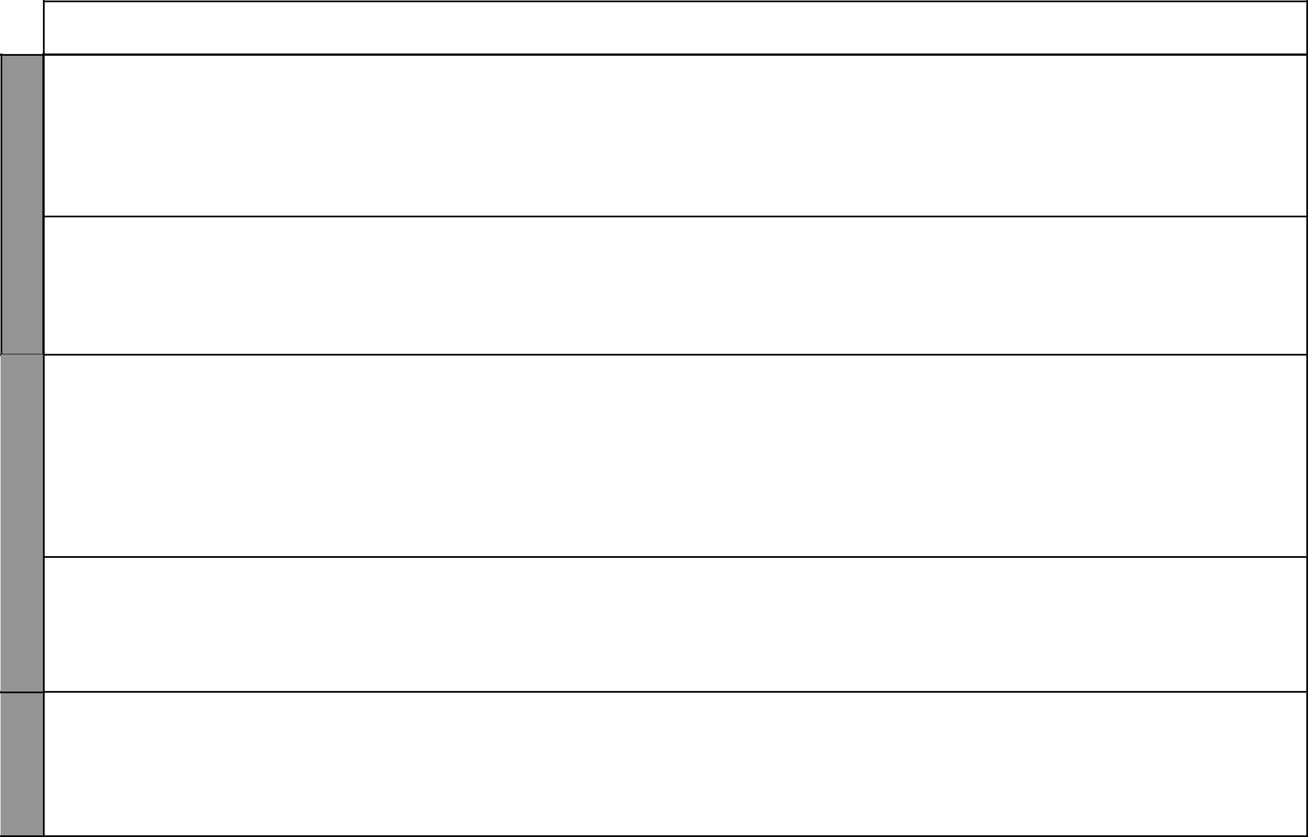
LESSON | TOPIC | SUB-TOPICS | OBJECTIVES |  | TEACHING/LEARNING | TEACHING/LEARNING |  | REFERENCES | REMARKS
 |  |  |  |  | ACTIVITIES |  | RESOURCES
3 – 4 | Resources | Agriculture: | By the end of the lesson, the | - | Stating areas where poultry | • | Sketch map showing | Our Lives Today
 | and | Poultry farming | learner should be able to: |  | farming is practised |  | areas where poultry | SST Pupil’s Book 4
 | economic |  | (i) Identify areas where | - | Discussing about poultry |  | farming is practised | pages 162 – 164
 | activities |  | poultry farming is |  | farming in the province | • | Relevant pictures
 |  |  | practised
 |  |  | (ii) State the importance
 |  |  | of poultry farming
5 | Resources | Forests: | By the end of the lesson, | - | Defining the term forests | • A map showing the |  | Our Lives Today
 | and | Types of | the learner should be able | - | Stating the various types of |  | forested areas of our | SST Pupil’s Book 4
 | economic | Forests | to identify the various types |  | forests |  | country | page 165
 | activities |  | of forests | - | Discussing the above forests | • | Local environment | Primary Atlas
 |  |  |  | - | Naming some forests known | • | Atlas
 |  |  |  |  | by learners
1 – 4 | Resources | Forestry: | By the end of the lesson, the | - | Observing a map of our | • A sketch map of our |  | Our Lives Today
 | and | Distribution of | learner should be able to: |  | province and identifying the |  | province showing where | SST Pupil’s Book 4
 | economic | forests | (i) Give the names of the |  | major forests |  | major forests are located | pages 166 – 168
 | activities |  | major forests in our | - | Discussing the reasons why
 |  |  | province |  | the forests are located in the
 |  |  | (ii) Locate the major |  | areas
 |  |  | forests in our province | - | Drawing a map of our
 |  |  |  |  | province and indicating the
 |  |  |  |  | main forested areas
5 | Resources | Forestry: | By the end of the lesson, the | - | Naming the various types of | • | Pictures showing | Our Lives Today
 | and | Uses of trees | learner should be able to |  | trees |  | the uses of trees e.g. | SST Pupil’s Book 4
 | economic |  | state the uses of trees | - | Stating the uses of these trees |  | building houses, making | page 169
 | activities |  |  | - | Asking and answering |  | furniture, etc.
 |  |  |  |  | questions
 |  |  |  | - | Observing pictures
 | Resources | Forestry: | By the end of the lesson, the | - | Defining the term | • Pictures in the Pupil’s |  | Our Lives Today
 | and | Deforestation | learner should be able to: |  | deforestation |  | Book | SST Pupil’s Book 4
 | economic |  | (i) Define the term | - | Stating the effects of | • | Local environment | page 170
 | activities |  | deforestation |  | deforestation
 | activities |  | (ii) State the effects of | - | Discussing the effect of
 |  |  | deforestation |  | deforestation
 |  |  |  | - | Taking notes

8 For use with Our Lives Today Standard Four

Our Lives Today: Social Studies Standard Four

Schemes of Work

Term 2
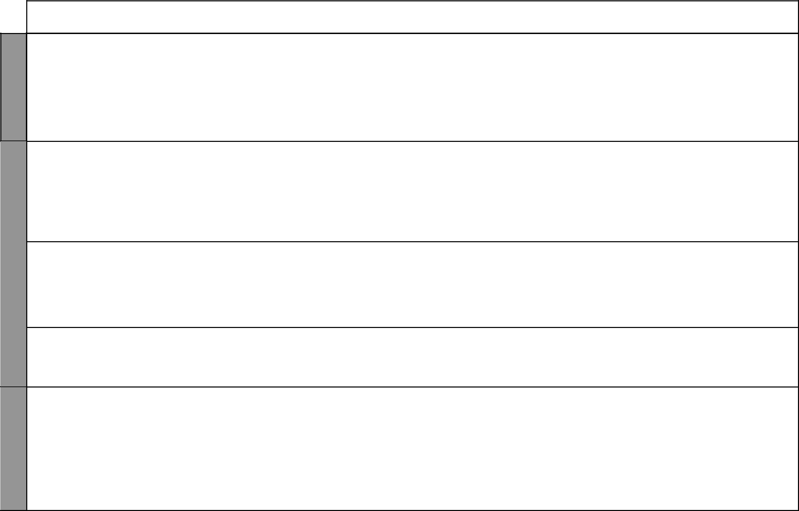

WEEK 6

WEEK 7

WEEK 8

LESSON | TOPIC | SUB-TOPICS | OBJECTIVES |  | TEACHING/LEARNING | TEACHING/LEARNING |  | REFERENCES | REMARKS
 |  |  |  |  | ACTIVITIES |  | RESOURCES
1 – 5 | Resources | Forestry: | By the end of the lesson, the | - Explaining various ways of |  | • | Pictures showing people | Our Lives Today
 | and | Forest | learner should be able to: |  | conserving forests |  | planting tress | SST Pupil’s Book 4
 | economic | conservation | (i) State the importance | - | Asking and answering | • Pictures in the Pupil’s |  | pages 170 – 171
 | activities | measures | of conserving our |  | questions |  | Book
 |  |  | forests | - | Taking notes | • | Resource person
 |  |  | (ii) Develop a sense | - | Tree planting/nursery
 |  |  | of responsibility in |  | preparation
 |  |  | conserving forests
1 & 2 | Resources | Wildlife and | By the end of the lesson, | - Naming various types of |  | • Cut out pictures of |  | Our Lives Today
 | and | tourism: | the learner should be able |  | animals and birds |  | different wildlife | SST Pupil’s Book 4
 | economic | Types of | to identify various types of | - | Observing pictures | • | Local environment | pages 172 – 173
 | activities | animals and | wild animals and birds | - Discussing various types of
 |  | birds |  |  | animal and birds
 |  |  |  | - Observing birds and animals
 |  |  |  |  | found in the local area
3 & 4 | Resources | Wildlife and | By the end of the lesson, | - Naming major game reserves |  | • A map showing the major |  | Our Lives Today
 | and | tourism: | the learner should be able |  | and national parks |  | national parks and game | SST Pupil’s Book 4
 | economic | Major game | to name and locate the | - | Observing a map |  | reserves | pages 174 – 175
 | activities | parks and | major game parks and | - Drawing a map showing |  | • Map in the Pupil’s Book
 |  | national parks | reserves in our province |  | major game parks and
 |  |  |  |  | national parks
5 | Resources | Wildlife and | By the end of the lesson, | - | Observing pictures | • | Resource person | Our Lives Today
 | and | tourism: | the learner should be able |  |  | • | Newspaper cuttings | SST Pupil’s Book 4
 | economic | Importance of | to explain the importance |  |  |  |  | pages 175 – 176
 | activities | wildlife | of wildlife
1 | Resources | Wildlife and | By the end of the lesson, | - | Stating various wildlife | • | Cut-out pictures showing | Our Lives Today
 | and | tourism: | the learner should be |  | conservation measures |  | the fencing of wildlife | SST Pupil’s Book 4
 | economic | Wildlife | able to identify wildlife | - | Discussing conservation |  | areas | pages 176 – 177
 | activities | conservation | conservation measures |  | measures | • Also cut-out pictures of
 |  | measures |  | - | Taking notes |  | the game rangers

9 For use with Our Lives Today Standard Four

LESSON

2 & 3

8 | 4
WEEK | 4
 | 5

1 – 3

9
WEEK | 4 – 5

Our Lives Today: Social Studies Standard Four

Schemes of Work

Term 2
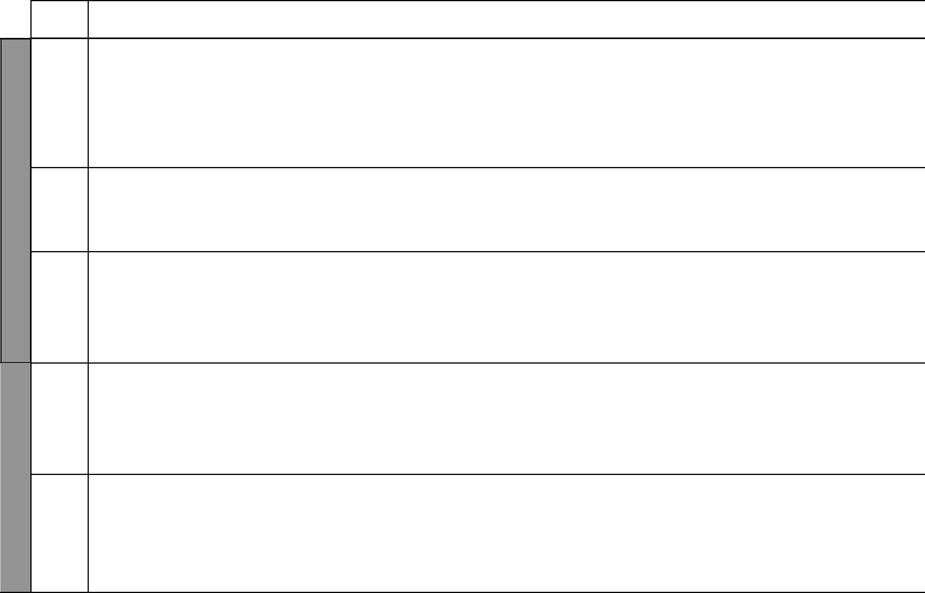
TOPIC | SUB-TOPICS |  | OBJECTIVES |  | TEACHING/LEARNING | TEACHING/LEARNING |  | REFERENCES | REMARKS
 |  |  |  |  | ACTIVITIES |  | RESOURCES
Resources | Wildlife and | By the end of the lesson, |  | - | Discussing the various tourist | • | Cut-out pictures of | Our Lives Today
and | tourism: | the learner should be able |  |  | attractions in our province like |  | hotels in our game | SST Pupil’s Book 4
economic | Tourist | to name major tourist |  |  | wildlife, scenery, historical |  | reserves and national | pages 177 – 180
activities | attractions | attractions in our province |  |  | sites, marine parks, landscapes |  | parks
 |  |  |  |  | etc. | • | Cut-out pictures
 |  |  |  | - | Taking notes |  | of tourists taking
 |  |  |  |  |  |  | photographs in our
 |  |  |  |  |  |  | wildlife areas
Resources | Wildlife and | By the end of the lesson, |  | - | Stating the importance of | • | A chart listing | Our Lives Today
and | tourism: | the learner should be able |  |  | tourism |  | main points on the | SST Pupil’s Book 4
economic | Importance of | to state the importance of |  | - | Discussing the importance of |  | importance of tourism | page 180
activities | tourism | tourism |  |  | tourism in groups | • | Resource person
 |  |  |  | - | Taking notes | • | Local environment
Resources | Industries: | By the end of the lesson, the |  | - | Naming examples of | • | Pictures showing the | Our Lives Today
and | Traditional | learner should be able to |  |  | traditional industries like |  | products of some of the | SST Pupil’s Book 4
economic | industries | name the various examples |  |  | pottery, weaving, curving and |  | traditional industries | page 181
activities |  | of traditional industries |  |  | iron-working | • Pictures in the Pupil’s
 |  |  |  | - | Asking and answering |  | Book
 |  |  |  |  | questions
 |  |  |  | - | Taking notes
Resources | Industries: | By the end of the lesson, the |  | - | Observing a map of our | • | Pictures showing | Our Lives Today
and | Traditional | learner should be able to: |  |  | province and locating the |  | workers in our local | SST Pupil’s Book 4
economic | industries | (i) | Locate the traditional |  | various traditional industries |  | industries | pages 181 – 191
activities |  |  | industries | - | Discussing the work and | • Pictures in the Pupil’s
 |  | (ii) | Name the products |  | products of these industries |  | Book
 |  |  | made from the | - | Taking notes | • | Realia
 |  |  | traditional industries
Resources | Industries: | By the end of the lesson, the |  | - | Stating reasons for the establi- | • | Cut-out pictures | Our Lives Today
and | Jua Kali | learner should be able to: |  |  | shment of Jua Kali industries |  | displaying the Jua Kali | SST Pupil’s Book 4
economic | Industries | (i) | State the reason | - | Visiting a Jua Kali site |  | industries | SST Pupil’s Book 4
 |  |  |  |  |  |  | industries | pages 191 – 192
activities |  |  | that led to the | - | Observing items made in the | • Items made in Jua Kali |  | pages 191 – 192
 |  |  | establishment of Jua |  | Jua Kali industries |  | industries
 |  |  | establishment of Jua |  | Jua Kali industries | • | Realia
 |  |  | Kali industries | - | Discussing the products made | • | Realia
 |  | (ii) | Name the products |  | from Jua Kali industries | • Pictures of some of the
 |  | (ii) | Name the products |  | from Jua Kali industries |  | products of the Jua Kali
 |  |  | made from Jua Kali | - | Asking and answering |  | products of the Jua Kali
 |  |  | made from Jua Kali | - | Asking and answering |  | industries in the Pupil’s
 |  |  | industries |  | questions |  | Book
 |  |  |  |  | 10 |  | For use with Our Lives Today Standard Four

Our Lives Today: Social Studies Standard Four

Schemes of Work

Term 2
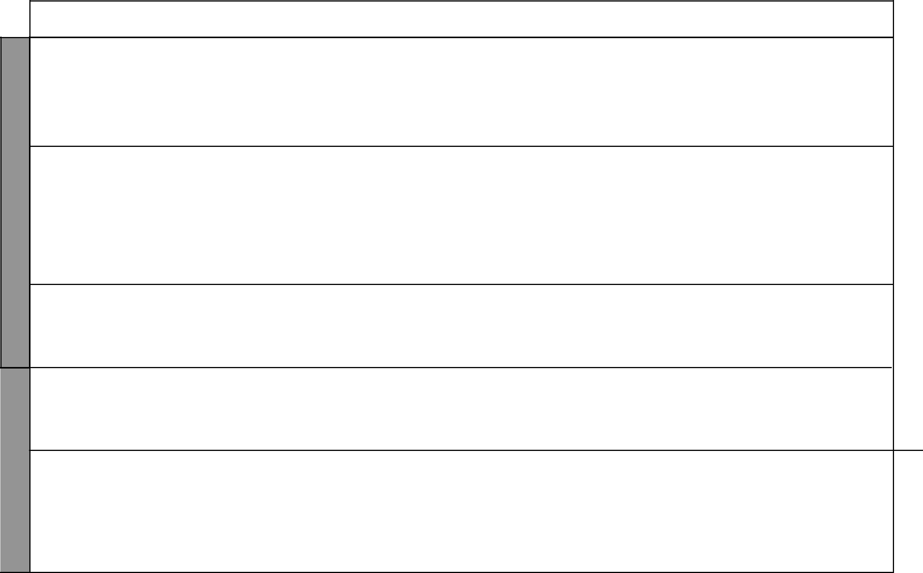

WEEK 10

WEEKWEEK12 11

LESSON | TOPIC | SUB-TOPICS | OBJECTIVES |  | TEACHING/LEARNING | TEACHING/LEARNING |  | REFERENCES | REMARKS
 |  |  |  |  | ACTIVITIES |  | RESOURCES
1 – 2 | Resources | Trade: | By the end of the lesson, the | - | Stating the various forms of | • | Pictures showing a | Our Lives Today
 | and | Traditional | learner should be able to: |  | traditional trade |  | market place where items | SST Pupil’s Book 4
 | economic | forms of trade | (i) Describe traditional | - | Discussing the various forms |  | are exchanged | pages 193 – 194
 | activities |  | forms of trade |  | of traditional trade | • Cut-out pictures of the
 |  |  | (ii) Name items of trade in | - | Naming the items used in |  | items of trade in the
 |  |  | the traditional trade |  | traditional trade |  | traditional way
 |  |  |  | - Observing the items of trade
3 | Resources | Trade: | By the end of the lesson, | - | Describing the inter- | • Pictures in the Pupil’s |  | Our Lives Today
 | and | Intercommunity | the learner should be able |  | community trade in the |  | Book | SST Pupil’s Book 4
 | economic | trade | to:- |  | province | • Map of the provinces |  | pages 195 – 198
 | activities |  | (i) Explain what | - | Observing pictures
 |  |  | intercommunity trade | - | Naming communities that
 |  |  | means |  | traded
 |  |  | (ii) Describe the inter- | - | Naming market centres
 |  |  | community trade in
 |  |  | the province
4 & 5 | Resources | Trade: | By the end of the lesson, | - | Naming major trading centres | • Table in the Pupil’s |  | Our Lives Today
 | and | Major trading | the learner should be able |  | and towns |  | Book | SST Pupil’s Book 4
 | economic | centres and | to name major trading | - | Observing a table in the | • | Learner’s own | pages 198 – 199
 | activities | towns | centres and towns |  | Pupil’s Book |  | experiences
 |  |  |  | - | Copying the table
1 | Resources | Trade: | By the end of the lesson, | - | Identifying problems facing | • Pictures in the Pupil’s |  | Our Lives Today
 | and | Problems facing | the learner should be |  | trade |  | Book | SST Pupil’s Book 4
 | economic | trade in the | able to identify problems | - | Demonstrating barter trade | • | Learner’s own | page 200
 | activities | province | facing trade in the | - | Taking notes |  | experiences
 |  |  | province | - | Observing pictures | • | Resource person
2 | Resources | Transport and | By the end of the lesson, | - | Stating the traditional forms | • Pictures in the Pupil’s |  | Our Lives Today
 | and | communication: | the learner should be able |  | of transport |  | Book | SST Pupil’s Book 4
 | economic | Traditional | to state traditional forms | - | Observing pictures | • | Traditional forms of | pages 201 – 202
 | activities | forms of | of transport | - | Listing forms of traditional |  | transport in the local
 |  | transport |  |  | transport |  | community
 |  |  |  | - | Story telling | • | Local environment

11 For use with Our Lives Today Standard Four

WEEK 11

WEEK 12
Our Lives Today: Social Studies Standard Four

Schemes of Work

Term 2
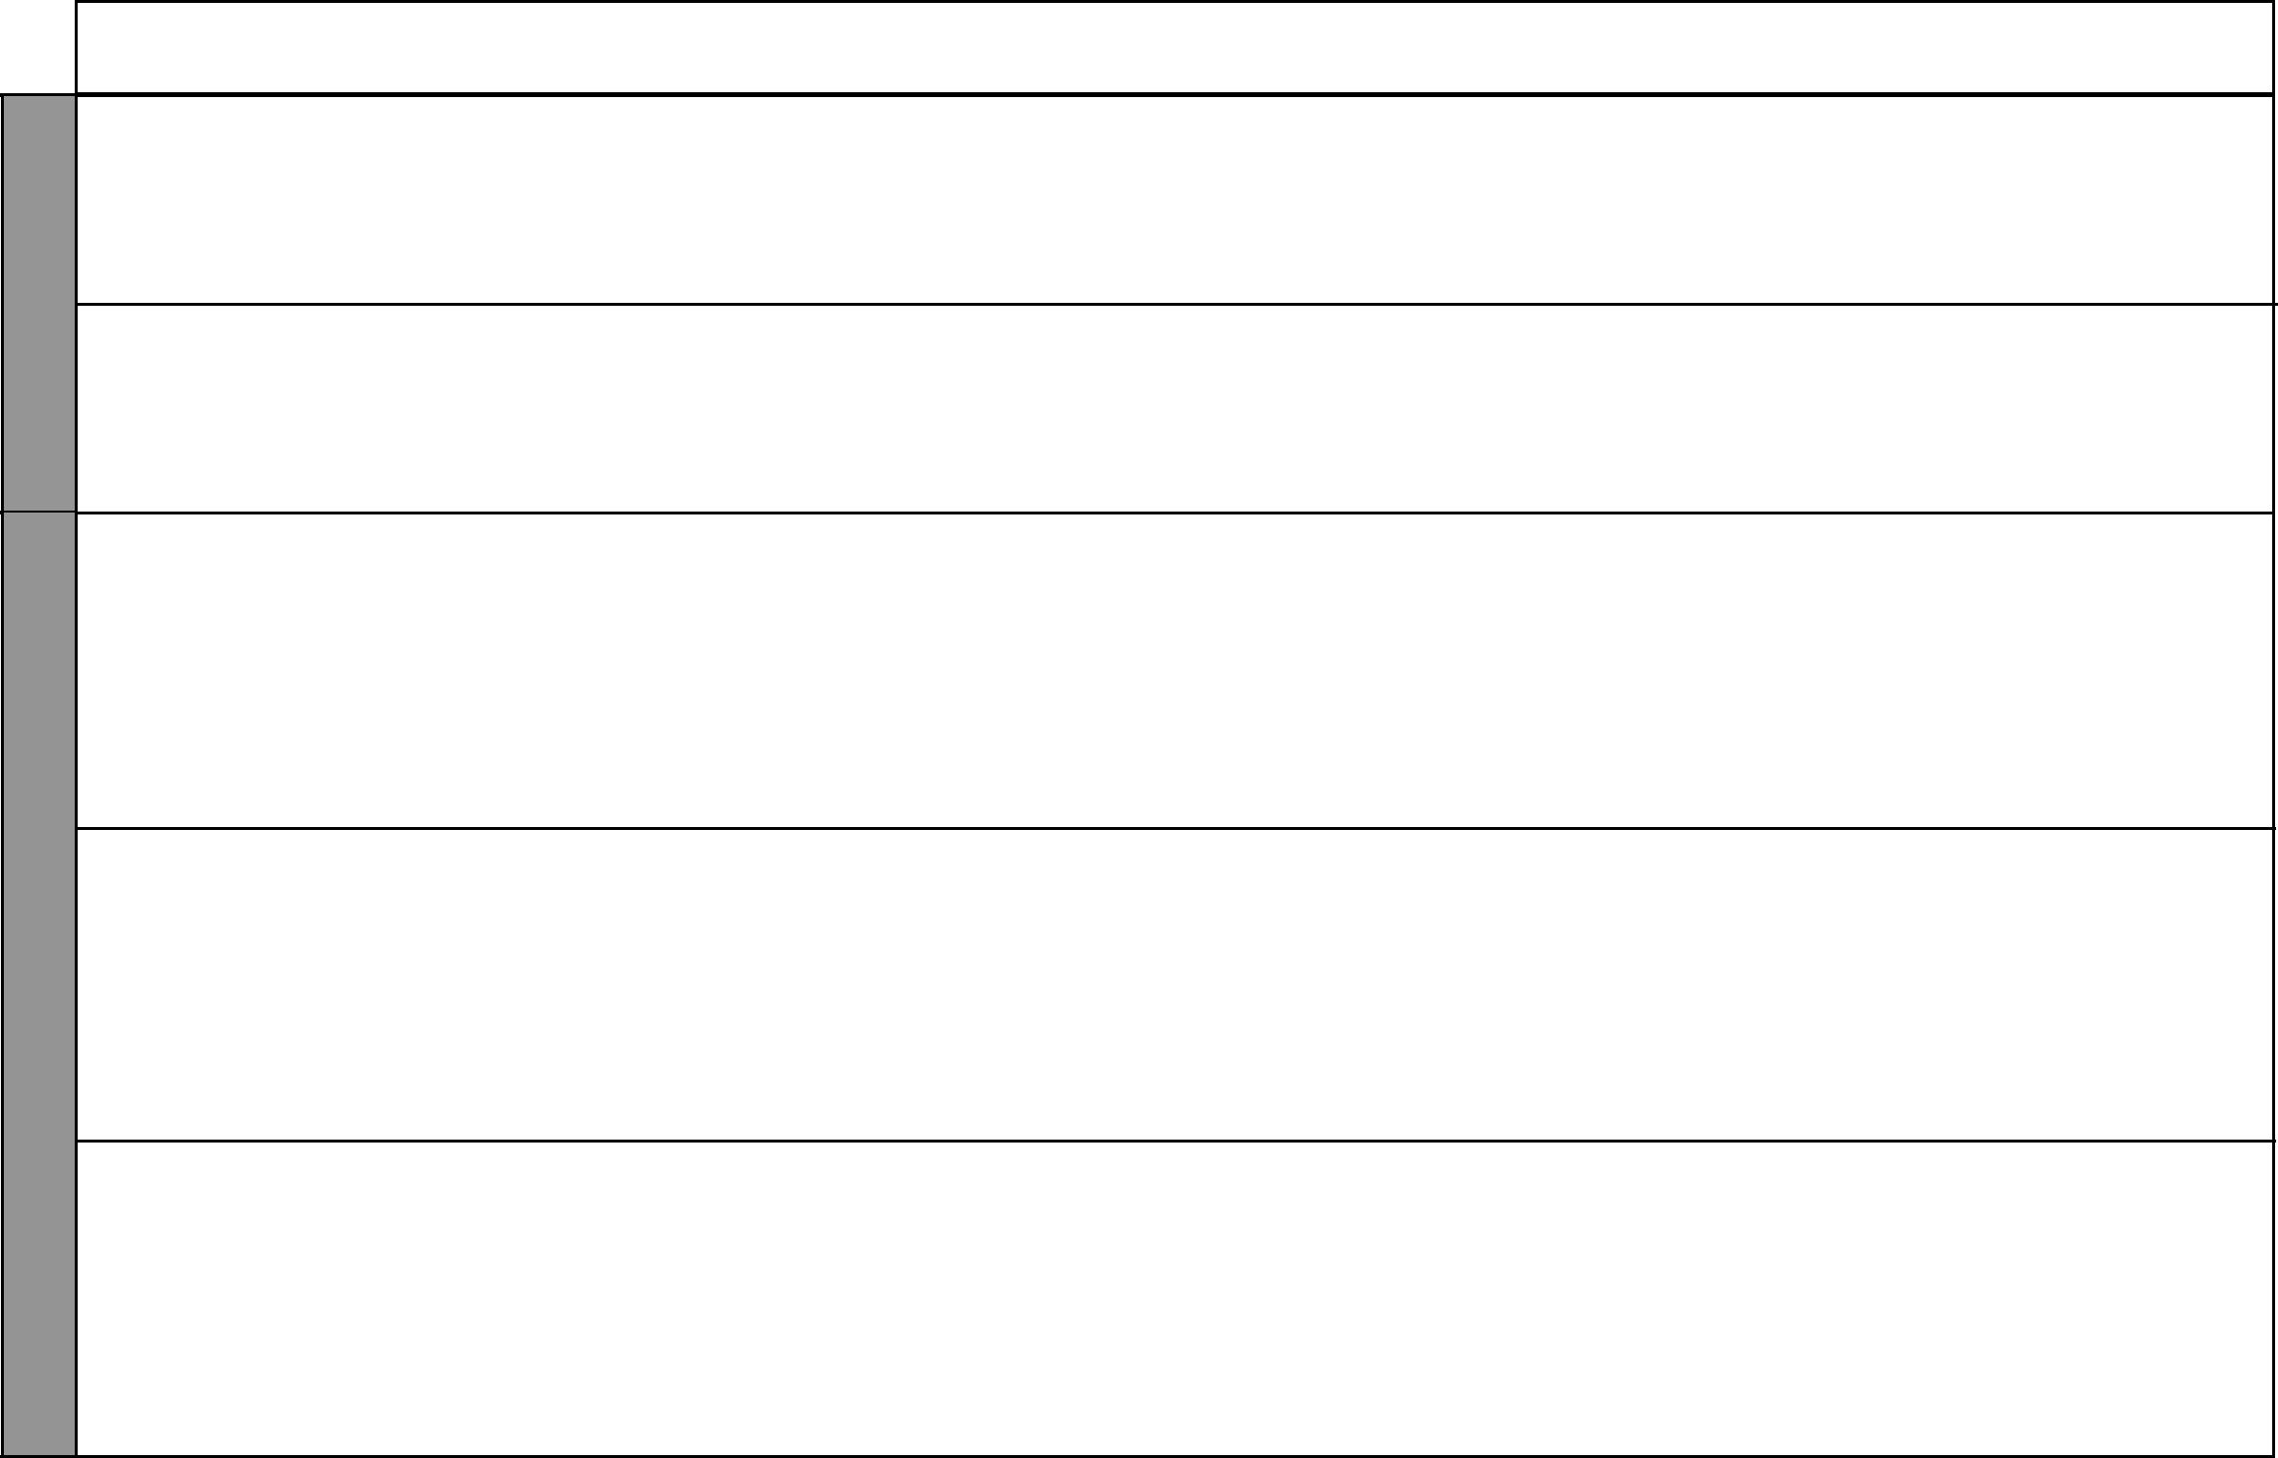
LESSON | TOPIC | SUB-TOPICS | OBJECTIVES |  | TEACHING/LEARNING | TEACHING/LEARNING |  | REFERENCES | REMARKS
 |  |  |  |  | ACTIVITIES |  | RESOURCES
3 & 4 | Resources | Transport and | By the end of the lesson, | - | Describing modern forms of | • Pictures in the Pupil’s |  | Our Lives Today
 | and | communication: | the learner should be able |  | transport |  | Book | SST Pupil’s Book 4
 | economic | Modern forms | to describe modern forms | - | Observing pictures | • Chart in the Pupil’s |  | pages 202 – 208
 | activities | of transport | of transport | - | Taking notes |  | Book
 |  |  |  |  |  | • | Local environment
5 | Resources | Transport and | By the end of the lesson, | - | Identifying major road signs | • Pictures of road signs |  | Our Lives Today
 | and | communication: | the learner should be able | - | Observing pictures of road | • Road signs in the Pupil’s |  | SST Pupil’s Book 4
 | economic | Road safety | to identify major road |  | signs |  | Book | pages 208 – 212
 | activities |  | signs | - | Drawing and labelling road
 |  |  |  |  | signs
1 & 2 | Resources | Transport and | By the end of the lesson, | - | Stating the causes of road | • Pictures in the Pupil’s |  | Our Lives Today
 | and | communication: | the learner should be able |  | accidents |  | Book | SST Pupil’s Book 4
 | economic | Causes of road | to: | - | Observing pictures | • | Pictures e.g. bumps | pages 210 – 212
 | activities | accidents | (i) State the causes of | - | Suggesting ways of preventing
 |  |  | road accidents |  | road accidents
 |  |  | (ii) Suggest ways of | - | Taking notes
 |  |  | preventing road | - | Group discussions
 |  |  | accidents
3 | Resources | Transport and | By the end of the lesson, | - | Listing traditional forms of | • Pictures in the Pupil’s |  | Our Lives Today
 | and | communication: | the learner should be able |  | communication |  | Book | SST Pupil’s Book 4
 | economic | Traditional | to list traditional forms of | - | Explaining traditional forms of | • Real items e.g. drums, |  | pages 213 – 215
 | activities | forms of | communication |  | communication |  | horns
 |  | communication |  | - | Taking notes
 |  |  |  | - | Observing pictures
 |  |  |  | - | Drawing traditional
 |  |  |  |  | instruments
4 – 5 | Resources | Transport and | By the end of the lesson, | - | Listing modern forms of | • | Radio | Our Lives Today
 | and | communication: | the learner should be able |  | communication | • | Pictures | SST Pupil’s Book 4
 | economic | Modern | to list the modern forms | - | Observing pictures | • | Newspapers | pages 215 – 219
 | activities | forms of | of communication | - | Listing types of messages | • | Magazines
 |  | communication |  |  | communicated through the
 |  |  |  |  | radio

12 For use with Our Lives Today Standard Four

Our Lives Today: Social Studies Standard Four

Schemes of Work

Term 2
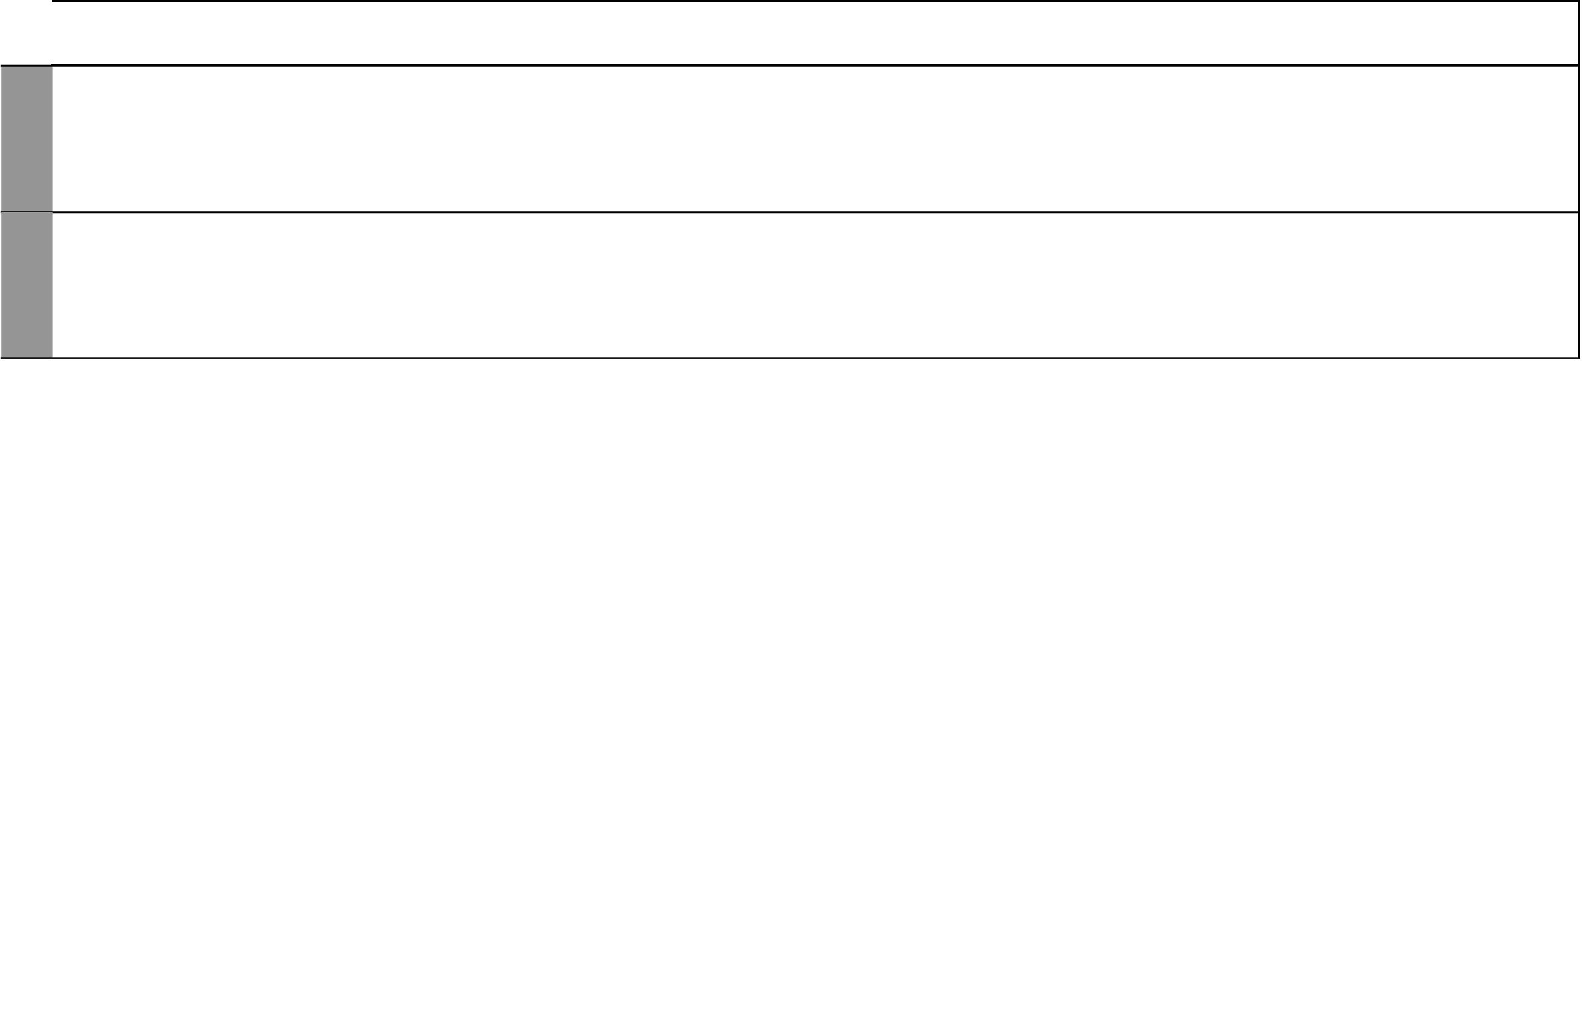

WEEK 14 WEEK 13

LESSON | TOPIC | SUB-TOPICS | OBJECTIVES |  | TEACHING/LEARNING | TEACHING/LEARNING |  | REFERENCES | REMARKS
 |  |  |  |  | ACTIVITIES |  | RESOURCES
1 – 5 | Exam | Revision | By the end of the lesson, | - | Writing the test | • | Question papers | Our Lives Today
 |  |  | the learner should be able | - | Revising the test |  |  | SST Pupil’s Book 4
 |  |  | to answer questions based
 |  |  | on the work covered
1 – 5 | Revision | Revision | By the end of the lesson, | - Discussing the test done |  | • | Test done | Our Lives Today
 |  |  | the learner should be able |  |  |  |  | SST Pupil’s Book 4
 |  |  | to revise the test

13 For use with Our Lives Today Standard Four

Our Lives Today: Social Studies Standard Four Schemes of Work: Term Three
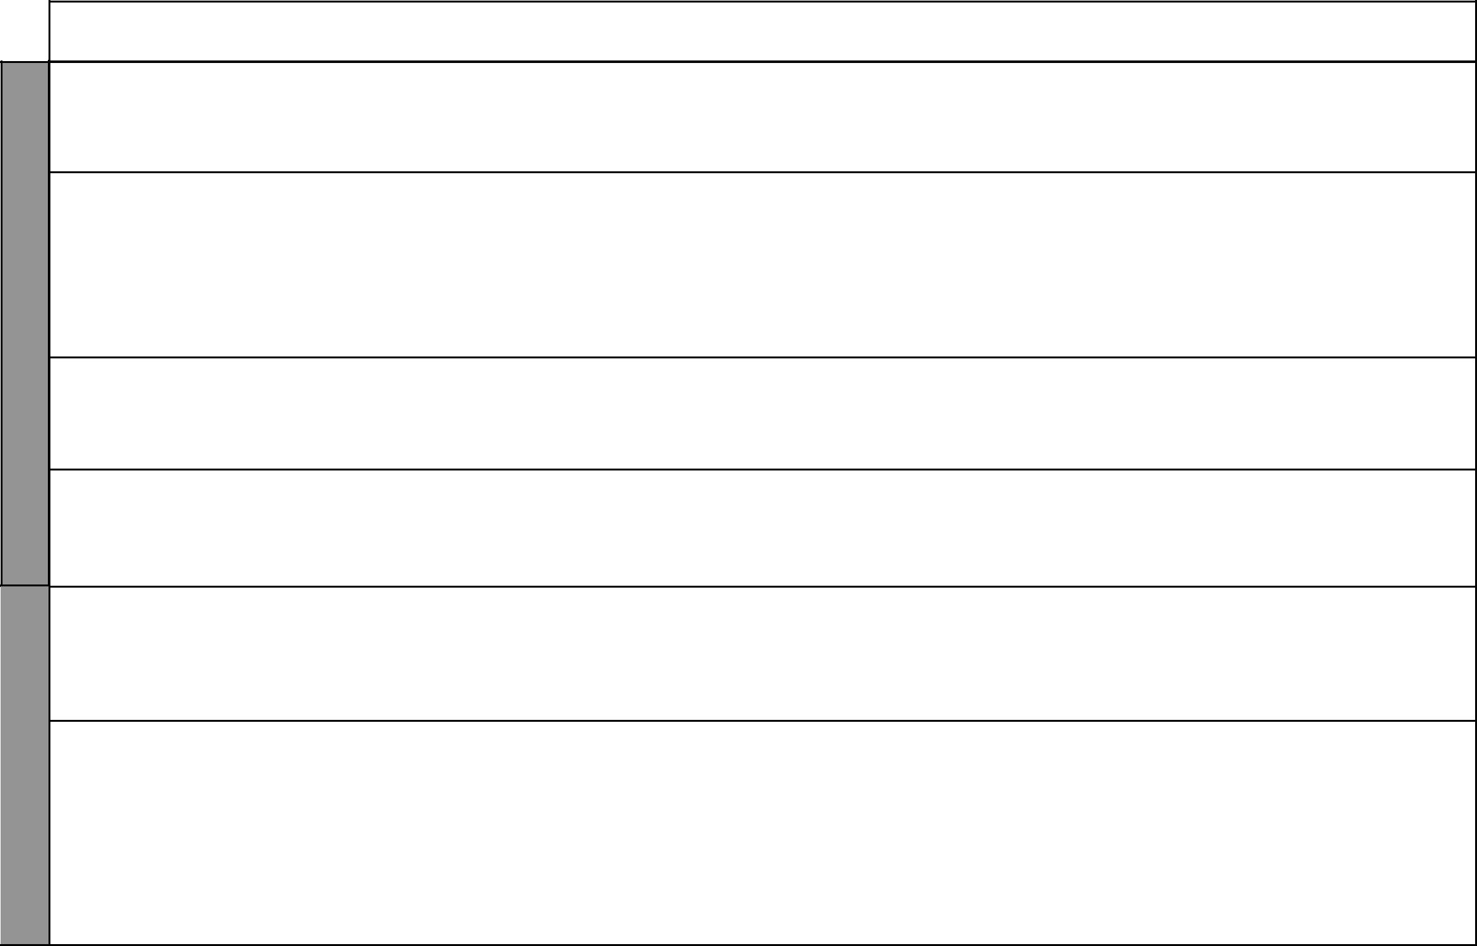

WEEK 1

WEEK 2

LESSON | TOPIC | SUB-TOPICS | OBJECTIVES |  | TEACHING/LEARNING | TEACHING/LEARNING |  | REFERENCES | REMARKS
 |  |  |  |  | ACTIVITIES |  | RESOURCES
1 | Citizenship | Becoming a | By the end of the lesson, | - | Stating how one becomes a | • Sample of the birth |  | Our Lives Today
 |  | Kenyan citizen | the learner should be able |  | Kenyan citizen |  | certificate | SST Pupil’s Book 4
 |  |  | to state how one becomes |  |  | • | National ID Card | page 222
 |  |  | a Kenyan citizen
2 | Citizenship | Elements of | By the end of the lesson, | - | Identifying responsibilities of | • A chart showing a list of |  | Our Lives Today
 |  | good citizenship | the learner should be able |  | a good citizen |  | the responsibilities of a | SST Pupil’s Book 4
 |  |  | to: | - | Taking notes |  | good citizen | pages 222 – 223
 |  |  | (i) Demonstrate traits of a | - | Dramatization | • | Relevant pictures
 |  |  | good citizen
 |  |  | (ii) Identify responsibilities
 |  |  | of a good citizen
3 | Citizenship | Traits of a good | By the end of the lesson, | - | Giving traits of a good citizen | • A list with the traits of a |  | Our Lives Today
 |  | citizen | the learner should be able | - | Discussing various traits |  | good citizen | SST Pupil’s Book 4
 |  |  | to give the traits of a good |  |  |  |  | pages 223 – 224
 |  |  | citizen
4 – 5 | Citizenship | Responsibilities | By the end of the lesson, | - | Stating duties of a good | • A list of the duties of a |  | Our Lives Today
 |  | of a good citizen | the learner should be able |  | citizen |  | good citizen | SST Pupil’s Book 4
 |  |  | to state the duties of a | - | Discussing some of the duties | • | Resource person | page 224
 |  |  | good citizen |  | expected of a good citizen
1 & 2 | Democracy | The meaning of | By the end of the lesson, | - | Defining democracy | • Picture in the Pupil’s |  | Our Lives Today
 | and human | democracy | the learner should be able | - | Writing down the definition |  | Book | SST Pupil’s Book 4
 | rights |  | to define democracy | - | Asking and answering |  |  | page 226
 |  |  |  |  | questions
 |  |  |  | - | Demonstrations/illustrations
3 – 5 | Democracy | Importance of | By the end of the lesson, | - | Explaining the importance of | • A picture showing a |  | Our Lives Today
 | and human | democracy | the learner should be able |  | democracy |  | meeting being addressed | SST Pupil’s Book 4
 | rights |  | to explain the importance | - | Asking and answering |  | by a leader | pages 226 – 227
 |  |  | of democracy |  | questions
 |  |  |  | - | Taking notes

14 For use with Our Lives Today Standard Four

Our Lives Today: Social Studies Standard Four

Schemes of Work

Term 3
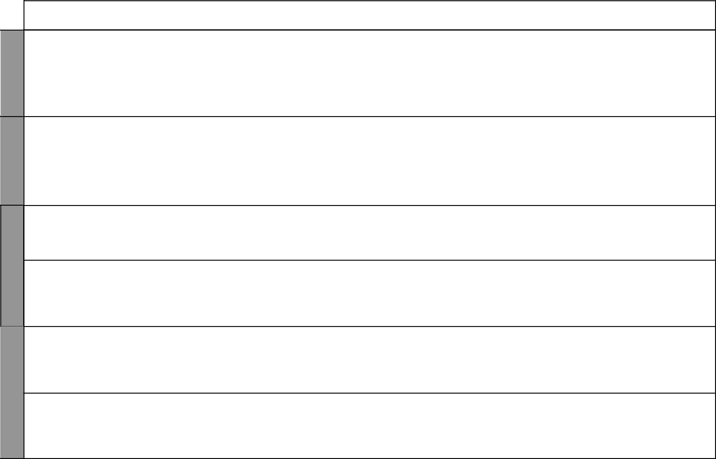

WEEK 4 WEEK 3
WEEK 5

WEEK 6

LESSON | TOPIC | SUB-TOPICS |  | OBJECTIVES |  | TEACHING/LEARNING | TEACHING/LEARNING |  | REFERENCES | REMARKS
 |  |  |  |  |  | ACTIVITIES |  | RESOURCES
1 – 5 | Democracy | Human rights | By the end of the lesson, |  | - | Identifying types of human | • Pictures in the Pupil’s |  | Our Lives Today
 | and human |  | the learner should be able |  |  | rights |  | Book | SST Pupil’s Book 4
 | rights |  | to: |  | - | Explaining human rights |  |  | pages 227 – 229
 |  |  | (i) | Identify types of | - | Asking and answering
 |  |  |  | human rights |  | questions
 |  |  | (ii) | Demonstrate respect | - | Taking notes
 |  |  |  | for human rights | - | Observing pictures
1 – 5 | Law, | Law and order | By the end of the lesson, |  | - | Stating the importance of law | • | Resource person e.g. | Our Lives Today
 | peace and |  | the learner should be able |  |  | and order |  | Chief, Assistant-Chief | SST Pupil’s Book 4
 | reconciliation |  | to state the importance of |  | - | Asking and answering | • | Police officer | pages 230 – 231
 |  |  | law and order |  |  | questions
 |  |  |  |  | - | Taking notes
 |  |  |  |  | - | Demonstrations
 |  |  |  |  | - | Group discussions
1 & 2 | Law, | Importance of | By the end of the lesson, |  | - | Stating the importance of | • Pictures in the Pupil’s |  | Our Lives Today
 | peace and | peace in society | the learner should be able |  |  | peace in society |  | Book | SST Pupil’s Book 4
 | reconciliation |  | to state the importance of |  | - | Observing pictures |  |  | page 231
 |  |  | peace in the society
3 – 5 | Law, | Causes of | By the end of the lesson, |  | - | Stating the causes of conflict | • Pictures in the Pupil’s |  | Our Lives Today
 | peace and | conflict in | the learner should be |  |  | in society |  | Book | SST Pupil’s Book 4
 | reconciliation | society | able to state the causes of |  | - | Explaining the causes of | • | Resource person | page 232
 |  |  | conflict in the society |  |  | conflict in society
 |  |  |  |  | - | Observing pictures
1 & 2 | Law, | Resolving | By the end of the lesson, |  | - | Suggesting ways of resolving | • Pictures in the Pupil’s |  | Our Lives Today
 | peace and | conflicts | the learner should be |  |  | conflicts |  | Book | SST Pupil’s Book 4
 | reconciliation |  | able to suggest ways of |  | - | Observing pictures |  |  | pages 233 – 235
 |  |  | resolving conflict in and |  | - | Asking questions
 |  |  | out of school |  | - | Writing down main points
3 – 5 | The | Provincial | By the end of the lesson, |  | - | Outlining administrative | • | Chart showing | Our Lives Today
 | Government | Administration | the learner should be |  |  | structure in the province |  | administration structure | SST Pupil’s Book 4
 | of Kenya |  | able to outline the |  | - | Listing the administrators | • Pictures in the Pupil’s |  | pages 236 – 237
 |  |  | administrative structure |  | - | Drawing administration |  | Book
 |  |  | in the province |  |  | structure
 |  |  |  |  | - | Taking notes

15 For use with Our Lives Today Standard Four

WEEK 7

WEEK 8

WEEK 11 WEEK 10 WEEK 9
Our Lives Today: Social Studies Standard Four

Schemes of Work

Term 3
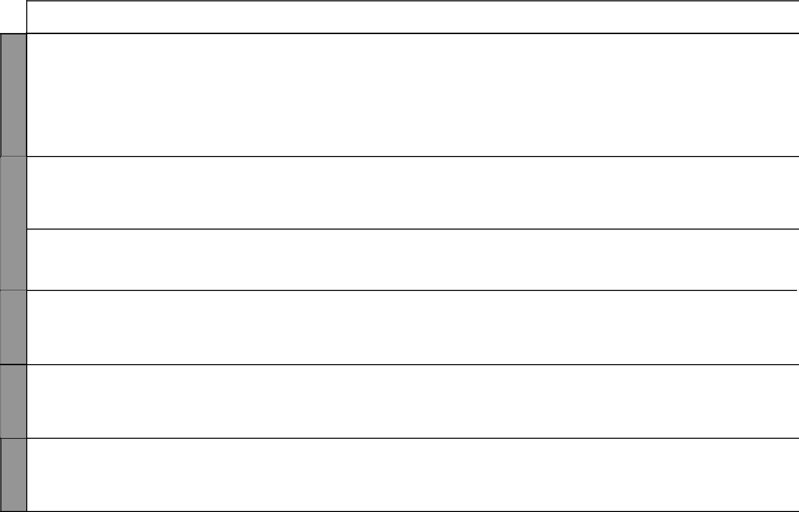
LESSON |  | TOPIC | SUB-TOPICS | OBJECTIVES |  | TEACHING/LEARNING | TEACHING/LEARNING |  | REFERENCES | REMARKS
 |  |  |  |  |  | ACTIVITIES |  | RESOURCES
1 | – 3 | The | Role of | By the end of the lesson, | - | Stating the role of | • | Local environment | Our Lives Today
 |  | Government | administration | the learner should be |  | administration officers |  |  | SST Pupil’s Book 4
 |  | of Kenya | officers | able to state the role of |  |  |  |  | page 238
 |  |  |  | administration officers
4 | & 5 | The | Importance of | By the end of the lesson, | - | Stating the importance of | • | Pictures in the Pupil’s | Our Lives Today
 |  | Government | administration | the learner should be able |  | administration |  | Book | SST Pupil’s Book 4
 |  | of Kenya |  | to state the importance of | - | Observing pictures in the | • | Resource person | page 238
 |  |  |  | administration |  | Pupil’s Book
1 | – 3 | The | Social services | By the end of the lesson, | - | Listing types of social | • | Pictures in the Pupil’s | Our Lives Today
 |  | Government | in the province | the learner should be able |  | services |  | Book | SST Pupil’s Book 4
 |  | of Kenya |  | to list the types of social | - | Observing pictures | • | Local environment | pages 239 – 241
 |  |  |  | services available in their | - | Local environment
 |  |  |  | province
4 | & 5 | The | Importance of | By the end of the lesson, | - | Stating the importance of | • | Pictures in the Pupil’s | Our Lives Today
 |  | Government | social services | the learner should be able |  | social services |  | Book | SST Pupil’s Book 4
 |  | of Kenya |  | state the importance of | - | Observing pictures |  |  | pages 241 – 242
 |  |  |  | social services
1 | – 5 | The | Problems | By the end of the lesson, | - | Stating problems | • | Pictures in the Pupil’s | Our Lives Today
 |  | Government | encountered in | the learner should be |  | encountered in provision of |  | Book | SST Pupil’s Book 4
 |  | of Kenya | the provision of | able to state the problems |  | social services |  |  | page 242
 |  |  | social services | encountered in the | - Asking and answering oral
 |  |  |  | provision of social services |  | questions
1 | – 5 | Revision | Revision of | By the end of the lesson, | - | Revising the work covered | • | Maps | Our Lives Today
 |  |  | work covered | the learner should be |  |  | • | Charts | SST Pupil’s Book 4
 |  |  |  | able to identify the main |  |  |  |  | page 243
 |  |  |  | concepts in work covered
 |  |  |  | during the term
1 | – 5 | Revision | Revision of | By the end of the lesson, | - | Revising the work covered | • | Maps | Our Lives Today
 |  |  | work covered | the learner should be |  |  | • | Charts | SST Pupil’s Book 4
 |  |  |  | able to identify the main |  |  |  |  | page 243
 |  |  |  | concepts in work covered
 |  |  |  | during the term

16 For use with Our Lives Today Standard Four

Our Lives Today: Social Studies Standard Four

Schemes of Work

Term 3
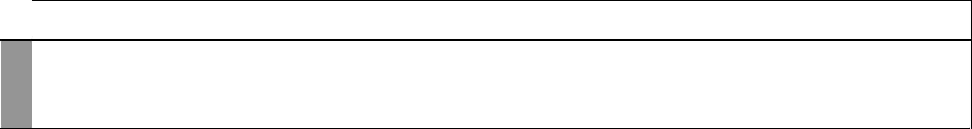

WEEK 12

LESSON | TOPIC | SUB-TOPICS | OBJECTIVES |  | TEACHING/LEARNING | TEACHING/LEARNING | REFERENCES | REMARKS
 |  |  |  |  | ACTIVITIES | RESOURCES
1 – 5 | Revision | Revision and | By the end of the lesson, | - | Answering written questions | • Question papers
 | and exams | exams | the learner should be able | - | Answering oral questions
 |  |  | to answer questions based |  | during revision
 |  |  | on work covered


17 For use with Our Lives Today Standard Four

