SOCIAL STUDIES SCHEME OF WORK CLASS 3

Available Online:
Schools Net Kenya Consultancy
P.O. Box 8076 – 00200 Nairobi, Kenya | Tel: +254202319748
E-mail: infosnkenya@gmail.com | www.schoolsnetkenya.com

Our Lives Today: Social Studies Schemes of Work for Standard Three: Term One

WEEK 2 WEEK 1

WEEK 3

WEEK 4

WEEK 5

 | TOPIC | SUB-TOPIC | OBJECTIVES |  | TEACHING/LEARNING | LEARNING/TEACHING | REMARKS
 | TOPIC | SUB-TOPIC | OBJECTIVES |  | ACTIVITIES | RESOURCES | REMARKS
 | Physical | Position of our | By the end of the lesson the learners | • | Give the direction of various places and | Our Lives Today SST Book 3 Page 2
 | environment | division | should be able to give different directions |  | features in the division and district | • School environment
 |  |  | and features in their division and district | • | Point at the direction of different
 |  |  | by the use of compass points. |  | places and features from the school
 | Physical | Uses of compass | By the end of the lesson the learners | • | State the uses of compass points. | Our Lives Today SST Book 3 Pages 2-3
 | environment | points | should be able to: | • | Draw the four cardinal points of a | • School environment
 |  |  | • state the uses of compass points. |  | compass. | • Diagram showing the four cardinal
 |  |  | • name the four cardinal points of a compass. | • | Point at the direction where the sun | points
 |  |  |  |  | rises and sets. | • Pictures in the Pupil’s Book
 | Physical | Position of the | By the end of the lesson the learners | • | Describe the position of the division | Our Lives Today SST Book 3 Pages 3-6
 | environment | division | should be able to describe the position of | • | Draw a map showing divisions in the | • Map showing divisions in the
 |  |  | the division. |  | district | district
 |  |  |  | • Observe a map of the divisions and
 |  |  |  |  | the district
 | Physical | Position of the | By the end of the lesson the learners | • | Describe the position of the district | Our Lives Today SST Book 3 Page 6
 | environment | division | should be able to describe the position of | • | Draw a map of one district showing | • Map of Kenya showing the
 |  |  | the district. |  | neighbouring districts | neighbouring districts
 |  |  |  | • Observe the map in the Pupil’s Book |  | • Map in the Pupil’s Book
 | Physical | Physical features in | By the end of the lesson the learners | • | Name and locate physical features | Our Lives Today SST Book 3 Pages 4-5
 | environment | the division | should be able to name and locate |  | found in the division | • Map of the division showing
 |  |  | physical features found in the division. | • | Draw physical features on a map of | physical features
 |  |  |  |  | the division | • Maps in the Pupil’s Book
 | Physical | Physical features in | By the end of the lesson the learners | • | Name and locate physical features in | Our Lives Today SST Book 3 Page 8
 | environment | the district | should be able to name and locate |  | the district | • Map of the district showing
 |  |  | physical features in the district. | • | Draw physical features found in the | physical features
 |  |  |  |  | district | • Picture in the Pupil’s Book
 |  |  |  | • Observe the picture in the Pupil’s Book
 | Physical | Importance of | By the end of the lesson the learners | • | List the importance of the physical | Our Lives Today SST Book 3 Pages 10-11
 | environment | physical features to | should be able to list the importance of |  | features to the people | • Local environment
 |  | the people | the physical features to the people of the | • | Ask and answer questions orally | • Pictures in the Pupil’s Book
 |  |  | division and district. | • | Observe the pictures in the Pupil’s
 |  |  |  |  | Book


1 For use with Our Lives Today Standard Three

WEEK 6

WEEK 7

WEEK 8

WEEK 9
Our Lives Today: Social Studies Standard Three

Schemes of Work

Term 1

TOPIC | SUB-TOPIC | OBJECTIVES | TEACHING/LEARNING |  | LEARNING/TEACHING | REMARKS
TOPIC | SUB-TOPIC | OBJECTIVES | ACTIVITIES |  | RESOURCES | REMARKS
Weather and | Meaning of | By the end of the lesson the learners | • State the meaning of weather | Our Lives Today SST Book 3 Page 12
seasons in | weather | should be able to state the meaning of | • Ask and answer oral questions | • Pictures in the Pupil’s Book
the district |  | weather. | • Identify types of weather |  | showing types of weather
 |  |  | • Draw pictures showing types of
 |  |  | weather
Weather and | Elements of | By the end of the lesson the learners should | • List elements of weather | Our Lives Today SST Book 3 Page 13
seasons in | weather | be able to list the elements of weather (rain, | • Observe the pictures in the Pupil’s Book | • | School environment
the district |  | sunshine, wind and cloud). | • Observe weather conditions | • Pictures in the Pupil’s Book
Weather and | Changes in | By the end of the lesson the learners | • State weather changes in the | Our Lives Today SST Book 3 Page 14
seasons in | weather | should be able to state weather changes | division/district | • | School environment
the district |  | in their division/district. | • Observe the weather conditions | • | Weather chart
 |  |  | • Draw a weather chart
Weather and | Effects of the | By the end of the lesson the learners | • State how the weather affects human | Our Lives Today SST Book 3 Page 15
seasons in | weather on human | should be able to state how the weather | activities | • Pictures in the Pupil’s Book
the district | activities | affects human activities. | • Draw pictures showing various | • | School environment
 |  |  | effects both good and bad, e.g.
 |  |  | floods, good crops
 |  |  | • Observe the pictures in the Pupil’s Book
Weather and | Effects of the | By the end of the lesson the learners | • State how the weather affects animals | Our Lives Today SST Book 3 Pages 16-
seasons in | weather on animals | should be able to state how the weather | and plants |  | 17
the district | and plants | affects animals and plants. | • Ask and answer questions | • Pictures in the Pupil’s Book
 |  |  | • Observe the pictures in the Pupil’s Book | • | Local environment
Weather and | Ways of protecting | By the end of the lesson the learners | • List ways of protecting ourselves | Our Lives Today SST Book 3 Pages 17-
seasons in | ourselves from bad | should be able to list ways of protecting | from bad weather |  | 18
the district | weather | ourselves from bad weather. | • Ask and answer oral questions | • Pictures of various types of clothes
 |  |  | • Discuss the clothes they are wearing | • Buildings in the school
 |  |  | • Observe the pictures in the Pupil’s Book | • Pictures in the Pupil’s Book
Weather and | Seasons of the year | By the end of the lesson the learners | • State seasons of the year experienced | Our Lives Today SST Book 3 Page 19
seasons in |  | should be able to state the seasons of the | in the district | • Chart showing seasons of the year
the district |  | year experienced in the district. | • Draw a chart showing seasons of the | • Chart in the Pupil’s Book
 |  |  | year
 |  |  | • Observe the chart in the Pupil’s Book


2 For use with Our Lives Today Standard Three

Our Lives Today: Social Studies Standard Three

Schemes of Work

Term 1

WEEK 13 WEEK 12 WEEK 11 WEEK 10 WEEK 9

TOPIC | SUB-TOPIC | OBJECTIVES |  | TEACHING/LEARNING |  | LEARNING/TEACHING | REMARKS
TOPIC | SUB-TOPIC | OBJECTIVES |  | ACTIVITIES |  | RESOURCES | REMARKS
Weather and | Effects of seasons | By the end of the lesson the learners | • State how different seasons affect |  | Our Lives Today SST Book 3 Page 20
seasons in | on human activities | should be able to state how different |  | human activities | • Chart showing various activities
the district |  | seasons affect the human activities in the | • Ask and answer questions |  |  | carried out during the year
 |  | division/district. | • Draw a chart showing various
 |  |  |  | activities carried out in each season
Communities | Main language | By the end of the lesson the learners | • List the language groups in the |  | Our Lives Today SST Book 3 Pages 22-23
living in the | groups in the | should be able to list down the language |  | district | • Map of the district showing the
district | district | groups found in the district. | • Map showing various language |  |  | location of various language
 |  |  |  | groups in the district |  | groups
 |  |  | • Observe the picture in the Pupil’s Book
Communities | Stories of origin | By the end of the lesson the learners | • Narrate stories of origin |  | Our Lives Today SST Book 3 Pages 24-26
living in the |  | should be able to narrate their stories of | • Ask and answer questions orally
district |  | origin.
Communities | Their culture | By the end of the lesson the learners | • Identify the culture of the people in |  | Our Lives Today SST Book 3 Pages 26-31
living in the |  | should be able to identify the culture of |  | the district | • Pictures showing various festivals
district |  | the people in the district. | • Ask and answer questions
 |  |  | • Observe pictures showing various
 |  |  |  | festivals
Topics | Revision | By the end of the lesson the learners | • Revise the work covered |  | Our Lives Today SST Book 3 Pages 2-31
covered |  | should be able to revise the work |  |  | • | Pictures
within the |  | covered. |  |  | • | Charts
term
Exam | Work covered | By the end of the lesson the learners | • | Write the test | Our Lives Today SST Book 3 Pages 2-31
 |  | should be able to answer questions based | • | Revise the test | • | Papers
 |  | on the work covered. |  |  | • | Pencil


3 For use with Our Lives Today Standard Three


Our Lives Today: Social Studies Schemes of Work for Standard Three: Term Two

WEEK 2 WEEK 1

WEEK 5 WEEK 4 WEEK 3

 | TOPIC | SUB-TOPIC | OBJECTIVES |  | TEACHING/LEARNING | LEARNING/TEACHING | REMARKS
 | TOPIC | SUB-TOPIC | OBJECTIVES |  | ACTIVITIES | RESOURCES | REMARKS
 | Communities | Interdependence | By the end of the lesson the learners | • | State different ways in which people | Our Lives Today SST Book 3 Pages 30-31
 | living in the | among people | should be able to state different ways in |  | depend on one another | • Pictures of people doing various
 | district |  | which different people depend on one | • | Ask and answer oral questions | activities of helping one another in
 |  |  | another. | • | Observe the pictures in the Pupil’s Book | the Pupil’s Book
 |  |  |  |  |  | • School community
 | Our needs in | Our needs in the | By the end of the lesson the learners | • | Name types of needs in the district | Our Lives Today SST Book 3 Pages 32-34
 | the district | district | should be able to name types of needs in | • | Observe the pictures in the Pupil’s Book | • Pictures in the Pupil’s Book
 |  |  | the district. | • | Observe buildings in the school | • School environment
 |  |  |  | • | Identify school equipment
 | Our needs in | How we meet our | By the end of the lesson the learners | • | State how needs are met in the | Our Lives Today SST Book 3 Pages 35-37
 | the district | needs | should be able to state how needs in the |  | district | • Local environment
 |  |  | district are met. | • | Ask and answer questions orally | • Pictures in the Pupil’s Book
 |  |  |  | • Observe the pictures in the Pupil’s Book
 | Our needs in | Difficulties in | By the end of the lesson the learners | • | State the difficulties experienced in | Our Lives Today SST Book 3 Pages 38-41
 | the district | meeting our needs | should be able to: |  | meeting our needs | • Pictures in the Pupil’s Book
 |  | Efforts in solving | • state the difficulties experienced in | • | Ask and answer questions | • Local environment
 |  | these problems | meeting our needs. | • | Appreciate the efforts being made in
 |  |  | • appreciate the efforts being made to |  | solving the problems
 |  |  | solve these problems. | • | Observe the pictures in the Pupil’s Book
 |  |  |  | • Observe activities in the local
 |  |  |  |  | environment
 | Our needs in | Protection of | By the end of the lesson the learners | • | Suggest ways of protecting children | Our Lives Today SST Bk 3 Pages 41-43
 | the district | children against | should be able to suggest ways of |  | from abuse | • Pictures in the Pupil’s Book.
 |  | abuse in home and | protecting children from abuse. | • | Draw pictures showing various forms
 |  | school |  |  | of child abuse
 |  |  |  | • Observe the pictures in the Pupil’s Book
 | Administra- | Administrative | By the end of the lesson the learners | • | Name administrative units in the | Our Lives Today SST Book 3 Pages 44-45
 | tion in the | units | should be able to name administrative |  | district | • A map of the district showing
 | district |  | units in the district. | • | Ask and answer questions orally | administrative divisions
 |  |  |  | • Observe a map showing
 |  |  |  |  | administrative divisions


4 For use with Our Lives Today Standard Three

Our Lives Today: Social Studies Standard Three

Schemes of Work

Term 2
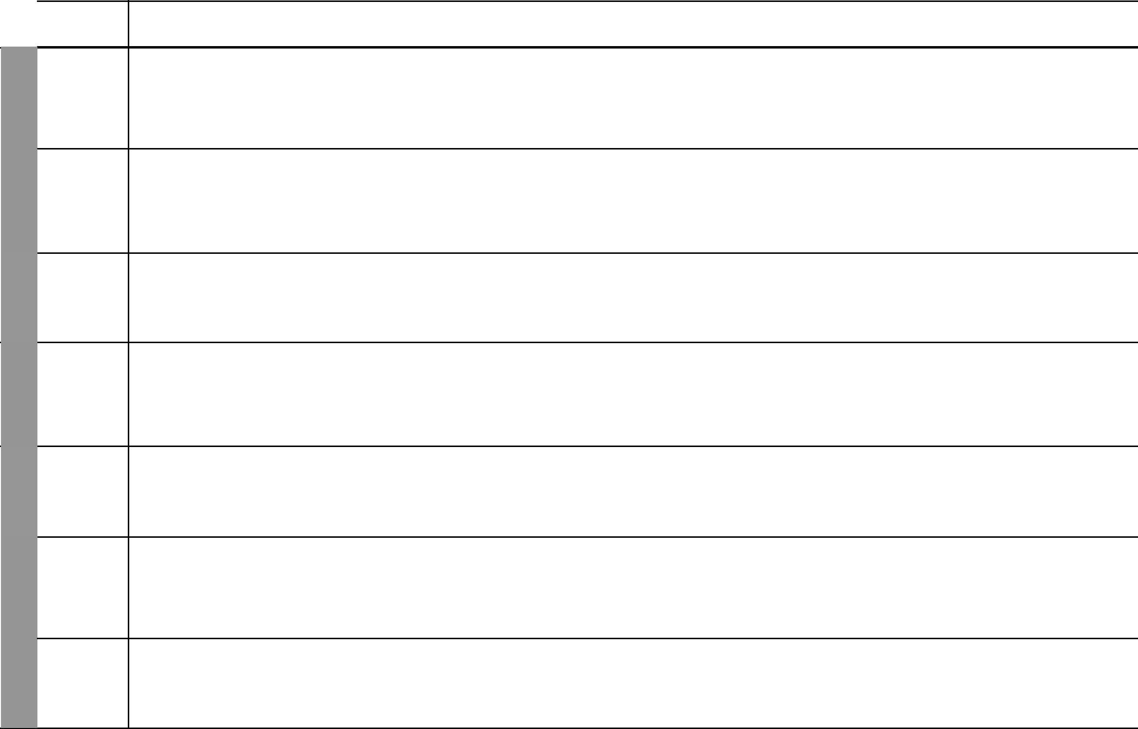

 | TOPIC
 | Administra-
6 | Administra-
WEEK | tion in the
WEEK | district
7 | Administra-
WEEK | tion in the
WEEK | district
8 | Administra-
WEEK | Administra-
WEEK | tion in the
WEEK | district
 | Administra-
9 | Administra-
WEEK | tion in the
WEEK | district
10 | Administra-
WEEK | tion in the
WEEK | district
 | Resources
 | and
11 | economic
11 | activities
WEEK | Resources
WEEK | and
 | economic
 | activities

SUB-TOPIC | OBJECTIVES | TEACHING/LEARNING | LEARNING/TEACHING | REMARKS
SUB-TOPIC | OBJECTIVES | ACTIVITIES | RESOURCES | REMARKS
Hierarchy of | By the end of the lesson the learners | • Name the leaders of the | Our Lives Today SST Book 3 pages 45-46
leaders | should be able to name the leaders of the | administrative units | • A chart showing hierarchy of
 | administrative units. | • Draw a chart showing the hierarchy | leaders in the district
 |  | of the leaders | • Illustrations in the Pupil’s Book
 |  | • Ask and answer questions orally
Hierarchy of | By the end of the lesson the learners | • Describe the hierarchy of leaders in | Our Lives Today SST Book 3 page 46
leaders | should be able to describe the hierarchy | administration | • Pictures in the Pupil’s Book
 | of leaders in the administration. | • Ask and answer questions on
 |  | administration
 |  | • Observe the pictures in the Pupil’s Book
Role of leaders in | By the end of the lesson the learners | • State the role of leaders in | Our Lives Today SST Book 3 page 47
the administration | should be able to state and appreciate | administration | • Pictures in the Pupil’s Book
 | the role of leaders in administration. | • Dramatize various leaders | • Costumes
 |  | • Observe the pictures in the Pupil’s Book
Role of the | By the end of the lesson the learners | • State the role of the community in | Our Lives Today SST Book 3 page 48
community in | should be able to state and appreciate | administration | • Pictures in the Pupil’s Book
administration | the role of the community in | • Ask and answer questions
 | administration. | • Take part in community work
 |  | • Observe the pictures in the Pupil’s Book
Importance of law | By the end of the lesson the learners | • Demonstrate respect for law and | Our Lives Today SST Book 3 page 49
and order | should be able to demonstrate respect | order
 | for law and order. | • Ask and answer questions orally
Resources in the | By the end of the lesson the learners | • List the resources found in the | Our Lives Today SST Book 3 pages 50-53
district | should be able to list the resources found | district | • Resources in the local
 | in the district. | • Observe the pictures in the Pupil’s Book | environment
 |  | • Ask and answer oral questions
Proper use of | By the end of the lesson the learners | • Suggest proper uses of resources | Our Lives Today SST Book 3 page 54
resources | should be able to suggest proper uses of | • Ask and answer oral questions | • Local environment
 | resources.
 |  | 5 | For use with Our Lives Today Standard Three

WEEK 14 WEEK 13 WEEK 12

 |  |  |  |  |  | Our Lives Today: Social Studies Standard Three
 |  |  |  |  |  | Schemes of Work
 |  |  |  |  |  |  | Term 2
TOPIC | SUB-TOPIC | OBJECTIVES |  | TEACHING/LEARNING |  | LEARNING/TEACHING | REMARKS
TOPIC | SUB-TOPIC | OBJECTIVES |  | ACTIVITIES |  | RESOURCES | REMARKS
Resources | Effects of misusing | By the end of the lesson the learners | • State ways in which resources are |  | Our Lives Today SST Book 3 pages 55-57
and | our resources | should be able to state ways in which |  | misused | • Pictures in the Pupil’s Book
economic |  | resources are misused. | • Observe the pictures in the Pupil’s Book |  | • | Local environment
activities |  |  | • Observe the local environment
Topics | Revision
covered |  | By the end of the lesson the learners | • Revise the work covered |  | Our Lives Today SST Book 3 pages 30-57
within the |  | should be able to revise the work | • Ask and answer oral questions |  | • | Charts
term |  | covered. |  |  | • | Maps
Exam | Work covered | By the end of the lesson the learners | • | Write the test | Our Lives Today SST Book 3 pages 30-57
 |  | should be able to answer questions based | • | Revise the test | Pencils
 |  | on the work covered. |  |  | Papers
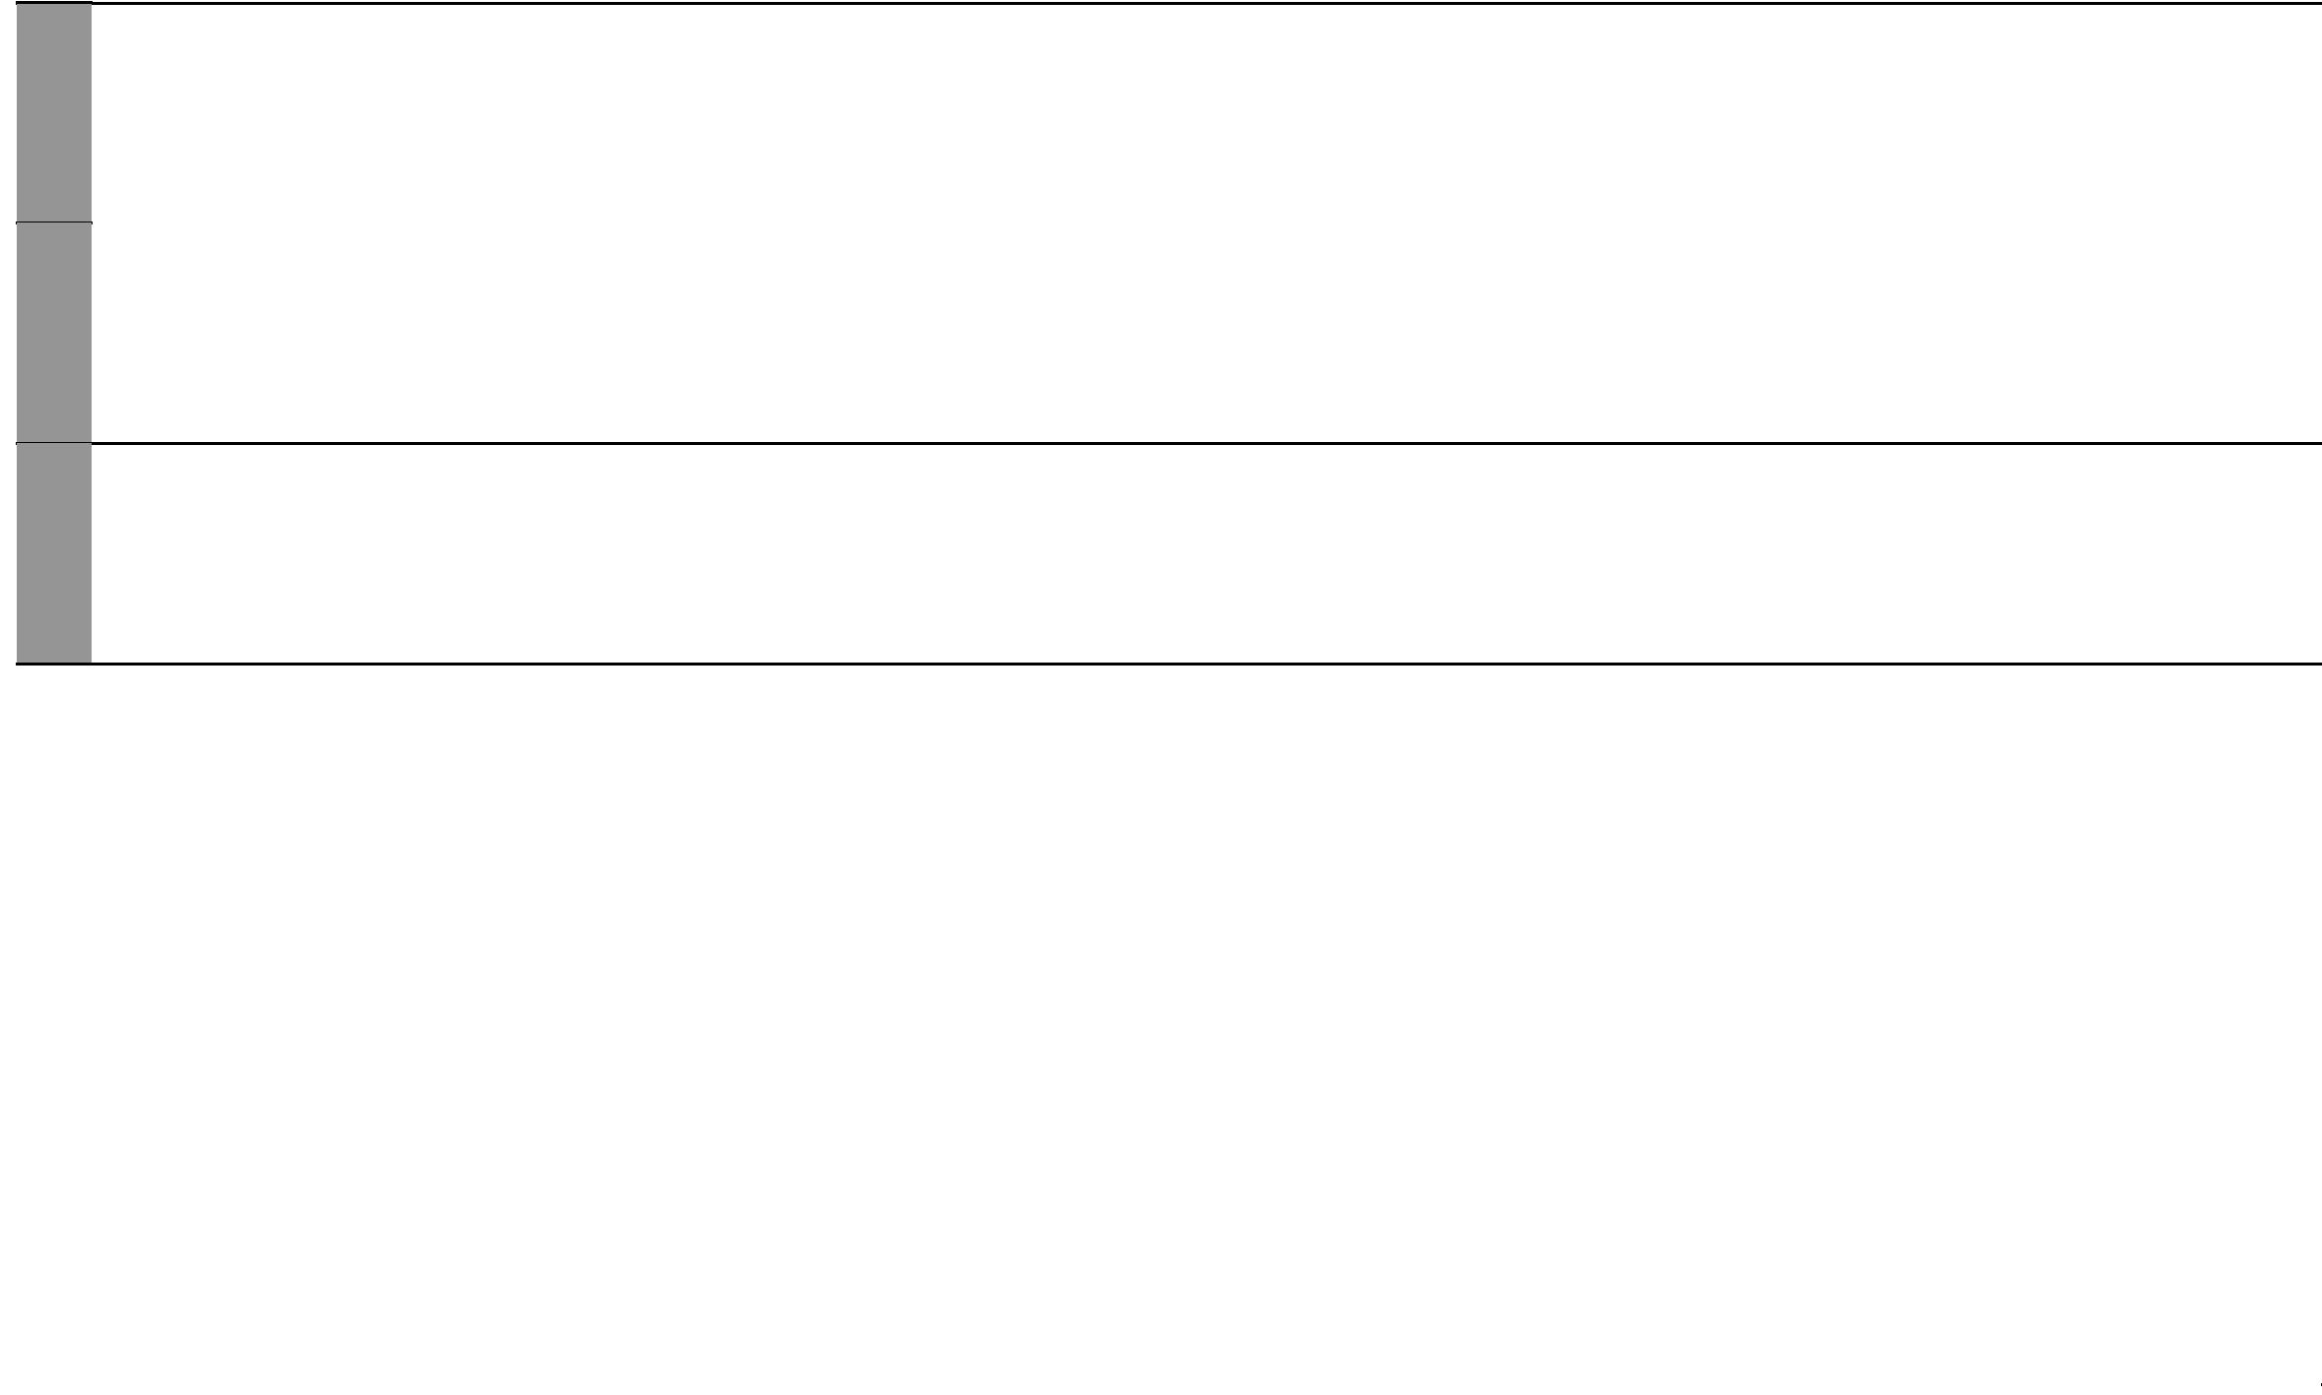

6 For use with Our Lives Today Standard Three

Our Lives Today: Social Studies Schemes of Work for Standard Three: Term Three


WEEK 4 WEEK 3 WEEK 2 WEEK 1
WEEK 5

WEEK 6

 | TOPIC | SUB-TOPIC | OBJECTIVES | TEACHING/LEARNING |  | LEARNING/TEACHING | REMARKS
 | TOPIC | SUB-TOPIC | OBJECTIVES | ACTIVITIES |  | RESOURCES | REMARKS
 | Resources | Effects of misuse | By the end of the lesson the learners | • State the effects of misuse of | Our Lives Today SST Book 3 pages 56-57
 | and | of resources | should be able to state the effects of | resources | • Pictures in the Pupil’s Book
 | economic |  | misuse of resources. | • Observe the pictures in the Pupil’s Book | • | Local environment
 | activities |  |  | • Observe the local environment
 | Resources | Importance | By the end of the lesson the learners | • Appreciate the importance of | Our Lives Today SST Book 3 pages 57-58
 | and | of conserving | should be able to: | resources | • Pictures in the Pupil’s Book
 | economic | resources | • appreciate the importance of conserving | • State the importance of conserving | • | Local environment
 | activities |  | resources. | resources
 |  |  | • state the importance of conserving | • Observe the pictures in the Pupil’s
 |  |  | resources. | Book
 | Resources | Economic | By the end of the lesson the learners | • Identify the main economic activities | Our Lives Today SST Book 3 pages 59-61
 | and | activities in the | should be able to identify the main | practised in the district | • | Local market
 | economic | district | economic activities practised in the | • Visit a local market | • Pictures in the Pupil’s Book
 | activities |  | district. | • Observe the pictures in the Pupil’s Book
 | Resources | Benefits of | By the end of the lesson the learners | • Appreciate the importance of | Our Lives Today SST Book 3 pages 61-62
 | and | economic activities | should be able to: | economic activities in the district | • | Local market centres
 | economic |  | • appreciate the importance of economic | • Name the main commercial centres | • | Local factories
 | activities |  | activities in the district. | • Observe the picture in the Pupil’s
 |  |  | • name the main commercial centres. | Book
 | Resources | Main means | By the end of the lesson the learners | • Identify the main means of travel in | Our Lives Today SST Book 3 pages 63-65
 | and | of travel in the | should be able to identify the main means | the district | • Pictures showing means of travel
 | economic | district | of travel in the district. | • Observe pictures showing means of |  | in the Pupil’s Book
 | activities |  |  | travel | • Means of travel in the locality

- Draw pictures showing main means of travel

- Observe means of travel in the locality

- Discuss how the pupils come to school

Caring | Caring for people | By the end of the lesson the learners | • | State ways in which people with | Our Lives Today SST Book 3 pages 66-68
for the | with special needs | should be able to state ways in which |  | special needs should be cared for | • Pictures of people with special
environment |  | people with special needs should be cared | • | List special needs | needs
 |  | for. | • | Draw people with special needs
 |  |  | • | Observe the pictures in the Pupil’s Book.

7 For use with Our Lives Today Standard Three

WEEK 12 WEEK 11 WEEK 10 WEEK 9 WEEK 8 WEEK 7

 |  |  |  | Our Lives Today: Social Studies Standard Three
 |  |  |  |  | Schemes of Work
 |  |  |  |  | Term 3
TOPIC | SUB-TOPIC | OBJECTIVES | TEACHING/LEARNING | LEARNING/TEACHING | REMARKS
TOPIC | SUB-TOPIC | OBJECTIVES | ACTIVITIES | RESOURCES | REMARKS
Caring | Caring for water | By the end of the lesson the learners | • State the importance of caring for | Our Lives Today SST Book 3 pages 69-70
for the | sources | should be able to state the importance of | water sources | • Pictures showing water sources
environment |  | caring for water sources. | • Observe pictures showing water | • Local environment
 |  |  | sources | • Pictures in the Pupil’s Book

- Observe sources of water in the locality

- Discuss how the learners get water in their homes

Caring | Caring for water | By the end of the lesson the learners | • List how water sources may be |  | Our Lives Today SST Book 3 pages 70-72
for the | sources | should be able to list how water sources |  | protected | • Pictures showing how water
environment |  | may be protected. | • Observe how water sources are |  |  | sources are protected in the
 |  |  |  | protected around the school |  | district
 |  |  | • Ask and answer questions orally |  | • | Local environment
Caring | Caring for | By the end of the lesson the learners | • State how vegetation should be cared |  | Our Lives Today SST Book 3 pages 73-74
for the | vegetation | should be able to state how vegetation |  | for | • | Local environment
environment |  | should be cared for. | • Observe vegetation around the |  | • Pictures in the Pupil’s Book
 |  |  |  | school
 |  |  | • Observe the pictures of vegetation in
 |  |  |  | the Pupil’s Book
Caring | Caring for animals | By the end of the lesson the learners | • List the animals in the district |  | Our Lives Today SST Book 3 pages 75-77
for the |  | should be able to list ways in which | • List ways in which animals should be |  | • Pictures showing animals in the
environment |  | animals should be cared for. |  | cared for |  | Pupil’s Book
 |  |  | • Discuss the animals in their |  | • Animals found around the school
 |  |  |  | environment
 |  |  | • Observe pictures of animals
Topics | Revision | By the end of the lesson the learners | • Revise the work covered |  | Our Lives Today SST Book 3 pages 56-78
covered |  | should be able to revise the work covered | • | Observe pictures | • | Pictures
within the |  | within the term. | • Observe the local environment |  | • | Local environment
term
Exam | Work covered | By the end of the lesson the learners | • | Answer written questions | Our Lives Today SST Book 3 pages 56-78
 |  | should be able to answer written | • | Revise the test | • | Papers
 |  | questions based on the work covered. |  |  | • | Pencils

8 For use with Our Lives Today Standard Three

