SOCIAL STUDIES SCHEME OF WORK CLASS 2

Available Online:
Schools Net Kenya Consultancy
P.O. Box 8076 – 00200 Nairobi, Kenya | Tel: +254202319748
E-mail: infosnkenya@gmail.com | www.schoolsnetkenya.com


Our Lives Today: Social Studies Schemes of Work for Standard Two: Term One

WEEK 1

WEEK 3 WEEK 2

WEEK 4

 | TOPIC | SUB-TOPIC | OBJECTIVES |  | TEACHING/LEARNING |  | LEARNING/TEACHING | REMARKS
 | TOPIC | SUB-TOPIC | OBJECTIVES |  | ACTIVITIES |  | RESOURCES | REMARKS
 | Our school | Location of the | By the end of the lesson the learners | • | Stating where the school is found | Our Lives Today SST Book 2 pages 2-3
 |  | school | should be able to state where the school | • | Observing the features surrounding | • | The school environment
 |  |  | is found. |  | the school | • | Pencils and crayons
 |  |  |  | • | Drawing/modelling the school
 | Our school | Direction of home | By the end of the lesson the learners | • | Point different directions from their | Our Lives Today SST Book 2 page 4
 |  | from the school | should be able to point at the direction of |  | classroom | • Pictures in the Pupil’s Book
 |  |  | their home from school. | • | Point at the direction of their home | • | The school environment
 |  |  |  | • Point at the direction of sunrise and
 |  |  |  |  | sunset
 |  |  |  | • Point at the direction of their shadow.
 | Our school | Buildings in the | By the end of the lesson the learners | • | Name the buildings found in the school | Our Lives Today SST Book 2 page 5
 |  | school | should be able to name the buildings | • | Observe a picture of school buildings | • A picture showing school buildings
 |  |  | found in the school. | • | Walk in the school compound | • | The school environment
 |  |  |  | • Compile the category of the buildings
 |  |  |  |  | in the school
 |  |  |  | • Draw the buildings found in the school
 | Our school | Things found in | By the end of the lesson the learners | • | Name and identify the things found | Our Lives Today SST Book 2 pages 6-7
 |  | the school | should be able to name and identify the |  | in the school. | • | Things found in the school, e.g.
 |  |  | things found in the school. | • | Observe the things found in the school |  | desks, books, chalkboard, flag-post
 |  |  |  | • | walk in the school compound |  | etc.
 |  |  |  | • | Compile a list of all things found in | • | The school environment
 |  |  |  |  | the school compound
 |  |  |  | • Different groups to be assigned
 |  |  |  |  | different parts of the school
 | Our school | Difference between | By the end of the lesson the learners | • | State the difference between a map | Our Lives Today SST Book 2 pages 8-9
 | and its | a map and a | should be able to state the difference |  | and a picture | • | Different items, e.g. cups, bottles,
 | surroundings | picture | between a map and a picture. | • | Observe a map and pictures |  | desk etc.
 |  |  |  |  |  | • | Map and pictures
 |  |  |  |  |  | • Picture of the buildings in the
 |  |  |  |  |  |  | school
 | Our school | Map of the school | By the end of the lesson the learners | • | Guide the pupils to draw a map | Our Lives Today SST Book 2 pages 8-9
 | and its |  | should be able to draw a map of the | • | Observe a sketch map of the school
 | surroundings |  | school. | • | Modelling


1 For use with Our Lives Today Standard Two

WEEK 5

WEEK 6

WEEK 7

WEEK 8

 |  |  |  |  |  | Our Lives Today: Social Studies Standard Two
 |  |  |  |  |  | Schemes of Work
 |  |  |  |  |  |  | Term 1
TOPIC | SUB-TOPIC | OBJECTIVES |  | TEACHING/LEARNING |  | LEARNING/TEACHING | REMARKS
TOPIC | SUB-TOPIC | OBJECTIVES |  | ACTIVITIES |  | RESOURCES | REMARKS
Our school | How the land of | By the end of the lesson the learners | • | Describe how the land of the school | Our Lives Today SST Book 2 page 10
environ- | the school is | should be able to describe how the land |  | is | • | The school environment
ment |  | of the school is. | • | Observe features in the school
Our school | Weather | By the end of the lesson the learners | • | Describe the weather experienced | Our Lives Today SST Book 2 pages 11-13
environ- | experienced | should be able to describe the weather |  | around the school | • Weather chart showing various
ment | around the school | experienced around the school. | • | Observe the weather |  | weather changes, e.g. sunny,
 |  |  | • | Experiment with leaves, grass and |  | windy etc.
 |  |  |  | dust about the weather | • | Grass/pieces of paper
 |  |  |  |  | • | Windmills
Activities in | Learning | By the end of the lesson the learners | • | Appreciating the need to learn | Our Lives Today SST Book 2 page 14
the school |  | should be able to appreciate the need to | • | Demonstration | • | The school environment
 |  | learn | • | Asking and answering questions
Activities in | Playing | By the end of the lesson the learners | • | List different ways of playing | Our Lives Today SST Book 2 page 14
the school |  | should be able to list different ways of | • | Pictures showing different ways of | • | The school environment
 |  | playing |  | playing | • | Field
 |  |  | • | Pictures showing people playing | • | Game equipment/apparatus
 |  |  | • | Demonstrations
 |  |  | • Practising different ways of playing
Activities in | Playing | By the end of the lesson the learners | • | State the importance of playing | Our Lives Today SST Book 2 page 14
the school |  | should be able to state the importance of | • | Give examples of the best players in | • Pictures showing various games
 |  | playing. |  | the school |  | being played
 |  |  | • | Observe a picture
Activities in | Playing | By the end of the lesson the learners | • | Name the games that take place in | Our Lives Today SST Book 2 page 14
the school |  | should be able to name the games that |  | the school | • Pictures of people playing
 |  | take place in the school. | • | Demonstrate how various games are |  | football
 |  |  |  | played
Activities in | Keeping the school | By the end of the lesson the learners | • | List ways of keeping the school clean | Our Lives Today SST Book 2 pages 15-16
the school | clean | should be able to list ways of keeping the | • | State the ways you commonly use | • Picture of pupils doing various
 |  | school clean |  |  |  | cleaning activities
 |  |  |  |  | • | The school environment
 |  |  |  |  | • | Various cleaning materials


2 For use with Our Lives Today Standard Two

Our Lives Today: Social Studies Standard Two

Schemes of Work

Term 1

WEEK 9 WEEK 8

WEEK 10

WEEK 11

TOPIC | SUB-TOPIC | OBJECTIVES |  | TEACHING/LEARNING |  | LEARNING/TEACHING | REMARKS
TOPIC | SUB-TOPIC | OBJECTIVES |  | ACTIVITIES |  | RESOURCES | REMARKS
Activities in | Keeping the school | By the end of the lesson the learners | • | Participate in cleaning the school | Our Lives Today SST Book 2 pages 15-16
the school | clean | should be able to participate in cleaning |  |  | • | Pangas
 |  | the school |  |  | • | Slashers
 |  |  |  |  | • | Brooms
Activities in | Ways of keeping | By the end of the lesson the learners | • | State ways of keeping order in the school | Our Lives Today SST Book 2 pages 16-17
the school | order in the school | should be able to state ways of keeping | • | Identify where the bell is rung | • | School bell
 |  | order in the school. | • | Discuss various ways of keeping | • | Timetable
 |  |  |  | order | • | School garden
 |  |  | • Name prefects and teachers in
 |  |  |  | charge of activities
Our needs | Requirements at | By the end of the lesson the learners | • | Name the items required in school | Our Lives Today SST Book 2 page 18
at school | school | should be able to name the items |  | for learning | • Facilities at the school
 |  | required at school for learning. | • | Ask and answer questions | • Classrooms, fields, toilets, offices,
 |  |  |  |  |  | fences etc.
Our needs | Our needs at | By the end of the lesson the learners | • | Stating their needs at school | Our Lives Today SST Book 2 page 18
at school | school | should be able to state their needs at | • | Identifying different items used in | • | Books
 |  | school. |  | school | • | Pencils
 |  |  | • | Classifying the items | • | Rubbers
 |  |  |  |  | • | School bags etc.
Our needs | Sources of school | By the end of the lesson the learners | • | State the sources of their requirments | Our Lives Today SST Book 2 page 19
at school | requirements | should be able to state the sources of | • | Observe a picture of a guest donating | • Picture of a guest donating books
 |  | their requirments |  | books | • | The school environment
 |  |  | • Ask and answer questions
Our needs | Problems faced in | By the end of the lesson the learners | • | State the problems experienced in | Our Lives Today SST Book 2 page 20
at school | meeting the school | should be able to: |  | trying to meet the school needs | • The school and the local
 | needs | • state the problems experienced in | • | List the problems the learners |  | environment
 |  | trying to meet their needs in school |  | experience right from home to school
 |  | •list the problems they experience right
 |  | from home to school.


3 For use with Our Lives Today Standard Two

WEEK 13 WEEK 12

 |  |  |  |  |  | Our Lives Today: Social Studies Standard Two
 |  |  |  |  |  | Schemes of Work
 |  |  |  |  |  |  | Term 1
TOPIC | SUB-TOPIC | OBJECTIVES |  | TEACHING/LEARNING |  | LEARNING/TEACHING | REMARKS
TOPIC | SUB-TOPIC | OBJECTIVES |  | ACTIVITIES |  | RESOURCES | REMARKS
Our needs | Solutions | By the end of the lesson the learners | • State the solutions to problems |  | Our Lives Today SST Book 2 page 21
at school | to problems | should be able to state solutions to |  | experienced in meeting their needs in | • | Newspaper cuttings
 | experienced in | problems experienced in meeting their |  | school | • | Magazines
 | trying to meet | needs in school. | • Ask and answer questions
 | school needs
Our needs | Care of our school | By the end of the lesson the learners | • State ways of caring for school |  | Our Lives Today SST Book 2 page 22
at school | property | should be able to state ways of caring for |  | property | • | School property, e.g. desks, books
 |  | school property. | • | Observe pictures
 |  |  | • Take part in organizing things
Exam | Work covered | Learners should be able to answer | • | Write the test | Our Lives Today SST Book 2 pages 2-22
 | during the term | questions based on the work covered. | • | Revise the test | • | Pupils’ drawings
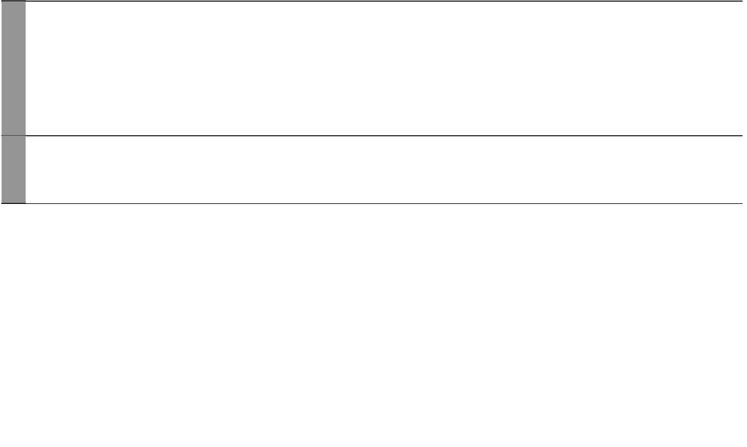

4 For use with Our Lives Today Standard Two

Our Lives Today: Social Studies Schemes of Work for Standard Two: Term Two

WEEK 4 WEEK 5 WEEK 4 WEEK 3 WEEK 2 WEEK 1

 | TOPIC | SUB-TOPIC | OBJECTIVES |  | TEACHING/LEARNING |  | LEARNING/TEACHING | REMARKS
 | TOPIC | SUB-TOPIC | OBJECTIVES |  | ACTIVITIES |  | RESOURCES | REMARKS
 | Our needs at | Importance of | By the end of the lesson the learners | • | State the importance of taking care of | Our Lives Today SST Book 2 pages 23-25
 | school | taking care of | should be able to state the importance of |  | school property | • Picture of a pupil sitting on the
 |  | school property | taking care of school property. | • | Ask and answer questions |  | floor
 |  |  |  |  |  | • | School environment
 |  |  |  |  |  | • | School property
 |  |  |  |  |  | • | Books
 |  |  |  |  |  | • | Desks etc.
 | Safe travel | How to ride a | By the end of the lesson the learners | • | State the ways of riding a bicycle safely | Our Lives Today SST Book 2 pages 26-27
 | to and from | bicycle safely | should be able to state the ways of riding | • | Name the parts of a bicycle and | • Picture of a bicycle
 | school |  | a bicycle safely. |  | discuss their uses | • | Real bicycle
 |  |  |  | • | Draw a bicycle
 |  |  |  | • Demonstrate how to ride a bicycle
 | Safe travel | Basic road signs | By the end of the lesson learners should | • | Observe basic road signs | Our Lives Today SST Book 2 pages 28-29
 | to and from |  | be able to: | • | Draw basic road signs | • Chart showing basic road signs
 | school |  | • state the basic road signs. | • | Demonstrate safe crossing of the road
 |  |  | • appreciate the importance of basic
 |  |  | road signs.
 | Safe travel | Dangers to avoid | By the end of the lesson the learners | • | State the dangers on the road | Our Lives Today SST Book 2 pages 30-33
 | to and from | on the road | should be able to state the dangers on the | • | Ask and answer oral questions | • Pictures of dangerous animals
 | school |  | road. | • | Draw pictures of dangerous animals | • Real plants which are dangerous
 |  |  |  |  | and plants
 | Safe travel | How to react when | By the end of the lesson the learners | • | Draw pictures of children running | Our Lives Today SST Book 2 pages 30-33
 | to and from | faced with danger | should be able to state how to react when |  | away from a stranger | • Picture of pupils running away
 | school |  | faced with danger on the road. | • | State the dangers on the road |  | from strangers/animals
 |  |  |  | • | State how to react when faced with | • | Costumes
 |  |  |  |  | dangers on the road
 |  |  |  | • | Observe a picture
 |  |  |  | • Dramatize how to react
 | Our school | Names of pupils, | By the end of the lesson the learners | • | Give the names of the pupils in the class | Our Lives Today SST Book 2 pages 34-38
 | community | teachers and | should be able to give the names of | • | Give the names of pupils in other classes | • | School environment
 |  | workers in the | pupils, workers and teachers in the | • Identify the names of the teachers
 |  | workers in the | pupils, workers and teachers in the | • Walk around the school asking the names of
 |  | school | school.
 |  | school | school. |  | the other people in the school community


5 For use with Our Lives Today Standard Two

WEEK 12 WEEK 11 WEEK 10 WEEK 9 WEEK 8 WEEK 7

 |  |  |  |  | Our Lives Today: Social Studies Standard Two
 |  |  |  |  | Schemes of Work
 |  |  |  |  |  | Term 2
TOPIC | SUB-TOPIC | OBJECTIVES | TEACHING/LEARNING |  | LEARNING/TEACHING | REMARKS
TOPIC | SUB-TOPIC | OBJECTIVES | ACTIVITIES |  | RESOURCES | REMARKS
Our school | The school | By the end of the lesson the learners | • State the number of people in the | Our Lives Today SST Book 2 pages 34-38
community | population | should be able to state the number of | school compound | • | School environment
 |  | people in the school. | • Count the people in the school
 |  |  | compound
 |  |  | • Group the people in the school
 |  |  | compound
 |  |  | • Identify the names of various people
 |  |  | in the school compound
 |  |  | • Write down the names of the people
 |  |  | in the school compound
Our school | The role of pupils | By the end of the lesson the learners | • State the role of the pupils in the | Our Lives Today SST Book 2 pages
community | in the school | should be able to state the role of pupils | school |  | 16-17, 36-37
 |  | in the school. | • State the work of prefects | • | Our class
 |  |  | • Ask and answer questions | • | The school environment
Our school | The role of | By the end of the lesson the learners | • Identify the work of the class teacher | Our Lives Today SST Book 2 pages 35-36
community | teachers in the | should be able to state the role of | • Identify the role of other teachers | • Teachers in the school
 | school | teachers in the school. | • State the names of the teachers
 |  |  | • Tell the role of the headteacher and
 |  |  | the deputy headteacher
Our school | The role of school | By the end of the lesson the learners | • Identify the names of workers in the | Our Lives Today SST Book 2 pages 36-38
community | workers | should be able to state the role of | school | • | School environment
 |  | workers in the school. | • State the work that each does and its | • Pictures of workers doing various
 |  |  | importance to the pupils |  | jobs
 |  |  | • Observe the workers doing their work
Our school | The role of the | By the end of the lesson the learners | • State the role of the school | Our Lives Today SST Book 2 page 39
community | school committee | should be able to state the role of the | committee in the school | • | The school
 | in the school | school committee in the school | • Name some members of the school
 |  |  | committee
Child | Child rights | By the end of the lesson the learners | • Identify the rights of a child | Our Lives Today SST Book 2 pages 40-45
protection |  | should be able to identify the rights of a | • Observe pictures of children studying | • | Pictures
 |  | child | in class | • | Pencils and crayons
 |  | child | • Draw a child being beaten | • | Pencils and crayons
 |  |  | • Ask and answer questions
 |  |  | • List the rights of a child.
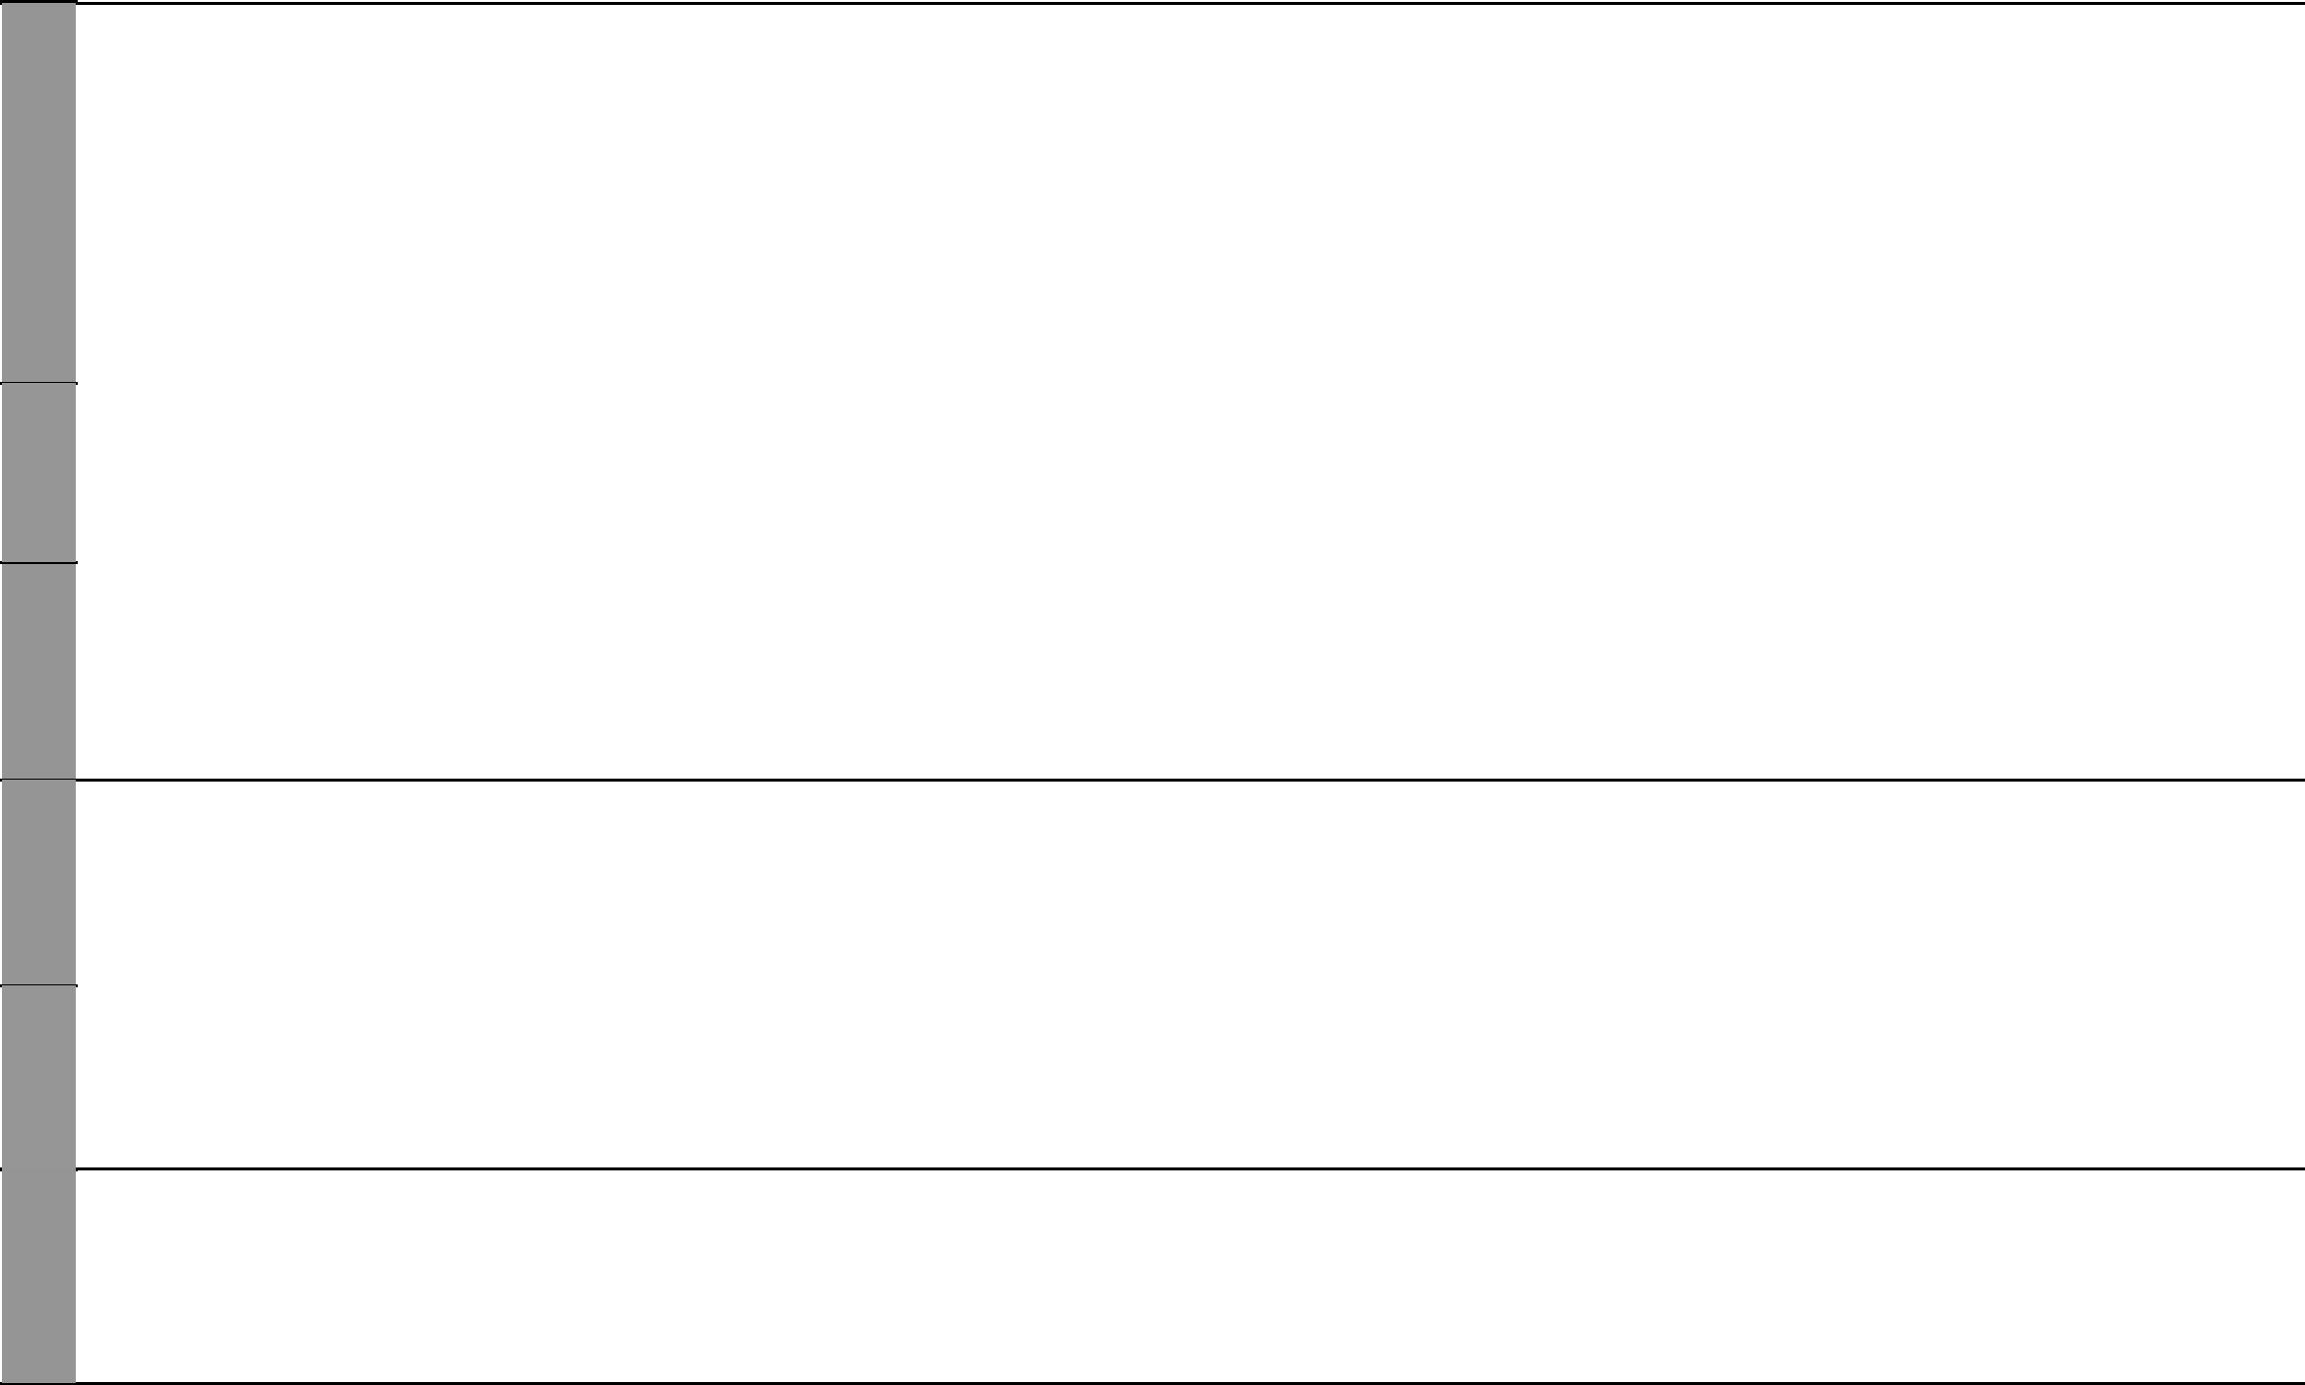

6 For use with Our Lives Today Standard Two

Our Lives Today: Social Studies Standard Two

Schemes of Work

Term 2

WEEK 14 WEEK 13

TOPIC | SUB-TOPIC | OBJECTIVES |  | TEACHING/LEARNING | LEARNING/TEACHING | REMARKS
TOPIC | SUB-TOPIC | OBJECTIVES |  | ACTIVITIES | RESOURCES | REMARKS
Child | Types of child | By the end of the lesson the learners | • Identify ways of child abuse at home |  | Our Lives Today SST Book 2 pages 41-43
protection | abuse in the home | should be able to identify ways of child | • Observe a picture of a child being |  | • A picture of a child being mis-
 |  | abuse at home. |  | mistreated at home | treated at home
Exam | Work covered | The learners should be able to answer | • | Write the test | Our Lives Today SST Book 2 pages 23-43
 | during the term | questions based on the work covered. | • | Revise the test | • Drawings and pictures


7 For use with Our Lives Today Standard Two

Our Lives Today: Social Studies Schemes of Work for Standard Two: Term Three

WEEK 1

WEEK 2

WEEK 3

WEEK 5 WEEK 4

 | TOPIC | SUB-TOPIC | OBJECTIVES | TEACHING/LEARNING |  | LEARNING/TEACHING | REMARKS
 | TOPIC | SUB-TOPIC | OBJECTIVES | ACTIVITIES |  | RESOURCES | REMARKS
 | Child | Problems | By the end of the lesson the learners | • Appreciate the problems associated | Our Lives Today SST Book 2 pages 41-44
 | protection | associated with | should be able to appreciate the problems | with child abuse | • | Pictures
 |  | child abuse | associated with child abuse.
 | Child | Ways of providing | By the end of the lesson the learners | • State ways of protecting a child from | Our Lives Today SST Book 2 page 45
 | protection | child protection | should be able to state ways of protecting | abuse | • A picture of a person being
 |  |  | a child from abuse. | • Observe a person being arrested |  | arrested
 | Our school | Physical features | By the end of the lesson the learners | • Name the physical features around | Our Lives Today SST Book 2 page 47
 | neighbour- | around the school | should be able to name the physical | the school | • | Local environment
 | hood |  | features around the school. | • Observe the physical features in the
 |  |  |  | school neighbourhood
 | Our school | Communities | By the end of the lesson the learners | • Identify the communities living | Our Lives Today SST Book 2 pages 47-48
 | neighbour- | living in the school | should be able to identify communities | around the school | • | Local environment
 | hood | neighbourhood | living around the school.
 | Our school | Types if dwelling | By the end of the lesson the learners | • Identify the types of dwelling-places | Our Lives Today SST Book 2 page 49
 | neighbour- | places | should be able to identify types of | • Draw types of houses | • | Local environment
 | hood |  | dwelling-places near the school. |  | • | Pictures of houses
 | Our school | Materials used | By the end of the lesson the learners | • Identify materials used in building | Our Lives Today SST Book 2 page 49
 | neighbour- |  | should be able to identify the materials | dwelling-places | • Real materials like sand, grass,
 | hood |  | used in building their dwelling-places. | • Collect real materials like sand, grass, |  | nails, timber etc.
 |  |  |  | nails
 | Our school | Needs of the | By the end of the lesson the learners | • List the needs of the people living | Our Lives Today SST Book 2 pages 50-52
 | neighbour- | people | should be able to list the needs of the | around the school | • Real objects like water, plants,
 | hood |  | people living around the school. | • Draw pictures |  | spoons, clothes
 | Our school | How people meet | By the end of the lesson the learners | • State how people around the school | Our Lives Today SST Book 2 pages 50-52
 | neighbour- | their needs | should be able to state how people living | meet their needs | • | Local environment
 | hood |  | around the school meet their needs. | • Draw pictures of a matatu, shop
 | Our school | How the school | By the end of the lesson the learners | • State various ways in which the | Our Lives Today SST Book 2 pages 53-55
 | neighbour- | relates with the | should be able to state various ways | school relates with the community | • | Local community
 | hood | community | in which their school relates with the | • Clean a local market | • | Brooms
 |  |  | community. |  | • | Gloves


8 For use with Our Lives Today Standard Two

Our Lives Today: Social Studies Standard Two

Schemes of Work

Term 3

WEEK 6

WEEK 7

WEEK 10 WEEK 9 WEEK 8

TOPIC | SUB-TOPIC | OBJECTIVES |  | TEACHING/LEARNING |  | LEARNING/TEACHING | REMARKS
TOPIC | SUB-TOPIC | OBJECTIVES |  | ACTIVITIES |  | RESOURCES | REMARKS
Our school | Social activities | By the end of the lesson the learners | • | State social activities in the school | Our Lives Today SST Book 2 pages 56-57
neighbour- |  | should be able to state the social |  | neighbourhood | • | Local environment
hood |  | activities in the school neighbourhood. | • | Dances
 |  |  | • | Dramatize a wedding
Our school | Administrative | By the end of the lesson the learners | • | State the administrative units in their | Our Lives Today SST Book 2 pages 58-61
neighbour- | units | should be able to state the administrative |  | location | • Map of the location
hood |  | units in their location. | • | Draw a map of the location
Our school | Administrative | By the end of the lesson the learners | • | Appreciate the role of administration | Our Lives Today SST Book 2 pages 58-61
neighbour- | units | should be able to appreciate the role of |  | in their location
hood |  | administration in their location.
Our school | Main resources in | By the end of the lesson the learners | • | List the main resources found in | Our Lives Today SST Book 2 pages 62-66
neighbour- | the location | should be able to list the main resources |  | their location | • A picture of a forest
hood |  | found in their location.
Resources | Main resources in | By the end of the lesson the learners | • | List the main resources found in | Our Lives Today SST Book 2 pages 62-66
in the loca- | the location | should be able to list the main resources |  | their location | • | Local environment
tion |  | found in their location. | • | Sample the resources in the location | • Real objects like soil, water etc.
Resources | Economic | By the end of the lesson the learners | • | Name the main economic activities | Our Lives Today SST Book 2 pages 67-68
in the loca- | activities in the | should be able to name the main |  | in their location | • Pictures showing various items
tion | location | economic activities in their location. | • | Dramatize various activities | • | Jembes
 |  |  |  |  | • Items sold in the local market
Resources | Proper use of the | By the end of the lesson the learners | • | State how the resources are used | Our Lives Today SST Book 2 page 67
in the loca- | resources | should be able to state how the resources |  | properly | • | Tree seedlings
tion |  | are used properly. | • | Plant trees in the school | • | Watering-can
 |  |  |  |  | • Pictures showing good soil use
Resources | Commercial | By the end of the lesson the learners | • | Name the commercial centres in | Our Lives Today SST Book 2 pages 69-70
in the loca- | centres in the | should be able to name the commercial |  | their location | • Map showing commercial centres
tion | location | centres in their location. | • | Locate the commercial centres on a
 |  |  |  | map
 |  |  | • Draw a map showing commercial
 |  |  |  | centres


9 For use with Our Lives Today Standard Two

WEEK 12 WEEK 11

 |  |  |  |  |  | Our Lives Today: Social Studies Standard Two
 |  |  |  |  |  | Schemes of Work
 |  |  |  |  |  |  | Term 3
TOPIC | SUB-TOPIC | OBJECTIVES |  | TEACHING/LEARNING |  | LEARNING/TEACHING | REMARKS
TOPIC | SUB-TOPIC | OBJECTIVES |  | ACTIVITIES |  | RESOURCES | REMARKS
 | Work covered | The learners should be able to revise the | • Revise the work covered |  | Our Lives Today SST Book 2 pages 41-70
Revision | during the term | work covered. |  |  | • | Work covered
 |  |  |  |  | • | Pictures, maps
Exam | Work covered | The learners should be able to answer | • | Write the test | Our Lives Today SST Book 2 pages 41-70
 | during the term | questions based on the work covered. | • | Revise the test | • | Maps
 |  |  |  |  | • | Work covered
 |  |  |  |  | • | Pictures etc.


10 For use with Our Lives Today Standard Two

