SOCIAL STUDIES SCHEME OF WORK CLASS 1

Available Online:
Schools Net Kenya Consultancy
P.O. Box 8076 – 00200 Nairobi, Kenya | Tel: +254202319748
E-mail: infosnkenya@gmail.com | www.schoolsnetkenya.com


Our Lives Today: Social Studies Schemes of Work for Standard One: Term One


TOPIC

Our home

1
WEEK | Our home
 | Our home
2
WEEK | Our home

 | Our home
3
WEEK | Our home
 | Our home
4 | Our home
WEEK | Our home

SUB-TOPIC | OBJECTIVES |  | TEACHING/LEARNING | LEARNING/TEACHING | REMARKS
SUB-TOPIC | OBJECTIVES |  | ACTIVITIES | RESOURCES | REMARKS
A home | By the end of the lesson the learners | • | Describe the pictures in the Pupil’s Book | Our Lives Today SST Book 1 page 2
 | should be able to state what a home is. | • | Describe what a home is. | • Pictures in the Pupil’s Book
 |  | • | Observe the pictures in the Pupil’s
 |  |  | Book
Types of houses | By the end of the lesson the learners | • | Collect materials for modelling | Our Lives Today SST Book 1 page 4
found in different | should be able to list different types of | • | Make models | • Pictures of different types of
places | houses. | • | Observe the pictures in the pupil’s book: | houses
 |  |  | Manyatta; storeyed houses; Grass- | • Pictures in the Pupil’s Book
 |  |  | thatched etc.
Materials used in | By the end of the lesson the learners | • | Identifying different materials used to | Our Lives Today SST Book 1 page 4
building houses | should be able to name the materials |  | build | • Pictures of different types of
 | needed in building houses. | • | Stone, mud, bricks, wood etc. | houses
 |  | • | Model houses | • Pictures in the Pupil’s Book
Materials used in | By the end of the lesson the learners | • | Describe the materials used to build | Our Lives Today SST Book 1 Page 4
building houses | should be able to describe the materials |  | houses, e.g. iron sheets, bricks etc. | • Different materials used to build
 | used to build houses and identify | • | Identify houses other people live in | houses, e.g. bricks, cement, iron
 | different types of houses other people live | • | Ask oral questions | sheets, grass, mud, etc.
 | in. | • | Draw houses
 |  | • | Visit to a school neighbourhood
Parts of a house | By the end of the lesson the learners | • | Name different parts of a house | Our Lives Today SST Book 1 page 5
and their uses | should be able to: | • | Draw different parts of a house. | • Pictures in the Pupil’s Book
 | • identify different parts of a house | • | Name the uses of different parts of a
 | • state the uses of different parts of a |  | house
 | house. | • | Observe the pictures in the Pupil’s Book
Parts of a house | By the end of the lesson the learners | • | List the things found in each part of a | Our Lives Today SST Book 1 page 5
and their uses | should be able to list the things found in |  | house | • Pictures in the Pupil’s Book
 | each part of a house. | • | Observe the pictures in the pupils book.
Importance of | By the end of the lesson the learners | • | Explain the importance of houses | Our Lives Today SST Book 1 page 6
houses | should be able to state the importance of | • | Stand outside to experience cold or | • Pictures in the Pupil’s Book
 | houses. |  | hot weather
Implements in the | By the end of the lesson the learners | • | Identify the tools used in the home. | Our Lives Today SST Book 1 page 7
house | should be able to name the tools used in | • | Ask the pupils to uproot grass using | • Real objects, e.g. pangas, slashers,
 | the home. |  | their hands. | hammers etc.
 |  |  | 1 | For use with Our Lives Today Standard One

WEEK 5

WEEK 6

WEEK 8 WEEK 7

 |  |  |  |  | Our Lives Today: Social Studies Standard One
 |  |  |  |  | Schemes of Work
 |  |  |  |  |  | Term 1
TOPIC | SUB-TOPIC | OBJECTIVES |  | TEACHING/LEARNING | LEARNING/TEACHING | REMARKS
TOPIC | SUB-TOPIC | OBJECTIVES |  | ACTIVITIES | RESOURCES | REMARKS
Our home | Implements in the | By the end of the lesson the learners | • | Explain the uses of tools used at | Our Lives Today SST Book 1 page 7
 | home | should be able to state the uses of |  | home | • Real objects e.g. jembes, pangas,
 |  | different types of implements in the | • | Answer oral questions on the tools | spanners, axes
 |  | home. |  | used at home | • Pictures in the pupil’s book
 |  |  | • Draw the tools used at home
Our home | Safety in the home | By the end of the lesson the learners | • | Name things that can harm us in our | Our Lives Today SST Book 1 pages 8
 |  | should be able to name the dangerous |  | homes | and 9
 |  | things in the home. | • | Observe the pictures in the pupil’s books | • Pictures in the pupil’s book
 |  |  | • | Demonstrate how fire can be caused | • Real things like fire, knives
 |  |  |  | in the house
Our home | Safety in the home | By the end of the lesson the learners | • | Identify ways of keeping dangerous | Our Lives Today SST Book 1 pages 8
 |  | should be able identify ways of keeping |  | things in the home safely | and 9
 |  | dangerous things in the home safely. | • | Ask oral questions on how to keep | • Pictures showing people carrying
 |  |  |  | our homes safe | out activities to keep the homes
 |  |  |  |  | safe
Our home | Safety in the home | By the end of the lesson the learners | • | Identify ways of handling fire safely | Our Lives Today SST Book 1 pages 8
 |  | should be able to suggest safe methods |  |  | and 9
 |  | of handling fire. |  |  | • Pictures showing people putting
 |  |  |  |  | out fire
Our family | Meaning of a family | By the end of the lesson the learners | • | Give the meaning of a family | Our Lives Today SST Book 1 page 10
 |  | should be able to: | • | Name brothers and sisters | • Pictures in the pupil’s books
 |  | • give the meaning of a family. | • | State the names of their mother and
 |  | • state the names of their brothers and |  | father
 |  | sisters.
 |  | • state the name of their mother.
Our family | Types of families | By the end of the lesson the learners | • | Name different types of families | Our Lives Today SST book 1 page 11
 |  | should be able to state the different types | • | Draw members of their families | • Pictures in the pupil’s book
 |  | of families. | • | Observe the pictures in the pupil’s book
Our family | Other members of | By the end of the lesson the learners | • | Name members of the extended | Our Lives Today SST book 1 page 12
 | the family | should be able to name the members of |  | family | • Pictures in the pupil’s book
 |  | each type of family. | • | Draw their grandmother and
 |  |  |  | different members of the family


₂ For use with Our Lives Today Standard One

Our Lives Today: Social Studies Standard One

Schemes of Work

Term 1

WEEK 13 WEEK 12 WEEK 11 WEEK 10 WEEK 9

TOPIC | SUB-TOPIC | OBJECTIVES |  | TEACHING/LEARNING | LEARNING/TEACHING | REMARKS
TOPIC | SUB-TOPIC | OBJECTIVES |  | ACTIVITIES | RESOURCES | REMARKS
Our family | How family | By the end of the lesson the learners | • State the names of family members |  | Our Lives Today SST Book 1 page 13
 | members relate to | should be able state the names given to | • | Draw grand-parents | • Pictures in the Pupil’s Book
 | each other | family members. | • Observe the pictures in the Pupil’s Book
Our family | How family | By the end of the lesson the learners | • State how members of the family |  | Our Lives Today SST Book 1 page 13
 | members relate to | should be able state how family |  | relate to each other | • Pictures in the Pupil’s Book
 | each other | members relate to each other. | • Observe the pictures in the Pupil’s Book
Our family | Roles and | By the end of the lesson the learners | • Identify the roles and responsibilities |  | Our Lives Today SST Book 1 page 15
 | responsibilities of | should be able to identify the roles and |  | of family members | • Pictures in the Pupil’s Book
 | family members | responsibilities of family members. | • Observe the pictures in the Pupil’s Book
Our family | Roles and | By the end of the lesson learners | • Dramatize the role of various |  | Our Lives Today SST Book 1 page 15
 | responsibilities of | should be able to identify the role and |  | members | • Drama costumes
 | family members | responsibilities of family members | • | Answer oral questions
Our family | Roles and | By the end of the lesson, the learners | • Explain how family members share |  | Our Lives Today SST Book 1 page 15
Our family | Roles and | should be able to appreciate the |  |  | Our Lives Today SST Book 1 page 15
 | responsibilities of | should be able to appreciate the |  | out responsibilities
 | responsibilities of | contribution of family members in |  | out responsibilities
 | family members | contribution of family members in
 | family members | sharing out responsibilities.
Our family | Family celebrations | By the end of the lesson the learners | • Identify various celebrations in the |  | Our Lives Today SST Book 1 Pages
 |  | should be able to identify various |  | family | 16–17
 |  | celebrations in the family. | • Draw pictures of family celebrations, |  | • Pictures in the Pupil’s Book
 |  |  |  | e.g. weddings | • Pictures showing family
 |  |  |  |  | celebrations
Revision | Work covered | By the end of the lesson the learners | • Answer oral questions based on the |  | Our Lives Today SST Book 1 pages
 | during the term | should be able to revise the work |  | work covered | 2–17
 |  | covered. |  |  | • Pupils drawing and making model
Exam | Work covered | The learners should be able to answer | • | Write the test | Our Lives Today SST Book 1 pages
 | during the term. | questions based on the work covered | • | Revise the test | 2–17
 |  | during the term. |  |  | • Pupils drawing and making
 |  |  |  |  | models


₃ For use with Our Lives Today Standard One

Our Lives Today: Social Studies Schemes of Work for Standard One: Term Two

WEEK 1

WEEK 2

WEEK 3

WEEK 4

 | TOPIC | SUB-TOPIC | OBJECTIVES |  | TEACHING/LEARNING |  | LEARNING/TEACHING | REMARKS
 | TOPIC | SUB-TOPIC | OBJECTIVES |  | ACTIVITIES |  | RESOURCES | REMARKS
 | Our family | Family needs | By the end of the lesson the learners | • | Name basic family needs, e.g. | Our Lives Today SST Book 1
 | needs and |  | should be able to list basic family needs. |  | food, clothes, house etc. | pages 18-22
 | child rights |  |  | • | Ask oral questions on basic needs | • | Real objects, e.g. food
 |  |  |  | • | List family needs | • Pictures in the Pupil’s Book
 |  |  |  |  |  | • | The curiosity chart
 |  |  |  |  |  | • | Nature corner
 | Our family | How to meet | By the end of the lesson the learners | • | Explain how family needs can be met | Our Lives Today SST Book 1
 | needs and | family needs | should be able to state ways of meeting | • | Observe the pictures in the Pupil’s Book | pages 18-22
 | child rights |  | family needs. | • | Ask and answer questions. | • Pictures in the Pupil’s Book
 |  |  |  |  |  | • | Real objects
 | Our family | Problems in | By the end of the lesson the learners | • | Identify problems encountered in | Our Lives Today SST Book 1
 | needs and | meeting family | should be able to state the problems |  | meeting family needs | pages 23-24
 | child rights | needs | families encounter when trying to meet | • | Ask and answer oral questions | • Pictures in the Pupil’s Book
 |  |  | family needs. | • | Observe the pictures in the Pupil’s Book | • | Curiosity chart
 | Our family | Solutions to | By the end of the lesson the learners | • | Suggest possible solutions | Our Lives Today SST Book 1
 | needs and | meeting family | should be able to suggest possible | • | Ask oral questions | pages 23-24
 | child rights | needs | solutions to these problems and | • | Observe pictures | • Drawing showing activities of
 | child rights | needs | appreciate the efforts made by family | • | Observe pictures
 |  |  | appreciate the efforts made by family |  |  |  | meeting family needs
 |  |  | members. |  |  |  | meeting family needs
 | Our family | Importance of | By the end of the lesson the learners | • | State the importance of basic needs to | Our Lives Today SST Book 1 page 28
 | needs and | basic needs to a | By the end of the lesson the learners |  | a child
 | needs and | basic needs to a | should be able to state the importance of |  | a child
 | child rights | child | should be able to state the importance of | • | Ask and answer oral questions
 |  |  | basic needs to a child.
 | Our family | Importance of | By the end of the lesson the learners | • | Explain the importance of being loved | Our Lives Today SST Book 1 page 28
 | needs and | basic needs to a | should be able to explain the importance |  | by family members and appreciate | • | Picture cuttings
 | child rights | child | of being loved by family members and |  | that love | • | Toys
 |  |  | appreciate that love. | • | Ask and answer oral questions | • | Balls
 | Our family | Good behaviour in | By the end of the lesson the pupils should | • | State the importance of good | Our Lives Today SST Book 1 page 27
 | needs and | the family | be able to state the importance of good |  | behaviour in a family. | • Pictures in the Pupil’s Book
 | child rights |  | behaviour in the family. | • | Observe the pictures in the Pupil’s | • Pictures showing a child doing
 |  |  |  |  | Book |  | various activities in the home


₄ For use with Our Lives Today Standard One

Our Lives Today: Social Studies Standard One

Schemes of Work

Term 2
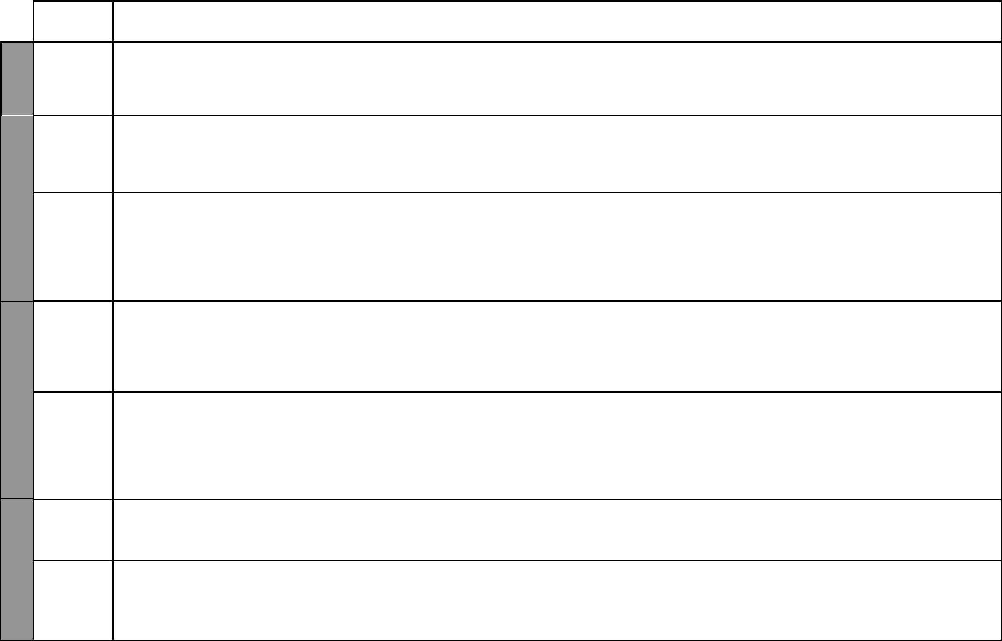

TOPIC

4 | Our family
WEEK | Our family
WEEK | needs and
WEEK | child rights
 | Our family
 | needs and
 | child rights
5
WEEK | Our family
WEEK | possessions

Our family possessions

6
WEEK | Our family
WEEK | possessions

 | Our family
 | possessions
7
WEEK | Our family
WEEK | possessions

SUB-TOPIC | OBJECTIVES | TEACHING/LEARNING |  | LEARNING/TEACHING | REMARKS
SUB-TOPIC | OBJECTIVES | ACTIVITIES |  | RESOURCES | REMARKS
Child rights | By the end of the lesson the learners | • Identify the rights of children | Our Lives Today SST Book 1
 | should be able to list the rights of a | • Observe pictures showing children’s | pages 28-29
 | child. | rights | • Pictures showing children’s rights
 |  |  | • | Curiosity chart
Child rights | By the end of the lesson the learners | • Discuss children’s rights | Our Lives Today SST Book 1
 | should be able to list the rights of a | • Observe the pictures showing some | pages 28-29
 | child. | children’s rights in the Pupil’s Book | • Pictures in the Pupil’s Book
 |  |  | • | Curiosity chart
Animals we keep | By the end of the lesson the learners | • Draw the animals kept at home | Our Lives Today SST Book 1 page 30
at home | should be able to name the types of | • Name the animals kept at home | • | Local environment
 | animals owned by the family. | • Classify animals | • | Curiosity chart
 | • Classify the animals (livestock and pets). | • State the uses of animals | • Pictures of animals in the Pupil’s
 | • State the uses of the animals in their | • Sing a song about animals |  | Book
 | homes.
Animals we keep | By the end of this lesson the learners | • Sing a song about animals | Our Lives Today SST Book 1 page 30
at home | should be able to name the animals | • Name the animals kept at home | • Pictures of animals in the Pupil’s
 | owned by the family. | • Draw the animals kept at home |  | Book
 |  |  | • | Curiosity chart
 |  |  | • | Local environment
Things found in | By the end of the lesson the learners | • Identify the things found in the house | Our Lives Today SST Book 1 page 31
the house | should be able to: | • Draw the things found in the house | • Pictures of the things found in
 | • List the things found in the house. | • Observe the pictures in the Pupil’s |  | the house
 | • Mention the uses of the things found | Book | • Real items found in the house,
 | in the house. |  |  | e.g. radio
 |  |  | • Pictures in the Pupil’s Book
Other things found | By the end of this lesson the learners should | • State the things owned by the family | Our Lives Today SST Book 1 page 32
in our homes and | be able to identify the family possessions in | • Draw the things owned by the family | • Pictures in the Pupil’s Book
their uses | their homes and their uses. |  | • | Curiosity chart
Care of family | By the end of this lesson the learners | • Describe how to take care of things | Our Lives Today SST Book 1 page 33
possessions | should be able to state ways of caring for | at home | • Pictures in the Pupil’s Book
 | family possessions. | • Ask oral questions on how to take | • Items like buckets, soap, brooms
 |  | care of things at home |  | etc.
 |  | 5 |  | For use with Our Lives Today Standard One

WEEK 8

WEEK 9

WEEK 10

 |  |  |  |  | Our Lives Today: Social Studies Standard One
 |  |  |  |  | Schemes of Work
 |  |  |  |  |  | Term 2
TOPIC | SUB-TOPIC | OBJECTIVES |  | TEACHING/LEARNING | LEARNING/TEACHING | REMARKS
TOPIC | SUB-TOPIC | OBJECTIVES |  | ACTIVITIES | RESOURCES | REMARKS
Our family | Keeping our home | By the end of the lesson the learners | • Identify the ways of keeping our |  | Our Lives Today SST Book 1
possessions | clean and safe | should be able to identify ways of |  | homes clean and safe. | pages 34-35
 |  | keeping their homes clean and safe and | • Observe the pictures in the Pupil’s |  | • Pictures in the Pupil’s Book
 |  | appreciate the importance of keeping |  | Book | • Implements used to keep our
 |  | their homes clean and safe. | • | Sweep the class. | home clean, e.g. pangas, slashers,
 |  |  | • Arrange items in the classroom |  | brooms
Our family | Keeping our home | By the end of the lesson the learners | • | Group activities | Our Lives Today SST Book 1
possessions | clean and safe | should be able to demonstrate how to | • | Quiz | pages 34-35
 |  | keep their homes clean and safe.
Our family | What the family | By the end of the lesson the learners | • Identify various jobs that members of |  | Our Lives Today SST Book 1
possessions | members do to | should be able to identify ways in which |  | the family can do. | pages 36-37
 | earn a living | families earn their living. | • Observe the pictures in the Pupil’s |  | • Curiosity chart
 |  |  |  | Book | • Pictures in the Pupil’s Book
 |  |  |  |  | • Pictures/Drawings of people
 |  |  |  |  | doing various jobs
Our family | What the family | By the end of the lesson the learners | • Identify various jobs that members of |  | Our Lives Today SST Book 1
possessions | members do to | should be able to identify ways in which |  | the family can do. | pages 36-37
 | earn a living | families earn their living. | • Observe pictures in the Pupil’s Book |  | • Curiosity chart
 |  |  | • Draw family members doing various |  | • Pictures in the Pupil’s Book
 |  |  |  | jobs | • Pictures showing members of the
 |  |  |  |  | family doing various jobs
Our school | Name and history | By the end of the lesson the learners | • Give the name of the school. |  | Our Lives Today SST Book 1 page 38
 | of the school | should be able to: | • State when the school was started |  | • School signpost
 |  | • Give the name of their school. | • Listen to a resource person |  | • Resource person, e.g. an old boy
 |  | • State when the school was started. | • Recite the history of the school |  | or girl
 |  | • Appreciate how the school has |  |  | • Old photographs of the school
 |  | developed.
Our school | Symbols of the |  | • Identify the school symbols |  | Our Lives Today SST Book 1 page 39
 | school and their | By the end of the lesson the learners | • Draw the school symbols |  | • Pictures in the Pupil’s Book
 | importance | should be able to identify at least three | • Observe the pictures in the Pupil’s |  | • School uniforms from
 |  | symbols of their school that make it |  | Book | neighbouring schools
 |  | different from the others.


₆ For use with Our Lives Today Standard One

Our Lives Today: Social Studies Standard One

Schemes of Work

Term 2

WEEK 11

WEEK 14 WEEK 13 WEEK 12

TOPIC | SUB-TOPIC | OBJECTIVES |  | TEACHING/LEARNING | LEARNING/TEACHING | REMARKS
TOPIC | SUB-TOPIC | OBJECTIVES |  | ACTIVITIES | RESOURCES | REMARKS
Our school | Symbols of the | By the end of the lesson the learners | • State the importance of the school |  | Our Lives Today SST Book 1 page 39
 | school and their | should be able to state the importance of |  | symbols | • Pictures in the Pupil’s Book
 | importance | the symbols of their school. | • Observe the pictures in the Pupil’s Book |  | • school uniforms from
 |  |  | • Sing the school anthem/prayer |  | neighbouring schools
Our school | Our school | By the end of the lesson the learners | • Mention the activities done in the |  | Our Lives Today SST Book 1
 | activities | shoud be able to mention four activities |  | school | pages 40-41
 |  | they do at school each day. | • Demonstrate some of the activities, |  | • School environment
 |  |  |  | e.g. sweeping | • Pictures showing various activities
 |  |  |  |  | • School timetable
Our school | Our school routine | By the end of the lesson the learners | • State the importance of doing each |  | Our Lives Today SST Book 1
 |  | should be able to state the importance of |  | activity at the right time | pages 40-41
 |  | doing each of the school activities at the | • Observe the pictures in the Pupil’s |  | • Pictures drawn by the teacher
 |  | right time. |  | Book.
Our school | The people in our | By the end of the lesson the learners | • Identify various groups of people in |  | Our Lives Today SST Book 1 page 42
 | school and their | should be able to identify the different |  | the school community | • Pictures in the Pupil’s Book
 | school and their | groups of people who make the school |  | the school community | • Pictures in the Pupil’s Book
 | roles | groups of people who make the school | • Observe the pictures in the Pupil’s Book |  | • Local environment
 | roles | community. |  |  | • Local environment
Our school | The people in our | By the end of the lesson the learners | • Identify various groups of people |  | Our Lives Today SST Book 1 page 42
 | school and their | should be able to state the different |  | that make up the school community | • Pictures in the Pupil’s Book
 | roles | roles of people who make up the school | • Observe pictures in the Pupil’s Book. |  | • The school
 |  | community.
Our school | Revision | By the end of the term the learners | • Answer oral questions based on the |  | Our Lives Today SST Book 1
 |  | should be able to revise the work |  | work covered | pages 18-42
 |  | covered during the term. |  |  | • Pupils’ drawings
Exam | Revision | The learners should be able to answer | • | Write the test. | Our Lives Today SST Book 1
 |  | questions based on the work covered | • | Revise the test. | pages 18-42
 |  | during the term.


₇ For use with Our Lives Today Standard One

Our Lives Today: Social Studies Schemes of Work for Standard One: Term Three

WEEK 1

WEEK 2

WEEK 3

WEEK 4

 | TOPIC | SUB-TOPIC | OBJECTIVES |  | TEACHING/LEARNING | LEARNING/TEACHING | REMARKS
 | TOPIC | SUB-TOPIC | OBJECTIVES |  | ACTIVITIES | RESOURCES | REMARKS
 | Our school | The people in our | By the end of the lesson the learners | • | Identify different groups of people in | Our Lives Today SST Book 1 page 42
 |  | school and their | should be able to identify different |  | the school | • Pictures in the Pupil’s Book
 |  | roles | groups of people in the school. | • | State different roles in the school | • School environment
 |  |  |  | • Observe the pictures in the Pupil’s Book
 |  |  |  | • | Role-play
 | Our school | Our classroom | By the end of the lesson the learners | • | Identify the position of the classroom | Our Lives Today SST Book 1 page 43
 | Our school | Our classroom | should be able to identify the position | • | Identify the position of the classroom | Our Lives Today SST Book 1 page 43
 |  |  | should be able to identify the position |  | in relation to other classrooms | • Pictures in the Pupil’s Book
 |  |  | of their classroom in relation to other |  | in relation to other classrooms | • Pictures in the Pupil’s Book
 |  |  | of their classroom in relation to other | • Observe the pictures in the Pupil’s Book
 |  |  | classrooms.
 | Our school | Members of our | By the end of the lesson the learners | • | Identify different members of the | Our Lives Today SST Book 1 page 44
 |  | class | should be able to identify different |  | class | • Pictures in the Pupil’s Book
 |  |  | members of their class and call at least | • | Call at least half of the learners by | • Classroom
 |  |  | half the learners by their names. |  | name
 |  |  |  | • Observe the pictures in the Pupil’s Book
 | Our school | Seating | By the end of the lesson the learners | • | Name the pupils who sit in each group | Our Lives Today SST Book 1 page 44
 |  | arrangement | should be able to name the pupils who sit | • | Draw desk arrangement | • Pictures in the Pupil’s Book
 |  |  | in each group and draw pictures of the | • | Observe the picture in the Pupil’s | • Classroom
 |  |  | desk arrangement. |  | Book
 | Our school | Our roles as | By the end of the lesson the learners | • | State activities done by class members | Our Lives Today SST Book 1 page 45
 |  | members of our | should be able to identify the role of their | • | Demonstrate some activities like
 |  | class | class. |  | sweeping
 |  |  |  | • | Arrange books
 | Our school | Our roles as | By the end of the lesson the learners | • | Identify class leaders | Our Lives Today SST Book 1 page 45
 |  | members of our | should be able to: | • | State the role of class teachers | • Class environment
 |  | class | • identify the role of the class prefect.
 |  |  | • state the role of their class teacher.
 | Our school | Our class rules | By the end of the lesson the learners | • | Stating the rules that they observe in | Our Lives Today SST Book 1 page 46
 |  |  | should be able to state five rules that they |  | class | • Chart showing class rules
 |  |  | observe in class | • | Writing and displaying the class rules | • Set of rules in the Pupil’s Book


₈ For use with Our Lives Today Standard One

Our Lives Today: Social Studies Standard One

Schemes of Work

Term 3

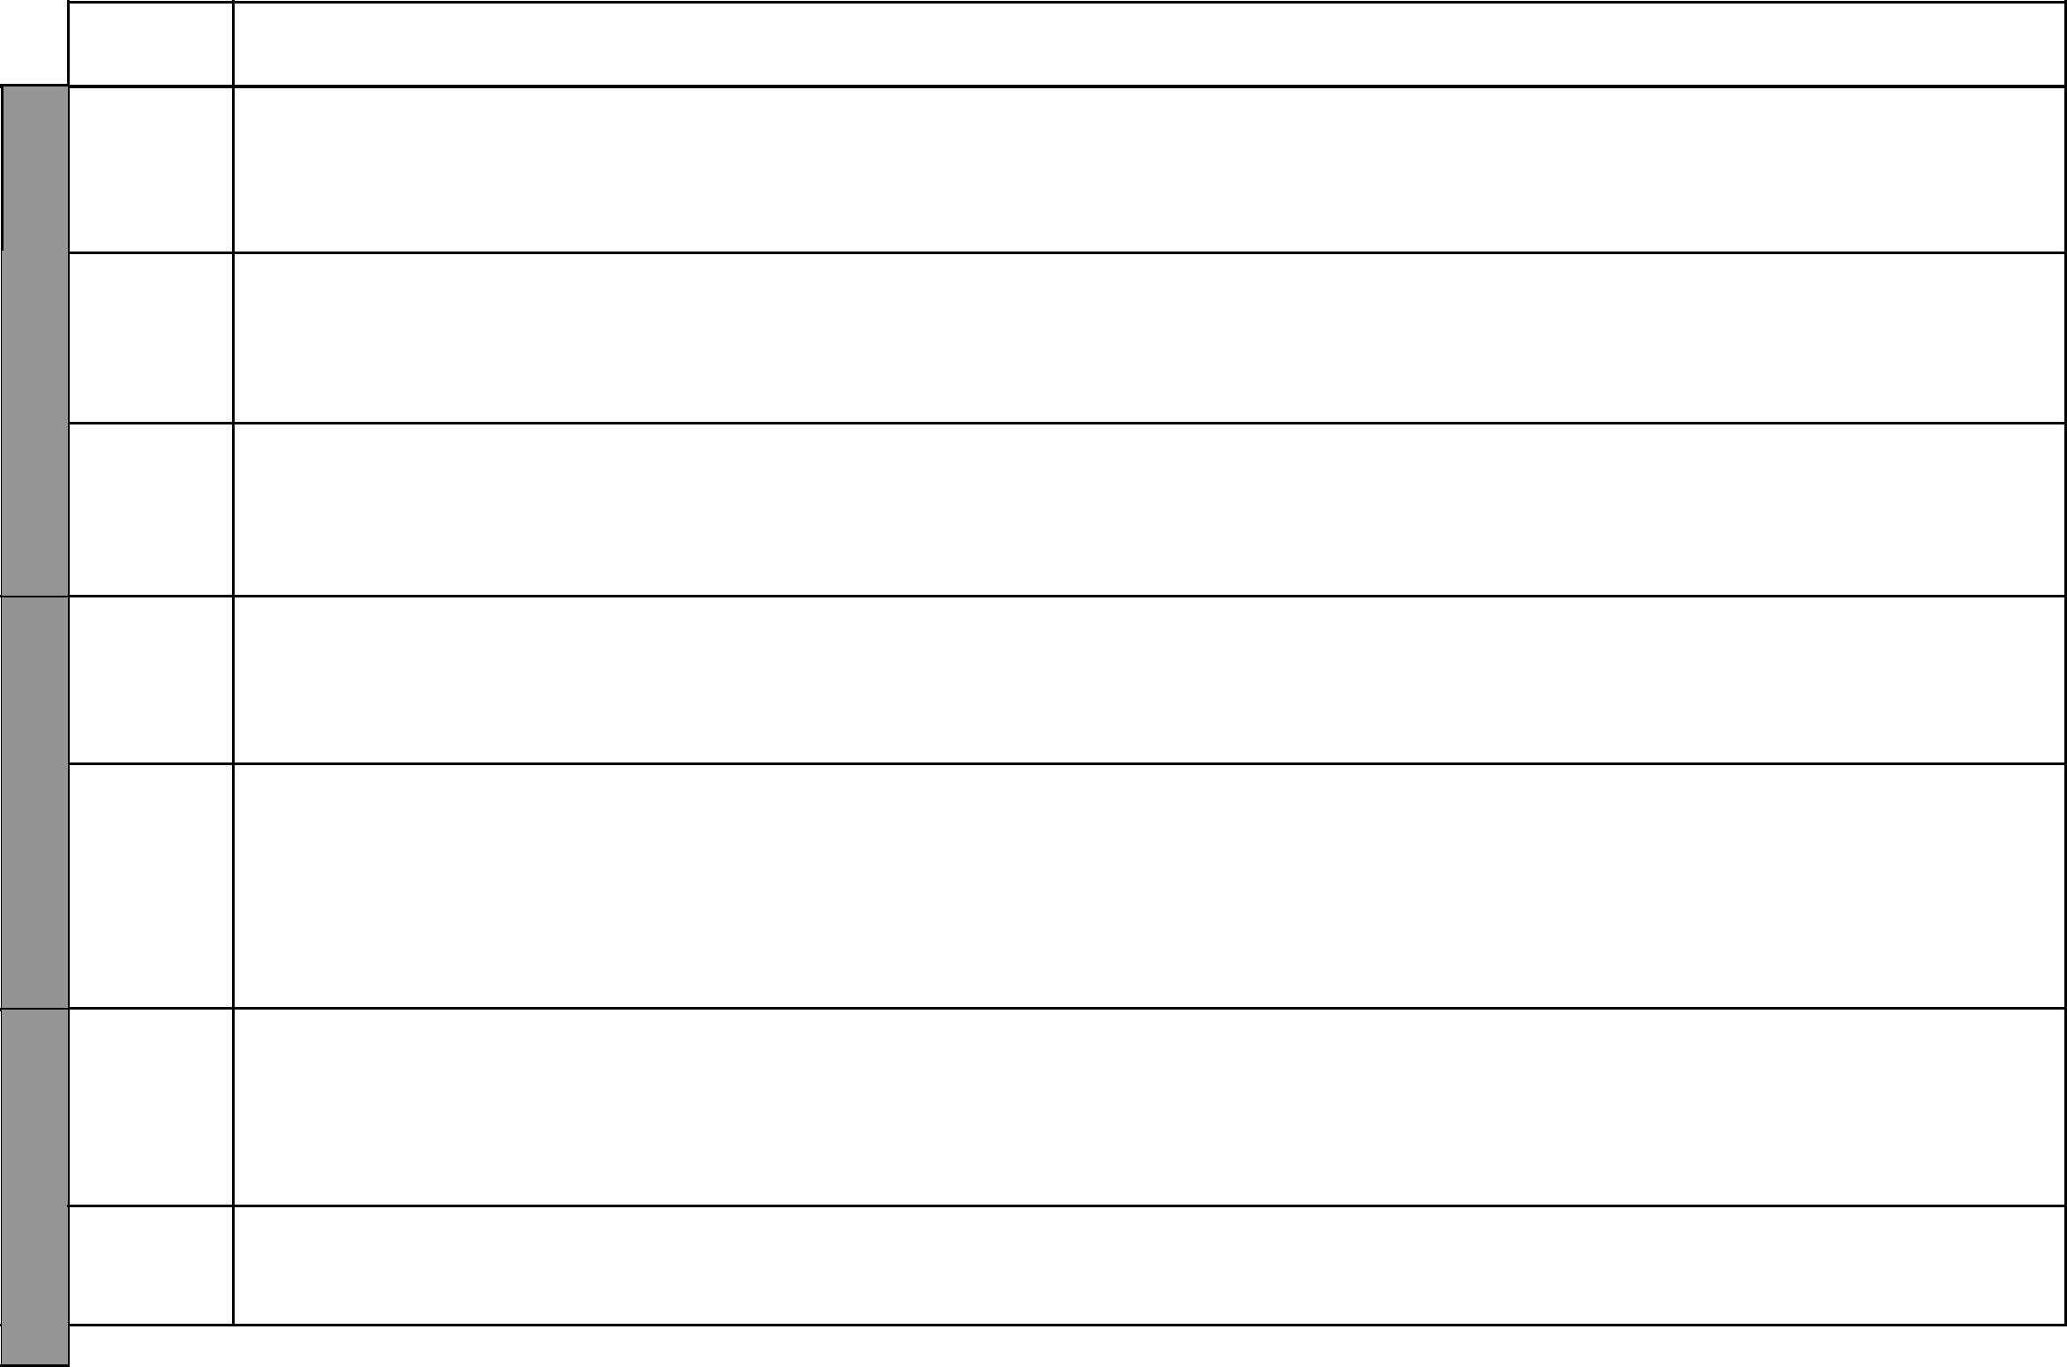
TOPIC

4 | Our school
WEEK | Our school
 | Our school

5
WEEK | Our school

Our school

6
WEEK | Our school

 | Safety on
7 | the way to
7 | and from
WEEK | and from
WEEK | school
WEEK | Safety on the
 | way to and
 | from school

SUB-TOPIC | OBJECTIVES | TEACHING/LEARNING | LEARNING/TEACHING | REMARKS
SUB-TOPIC | OBJECTIVES | ACTIVITIES | RESOURCES | REMARKS
Our class rules | By the end of the lesson the learners | • State the reasons for obeying rules | Our Lives Today SST Book 1 page 46
 | should be able to state the importance of | in class | • Displayed rules
 | obeying class rules. | • Recite the class rules
Keeping our | By the end of the lesson the learners | • State ways of keeping their class | Our Lives Today SST Book 1 page 47
classroom clean | should be able to: | clean | • Classroom
 | • state ways of keeping their class clean. | • Demonstrate how to keep the class | • Pictures in the Pupil’s Book
 | • appreciate the importance of keeping | clean
 | their class clean. | • Observe the pictures in the Pupil’s Book
Taking care of | By the end of the lesson the learners | • Mention the ways in which they help | Our Lives Today SST Book 1 page 48
things in our | should be able mention five ways in | to take care of things in class | • Classroom and items in it.
classroom | which they can help take care of things | • Observe the pictures in the Pupil’s Book
classroom | which they can help take care of things | • Identify different items in the
 | in class. | • Identify different items in the
 | in class. | classroom
How to take care | By the end of the lesson the learners | • Tell why it is necessary to take care | Our Lives Today SST Book 1 page 48
of things in our | should be able to appreciate the need of | of things in class | • Pictures in the Pupil’s Book
classroom | taking care of things in the classroom. | • Cover books | • Papers
The class time- | By the end of the lesson the learners | • Identify parts of the timetable. | Our Lives Today SST Book 1 page 49
The class time- | should be able to: | • State the importance of the class | • Class timetable
table | should be able to: | • State the importance of the class | • Class timetable
table | • identify parts of the timetable. | timetable
 | • state the importance of the class time
 | table.
 | • appreciate the importance of the class
 | timetable.
Different ways of | By the end of the lesson the learners | • Draw the means used to go to school. | Our Lives Today SST Book 1 page 50
going to school | should be able to: | • Draw the means used to go to school. | Our Lives Today SST Book 1 page 50
going to school | should be able to: | • Mention different ways of going to | • Pictures in the Pupil’s Book
 | • mention ways of going to school and back. | • Mention different ways of going to | • Pictures in the Pupil’s Book
 | • tell the means used by most learners | school. | • Pupils’ own experiences
 | • tell the means used by most learners | • Observe the pictures in the Pupil’s
 | to get to the school. | • Observe the pictures in the Pupil’s
 | to get to the school. | Book.
How to use the | By the end of the lesson the learners | • Demonstrate how to use the road safely | Our Lives Today SST Book 1
road safely | should be able to demonstrate how to | • Dramatize safe use of roads and | Pages 51-53
 | use the road safely. | scenes of accidents. | • Zebra crossing
 |  | 9 | For use with Our Lives Today Standard One

WEEK 12 WEEK 11 WEEK 10 WEEK 9 WEEK 8

 |  |  |  |  | Our Lives Today: Social Studies Standard One
 |  |  |  |  | Schemes of Work
 |  |  |  |  |  | Term 3
TOPIC | SUB-TOPIC | OBJECTIVES |  | TEACHING/LEARNING | LEARNING/TEACHING | REMARKS
TOPIC | SUB-TOPIC | OBJECTIVES |  | ACTIVITIES | RESOURCES | REMARKS
Safety on | How to use the | By the end of the lesson the learners | • State the rules that should be |  | Our Lives Today SST Book 1
the way to | road safely | should be able to state some basic rules |  | followed by pedestrians | pages 51-53
and from |  | that should be use by pedestrians.
school
Safety on | Danger of | By the end of the lesson the learners | • | Narrate a story | Our Lives Today SST Book 1 page 54
the way to | talking to and | should be able to state the dangers of | • Observe the pictures in the Pupil’s |  | • Pictures in the Pupil’s Book
and from | accompanying | talking to strangers. |  | Book
school | strangers
Safety on | Danger of | By the end of the lesson the learners | • Identify the dangers of accompanying |  | Our Lives Today SST Book 1 page 55
the way to | talking to and | should be able to: |  | strangers
and from | accompanying | • identify the dangers of accompanying | • List what to do when confronted by
school | strangers | strangers. |  | a stranger
 |  | • list what to do when confronted by a
 |  | stranger.
Important | Features seen | By the end of the lesson the learners | • List and identify the important |  | Our Lives Today SST Book 1 page 56
features on | along the way | should be able to identify important |  | features on the way to school | • Picture in the Pupil’s Book
the way to |  | features on the way to school. | • Observe the picture in the Pupils’
school |  |  |  | Book
Important | Importance of the | By the end of the lesson the learners | • State the importance of the things |  | Our Lives Today SST Book 1 page 57
features on | things we see on | should be able to state the importance of |  |  | • Pictures in the Pupil’s Book
the way to | our way to school | the things they see on their way to school
school |  | to the people living near them.
Important | Importance of the | By the end of the lesson the learners | • List the features identified on the |  | Our Lives Today SST Book 1 page 57
features on | things we see on | should be able to list the features |  | way to and from school
the way to | our way to school | identified on the way to and from school.
school
Exam | Work covered | The learners should be able to answer | • | Write the test | Our Lives Today SST Book 1 pages
 | during the term | questions based on the work covered. | • | Revise the test | 42-57
 |  |  |  |  | • Pupils’ drawings and models


₁₀ For use with Our Lives Today Standard One

