SCIENCE SCHEME OF WORK CLASS 5

Available Online:
Schools Net Kenya Consultancy
P.O. Box 8076 – 00200 Nairobi, Kenya | Tel: +254202319748
E-mail: infosnkenya@gmail.com | www.schoolsnetkenya.com

Science in Action Schemes of Work for Standard Five: Term One


WEEK 1

WEEK 6 WEEK 5 WEEK 4 WEEK 3 WEEK 2

LESSONS | UNIT | TOPIC |  | OBJECTIVES | LEARNING ACTIVITIES |  | LEARNING/TEACHING |  | REFERENCES | REMARKS
 |  |  |  |  |  |  |  | MATERIALS
1-3 | 1. | The meaning and | The learner should be able to: |  | • | Defining breathing | • | Charts | Science In Action
1-3 | The | The meaning and | • | Define breathing | • | Explaining the importance of | • | Models of breathing system | Book 5 page 2
 | The | importance of
 | breathing | breathing | • | Distinguish between |  | breathing |  |  | Teacher’s Book 5
 | system |  |  | inspiration and expiration | • | Demonstrating breathing |  |  | pages 1-2
 |  |  | • Explain the importance of |  |  | using a model
 |  |  |  | breathing
1-3 |  | Parts of the | • The learner should be able |  | • | Identifying parts of the | • | Diagrams of breathing organs | Science In Action
1-3 |  | Parts of the |  | to identify and name main |  | breathing system | • | Lungs of slaughtered chicken | Book 5 page 2
 |  | human breathing |  | to identify and name main
 |  | human breathing |  | parts of the human | • | Naming and drawing parts of |  | or goat | Teacher’s Book 5
 |  | system |  | parts of the human | • | Naming and drawing parts of |  | or goat | Teacher’s Book 5
 |  | system |  | breathing system |  | the breathing system |  |  | page 2
1-6 |  | Functions of | The learner should be able to |  | • | Discussing functions of each | • | Model of human breathing | Science In Action
 |  | parts of human | state the functions of the parts |  |  | part of the breathing system |  | system | Book 5 pages 3-5
 |  | breathing system | of the breathing system |  |  |  | • | Chart on functions of parts of | Teacher’s Book 5
 |  |  |  |  |  |  |  | the breathing system | page 3
1-3 | 2. The | The meaning and | The learner should be able to |  | • | Defining digestion | • | Chart on digestion | Science In Action
 | digestive | importance of | define digestion and explain |  | • | Explaining the importance of | • | Model of the digestive system | Book 5 page 8
 | system | digestion | the importance of digestion |  |  | digestion |  |  | Teacher’s Book 5
 | system | digestion |  |  |  | digestion |  |  | pages 4-5
1-3 |  | Parts of the | The learner should be able to |  | • Identifying parts of the |  | • | Chart on digestion | Science In Action
 |  | digestive system |  |  |  | digestive system | • | Chart on digestion | Book 5 page 8
 |  | digestive system | name the main parts of the |  | • | digestive system | • | Model of the digestive system | Book 5 page 8
 |  |  | digestive system |  | • | Naming and drawing parts of |  |  | Teacher’s Book 5
 |  |  |  |  |  | the digestive system |  |  | pages 5-6
1-6 |  | The functions of | The learner should be able to |  | • Discussing functions of each |  |  |  | Science In Action
1-6 |  | The functions of |  |  |  |  | • | Chart on digestive system | Book 5 page 9
 |  | the parts of the | state the functions of the parts |  |  | part of the digestive system | • | Chart on digestive system | Book 5 page 9
 |  | the parts of the |  |  |  | part of the digestive system | • | Model of the digestive system | Teacher’s Book 5
 |  | digestive system | of the digestive system |  |  |  | • | Model of the digestive system | Teacher’s Book 5
 |  | digestive system |  |  |  |  |  |  | page 6
1-6 | 3. Health | Classifying drugs | The learner should be able |  | • | Distinguishing between | • | Samples of drugs | Science In Action
 | education |  | to classify drugs according to |  |  | sedatives, stimulants, | • | Samples of drugs | Book 5 page 12
 | education |  |  |  |  | sedatives, stimulants, | • | Chart on classification of | Book 5 page 12
 |  |  | their effects on the body |  |  | medicines, hallucinogens, | • | Chart on classification of | Teacher’s Book 5
 |  |  |  |  |  | medicines, hallucinogens, |  | drugs | Teacher’s Book 5
 |  |  |  |  |  | narcotics and poisons |  | drugs | pages 7-8
1-6 |  | Medicinal drugs | The learner should be able |  | • Describing the proper storage |  | • | Samples of medicinal drugs | Science In Action
 |  |  | to store and use medicine |  |  | of medicine | • | Samples of medicinal drugs | Book 5 pages 12-14
 |  |  |  |  |  | of medicine | • | Chart on procedure for drug | Book 5 pages 12-14
 |  |  | properly |  | • Reading labels of medicinal |  | • | Chart on procedure for drug | Teacher’s Book 5
 |  |  |  |  |  |  |  | storage | Teacher’s Book 5
 |  |  |  |  |  | drugs |  | storage | pages 8-9
 |  |  |  |  | • Resource person’s talk on
 |  |  |  |  |  | proper use of medicine

1 For use with Science in Action Standard Five

Science in Action Schemes of Work for Standard Five Term 1
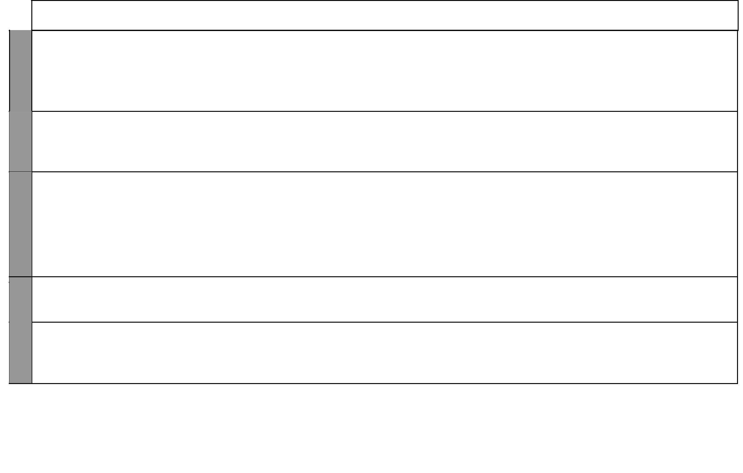

WEEK 8 WEEK 7

WEEK 11 WEEK 10 WEEK 9

LESSONS | UNIT | TOPIC | OBJECTIVES | LEARNING ACTIVITIES |  | LEARNING/TEACHING |  | REFERENCES | REMARKS
 |  |  |  |  |  |  | MATERIALS
1-6 |  | Handling | The learner should be able | • | Outlining the correct | • | Washing detergents | Science In Action
 |  | chemicals | to take safety measures when |  | procedure for handling | • | Disinfectants | Book 5 page 14
 |  |  | handling the chemicals used |  | chemicals | • | Chemical fertilizers | Teacher’s Book 5
 |  |  | at home | • | Demonstration on how to | • Paraffin |  | page 9
 |  |  |  |  | handle chemicals | • | Diesel
 |  |  |  |  |  | • | Protective clothing like
 |  |  |  |  |  |  | overalls, masks, gloves and goggles
1-6 |  | First aid for | The learner should be able to | • | Identifying sources of poison | • | Milk | Science In
 |  | poisoning | carry out first aid in case of | • | Describing first aid | • | Water | Action Book 5
 |  |  | poisoning |  | procedures for poisoning | • | Medicine | pages 15-16
 |  |  | poisoning |  | procedures for poisoning | • | Medicine | Teacher’s Book 5
 |  |  |  | • | Identifying symptoms of | • | Charts on poisoning | Teacher’s Book 5
 |  |  |  |  |  |  |  | pages 9-10
 |  |  |  |  | poisoning |  |  | pages 9-10
 |  | Transmission of | The learner should be able to | • | Describing the meaning of | • Video cassettes |  | Science In
 |  | HIV/AIDS | state: |  | HIV/AIDS |  |  | Action Book 5
 |  | HIV/AIDS | state: | • | Discussing the transmission | • | Pictures | pages 17-19
 |  |  | • How HIV is transmitted
 |  |  | • How HIV is transmitted |  | of HIV/AIDS | • Poems |  | Teacher’s Book 5
 |  |  | • How HIV is not transmitted |  | of HIV/AIDS |  |  | Teacher’s Book 5
 |  |  | • How HIV is not transmitted | • Composing poems and songs |  | • Newspaper cuttings |  | pages 10-11
 |  |  | • How HIV is prevented |  |  |  |  | pages 10-11
 |  |  | • How HIV is prevented |  | on HIV/AIDS
 |  |  | • The stages of HIV infection |  | on HIV/AIDS
 |  |  | • The stages of HIV infection | • | Discussing prevention of
 |  |  |  |  | HIV/AIDS
 |  |  |  | • Outlining the stages of
 |  |  |  |  | HIV infection
 |  |  |  | • | Collecting and classifying |  |  | Science In
 | 4. Plants | Classifying | The learner should be able to | • | Collecting and classifying | • | Common plants from locality | Action Book 5
 |  | plants | classify plants |  | plants |  |  | pages 22-24
 |  | plants | classify plants |  |  |  |  | Teacher’s Book 5
 |  |  |  |  |  |  |  | pages 12-13
 |  | The external | The learner should be able to | • | Naming and drawing external | • | Whole plants | Science In
 |  | parts of a plant | name and describe the func- |  | parts of a plant | • | Water | Science In
 |  | parts of a plant | name and describe the func- |  | parts of a plant | • | Water | Action Book 5
 |  | parts of a plant | name and describe the func- | • | Describing functions of each | • | Water | Action Book 5
 |  |  | tions of the external parts of | • | Describing functions of each | • | Manila papers | pages 24-31
 |  |  | a plant |  | part of a plant | • | Pins, stones, cello tape, | Teacher’s Book 5
 |  |  | a plant |  |  |  | containers, ink, flowers, | Teacher’s Book 5
 |  |  |  |  |  |  | containers, ink, flowers, | pages 13-15
 |  |  |  |  |  |  | polythene bags, razor blades | pages 13-15

2 For use with Science in Action Standard Five

Science in Action Schemes of Work for Standard Five: Term Two


WEEK 1

WEEK 7 WEEK 6 WEEK 5 WEEK 4 WEEK 3 WEEK 2

LESSONS | UNIT | TOPIC | OBJECTIVES | LEARNING ACTIVITIES |  |  | LEARNING/TEACHING | REFERENCES | REMARKS
 |  |  |  |  |  |  | MATERIALS
1-3 | 5. | The meaning of | The learner should be able | • | Identifying weather symbols | • Chart on weather symbols |  | Science In
 | Weather | weather | to define the terms weather, | • | Distinguishing between | • Pictures of weather effects |  | Action Book 5 page 34
 | instru- |  | atmosphere and climate |  | atmosphere, weather and |  |  | Teacher’s Book 5 pages
 | ments |  |  |  | climate |  |  | 16-17
1-3 |  | Weather | The learner should be able to | • | Observing different weather | • Chart on weather instruments |  | Science In
1-3 |  |  |  |  |  |  |  | Action Book 5 pages
 |  | instruments | name correctly the different |  | instruments | • | Real weather instruments | 34-39
 |  |  | instruments for measuring |  | instruments |  |  | 34-39
 |  |  | instruments for measuring | • | Describing how weather |  |  | Teacher’s Book 5
 |  |  | weather conditions |  | instruments are used |  |  | page 17
1-6 |  | The rain gauge | The learner should be able | • | Constructing a simple rain | • | Tins, rulers, funnels and | Science In Action Book
 |  |  | to construct and use a simple |  | gauge |  | bottles | 5 page 34
 |  |  | rain gauge | • | Using a simple rain gauge |  |  | Teacher’s Book 5
 |  |  |  |  |  |  |  | pages 17-18
1-6 |  | The windsock | The learner should be able to | • | Constructing a simple | • | Nylon bags, nylon stockings, | Science In
 |  |  | construct and use a windsock |  | windsock |  | tall posts, nails, pieces of wire, | Action Book 5 pages
 |  |  |  | • | Using a simple windsock |  | bottle tops, strings | 35-36
 |  |  |  | • | Using a simple windsock |  |  | Teacher’s Book 5
 |  |  |  |  |  |  |  | page 18
1-6 |  | The wind vane | The learner should be able to | • | Constructing a simple | • Bottle with a cork. Maize stalk, |  | Science In
1-6 |  |  | construct and use a wind vane | • | Constructing a simple |  | sheet of cardboard, drinking | Action Book 5 pages
 |  |  | construct and use a wind vane |  | wind vane |  | sheet of cardboard, drinking | 36-37
 |  |  |  | • | Using a wind vane |  | straw, nails | 36-37
 |  |  |  | • | Using a wind vane |  | straw, nails | Teacher’s Book 5
 |  |  |  |  |  |  |  | pages 18-19
 |  | The thermometer | The learner should be able | • | Constructing a water | • Empty ink bottle with cork, |  | Science In Action Book
 |  | The thermometer | to construct and use a water |  | thermometer |  | stand, drinking straw, tin, | Science In Action Book
1-6 |  | The thermometer | to construct and use a water |  | thermometer |  | stand, drinking straw, tin, | 5 pages 37-39
1-6 |  |  | thermometer and an air ther- | • | Using a water thermometer |  | cardboard, chewing gum, | 5 pages 37-39
 |  |  | thermometer and an air ther- | • | Using a water thermometer |  | cardboard, chewing gum, | Teacher’s Book 5
 |  |  | mometer | • | Constructing an air |  | coloured water, a scale on | Teacher’s Book 5
 |  |  | mometer | • | Constructing an air |  | coloured water, a scale on | pages 19-20
 |  |  |  |  | thermometer |  | cardboard. | pages 19-20
 |  |  |  | • | thermometer |  | cardboard.
 |  |  |  | • | Using an air thermometer
 | 6. | Classifying | The learner should be able to | • | Describing the difference | • Pictures of small and large |  | Science In Action Book
1-6 | 6. | animals | state the differences between |  | between vertebrates and |  |  | 5 page 42
1-6 | Animals | animals | state the differences between |  | between vertebrates and |  |  | 5 page 42
 |  |  |  |  | invertebrates |  | animals, pieces of paper, | 5 page 42
 |  |  | vertebrates and invertebrates |  | invertebrates |  | animals, pieces of paper, | Teacher’s Book 5
 |  |  |  | • | Grouping animals into |  | pencils, bottles and tins, pins | pages 22-23
 |  |  |  |  | vertebrates and invertebrates |  | or thorns
1-6 |  | Classifying | The learner should be able to | • | Classifying vertebrates into | • | Real animals | Science In Action Book
 |  | vertebrates | classify vertebrates and give |  | mammals, reptiles, birds, | • | Charts, diagrams and | 5 pages 42-46
 |  | vertebrates | classify vertebrates and give |  | amphibians and fish |  | photographs | Teacher’s Book 5
 |  |  | examples of each group |  | amphibians and fish |  | photographs | Teacher’s Book 5
 |  |  | examples of each group | • | Describing groups of |  |  | pages 23-25
 |  |  |  |  | vertebrates

3 For use with Science in Action Standard Five

Science in Action Schemes of Work for Standard Five Term 2
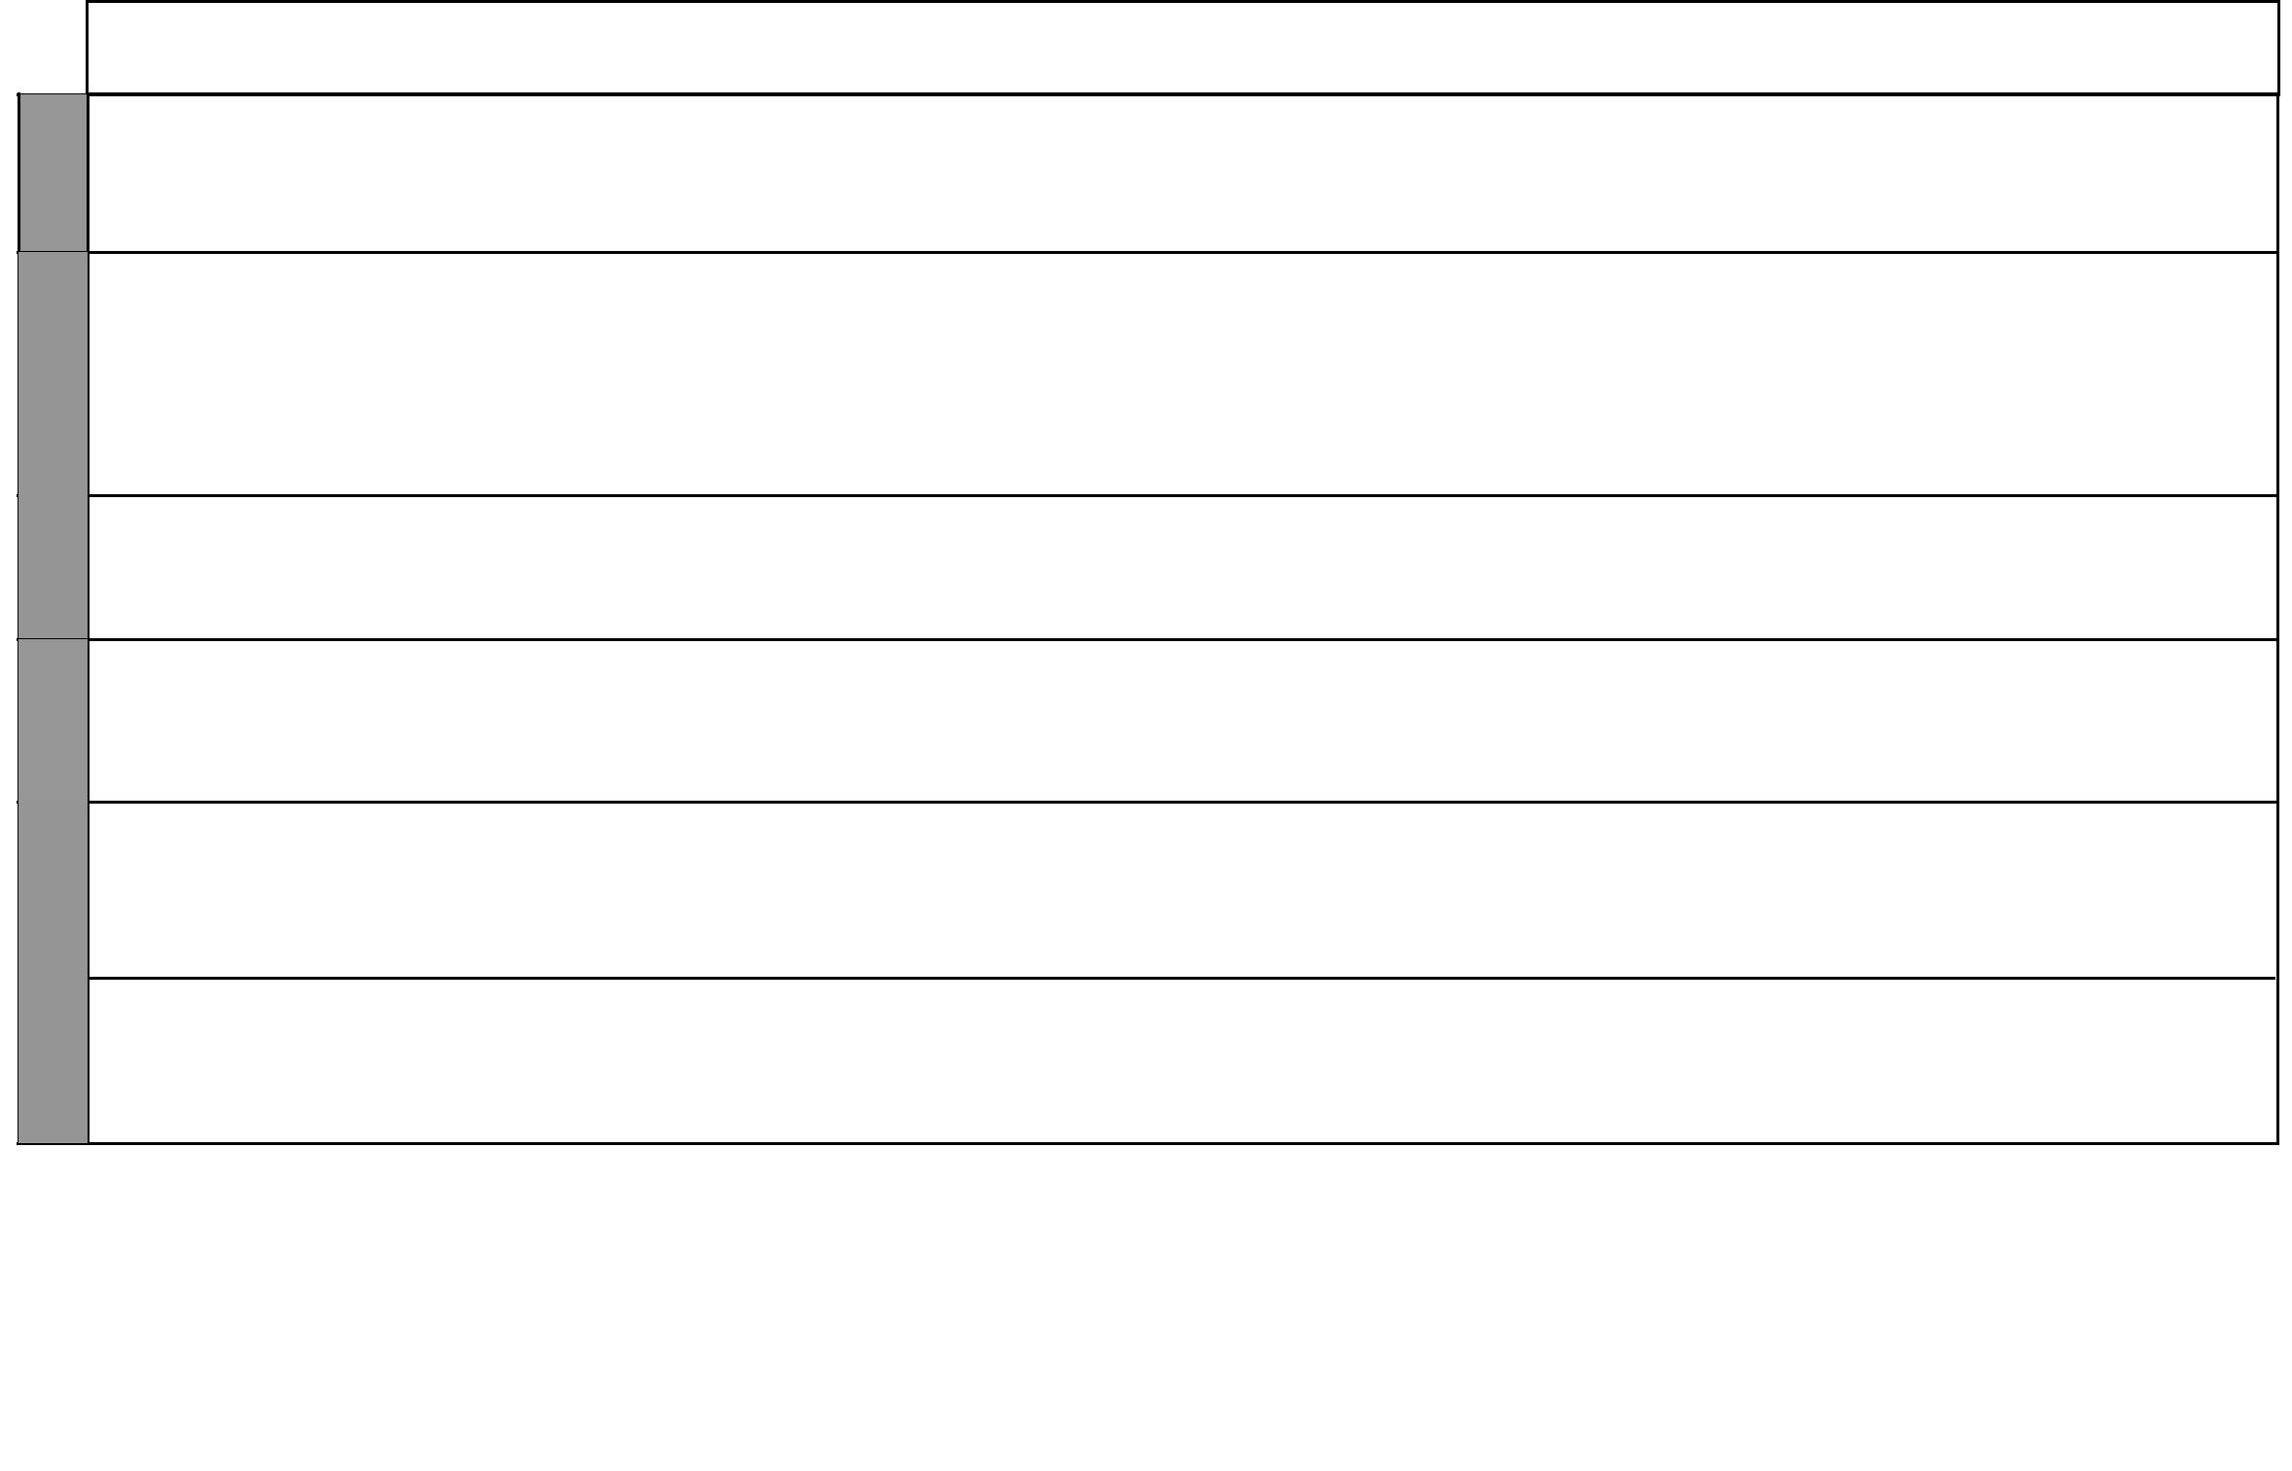

WEEK 8

WEEK 9

WEEK 10

WEEK 11

LESSONS | UNIT | TOPIC | OBJECTIVES | LEARNING ACTIVITIES |  | LEARNING/TEACHING |  | REFERENCES | REMARKS
 |  |  |  |  |  |  | MATERIALS
1-6 | 7. Soil | Formation of soil | The learner should be able to | • Describing how soils are |  | • | Soils, water, tins | Science In Action
 |  |  | define weather and identify |  | formed | • Hard core |  | Book 5 page 50
 |  |  | the different agents of weath- | • | Naming agents of weathering |  |  | Teacher’s Book 5
 |  |  | ering |  |  |  |  | pages 26-27
1-3 |  | Soil texture | The learner should be able to: | • | Distinguishing different types | • | Clay soils, loam soil, sandy | Science In Action
 |  |  | • Distinguish between fine, |  | of soil texture |  | soil, water, tins, glasses, dishes | Book 5 pages 50-51
 |  |  | • Distinguish between fine, |  | of soil texture |  | soil, water, tins, glasses, dishes | Teacher’s Book 5
 |  |  | • Distinguish between fine, | • | Testing soil texture |  | soil, water, tins, glasses, dishes | Teacher’s Book 5
 |  |  | smooth, coarse and rough | • | Testing soil texture |  |  | page 27
 |  |  | texture of soil | • Classifying soils according to |  |  |  | page 27
 |  |  | • Classify soils according to |  | texture
 |  |  | texture
1-3 |  | Drainage in soil | The learner should be able to | • Experimenting on water drainage |  | • | Clay soil loam soil, sandy soil | Science In Action
 |  |  | compare drainage in sandy, | • | Describing the difference | • | Measuring bottle, tin, water | Book 5 pages 51-52
 |  |  | clay and loamy soils |  | between drainage capacities of | • | Measuring bottle, tin, water | Teacher’s Book 5
 |  |  |  |  | different soils |  |  | pages 27-28
1-6 |  | Capillarity in soil | The learner should be able | • | Experimenting on soil | • | Bloating paper, glasses, chalk, | Science In Action
1-6 |  | Capillarity in soil | to measure and record the |  | capillarity |  | maize stalk, pieces of wood, | Book 5 pages 52-53
 |  |  | different rates of capillarity in | • Describing the differences in |  |  | ball-point pens | Teacher’s Book 5
 |  |  | sandy, clay and loamy soils |  | the capillarity of different soils |  |  | page 28
 | 8. Food | Classifying foods | The learner should be able to | • Identifying types of food |  | • | Charts, pictures of food, a | Science In Action
 | 8. Food | Classifying foods | identify and classify foods as | • | Grouping foods according to |  | variety of locally available | Book 5 page 56
 | and |  | identify and classify foods as | • | Grouping foods according to |  | variety of locally available | Book 5 page 56
 | and |  | identify and classify foods as | • | Grouping foods according to |  | foods | Teacher’s Book 5
 | and |  | energy providing foods, body |  | nutrients |  | foods | Teacher’s Book 5
 | nutrition |  | energy providing foods, body |  | nutrients |  | foods | Teacher’s Book 5
 | nutrition |  | building foods and protective |  |  |  |  | pages 30-31
 |  |  | foods
 |  |  | The learner should be able to | • Identifying foods rich in |  | • | Pictures and samples of foods | Science In Action
 |  | Carbohydrates |  |  |  |  |  | Book 5 page 57
 |  |  | identify foods that are rich in |  | carbohydrates |  | rich in carbohydrates | Teacher’s Book 5
 |  |  | carbohydrates | • Explaining the functions of |  |  |  | page 31
 |  |  |  |  | carbohydrates in the body

4 For use with Science in Action Standard Five

Science in Action Schemes of Work for Standard Five: Term Three

 |  | LESSONS | UNIT | TOPIC | OBJECTIVES | LEARNING ACTIVITIES |  | LEARNING/TEACHING |  | REFERENCES | REMARKS
 |  |  |  |  |  |  |  |  | MATERIALS
 | 1-3 |  |  | Fats and oils | The learner should be able to | • Identifying foods rich in fats |  | • | Pictures and samples of foods | Science In Action
 |  |  |  |  |  |  |  |  |  | Book 5 page 57
 |  |  |  | Fats and oils | identify foods that are rich in
 |  |  |  |  | identify foods that are rich in |  | and oils |  | rich in fats and oils | Teacher’s Book 5
 |  |  |  |  | fats and oils |  | and oils |  | rich in fats and oils | Teacher’s Book 5
1 |  |  |  |  | fats and oils | • Explaining the functions of |  |  |  | page 32
1 |  |  |  |  |  |  | fats and oils in the body
WEEK | 1-3 |  |  | Proteins | The learner should be able to | • Identifying foods rich in |  | • | Pictures and samples of foods | Science In Action
WEEK |  |  |  |  |  |  |  |  |  | Book 5 page 57
 |  |  |  |  | identify foods that are rich in |  | proteins |  | rich in proteins | Teacher’s Book 5
 |  |  |  |  | proteins | • Explaining the functions of |  |  |  | pages 32-33
 |  |  |  |  |  |  | proteins in the body
 | 1-3 |  |  | Vitamins | The learner should be able to | • Identifying foods rich in |  | • | Pictures and samples of foods | Science In Action
 |  |  |  |  |  |  |  |  |  | Book 5 page 58
 |  |  |  | Vitamins | identify foods that are rich in
 |  |  |  |  | identify foods that are rich in |  | vitamins |  | rich in vitamins | Teacher’s Book 5
 |  |  |  |  | vitamins |  | vitamins |  | rich in vitamins | Teacher’s Book 5
2 |  |  |  |  | vitamins | • Explaining the functions of |  |  |  | page 33
2 |  |  |  |  |  |  | vitamins in the body
WEEK |  |  |  |  |  |  | vitamins in the body
WEEK | 1-3 |  |  | Mineral elements | The learner should be able to | • Identifying foods rich in |  | • | Pictures and samples of foods | Science In Action
 |  |  |  |  | name the mineral elements |  | mineral elements |  | rich in mineral elements | Book 5 pages 58-59
 |  |  |  |  | name the mineral elements |  | mineral elements |  | rich in mineral elements | Teacher’s Book 5
 |  |  |  |  | required in a diet and identify |  | mineral elements |  | rich in mineral elements | Teacher’s Book 5
 |  |  |  |  | required in a diet and identify | • Explaining the functions of |  |  |  | Teacher’s Book 5
 |  |  |  |  | required in a diet and identify |  |  |  |  | pages 33-34
 |  |  |  |  | foods rich in mineral salts |  | mineral elements in the body
 | 1-3 |  |  | Water and fibre | The learner should be able to | • Explaining the importance of |  | • | Charts and pictures | Science In Action
 |  |  |  |  | state the importance of fibre |  | water and fibre in a diet | • | Pictures and samples of foods | Book 5 page 59
 |  |  |  |  | and water in a diet |  | water and fibre in a diet | • | Pictures and samples of foods | Teacher’s Book 5
 |  |  |  |  | and water in a diet |  |  |  | rich in fibre | Teacher’s Book 5
3 |  |  |  |  | and water in a diet |  |  |  | rich in fibre | page 34
WEEK | 1-3 |  |  | Nutritional | The learner should be able to | • | Identifying nutritional | • | Charts and pictures | Science In Action
 |  |  |  | deficiency diseases | identify names and symptoms |  | deficiency diseases |  |  | Book 5 pages 59-61
 |  |  |  |  | of nutrient deficiency diseases | • | Explaining the symptoms of |  |  | Teacher’s Book 5
 |  |  |  |  |  |  | kwashiorkor, marasmus, |  |  | pages 34-35
 |  |  |  |  |  |  | anaemia and rickets
 | 1-3 |  | 9. Sound | Producing sound | The learner should be able to | • | Describing sounds produced | • | Thin bamboo cane, dry sticks, | Science In Action
 |  |  |  |  | describe the sounds produced |  | by different objects |  | glass bottles, tins, drums, | Book 5 page 64
4 |  |  |  |  | describe the sounds produced |  | by different objects |  | glass bottles, tins, drums, | Teacher’s Book 5
4 |  |  |  |  | by various objects |  | by different objects |  | glass bottles, tins, drums, | Teacher’s Book 5
4 |  |  |  |  | by various objects |  |  |  | rattles, strings, water | page 36
WEEK | 1-3 |  |  | Classifying sound | The learner should be able to | • | Classifying sounds | • | Thin bamboo cane, dry sticks, | Science In Action
 |  |  |  |  | classify sounds according to |  |  |  | glass bottles, tins, drums, | Book 5 page 64
 |  |  |  |  | classify sounds according to |  |  |  | glass bottles, tins, drums, | Teacher’s Book 5
 |  |  |  |  | common characteristics (good, |  |  |  | glass bottles, tins, drums, | Teacher’s Book 5
 |  |  |  |  | common characteristics (good, |  |  |  | rattles, strings, water | page 37
 |  |  |  |  | bad, low, high, soft, loud)
5 | 1-3 |  |  | Loud and soft | The learner should be able to | • Identifying loud and soft |  | • | Thin bamboo cane, dry sticks, | Science In Action
WEEK |  |  |  | Loud and soft | The learner should be able to |  |  |  | glass bottles, tins, drums, | Book 5 pages 65-66
WEEK |  |  |  | sound | distinguish between loud and |  | sounds |  | glass bottles, tins, drums, | Teacher’s Book 5
 |  |  |  | sound | distinguish between loud and |  | sounds |  | rattles, strings, water | Teacher’s Book 5
 |  |  |  |  | soft sounds |  |  |  | rattles, strings, water | pages 37-38
 |  |  |  |  |  |  | 5 |  | For use with Science in Action Standard Five

Science in Action Schemes of Work for Standard Five Term 3


WEEK 7 WEEK 6 WEEK 5

WEEK 8

WEEK 9

LESSONS | UNIT | TOPIC | OBJECTIVES | LEARNING ACTIVITIES |  | LEARNING/TEACHING |  | REFERENCES | REMARKS
 |  |  |  |  |  |  | MATERIALS
1-3 |  | Good and bad | The learner should be able to | • | Distinguishing between | • | Thin bamboo cane, dry sticks, | Science In Action Book 5
 |  |  |  |  |  |  |  | pages 66-67
 |  | sounds | distinguish between pleasant |  | pleasant and unpleasant |  | glass bottles, tins, drums, | Teacher’s Book 5
 |  |  | and unpleasant sound |  | sounds |  | rattles, strings, water | page 38
1-6 |  | Pollution from | The learner should be able | • | Defining noise pollution | • | Recorded sound | Science In Action Book 5
1-6 |  | sound | to identify the main effects of | • | Identifying the effects of noise | • | Thin bamboo cane, dry sticks, | pages 68-69
 |  |  | sound pollution |  | pollution |  | glass bottles, tins, drums, | Teacher’s Book 5
 |  |  |  |  |  |  | rattles, strings, water | pages 38-39
1-2 | 10. | Conduction | The learner should be able to | • | Observing conduction of heat | • | Water, copper wire, iron wire, | Science In Action Book 5
1-2 | Transfer |  | differentiate between conduc- | • | Identifying conductors and |  | plastic, wood, alcohol, | pages 72-74
 | of heat |  | differentiate between conduc- | • | Identifying conductors and |  | plastic, wood, alcohol, | Teacher’s Book 5
 | of heat |  | tors and non-conductors of |  | non-conductors |  | paraffin, stones, drawing pins, | Teacher’s Book 5
 |  |  | tors and non-conductors of |  | non-conductors |  | paraffin, stones, drawing pins, | pages 40-41
 |  |  | heat |  |  |  | grease/vaseline | pages 40-41
 |  | Convection | The learner should be able to | • | Observing convection in air | • | Transparent bottle, handle, | Science In Action Book 5
3-4 |  |  |  |  |  |  |  | pages 74-75
3-4 |  |  | describe convection of heat in |  | and water |  | water tin filled with sand, ink, | pages 74-75
3-4 |  |  | describe convection of heat in |  | and water |  | water tin filled with sand, ink, | Teacher’s Book 5
 |  |  | water and air | • | Describing how convection |  | square card and thread | pages 41-42
 |  |  |  |  | occurs
 |  | Radiation | The learner should be able to | • | Observing heat transfer by | • | Magnifying lens, pile of dry | Science In Action Book 5
5-6 |  | Radiation | The learner should be able to |  | radiation | • | Magnifying lens, pile of dry | page 76
5-6 |  |  | describe how heat is trans- |  | radiation |  | grass or paper, mirrors, shiny | page 76
 |  |  | describe how heat is trans- | • | Demonstrating effects of |  | grass or paper, mirrors, shiny | Teacher’s Book 5
 |  |  | ferred from the sun to the earth |  | radiation |  | objects | page 42
 |  | Uses of good and | The learner should be able | • | Observing effects of insulation | • | Samples of conductors and | Science In Action Book 5
 |  | poor conductors of | to state the uses of good and | • | Explaining the working of a |  | insulators, pictures, photos | Science In Action Book 5
 |  |  |  |  |  |  | insulators, pictures, photos | pages 77-80
1-3 |  | heat | poor conductors of heat |  | vacuum flask |  | and charts | pages 77-80
1-3 |  | heat | poor conductors of heat |  | vacuum flask |  | and charts | Teacher’s Books
 |  |  |  | • | Describing uses of heat |  |  | pages 42-43
 |  |  |  |  | conductors |  |  | pages 42-43
 |  |  |  | • | Describing uses of insulators
1-3 | 11. | States of matter | The learner should be able to | • | Distinguishing among solids, | • Common solids around the |  | Science In Action Book 5
 |  |  |  |  |  |  | classroom, water, paraffin, oil, | pages 82-83
 | Proper- |  | identify and describe the three |  | liquids and gases |  | classroom, water, paraffin, oil, | pages 82-83
 | Proper- |  | identify and describe the three |  | liquids and gases |  | balloons, plastic bags, sponges, | Teacher’s Book 5
 | ties of |  | states of matter | • | Naming examples of solids, |  | balloons, plastic bags, sponges, | Teacher’s Book 5
 | ties of |  | states of matter | • | Naming examples of solids, |  | polystyrene, charts | pages 44-45
 | matter |  |  |  | liquids and gases |  | polystyrene, charts | pages 44-45
1-3 |  | Characteristics of | The learner should be able to | • | Explaining the shape and | • | Water, polythene bags, | Science In Action Book 5
1-3 |  |  |  |  |  |  | balloons, bottles of different | page 84
 |  | matter | distinguish between solids, liq- |  | volume of solids, liquids and |  | balloons, bottles of different | Teacher’s Book 5
 |  | matter | distinguish between solids, liq- |  | volume of solids, liquids and |  | shapes, charts | Teacher’s Book 5
 |  |  | uids and gases with reference |  | gases |  | shapes, charts | pages 45-46
 |  |  | to mass, shape and volume
 |  |  | The learner should be able | • | Observing expansion | • | Sugar, salt, water, spirit, heat, | Science In Action Book 5
1-3 |  | Effects of heat on | The learner should be able | • | Observing change of state | • | Sugar, salt, water, spirit, heat, | pages 84-89
1-3 |  | Effects of heat on | to state the effects of heat on | • | Demonstrating evaporation |  | bottle tops, margarine, butter, | Teacher’s Book 5
 |  | matter | solids, liquids and gases |  | and condensation |  | wax | pages 46-47
 |  |  | solids, liquids and gases | • | and condensation |  | wax | pages 46-47
 |  |  |  | • | Comparing evaporation rates

6 For use with Science in Action Standard Five

Science in Action Schemes of Work for Standard Five Term 3


WEEK 10

WEEK 11

LESSONS | UNIT | TOPIC | OBJECTIVES | LEARNING ACTIVITIES |  |  | LEARNING/TEACHING | REFERENCES | REMARKS
 |  |  |  |  |  |  | MATERIALS
1-3 |  | Making a steam | The learner should be able | • Constructing a steam engine |  | • | A strong pair of scissors, two | Science In Action
 |  | engine
 |  | engine | to construct a simple steam | • | Observing a steam engine |  | tins with lids, lid of a tin to | Book 5 pages 89-90
 |  |  | engine |  |  |  | make a fly wheel, a container | Teacher’s Book 5
 |  |  | engine |  |  |  | make a fly wheel, a container | page 47
 |  |  |  |  |  |  | of a ball-point pen, pieces of | page 47
 |  |  |  |  |  |  | wire, jiko/stove
4-6 |  | Measuring | The learner should be able | • | Identifying thermometers | • | Thermometer, ice, water | Science In Action
4-6 |  | temperature | to state the scale and unit of | • Describing the scale and unit |  | • | Sources of heat | Book 5 page 90
 |  |  |  |  |  |  |  | Teacher’s Book 5
 |  |  | measuring temperature |  | for measuring temperature |  |  | Teacher’s Book 5
 |  |  | measuring temperature |  | for measuring temperature |  |  | pages 47-48
1-3 | 12. | The sea-saw | The learner should be able to | • Balancing on a sea-saw |  | • | Actual sea-saw, chart, | Science In Action
1-3 | 12. |  |  |  |  |  |  | Book 5 pages 92-94
1-3 | Making |  | balance on a sea-saw | • Identifying heavy and light |  |  | meter rule | Book 5 pages 92-94
 | Making |  | balance on a sea-saw |  |  |  | meter rule | Teacher’s Book 5
 | work |  |  |  | using a sea-saw | • | Balancing pegs | Teacher’s Book 5
 | work |  |  |  | using a sea-saw | • | Balancing pegs | page 49
 | easier
4-6 |  | The beam balance | The learner should be able to | • Making a plate balance |  | • | Bamboo cane, large tin, sand | Science In Action
 |  |  |  |  |  |  |  | Book 5 pages 94-96
 |  |  | make and use a simple beam | • | Making a beam balance |  | and nails, straight piece of | Book 5 pages 94-96
 |  |  | make and use a simple beam | • | Making a beam balance |  | and nails, straight piece of | Teacher’s Book 5
 |  |  | balance | • | Making weights |  | wood that is 50cm long | Teacher’s Book 5
 |  |  | balance | • | Making weights |  | wood that is 50cm long | page 50
 |  |  |  | • | Using a beam balance |  |  | page 50

REVISION

7 For use with Science in Action Standard Five

