SCIENCE SCHEME OF WORK CLASS 4

Available Online:
Schools Net Kenya Consultancy
P.O. Box 8076 – 00200 Nairobi, Kenya | Tel: +254202319748
E-mail: infosnkenya@gmail.com | www.schoolsnetkenya.com

 | TOPIC
 | Teeth
WEEK 1 | Teeth
WEEK 2
WEEK 3
WEEK 4
WEEK 5
6 | The
WEEK | meaning
WEEK | and cause
WEEK | of AIDS

Science in Action Standard Four Schemes of Work: Term One
SUB-TOPICS | PERIODS | OBJECTIVES | LEARNING ACTIVITIES |  |  |  | TEACHING AIDS AND | EVALUATION | REMARKS
 |  |  |  |  |  |  | REFERENCES
Types of teeth | 3 | The learner should be | • | Studying photographs and |  |  | SCIA - 4 pg 2-5
 |  | able to identify different |  | pictures of teeth. |  |  | TG - 4 pg 2-3
 |  | types of teeth | • | Identifying types of teeth |  |  | Photographs and charts on
 |  |  | • | Observing the arrangement |  |  | types of teeth
 |  |  |  | of teeth in the mouth
The functions | 3 | The learner should be | • | Discussing the function of |  |  | SCIA - 4 pg 6-7
of teeth |  | able to state the functions |  | teeth |  |  | TG - 4 pg 3-4
 |  | of different types of teeth | • | Explaining the shapes of |  |  | Pictures and diagrams on
 |  |  |  | different types of teeth |  |  | types of teeth
 |  |  | • Demonstrating the use of |  |  |  | Charts on function of teeth
 |  |  |  | different types of teeth
Shedding of | 3 | The learner should be | • | Observing charts on |  |  | SCIA - 4 pg 7-8
teeth |  | able to describe shedding |  | shedding of teeth |  |  | TG - 4 pg 4
 |  | of teeth | • | Distinguishing between |  |  | Pictures and diagrams on
 |  |  |  | milk teeth and permanent |  |  | shedding of teeth
 |  |  |  | teeth
Taking care of | 2 | The learner should be | • | Drawing various parts of |  |  | SCIA - 4 pg 8-12
teeth |  | able to identify the proper |  | teeth |  |  | TG - 4 pg 5-6
 |  | procedure to care for teeth | • | Observing the parts of |  |  | Tools for cleaning teeth
 |  |  |  | teeth |  |  | Pictures of healthy teeth
 |  |  |  |  |  |  | Chart on procedure for
 |  | The learners should be | • | Discussing the causes of |  |  | Chart on procedure for
Problems | 1 | The learners should be | • |  |  |  | cleaning teeth
Problems | 1 | able to identify problems |  | unhealthy teeth |  |  | cleaning teeth
related to teeth |  | able to identify problems
related to teeth |  | related to teeth | • | Cleaning teeth correctly
 | 3 | The learner should | • Discussing the foods that |  |  |  | SCIA - 4 pg 12-13
Maintaining |  | be able to identify |  |  |  |  | TG - 4 pg 6
Maintaining |  | be able to identify |  | help us to maintain strong |  |  | TG - 4 pg 6
strong teeth |  | the requirements for |  |  |  |  | Pictures and diagrams
strong teeth |  | the requirements for |  | teeth |  |  | Pictures and diagrams
 |  | maintaining strong teeth |  | teeth |  |  | showing strong teeth
The meaning of | 3 | The learner should be | • | Stating | the meaning of |  | SCIA - 4 pg 16
HIV/AIDS |  | able to state the meaning | • | Stating |  |  | TG - 4 pg 8-9
HIV/AIDS |  | able to state the meaning |  | HIV |  |  | TG - 4 pg 8-9
 |  | of HIV/AIDS |  | HIV |  |  | Appropriate charts showing
 |  | of HIV/AIDS | • | Stating | the meaning of |  | Appropriate charts showing
 |  |  | • | Stating |  |  | meaning and signs of AIDS
 |  |  |  | AIDS |  |  | meaning and signs of AIDS
 |  |  | • Discussing signs of AIDS
 |  |  |  | 1 |  |  | For use with Science in Action Standard Four


WEEK 12 WEEK 11 WEEK 10 WEEK 9 WEEK 8 WEEK 7

 |  |  |  |  |  |  |  | Science in Action Standard Four
 |  |  |  |  |  |  |  | Schemes of Work
 |  |  |  |  |  |  |  |  | Term 1
 |  |  |  | LEARNING ACTIVITIES |  |  | TEACHING AIDS AND
TOPIC | SUB-TOPICS | PERIODS | OBJECTIVES |  |  |  | TEACHING AIDS AND | EVALUATION | REMARKS
 |  |  |  |  |  |  | REFERENCES
 | The cause of | 3 | The learner should be | • | Distinguishing between |  | SCIA - 4 pg 17-18
 | AIDS |  | able to explain the cause |  | HIV and AIDS |  | TG - 4 pg 10
 |  |  | of AIDS | • | Explaining how HIV |  | Charts and pictures on
 |  |  |  |  | causes AIDS |  | HIV/AIDS
Crops and | Types of crops | 3 | The learner should | • | Discussing the meaning |  | SCIA - 4 pg 20-28
weeds |  |  | be able to identify the |  | of cash crops |  | TG - 4 pg 11-13
 |  |  | differences between cash | • | Discussing the meaning |  | Pictures of crops
 |  |  | crops and food crops |  | of food crops |  | Real samples of cash crops
 |  |  |  | • | Identifying food crops |  | and food crops
 |  |  |  |  | and cash crops
 | Weeds | 3 | The learner should be | • | Reading and comparing |  | SCIA - 4 pg 28-29
 |  |  | able to identify weeds in |  | charts on weeds |  | TG - 4 pg 14
 |  |  | their locality | • | Identifying weeds in the |  | Local weeds
 |  |  |  |  | locality |  | Pictures of weeds
 | Controlling | 3 | The learner should be | • | Identifying different |  | SCIA - 4 pg 30-31
 | weeds |  | able to explain how |  | methods of weed control |  | TG - 4 pg 14-15
 |  |  | weeds are controlled | • | Discussing the |  | Pictures and charts showing
 |  |  |  |  | effectiveness of uprooting, |  | how to control weeds
 |  |  |  |  | digging and use of
 |  |  |  |  | herbicides
Weather | The sky during | 3 | The learner should be | • | Discussing the meaning |  | SCIA - 4 pg 34-36
and the | the day |  | able to observe and |  | of weather and the sky |  | TG - 4 pg 16-18
sky |  |  | identify different objects | • | Observing the sky during |  | Pictures and charts showing
 |  |  | in the sky during the day |  | the day |  | different types of clouds
 |  |  |  | • | Identifying and describing
 |  |  |  |  | clouds
 | The sky at night | 3 | The learner should be | • | Discussion of the moon, |  | SCIA - 4 pg 37-39
 |  |  | able to observe and |  | stars, and planets |  | TG - 4 pg 18-19
 |  |  | identify objects in the sky | • | Identifying phases of the |  | Pictures and charts showing
 |  |  | at night |  | moon |  | the moon, stars and phases
 |  |  |  |  |  |  | of the moon
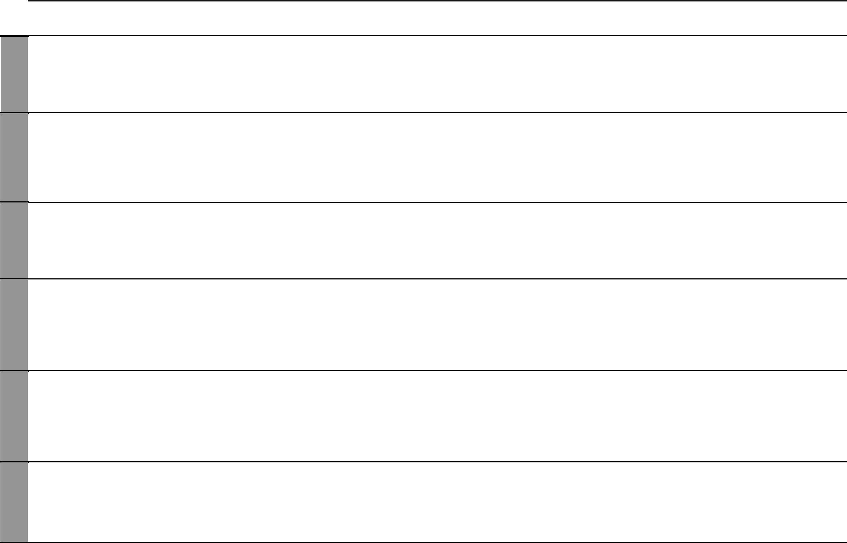

2 For use with Science in Action Standard Four

WEEK 1

WEEK 6 WEEK 5 WEEK 4 WEEK 3 WEEK 2
Science in Action Standard Four Schemes of Work: Term Two

TOPIC | SUB-TOPICS | PERIODS |  | OBJECTIVES | LEARNING ACTIVITIES |  | TEACHING AIDS AND | EVALUATION | REMARKS
 |  |  |  |  |  |  | REFERENCES
Animals | Characteristics | 3 | The learner should be able |  | • | Observing animals feeding | SCIA - 4 pg 42-52
 | of animals |  | to observe characteristics |  | • | Observing animals moving | TG - 4 pg 20-22
 |  |  | of animals |  | • | Describing reproduction | Charts and pictures of
 |  |  |  |  |  | and growth in animals | various animals
 |  |  |  |  | • | Observing animals | Real animals in the
 |  |  |  |  |  | responding to change | environment
 |  |  |  |  | • Discussing the causes of
 |  |  |  |  |  | death among animals
 | Classifying farm | 3 | The learner should be able |  | • | Naming and describing | SCIA - 4 pg 52-55
 | animals |  | to: |  |  | animal products | TG - 4 pg 23-24
 |  |  | i. | identify the different | • | Discussing the importance | Pictures of animals
 |  |  |  | farm animals |  | of products from farm | Real examples of farm
 |  |  | ii. | classify farm animals |  | animals | animals and their products
 |  |  |  | according to their
 |  |  |  | products
Water | Uses of water | 3 | The learner should be able |  | • | Identifying different uses | SCIA - 4 pg 58
 | at home |  | to describe different uses |  |  | of water at home | TG - 4 pg 26
 |  |  | of water at home |  |  |  | Charts on uses of water at
 |  |  |  |  |  |  | home
 | Uses of water in | 3 | The learner should be able |  | • Drawing and naming parts |  | SCIA - 4 pg 59
 | the farm |  | to explain how water is |  |  | of a farm | TG - 4 pg 26
 |  |  | used for different purposes |  | • | Discussion of different | Pictures of uses of water in
 |  |  | in the farm |  |  | uses of water in the farm | the farm
 | Uses of water in | 3 | The learner should be able |  | • | Identifying and naming | SCIA - 4 pg 59
 | the Industry |  | to identify different uses of |  |  | different uses of water in | TG - 4 pg 26
 |  |  | water in industries |  |  | industry | Pictures on industrial uses of
 |  |  |  |  |  |  | water
 | Uses of water | 3 | The learner should be able |  | • | Discussing different ways | SCIA - 4 pg 60
 | for transport |  | to describe how water is |  |  | in which water is used in | TG - 4 pg 27
 | and recreation |  | used for transport and |  |  | transport | Pictures and charts on
 |  |  | recreation |  | • | Identifying different | transport and recreational
 |  |  |  |  |  | recreational uses of water | uses of water


3 For use with Science in Action Standard Four

WEEK 11 WEEK 10 WEEK 9 WEEK 8 WEEK 7

 |  |  |  |  |  |  |  | Science in Action Standard Four
 |  |  |  |  |  |  |  | Schemes of Work
 |  |  |  |  |  |  |  |  | Term 2
 |  |  |  | LEARNING ACTIVITIES |  |  | TEACHING AIDS AND
TOPIC | SUB-TOPICS | PERIODS | OBJECTIVES |  |  |  | TEACHING AIDS AND | EVALUATION | REMARKS
 |  |  |  |  |  |  | REFERENCES
 | Storing water | 3 | The learner should be able | • | Discussing different ways |  | SCIA - 4 pg 61
 |  |  | to identify different ways |  | of storing clean water |  | TG - 4 pg 27-28
 |  |  | of storing water | • | Distinguishing between |  | Water storage means and
 |  |  |  |  | means of storing large |  | sites
 |  |  |  |  | quantities of water
The | Mineral | 3 | The learner should be able | • | Performing investigations |  | SCIA - 4 pg 64-66
composition | particles and |  | to investigate the presence |  | to identify mineral |  | TG - 4 pg 29-30
of soil | living things in |  | of mineral particles and |  | particles in the soil |  | Soil samples
 | the soil |  | living organisms in the soil | • | Perfoming investigations to
 |  |  |  |  | identify living organisms in
 |  |  |  |  | the soil
 | Humus in the | 3 | The learner should be able | • | Observing components of |  | SCIA - 4 pg 67-68
 | soil |  | to investigate the presence |  | soil |  | TG - 4 pg 31
 |  |  | of humus in the soil | • | Identifying and observing |  | Real samples of humus
 |  |  |  |  | humus
 | Water in the | 3 | The learner should be | • | Performing an experiment |  | SCIA - 4 pg 68
 | soil |  | able to demonstrate the |  | to show the presence of |  | TG - 4 pg 31-32
 |  |  | presence of water in the |  | water in the soil |  | Apparatus for demonstrating
 |  |  | soil |  |  |  | presence of water in the soil
 | Air in the soil | 3 | The learner should be | • | Performing an experiment |  | SCIA - 4 pg 69
 |  |  | able to demonstrate the |  | to show the presence of air |  | TG - 4 pg 32
 |  |  | presence of air in the soil |  | in the soil |  | Apparatus for demonstrating
 |  |  |  |  |  |  | presence of air in the soil
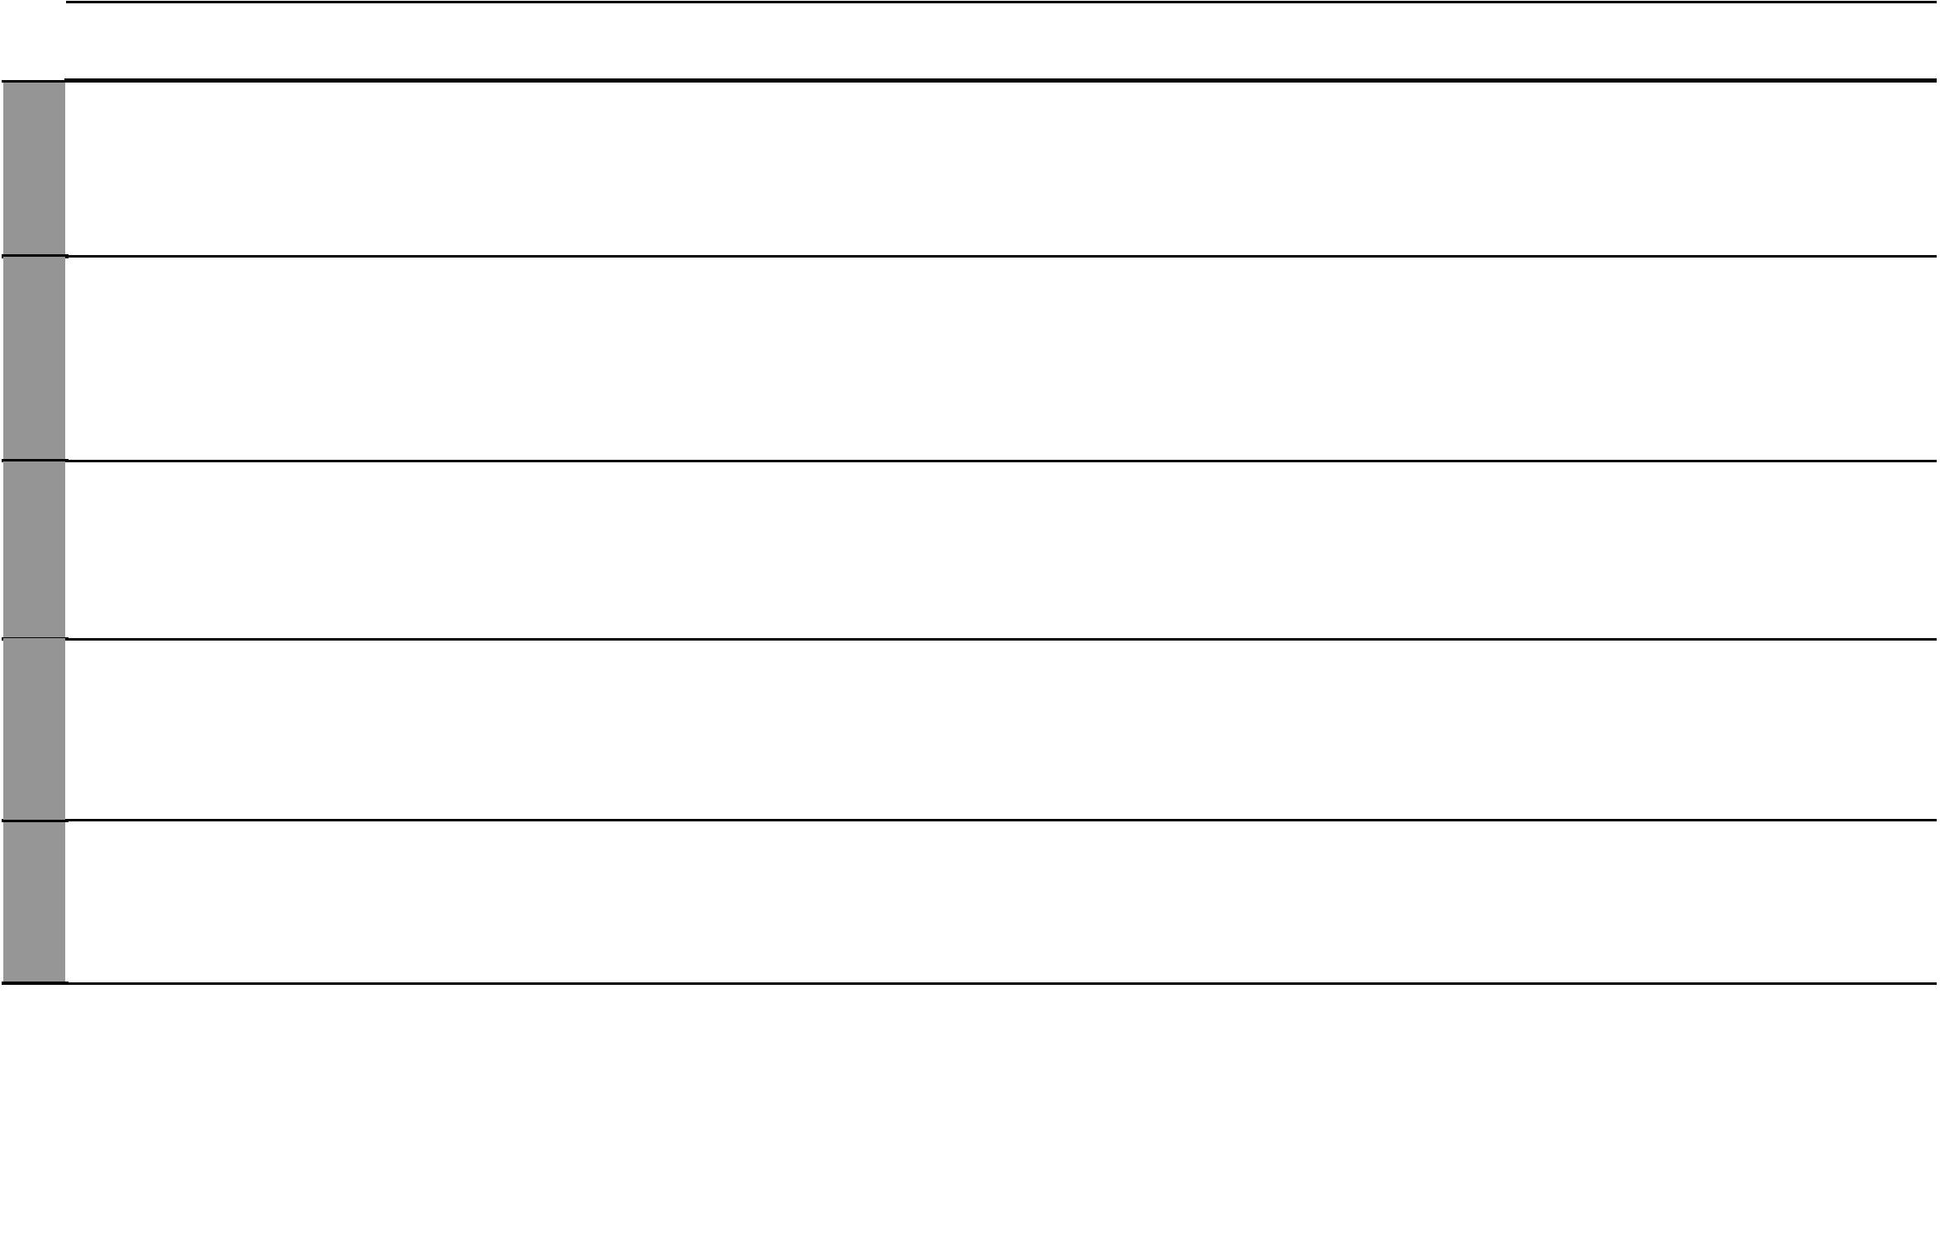

4 For use with Science in Action Standard Four

WEEK 7 WEEK 6 WEEK 5 WEEK 4 WEEK 3 WEEK 2 WEEK 1
Science in Action Standard Four Schemes of Work: Term Three

TOPIC | SUB-TOPICS | PERIODS | OBJECTIVES | LEARNING ACTIVITIES |  | TEACHING AIDS AND | EVALUATION | REMARKS
 |  |  |  |  |  | REFERENCES
Food and | Food groups | 3 | The learner should be | • | Identifying body building | SCIA - 4 pg 72-74
nutrition |  |  | able to state and identify |  | foods | TG - 4 pg 34-36
 |  |  | the three groups of food | • | Identifying energy giving | Charts and pictures on food
 |  |  |  |  | foods | groups
 |  |  |  | • | Identifying protective foods
 | Classifying | 3 | The learner should be | • | Observing pictures of | SCIA - 4 pg 75
 | locally available |  | able to classify locally |  | foods | TG - 4 pg 36
 | foods |  | available foods into the | • | Classifying foods | Appropriate charts and
 |  |  | three food groups |  |  | pictures on classes of foods
 | Balanced diet | 3 | The learner should | • | Explaining a balanced diet | SCIA - 4 pg 76-77
 |  |  | be able to identify the | • | Discussing examples of | TG - 4 pg 36-37
 |  |  | be able to identify the |  | foods eaten for breakfast | TG - 4 pg 36-37
 |  |  | components of a balanced |  | foods eaten for breakfast | Appropriate charts and
 |  |  | components of a balanced | • | Discussing examples of | Appropriate charts and
 |  |  | diet | • | Discussing examples of | pictures on balanced diet
 |  |  | diet |  | foods eaten for lunch | pictures on balanced diet
 |  |  |  | • | Discussing examples of
 |  |  |  |  | foods eaten for supper
Light and | Uses of light | 3 | The learner should be | • | Observing charts on uses | SCIA - 4 pg 80-82
Heat |  |  | able to identify and |  | of light | TG - 4 pg 38-39
 |  |  | describe the uses of light | • | Explaining why light is | Pictures on uses of light
 |  |  |  |  | important
 | Ways of lighting | 3 | The learner should be | • | Observing charts on ways | SCIA - 4 pg 82
 | a house |  | able to describe different |  | of lighting a house | TG - 4 pg 40
 |  |  | ways of lighting a house |  |  | Appropriate charts and
 |  |  |  |  |  | pictures on ways of lighting
 |  |  |  |  |  | a house
 | Sources of heat | 3 | The learner should be | • | Observing charts on | SCIA - 4 pg 83-84
 |  |  | able to identify sources of |  | sources of heat | TG - 4 pg 40-41
 |  |  | heat | • | Classifying sources of heat | Appropriate charts and
 |  |  |  |  | into natural and artificial | pictures on sources of heat
 | Uses of heat | 3 | The learner should be | • | Observing pictures on uses | SCIA - 4 pg 84-85
 |  |  | able to describe different |  | of heat | TG - 4 pg 41
 |  |  | uses of heat |  |  | Chart on uses of heat

5 For use with Science in Action Standard Four

WEEK 12 WEEK 11 WEEK 10 WEEK 9 WEEK 8

 |  |  |  |  |  |  |  | Science in Action Standard Four
 |  |  |  |  |  |  |  | Schemes of Work
 |  |  |  |  |  |  |  |  | Term 3
 |  |  |  | LEARNING ACTIVITIES |  |  | TEACHING AIDS AND
TOPIC | SUB-TOPICS | PERIODS | OBJECTIVES |  |  |  | TEACHING AIDS AND | EVALUATION | REMARKS
 |  |  |  |  |  |  | REFERENCES
Properties | Floating and | 3 | The learner should be | • | Defining floating and |  | SCIA - 4 pg 88-90
of matter | sinking |  | able to identify factors |  | sinking |  | TG - 4 pg 43-44
 |  |  | that determine floating | • | Observing floating and |  | Variety of objects
 |  |  | and sinking |  | sinking objects
 | Factors that | 3 | The learner should be | • | Demonstrating effect of |  | SCIA - 4 pg 91-92
 | affect floating |  | able to demonstrate |  | shape on floating and |  | TG - 4 pg 44-45
 | and sinking |  | factors affecting floating |  | sinking |  | Variety of common objects
 |  |  | and sinking | • | Demonstrating effect of |  | Basins and water
 |  |  |  |  | size on floating and sinking
 |  |  |  | • | Demonstrating effect
 |  |  |  |  | of type of material on
 |  |  |  |  | floating and sinking
 | Pressure in | 3 | The learner should be | • Discussing the meaning of |  |  | SCIA - 4 pg 93
 | liquids |  | able to investigate pressure |  | pressure |  | TG - 4 pg 45
 |  |  | in liquids | • | Observing the dependence |  | Tins and water
 |  |  |  |  | of pressure on depth in |  | A nail
 |  |  |  |  | liquids
Simple | Safe use of | 3 | The learner should be | • | Identifying simple tools |  | SCIA - 4 pg 96-103
tools | simple tools |  | able to safely use simple | • Describing the use of each |  |  | TG - 4 pg 47-49
 |  |  | tools |  | simple tool |  | Real samples of simple tools
 |  |  |  | • Learning the safety rules
 |  |  |  |  | for handling simple tools
 | Maintenance of | 3 | The learner should be | • | Observing the procedure |  | SCIA - 4 pg 103-104
 | farm tools |  | able to describe how to |  | for maintaining farm tools |  | TG - 4 pg 49-50
 |  |  | maintain farm tools |  |  |  | Samples of farm tools
 |  |  |  |  |  |  | Chart on maintenance of
 |  |  |  |  |  |  | simple tools
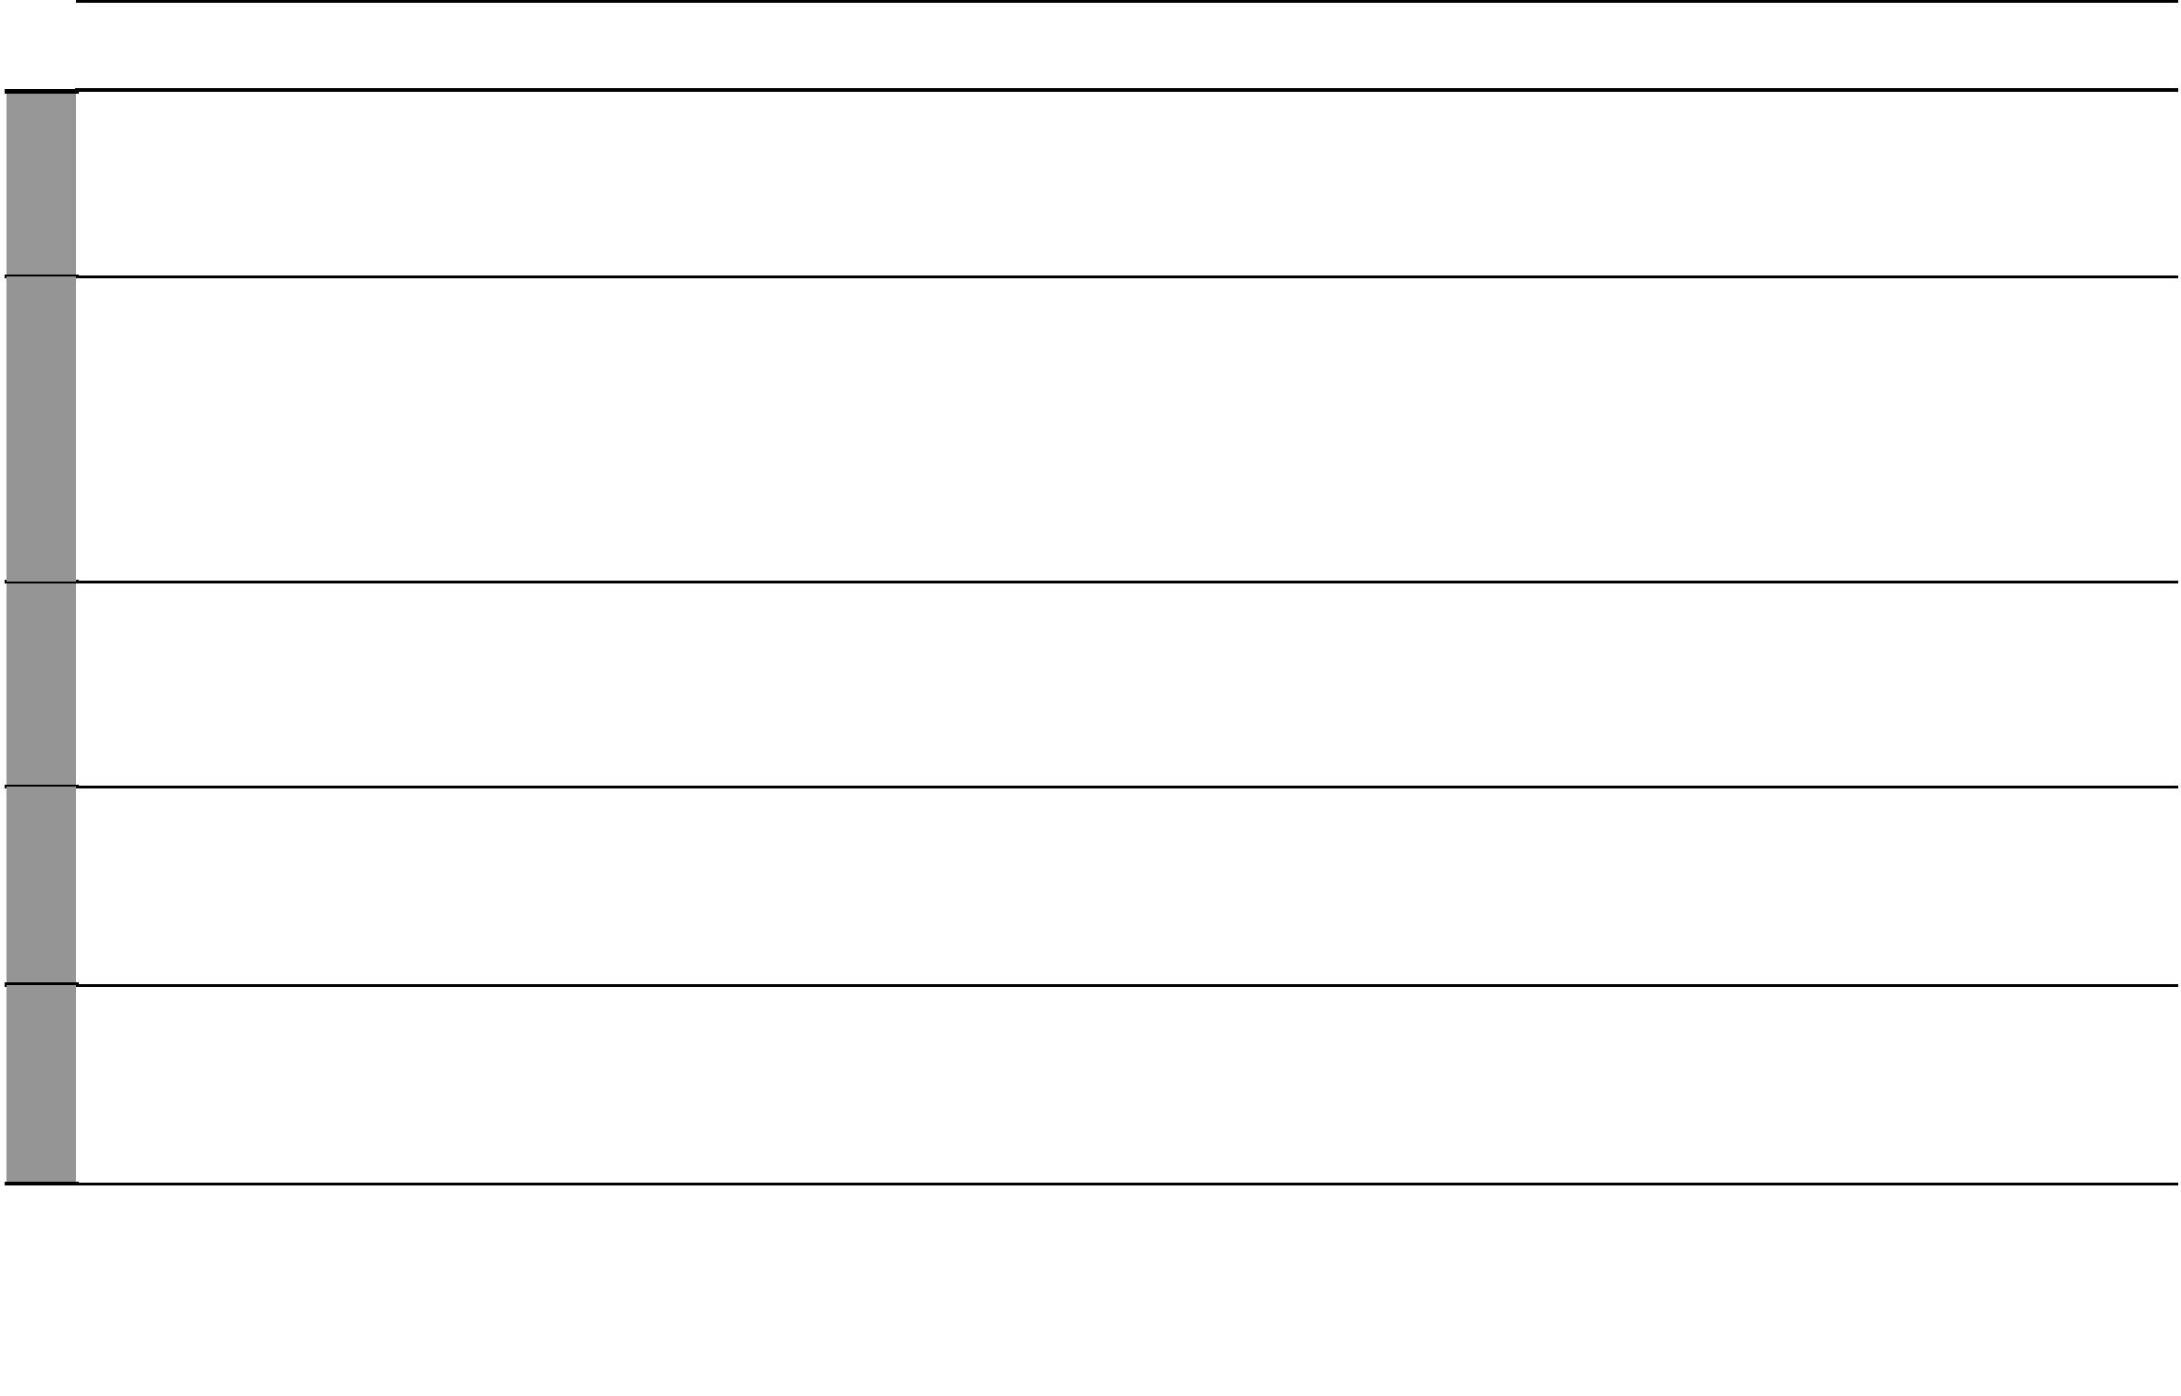

6 For use with Science in Action Standard Four

