MATHS SCHEME OF WORK CLASS 7

Available online:
Schools Net Kenya Consultancy
P.O. Box 8076 – 00200 Nairobi, Kenya | Tel: +254202319748
E-mail: infosnkenya@gmail.com | www.schoolsnetkenya.com

Progressive Primary Mathematics Book 7: Sample Schemes of Work: Term One
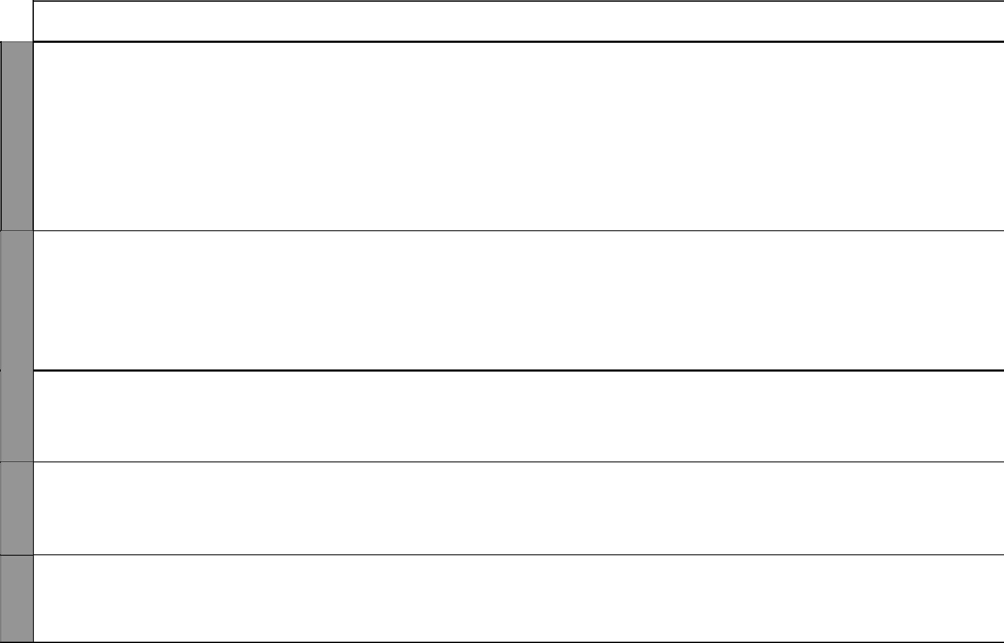

WEEK 1

WEEK 2

WEEK 4 WEEK 3

UNIT | TOPIC | LESSONS | OBJECTIVES | TEACHING/LEARNING |  | LEARNING/TEACHING | REFERENCES | REMARKS
 |  |  |  |  | ACTIVITIES | RESOURCES
1 | Place value | 3 | By the end of this topic, the | • | Using place value tables | Place value table and | Pupil’s Book pages
Whole | and total |  | pupils should be able to find the | • | Positioning digits in a place | charts, number cards | 2-4
numbers | value |  | place value and total value of | • | value table |  | Teacher’s Book
 |  |  | digits in numbers up to millions. | • | Discussions |  | pages 1-2
 | Squares and | 4 | By the end of this topic, the | • | Working out squares of | Square cut-outs, counters | Pupil’s Book
 | squares roots |  | pupils should be able to work out |  | numbers | like bottle tops, stones, | pages 4-6
 | of numbers |  | problems involving squares and | • | Discussing real-life situations | buttons | Teacher’s Book
 |  |  | square roots of whole numbers. |  | involving squares |  | pages 2-4
 |  |  |  | • Working out square roots of
 |  |  |  |  | numbers
 | Divisibility | 2 | By the end of this topic, the | • | Revising divisibility tests for | Multiplication tables | Pupil’s Book
 | test for 11 |  | pupils should be able to apply |  | 2, 3, 4, 5, 6, 8, 9, 10 |  | page 7
 |  |  | the divisibility test for 11. | • | Developing a multiplication |  | Teacher’s Book
 |  |  |  |  | table for 11 |  | pages 4-5
 |  |  |  | • | Establishing the divisibility
 |  |  |  |  | test for 11
 |  |  |  | • Divisibility test for 11
 |  |  |  | • | Discussions
2 | Addition and | 4 | By the end of this topic, the | • | Adding of numbers up to | Place value charts and | Pupil’s Book
Opera- | subtraction |  | pupils should be able to work out |  | millions | tables | pages 8-10
tions on |  |  | problems involving addition and | • | Subtracting numbers |  | Teacher’s Book
tions on |  |  | subtraction of whole numbers up |  |  |  | pages 8-9
whole |  |  | subtraction of whole numbers up |  |  |  | pages 8-9
whole |  |  | to millions.
numbers |  |  | to millions.
 | Multiplication | 4 | By the end of this topic, the | • | Multiplying a five-digit | Multiplication tables | Pupil’s Book
 | and division |  | pupils should be able to multiply |  | number by a three-digit |  | pages 11-13
 |  |  | whole numbers and divide |  | number |  | Teacher’s Book
 |  |  | whole numbers by up to 3-digit | • | Dividing numbers by 3-digit |  | pages 9-11
 |  |  | numbers. |  | numbers
 | Combined | 2 | The pupils should be able to | • | Discussing order of operations | Multiplication tables, place | Pupil’s Book
 | operations |  | work out problems involving | • | Adding, subtracting, | value tables | page 14
 |  |  | combined operations on whole |  | multiplying and dividing |  | Teacher’s Book
 |  |  | numbers. |  | numbers |  | page 12

1 For use with Progressive Primary Mathematics Standard Seven

UNIT

WEEK 4

3
Frac-tions

WEEK 5

WEEK 6

Progressive Primary Mathematics Standard Seven

Schemes of Work

Term 1
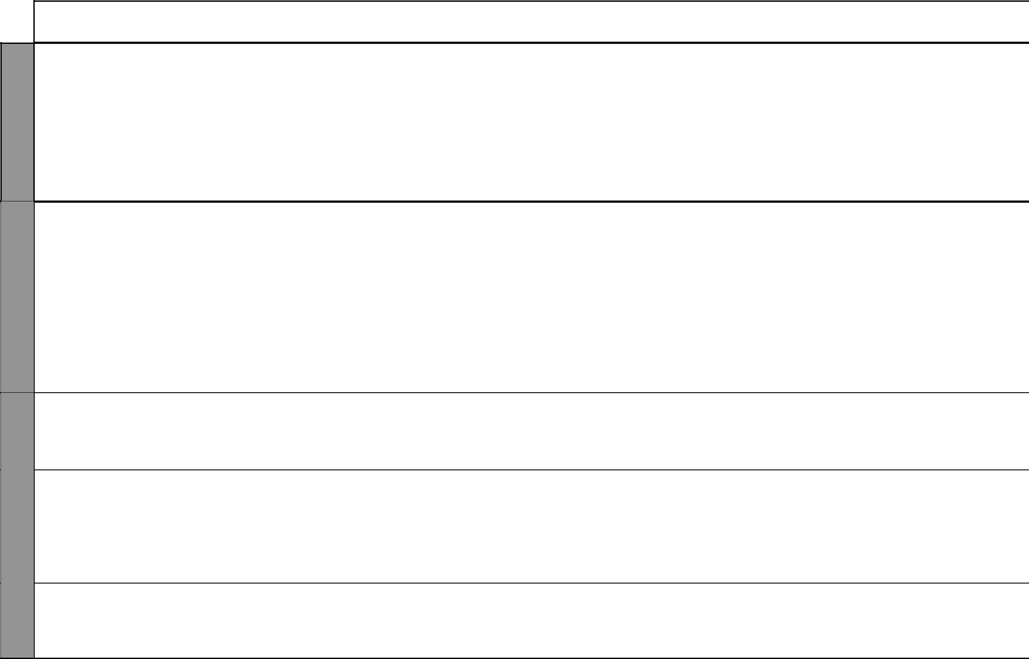
TOPIC | LESSONS | OBJECTIVES | TEACHING/LEARNING |  | LEARNING/TEACHING | REFERENCES | REMARKS
 |  |  |  | ACTIVITIES | RESOURCES
Number | 2 | By the end of this topic, | • | Forming sequences using | Multiplication tables | Pupil’s Book page
sequences |  | the pupils should be able to |  | addition |  | 15
 |  | recognize and identify number | • | Forming sequences using |  | Teacher’s Book
 |  | sequences involving whole |  | subtraction |  | page 13
 |  | numbers. | • | Forming sequences using
 |  |  |  | multiplication
 |  |  | • | Forming sequences using
 |  |  |  | division
 |  |  | • | Discussion
Addition and | 2 | By the end of this topic, the | • | Adding mixed numbers | Equivalent fraction charts | Pupil’s Book pages
subtraction of |  | pupils should be able to add and | • | Subtracting fractions |  | 16-18
fractions |  | subtract fractions involving up |  |  |  | Teacher’s Book
 |  | to 3 fractions including mixed |  |  |  | pages 16-17
 |  | numbers.
Multiplication | 3 | By the end of this topic, | • | Multiplying fractions | Equivalent fraction charts, | Pupil’s Book
and division |  | the pupils should be able | • | Dividing fractions | multiplication tables | pages 19-20
involving |  | to problems involving | • | Finding the reciprocal of numbers |  | Teacher’s Book
fractions |  | multiplication and division of | • | Converting mixed fractions to |  | pages 17-18
 |  | fractions. |  | improper fractions
Combined | 2 | By the end of this topic, the | • | Adding fractions | Equivalent fraction charts, | Pupil’s Book
operations on |  | pupils should be able to work | • | Subtracting fractions | multiplication tables | pages 21-22
fractions |  | out combined operations on | • | Multiplying fractions |  | Teacher’s Book
 |  | fractions two at a time. | • | Dividing fractions |  | pages 18-19
Squares/ | 3 | By the end of this topic, the | • | Working out squares/square | Equivalent fraction charts, | Pupil’s Book
square roots |  | pupils should be able to work |  | roots of whole numbers | multiplication tables | pages 23-24
of fractions |  | out squares of fractions and | • | Dividing fractions |  | Teacher’s Book
 |  | square roots of fractions that are | • | Multiplying fractions |  | pages 19-20
 |  | perfect squares. | • | Working out squares/square
 |  |  |  | roots of fractions
Number | 2 | By the end of this topic, | • | Identifying sequences | Multiplication tables | Pupil’s Book
sequences |  | the pupils should be able to |  | involving fractions | Equivalent fraction charts | page 25
 |  | recognize and identify number | • | Adding, substracting, multiplying |  | Teacher’s Book
 |  | sequences involving fractions. |  | and dividing fractions |  | page 20
 |  |  |  | 2 | For use with Progressive Primary Mathematics Standard Seven

Progressive Primary Mathematics Standard Seven

Schemes of Work

Term 1
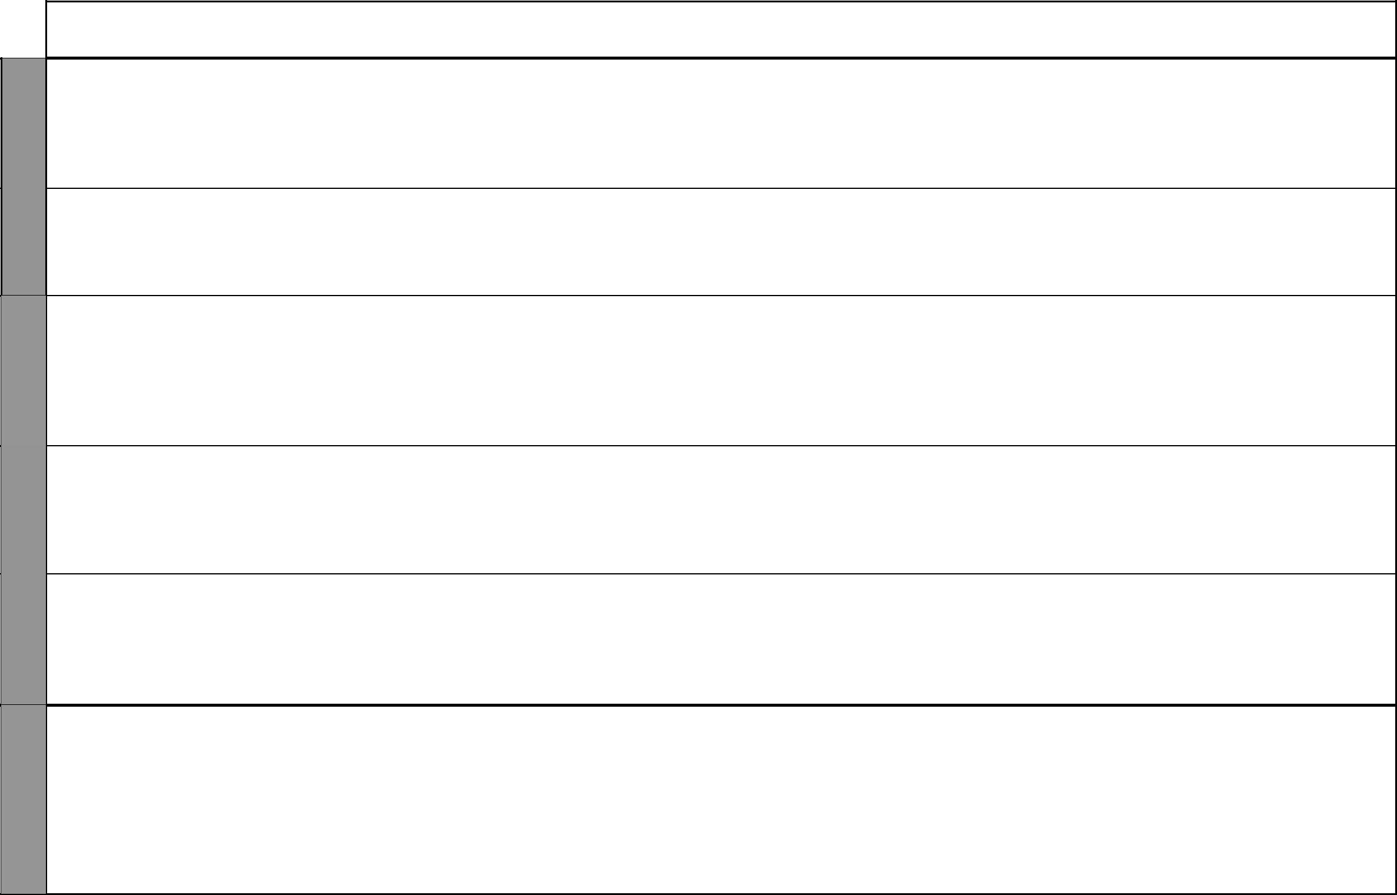

WEEK 7

WEEK 8

WEEK 9

WEEK 10

UNIT | TOPIC | LESSONS | OBJECTIVES | TEACHING/LEARNING |  | LEARNING/TEACHING | REFERENCES |  | REMARKS
 |  |  |  |  | ACTIVITIES | RESOURCES
4 | Place value | 2 | By the end of this topic, the | • | Drawing place value tables | Multiplication tables, place | Pupil’s Book | page
Deci- | and total |  | pupils should be able to identify | • | Positioning digits in place | value tables | 26
Deci- | value of |  | the place value of digit in |  | value tables |  | Teacher’s Book
mals | value of |  | the place value of digit in |  | value tables
mals | decimals |  | decimals. | • | Writing place value and total |  | pages 24-25
 |  |  |  |  | value of digits in a decimal
 | Conversion | 3 | By the end of this topic, the | • | Converting fractions to | Multiplication tables | Pupil’s Book | page
 | of decimals |  | pupils should be able to convert |  | decimals and vice versa |  | 27
 | and |  | decimals to fractions and vice | • | Dividing numbers |  | Teacher’s Book
 | fractions |  | versa. |  |  |  | pages 25-26
 | Operations | 6 | By the end of this topic, the | • | Adding and subtracting of | Place value tables, | Pupil’s Book
 | on decimals |  | pupils should be able to work |  | decimals | multiplication tables | pages 26-33
 |  |  | out addition, subtraction, | • | Multiplying decimals by whole |  | Teacher’s Book
 |  |  | multiplication and division |  | numbers and by decimals |  | page 26
 |  |  | involving decimals. | • | Dividing decimals by whole
 |  |  |  |  | numbers by decimals
 | Combined | 3 | By the end of this topic, | • | Adding decimals | Addition charts, | Pupil’s Book | page
 | operations |  | the pupils should be able to | • | Subtracting decimals | multiplication tables | 34
 | on decimals |  | work out problems involving | • | Multiplying decimals |  | Teacher’s Book
 |  |  | combined operations on | • | Dividing decimals |  | pages 26-27
 |  |  | decimals.
 | Squares and | 3 | By the end of this topic, the | • | Multiplying decimals | Multiplication tables | Pupil’s Book
 | square roots |  | pupils should be able to work | • | Dividing decimals |  | page 28
 |  |  | out squares of decimals and | • | Working out squares |  | Teacher’s Book
 |  |  | square roots of decimals | • | Work out square roots |  | page 27
 |  |  | involving perfect squares.
5 | Percentages, | 4 | By the end of this topic, the | • | Converting percentage to | Multiplication tables | Pupil’s Book
Percent- | fractions and |  | pupils should be able to convert | • | fraction |  | pages 36-37
ages | decimals |  | percentages to fraction and | • | Converting percentage to |  | Teacher’s Book
ages |  |  | decimal and vice versa. |  | decimal |  | page 31-32
 |  |  |  | • | Converting fraction to
 |  |  |  |  | percentage
 |  |  |  | • | Converting decimal to
 |  |  |  |  | percentage

3 For use with Progressive Primary Mathematics Standard Seven

UNIT

WEEK 10

6
Angles

WEEK 11 - 12

WEEK 13

Progressive Primary Mathematics Standard Seven

Schemes of Work

Term 1
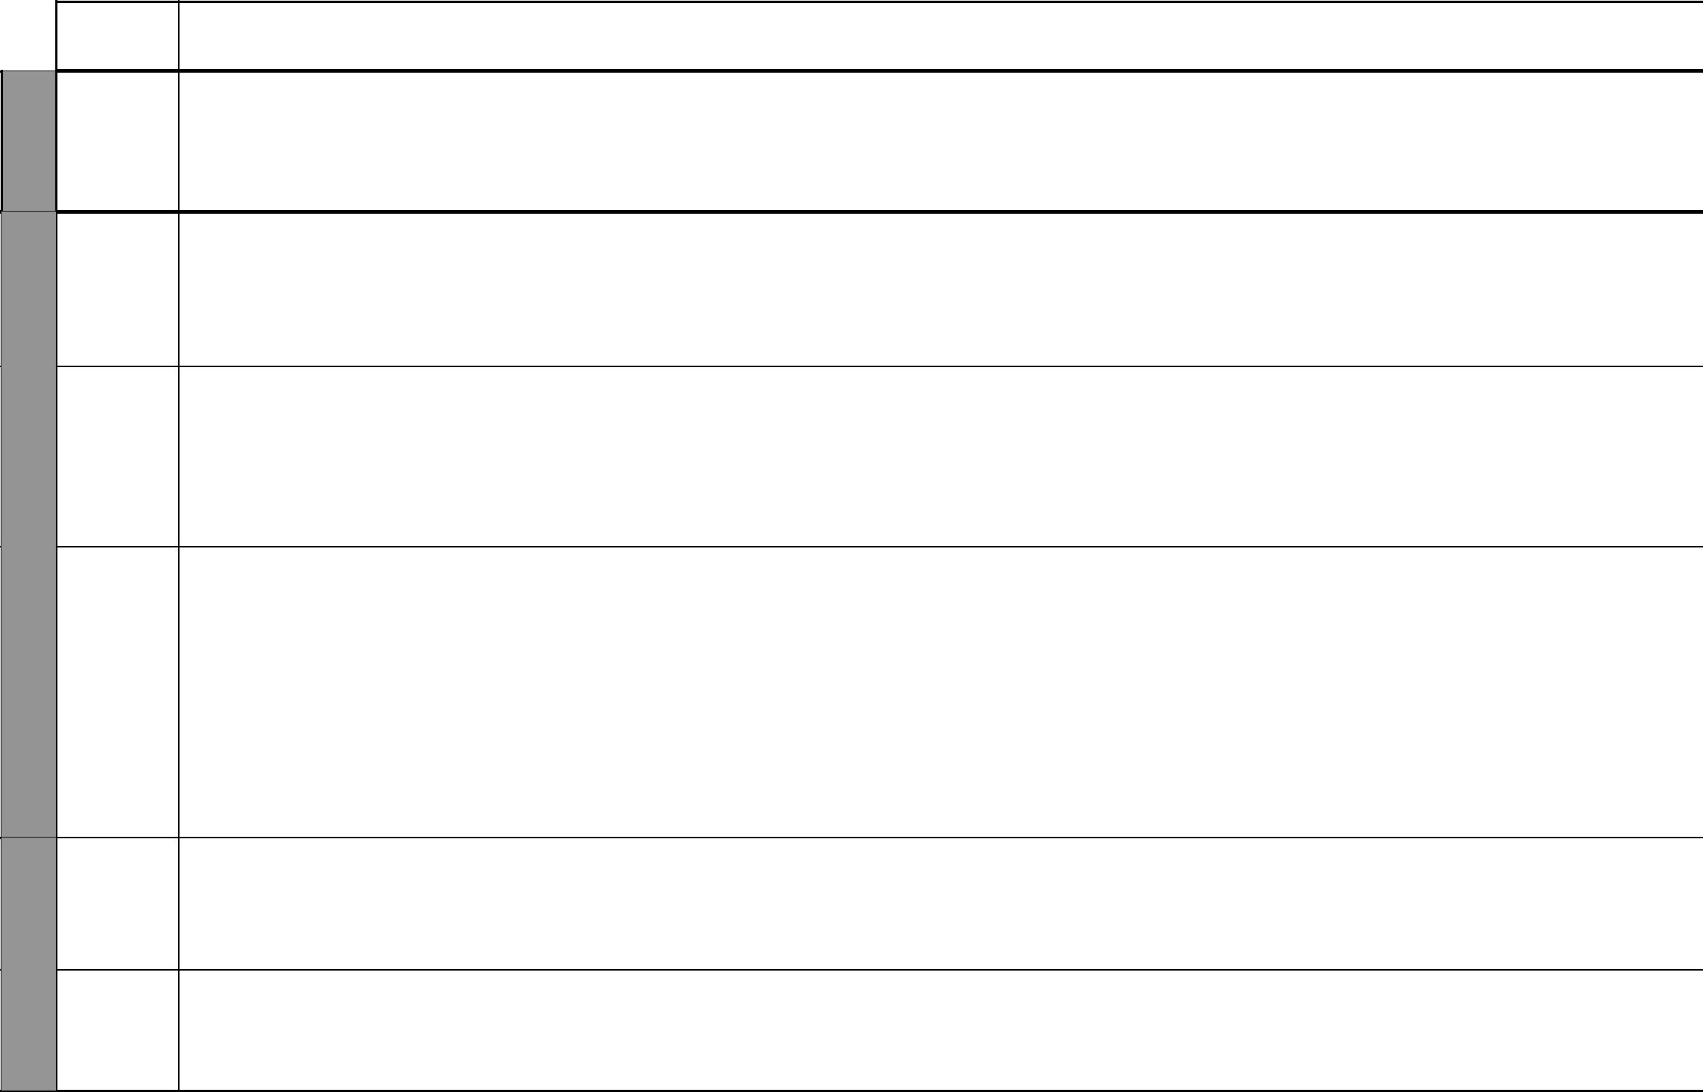
TOPIC | LESSONS | OBJECTIVES | TEACHING/LEARNING |  | LEARNING/TEACHING | REFERENCES | REMARKS
 |  |  |  | ACTIVITIES | RESOURCES
Percentage | 2 | By the end of this topic, the | • | Discussing cases of quantities | Multiplication tables | Pupil’s Book
increase and |  | pupils should be able to work |  | that increase or decrease |  | pages 38-39
decrease |  | out percentage increase and | • | Working out problems involving |  | Teacher’s Book
 |  | decrease. |  | percentage increase and decrease |  | pages 32-33
Parallel | 10 | By the end of this topic, the | • | Drawing parallel lines | Ruler, protractor, pair of | Pupil’s Book
lines and |  | pupils should be able to work | • | Drawing transversals | compasses | pages 42-48
transversals |  | out problems involving the angle | • | Measuring angles |  | Teacher’s Book
 |  | properties of parallel lines and | • | Calcuting the size of angles |  | pages 36-38
 |  | transversals.
Rectangles | 2 | By the end of this topic, the | • | Drawing rectangles | Cut-outs of rectangles and | Pupil’s Book
and squares |  | pupils should be able to identify | • | Drawing diagonals | squares; ruler, protractor, | pages 48-49
 |  | and use the angle properties of | • | Folding cut-outs | pair of compasses | Teacher’s Book
 |  | rectangles and squares. | • | Drawing squares |  | page 38
 |  |  | • | Drawing diagonals
 |  |  | • | Measuring angles
Parallelograms | 2 | By the end of this topic, | • | Revising parallel lines, | Ruler, protractor, cut-outs | Pupil’s Book
and |  | the pupils should be able to |  | corresponding angles, | of parallelograms | pages 50-51
rhombuses |  | recognize parallelograms and |  | co-interior angles |  | Teacher’s Book
 |  | rhombuses and their properties. | • | Drawing quadrilaterals |  | page 39
 |  |  | • Measuring and naming equal
 |  |  |  | sides
 |  |  | • Identifying opposite angles in
 |  |  |  | a parallelogram
 |  |  | • | Identifying properties of
 |  |  |  | parallelograms and rhombuses
Trapeziums | 1 | By the end of this topic, the | • | Revising parallel lines and | Protractor, paper cut-outs | Pupil’s Book
 |  | pupils should be able to identify |  | co-interior angles | of trapeziums | pages 52-53
 |  | the properties of a trapezium. | • | Identifying parallel sides of a |  | Teacher’s Book
 |  |  |  | trapezium |  | page 40
Revision |  | By the end of this week, the | • | Answering questions |  | Pupil’s Book
 |  | pupils should be able to answer | • | Doing mixed exercise 1 |  | pages 40-41
 |  | questions on the topics covered | • | Doing end of term tests |  | Teacher’s Book
 |  | during the term. | • | Remedial work |  | pages 34-35
 |  |  |  | 4 | For use with Progressive Primary Mathematics Standard Seven

WEEK 1

WEEK 2

WEEK 3
Mathematics Scheme of Work for Standard Seven: Term Two
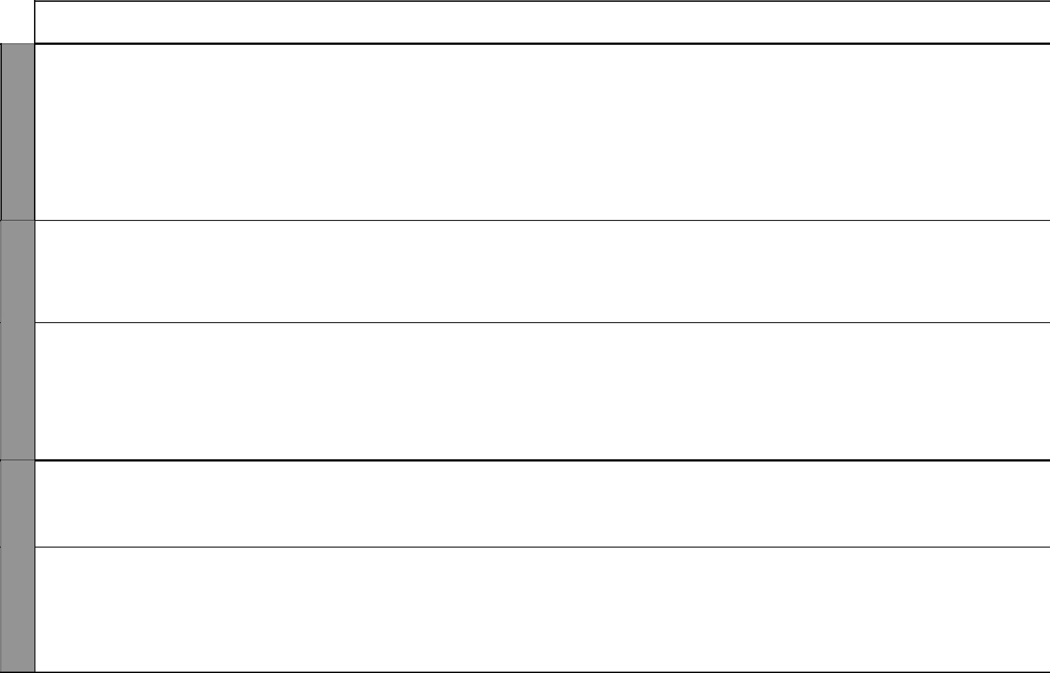
UNIT | TOPIC | LESSONS | OBJECTIVES | TEACHING/LEARNING |  | LEARNING/TEACHING | REFERENCES | REMARKS
 |  |  |  |  | ACTIVITIES | RESOURCES
7 | Constructing | 2 | By the end of this topic, | • | Drawing lines | Ruler, protractor, pair of | Pupil’s Book
Constra- | perpendicular |  | the pupils should be able | • Bisecting lines using pair of |  | compasses | pages 54-55
ctions | bisectors |  | to construct perpendicular |  | compasses |  | Teacher’s Book
 |  |  | bisectors of lines. | • | Measuring angles |  | pages 42-43
 | Constructing | 4 | By the end of this topic, | • | Constructing triangles | Ruler, protractor, pair of | Pupil’s Book
 | triangles |  | the pupils should be able to | • | Measuring angles | compasses | pages 56-59
 |  |  | construct isosceles, equilateral | • | Measuring sides |  | Teacher’s Book
 |  |  | and right-angled triangles. |  |  |  | page 43
 | Constructing | 2 | By the end of this topic, | • | Constructing triangles | Ruler, pair of compasses, | Pupil’s Book pages
 | circles |  | the pupils should be able to | • Bisecting the sides of triangles |  | protractor | 59-61
 |  |  | construct a circle passing | • Drawing circles that pass |  |  | Teacher’s Book
 |  |  | through the vertices of a |  | through the vertices of |  | pages 43-44
 |  |  | triangle. |  | triangles
 | The | 3 | By the end of this topic, the | • Working out squares of whole |  | Ruler, pair of compasses, | Pupil’s Book
 | pythagorean |  | pupils should be able to work |  | numbers | protractor | pages 61-65
 | relationship |  | out problems involving the sides | • | Drawing right-angled triangles |  | Teacher’s Book
 |  |  | of right-angled triangles using | • Identifying the hypotenuse of a |  |  | pages 44-45
 |  |  | the Pythagorean relationship. |  | right-angled triangles
 |  |  |  | • | Using the Pythagorean
 |  |  |  |  | relationship
8 | Simplifying | 2 | By the end of this topic, the | • | Simplifying algebraic | Simple beam balance | Pupil’s Book
Algebra | expressions |  | pupils should be able to simplify |  | expressions by collecting like |  | pages 66-67
 |  |  | an algebraic expression by |  | terms |  | Teacher’s Book
 |  |  | opening brackets. | • | Forming algebraic expressions |  | pages 48-49
 | Substitution | 1 | By the end of this topic, the | • | Simplifying algebraic |  | Pupil’s Book
 |  |  | pupils should be able to simplify |  | equations |  | pages 67-68
 |  |  | an algebraic expression by | • Finding the value of an |  |  | Teacher’s Book
 |  |  | substitution. |  | algebraic expression |  | page 49
 |  |  |  | • Substituting values in an
 |  |  |  |  | algebraic expression

5 For use with Progressive Primary Mathematics Standard Seven

WEEK 3

WEEK 4

WEEK 5
Progressive Primary Mathematics Standard Seven

Schemes of Work

Term 2
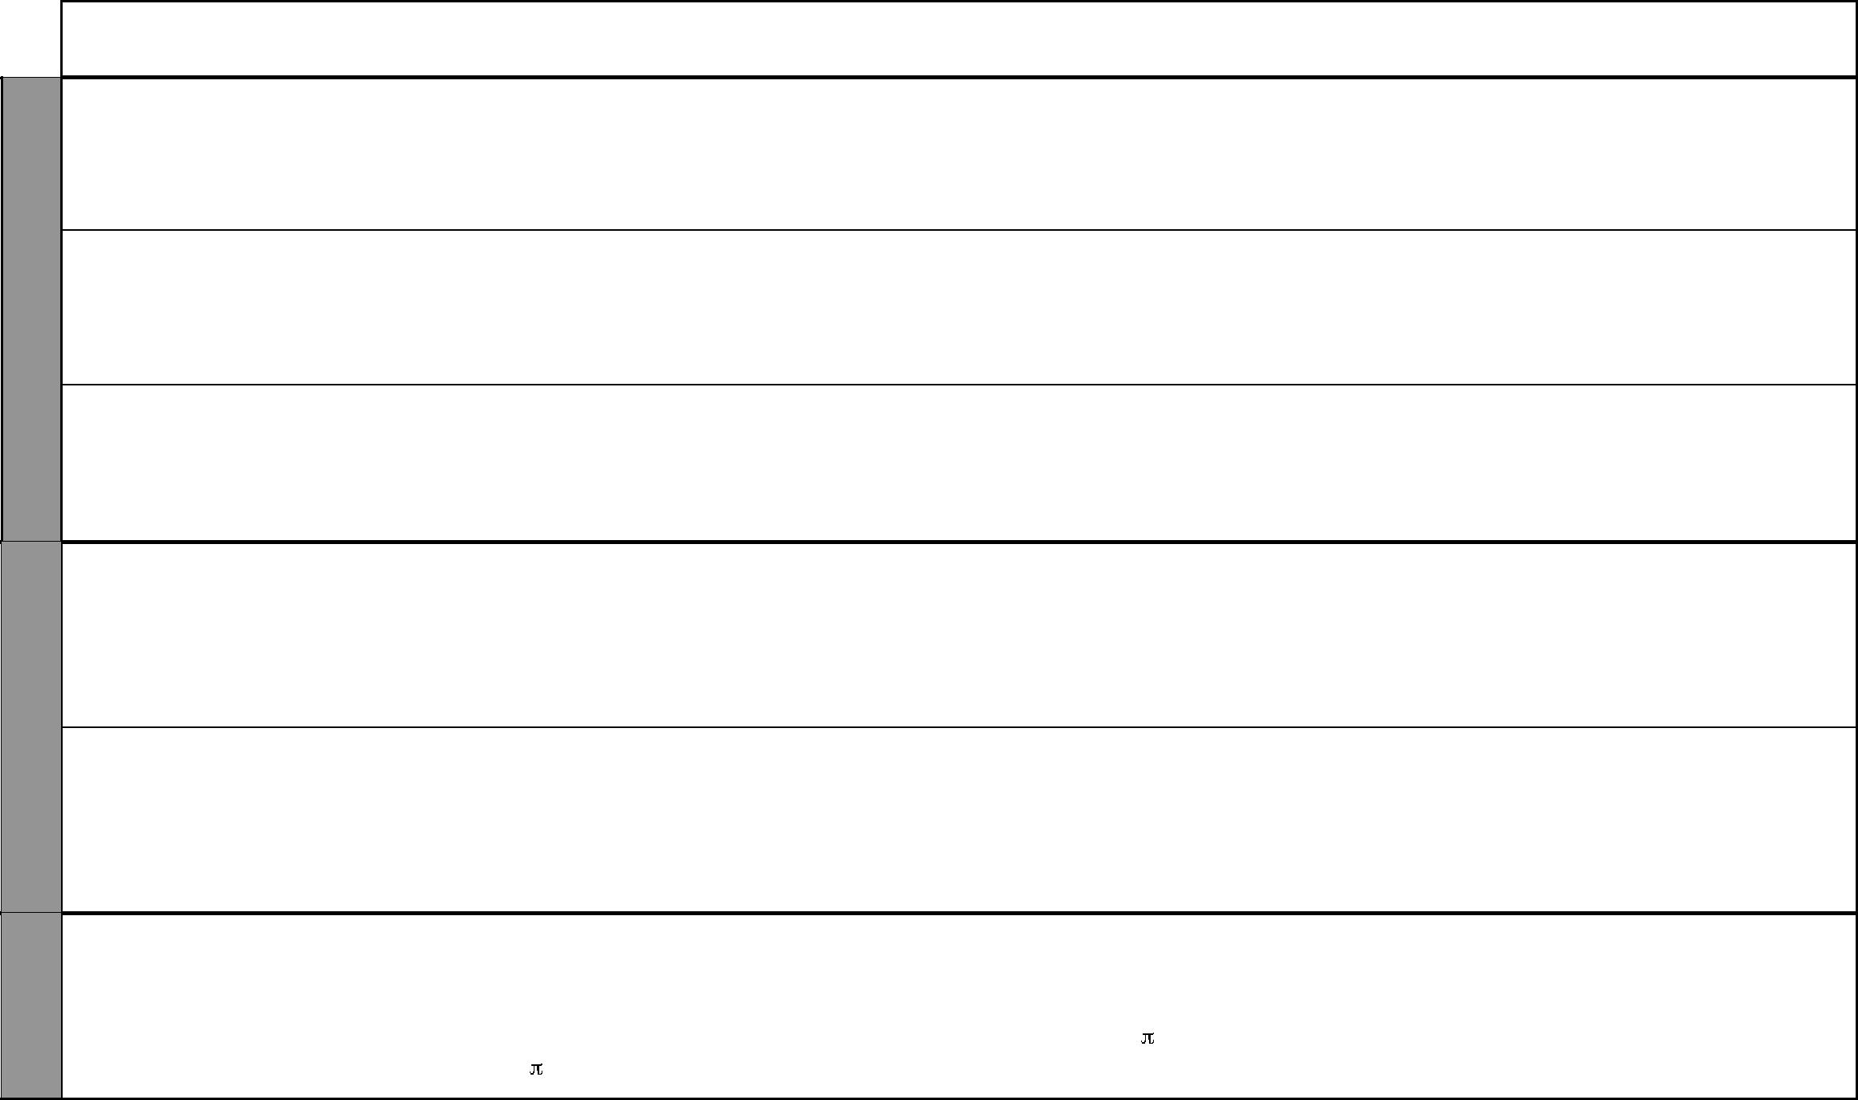
UNIT | TOPIC | LESSONS | OBJECTIVES | TEACHING/LEARNING |  | LEARNING/TEACHING | REFERENCES | REMARKS
 |  |  |  |  | ACTIVITIES | RESOURCES
 | Forming | 1 | By the end of this topic, | • | Forming algebraic expressions |  | Pupil’s Book
 | expressions |  | the pupils should be able to | • | Simplifying algebraic |  | pages 68-70
 |  |  | form and simplify algebraic |  | expressions |  | Teacher’s Book
 |  |  | expressions. |  |  |  | pages 49-50
 | Equations | 1 | By the end of this topic, the | • | Forming algebraic expressions | Simple beam balance | Pupil’s Book
 |  |  | pupils should be able to form |  | using daily-life situations |  | pages 70-71
 |  |  | and solve equations with one | • | Solving real-life algebraic |  | Teacher’s Book
 |  |  | unknown. |  | expression with one unknown |  | pages 50-51
 | Inequalities | 1 | By the end of this topic, the | • | Comparing quantities using | Simple beam balance | Pupil’s Book page
 |  |  | pupils should be able to simplify |  | “greater than”, “less than” and |  | 71
 |  |  | and solve inequalities in one |  | “equal to” |  | Teacher’s Book
 |  |  | unknown. |  |  |  | page 51
9 | Decimeter, | 5 | By the end of this topic, the | • | Working out conversion | Ruler, tape measure | Pupil’s Book
Length | decameter |  | pupils should be able to identify |  | involving mm, cm, m, km |  | pages 72-75
 | and |  | and use decimeters, decameters | • Drawing lines in decimeters |  |  | Teacher’s Book
 | hectometer |  | and hectometers as units of | • Measuring length outside the |  |  | page 54-55
 |  |  | measuring length. |  | classroom in dm
 | Perimeter | 3 | By the end of this topic, | • Discussing the meaning of |  | Paper cut-outs of different | Pupil’s Book
 |  |  | the pupils should be able to |  | perimeter | shapes | pages 75-77
 |  |  | work out problems involving | • Working out the perimeter of |  |  | Teacher’s Book
 |  |  | perimeter of a circle, triangle |  | shapes |  | page 55-56
 |  |  | and quadrilaterial. | • | Drawing sketch diagram
10 | Area of a | 3 | By the end of this topic, the | • | Drawing circles | Circular cut-outs, pair of | Pupil’s Book
Area | circle |  | pupils should be able to work | • Folding cut-outs to get the |  | scissors, pair of compasses | pages 80-82
 |  |  | out problems involving the area |  | radius of a circle |  | Teacher’s Book
 |  |  | of a circle using the formula | • | Deriving the formula A = r² |  | page 58-59
 |  |  | A = r².

6 For use with Progressive Primary Mathematics Standard Seven

Progressive Primary Mathematics Standard Seven

Schemes of Work

Term 2
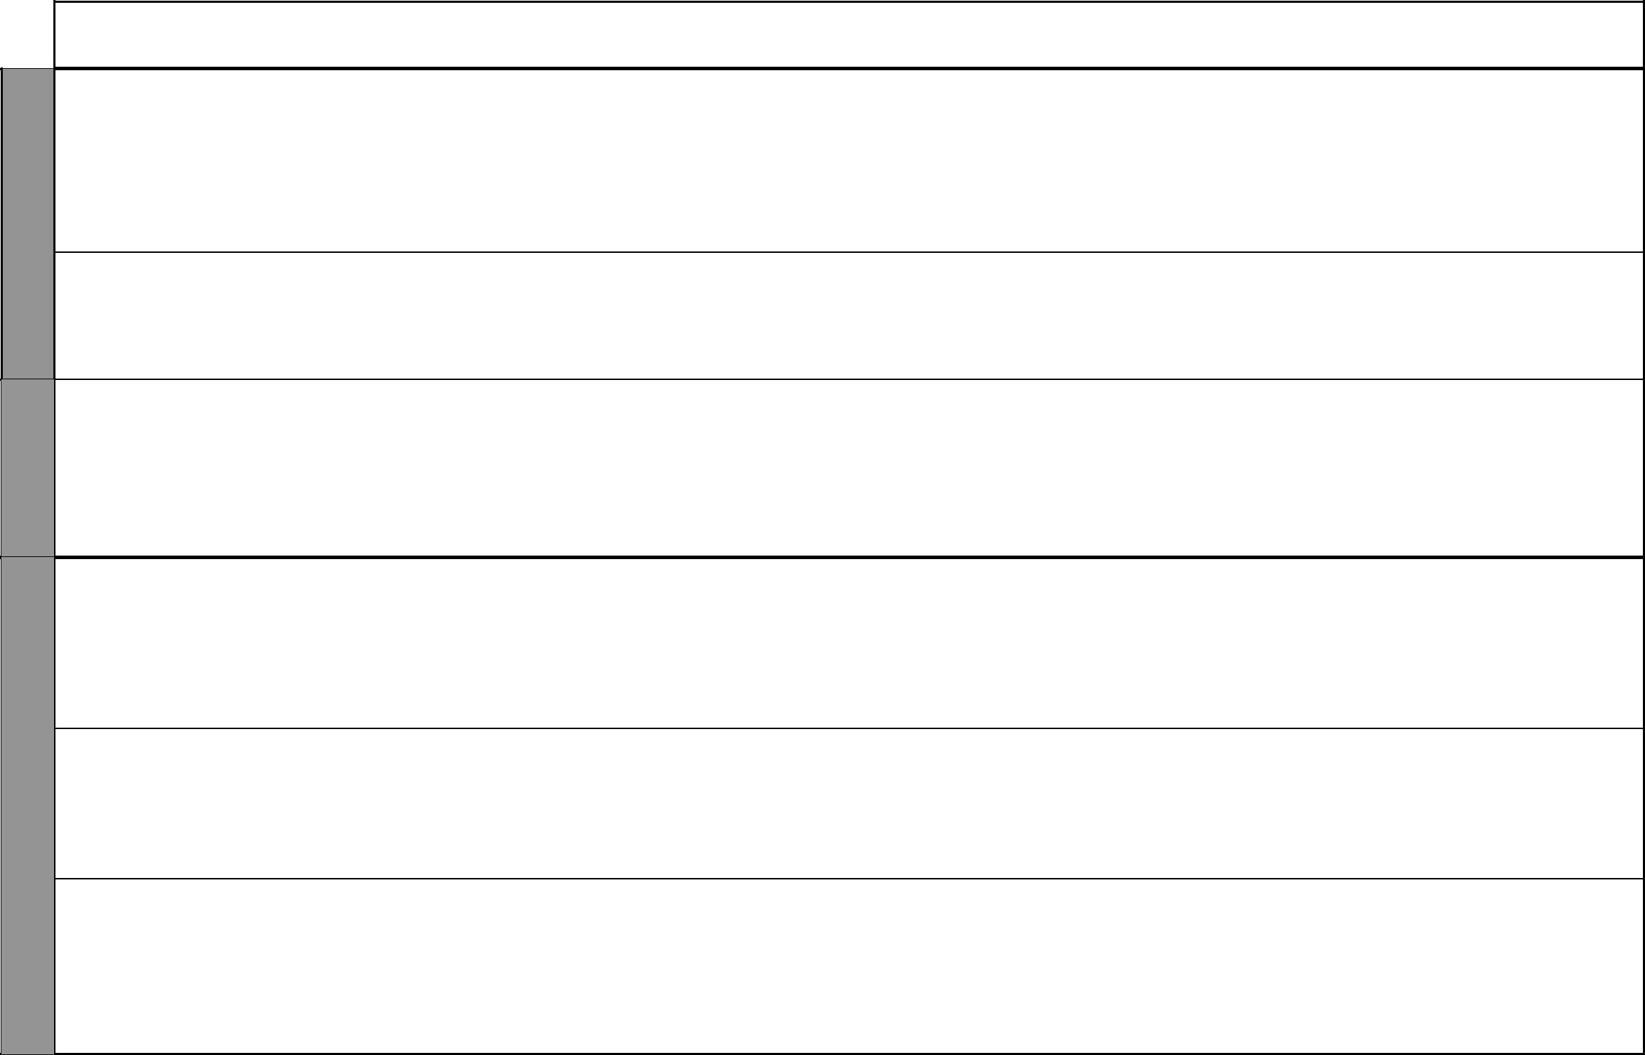

WEEK 6

WEEK 7

WEEK 8

UNIT | TOPIC | LESSONS | OBJECTIVES | TEACHING/LEARNING |  | LEARNING/TEACHING | REFERENCES | REMARKS
 |  |  |  |  | ACTIVITIES | RESOURCES
 | Area of | 4 | By the end of this topic, the | • | Drawing parallelograms | Cut-outs of parallelograms | Pupil’s Book
 | parallelograms |  | pupils should be able to work | • | Drawing perpendicular lines in | and trapeziums | pages 82-85
 | and |  | out the area of parallelograms |  | the parallelograms |  | Teacher’s Book
 | trapeziums |  | and trapeziums. | • | Working out problems |  | pages 59-60
 |  |  |  |  | involving the area of
 |  |  |  |  | parallelograms and trapeziums
 | Area of | 2 | By the end of this topic, the | • | Finding the area of rectangles, | Cut-outs of circles, | Pupil’s Book
 | combined |  | pupils should be able to find the |  | circles and triangles | triangles, rectangles | pages 86-89
 | shapes |  | area of combined shapes. | • | Working out problems |  | Teacher’s Book
 |  |  |  |  | involving combined shapes |  | page 60
 | Surface area | 5 | By the end of this topic, the | • | Identifying the number of | Cuboids, cylinders | Pupil’s Book
 | of cuboids and |  | pupils should be able to find |  | faces in a cuboids |  | pages 89-93
 | cylinders |  | the surface area of cuboids and | • | Opening and identifying the |  | Teacher’s Book
 |  |  | cylinders. |  | nets of cuboid |  | pages 61-62
 |  |  |  | • | Finding the area of cuboids
 |  |  |  |  | and cylinders
11 | Time in | 3 | By the end of this topic, the | • | Converting time in 12-hour | Clock face, 12-hour/24-hour | Pupil’s Book
Time, | 12-hour and |  | pupils should be able to work |  | clock system to 24-hour clock | time charts, calendars | pages 94-95
Time, | 24-hour |  | out problems involving units of |  | system |  | Teacher’s Book
speed and | 24-hour |  | out problems involving units of |  | system |  | Teacher’s Book
tempera- | clock systems |  | time. | • | Working out problems |  | pages 64-65
ture |  |  |  |  | involving time on the 12-hour/
ture |  |  |  |  | 24-hour clock systems
 | Travel | 3 | By the end of this topic, the | • | Reading and interpreting travel | Bus, train and airline travel | Pupil’s Book
 | timetables |  | pupils should be able to read |  | timetables | timetables, fare tables, | pages 95-97
 |  |  | and interpret travel timetables | • | Adding and subtracting time | distance tables | Teacher’s Book
 |  |  | and fare tables. | • | Reading time in 24-hour clock |  | pages 65-66
 |  |  |  |  | systems
 | Speed | 2 | By the end of this topic, the | • | Discussing relationship |  | Pupil’s Book
 |  |  | pupils should be able to work |  | between speed, distance and |  | pages 97-100
 |  |  | out problems involving speed in |  | time |  | Teacher’s Book
 |  |  | km/h and m/s. | • | Multiplying numbers |  | page 66
 |  |  |  | • | Dividing numbers

7 For use with Progressive Primary Mathematics Standard Seven

WEEK 9

WEEK 11 WEEK 10
Progressive Primary Mathematics Standard Seven

Schemes of Work

Term 2
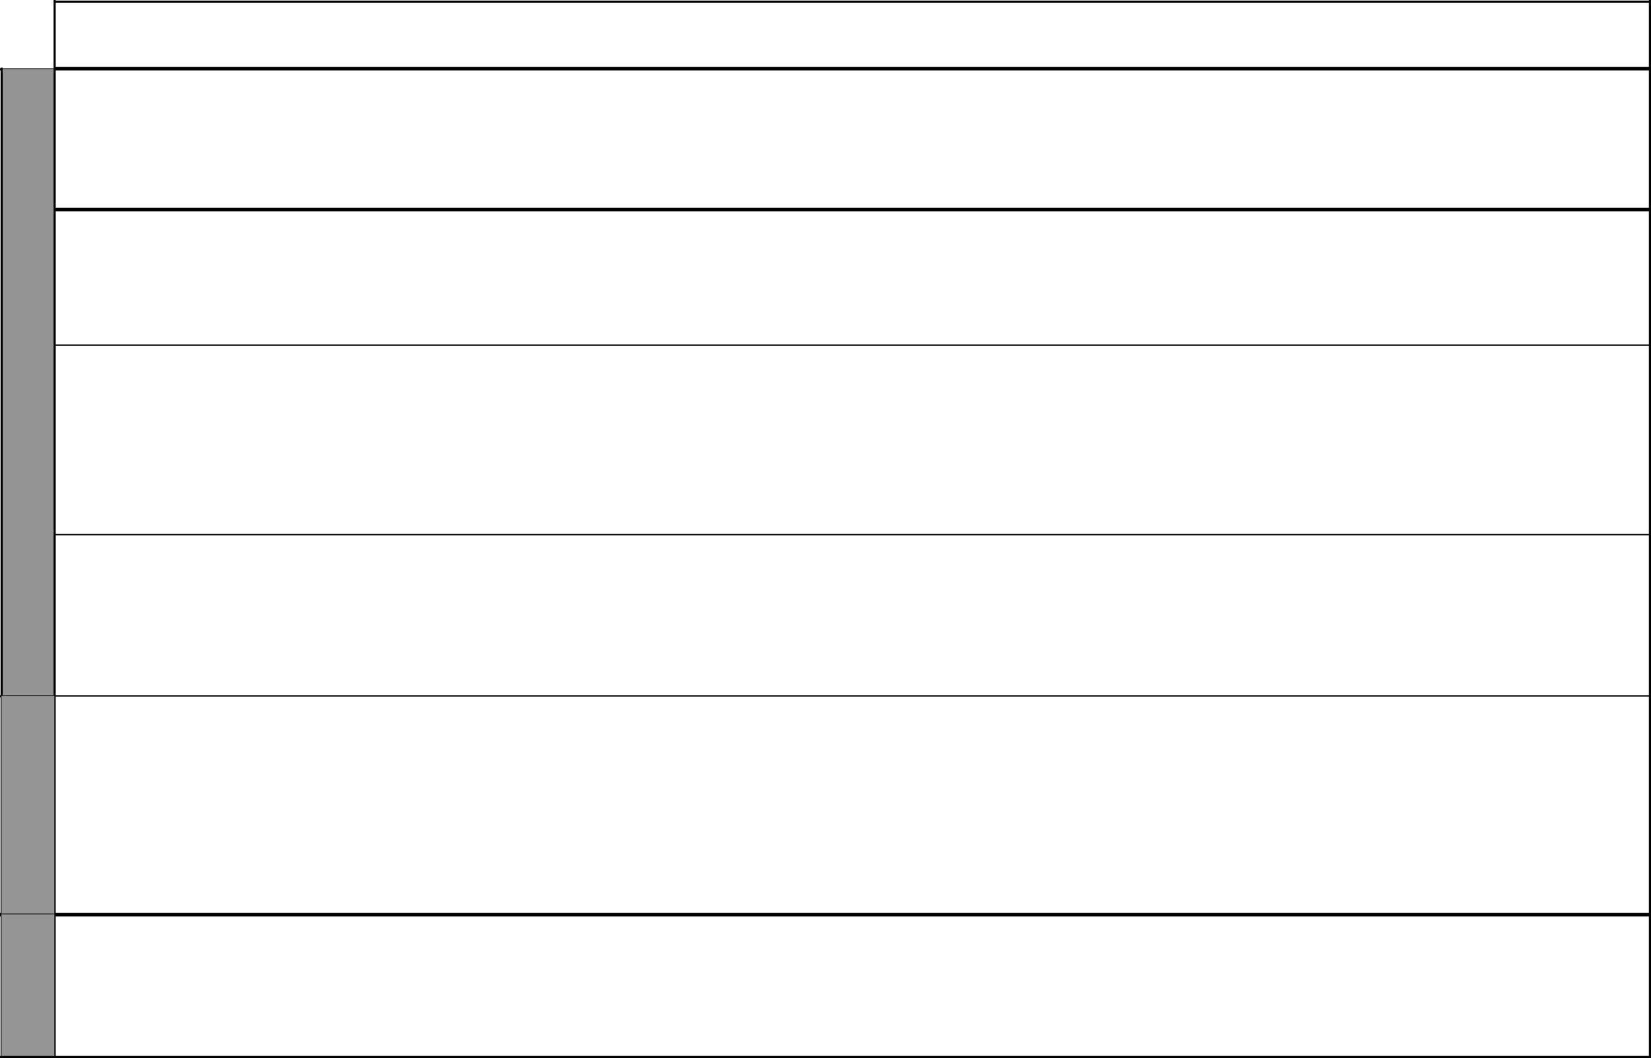
UNIT | TOPIC | LESSONS | OBJECTIVES | TEACHING/LEARNING |  | LEARNING/TEACHING | REFERENCES | REMARKS
 |  |  |  |  | ACTIVITIES | RESOURCES
 | Temperature | 2 | By the end of this topic, | • | Discussing the weather of the | Clinical thermometer | Pupil’s Book page
 |  |  | the pupils should be able to |  | day |  | 101
 |  |  | work out problems involving | • | Discussing the thermometer |  | Teacher’s Book
 |  |  | temperature in degrees Celsius. | • | Reading the thermometer |  | page 66
12 | Ratio as a | 2 | By the end of this topic, the | • | Writing fractions in ratio form | Counters | Pupil’s Book
Ratio | fraction |  | pupils should be able to identify | • | Comparing quantities using |  | pages 102-103
and pro- |  |  | ratio as afraction. |  | ratio |  | Teacher’s Book
portion |  |  |  | • | Writing ratio as a fraction |  | pages 59-60
 | Sharing | 2 | By the end of this topic, | • | Sharing quantities using real- | Counters | Pupil’s Book
 | using |  | the pupils should be able to |  | life situations |  | pages 104-105
 | ratio |  | interpret use ratio in sharing out | • | Sharing experiences using |  | Teacher’s Book
 |  |  | quantities. |  | ration |  | pages 70
 |  |  |  | • | Working out problems
 |  |  |  |  | involving sharing using ratio
 | Increasing | 2 | By the end of this topic, the | • | Writing ratio as fractions | Counters | Pupil’s Book
 | and |  | pupils should be able to use | • | Increasing quantities in given |  | pages 105-106
 | decreasing |  | ratio to increase and decrease |  | ratio |  | Teacher’s Book
 | in given ratio |  | quantities. | • | Decreasing in quantities given |  | pages 70-71
 |  |  |  |  | ratio
 | Proportion | 5 | By the end of this topic, the | • | Comparing quantities using | Counters | Pupil’s Book
 |  |  | pupils should be able to identify |  | ratio |  | pages 106-108
 |  |  | and apply direct and indirect | • | Identifying situations in which |  | Teacher’s Book
 |  |  | proportion in real-life situations. |  | there is increase or decrease in |  | pages 71-72
 |  |  |  |  | quantities
 |  |  |  | • | Working out problems
 |  |  |  |  | involving direct proportion
13 | Area of a | 3 | By the end of this topic, the | • | Drawing cross sections of | Cuboids, cylinders, cubes, | Pupil’s Book
Volume, | cross section |  | pupils should be able to identify |  | solids | squares, circles and | pages 110-113
capacity |  |  | and work out the area cross | • | Working out area | rectangles | Teacher’s Book
and mass |  |  | sectional of a solid |  |  |  | pages 74-75

8 For use with Progressive Primary Mathematics Standard Seven

Progressive Primary Mathematics Standard Seven

Schemes of Work

Term 2
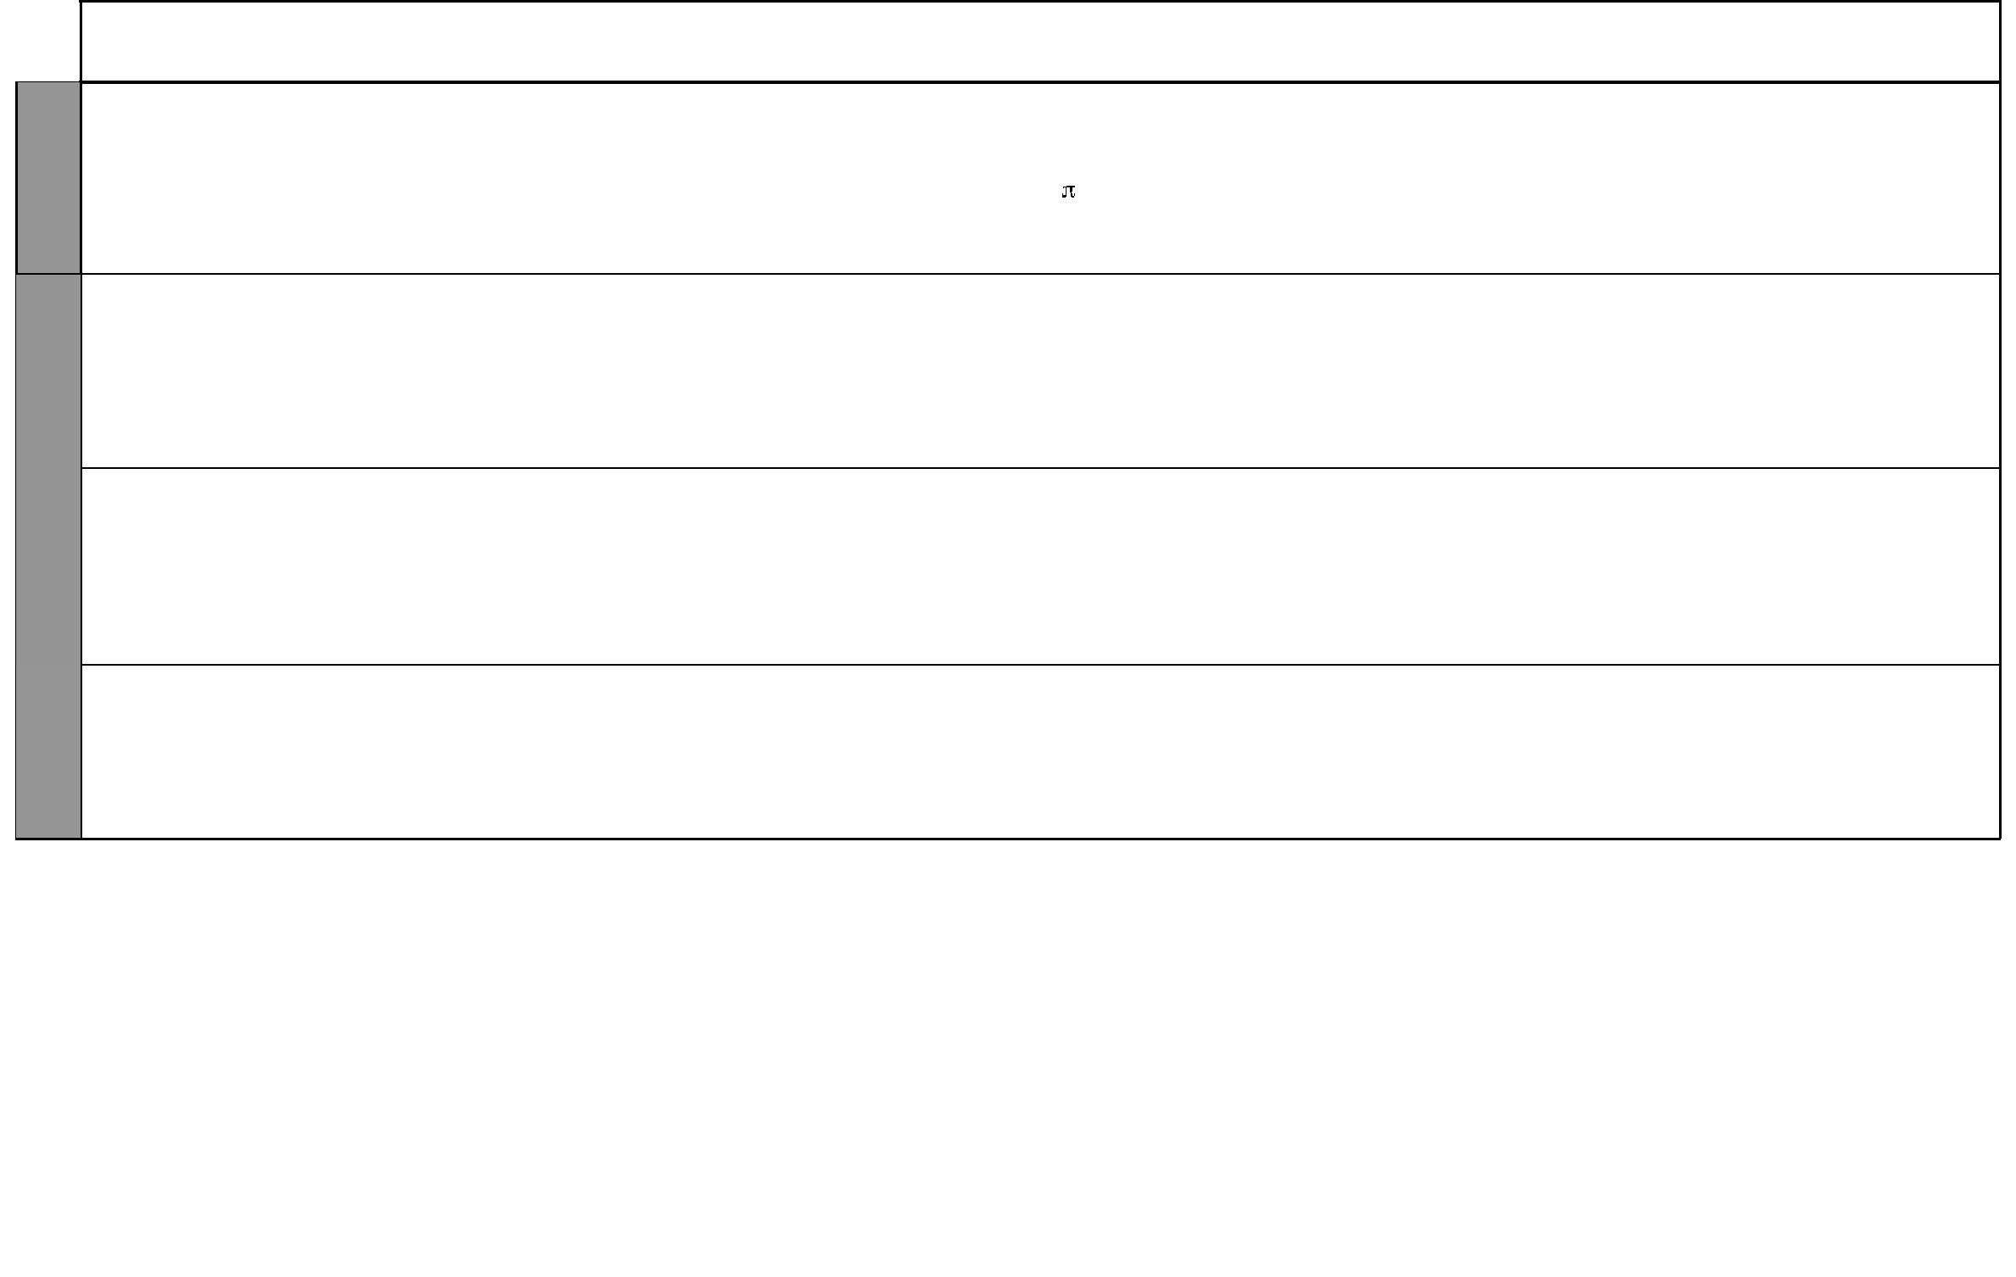

WEEK 11

WEEK 12

WEEK 13

UNIT | TOPIC | LESSONS | OBJECTIVES | TEACHING/LEARNING |  | LEARNING/TEACHING | REFERENCES | REMARKS
 |  |  |  |  | ACTIVITIES | RESOURCES
 | Volume of a | 2 | By the end of this topic, the | • Converting units of volume |  | Cuboids, cylinders, coins | Pupil’s Book
 | cube and a |  | pupils should be able to work |  | using the formula |  | pages 110-117
 | cylinder |  | out problems involving the |  | Volume = r²h to find the |  | Teacher’s Book
 |  |  | volume of cuboids and cylinders. |  | volume of a cylinder |  | pages 75-76
 | Capacity | 5 | By the end of this topic, the | • Converting units of capacity |  | Wooden blocks, water, | Pupil’s Book
 |  |  | pupils should be able to work |  | (deciliter, ml, litre) | open containers, | pages 117-121
 |  |  | out problems involving units of | • | Working out problems | measuring cylinders | Teacher’s Book
 |  |  | capacity. |  | involving units of capacity |  | pages 76-77
 | Mass | 2 | By the end of this topic, the | • | Working out problems | Weights used in shops and | Pupil’s Book
 |  |  | pupils should be able to work |  | involving units of mass | preweight goods | pages 122-123
 |  |  | out problems involving units of |  |  |  | Teacher’s Book
 |  |  | mass. |  |  |  | pages 77-78
 | Revision |  | By the end of this week, the pupils | • | Answering questions
 |  |  | should be able to answer questions | • | Remedial work
 |  |  | in the topics covered in the term | • Doing end of term tests

9 For use with Progressive Primary Mathematics Standard Seven

WEEK 1

WEEK 4&5 WEEK 3 WEEK 2
Mathematics Scheme of Work for Standard Seven: Term Three
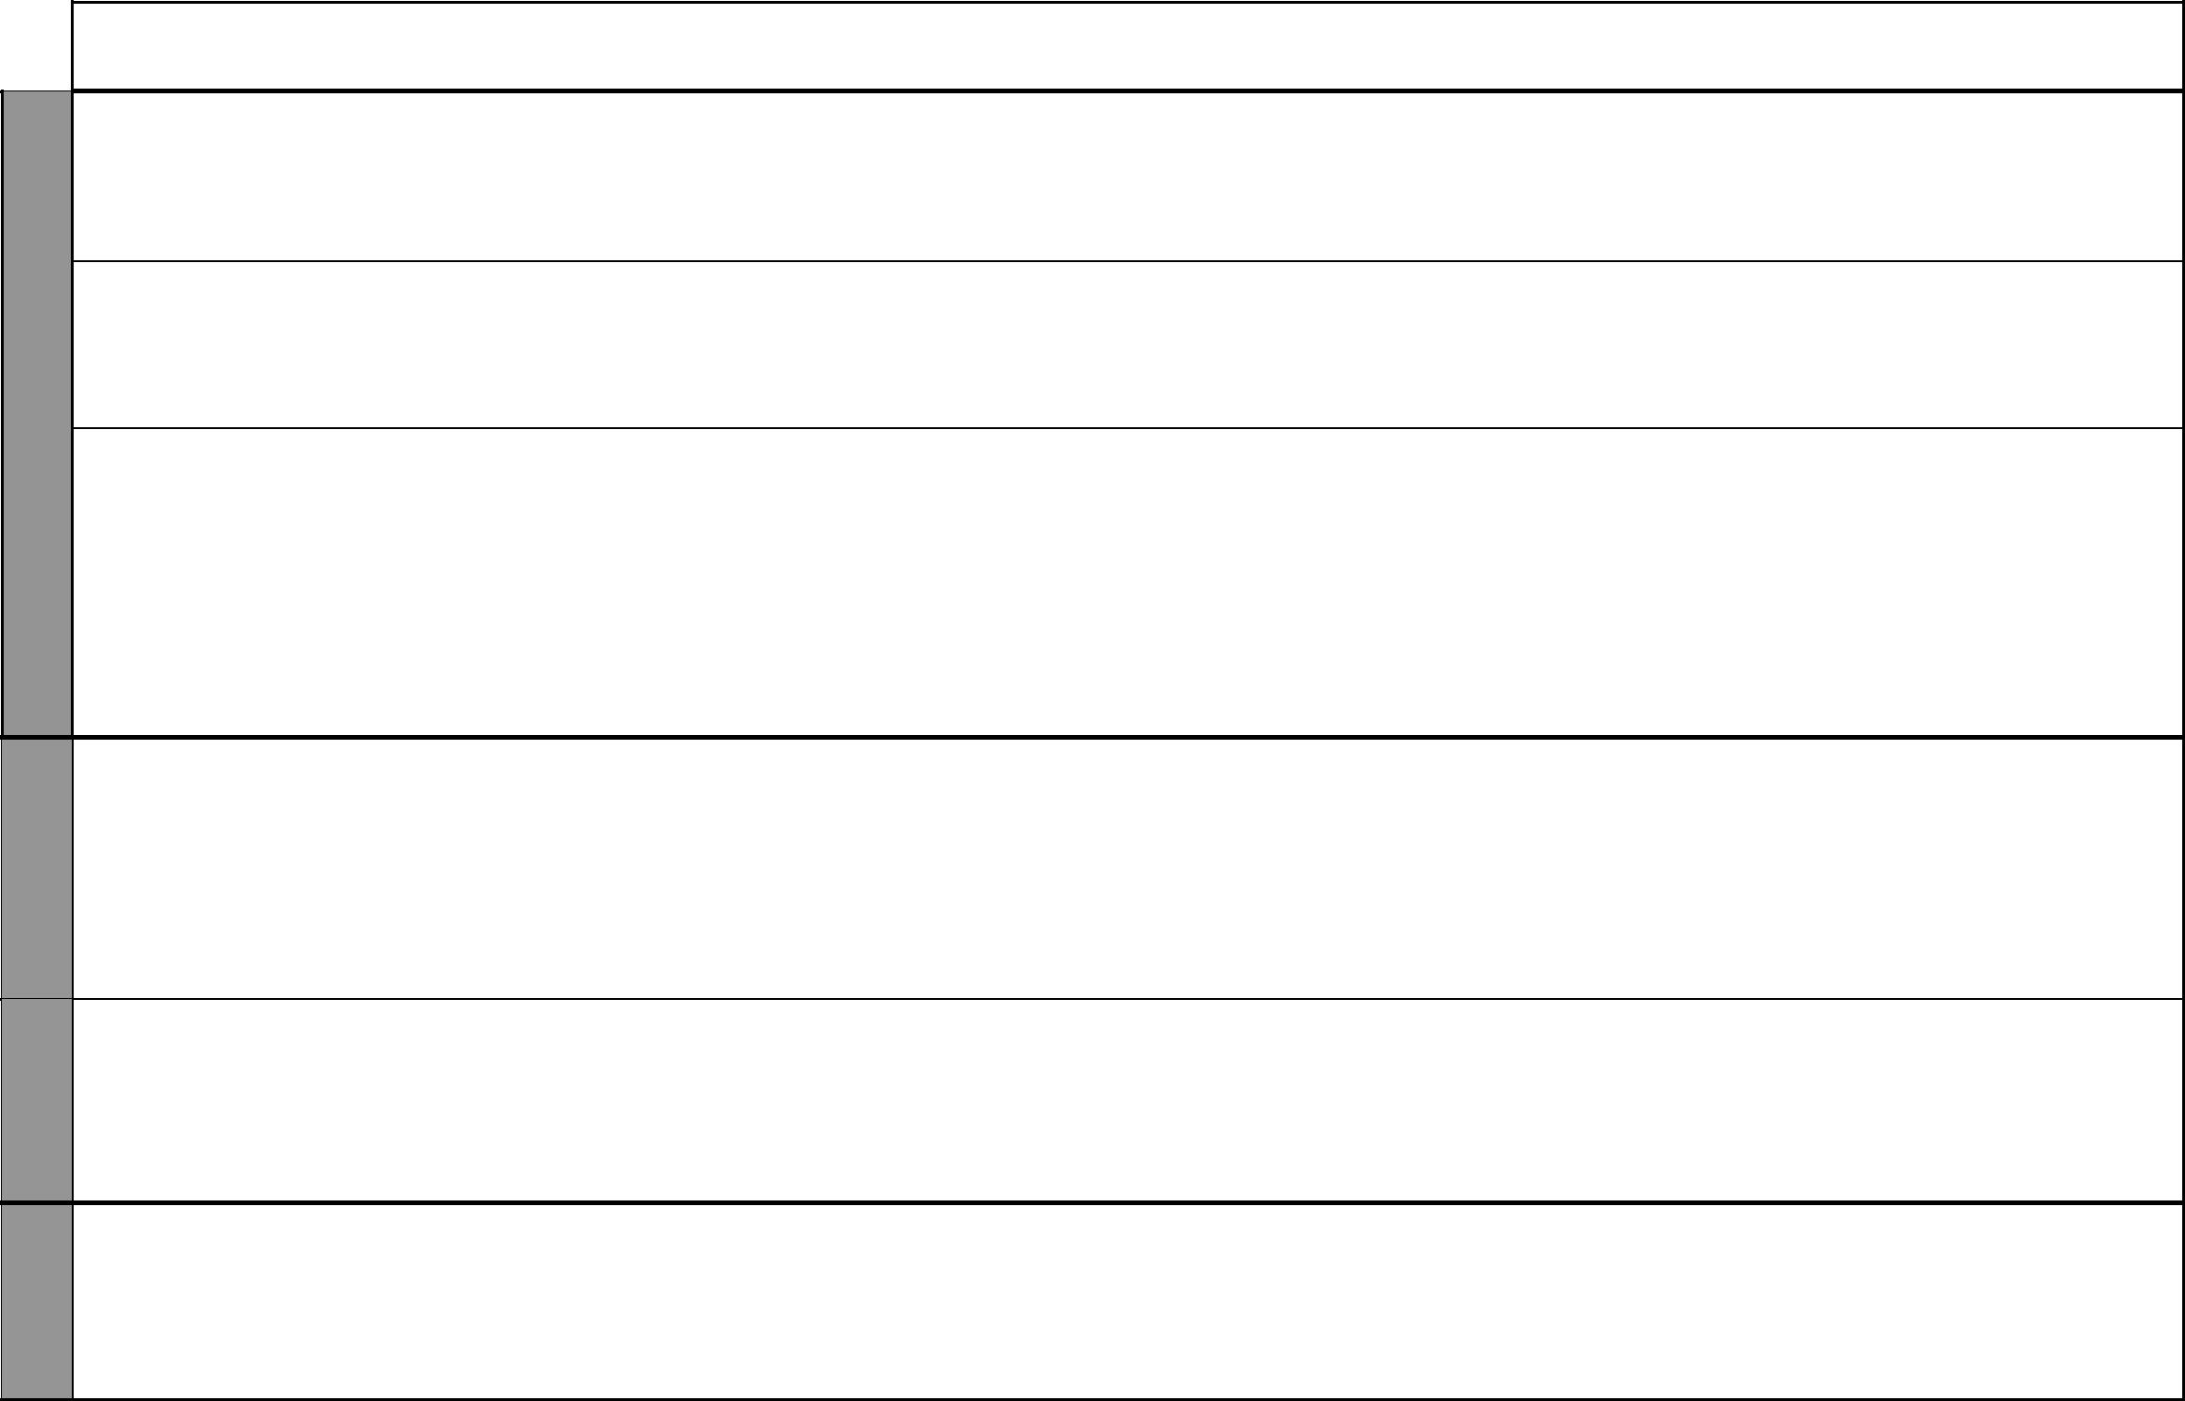
UNIT |  | TOPIC | LESSONS | OBJECTIVES |  | TEACHING/LEARNING | LEARNING/TEACHING | REFERENCES | REMARKS
 |  |  |  |  |  | ACTIVITIES | RESOURCES
14 |  | Discount, | 3 | By the end of this topic, the pupils | • Working out discounts on |  | Price list | Pupil’s Book
Money |  | bills, profit |  | should be able to work out | • | given prizes |  | pages 128-129
 |  | and loss |  | problems involving bills, percentage | • | Writing bills |  | Teacher’s Book
 |  |  |  | discount, profit and loss. | • Working out profit and loss |  |  | pages 81-82
 |  | Simple | 2 | By the end of this topic, the | • Discussing the meaning of |  | Interest rates from banks | Pupil’s Book
 |  | interest |  | pupils should be able to work |  | interest | and financial institutions | pages 129-132
 |  |  |  | out problems involving simple | • | Working out problems |  | Teacher’s Book
 |  |  |  | interest. |  | involving simple interest |  | pages 82
 |  | Commission | 2 | By the end of this topic, | • Discussing the meaning of |  | Commissions offered by | Pupil’s Book
 |  | and hire |  | the pupils should be able to |  | commission giving various | service and commodity | pages 131-133
 |  | purchase |  | work out problems involving |  | daily examples | providers | Teacher’s Book
 |  |  |  | percentage commission and hire | • | Working out problems |  | pages 82-83
 |  |  |  | purchase. |  | involving percentage
 |  |  |  |  |  | commission and hire purchase
 |  |  |  |  | • Discusssing different ways of
 |  |  |  |  |  | buying goods
15 |  | Inland and | 4 | By the end of this topic, the | • Calculating the costs of |  | Postal charges from post | Pupil’s Book
Postal |  | international |  | pupils should be able to work |  | sending letters | office | pages 134-138
Postal |  | postal |  | out the costs of sending letters | • Calculating the costs of |  |  | Teacher’s Book
changes |  | postal |  | out the costs of sending letters |  |  |  | Teacher’s Book
 |  | charges |  | and printed papers. |  | sending printed materials and |  | pages 86-87
 |  |  |  |  |  | newspapers
 |  |  |  |  | • Calculating the costs of
 |  |  |  |  |  | sending international letters
 |  | Money | 3 | By the end of this topic, the | • Discussing the meaning of |  | Money orders, postal | Pupil’s Book
 |  | orders, postal |  | pupils should be able to work |  | commission | orders, telegrams | pages 138-141
 |  | orders, |  | out problems involving money | • | Working out problems |  | Teacher’s Book
 |  | telegrams |  | orders, postal orders and |  | involving postal orders, money |  | pages 87-88
 |  |  |  | telegrams. |  | orders and telegrams
16 |  | Linear scale in | 3 | By the end of this topic, the | • | Converting scale from | Ruler, protractor | Pupil’s Book
Scale |  | ratio form |  | pupils should be able to convert |  | statement to ratio form and |  | pages 142-145
drawing |  |  |  | scale in statement form to ratio |  | vice versa. |  | Teacher’s Book
drawing |  |  |  | form and vice versa. | • Writing scale in statement and |  |  | pages 89-90
 |  |  |  |  |  | ratio form.

10 For use with Progressive Primary Mathematics Standard Seven

Progressive Primary Mathematics Standard Seven

Schemes of Work

Term 3
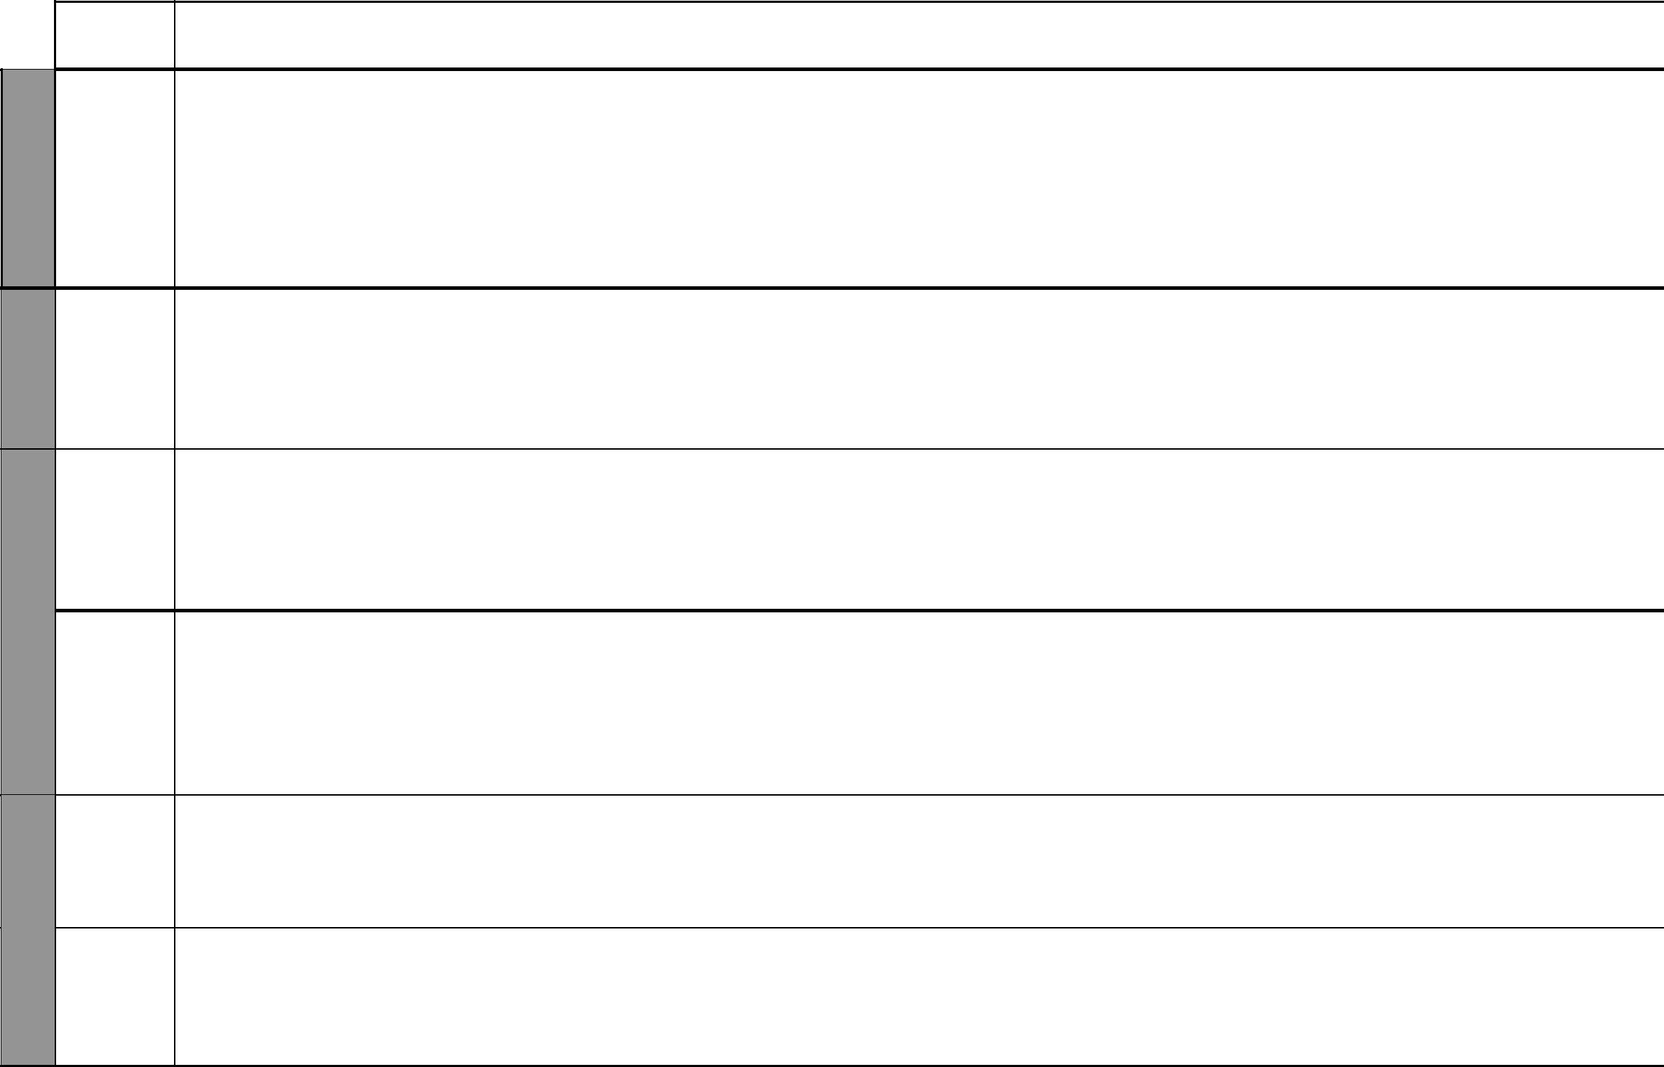

UNIT

WEEK 6

17
Tables and graphs

WEEK 7

18
Models and patterns

WEEK 8

TOPIC | LESSONS | OBJECTIVES | TEACHING/LEARNING |  | LEARNING/TEACHING | REFERENCES | REMARKS
 |  |  |  | ACTIVITIES | RESOURCES
Drawing to | 4 | By the end of this topic, the | • | Converting scale in statement | Ruler, tape measure | Pupil’s Book
scale |  | pupils should be able to work |  | from to ratio form and vice versa |  | pages 143-145
 |  | out problems involving scale | • | Making scale drawings |  | Teacher’s Book
 |  | drawing | • | Working actual lengths to |  | pages 90-91
 |  |  |  | given ratio
 |  |  | • Working out the ratio given
 |  |  |  | drawing and actual lengths
Tables and | 11 | By the end of this topic, | • | Interpreting data from a table | Graph paper rule, | Pupil’s Book
graphs |  | the pupils should be able to | • | Discussing how to represent | protractor, pair of | pages 146-160
 |  | interpret and represent data in |  | data in tables and graphs | compasses, square paper | Teacher’s Book
 |  | tables and graphs. | • | Collecting data and |  | pages 94-95
 |  |  |  | representing data
Mean and | 2 | By the end of this topic, | • | Identifying the items that | Locally available materials | Pupil’s Book
mode |  | the pupils should be able to |  | occur more often in given data |  | pages 160-161
 |  | identify the mean and mode of | • | Finding mean of given data |  | Teacher’s Book
 |  | given data. | • | Collecting data |  | page 95
 |  |  | • | Answering questions
Nets and | 5 | By the end of this topic, the | • | Drawing nets | Manila paper, pair of | Pupil’s Book
models |  | pupils should be able to draw | • | Folding nets to form models | scissors, ruler, glue, models | pages 162-165
 |  | nets and make models of | • | Opening up models to make | of cubes, cuboids and | Teacher’s Book
 |  | cubes, cuboids and cylinders. |  | net. | cylinders | pages 106-107
 |  |  | • | Working out problems
 |  |  |  | involving models and nets
Patterns | 4 | By the end of this topic, the | • | Joining shapes to form | Ruler, cuboids, cylinders | Pupil’s Book
 |  | pupils should be able to make |  | patterns |  | pages 166-171
 |  | patterns involving rectangles | • | Completing patterns |  | Teacher’s Book
 |  | and circles. | • | Studying patterns |  | page 107
Revision |  | By the end of this week, the | • | Answering questions
 |  | pupils should be able to answer | • | Remedial work
 |  | questions in the topics covered in | • | Doing end of term tests
 |  | the term
 |  |  |  | 11 | For use with Progressive Primary Mathematics Standard Seven

