MATHS SCHEME OF WORK CLASS 6
AVAILABLE ONLINE AT:
Schools Net Kenya Consultancy
P.O. Box 8076 – 00200 Nairobi, Kenya | Tel: +254202319748
E-mail: infosnkenya@gmail.com | www.schoolsnetkenya.com

WEEK 1

WEEK 2

WEEK 3
Progressive Primary Mathematics Book 6: Sample Schemes of Work: Term One
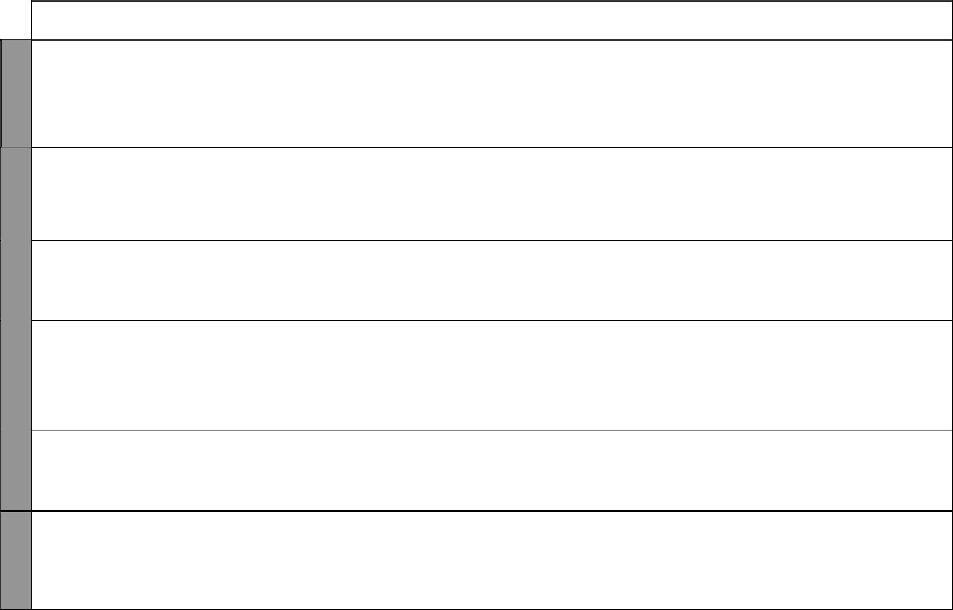
UNIT | TOPIC | LESSONS | OBJECTIVES | TEACHING/LEARNING | LEARNING/TEACHING | REFERENCES | REMARKS
 |  |  |  | ACTIVITIES | RESOURCES
1 | Place values | 5 | By the end of this topic, the pupils | • Revision of place values up to | Place value tables and | Pupil’s Book
Whole | of numbers |  | should be able to recognize and | hundreds of thousands | columns | pages 2-4
numbers |  |  | identify the place values and total | • Counting in thousands |  | Teacher’s Book
 |  |  | values of numbers, read and write |  |  | pages 1-3
 |  |  | numbers in words and in figures
 |  |  | up to hundreds of millions
 | Rounding | 2 | By the end of this topic, the | • Identification of the place value | Place value tables, number | Pupil’s Book
 | off to the |  | pupils should be able to round | of whole numbers | lines | page 5
 | nearest |  | off numbers to the nearest | • Drawing number lines |  | Teacher’s Book
 | thousand |  | thousand | • Estimating and rounding off |  | page 4
 |  |  |  | numbers
 | Divisibility | 2 | By the end of this topic, the | • Listing multiples of numbers | Multiplication tables | Pupils’ Book
 | test for 8 |  | pupils should be able to apply the | • Dividing numbers |  | page 6
 |  |  | divisibility test for 8 to determine |  |  | Teacher’s Book
 |  |  | numbers that are divisible by 8 |  |  | pages 4-5
 | Squares of | 3 | By the end of this topic, the | • Multiplying numbers | Multiplication tables | Pupil’s book
 | numbers |  | pupils should be able to identify | • Listing numbers |  | pages 7-8
 |  |  | and to work out squares of up to |  |  | Teacher’s Book
 |  |  | 3-digit numbers, list the square |  |  | pages 5-6
 |  |  | numbers between 1 and 100 and
 |  |  | find the square of a number
 | Square roots | 4 | By the end of this topic, the | • Multiplying numbers | Multiplication tables, | Pupil’s Book
 | of numbers |  | pupils should be able to work | • Dividing numbres | charts with lists of whole | pages 8-9
 |  |  | out the square roots of perfect |  | numbers up to 100 | Teacher’s Book
 |  |  | squares up to 3-digit numbers |  |  | pages 6-7
2 | Addition | 3 | By the end of this topic, the | • Adding numbers | Place value tables and | Pupil’s Book
Addition |  |  | pupils should be able to add | • Aligning numbers in place | charts, addition tables | pages 10-11
and |  |  | numbers up to millions with | value charts |  | Teacher’s Book
subtra- |  |  | sums not exceeding 999 999 999 |  |  | pages 11-12
ction |  |  | with and without carrying

1 For use with Progressive Primary Mathematics Standard Six

UNIT

WEEK 4

3
Multi-plication and division

WEEK 5

6

WEEK | 4
WEEK | Fraac-
 | tions

Progressive Primary Mathematics Standard Six

Schemes of Work

Term 1
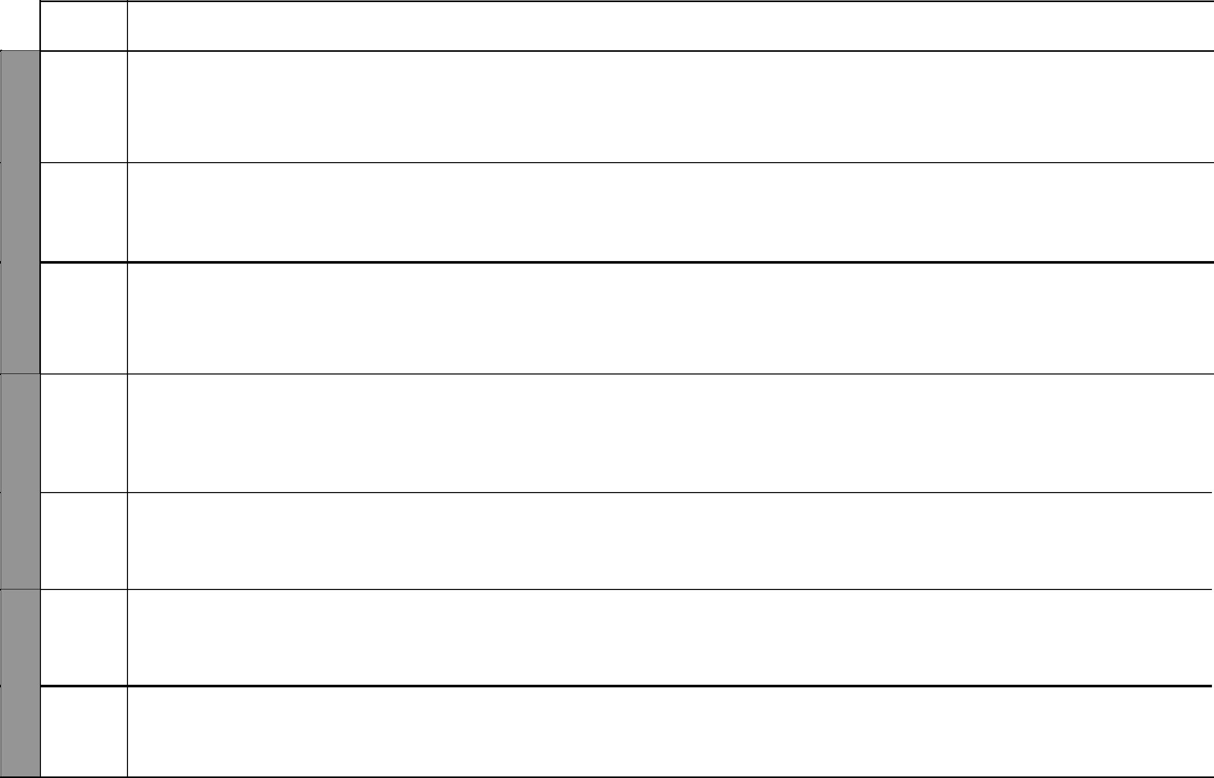
TOPIC | LESSONS | OBJECTIVES | TEACHING/LEARNING | LEARNING/TEACHING | REFERENCES | REMARKS
 |  |  | ACTIVITIES | RESOURCES
Subtraction | 3 | By the end of this topic, the | • Subtracting numbers | Place value tables, addition | Pupil’s Book
 |  | pupils should be able to work | • Aligning numbers in place | tables | pages 12-13
 |  | out subtraction of numbers up | value charts and tables |  | Teacher’s Book
 |  | to millions with and without |  |  | pages 12-13
 |  | borrowing
Number | 2 | By the end of this topic, the | • Adding numbers | Addition tables | Pupil’s Book
sequences |  | pupils should be able to identify | • Subtracting number |  | page 13
 |  | and recognise number sequences | • Identifying number |  | Teacher’s Book
 |  | involving addition and subtraction | sequences |  | page 13
Multiplication | 2 | By the end of this topic, the | • Listing the multiples of | Multiplication tables | Pupil’s Book
 |  | pupils should be able to multiply | numbers |  | pages 14-15
 |  | up to 3-digit numbers by 3-digit | • Multiplying whole numbers |  | Teacher’s Book
 |  | numbers with products not |  |  | pages 15-16
 |  | exceeding 999 999 999
Division | 5 | By the end of this topic, the | • Listing the multiples of | Multiplication tables | Pupil’s Book
 |  | pupils should be able to divide | numbers |  | pages 16-19
 |  | up to 5-digit numbers by 2-digit | • Dividing numbers |  | Teacher’s Book
 |  | numbers with the divisor less |  |  | pages 16-18
 |  | than the dividend
LCM and | 4 | By the end of this topic, the | • Dividing numbers | Multiplication tables | Pupil’s Book
GCD |  | pupils should be able to work | • Multiplying numbers |  | pages 19-20
 |  | out the LCM and GCD of | • Answering questions |  | Teacher’s Book
 |  | numbers |  |  | page 18
Number | 2 | By the end of this topic, the | • Multiplying numbers | Multiplication tables | Pupils’ Book
sequences |  | pupils should be able to find | • Dividing numbers |  | page 21
 |  | the missing numbers in a given | • Finding missing numbers |  | Teacher’s Book
 |  | sequence |  |  | pages 18-19
Adding | 3 | By the end of this topic, the | • Listing multiples of numbers | Paper strips, fruits, cakes, | Pupil’s Book
fractions |  | pupils should be able to add up | • Listing divisors of numbers | etc | pages 22-24
 |  | to three mixed numbers using | • Adding fractions |  | Teacher’s Book
 |  | LCM | • Finding the LCM of numbers |  | pages 21-22
 |  |  | 2 | For use with Progressive Primary Mathematics Standard Six

Progressive Primary Mathematics Standard Six

Schemes of Work

Term 1
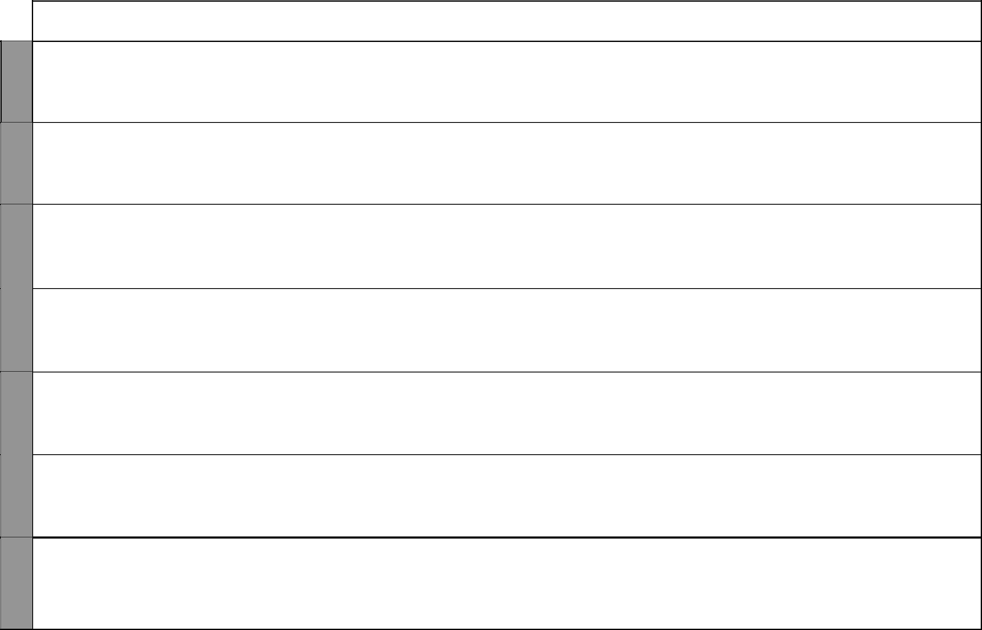

WEEK 7 WEEK 6

WEEK 8

WEEK 9

WEEK 10

UNIT | TOPIC | LESSONS | OBJECTIVES | TEACHING/LEARNING | LEARNING/TEACHING | REFERENCES | REMARKS
 |  |  |  | ACTIVITIES | RESOURCES
 | Subtracting | 2 | By the end of this topic, the | • Listing multiples of numbers | Paper strips, fruits, cakes, | Pupil’s Book
 | fractions |  | pupils should be able to subtract | • Listing divisors of numbers | etc | pages 24-26
 |  |  | up to three mixed numbers | • Subtracting fractions |  | Teacher’s Book
 |  |  | using LCM | • Finding the LCM of numbers |  | pages 22-23
 | Multiplying | 7 | By the end of this topic, the | • Cutting into equal parts | Paper strips, fruits, cakes, | Pupil’s Book
 | fractions |  | pupils should be able to multiply | • Counting parts of a fraction | etc | pages 26-29
 |  |  | a fraction by a fraction, and by a | • Multiplying fractions |  | Teacher’s Book
 |  |  | mixed number |  |  | pages 23-24
 | Dividing a | 4 | By the end of this topic, the | • Cutting into equal parts | Paper stips, fruits, cakes etc | Pupil’s Book
 | fraction by a |  | pupils should be able to divide a | • Counting parts of a fraction |  | pages 29-30
 | whole number |  | fraction by a whole number and | • Dividing fractions |  | Teacher’s Book
 |  |  | vice versa |  |  | pages 24-25
 | Dividing a | 2 | By the end of the topic, the | • Cutting into equal parts | Paper strips, fruits, cakes, | Pupil’s Book
 | fraction by a |  | pupils should be able to divide a | • Counting parts of a fraction | etc | pages 30-31
 | fraction |  | fraction by a fraction | • Dividing fractions |  | Teacher’s Book
 |  |  |  |  |  | page 25
 | Squares and | 4 | By the end of this topic, the | • Multiplying fractions | Paper strips, fruits, cakes, | Pupil’s Book
 | square roots |  | pupils should be able to work | • Dividing fractions | etc | pages 31-32
 | of fractions |  | out sequences of fractions and |  |  | Teacher’s Book
 |  |  | the square roots of fractions |  |  | page 26
 | Number | 3 | By the end of this topic, | • Multiplying fractions | Paper strips, fruits, cakes, | Pupil’s Book
 | sequences |  | the pupils should be able to | • Dividing fractions | etc | pages 32-33
 |  |  | recognize and identify missing | • Finding missing numbers |  | Teacher’s Book
 |  |  | numbers involving fractions |  |  | pages 26-27
5 | Place values | 3 | By the end of this topic, the | • Multiplying by 100 000 | Place value tables | Pupils’ Book
Deci- | of decimals |  | pupils should be able to read | • Dividing by 10 000 |  | pages 34-36
mals |  |  | and write decimals up to 4 | • Converting decimals to |  | Teacher’s Book
 |  |  | decimal places | fractions and vice versa |  | pages 31-32

3 For use with Progressive Primary Mathematics Standard Six

WEEK 10

WEEK 11

WEEK 12
Progressive Primary Mathematics Standard Six

Schemes of Work

Term 1
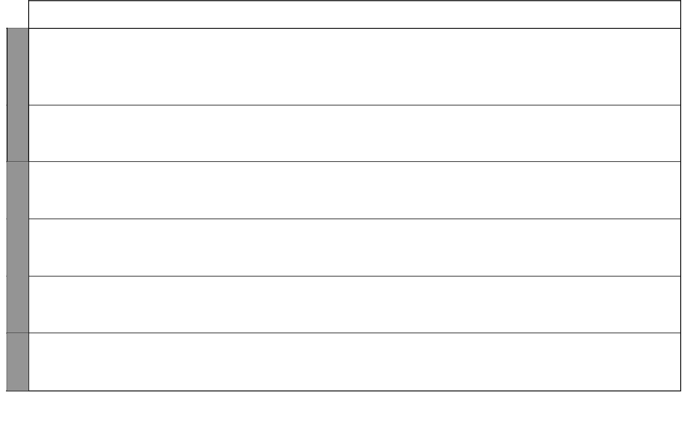
UNIT | TOPIC | LESSONS | OBJECTIVES | TEACHING/LEARNING | LEARNING/TEACHING | REFERENCES | REMARKS
 |  |  |  | ACTIVITIES | RESOURCES
 | Rounding off | 3 | By the of this topic, the pupils | • Multiplying by 10000 | Place value tables | Pupil’s Book
 | decimals |  | should be able to round | • Dividing by 10000 |  | pages 36-37
 |  |  | off decimals to the nearest | • Converting decimals to |  | Teacher’s Book
 |  |  | thousandth | fractions and vice versa |  | pages 32-33
 |  |  |  | • Rounding off to the nearest
 |  |  |  | thousandth
 | Addition and | 2 | By the end of this topic, the | • Alignment of numbers in place | Place value tables | Pupil’s Book
 | subtraction |  | pupils should be able to add | value tables |  | pages 38-39
 | of decimals |  | and subtract decimals up to ten | • Adding and subtracting |  | Teacher’s Book
 |  |  | thousandths | decimals |  | page 33
 | Multiplying | 2 | By the end of this topic, the | • Alignment of numbers in place | Place value tables | Pupil’s Book
 | decimals |  | pupils should be able to multiply | value tables |  | pages 39-40
 |  |  | a decimal by a decimal | • Multiplying decimals |  | Teacher’s Book
 |  |  |  |  |  | page 34
 | Dividing | 3 | By the end of this topic, the | • Aligning numbers in place value | Place value tables | Pupil’s Book
 | decimals |  | pupils should be able to work | tables |  | pages 41-43
 | by whole |  | out division involving decimals | • Dividing decimal numbers by |  | Teacher’s Book
 | numbers |  |  | whole numbers |  | pages 34-35
 | Decimals | 2 | By the end of this topic, the | • Converting decimals to | Place value tables | Pupil’s Book
 | and fractions |  | pupils should be able to convert | fractions and vice versa |  | pages 44-45
 |  |  | decimals to fractions and vice |  |  | Teacher’s Book
 |  |  | versa |  |  | pages 35-36
 | Revision |  | By the end of this week, the | • Answering questions |  | Pupil’s Book
 |  |  | pupils should be able to do | • Remedial work |  | pages 45-47
 |  |  | revision work on the topics | • Doing mixed exercise 1 |  | Teacher’s Book
 |  |  | covered during the term |  |  | pages 39-40

4 For use with Progressive Primary Mathematics Standard Six

Progressive Primary Mathematics Book 6: Sample Schemes of Work: Term Two
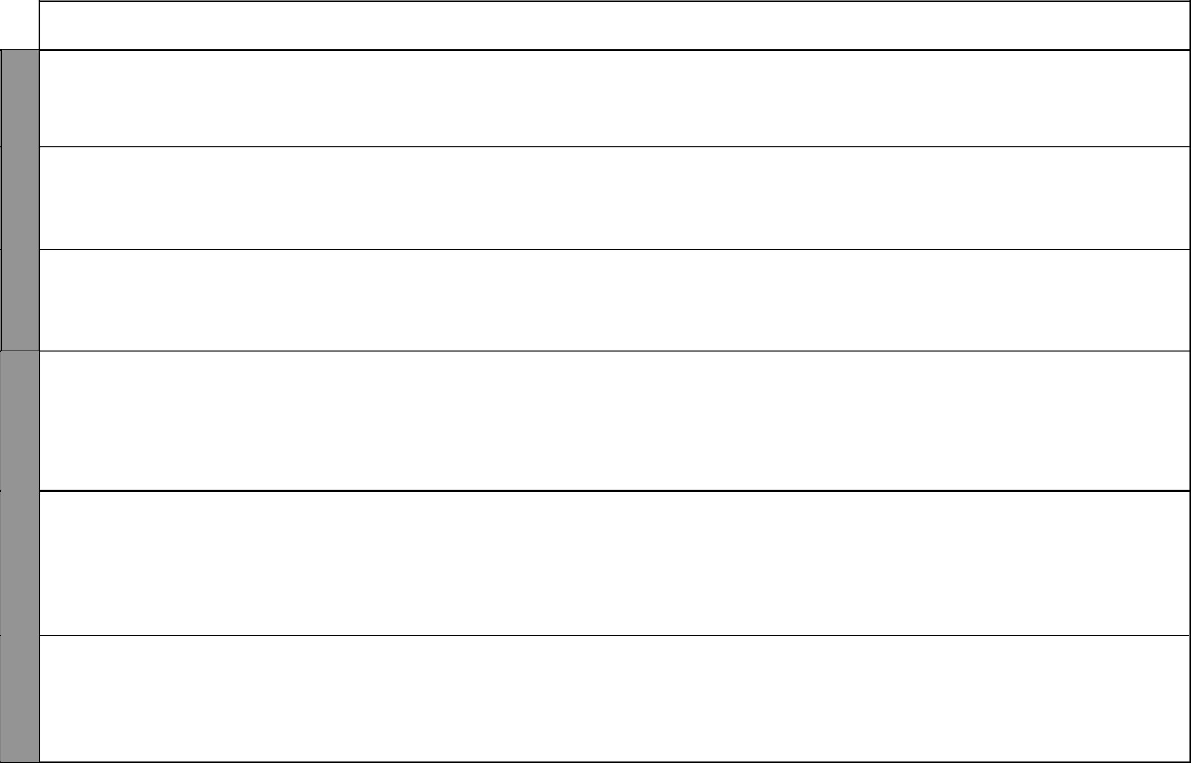

WEEK 1

WEEK 2 & 3

UNIT | TOPIC | LESSONS | OBJECTIVES | TEACHING/LEARNING | LEARNING/TEACHING | REFERENCES | REMARKS
 |  |  |  | ACTIVITIES | RESOURCES
6 | The | 2 | By the end of this topic, the | • Drawing a 100-square grid | 100-square grids, 100 | Pupil’s Book
Percent- | meaning of |  | pupils should be able to convert | • Listing equivalent fractions | counters | pages 48-49
age | percentage |  | decimals and fractions to | • Converting fractions and |  | Teacher’s Book
 |  |  | percentages and vice versa | decimals to percentage |  | pages 41-42
 | Converting | 3 | By the end of this topic, the | • Converting fractions/decimals | Multiplication tables, | Pupil’s Book
 | fractions, |  | pupils should be able to convert | to percentages and vice versa | 100-square grids, | pages 49-50
 | decimals and |  | fractions and decimals to |  | 100 counters | Teacher’s Book
 | percentages |  | percentages and vice versa |  |  | pages 42-43
 | Calculating | 4 | By the end of this topic, the | • Converting fractions to | Multiplication tables | Pupil’s Book
 | percentage |  | pupils should be able to work | decimals |  | pages 51-52
 |  |  | out the percentage given | • Converting fractions and |  | Teacher’s Book
 |  |  | quantities | decimals to percentage |  | page 43
 | Calculating | 4 | By the end of this topic, the | • Converting fractions/decimals | Multiplication tables, 100- | Pupil’s Book
 | amount |  | pupils should be able to work | to percentages and vice versa | square grids, 100 counters | pages 53-55
 | from the |  | out quantities when given their | • Working out fractions of given |  | Teacher’s Book
 | percentage |  | percentage in relation to others | quantities and vice versa |  | page 44
 |  |  |  | • Calculating amount from
 |  |  |  | percentage
7 | Circles | 6 | By the end of this topic, | • Drawing circles by tracing | A pair of compasses, a | Pupil’s Book
Circles |  |  | the pupils should be able to | around objects | ruler, circular objects | pages 56-58
and |  |  | construct circles using a pair | • Measuring the diameters, radii |  | Teacher’s Book
models |  |  | of compasses and identify the | and circumference of circles |  | pages 47-49
 |  |  | sector of a circle | • Deriving the relationship
 |  |  |  | 2r = d or r = ₂¹d
 | Making | 3 | By the end of this topic, the | • Drawing circles by tracing | A pair of compasses, a | Pupil’s Book
 | patterns |  | pupils should be able to make | around round objects | ruler, circular objects | pages 58-60
 | with circles |  | patterns using circles | • Measuring the diameters, radii |  | Teacher’s Book
 |  |  |  | and circumferences of circles |  | pages 49-50
 |  |  |  | • Overlapping circles

5 For use with Progressive Primary Mathematics Standard Six

Progressive Primary Mathematics Standard Six

Schemes of Work

Term 2
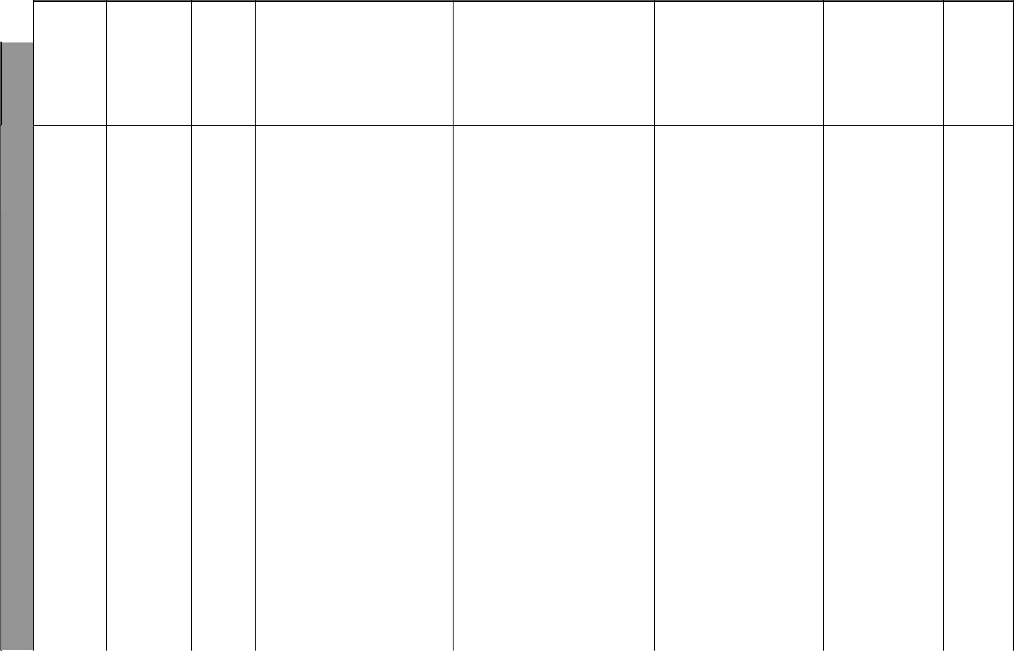
UNIT | TOPIC | LESSONS | OBJECTIVES | TEACHING/LEARNING | LEARNING/TEACHING | REFERENCES REMARKS
 |  |  |  | ACTIVITIES | RESOURCES
WEEK2&3 | Cubes and | 2 | By the end of this topic, the | • Drawing and sorting cubes | Closed carton boxes, | Pupil’s Book
WEEK2&3 | cuboids |  | pupils should be able to identify | fromd cuboids | cubes and cuboids | pages 60-62
WEEK2&3 |  |  | faces, edges and vertices of | • Identifying faces, edges and |  | Teacher’s Book
WEEK2&3 |  |  | cubes and cuboids | vertices of cubes and cuboids |  | page 50

4 |  | Models of | 5 | By the end of this topic, the | • Drawing and sorting out cubes | Closed carton boxes, | Pupil’s Book
WEEK
 |  | cubes and |  | pupils should be able to make | and cuboids | cubes and cuboids | pages 62-63
 |  | cuboids |  | models of cubes and cuboids | • Opening boxes and drawing |  | Teacher’s Book
 |  |  |  | using the appropriate nets | nets of these boxes |  | pages 50-51
8 |  | Measuring | 2 | By the end of this topic, | • Measuring length in mm, cm, m | Rulers, strips of paper | Pupil’s Book
 | Length | length in |  | the pupils should be able to | • Making a ruler marked in |  | pages 64-66
 |  | millimetres |  | recognize the millimetre as unit | millimetres |  | Teacher’s Book
5 |  |  |  | of measuring length and convert | • Converting mm to cm and vice |  | pages 53-54
5 |  |  |  | mm to cm and vice versa | versa
WEEK |  | Circumference | 6 | By the end of this topic, | • Drawing circles and measuring | Circular tins, rulers, | Pupil’s Book
 |  | and diameter |  | the pupils should be able | circumferences and radii | strings | pages 66-69
 |  |  |  | to practically find the value | • Measuring the circumference of |  | Teacher’s Book
 |  |  |  | of (pi) and use its value to | circular objects |  | pages 54-55
 |  |  |  | work out questons involving | • Dividing the circumfrence by
 |  |  |  | circumference | the diameter.
9 |  | Measuring | 5 | By the end of this topic, | • Finding the area of rectangles | Metre rule, tape measure, | Pupil’s Book
 | Area | area in acres |  | the pupils should be able to | and squares | string, etc | pages 70-72
 |  | and hectares |  | recognize acres and hectares as | • Converting acres, hectares and |  | Teacher’s Book
6 |  |  |  | units of measuring area | _{m}2 |  | pages 57-58
WEEK |  | Area of a | 4 | By the end of this topic, the | • Finding the area of rectangles | Rectangular and square | Pupil’s Book
 |  | triangle |  | pupils should be able to find | and squares | cut-outs | pages 72-75
 |  |  |  | the area of a triangle using the | • Dividing rectangles into halves |  | Teacher’s Book
 |  |  |  | formula A = ₂¹bh | through the diagonals |  | pages 58-59
 |  |  |  |  | • Deriving the formula A = ₂¹bh
 |  |  |  |  | 6 | For use with Progressive Primary Mathematics Standard Six

Progressive Primary Mathematics Standard Six

Schemes of Work

Term 2
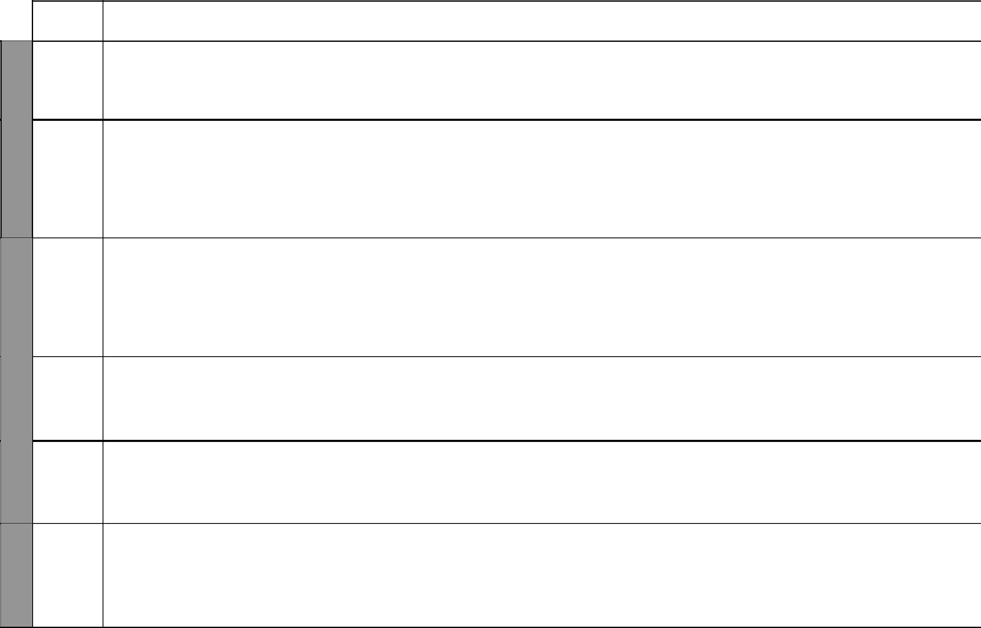

UNIT

7

WEEK | 10
WEEK | Time
WEEK | and
 | speed

WEEK 8

11
Lines

WEEK 9

TOPIC | LESSONS | OBJECTIVES | TEACHING/LEARNING | LEARNING/TEACHING | REFERENCES | REMARKS
 |  |  | ACTIVITIES | RESOURCES
Area of | 4 | By the end of this topic, the | • Finding the area of rectangles, | Rectangular, square and | Pupil’s Book
combined |  | bb | squares and triangles | triangular cut-outs | pages 75-79
combined |  | pupils should be able to find the | squares and triangles | triangular cut-outs | pages 75-79
shapes and |  | area of combined shapes and | • Drawing combined shapes of |  | Teacher’s Book
borders |  | borders | rectangles and triangles |  | pages 59-60
Time in the | 5 | By the end of this topic, the | • Drawing clock faces and | Charts showing time in the | Pupil’s Book
24-hour clock |  | pupils should be able to work | reading time in the 12-hour | 24-hour clock system, clock | pages 82-85
 |  | out questions involving time in | and 24-hour clock systems | faces | Teacher’s Book
 |  | the 12-hour and 24-hour clock | • Converting 12-hour clock time |  | pages 62-64
 |  | systems | to 24-hour clock time and vice
 |  |  | versa
Travel | 2 | By the end of this topic, the | • Drawing clock faces and | Stickers showing speed | Pupil’s Book
timetables |  | pupils should be able to read | reading time using the 12-hour | limit, stopwatches | pages 86-87
 |  | and interpret air, bus and train | and 24-hour clock systems |  | Teacher’s Book
 |  | timetables | • Converting 12-hour clock time |  | page 64
 |  |  | to 24-hour clock time and vice
 |  |  | versa
Speed | 2 | By the end of this topic, the | • Running short distances | A pair of compasses, a ruler | Pupil’s Book
 |  | pupils should be able to work | • Timing events |  | pages 87-89
 |  | out problems involving speed in | • Calculating speed |  | Teacher’s Book
 |  | km/h and m/s |  |  | pages 64-65
Bisecting a | 3 | By the end of this topic, the | • Drawing and bisecting straight | A pair of compases, a ruler | Pupil’s Book
line segment |  | pupils should be able to bisect | lines |  | pages 90-92
 |  | a line segment using a pair of | • Marking line bisectors |  | Teacher’s Book
 |  | compasses and ruler |  |  | pages 68-69
Constructing | 3 | By the end of this topic, | • Drawing and bisecting straight | A pair of compasses, a ruler | Pupil’s Book
perpendicular |  | the pupils should be able to | lines |  | pages 92-93
lines |  | construct perpendicular lines | • Constructing perpendicular |  | Teacher’s Book
 |  | using a pair of compasses and a | bisectors |  | page 69
 |  | ruler
 |  |  | 7 | For use with Progressive Primary Mathematics Standard Six

WEEK 9

WEEK 10

WEEK 11
Progressive Primary Mathematics Standard Six

Schemes of Work

Term 2
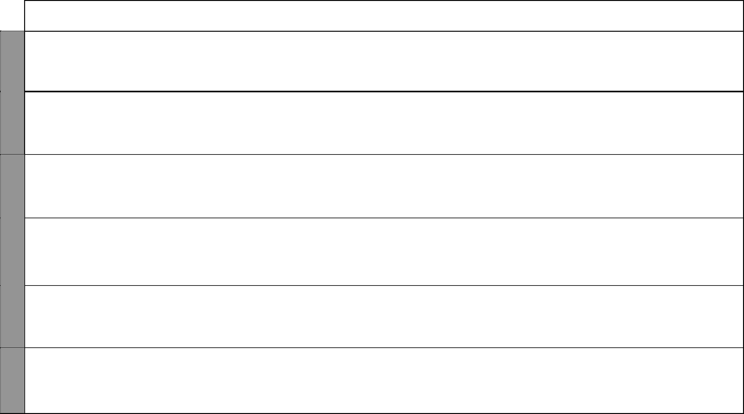
UNIT | TOPIC | LESSONS | OBJECTIVES | TEACHING/LEARNING | LEARNING/TEACHING | REFERENCES | REMARKS
 |  |  |  | ACTIVITIES | RESOURCES
 | Constructing | 3 | By the end of this topic, | • Drawing lines | A pair of compasses, a ruler | Pupils’ Book
 | parallel lines |  | the pupils should be able to | • Drawing parallel lines |  | pages 94-95
 |  |  | construct parallel lines using a |  |  | Teacher’s Book
 |  |  | pair of compasses and a ruler |  |  | pages 69-70
12 | Suplementary | 2 | By the end of this topic, the | • Measuring angles | A protractor, a ruler | Pupil’s Book
Angles | angles |  | pupils should be able to identify | • Drawing lines and angles |  | pages 96-98
 |  |  | angles on a straight line | • Rotating sticks to make angles |  | Teacher’s Book
 |  |  |  | • Calculating missing angles |  | pages 71-72
 | Vertically | 2 | By the end of this topic, the | • Measuring angles | A protractor, a ruler | Pupil’s Book
 | opposite |  | pupils should be able to identify | • Drawing lines and angles |  | pages 98-100
 | angles |  | vertically opposite angles | • Rotating sticks to make angles |  | Teacher’s Book
 |  |  |  | • Calculating missing angles |  | page 72
 |  | 2 | By the end of this topic, the | • Measuring angles | A protractor, a ruler | Pupil’s Book
 | Angles at a |  | pupils should be able to identify | • Drawing lines and angles |  | pages 100-101
 | point |  | angles at a point and state that | • Rotating sticks to make angles |  | Teacher’s Book
 |  |  | their sum is 360º | • Calculating missing angles |  | pages 72-73
 | Bisecting | 2 | By the end of this topic, the pupils | • Measuring angles | A pair of compasses, a ruler | Pupil’s Book
 | angles |  | should be able to bisect angles | • Drawing lines and angles |  | pages 101-102
 |  |  | using a pair of compasses and a | • Rotating sticks to make angles |  | Teacher’s Book
 |  |  | ruler only | • Calculating mising angles |  | page 73
 | Constructing | 5 | By the end of this topic, the pupils | • Measuring angles | A pair of compasses, a ruler | Pupil’s Book
 | angles |  | should be able to construct angles | • Drawing lines and angles |  | pages 102-103
 |  |  | using a pair of compasses and a | • Rotating sticks to make angles |  | Teacher’s Book
 |  |  | ruler only | • Calculating missing angles |  | pages 73-74

8 For use with Progressive Primary Mathematics Standard Six

WEEK 1

WEEK 2

WEEK 3

WEEK 4
Progressive Primary Mathematics Book 6: Sample Schemes of Work: Term Three
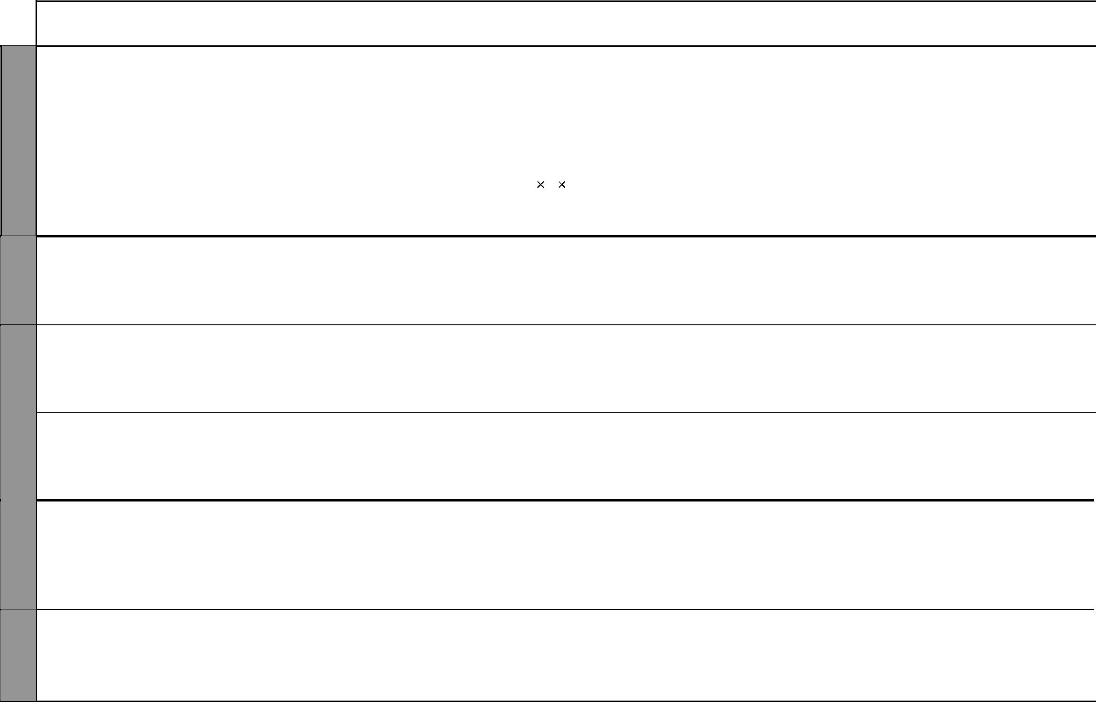
UNIT |  | TOPIC | LESSONS | OBJECTIVES | TEACHING/LEARNING | LEARNING/TEACHING | REFERENCES | REMARKS
 |  |  |  |  | ACTIVITIES | RESOURCES
13 |  | Volume | 4 | By the end of this topic, the | • Measuring angles | 1-cm cubes | Pupil’s Book
Volume |  |  |  | bb | • Drawing lines and angles |  | pages 104-107
 |  |  |  | pupils should be able to find the | • Drawing lines and angles |  | pages 104-107
and |  |  |  | volume of cubes and cuboids in | • Rotating sticks to make angles |  | Teacher’s Book
capacity |  |  |  | _{m}3 | • Calculating missing angles |  | pages 76-77
 |  | Capacity | 6 | By the end of this topic, | • Calculating the volume of | 1-litre and1-decilitre | Pupil’s Book
 |  |  |  | the pupils should be able to | cubes and cuboids using | containers | pages 107-111
 |  |  |  | identify the decilitre as a unit of | v = l b h |  | Teacher’s Book
 |  |  |  | measuring capacity and carry out |  |  | pages 77-78
 |  |  |  | operations on units of capacity
14 |  | Drawing | 4 | By the end of this topic, the | • Drawing triangles | A pair of compasses, a | Pupil’s Book
Triangles |  | triangles |  | pupils should be able to draw | • Measuring angles | ruler, a protractor | pages 112-114
 |  |  |  | triangles using a ruler and a |  |  | Teacher’s Book
 |  |  |  | protractor |  |  | pages 81-82
 |  | Angles of a | 3 | By the end of this topic, the pupils | • Drawing triangles | A protractor, a ruler, | Pupil’s Book
 |  | triangle |  | should be able to identify and work | • Calculating the angles and sides | triangular cut-outs, a pair of | pages 114-117
 |  |  |  | out questions involving the exterior | of a triangle | scissors | Teacher’s Book
 |  |  |  | and interior angles of a triangle |  |  | page 82
 |  | Patterns | 2 | By the end of this topic, the | • Drawing triangles, rectangles | Cut-outs of rectangles, | Pupil’s Book
 |  |  |  | pupils should be able to make | and squares | squares and triangles | pages 118-119
 |  |  |  | patterns involving squares, | • Making patterns |  | Teacher’s Book
 |  |  |  | rectangles and triangles |  |  | page 83
15 |  | Converting | 2 | By the end of this topic, the | • Estimating mass | Conversion table for the | Pupil’s Book
Mass |  | units of |  | pupils should be able to identify | • Converting units of mass | units of mass | pages 120-121
 |  | mass |  | and use the tonne as a unit of | • Addition, subtraction, |  | Teacher’s Book
 |  |  |  | mass and convert units of mass | multiplication and division |  | pages 85-86
 |  |  |  |  | involving units of mass
 |  | Operations | 5 | By the end of this topic, the pupils | • Adding, subtracting, | Conversion table for the | Pupil’s Book
 |  | on units of |  | should be able to carry out addition, | multiplying and dividing | units of mass | pages 122-123
 |  | mass |  | subtraction, multiplication and | • Converting units of mass |  | Teacher’s Book
 |  |  |  | division involving the units of mass |  |  | page 86

9 For use with Progressive Primary Mathematics Standard Six

WEEK 4

WEEK 5 & 6

WEEK 7
Progressive Primary Mathematics Standard Six

Schemes of Work

Term 3
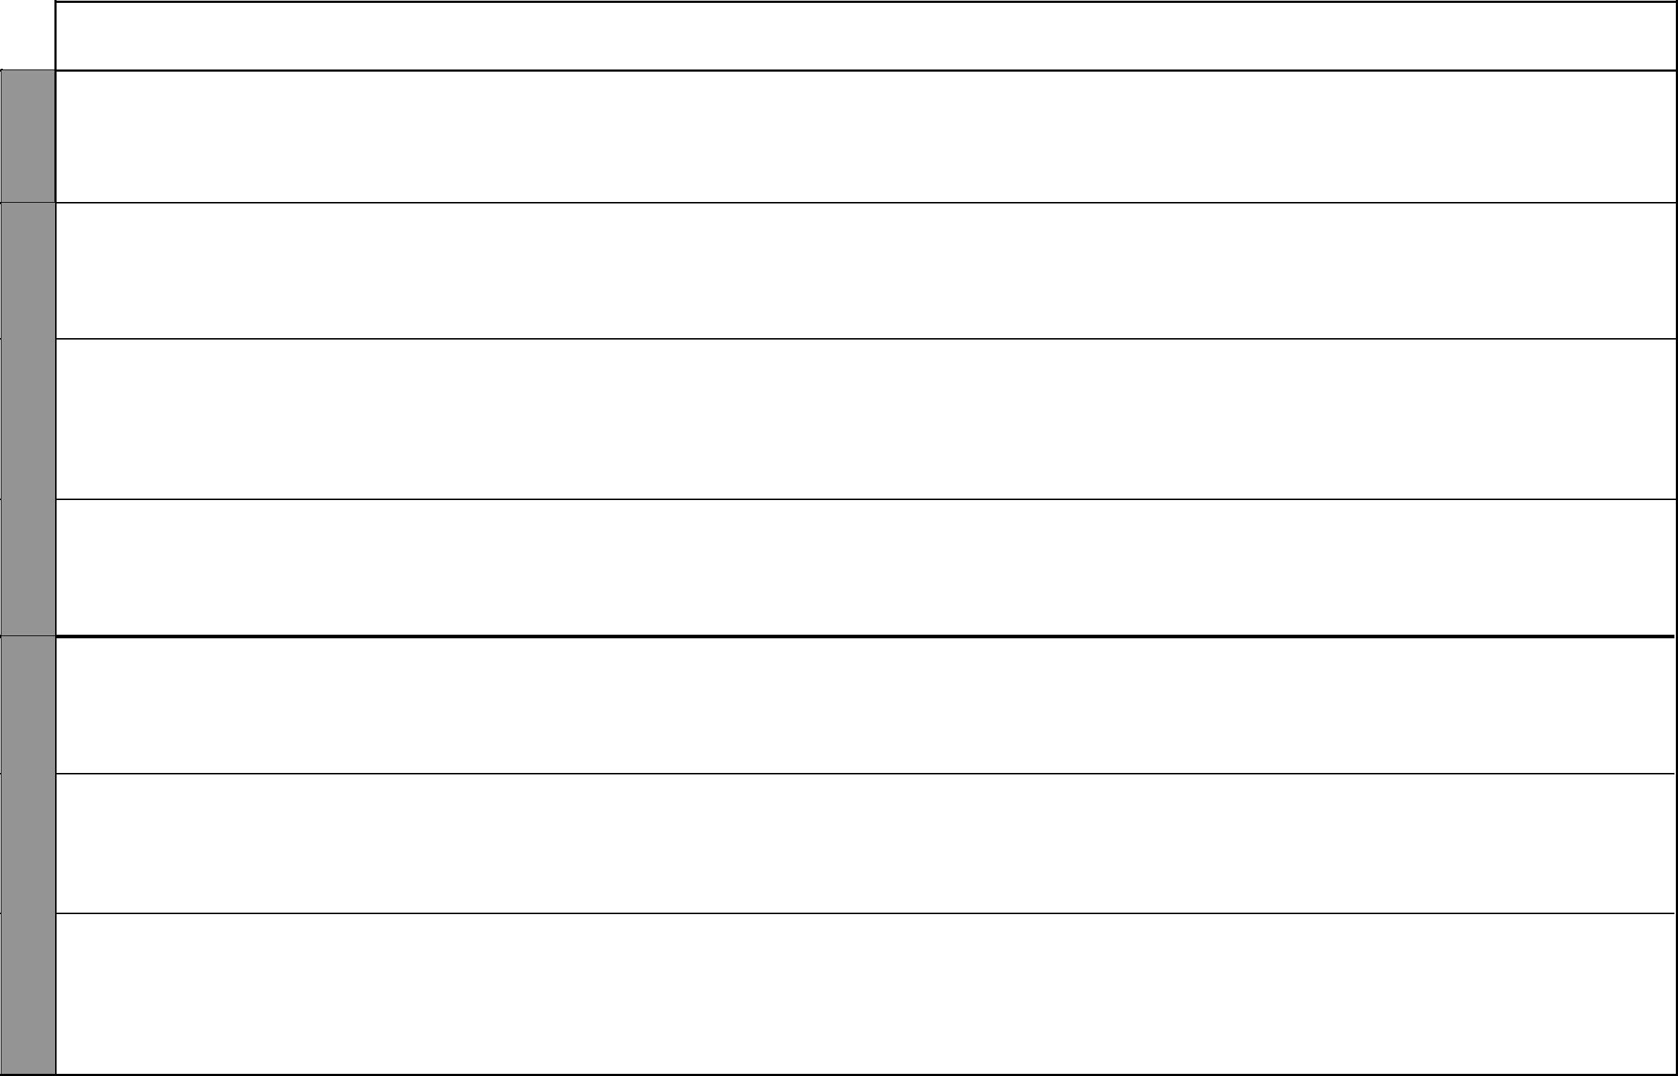
UNIT | TOPIC | LESSONS | OBJECTIVES | TEACHING/LEARNING | LEARNING/TEACHING | REFERENCES | REMARKS
 |  |  |  | ACTIVITIES | RESOURCES
16 | Bills | 3 | By the end of this topic, the | • Preparing a shopping list | Classroom duka and its | Pupil’s Book
16 |  |  | bb | • Buying and selling in the | stock | pages 124-125
Money |  |  | pupils should be able to work | • Buying and selling in the | stock | pages 124-125
and |  |  | out questions involving bills | classroom duka |  | Teacher’s Book
and |  |  |  | • Preparing bills |  | pages 88-89
notes |  |  |  | • Preparing bills |  | pages 88-89
 | Profit and | 3 | By the end of this topic, | • Buying and selling in the | Classroom duka and its | Pupil’s Book
 | loss |  | the pupils should be able to | classroom duka | stock | pages 126-128
 |  |  | work out problems involving | • Working out profit and loss |  | Teacher’s Book
 |  |  | percentage profit and loss |  |  | page 89
 | Postal rates | 6 | By the end of this topic, | • Discussing the charges for | Postal charges for letters, | Pupil’s Book
 |  |  | the pupils should be able to | sending airmail, telegrams, | telegrams, postal orders, | pages 128-135
 |  |  | calculate postal charges for | money orders and postal | money orders | Teacher’s Book
 |  |  | letters, telegrams, money orders | orders |  | pages 89-90
 |  |  | and postal orders
 | Revision |  |  | • Answering questions in mixed |  | Pupil’s Book
 |  |  |  | exercise 3 |  | pages 134-135
 |  |  |  | • Remedial work |  | Teacher’s Book
 |  |  |  |  |  | page 94
17 | Simplifying | 2 | By the end of this topic, the | • Forming algebraic expressions | Assorted items like pens, | Pupil’s Book
Algebra | algebraic |  | pupils should be able to simplify | • Simplifying algebraic | pencils, books | pages 136-137
 | expressions |  | algebraic expressions by | expressions |  | Teacher’s Book
 |  |  | collecting like terms together |  |  | page 95
 | Equations | 2 | By the end of this topic, the | • Comparing and balancing | Beam balance, weights, | Pupil’s Book
 |  |  | pupils should be able to solve | weights of objects using a beam | counters | pages 137-138
 |  |  | simple equations with one | balance |  | Teacher’s Book
 |  |  | unknown |  |  | page 96
 | Inequalities | 3 | By the end of this topic, the | • Comparing masses of objects | Beam balance, weights, | Pupil’s Book
 |  |  | pupils should be able to identify | using a beam balance | counters | pages 138-139
 |  |  | and use greater than (>) and less |  |  | Teacher’s Book
 |  |  | than s(<) correctly in algebraic |  |  | pages 96-97
 |  |  | expressions

10 For use with Progressive Primary Mathematics Standard Six

Progressive Primary Mathematics Standard Six

Schemes of Work

Term 3

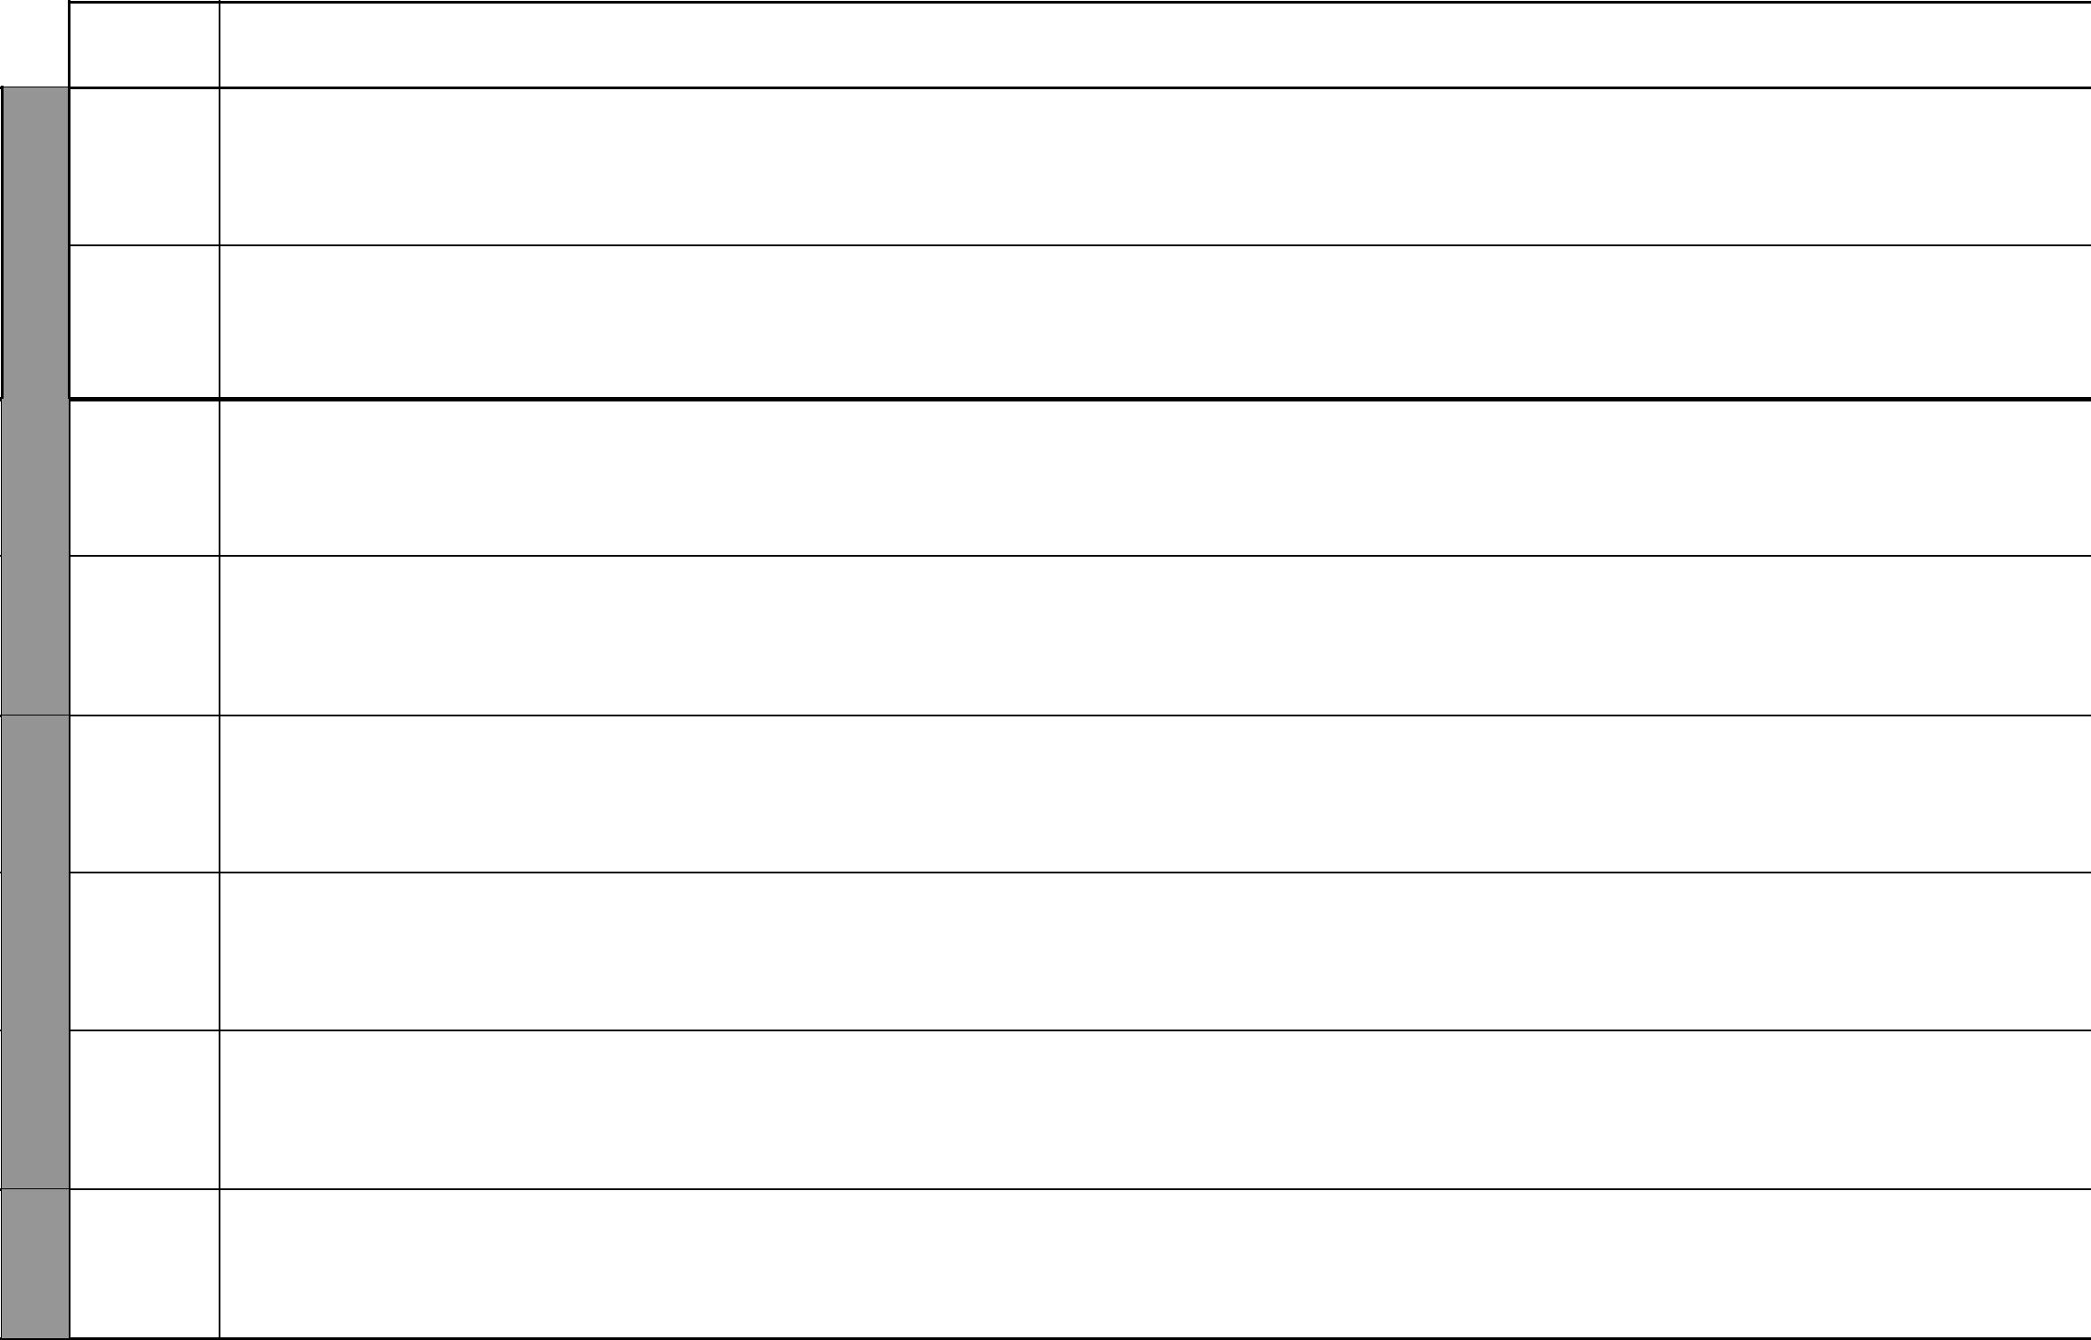
UNIT

 | 18
8 | Scale
8 | drawing
WEEK | drawing
 | 19
9 | Tables
9 | and
WEEK | and
WEEK | graphs

WEEK 10

11-12 WEEK

TOPIC | LESSONS | OBJECTIVES | TEACHING/LEARNING | LEARNING/TEACHING | REFERENCES | REMARKS
 |  |  | ACTIVITIES | RESOURCES
Reading and | 3 | By the end of this topic, the | • Reading, writing and | Maps, plans, rulers, atlases | Pupil’s Book
writing scale |  | pupils should be able to interpret | interpreting scale |  | pages 140-141
 |  | scale drawings, read and write |  |  | Teacher’s Book
 |  | scale in statement form |  |  | pages 99-100
Drawing to | 3 | By the end of this topic, the | • Reading, writing and | Maps, plans, rulers, atlases | Pupil’s Book
scale |  | pupils should be able to make | interpreting scale |  | pages 142-143
 |  | scale drawings | • Drawing to scale |  | Teacher’s Book
 |  |  |  |  | pages 100-101
Bar and | 4 | By the end of this topic, the | • Interpreting data | Graph paper, rulers | Pupil’s Book
picture |  | pupils should be able to interpret | • Drawing bar and picture graphs |  | pages 144-147
graphs |  | and respesent data in bar and | • Determining horizontal and |  | Teacher’s Book
 |  | picture graphs | vertical scales |  | pages 103-104
Line graphs | 3 | By the end of this topic, the pupils | • Interpreting data | Graph paper, rulers | Pupil’s Book
 |  | should be able to interpret and | • Drawing line graphs |  | pages 148-149
 |  | repesent data in line graphs | • Determining horizontal and |  | Teacher’s Book
 |  |  | vertical scales |  | pages 104-105
Pie charts | 4 | By the end of this topic, the | • Interpreting data | Protractor, pair of | Pupil’s Book
 |  | pupils should be able to interpret | • Drawing pie charts | compasses | pages 150-152
 |  | and represent data in pie charts | • Determining the angles |  | Teacher’s Book
 |  |  | representing each sector |  | page 105
Travel | 4 | By the end of this topic, the pupils | • Interpreting data | Graph paper, rulers | Pupil’s Book
graphs |  | should be able to interpret and | • Drawing travel graphs |  | pages 152-153
 |  | represent data in travel graphs | • Determining horizontal and |  | Teachers book
 |  |  | vertical scales |  | pages 105-106
The mean | 3 | By the end of this topic, the pupils | • Interpreting data | Groups of data | Pupil’s Book
 |  | should be able to work out the | • Calculating the arithmetic |  | pages 154-155
 |  | arithmetic mean of given data | mean of given data |  | Teacher’s Book
 |  |  |  |  | page 106
Revision |  | By the end of this topic, the pupils | • Asking questions in the test |  | Pupil’s Book
 |  | should be able to answer the | papers 1 to 5 |  | pages 156-162
 |  | questions in the test papers and |  |  | Teacher’s Book
 |  | end of year examination |  |  | pages 114-118
 |  |  | 11 | For use with Progressive Primary Mathematics Standard Six

