MATHS SCHEME OF WORK CLASS 3
Compiled By
Schools Net Kenya Consultancy
P.O. Box 8076 – 00200 Nairobi, Kenya | Tel: +254202319748
E-mail: infosnkenya@gmail.com | www.schoolsnetkenya.com

WEEK 7 WEEK 6 WEEK 5 WEEK 4 WEEK 3 WEEK 1&2
Progressive Primary Mathematics Book 3: Sample Schemes of Work: Term One
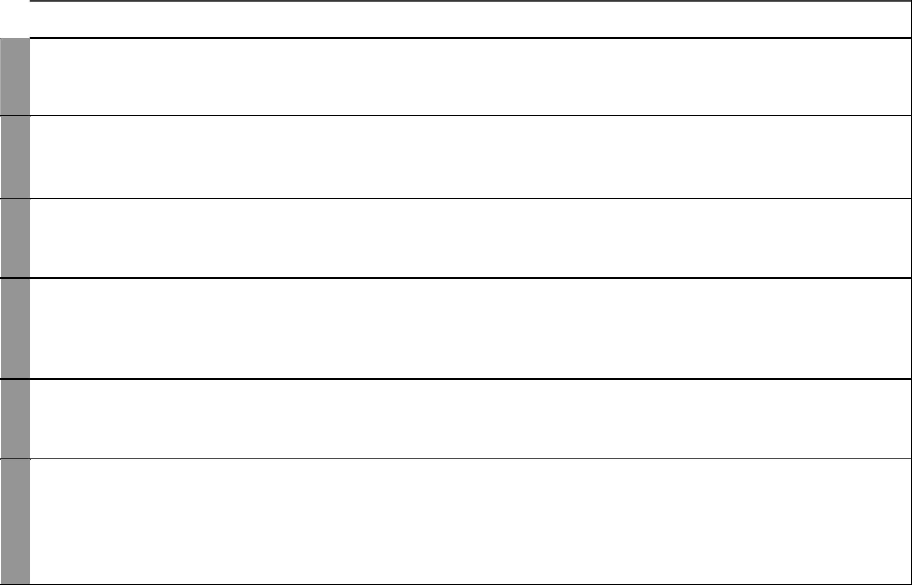
UNIT | TOPIC | LESSONS | OBJECTIVES | TEACHING/LEARNING |  | LEARNING/TEACHING | REFERENCES | REMARKS
 |  |  |  |  | ACTIVITIES | RESOURCES
1 | Place value | 8 | By the end of this topic, the | • | Making place value tables | Place value tables, the place | Pupil’s Book
1 |  |  | pupils should be able to state | • | Making bundles of tens, | value boxes, sticks, counters | pages 2-6
Whole
numbers |  |  | and write the place value of |  | hundreds and thousands |  | Teacher’s Book
 |  |  | numbers up to thousands. | • | Using the place value boxes |  | pages 1-2
 | Writing | 3 | By the end of this topic, the | • | Making place value tables | Place value tables | Pupil’s Book
 | numbers in |  | pupils should be able to write | • | Making bundles of tens, |  | pages 7-8
 | words and |  | numbers in words in figures and |  | hundreds and thousands |  | Teacher’s Book
 | figures |  | words given in figures. | • | Using place value boxes |  | page 2
 | Arranging | 4 | By the ends of this topic, the | • | Counting items | Cards with the words | Pupil’s Book
 | things in |  | pupils should be able to rank | • | Positioning objects | first, second, up to tenth | pages 9-13
 | order |  | objects into positions using first, | • | Discussions | written on them | Teacher’s Book
 |  |  | second, third, up to tenth. |  |  |  | page 3
2 | Measuring | 3 | By the end of this topic, | • | Estimating mass | Beam balance, soil, paper | Pupil’s Book
Mass | mass in |  | the pupils should be able to | • | Making improvised weights | bags, 1 kilogram standard | pages 14-17
 | kilograms |  | recognize, identify and use the | • | Balancing masses | mass | Teacher’s Book
 |  |  | kilogram as a unit of measuring | • | Weighing objects |  | pages 8-9
 |  |  | mass.
3 | Addition of | 5 | By the end of this topic, the | • | Counting up to thousands | Place value tables addition | Pupil’s Book pages
Addition | up to three, |  | pupils should be able to add | • | Making place value tables | tables | 18-22
of whole | 3-digit |  | upto three, 3-digit numbers | • | Adding numbers |  | Teacher’s Book
numbers | numbers |  | with and without carrying. | • | Discussions |  | pages 10-11
 | Addition | 2 | By the end of this unit, the | • | Counting up to thousands | Addition tables place value | Pupil’s Book
 | of up to |  | pupils should be able to add | • | Making place value tables | charts | pages 22-23
 | two, 4-digit |  | upto to two 4-digit numbers | • | Adding numbers |  | Teacher’s Book
 | numbers |  | with and without carrying work | • | Discussions |  | pages 11-12
 |  |  | sums not exceeding 9999.

1 For use with Progressive Primary Mathematics Standard Three

WEEK 11&12 WEEK 10 WEEK 8&9
Progressive Primary Mathematics Standard Three

Schemes of Work

Term 1
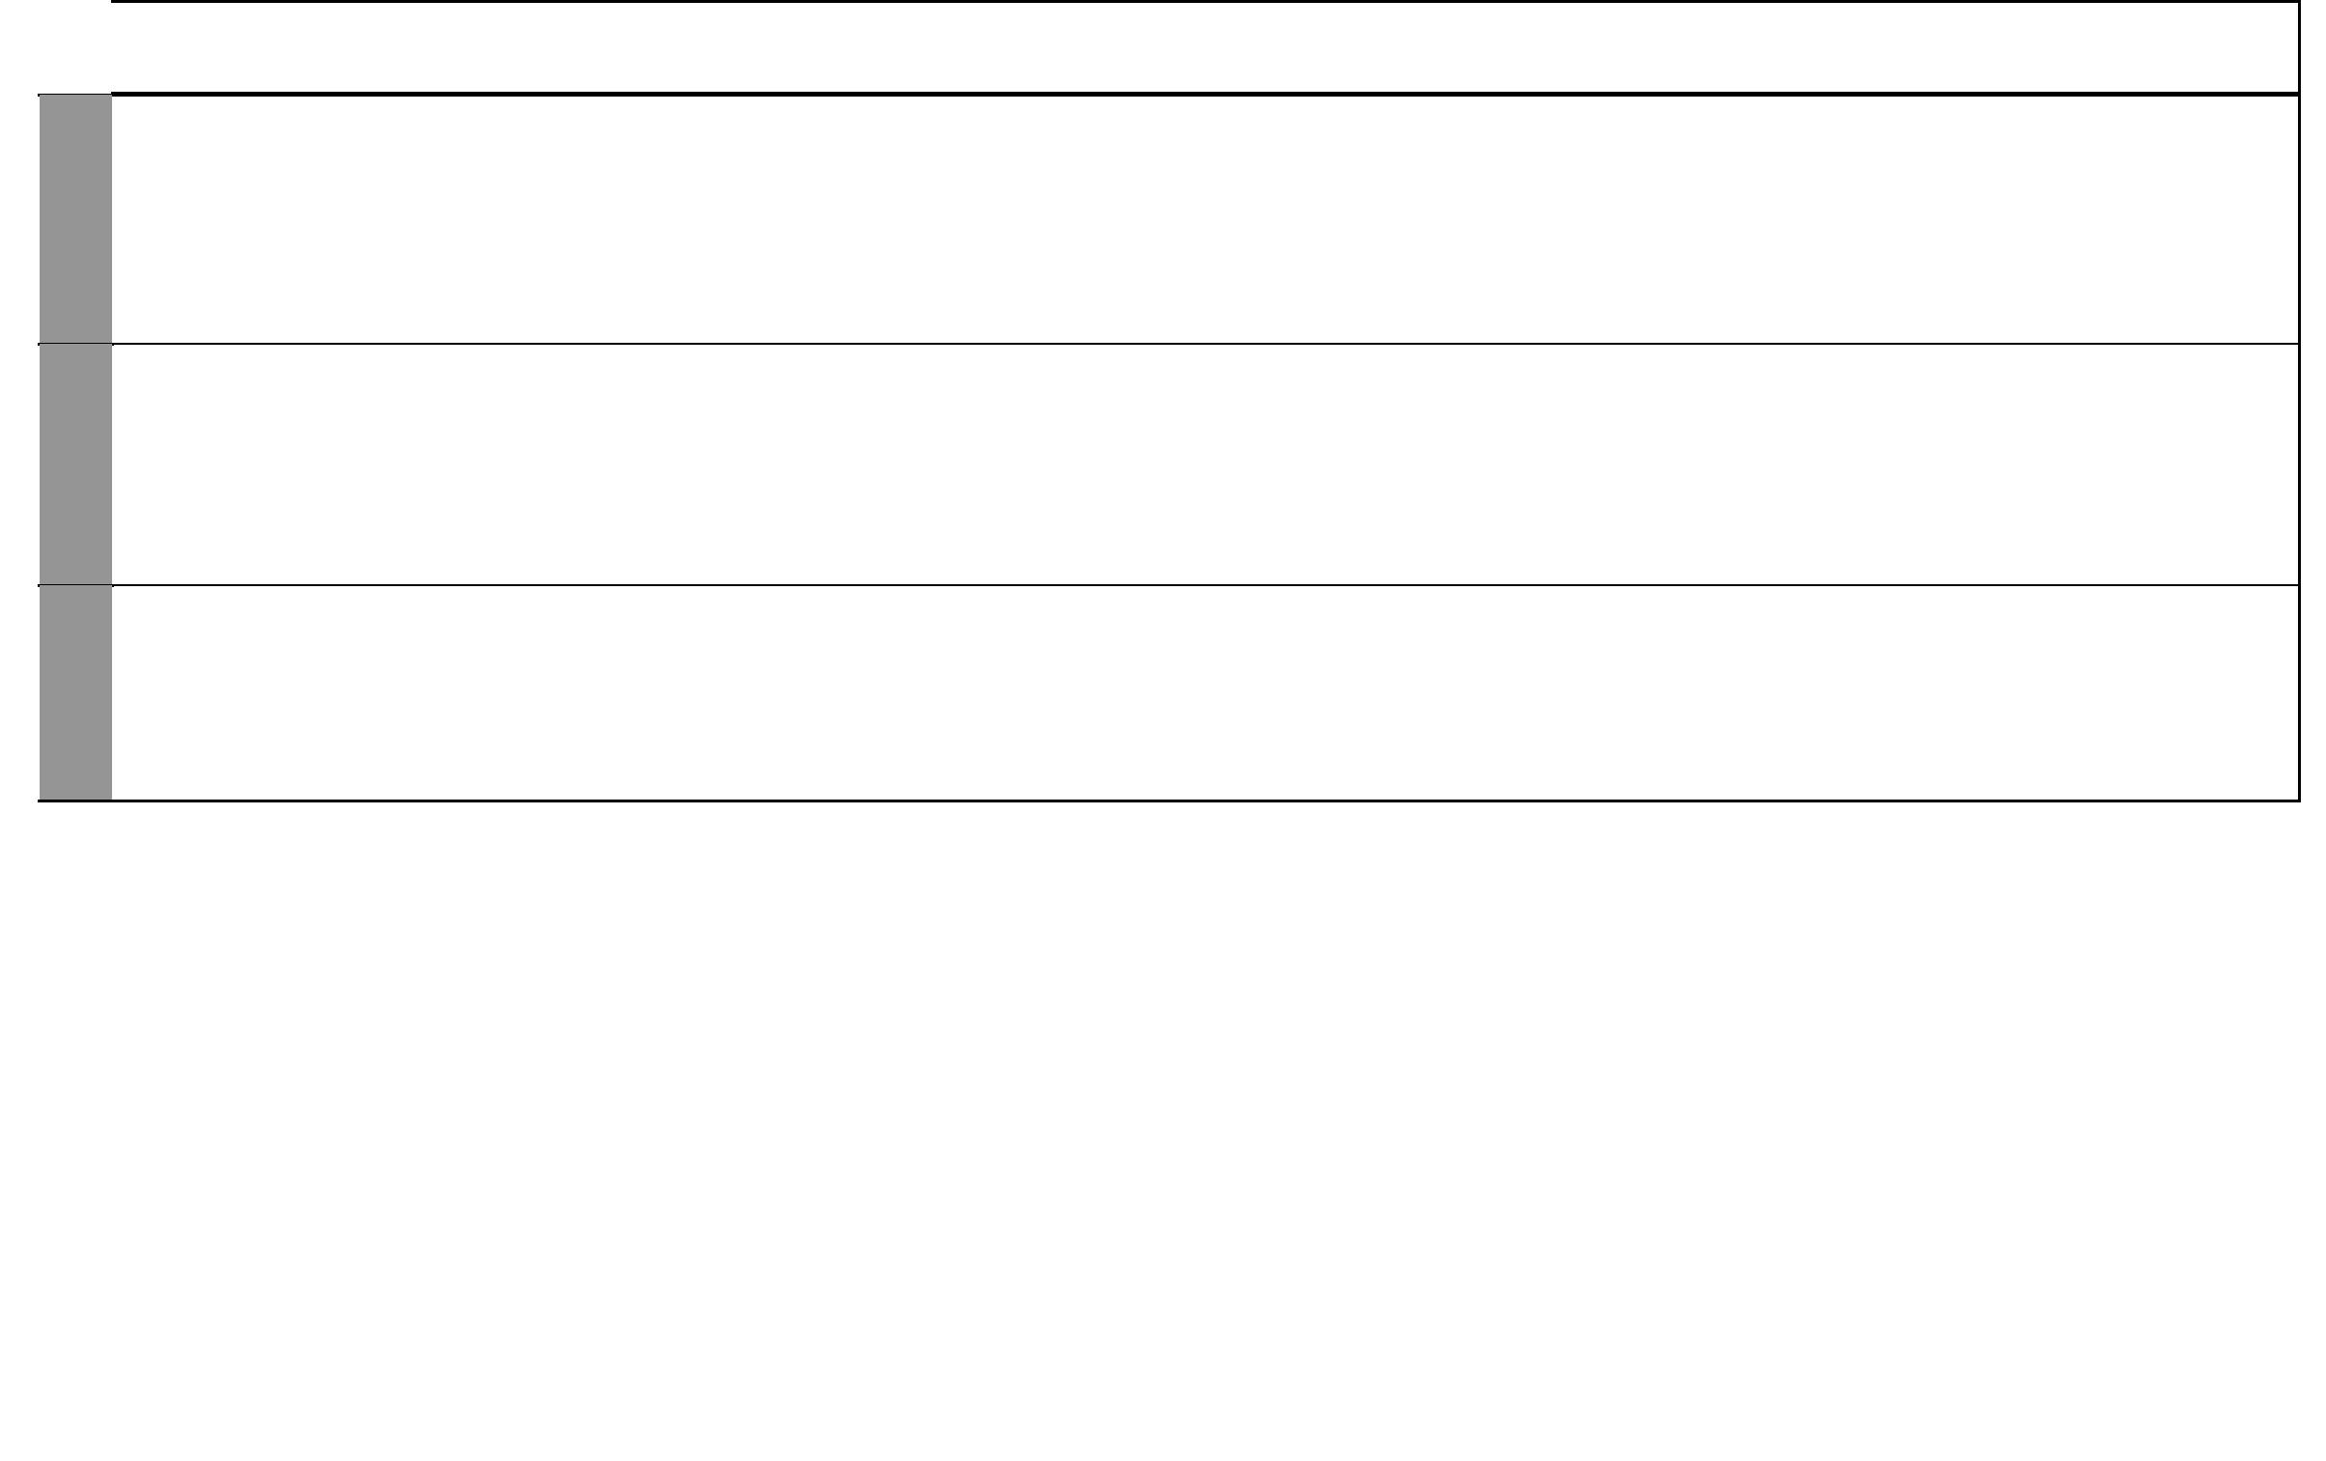
UNIT | TOPIC | LESSONS | OBJECTIVES | TEACHING/LEARNING |  | LEARNING/TEACHING | REFERENCES | REMARKS
 |  |  |  |  | ACTIVITIES | RESOURCES
4 | Subtracting | 6 | By the end of this topic, the | • | Counting up to thousands | Place value charts, place | Pupil’s Book 24-28
Subtrac- | numbers |  | pupils should be able to subtract | • | Making place value tables | value tables, bundles of tens | Teacher’s Book
tion |  |  | upto 4-digit numbers from | • | Subtracting numbers | and loose ones | pages 14-15
of whole |  |  | upto 4-digit numbers with and | • | Discussions
numbers |  |  | without borrowing.
 | Number | 2 | By the end of this topic, the | • | Making number patterns | Addition tables | Pupil’s Book
 | patterns |  | pupils should be able to identify |  | using addition |  | page 29
 |  |  | number patterns involving | • | Making number patterns |  | Teacher’s Book
 |  |  | addition and subtraction. |  | using subtraction |  | pages 15-16
 |  |  |  | • | Discussions
 | Revision |  | By the end of this weeks, the | • | Answering questions in mixed |  | Pupil’s Book
 |  |  | pupils should be able to answer |  | Exercises 1 |  | pages 2-31
 |  |  | any questions in units 1 to 5. | • | Doing end of term tests |  | Teacher’s Book
 |  |  |  | • | Remedial work |  | pages 1-17

2 For use with Progressive Primary Mathematics Standard Three

WEEK 4 WEEK 1 - 3
WEEK 5

WEEK 6
Progressive Primary Mathematics Book 3: Sample Schemes of Work: Term Two
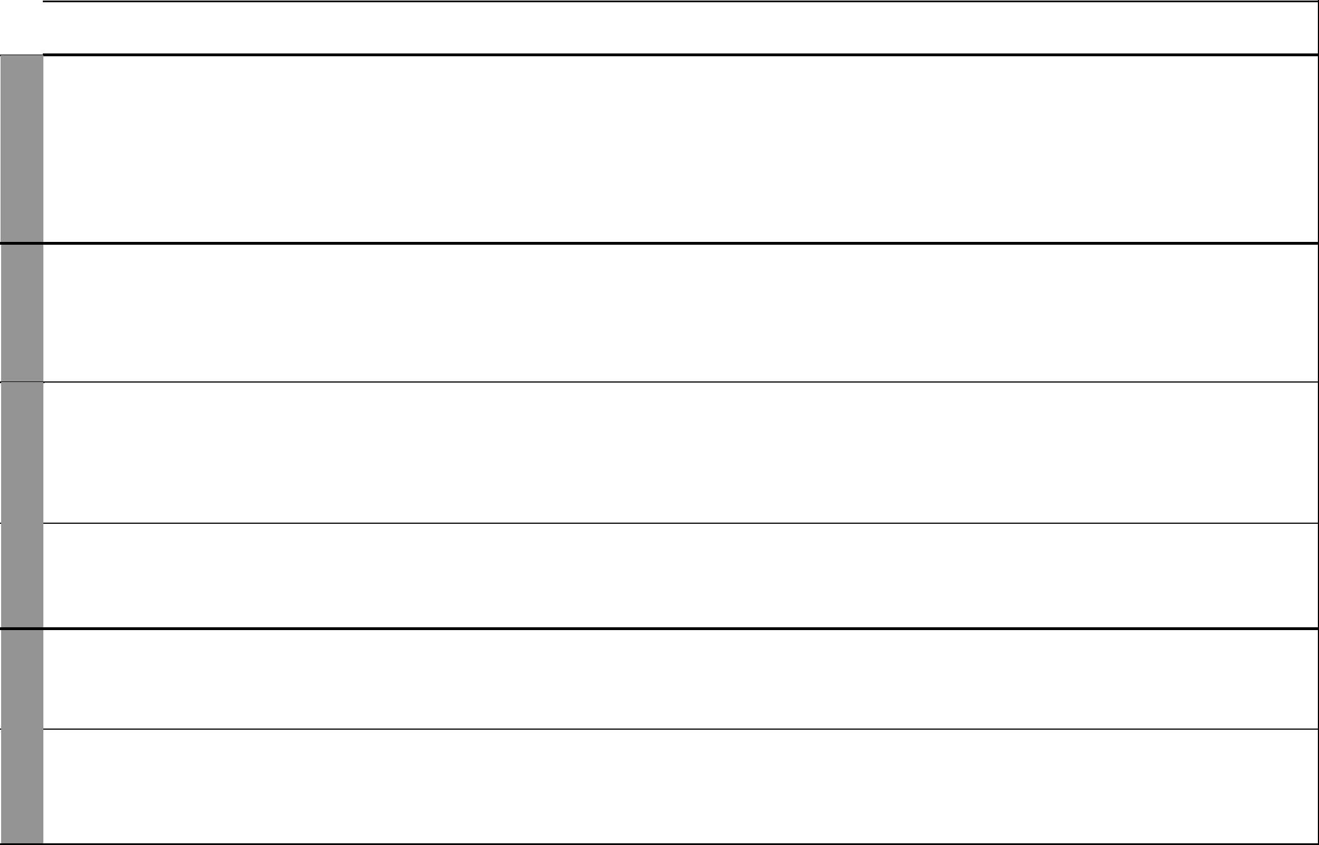
UNIT | TOPIC | LESSONS | OBJECTIVES | TEACHING/LEARNING |  | LEARNING/TEACHING | REFERENCES | REMARKS
 |  |  |  |  | ACTIVITIES | RESOURCES
5 | Multiplying | 12 | By the end of this topic, the | • | Arranging objects in rows | Counters such as stones, | Pupil’s Book
Multi- | numbers |  | pupils should be able to multiply |  | and columns from given | bottle tops, pencils, beans, | Page 29
plication |  |  | two single digit numbers |  | multiplication statements | buttons, multiplication | Teacher’s Book
 |  |  | horizontally and vertically. | • | Writing multiplication | tables | pages 18-19
 |  |  |  |  | statements using numbers
 |  |  |  |  | from given rows and columns
 |  |  |  | • | Playing games
 |  |  |  | • | Discussions
6 | Dividing | 4 | By the end of this topic, the | • | Making groups of equal | Sticks, stones, seeds | Pupil’s Book
Division | as repeated |  | pupils should be able to divide | • | numbers from set of items | and other counters, | pages 38-41
 | addition |  | 2-digit numbers by single digit | • | Subtracting a number | multiplication tables | Teacher’s Book
 |  |  | numbers through repeated |  | repeatedly from another |  | pages 24-25
 |  |  | subtraction | • | Dividing numbers
 |  |  |  | • | Discussions
 | Dividing | 3 | By the end of this topic, the | • | Making groups of equal | Counters like stones, bottle | Pupil’s Book
 | numbers |  | pupils should be able to divide |  | numbers from set of items | tops, pencils, beans, buttons | pages 42-43
 |  |  | 2-digit numbers by single | • | Dividing and multiplying | and multiplication tables | Teacher’s Book
 |  |  | digit numbers using basic |  | numbers |  | page 25
 |  |  | multiplication facts. | • | Subtracting repeatedly a
 |  |  |  |  | number from another one
 | Multiplication | 2 | By the end of this topic, the | • | Multiplying numbers | Multiplication tables | Pupil’s Book
 | and division |  | pupils should be able to | • | Dividing numbers |  | page 43
 | and number |  | recognize and identify number | • | Adding numbers |  | Teacher’s Book
 | patterns |  | patterns involving multiplication. | • | Subtracting numbers |  | page 26
7 | Measuring | 2 | By the end of this topic, the | • | Estimatimg length | Metre sticks, strings, metre | Pupil’s Book
Length | length in |  | pupils should be able to measure | • | Measuring length | rule, tape measure | pages 44-45
 | metres |  | length in metres. | • | Comparing lengths |  | Teacher’s Book
 |  |  |  |  |  |  | page 28
 | Adding and | 3 | By the end of this topic, | • | Measuring length | Metre sticks, strings, metre | Pupil’s Book
 | subtracting |  | pupils should be able to work | • | Addition and subtraction | rule, tape measure | pages 46-48
 | metres |  | out addition and subtraction |  | involving metres |  | Teacher’s Book
 |  |  | involving length in metres. | • | Discussions |  | page 29

3 For use with Progressive Primary Mathematics Standard Three

WEEK 11 WEEK 9 & 10 WEEK 7 & 8 WEEK 6
Progressive Primary Mathematics Standard Three

Schemes of Work

Term 2
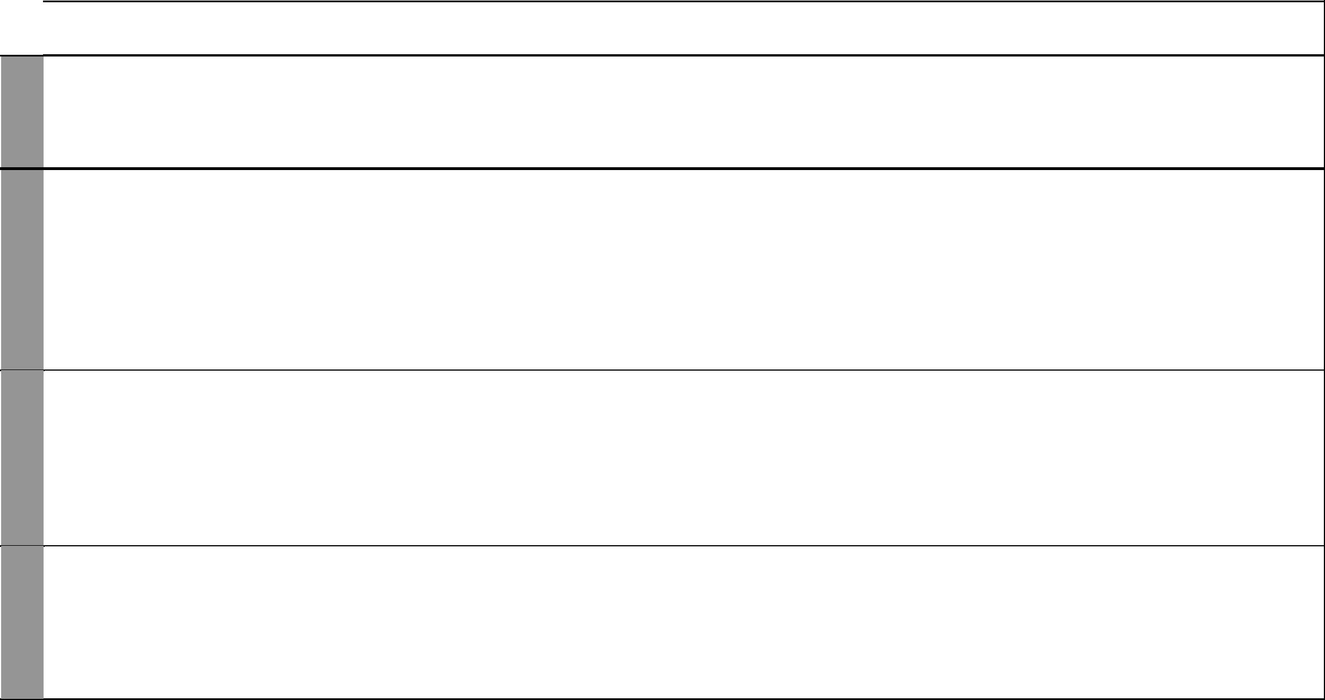
UNIT | TOPIC | LESSONS | OBJECTIVES | TEACHING/LEARNING |  | LEARNING/TEACHING | REFERENCES | REMARKS
 |  |  |  |  | ACTIVITIES | RESOURCES
 | Multiplying | 2 | By the end of this topic, the | • | Measuring length | Multiplication tables, metre | Pupil’s Book
 | and dividing |  | pupils should be able to work | • | Multiplication and division | sticks, strings, metre rule, | pages 49-51
 | metres |  | out multiplication and division |  | involving metres | tape measure | Teacher’s Book
 |  |  | involving lenght in metres |  |  |  | page 30
8 | Fraction as | 10 | By the end of this topic, | • | Identifying and naming halves, | Cut-outs of rectangles, | Pupil’s Book
Fractions | a part of a |  | the pupils should be able to |  | quarters and eighths | squares, ovals and strips | pages 52-61
 | whole |  | recognize a half, a quarter and | • | Cutting objects into halves, | of papers; objects such | Teacher’s Book
 |  |  | an eighth as parts of a whole. |  | quarters and eighths | as oranges, apples, cakes, | pages 33-34
 |  |  |  | • | Folding papers to form halves, | sticks.
 |  |  |  |  | quarters and eighths
 |  |  |  | • | Reading and writing halves,
 |  |  |  |  | quarters and eighths
 | Fraction as | 6 | By the end of this topic, | • | Sharing equally a number of | Seeds, bottle tops, marbles, | Pupil’s Book
 | a part of a |  | the pupils should be able to |  | items into halves, quarters and | pebbles, stones, fruits | pages 62-65
 | group |  | recognize a half, a quarter and |  | eighths |  | Teacher’s Book
 |  |  | an eighth as parts of a group. | • | Grouping objects into halves, |  | pages 34-35
 |  |  |  |  | quarters and eighths
 |  |  |  | • | Reading and writing halves,
 |  |  |  |  | quarters and eighths
 | Revision |  | By the end of the week, the | • | Answering questions in mixed |  | Pupil’s Book
 |  |  | pupils should be able to answer |  | exercise 2 |  | pages 32-69
 |  |  | any question on units 1 to 8. | • | Doing end of term tests |  | Teacher’s Book
 |  |  |  | • | Remedial work |  | pages 18-41


4 For use with Progressive Primary Mathematics Standard Three

Progressive Primary Mathematics Book 3: Sample Schemes of Work: Term Three
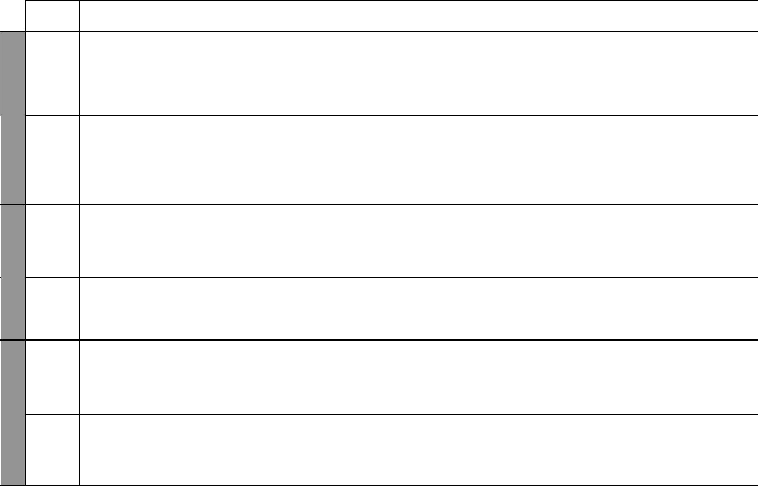

UNIT

1 | 8
WEEK | Fractions
WEEK 2
3&4 | 9
3&4 | Capacity
WEEK | Capacity
WEEK 5
 | 10
 | Money
WEEK 6

TOPIC | LESSONS | OBJECTIVES |  | TEACHING/LEARNING |  | LEARNING/TEACHING | REFERENCES | REMARKS
 |  |  |  |  | ACTIVITIES | RESOURCES
Addition of | 1 | By the end of this topic, |  | • | Identifying and naming halves, | Cut-outs of rectangles, | Pupil’s Book
fractions |  | the pupils should be able to |  |  | quarters and eighths | squares, triangles, ovals and | pages 65-66
 |  | add fractions with the same |  | • | Folding papers to form halves, | strips of paper; objects such | Teacher’s Book
 |  | denominator involving ¹ | , ¹ and |  | quarters and eighths | as oranges, apples, cakes, | page 35
 |  | 2 | 4
 |  | 1. |  | • | Subtracting halves, quarters | sticks, etc.
 |  | 8 |  |  | and eighths
Subtraction | 2 | By the end of this topic, |  | • | Identifying and naming halves, | Cut-outs of rectangles, | Pupil’s Book
of fractions |  | the pupils should be able to |  |  | quarters and eighths | squares, triangles, ovals | pages 66-67
 |  | subtract fractions with the same |  | • | Folding papers to form halves, | and strips of paper; objects | Teacher’s Book
 |  | denominator involving ¹ | , ¹ and |  | quarters and eighths | like oranges, apples, cakes, | page 36
 |  | 2 | 4
 |  | 1. |  | • | Subtracting halves, quarters | sticks, etc.
 |  | 8 |  |  | and eighths
Capacity in | 8 | By the end of this topic, the |  | • | Measuring capacity in litres | 1-litre and ¹-litre | Pupil’s Book
 |  |  |  |  |  | 2
litres and half |  | pupils should be able to measure |  |  | and half litres | containers, water and soil | pages 80-82
litres |  | capacity using litres and half |  | • | Filing and emptying containers |  | Teacher’s Book
 |  | litres. |  |  | with liquids |  | pages 42-43
 |  |  |  | • | Comparing capacity
Addition and | 3 | By the end of this topic, the |  | • | Addition and subtraction | 1-litre and ¹-litre | Pupil’s Book
 |  |  |  |  |  | 2
subtraction |  | pupils should be able to work |  |  | involving litres and half litres | containers, water and soil | pages 78-79
involving |  | out addition and subtraction |  |  |  |  | Teacher’s Book
litres |  | involving litres. |  |  |  |  | page 44
Shopping | 2 | By the end of this topic, |  | • | Buying and selling | Kenya currency, goods | Pupil’s Book
 |  | the pupils should be able to |  | • | Getting balance and change | found in shops | pages 80-82
 |  | recognize, identify and use the |  |  |  |  | Teacher’s Book
 |  | kenya currency including the |  |  |  |  | pages 46-47
 |  | one thousand shilling note.
Addition and | 4 | By the end of this topic, the |  | • | Converting shillings and cents | Place value columns | Pupil’s Book
subtraction |  | pupils should be able to work |  | • | Adding and subtracting | showing shillings and cents | pages 80-85
involving |  | out subtraction and addition |  |  | shillings and cents |  | Teacher’s Book
money |  | involving money without |  | • | Reading the value of money on |  | pages 47-48
 |  | conversion of cents and shillings. |  |  | coins and notes
 |  |  |  |  | 5
 |  |  |  |  | 5 | For use with Progressive Primary Mathematics Standard Three

WEEK 8 WEEK 7

WEEK 9

WEEK 11&12 WEEK 10
Progressive Primary Mathematics Standard Three

Schemes of Work

Term 3
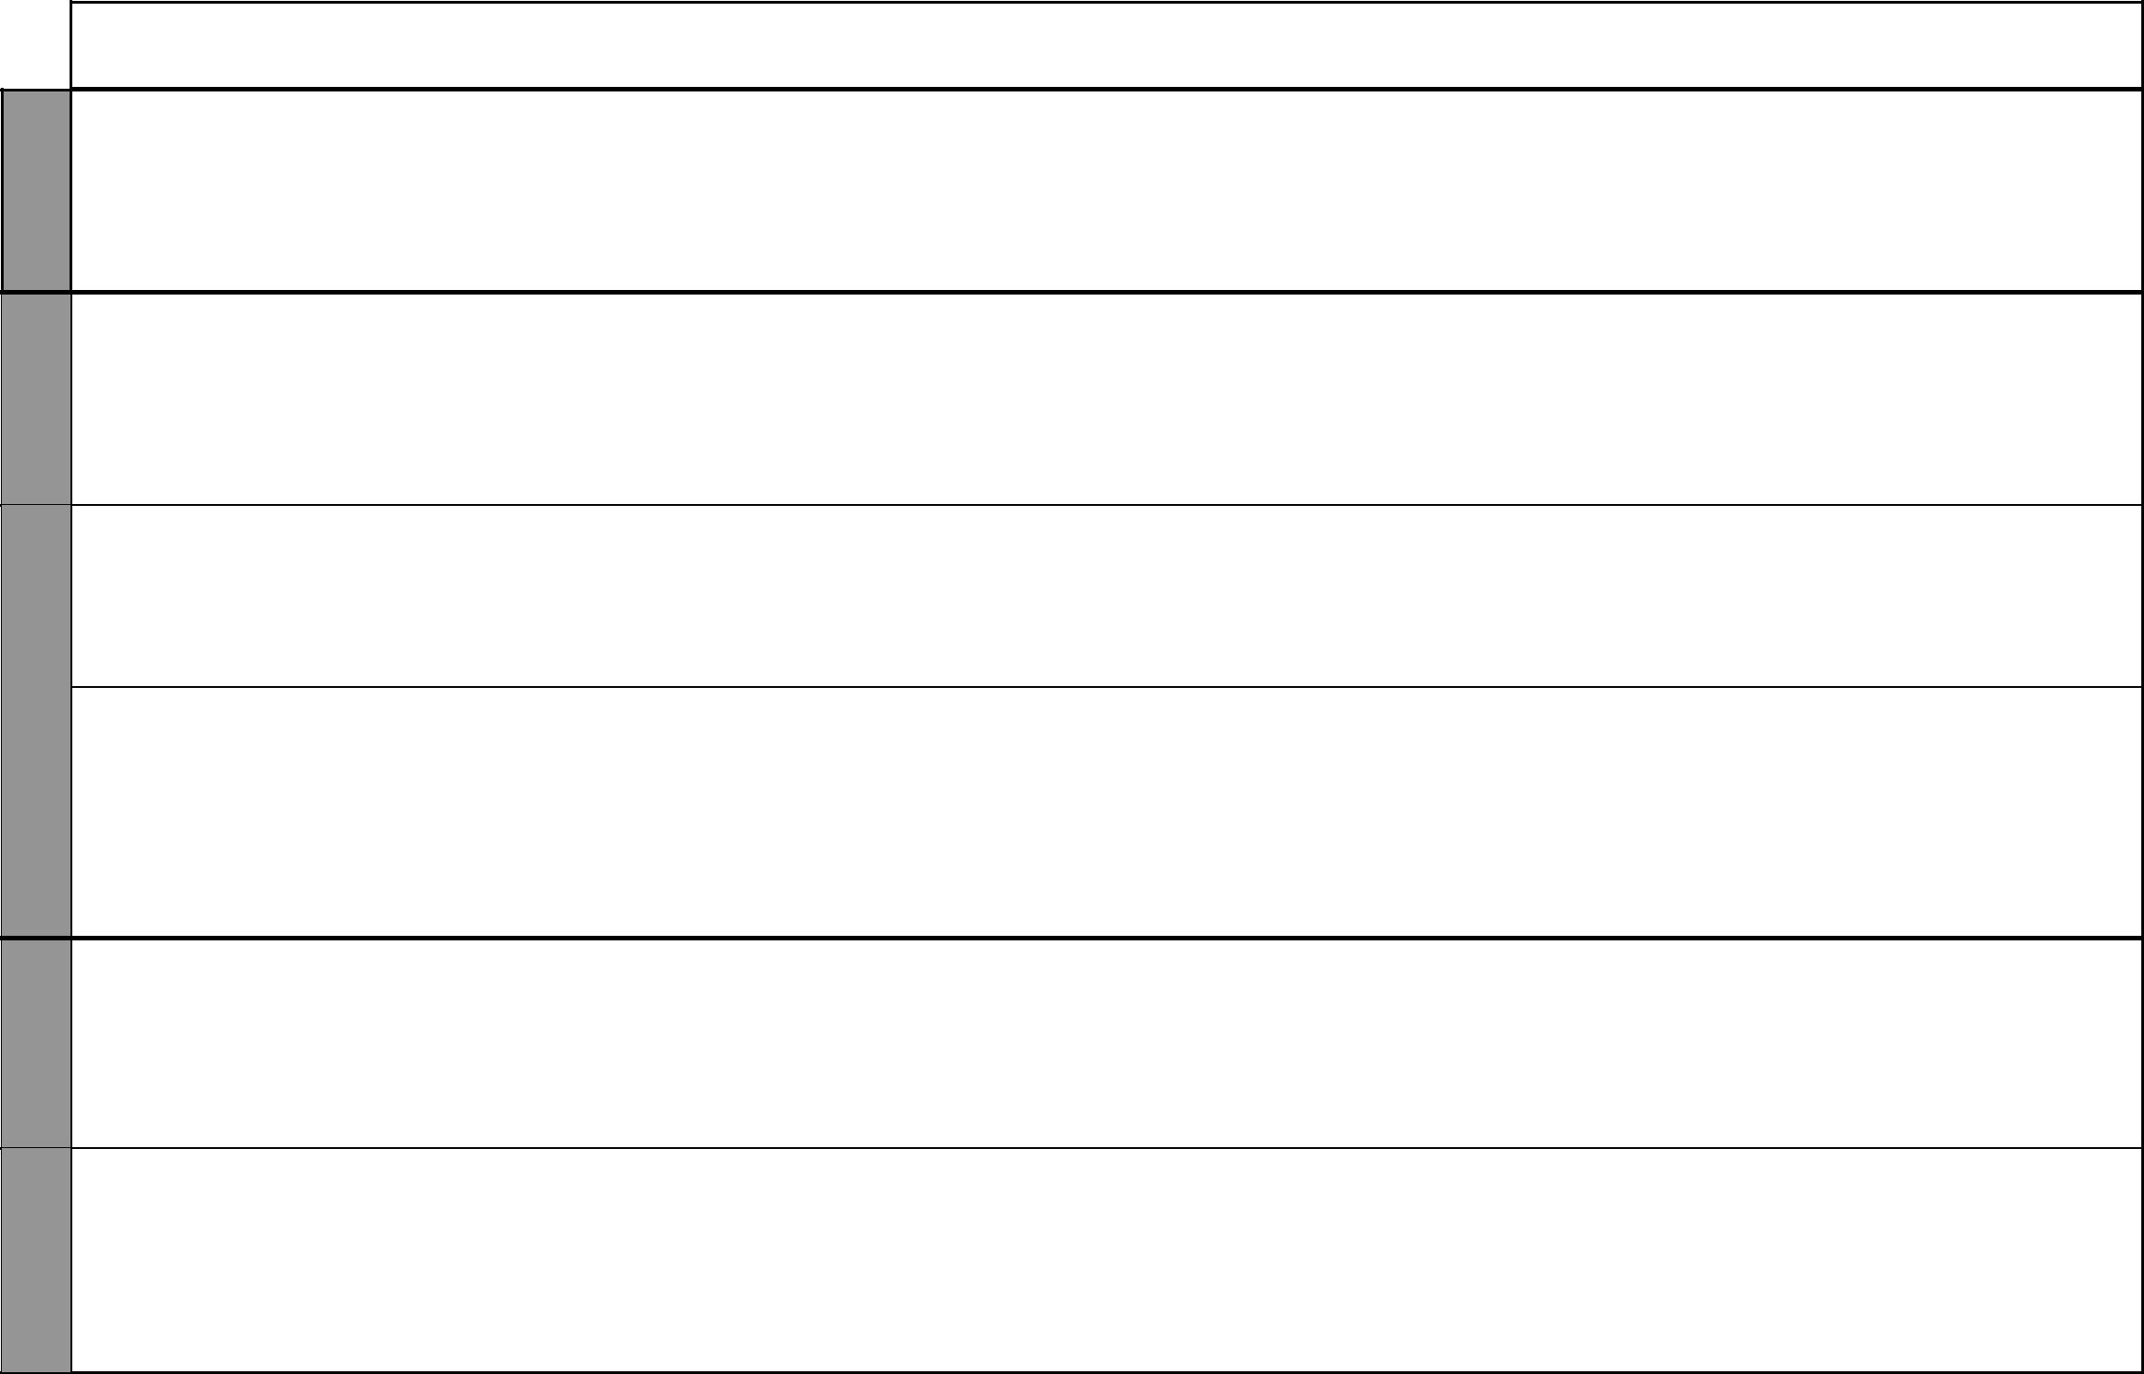
UNIT | TOPIC | LESSONS | OBJECTIVES | TEACHING/LEARNING |  | LEARNING/TEACHING | REFERENCES | REMARKS
 |  |  |  |  | ACTIVITIES | RESOURCES
 | Multiplication | 4 | By the end of this topic, the | • | Reading the value of money on | Conversion tables for | Pupil’s Book
 | and divition |  | pupils should be able to multiply |  | coins and notes | money, place value columns | pages 86-89
 | involving |  | and divide money by whole | • | Multiplying and dividing | showing shillings and cents | Teacher’s Book
 | money |  | numbers without conversion. |  | shillings and cents |  | page 48
 |  |  |  | • | Adding and dividing money
11 | Addition and | 6 | By the end of this topic, the | • | Adding and subtracting days | Conversion tables for time | Pupil’s Book
Time | subtraction |  | pupils should be able to work |  | and weeks with conversion |  | pages 90-93
 | involving |  | out addition and subtraction | • | Making columns of weeks and |  | Teacher’s Book
 | time |  | involving days and weeks with |  | days |  | pages 51-52
 |  |  | conversion of days and weeks.
 | Half past | 2 | By the end of this topic, the | • | Moving the hands of a clock to | Clock faces and watches | Pupil’s Book
 |  |  | pupils should be able to read |  | show time at half past |  | pages 93-94
 |  |  | time using half past. | • | Reading time on clocks and |  | Teacher’s Book
 |  |  |  |  | watches at half past |  | pages 52-53
 | Quarter past | 4 | By the end of this topic, the | • | Moving the hands of a clock to | Clock faces and watches | Pupil’s Book
 | and quarter |  | pupils should be able to read |  | show time as quarter past and |  | pages 95-97
 | to |  | time using quarter past and |  | quarter to |  | Teacher’s Book
 |  |  | quarter to. | • | Reading time on clocks and |  | pages 53-54
 |  |  |  |  | watches at quarter past and at
 |  |  |  |  | quarter to
12 | Making | 4 | By the end of this topic, | • | Drawing shapes | Cut-outs of triangles, | Pupil’s Book
Patterns | patterns |  | the pupils should be able to | • | Cutting out shapes | circles, rectangles, squares, | pages 98-100
 | using shapes |  | draw patterns using squares, | • | Combining shapes | crayons, colours | Teacher’s Book
 |  |  | rectangles, triangles, circles and | • | Shading shapes and patterns |  | pages 58-59
 |  |  | their combinations.
 | Revision |  | By the end of this topic, | • | Answering questions in the |  | Pupil’s Book
 |  |  | the pupils should be able to |  | mixed exercise 3 |  | pages 101-102
 |  |  | draw patterns using squares, | • | Doing end of year test |  | Teacher’s Book
 |  |  | rectangles, triangles, circles and | • | Remedial work |  | pages 61-62
 |  |  | their combinations.

6 For use with Progressive Primary Mathematics Standard Three

