MATHS SCHEME OF WORK CLASS 1
Compiled By
Schools Net Kenya Consultancy
P.O. Box 8076 – 00200 Nairobi, Kenya | Tel: +254202319748
E-mail: infosnkenya@gmail.com | www.schoolsnetkenya.com

WEEK 1

WEEK 2

WEEK 4 WEEK 3
Progressive Primary Mathematics Sample Schemes of Work for Standard One: Term One
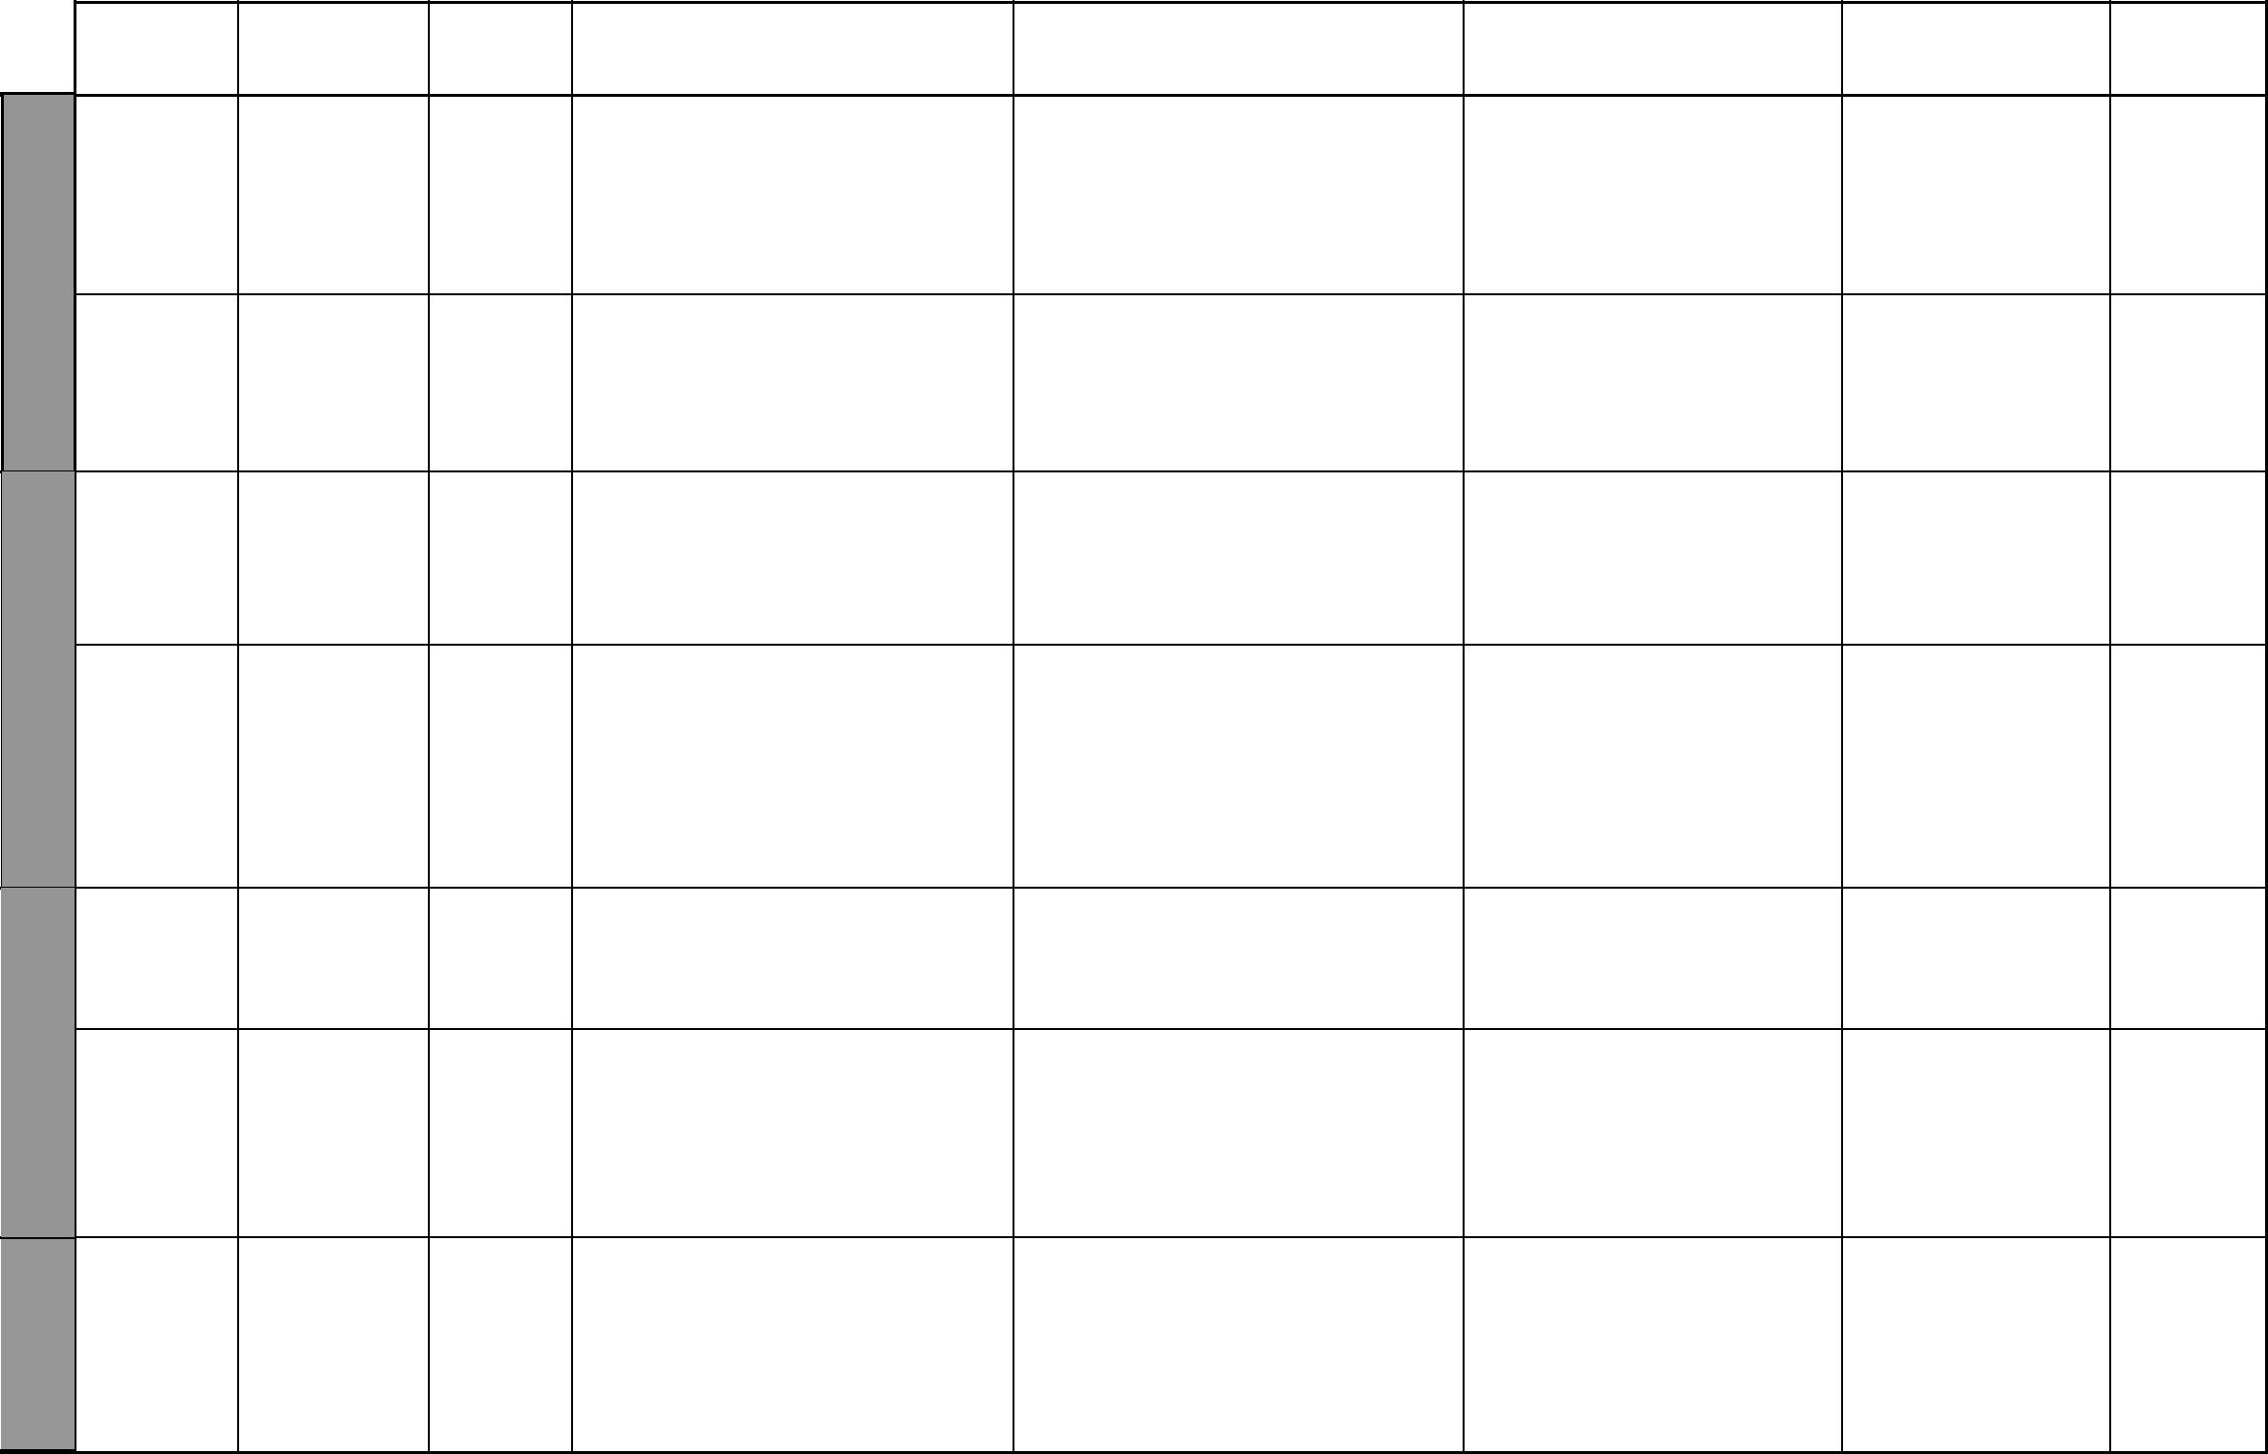
 | UNIT |  | TOPIC LESSONS |  |  | OBJECTIVES | TEACHING/LEARNING |  | LEARNING/TEACHING |  |  | REFERENCES REMARKS
 |  |  |  |  |  |  | ACTIVITIES |  | RESOURCES
1 |  | Grouping |  | 2 | By the end of this topic, the |  |  | • Grouping objects |  | Objects like tins, books, | Pupil’s Book
Pre- |  | objects |  |  | pupils should be able to group |  |  | • Naming objects |  | pencils, cups, pictures, etc. | page 2
 |  |  |  |  | objects around them according |  |  | • Labelling objects |  |  | Teacher’s Book
number
 |  |  |  |  | to common characteristics |  |  | • Matching objects according to |  |  | pages 1-2
work
 |  |  |  |  |  |  |  | common features
 |  | Grouping |  | 2 | By the end of this topic, the |  |  | • Identifying the size of an object |  | Objects like tins, books, | Pupil’s Book
 |  | things |  |  | pupils should be able to group |  |  | in relation to others |  | bottles, pictures, of | page 3
 |  | according to |  |  | objects according to size |  |  | • Matching objects according to size |  | different size | Teacher’s Book
 |  | size |  |  |  |  |  | • Comparing sizes of objects |  |  | pages 2-3
 |  | Grouping |  | 2 | By the end of this topic, the |  |  | • Identifying the colour of an |  | Coloured Manila cards | Pupil’s Book
 |  | things |  |  | pupils should be able to group |  |  | object |  | (squares, triangles, circles), | page 4
 |  | according to |  |  | objects according to colour |  |  | • Matching objects according to |  | books, beads, pieces of | Teacher’s Book
 |  | colour |  |  |  |  |  | colour |  | cloth, etc. | pages 3-4
 |  | Grouping |  | 2 | By the end of this topic, the |  |  | • Identifying the texture of an |  | Objects that have smooth | Pupil’s Book
 |  | things |  |  | pupils should be able to group |  |  | object as rough or smooth |  | or rough texture like wood, | page 5
 |  | according to |  |  | objects according to texture |  |  | • Matching objects according to |  | paper, glass, soil, mirror, | Teacher’s Book
 |  | texture |  |  |  |  |  | texture |  | leaves, etc. | pages 4-5
 |  |  |  |  |  |  |  | • Comparing the texture of
 |  |  |  |  |  |  |  | objects
 |  | Grouping |  | 2 | By the end of this topic, the |  |  | • Identifying the shape of an object |  | Rectangles, circles, triangles | Pupil’s Book
 |  | things accord- |  |  | pupils should be able to group |  |  | • Matching objects according to |  | of different sizes and | page 6
 |  |  |  |  |  |  |  |  |  | of different sizes and | Teacher’s Book
 |  | ing to shape |  |  | objects according to shape |  |  | shape |  | colours
 |  |  |  |  |  |  |  |  |  | colours | pages 5-6
 |  | More and |  | 2 | By the end of this topic, the |  |  | • Identifying a group of objects |  | Books, beans, stones, | Pupil’s Book
 |  | less |  |  | pupils should be able to compare |  |  | as having more objects than, |  | pencils, etc.
 |  |  |  |  |  |  |  |  |  | pencils, etc. | pages 7 – 8
 |  |  |  |  | things in groups using words |  |  | less objects than, or same
 |  |  |  |  |  |  |  |  |  |  | Teacher’s Book
 |  |  |  |  | like more than, less than and same |  |  | objects as another by matching
 |  |  |  |  |  |  |  |  |  |  | pages 6-7
 |  |  |  |  | number as
 |  | Ordering and |  | 4 | By the end of this topic, the |  |  | • Matching |  | Bottletops, stones, beans, | Pupil’s Book
 |  | sequencing |  |  | pupils should be able to arrange |  |  | • Counting |  | pencils, etc.
 |  |  |  |  |  |  |  |  |  | pencils, etc. | pages 9 – 11
 |  | groups |  |  | groups of objects in order |  |  | • Ordering
 |  |  |  |  |  |  |  |  |  |  | Teacher’s Book
 |  |  |  |  | depending on the number in
 |  |  |  |  |  |  |  |  |  |  | pages 7-8
 |  |  |  |  | each group.

₁ For use with Progressive Primary Mathematics Standard One

WEEK 7 WEEK 6 WEEK 5
WEEK 8

WEEK 10 WEEK 9
Progressive Primary Mathematics Standard One

Schemes of Work

Term 1

UNIT | TOPIC | LESSONS | OBJECTIVES | TEACHING/LEARNING | LEARNING/TEACHING | REFERENCES | REMARKS
 |  |  |  | ACTIVITIES | RESOURCES
2 | Counting, | 6 | By the end of this topic, the | • Counting 1, 2, 3 | Bottletops, sticks, stones, | Pupil’s Book pages
Numbers | reading and |  | pupils should be able to count, | • Reading 1, 2, 3 | cards with 1, 2, 3 objects | 12 – 13
 | writing 1, |  | read and write 1, 2, 3 | • Writing 1, 2, 3 | and the numbers in figures | Teacher’s Book
 | 2, 3 |  |  |  | on them | pages 10-11
 | Counting, | 4 | By the end of this topic, the | • Counting 4, 5, 6 | Bottletops, sticks, stones, | Pupil’s Book pages
 | reading and |  | pupils should be able to count, | • Reading 4, 5, 6 | cards with 4, 5, 6 objects | 14 – 15
 | writing 4, |  | read and write 4, 5, 6 | • Writing 4, 5, 6 | and the numbers in figures | Teacher’s Book
 | 5, 6 |  |  |  | on them | pages 11-12
 | Counting, | 4 | By the end of this topic, the | • Counting 7, 8, 9 | Bottletops, sticks, stones, | Pupil’s Book pages
 | reading and |  | pupils should be able to count, | • Reading 7, 8, 9 | cards with 7, 8, 9 objects | 16 – 17
 | writing 7, |  | read and write 7, 8, 9 | • Writing 7, 8, 9 | and the numbers in figures | Teacher’s Book
 | 8, 9 |  |  |  | on them | page 12
 | Ordering | 2 | By the end of this topic, the | • Counting 1 to 9 | Bottletops, sticks, stones, | Pupil’s Book page
 | numbers |  | pupils should be able to write 1 | • Reading 1 to 9 | cards with 1 to 9 on them | 17
 |  |  | to 9 in order starting from the | • Writing 1 to 9 | written in order. | Teacher’s Book
 |  |  | least to the greatest and vice | • Ordering numbers |  | pages 12-13
 |  |  | versa
3 | Comparing | 2 | By the end of this topic, | • Estimating the masses of | Locally available materials | Pupil’s Book pages
Mass | masses |  | the pupils should be able to | objects. | like pens, books, tins, | 18 – 21
Mass |  |  | compare masses of different | • Comparing masses of objects | stones, pencils | Teacher’s Book
 |  |  | objects using the words heavier | • Lifting objects |  | pages 14-15
 |  |  | than, lighter than, and same mass
 |  |  | as
4 | Putting | 3 | By the end of this topic, the | • Counting up to 9 | Counters like stones, | Pupil’s Book pages
Addition | together |  | pupils should be able to add | • Grouping objects to make | bottle-tops, beans, | 22 – 23
and sub- |  |  | 1-digit numbers with sums not | given numbers like 4, 7, 9 | buttons, etc. | Teacher’s Book
traction |  |  | exceeding 9 by counting | • Putting things together |  | pages 16-17
 | Taking away | 4 | By the end of this topic, | • Counting up to 9 | Counters like stones, | Pupil’s Book
 |  |  | the pupils should be able to | • Grouping objects to make | bottle-tops, beans, | pages 24 – 25
 |  |  | subtract 1-digit numbers from | given numbers like 4, 7, 9 | buttons, etc. | Teacher’s Book
 |  |  | 1-digit numbers | • Taking away |  | pages 18-19

2 For use with Progressive Primary Mathematics Standard One

Progressive Primary Mathematics Standard One

Schemes of Work

Term 1
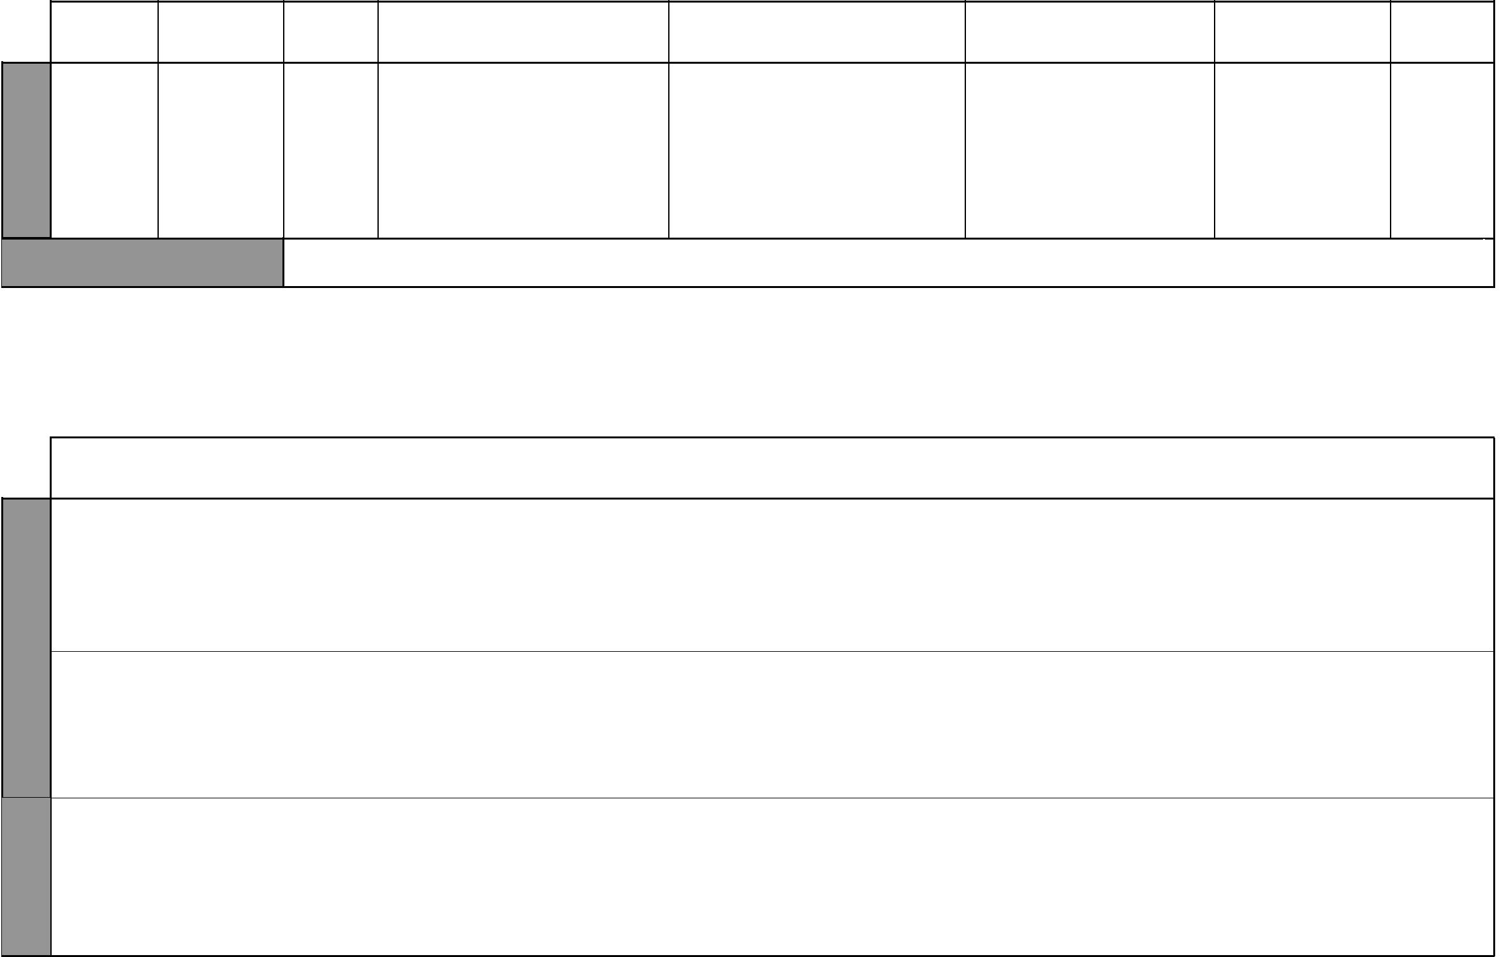

WEEK 11

UNIT | TOPIC | LESSONS | OBJECTIVES | TEACHING/LEARNING | LEARNING/TEACHING | REFERENCES REMARKS
 |  |  |  | ACTIVITIES | RESOURCES
5 | Comparing | 4 | By the end of this topic, | • Measuring capacity | Bottles, cups, spoons, | Pupil’s Book
Capacity | capacities |  | the pupils should be able | • Estimating capacity | water glasses, basins, tins, | pages 28 – 31
 |  |  | to compare the capacities of | • Comparing capacities | etc. | Teacher’s
 |  |  | different containers to establish |  |  | Book pages
 |  |  | which holds more, which holds |  |  | 21-22
 |  |  | less and which holds the same as
WEEK 12 – 13 |  | REVISION AND END TERM EXAMINATIONS

WEEK 1

WEEK 2

Progressive Primary Mathematics Sample Schemes of Work for Standard One: Term Two

UNIT | TOPIC | LESSONS | OBJECTIVES | TEACHING/LEARNING | LEARNING/TEACHING | REFERENCES | REMARKS
 |  |  |  | ACTIVITIES | RESOURCES
6 | The number | 2 | By the end of this topic, | • Counting up to 9 | Tins and counters | Pupil’s Book
Numbers | zero |  | the pupils should be able to | • Grouping objects to make given |  | page 32
 |  |  | recognize and use the number | numbers like 4, 7, 9 |  | Teacher’s
 |  |  | zero in counting and writing | • Putting together and taking |  | Book pages
 |  |  | numbers | away |  | 23-24
 | Adding zero | 2 | By the end of this topic, the | • Counting up to 9 | Tins and counters | Pupil’s Book
 |  |  | pupils should be able to add two | • Grouping objects to make given |  | page 33
 |  |  | 1-digit numbers including zero | numbers like 4, 7, 9 |  | Teacher’s
 |  |  | with sums not exceeding 9 by | • Putting together |  | Book pages
 |  |  | counting |  |  | 24-25
 | Taking away | 2 | By the end of this topic, the | • Counting up to 9 | Tins and counters | Pupil’s Book
 | zero and |  | pupils should be able to subtract | • Grouping objects to make given |  | pages 34 – 35
 | everything |  | zero from a number and get | numbers like 4, 7, 9 |  | Teacher’s
 |  |  | the same number, or subtract | • Taking away |  | Book page 25
 |  |  | everything and be left with zero

₃ For use with Progressive Primary Mathematics Standard One

WEEK 2

WEEK 3

WEEK 4

WEEK 5
Progressive Primary Mathematics Standard One

Schemes of Work

Term 2

UNIT | TOPIC | LESSONS | OBJECTIVES | TEACHING/LEARNING | LEARNING/TEACHING | REFERENCES | REMARKS
 |  |  |  | ACTIVITIES | RESOURCES
7 | Straight | 2 | By the end of this topic, the | • Drawing lines | Cardboard cut-outs, | Pupil’s Book
 |  |  |  |  |  | pages 36 – 39
Lines | lines |  | pupils should be able to identify | • Tracing lines | rectangular tins, objects | pages 36 – 39
Lines | lines |  | pupils should be able to identify | • Tracing lines | rectangular tins, objects | Teacher’s Book
 |  |  | and draw straight lines | • Naming lines | with straight edges | Teacher’s Book
 |  |  |  | • Feeling the edges of objects |  | pages 27-28
 | Curved lines | 3 | By the end of this topic, | • Drawing lines | Objects with curved edges | Pupil’s Book
 |  |  | the pupils should be able to | • Tracing lines | like coins, round tins | pages 36 – 39
 |  |  | recognize curved lines | • Naming lines |  | Teacher’s Book
 |  |  |  | • Feeling the edges of objects |  | page 28
8 | Rectangles | 2 | By the end of this topic, | • Identifying rectangular shapes | String, pegs, pins, | Pupil’s Book page
 |  |  |  |  |  | 40
Shapes |  |  | the pupils should be able to | in the classroom | rectangular solids, pieces of | 40
 |  |  | recognize and draw rectangles | • Naming rectangles | wire, matchboxes, blocks of | Teacher’s Book
 |  |  |  | • Cutting out rectangular shapes | wood, drinking straws | page 30
 |  |  |  | • Drawing rectangular shapes
 | Triangles | 2 | By the end of this topic, | • Identifying triangular shapes in | String, pegs, pins, triangular | Pupil’s Book page
 |  |  | the pupils should be able to | the classroom | solids, pieces of wire, | 41
 |  |  | recognize and draw triangles | • Naming triangles | drinking straws | Teacher’s Book
 |  |  |  | • Cutting out triangular shapes |  | page 31
 |  |  |  | • Drawing triangular shapes
 | Circles | 2 | By the end of this topic, | • Identifying circular shapes in | Round objects like coins, | Pupil’s Book
 |  |  | the pupils should be able to | the classroom | plates, circular tins, circular | pages 42 – 43
 |  |  | recognize and draw circles | • Naming circles | cut-outs, string, wire | Teacher’s Book
 |  |  |  | • Cutting out circular shapes |  | pages 31-32
 |  |  |  | • Drawing circular shapes
9 | Tens and | 5 | By the end of this topic, the | • Counting up to 10 | Bundles of sticks tied | Pupil’s Book
 |  |  |  |  |  | pages 46 – 51
Place | ones |  | pupils should be able to write the | • Making bundles of ten sticks | together and loose sticks, | pages 46 – 51
Place | ones |  | pupils should be able to write the | • Making bundles of ten sticks | together and loose sticks, | Teacher’s Book
value of |  |  | tens and ones in a given number | each | rubber bands, the abacus | Teacher’s Book
value of |  |  |  | • Counting in groups of 10 |  | pages 33-36
numbers |  |  |  | • Counting in groups of 10 |  | pages 33-36
numbers |  |  |  | • Making the place value tables
 |  |  |  | or columns
 |  |  |  | • Using the abacus

4 For use with Progressive Primary Mathematics Standard One

Progressive Primary Mathematics Standard One

Schemes of Work

Term 2
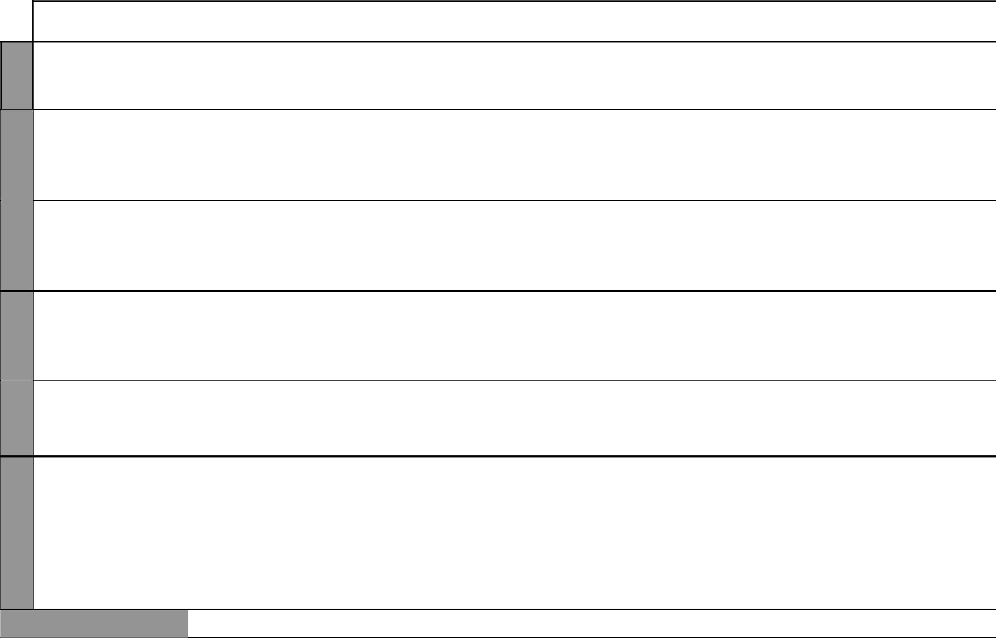

WEEK 6

WEEK 7

WEEK 10 – 11 WEEK 9 WEEK 8

 | UNIT | TOPIC | LESSONS | OBJECTIVES | TEACHING/LEARNING | LEARNING/TEACHING | REFERENCES | REMARKS
 |  |  |  |  | ACTIVITIES | RESOURCES
 |  | Counting in | 5 | By the end of this topic, the pupils | • Making bundles of ten sticks each | Bundles of sticks tied | Pupil’s Book
 |  |  |  |  |  |  | pages 51 – 53
 |  | groups of ten |  | should be able to count in multiples | • Counting in groups of 10 | together, rubber bands, the | pages 51 – 53
 |  |  |  | of 10, i.e. 10, 20, 30, 40, 50, etc. | • Using the abacus | abacus | Teacher’s Book
 |  |  |  | of 10, i.e. 10, 20, 30, 40, 50, etc. | • Using the abacus | abacus | pages 36-37
 |  | Numbers up | 1 | By the end of this topic, the | • Writing tens and ones | Place value tables, bundles | Pupil’s Book
 |  | to 99 |  | pupils should be able to count | • Drawing tables | of sticks tied together and | pages 53 - 55
 |  |  |  | and read from 1-99 | • Reading numbers from 1 to 99 | loose sticks, rubber bands, | Teacher’s Book
 |  |  |  |  | • Counting in groups of 10 | tables of numbers written in | page 37
 |  |  |  |  |  | order of size
 |  | Missing | 2 | By the end of this topic, the | • Writing and reading numbers | Tables of numbers written | Pupil’s Book
 |  | numbers |  | pupils should be able to find a | in order starting with the least | in order | pages 53 – 55
 |  |  |  | missing number or numbers in a | to the highest and vice versa. |  | Teacher’s Book
 |  |  |  | series | • Memorizing the order of numbers |  | page 37
 |  |  |  |  | from the least to the greatest
10 |  | Comparing | 4 | By the end of this topic, the pupils | • Comparing heights and lengths | Locally available objects | Pupil’s Book
 |  |  |  |  |  |  | pages 56 – 58
 | Length | lengths |  | should be able to compare lengths | by placing pupils or objects side | that the pupils can use to | pages 56 – 58
 | Length | lengths |  | should be able to compare lengths | by placing pupils or objects side | that the pupils can use to | Teacher’s Book
 |  |  |  | and express their relationships | by side | compare lengths like sticks, | Teacher’s Book
 |  |  |  | using the words longer than, shorter |  | pens, pencils, rulers, etc. | pages 40-41
 |  |  |  | than and same length as
 |  | Measuring | 3 | By the end of this topic, the | • Estimating length | Sticks, desks, ropes, rulers, | Pupil’s Book
 |  |  |  |  |  |  | page 59
 |  | length |  | pupils should be able to measure | • Measuring length | etc. | page 59
 |  | length |  | pupils should be able to measure | • Measuring length | etc. | Teacher’s Book
 |  |  |  | length using hand spans, | • Comparing lengths |  | Teacher’s Book
 |  |  |  | length using hand spans, | • Comparing lengths |  | pages 41-42
 |  |  |  | footsteps and sticks |  |  | pages 41-42
11 |  | Addition | 6 | By the end of this topic, the | • Counting to 20 | Counters such as stones, | Pupil’s Book
 |  |  |  |  |  |  | pages 60 – 61
 | Addition |  |  | pupils should be able to add | • Adding numbers | bottletops, beans, buttons, | pages 60 – 61
 | Addition |  |  | pupils should be able to add | • Adding numbers | bottletops, beans, buttons, | Teacher’s Book
 | and sub- |  |  | 1-digit numbers with sums up | • Putting groups of objects | etc. | Teacher’s Book
 | and sub- |  |  | 1-digit numbers with sums up | • Putting groups of objects | etc. | pages 43-44
 | and sub- |  |  | to 18 | together |  | pages 43-44
 | traction |  |  | to 18 | together |  | pages 43-44
 |  | Subtraction | 3 | By the end of this topic, the | • Counting to 20 | Counters such as stones, | Pupil’s Book
 |  |  |  | pupils should be able to subtract | • Subtracting numbers | bottletops, beans, buttons, | pages 62 – 63
 |  |  |  | 1-digit numbers from 2-digit | • Taking groups of objects away | etc. | Teacher’s Book
 |  |  |  | numbers | from a larger group. |  | page 45
 | WEEK 12 – 13 |  | REVISION AND END TERM EXAMINATIONS

₅ For use with Progressive Primary Mathematics Standard One

Progressive Primary Mathematics Sample Schemes of Work for Standard One: Term Three


UNIT

 | 11
 | Addition
 | and sub-
WEEK 1 | traction
 | 12
 | Time
WEEK 2
3 | 13
WEEK | 13
WEEK | Money
WEEK 4

TOPIC | LESSONS | OBJECTIVES | TEACHING/LEARNING | LEARNING/TEACHING | REFERENCES | REMARKS
 |  |  | ACTIVITIES | RESOURCES
Adding | 2 | By the end of this topic, the | • Counting to 20 | Counters such as stones, | Pupil’s Book
three 1-digit |  | pupils should be able to add | • Adding numbers | bottletops, beans, buttons, | page 64
numbers |  | three 1-digit numbers | • Combining groups of objects | etc. | T/b pg 46
Adding ones | 2 | By the end of this topic, the | • Drawing place value tables | Counters such as stones, | Pupil’s Book
and tens |  | pupils should be able to add a 2- | • Adding numbers | bottletops, beans, buttons, | pages 65 – 67
 |  | digit number to a 1-digit number | • Making bundles of ten sticks | etc. | Teacher’s Book
 |  | without carrying | • Grouping ones and tens |  | page 46
Subtracting | 2 | By the end of this topic, the | • Drawing place value tables | Counters such as bundles | Pupil’s Book
ones and |  | pupils should be able to subtract | • Subtracting numbers | of sticks, stones, beans, | pages 67 – 69
tens |  | a 1-digit number from a 2-digit | • Making bundles of ten sticks. | buttons, etc. | Teacher’s Book
 |  | number to get a 1-digit number | • Untying bundles of ten. |  | page 46
Time | 2 | By the end of this topic, the | • Discussing pupils’ daily | Cards with the words noon, | Pupil’s Book
 |  | pupils should be able to relate | activities | night, morning, evening | page 72
 |  | daily events to morning, noon, | • Doing certain activities that are |  | Teacher’s Book
 |  | evening, night | only done at particular times. |  | pages 51-52
Days of the | 2 | By the end of this topic, the | • Discussing pupils’ daily | List of the days of the week | Pupil’s Book
week |  | pupils should be able to narrate | activities |  | page 73
 |  | all the days of the week and the | • Reading the names of the days |  | Teacher’s Book
 |  | names in order | of the week. |  | pages 52-53
Kenyan coins | 4 | By the end of this topic, | • Counting coins | Kenyan coins, imitation | Pupil’s Book
 |  | the pupils should be able to | • Separating coins | coins | pages 74 – 75
 |  | recognize Kenyan coins | • Reading the values on coins |  | Teacher’s Book
 |  |  |  |  | pages 54-55
Shopping | 4 | By the end of this topic, the | • Counting coins | Kenyan coins, imitation | Pupil’s Book
 |  | pupils should be able to do | • Separating coins | coins, classroom duka and | pages 76 – 77
 |  | shopping activities using | • Reading the values on coins | its stock | Teacher’s Book
 |  | imitation coins and Kenyan | • Buying and selling |  | pages 55-56
 |  | coins
 |  |  | 6 | For use with Progressive Primary Mathematics Standard One

Progressive Primary Mathematics Standard One

Schemes of Work

Term 3


WEEK 8 – 12 WEEK 7 WEEK 6 WEEK 5

UNIT | TOPIC | LESSONS | OBJECTIVES | TEACHING/LEARNING | LEARNING/TEACHING | REFERENCES | REMARKS
 |  |  |  | ACTIVITIES | RESOURCES
14 | Addition | 4 | By the end of this topic, the | • Drawing place value tables | Bundles of ten sticks each, | Pupil’s Book
 |  |  |  |  |  | pages 78 – 79
Addition |  |  | pupils should be able to add | • Adding numbers | loose sticks, the abacus | pages 78 – 79
Addition |  |  | pupils should be able to add | • Adding numbers | loose sticks, the abacus | Teacher’s Book
and sub- |  |  | 2-digit numbers with sums not | • Using the abacus |  | Teacher’s Book
and sub- |  |  | exceeding 99 without carrying. |  |  | pages 57-58
traction |  |  | exceeding 99 without carrying. |  |  | pages 57-58
 | Subtraction | 5 | By the end of this topic, the | • Drawing place value tables | Bundles of ten sticks each, | Pupil’s Book
 |  |  | pupils should be able to subtract | • Subtracting numbers | loose sticks and other | pages 80 – 82
 |  |  | 2-digit numbers from 2-digit |  | counters | Teacher’s Book
 |  |  | numbers without borrowing. |  |  | page 59
 | Number | 2 | By the end of this topic, | • Filling in tables | Counters such as bundles | Pupil’s Book
 | patterns |  | the pupils should be able to | • Subtracting numbers | of sticks, beans, buttons | page 82
 |  |  | recognize and develop number | • Adding numbers |  | Teacher’s Book
 |  |  | recognize and develop number | • Adding numbers |  | page 60
 |  |  | patterns based on basic addition | • Making number patterns. |  | page 60
 |  |  | and subtraction

REVISION AND END YEAR EXAM

₇ For use with Progressive Primary Mathematics Standard One

