CRE SCHEME OF WORK CLASS 6
Compiled By
Schools Net Kenya Consultancy
P.O. Box 8076 – 00200 Nairobi, Kenya | Tel: +254202319748
E-mail: infosnkenya@gmail.com | www.schoolsnetkenya.com

Living in Christ Standard Six Schemes of Work: Term One


WEEK 1

 | LESSONS | TOPIC | SUB-TOPIC |  | OBJECTIVES | TEACHING/LEARNING | TEACHING/LEARNING | REFERENCES REMARKS
 |  |  |  |  |  | ACTIVITIES | RESOURCES
1 |  | 1. Crea- | Creation of the | By the end of the lesson the |  | • Explanation | • The Good News Bible: | • Pupil’s Book 6
 |  | tion of | earth | learner should be able to: |  | • Observation | Genesis 1:26-28, Psalms | page 2
 |  | human |  | 1. | narrate Biblical stories of | • Note taking | 139:16 | Teacher’s Guide
 |  | beings |  |  | creation |  | • Pictures, Charts showing | page 2
 |  |  |  | 2. | appreciate God’s creation |  | nature
 |  |  |  |  |  |  | • Chalkboard
2 |  |  | The creation | By the end of the lesson the |  | • Questions and answers |  | • Pupil’s Book 6
 |  |  | story | learner should be able to: |  | • Explanation | • The Good News Bible: | page 3
 |  |  |  | 1. | narrate the Biblical stories of | • Scripture reading | Genesis 1:26-28, Psalms | Teacher’s Guide
 |  |  |  |  | creation | • Drawing | 139:16, Matthew 19:4 | page 2
 |  |  |  | 2. | appreciate God’s creation | • Recitation | • Chalkboard
 |  |  |  |  |  |  | • Charts
 |  |  |  |  |  |  | • Drawing tools

3 | The second | By the end of the lesson the |  | • Questions |  | • The Good News Bible: |  | • Pupil’s Book 6
 | creation story | learner should be able to: |  | • | Explanation |  | Genesis 2:5-25, Psalms | pages 2-3
 |  | 1. | tell the story of creation | • | Practical activities |  | 139:4 | • Teacher’s Guide
 |  | 2. | appreciate God’s creation | • | Recitation and scripture | • | Chart drawing of Adam and | pages 2-3
 |  |  |  |  | reading |  | Eve in the garden
 |  |  |  | • | Discussions | • | Real objects: flowers, plants,
 |  |  |  | • | Dramatization |  | water, cans


1 For use with Living in Christ Standard Six

WEEK 2

WEEK 3

 |  |  |  |  |  |  |  |  |  |  |  |  |  | Living in Christ Standard Six
 |  |  |  |  |  |  |  |  |  |  |  |  |  | Schemes of Work
 |  |  |  |  |  |  |  |  |  |  |  |  |  |  |  | Term 1
LESSONS |  | TOPIC |  | SUB-TOPIC |  | OBJECTIVES |  | TEACHING/LEARNING |  |  | TEACHING/LEARNING |  |  | REFERENCES |  | REMARKS
 |  |  |  |  |  |  |  |  | ACTIVITIES |  |  | RESOURCES
1 |  | 2. Creation |  | The fall of | By the end of the lesson the |  |  | • Questions and answers |  |  | • | The Good News Bible: | • | Pupil’s Book 6
 |  | of human |  | human beings | learner should be able to: |  |  | • Explanation |  |  |  | Genesis 3:1-14 |  | page 4
 |  | beings |  |  | 1. | describe the fall of human |  | • Scripture reading |  |  | • | Chart drawing of Adam and | • | Teacher’s Guide
 |  |  |  |  |  | beings |  | • Narration |  |  |  | Eve in the garden of Eden |  | page 3
 |  |  |  |  | 2. | appreciate God’s creation |  | • Discussion |  |  | • | Chalkboard
 |  |  |  | Creation | By the end of the lesson the |  |  | • Explanation |  |  | • | The Good News Bible: | • | Pupil’s Book 6
2 |  |  |  | stories in | learner should be able to: |  |  | • Narration/story telling |  |  |  | Genesis 2:5-25 |  | page 5
2 |  |  |  | traditional | 1. | tell some creation stories from |  | • Scripture reading |  |  | • | Chalkboard | • | Teacher’s Guide
 |  |  |  | African Society |  | a traditional African society |  | • Recitation |  |  |  |  |  | page 4
 |  |  |  |  | 2. | appreciate the traditional
 |  |  |  |  |  | African stories of creation
 |  |  |  | Caring for the | By the end of the lesson the |  |  | • Explanation |  |  | • | The Good News Bible: | • | Pupil’s Book 6
2 |  |  |  | air and water | learner should be able to: |  |  | • Scripture reading |  |  |  | Genesis 1:28 |  | page 6
2 |  |  |  |  | 1. | write down ways of |  | • Note taking |  |  | • | Film or video | • | Teacher’s Guide
 |  |  |  |  |  | responding to God’s creation |  | • Watching film/video |  |  | • | Chalkboard |  | pages 6-7
 |  |  |  |  | 2. | Care for God’s creation
3 |  |  |  | Caring for | By the end of the lesson the |  |  | • Explanation |  |  | • | The Good News Bible: | • | Pupil’s Book 6
3 |  |  |  | animals and | learner should be able to: |  |  | • Demonstration |  |  |  | Genesis 1:28-30, Psalms |  | page 7
 |  |  |  | plants | 1. | write down ways of |  | • Practical work: planting trees |  |  |  | 104:20 | • | Teacher’s Guide
 |  |  |  |  |  | responding to God’s creation |  |  | or any other plants |  | • | Real objects i.e. plants |  | pages 7-8
 |  |  |  |  | 2. | care for God’s creation |  | • Note taking |  |  | • | Charts and pictures
 |  |  |  |  |  |  |  | • Scripture reading
 |  |  |  |  |  |  |  | • Prayer
1 |  | 3. New life |  | New life in the | By the end of the lesson the |  |  | • Explanation |  |  | • | The Good News Bible: | • | Pupil’s Book 6
1 |  |  |  | community | learner should be able to: |  |  | • Storytelling |  |  |  | 2 Corinthians 5:17 |  | page 8
 |  |  |  |  | 1. | state what new life is |  | • Scripture reading |  |  |  |  | • | Teacher’s Guide
 |  |  |  |  | 2. | desire to share the new life |  | • Note taking |  |  |  |  |  | pages 8-9
 |  |  |  |  |  | with others
2 |  |  |  | New life in the | By the end of the lesson the |  |  | • | Explanation: occasions of |  | • | The Good News Bible: | • | Pupil’s Book 6
2 |  |  |  | African society | learner should be able to: |  |  |  | new life in ATS |  |  | Ephesians 4:20-24 |  | pages 8-10
 |  |  |  |  | 1. | describe the occasions that |  | • | Discussion: significance of |  | • | Resource person | • | Teacher’s Guide
 |  |  |  |  |  | mark new life in the |  |  | these occasions |  |  |  |  | pages 9-12
 |  |  |  |  |  | traditional African society |  | • | Narration
 |  |  |  |  | 2. | desire to share new life with |  | • | Note taking
 |  |  |  |  |  | others |  | • | Scripture reading


2 For use with Living in Christ Standard Six

Living in Christ Standard Six

Schemes of Work

Term 1
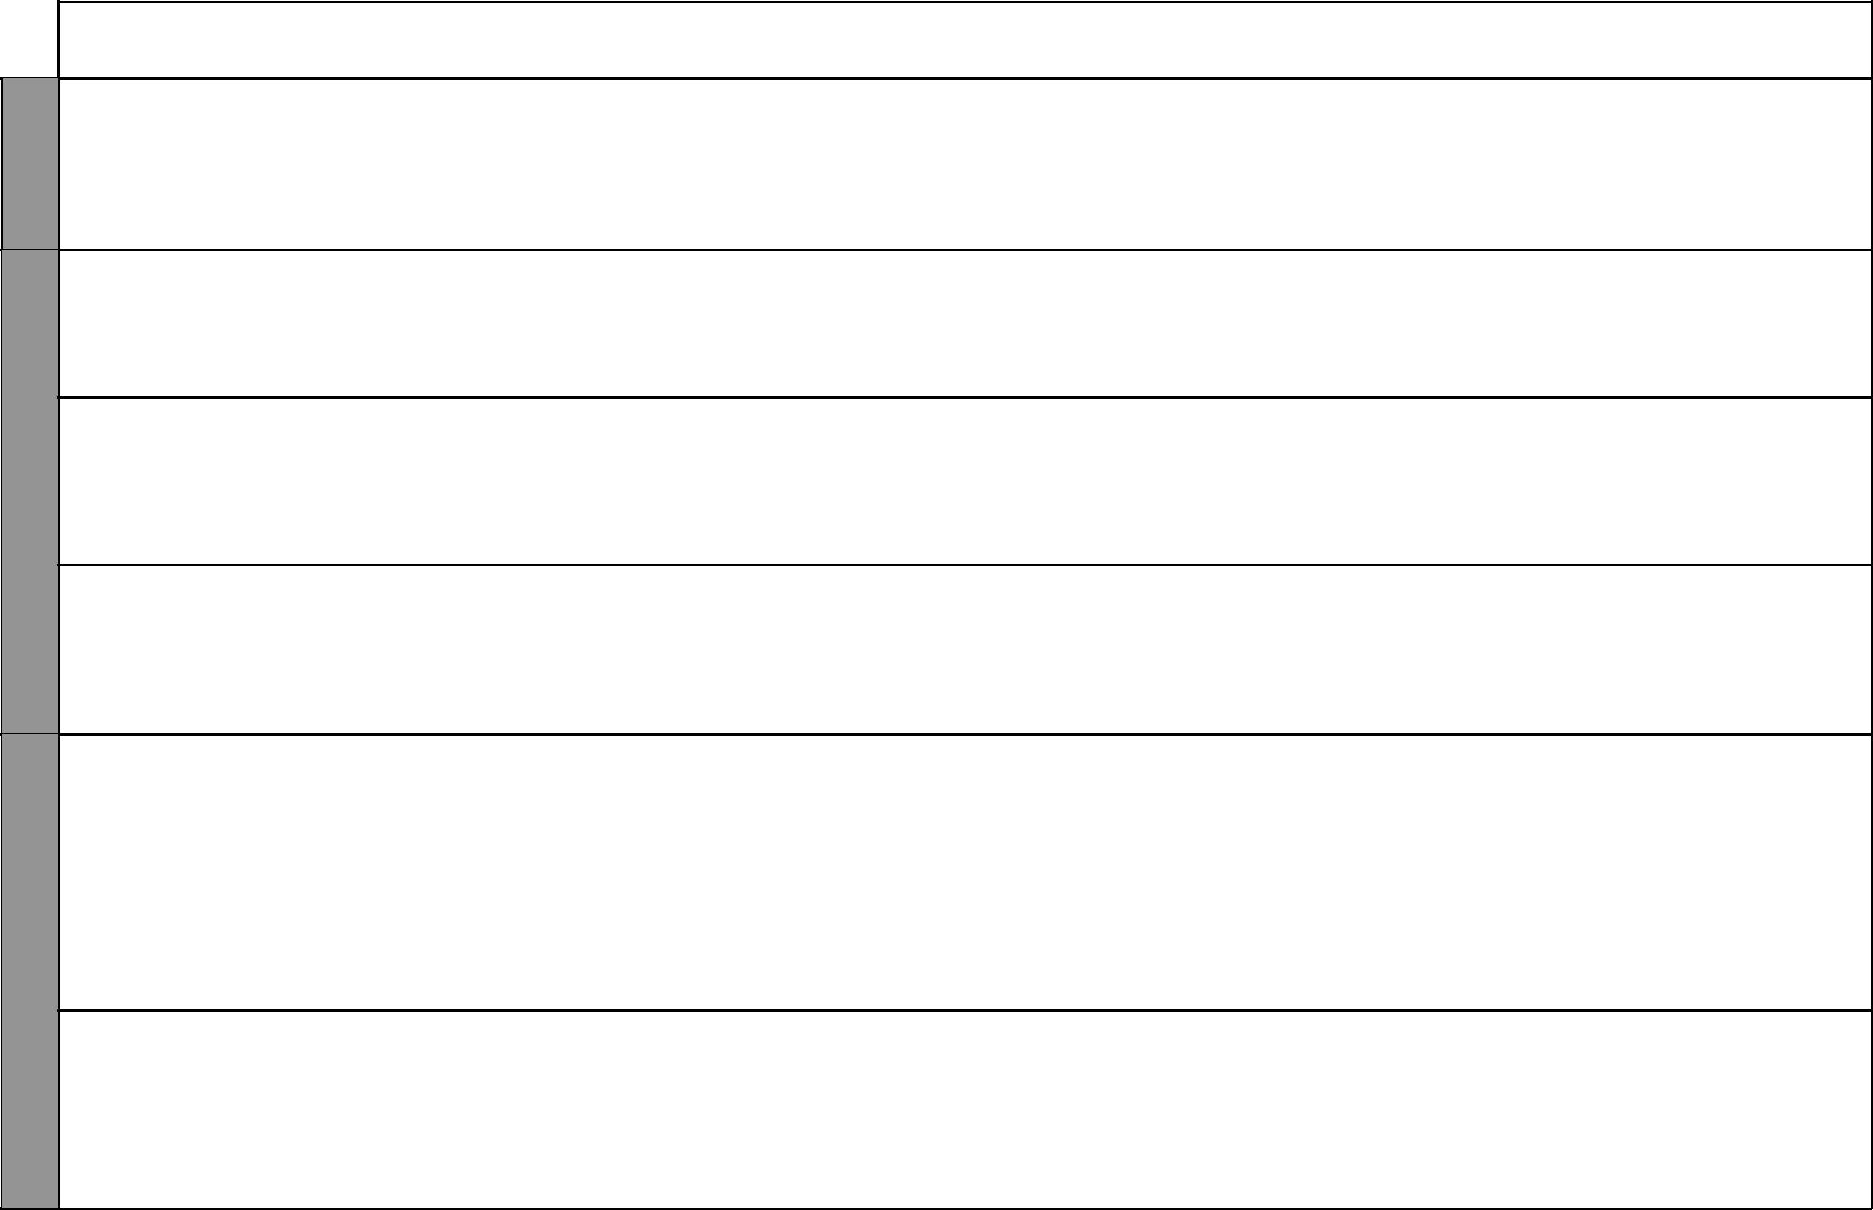

WEEK 3

WEEK 4

WEEK 5

LESSONS | TOPIC | SUB-TOPIC |  | OBJECTIVES | TEACHING/LEARNING | TEACHING/LEARNING |  | REFERENCES | REMARKS
 |  |  |  |  | ACTIVITIES | RESOURCES
3 |  | New life in | By the end of the lesson the |  | • Discussion | • The Good News Bible: | • | Pupil’s Book 6
 |  | Christianity | learner should be able to: |  | • Explanation | Ephesians 4:20 |  | pages 11-12
 |  |  | 1. | explain what new life means | • Scripture reading |  | • | Teacher’s Guide
 |  |  |  | to Christians | • Note taking |  |  | pages 12-13
 |  |  | 2. | desire to share new life with
 |  |  |  | others
1 |  | How we give | By the end of the lesson the |  | • Questions and answers | • The Good News Bible: | • Pupil’s Book 6
1 |  | our lives to | learner should be able to: |  | • Scripture reading | Genesis 12:1-9, |  | pages 11-12
 |  | God | 1. | state how Christians can give | • Explanation | Malachi 3:8-12 | • | Teacher’s Guide
 |  |  |  | their lives to God | • Discussion | • Chalkboard |  | pages 13-14
 |  |  | 2. | desire to share with others | • Note taking
 |  | God gives us | By the end of the lesson the |  | • Explanation | • The Good News Bible: | • Pupil’s Book 6
2 |  | new life | learner should be able to: |  | • Note taking | Titus 3:4-8 |  | pages 12-13
 |  |  | 1. | state how God gives us | • Questions and answers | • Chalkboard | • | Teacher’s Guide
 |  |  |  | new life | • Songs |  |  | pages 15-16
 |  |  | 2. | desire to share new life with | • Scripture reading
 |  |  |  | others
 |  | Christians | By the end of the lesson the |  | • Scripture reading | • The Good News Bible: | • Pupil’s Book 6
 |  | sharing with | learner should be able to: |  | • Explanation | • The Good News Bible:
3 |  | sharing with |  |  | • Explanation | Acts 6:1-6, 2:44-47, |  | 6 pages 13-14
3 |  | others | 1. | mention ways in which | • Questions and answers | Acts 6:1-6, 2:44-47, |  | 6 pages 13-14
 |  |  |  |  |  | James 2:14-17, | • | Teacher’s Guide
 |  |  |  | Christians share with others | • Note taking | James 2:14-17, | • | Teacher’s Guide
 |  |  |  | Christians share with others | • Note taking | Hebrews 13:15-18 |  | pages 16-17
 |  |  | 2. | desire to share his/her | • Project work | Hebrews 13:15-18 |  | pages 16-17
 |  |  |  | possessions with others
 |  | How our | By the end of the lesson the |  | • Scripture reading | • The Good News Bible: | • Pupil’s Book
 |  | ancestors | learner should be able to: |  | • Questions and answers | Genesis 1:26-29, |  | 6 pages 14-15
1 |  | served the clan | 1. | state how ancestors served | • Resource person | Hebrews 13:1 | • | Teachers Guide
 |  |  |  | the clan | • Explanation: ancestors served | • Resource person |  | pages 17-18
 |  |  | 2. | desire to share his/her | the community in the | • Chalkboard
 |  |  |  | possessions with others | Traditional African society
 |  |  |  |  | • They were rainmakers
 |  |  |  |  | counselors and herbalists
 |  |  |  |  | • Christians too serve the
 |  |  |  |  | community in various ways
2 |  | How our | By the end of the lesson the |  | • Explanation | • The Good News Bible: | • Pupil’s Book 6
 |  | ancestors | learner should be able to: |  | • Scripture reading | Matthew 25: 33-40 |  | page 16
 |  | shared their | 1. | state how our ancestors shared | • Questions and answers | • Chalkboard | • | Teacher’s Guide
 |  | possessions |  | their possessions | • Note taking |  |  | pages 18-19
 |  |  | 2. | desire to share his/her | • Storytelling
 |  |  |  | possessions

3 For use with Living in Christ Standard Six

WEEK 5

WEEK 6

WEEK 7

 |  |  |  |  |  |  |  |  | Living in Christ Standard Six
 |  |  |  |  |  |  |  |  | Schemes of Work
 |  |  |  |  |  |  |  |  |  |  | Term 1
LESSONS |  |  | OBJECTIVES |  | TEACHING/LEARNING |  | TEACHING/LEARNING |  | REFERENCES |  | REMARKS
LESSONS | TOPIC | SUB-TOPIC | OBJECTIVES |  | TEACHING/LEARNING |  | TEACHING/LEARNING |  | REFERENCES |  | REMARKS
 |  |  |  |  | ACTIVITIES |  | RESOURCES
3 |  | Sharing talents | By the end of the lesson the |  | • Narration |  | • The Good News Bible: |  | • Pupil’s Book 6
 |  | and skills with | learner should be able to: |  | • Scripture reading |  | Ephesians 4:11 |  | pages 16-17
 |  | others | 1. explain how Christians share |  | • Demonstration: using musical |  | • Musical instruments |  | • Teacher’s Guide
 |  |  | their skills and talents |  | instruments |  | • Chart drawings |  | pages 19-20
 |  |  | 2. be willing to share his/ her |  | • Recitation and memorizing
 |  |  | talents with others |  | • Explanation
 |  |  |  |  | • Note taking
 |  |  |  |  | • Observation
1 | 4. Break- | Sharing a meal | By the end of the lesson the |  | • Discussion |  | • The Good News Bible: |  | • Pupil’s Book 6
1 | 4. Break- |  | learner should be able to: |  | • Scripture reading |  | Luke 19:1-10 |  | page 18
 | ing |  | learner should be able to: |  | • Scripture reading |  | Luke 19:1-10 |  | page 18
 | ing |  | 1. write down the importance of |  | • Explanation |  | • Chalkboard |  | • Teacher’s Guide
 | bread |  | 1. write down the importance of |  | • Explanation |  | • Chalkboard |  | • Teacher’s Guide
 | bread |  | sharing a meal |  | • Dramatization: Zacchaeus |  |  |  | pages 21-22
 | together |  | sharing a meal |  | • Dramatization: Zacchaeus |  |  |  | pages 21-22
 | together |  | 2. desire to share a meal with |  | account
 |  |  | others |  | • Note taking
 |  | Meaning of | By the end of the lesson the |  | • Scripture reading |  | • The Good News Bible: |  | • Pupil’s Book 6
2 |  | Passover | learner should be able to: |  | • Narration |  | Exodus 12:21-28 |  | • Pupil’s Book 6
2 |  | Passover | learner should be able to: |  | • Narration |  | Exodus 12:21-28 |  | pages 19-20
 |  |  | 1. state the meaning of the |  | • Explanation: the Israelites feast |  | • Foodstuff |  | pages 19-20
 |  |  | 1. state the meaning of the |  | • Explanation: the Israelites feast |  | • Foodstuff |  | • Teacher’s Guide
 |  |  | Passover |  | • Dramatization of the Passover |  | • Chalkboard |  | • Teacher’s Guide
 |  |  | Passover |  | • Dramatization of the Passover |  | • Chalkboard |  | pages 22-23
 |  |  | 2. desire to share a meal with |  | • Note taking |  |  |  | pages 22-23
 |  |  | others
3 |  | The last supper | By the end of the lesson the |  | • Scripture reading |  | • The Good News Bible: |  | • Pupil’s Book 6
3 |  |  | learner should be able to: |  | • Note taking |  | • The Good News Bible: |  | page 20
 |  |  | learner should be able to: |  | • Note taking |  | Luke 22:17-18 |  | page 20
 |  |  | 1. narrate the events of the last |  | • Narration: story of the last |  | Luke 22:17-18 |  | • Teacher’s Guide
 |  |  | 1. narrate the events of the last |  | • Narration: story of the last |  | • Chalkboard |  | • Teacher’s Guide
 |  |  | supper of Jesus and his |  | supper |  | • Chalkboard |  | pages 23-25
 |  |  | supper of Jesus and his |  | supper |  | • Foodstuff |  | pages 23-25
 |  |  | disciples |  | • Questions and answers |  | • Foodstuff
 |  |  | 2. appreciate celebration of the |  | • Explanation
 |  |  | last supper |  | • Role play the last supper
1 |  | Christ suffered | By the end of the lesson the |  | • Scripture reading |  | • The Good News Bible: |  | • Pupil’s Book 6
 |  | and died for all | learner should be able to: |  | • Questions and answers |  | 1 Corinthians 11:23-26 |  | • Pupil’s Book 6
 |  | and died for all | learner should be able to: |  | • Questions and answers |  | 1 Corinthians 11:23-26 |  | pages 21-22
 |  |  | 1. describe how Jesus suffered |  | • Note taking |  |  |  | pages 21-22
 |  |  | 1. describe how Jesus suffered |  | • Note taking |  |  |  | • Teacher’s Guide
 |  |  | and died |  | • Dramatization |  |  |  | • Teacher’s Guide
 |  |  | and died |  | • Dramatization |  |  |  | page 25
 |  |  | 2. rejoice in the death and |  | • Explanation |  |  |  | page 25
 |  |  | resurrection of Jesus
2 |  | Sharing | By the end of the lesson the |  | • Questions and answers |  | • The Good News Bible: |  | • Pupil’s Book 6
2 |  | Sharing | By the end of the lesson the |  | • Questions and answers |  | • The Good News Bible: |  | pages 22-23
 |  | communion | learner should be able to: |  | • Note taking |  | 1 Corinthians 11:23-26, |  | pages 22-23
 |  | communion | learner should be able to: |  | • Note taking |  | 1 Corinthians 11:23-26, |  | • Teacher’s Guide
 |  |  | 1. explain how communion is |  | • Dramatization |  | Acts 2:42-47, John 6:1-14 |  | • Teacher’s Guide
 |  |  | 1. explain how communion is |  | • Dramatization |  | Acts 2:42-47, John 6:1-14 |  | pages 27-28
 |  |  | shared |  | • Explanation |  | • Foodstuffs |  | pages 27-28
 |  |  | 2. appreciate the sharing of the
 |  |  | holy communion
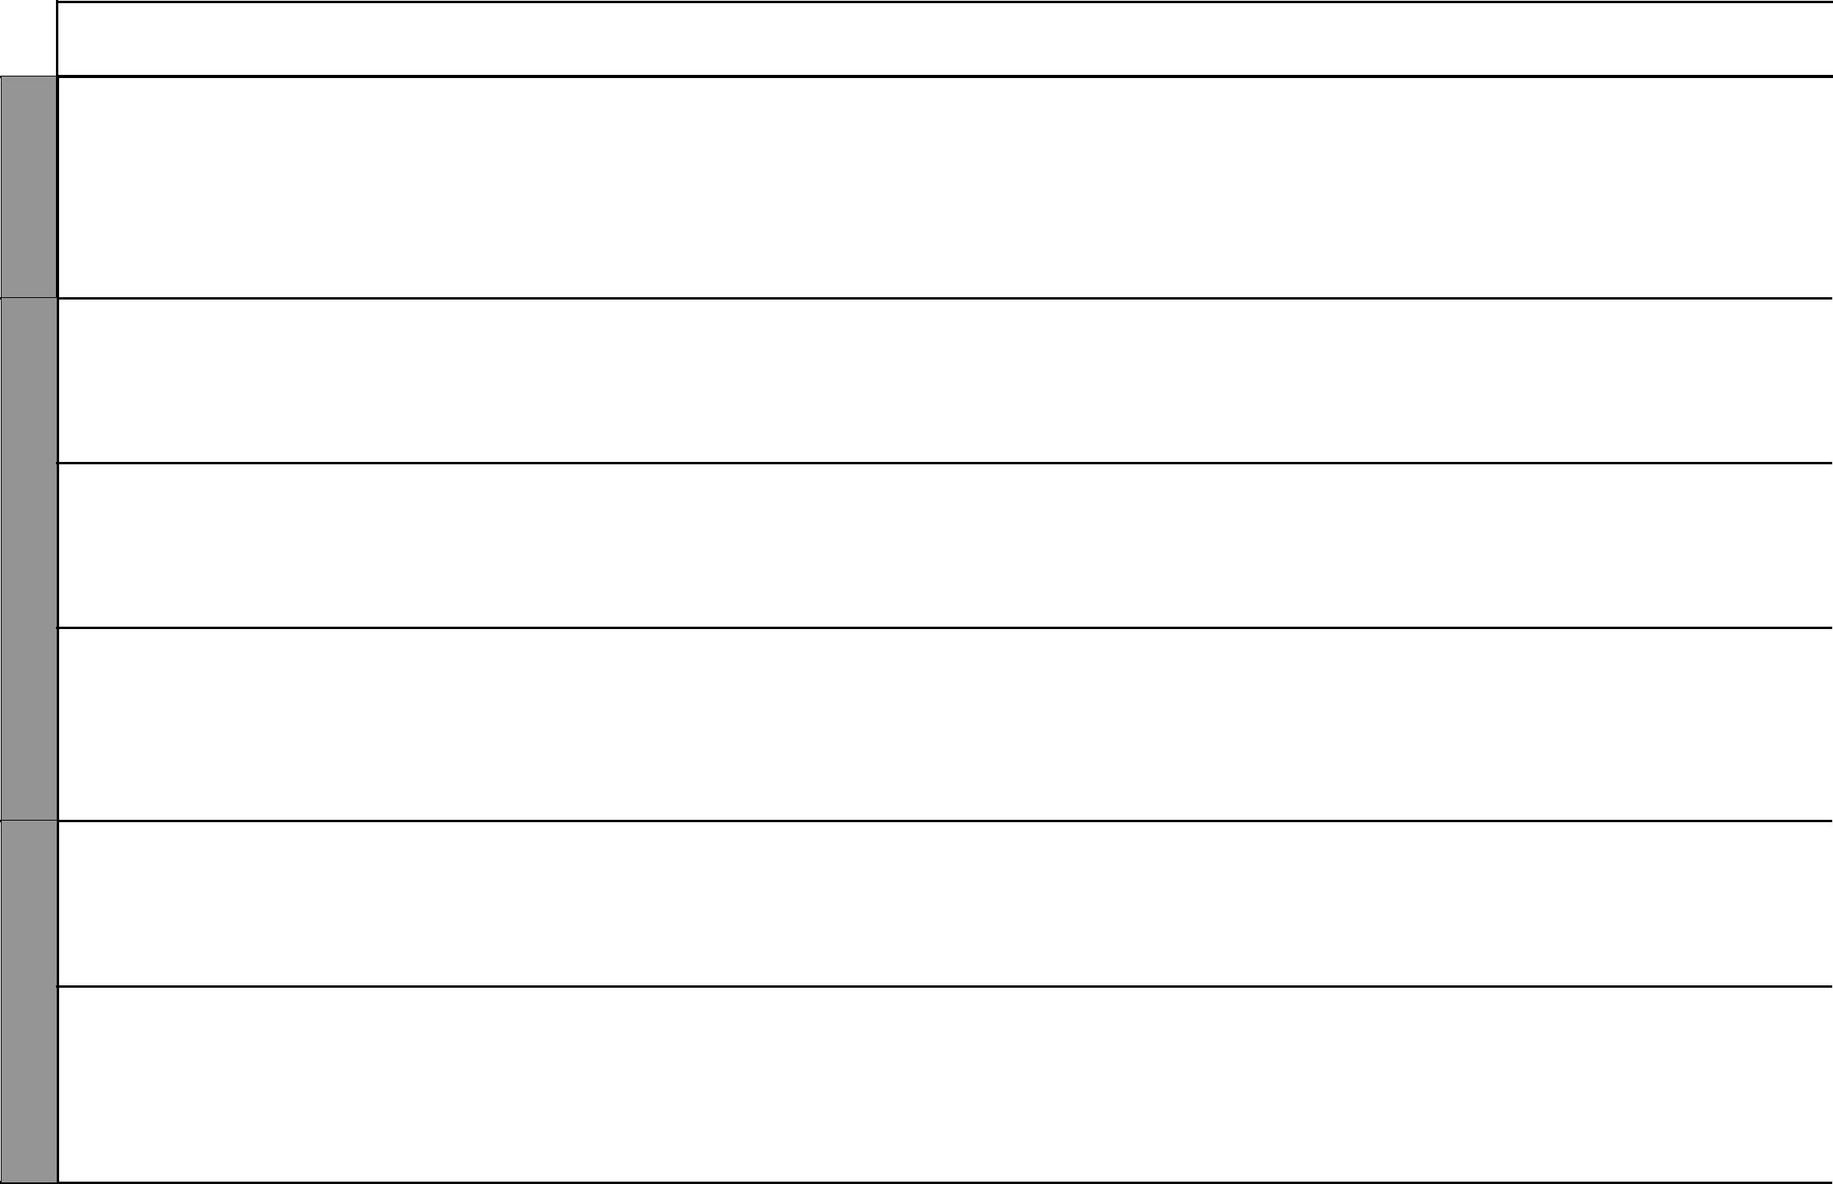

4 For use with Living in Christ Standard Six

Living in Christ Standard Six

Schemes of Work

Term 1


WEEK 7

WEEK 8

WEEK 1

LESSONS | TOPIC | SUB-TOPIC |  | OBJECTIVES | TEACHING/LEARNING |  | TEACHING/LEARNING |  |  | REFERENCES | REMARKS
 |  |  |  |  |  | ACTIVITIES |  | RESOURCES
3 |  | The Second | By the end of the lesson the |  | • | Questions and answers | • | The Good News Bible: 2 | • | Pupil’s Book 6
 |  | Coming | learner should be able to: |  | • | Note taking |  | Peter 3:10-15 |  | page 23
 |  |  | 1. | state how he/she can prepare | • | Dramatization | • | Chalkboard | • | Teacher’s Guide
 |  |  |  | for the second coming of | • Reciting and memorizing of |  |  |  |  | pages 28-29
 |  |  |  | Jesus Christ |  | scripture
 |  |  | 2. | look foward to the second | • | Explanation
 |  |  |  | coming of Jesus Christ
1 |  | Repentance | By the end of the lesson the |  | • | Questions and answers | • | The Good News Bible: Luke | • | Pupil’s Book 6
 |  | and forgiveness | learner should be able to: |  | • | Note taking |  | 15:11-32 |  | pages 24-25
 |  |  | 1. | write down the meaning of | • | Narration: prodigal son | • | Chart drawing of father | • | Teacher’s Guide
 |  |  |  | repentance and forgiveness | • | Scripture reading |  | hugging son |  | page 29-30
 |  |  | 2. | be willing to repent and | • | Dramatization: Prodigal son
 |  |  |  | forgive | • | Explanation
2 |  | Values in | By the end of the lesson the |  | • | Questions and answers | • | The Good News Bible: | • | Pupil’s Book 6
 |  | breaking of | learner should be able to: |  | • | Note taking |  | 1 Corinthians 11:23-36 |  | page 25
 |  | bread | 1. | list the values required during | • | Narration: the story of Kadzo |  |  | • | Teacher’s Guide
 |  |  |  | breaking of bread | • | Scripture reading |  |  |  | page 30
 |  |  | 2. | practice values required in | • | Explanation:
 |  |  |  | breaking of bread
1 | 5. Sup- | Christian sup- | By the end of the lesson the |  | • | Questions and answers | • | The Good News Bible: | • | Pupil’s Book 6
 | porting | port for people | learner should be able to: |  | • | Note taking |  | Psalms 139:14-15, James |  | pages 26-27
 | people | with special | 1. | give reasons why Christians | • | Demonstration |  | 2:14-17 | • | Teacher’s Guide
 | with Spe- | needs |  | should support people with | • | Scripture reading | • | Chart drawing of equipment |  | pages 32-33
 | cial Needs |  |  | special needs | • | Explanation |  | used by people with various
 |  |  | 2. | be willing to support people |  |  |  | disabilities
 |  |  |  | with special needs
2 |  | Supporting | By the end of the lesson the |  | • | Demonstration: charts | • | The Good News Bible: | • | Pupil’s Book 6
 |  | the physically | learner should be able to: |  | • | Explanation |  | Acts 3:1-10 |  | page 27
 |  | impaired | 1. | name types of special needs of | • | Scripture reading | • | Chart drawing of a wheel | • | Teacher’s Guide
 |  |  |  | the physically impaired | • | Note taking |  | chair and other equipment |  | pages 33-34
 |  |  | 2. | be willing to support people |  |  |  | used by people with physical
 |  |  |  | with special needs |  |  |  | disabilities
 |  |  |  |  |  |  | • | Chalkboard

5 For use with Living in Christ Standard Six

Living in Christ Standard Six Schemes of Work: Term Two
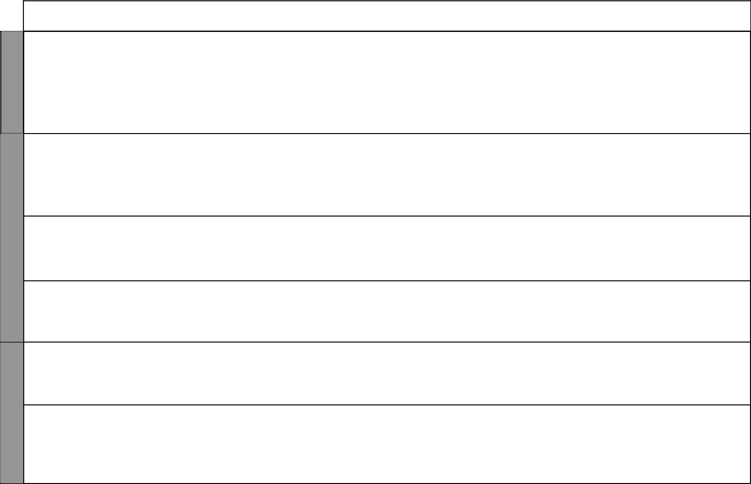

WEEK 1

WEEK 2

WEEK 3

LESSONS | TOPIC | SUB-TOPIC | OBJECTIVES | TEACHING/LEARNING |  | TEACHING/LEARNING |  |  | REFERENCES | REMARKS
 |  |  |  |  | ACTIVITIES |  | RESOURCES
3 |  | Supporting | By the end of the lesson the | • | Demonstration | • | The Good News Bible: | • | Pupil’s Book 6
 |  | the visually | learner should be able to: | • | Explanation: a visually | • | John 9:1-12 |  | page 28
 |  | impaired | 1. name types of special needs of |  | impaired person has | • | Chart drawing: equipment | • | Teacher’s Guide
 |  | impaired | 1. name types of special needs of |  | difficulty in seeing. There are |  | used by people with visual | • | Teacher’s Guide
 |  |  | the visually impaired |  | difficulty in seeing. There are |  | used by people with visual |  | pages 35-36
 |  |  | the visually impaired |  | various levels of visual |  | disabilities |  | pages 35-36
 |  |  | 2. be willing to support people |  | various levels of visual |  | disabilities
 |  |  | 2. be willing to support people |  | impairments. Visually | • | Chalkboard
 |  |  | with special needs |  | impairments. Visually | • | Chalkboard
 |  |  | with special needs |  | impaired persons use lenses | • | Chalkboard
 |  |  |  |  | and braille
 |  |  |  | • | Questions and answers
 |  |  |  | • | Note taking
1 |  | Supporting | By the end of the lesson the | • | Scripture reading | • | The Good News Bible: | • | Pupil’s Book 6
1 |  | Supporting | By the end of the lesson the | • | Explanation: levels of
 |  | the hearing | learner should be able to: | • | Explanation: levels of |  | Mark 7:31-37 |  | pages 28-29
 |  | the hearing | learner should be able to: |  | hearing impairments, use of |  | Mark 7:31-37 |  | pages 28-29
 |  | impaired | 1. name types of special needs of |  | hearing impairments, use of | • | Chart showing hearing aid | • | Teacher’s Guide
 |  | impaired | 1. name types of special needs of |  | sign language and hearing aids
 |  |  | the hearing impaired |  | sign language and hearing aids | • | Chalkboard |  | pages 36-37
 |  |  | the hearing impaired | • | Note taking |  |  |  | pages 36-37
 |  |  | 2. be willing to support people | • | Note taking
 |  |  | 2. be willing to support people | • | Demonstration: sign language
 |  |  | with special needs | • | Demonstration: sign language
 |  |  | with special needs | • | Discussion
2 |  | Caring for the | By the end of the lesson the | • | Scripture reading | • | The Good News Bible: | • | Pupil’s Book 6
 |  | Caring for the | learner should be able to: | • | Explanation |  | Matthew 8:28-34 | • | Pupil’s Book 6
 |  | mentally chal- | 1. name types of special needs of | • | Explanation |  | Matthew 8:28-34 |  | page 29
 |  | mentally chal- | 1. name types of special needs of | • | Note taking |  | Matthew 8:28-34 |  | page 29
 |  | lenged | 1. name types of special needs of | • | Note taking | • | Chalkboard | • | Teacher’s Guide
 |  | lenged | the mentally challenged
 |  |  | 2. be willing to support people |  |  |  |  |  | pages 37-38
 |  |  | with special needs
3 |  | Caring for peo- | By the end of the lesson the | • | Scripture reading | • | The Good News Bible: | • | Pupil’s Book 6
 |  | Caring for peo- | learner should be able to: | • | Explanation |  | Matthew 9:32-33 | • | Pupil’s Book 6
 |  | ple with speech | 1. name types of special needs of | • | Explanation |  | Matthew 9:32-33 |  | page 30
 |  | ple with speech | 1. name types of special needs of | • | Discussion |  | Matthew 9:32-33 |  | page 30
 |  | disorders | 1. name types of special needs of | • | Discussion | • | Chalkboard | • | Teacher’s Guide
 |  | disorders | those with speech disorders | • | Note taking
 |  |  | 2. Be willing to support people | • | Note taking |  |  |  | pages 38-39
 |  |  | 2. Be willing to support people | • | Prayer |  |  |  | pages 38-39
 |  |  | with special needs | • | Prayer
1 |  | Caring for | By the end of the lesson the | • | Scripture reading | • | The Good News Bible: | • | Pupil’s Book 6
 |  | people with | learner should be able to: | • | Explanation |  | Luke 8:42-48 | • | Pupil’s Book 6
 |  | people with | 1. name types of special needs of | • | Explanation |  | Luke 8:42-48 |  | page 30
 |  | emotional | 1. name types of special needs of | • | Questions and answers | • | Chalkboard |  | page 30
 |  | emotional | those with emotional and |  |  |  |  | • | Teacher’s Guide
 |  | and behaviour | behaviour problems | • | Dramatization |  |  | • | Teacher’s Guide
 |  |  |  |  |  |  |  |  | pages 39-40
 |  | problems | 2. be patient with people with | • | Note taking |  |  |  | pages 39-40
 |  | problems | special needs | • | Note taking
2 |  | Caring for | By the end of the lesson the | • | Scripture reading | • | The Good News Bible: | • | Pupil’s Book 6
2 |  | Caring for | By the end of the lesson the | • | Explanation
 |  | orphans | learner should be able to: | • | Explanation |  | Deuteronomy 26:12, |  | page 31
 |  | orphans | learner should be able to: | • | Discussion |  | Deuteronomy 26:12, |  | page 31
 |  |  | 1. name types of special needs | • | Discussion |  | James 1:27, Jeremiah 7:5-6 | • | Teacher’s Guide
 |  |  | 1. name types of special needs | • | Note taking |  | James 1:27, Jeremiah 7:5-6 | • | Teacher’s Guide
 |  |  | of orphans | • | Note taking | • | Chalkboard |  | pages 40-41
 |  |  | of orphans | • | Questions and answers | • | Chalkboard |  | pages 40-41
 |  |  | 2. be willing to support people | • | Questions and answers
 |  |  | 2. be willing to support people | • | Prayer
 |  |  | with special needs | • | Prayer

6 For use with Living in Christ Standard Six

Living in Christ Standard Six

Schemes of Work

Term 2


WEEK 3

WEEK 4

LESSONS | TOPIC | SUB-TOPIC | OBJECTIVES | TEACHING/LEARNING |  | TEACHING/LEARNING |  |  | REFERENCES | REMARKS
 |  |  |  |  | ACTIVITIES |  | RESOURCES
3 |  | Caring for the | By the end of the lesson the | • | Note taking | • | The Good News Bible: | • | Pupil’s Book 6
 |  | poor | learner should be able to: | • | Questions and answers |  | Psalms 41:1 |  | page 31
 |  |  | 1. name types of special needs of | • | Prayer |  |  | • | Teacher’s Guide
 |  |  | the poor | • | Explanation |  |  |  | pages 41-42
 |  |  | 2. tolerate people with special | • | Explanation |  |  |  | pages 41-42
 |  |  | needs
1 |  | Caring for peo- | By the end of the lesson the | • | Scripture reading | • | The Good News Bible: | • | Pupil’s Book 6
 |  | ple living with | learner should be able to | • | Note taking |  | Mark 1:34 |  | pages 32-33
 |  | HIV/AIDS | 1 name types of special needs | • | Explanation: guest speaker | • | Resource person | • | Teacher’s Guide
 |  |  | of those with HIV/AIDS | • | Watching video/audio | • | Video/audio resources |  | pages 42-43
 |  |  | 2. be patient with people with |  | materials on HIV/AIDS
 |  |  | special needs | • | Discussion
 |  |  |  | • | Prayer
2 |  | Supporting | By the end of the lesson the | • | Scripture reading | • | The Good News Bible: | • | Pupil’s Book 6
 |  | refugees | learner should be able to: | • | Explanation |  | Mark 2:1-12 |  | pages 33-34
 |  |  | 1. name types of special needs of | • | Discussion | • | Resource person | • | Teacher’s Guide
 |  |  | refugees | • | Note taking | • | Video/audio resources |  | page 44
 |  |  | 2. tolerate people with special | • | Reading newspaper cuttings
 |  |  | needs | • | Dramatization
 |  |  |  | • | Narration
 |  |  |  | • | Prayer
2 |  | Supporting | By the end of the lesson the | • | Scripture reading | • | The Good News Bible: | • | Pupil’s Book 6
 |  | street children | learner should be able to: | • | Watching film or video |  | James 2:14-17 |  | page 34
 |  |  | 1. name types of special needs of | • | Explanation | • | Resource person | • | Teacher’s Guide
 |  |  | street children | • | Discussion | • | Video/audio materials |  | pages 45-46
 |  |  | 2. be patient with people with | • | Questions and answers
 |  |  | special needs | • | Note taking
 |  |  |  | • | Prayer
3 | 6. Living a | Acquiring self- | By the end of the lesson the | • | Scripture reading | • | The Good News Bible: | • | Pupil’s Book 6
 | responsi- | awareness | learner should be able to: | • | Discussion |  | Isaiah 43: 4 |  | pages 36-37
 | ble Life |  | 1. state ways in which he/she can | • | Explanation | • | Realia i.e. mirror | • | Teacher’s Guide
 |  |  | express feelings of self-worth | • | Questions and answers | • | Chalkboard |  | pages 48-49
 |  |  | 2. appreciate himself/herself | • | Note taking | • | Chart showing relationship
 |  |  |  | • | Prayer |  | between body mind and soul

7 For use with Living in Christ Standard Six

WEEK 5

WEEK 6

 |  |  |  |  |  |  |  |  |  |  |  |  |  |  | Living in Christ Standard Six
 |  |  |  |  |  |  |  |  |  |  |  |  |  |  | Schemes of Work
 |  |  |  |  |  |  |  |  |  |  |  |  |  |  |  |  | Term 2
LESSONS |  | TOPIC |  | SUB-TOPIC |  | OBJECTIVES |  | TEACHING/LEARNING |  |  | TEACHING/LEARNING |  |  | REFERENCES |  |  | REMARKS
 |  |  |  |  |  |  |  |  | ACTIVITIES |  |  | RESOURCES
1 |  |  |  | Identifying | By the end of the lesson the |  |  | • | Scripture reading |  | • | The Good News Bible: |  | • | Pupil’s Book 6
 |  |  |  | interests and | learner should be able to: |  |  | • | Discussion |  |  | 1 Corinthians 12:4-11, |  |  | page 37
 |  |  |  | abilities | 1. | describe his/her interests and |  | • | Narration |  |  | Matthew 25:14-30 |  | • | Teacher’s Guide
 |  |  |  |  |  | abilities |  | • | Note taking |  | • | Realia: objects such as |  |  | pages 49-50
 |  |  |  |  | 2. | appreciate him/herself |  |  |  |  |  | football, art instruments etc
 |  |  |  |  |  |  |  |  |  |  | • | Flashcards
 |  |  |  |  |  |  |  |  |  |  | • | Chalkboard
2 |  |  |  | Using our | By the end of the lesson the |  |  | • | Scripture reading |  | • | The Good News Bible: |  | • | Pupil’s Book 6
 |  |  |  | abilities | learner should be able to: |  |  | • | Discussion |  |  | 1 Peter 4:10-11 |  |  | page 37
 |  |  |  |  | 1. | describe his/her interests and |  | • | Class presentation |  | • | Chalkboard |  | • | Teacher’s Guide
 |  |  |  |  |  | abilities |  | • | Narration |  |  |  |  |  | pages 50-51
 |  |  |  |  | 2. | appreciate him/herself |  | • | Explanation
 |  |  |  |  |  |  |  | • | Note taking
3 |  |  |  | Acceptable | By the end of the lesson the |  |  | • | Scripture reading |  | • | The Good News Bible: |  | • | Pupil’s Book 6
 |  |  |  | character traits | learner should be able to: |  |  | • | Discussion |  |  | 1 Peter 2:1-3 |  |  | pages 38-39
 |  |  |  |  | 1. | state his/ her own acceptable |  | • | Explanation |  | • | Chalkboard |  | • | Teacher’s Guide
 |  |  |  |  |  | and less acceptable character |  | • | Note taking |  |  |  |  |  | pages 51-52
 |  |  |  |  |  | traits |  | • | Questions and answers
 |  |  |  |  | 2. | appreciate him/herself
1 |  |  |  | Responsible | By the end of the lesson the |  |  | • | Questions and answers |  | • | The Good News Bible: |  | • | Pupil’s Book 6
 |  |  |  | behaviour at | learner should be able to: |  |  | • | Scripture reading |  |  | Ephesians 4:25-32, |  |  | pages 39-40
 |  |  |  | home | 1. | state how he/she can behave |  | • | Explanation |  |  | Colossians 3:20 |  | • | Teacher’s Guide
 |  |  |  |  |  | responsibly at home |  | • | Note taking |  | • | Chalkboard |  |  | pages 52-53
 |  |  |  |  | 2. | respect authority |  | • | Dramatization
 |  |  |  |  |  |  |  | • | Memorization
2 |  |  |  | Responsible | By the end of the lesson the |  |  | • | Scripture reading |  | • | The Good News Bible: |  | • | Pupil’s Book 6
 |  |  |  | behaviour in | learner should be able to: |  |  | • | Questions and answers |  |  | Ephesians 4:25-32, |  |  | pages 40-42
 |  |  |  | public | 1. | state how he/she can behave |  | • | Discussion |  |  | Romans 13:1-5 |  | • | Teacher’s Guide
 |  |  |  |  |  | responsibly in public |  | • | Dramatization |  | • | Chalkboard |  |  | pages 53-54
 |  |  |  |  | 2. | respect his/her property and |  | • | Explanation
 |  |  |  |  |  | that of others |  | • | Note taking
 |  |  |  |  |  |  |  | • | Recitation of scripture
3 |  |  |  | Developing | By the end of the lesson the |  |  | • | Scripture reading |  | • | The Good News Bible: |  | • | Pupil’s Book 6
 |  |  |  | goal seeking | learner should be able to: |  |  | • | Questions and answers |  |  | Matthew 25:14-30 |  |  | pages 42-44
 |  |  |  | behaviour | 1. | explain how he/she can |  | • | Discussion |  | • | Chalkboard |  | • | Teacher’s Guide
 |  |  |  |  |  | develop goal seeking behaviour |  | • | Explanation |  |  |  |  |  | pages 54-55
 |  |  |  |  | 2. | set clear goals |  | • | Note taking
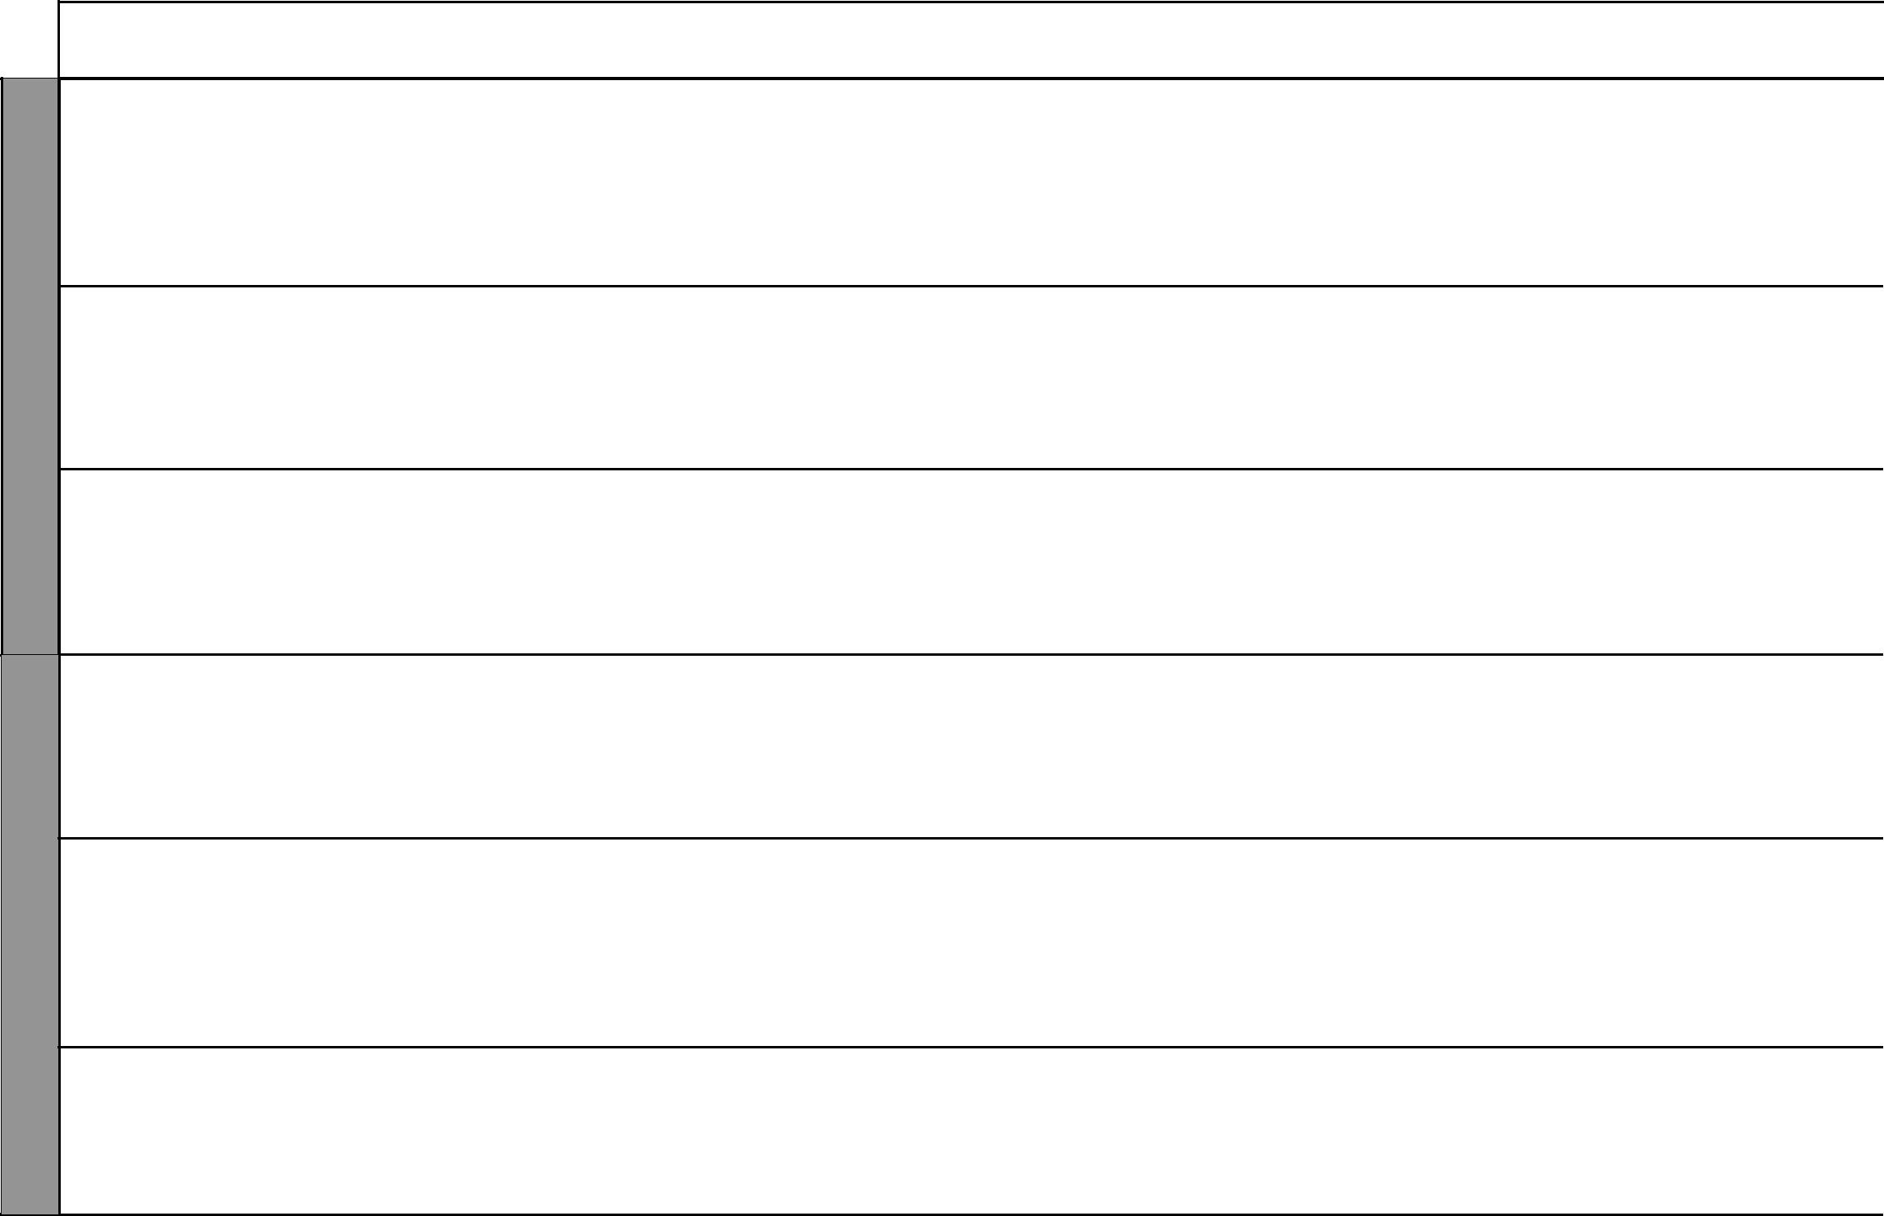

8 For use with Living in Christ Standard Six

Living in Christ Standard Six

Schemes of Work

Term 2
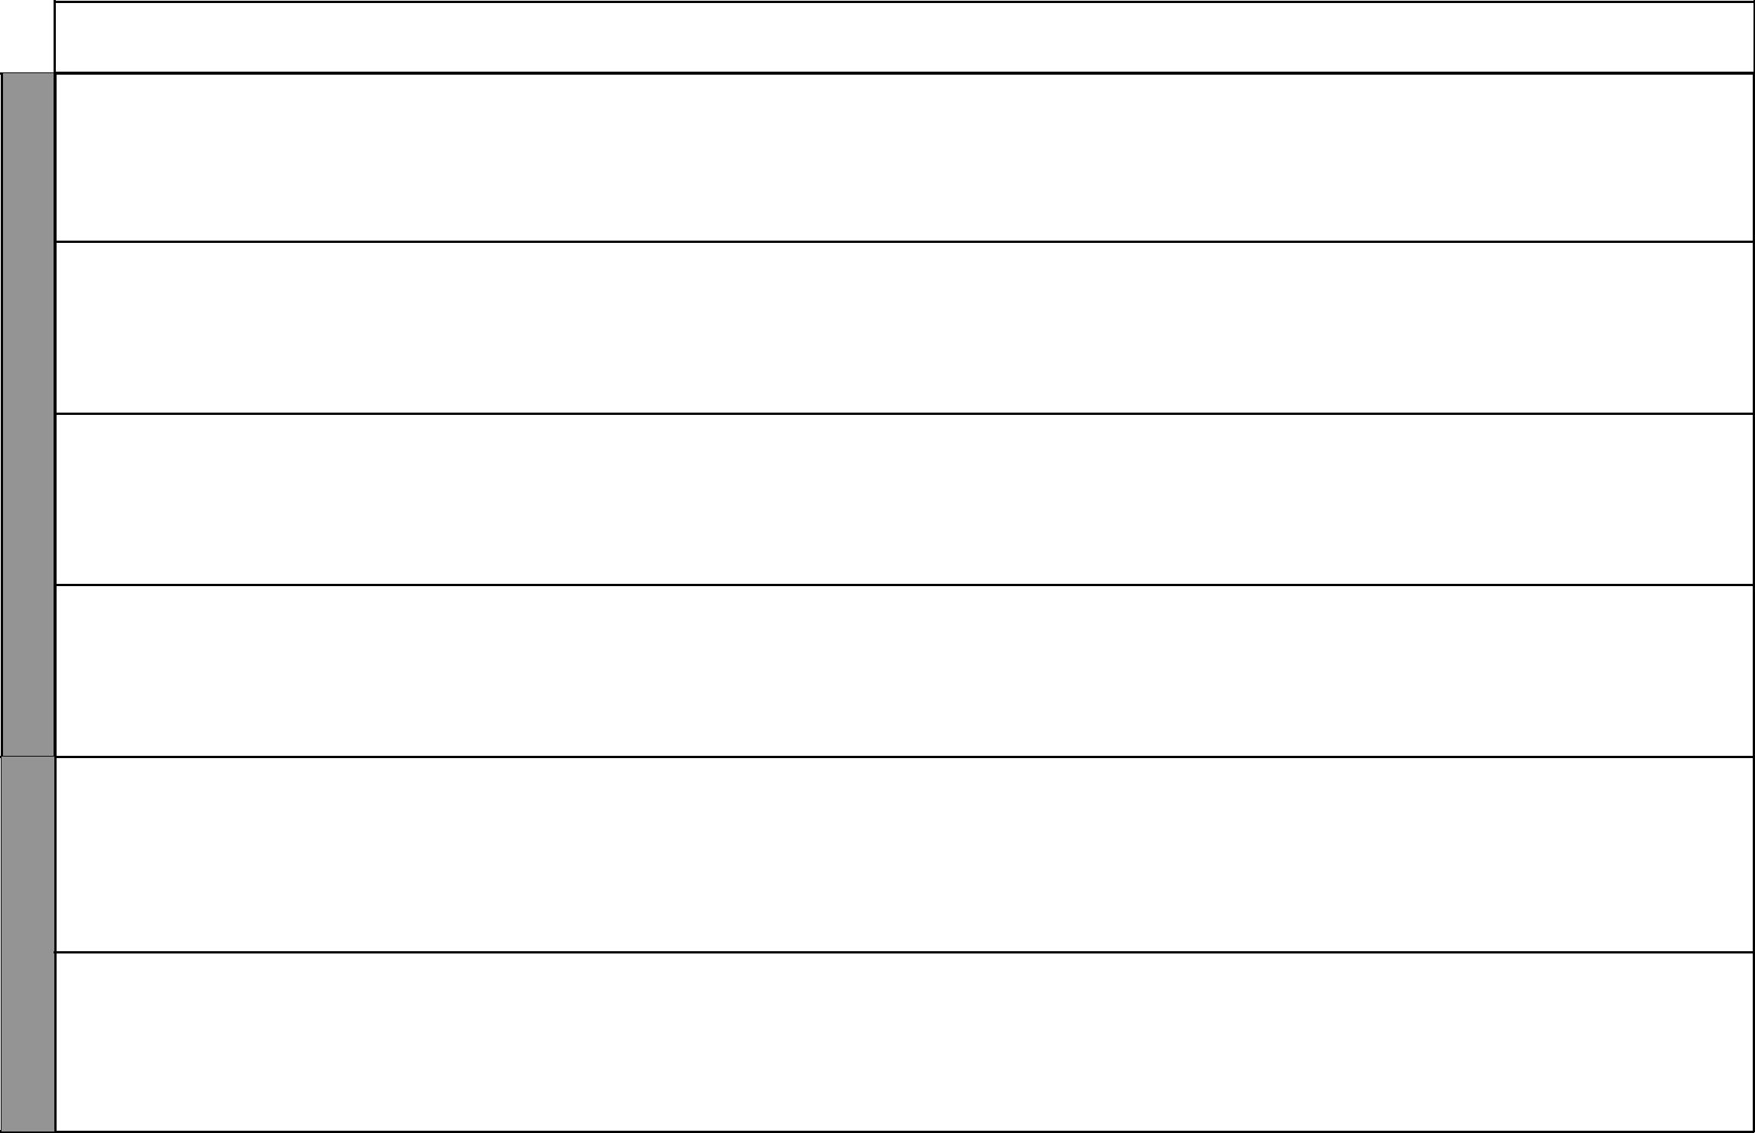

WEEK 7

WEEK 8

LESSONS | TOPIC | SUB-TOPIC |  | OBJECTIVES | TEACHING/LEARNING |  | TEACHING/LEARNING |  |  | REFERENCES | REMARKS
 |  |  |  |  |  | ACTIVITIES |  | RESOURCES
1 |  | Assertiveness | By the end of the lesson the |  | • | Scripture reading | • | The Good News Bible: | • | Pupil’s Book 6
 |  |  | learner should be able to: |  | • | Question and answer |  | Genesis 39:6-12 |  | pages 44-46
 |  |  | 1. | state how others regard | • | Explanation |  |  | • | Teacher’s Guide
 |  |  |  | him/her | • | Note taking | • | Chalkboard |  | pages 55-57
 |  |  | 2. | appreciate him/herself | • | Discussion
 |  |  |  |  | • | Miming
2 |  | Making deci- | By the end of the lesson the |  | • | Class quiz | • | The Good News Bible: | • | Pupil’s Book 6
 |  | sions | learner should be able to: |  | • | Scripture reading |  | Joshua 24:15 |  | pages 46-47
 |  |  | 1. | state the meaning of decision | • | Brainstorming | • | Chalkboard | • | Teacher’s Guide
 |  |  |  | making | • | Explanation |  |  |  | pages 57-58
 |  |  | 2. | desire to make the right | • | Discussion
 |  |  |  | decisions | • | Note taking
3 |  | Critical think- | By the end of the lesson the |  | • | Scripture reading | • | The Good News Bible: | • | Pupil’s Book 6
 |  | ing | learner should be able to: |  | • | Discussion |  | Luke 4:1-4 |  | pages 47-48
 |  |  | 1. | state the meaning of critical | • | Explanation | • | Chalkboard | • | Teacher’s Guide
 |  |  |  | thinking
 |  |  |  | thinking | • | Questions and answers |  |  |  | pages 58-59
 |  |  | 2. | explain situations that require | • | Questions and answers |  |  |  | pages 58-59
 |  |  |  | critical thinking and desire to | • | Class quizzes
 |  |  |  | develop those skills | • | Note taking
4 |  | Creative | By the end of the lesson the |  | • | Scripture reading | • | The Good News Bible: 1 | • | Pupil’s Book 6
4 |  | thinking | learner should be able to: |  | • | Class quizzes |  | Kings 3:16-28 |  | pages 49-50
 |  |  | 1. | explain the meaning of | • | Discussion | • | Chalkboard | • | Teacher’s Guide
 |  |  |  | creative thinking | • | Note taking | • | Chart |  | page 59
 |  |  | 2. | desire to develop creative | • | Questions and answers
 |  |  |  | thinking skills | • | Explanation
1 |  | Listening and | By the end of the lesson the |  | • | Scripture reading | • | The Good News Bible: | • | Pupil’s Book 6
 |  | responding to | learner should be able to: |  | • | Discussion |  | John 3:1-10 |  | pages 50-51
 |  | others | 1. | describe the importance of | • | Explanation | • | Chalkboard | • | Teacher’s Guide
 |  |  |  | following instructions | • | Questions and answers |  |  |  | page 60
 |  |  | 2. | make and maintain friendship | • | Narration
 |  |  |  |  | • | Note taking
 |  |  |  |  | • | Role playing
2 | 7. Being | Gifts and fruit | By the End of the lesson the |  | • | Scripture reading | • | The Good News Bible: | • | Pupil’s Book 6
 | led by | of the Holy | learner should be able to: |  | • | Questions and answers |  | 1 Corinthians 12:4-11, |  | pages 52-53
 | the Holy | Spirit | 1. | list the fruit and gifts of the | • | Explanation |  | Galatians 5:22-23 | • | Teacher’s Guide
 | Spirit |  |  | Holy Spirit | • | Dramatization | • | Charts |  | pages 61-62
 |  |  | 2. | desire to be led by the holy | • | Note taking | • | Chalkboard
 |  |  |  | spirit |  |  | • | Real objects i.e. fruits

9 For use with Living in Christ Standard Six

WEEK 8

WEEK 9

WEEK 10

 |  |  |  |  |  |  |  |  |  |  |  |  |  | Living in Christ Standard Six
 |  |  |  |  |  |  |  |  |  |  |  |  |  | Schemes of Work
 |  |  |  |  |  |  |  |  |  |  |  |  |  |  |  | Term 2
LESSONS |  | TOPIC |  | SUB-TOPIC |  | OBJECTIVES |  | TEACHING/LEARNING |  |  | TEACHING/LEARNING |  |  | REFERENCES |  | REMARKS
 |  |  |  |  |  |  |  |  | ACTIVITIES |  |  | RESOURCES
3 |  |  |  | Gideon: A |  | By the end of the lesson the |  | • | Scripture reading |  | • | The Good News Bible: | • | Pupil’s Book 6
 |  |  |  | brave and |  | learner should be able to: |  | • | Questions and answers |  |  | Judges 6:11-16, |  | pages 53-54
 |  |  |  | mighty man |  | 1. tell the story of Gideon |  | • | Narration |  |  | 7:1-3, 7:16-22 | • | Teacher’s Guide
 |  |  |  |  |  | 2. desire to be led by the Holy |  | • | Group discussion |  | • | Picture drawing of Gideon |  | pages 63-64
 |  |  |  |  |  | Spirit |  | • | Class presentation |  | • | Chalkboard
 |  |  |  |  |  |  |  | • | Explanation
 |  |  |  |  |  |  |  | • | Note taking
1 |  |  |  | Paul’s re- |  | By the End of the lesson the |  | • | Scripture reading |  | • | The Good News Bible: | • | Pupil’s Book 6
 |  |  |  | sponse to the |  | learner should be able to |  | • | Questions and answers |  |  | Acts 16:6-10, 18:9-11, |  | pages 54-55
 |  |  |  | Holy Spirit |  | 1. explain how Paul responded to |  | • | Explanation |  |  | 20:22-24 | • | Teacher’s Guide
 |  |  |  |  |  | the Holy Spirit |  | • | Note taking |  | • | Chalkboard |  | page 65
 |  |  |  |  |  | 2. desire to be led by the Holy |  | • | Discussion
 |  |  |  |  |  | spirit
2 |  |  |  | How the Holy |  | By the end of the lesson the |  | • | Scripture reading |  | • The Good News Bible: |  | • Pupil’s Book 6
 |  |  |  | Spirit led the |  | learner should be able to: |  | • | Questions and answers |  |  | 2 Timothy 3:14-17 |  | pages 55-56
 |  |  |  | writers of the |  | 1. explain how the Holy Spirit |  | • | Reading newspaper cuttings |  | • | Chalkboard | • | Teacher’s Guide
 |  |  |  | Bible |  | guided the writers of the Bible |  | • | Explanation |  | • | Newspaper cuttings |  | pages 65-66
 |  |  |  |  |  | 2. read the Bible daily |  | • | Demonstration |  | • | Picture of Bible
 |  |  |  |  |  |  |  | • | Note taking
3 |  |  |  | Using the |  | By the end of the lesson the |  | • | Scripture reading |  | • | The Good News Bible: | • | Pupil’s Book 6
 |  |  |  | Bible as our |  | learner should be able to: |  | • | Narration |  |  | Acts 8:26-40 |  | pages 56-57
 |  |  |  | guide |  | 1. narrate the story of Philip and |  | • | Explanation |  | • | Charts | • | Teacher’s Guide
 |  |  |  |  |  | the Ethiopian Eunuch |  | • | Questions and answers |  | • Chalkboard |  |  | pages 67-68
 |  |  |  |  |  | 2. use the Bible as his/her guide |  | • | Discussion
 |  |  |  |  |  |  |  | • | Dramatization
1 |  |  |  | Charismatic |  | By the end of the lesson the |  | • | Scripture reading |  | • | The Good News Bible: | • | Pupil’s Book 6
 |  |  |  | renewal in |  | learner should be able to: |  | • | Questions and answers |  |  | Acts 5:32, John 1:12, |  | pages 57-58
 |  |  |  | the church in |  | 1. describe the charismatic |  | • | Group discussion |  |  | Luke 11:13 | • | Teacher’s Guide
 |  |  |  | Kenya today |  | renewal in Kenya |  | • | Class presentation |  | • | Charts |  | pages 68-69
 |  |  |  |  |  | 2. appreciate the charismatic |  | • | Explanation |  | • | Chalkboard
 |  |  |  |  |  | renewal in the church today |  | • | Note taking
 |  |  |  |  |  |  |  | • | Memorization
2 |  |  |  | The Holy |  | By the end of the lesson the |  | • | Scripture reading |  | • The Good News Bible: |  | • Pupil’s Book 6
 |  |  |  | Spirit in the |  | learner should be able to: |  | • | Questions and answers |  |  | 2 Peter 1:2-4, John 16: |  | pages 56-58
 |  |  |  | Life of a |  | 1. list the gifts and fruit of the |  | • | Explanation |  |  | 15-32, Acts 13:1-4 | • | Teacher’s Guide
 |  |  |  | Life of a |  | 1. list the gifts and fruit of the |  | • | Note taking |  |  | 15-32, Acts 13:1-4 | • | Teacher’s Guide
 |  |  |  | Christian |  | Holy spirit |  | • | Singing |  | • | Chalkboard |  | pages 69-70
 |  |  |  |  |  | 2. desire to be led by the Holy |  | • | Discussion
 |  |  |  |  |  | Spirit |  | • | Memorization
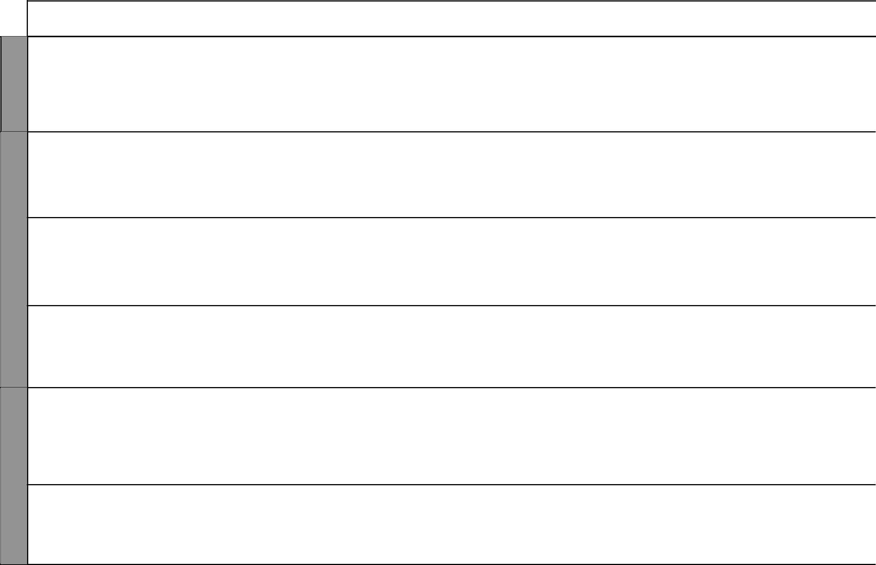

10 For use with Living in Christ Standard Six

Living in Christ Standard Six Schemes of Work: Term Three


WEEK 10

WEEK 1

WEEK 2

LESSONS | TOPIC | SUB-TOPIC |  | OBJECTIVES | TEACHING/LEARNING |  | TEACHING/LEARNING |  |  | REFERENCES | REMARKS
 |  |  |  |  |  | ACTIVITIES |  | RESOURCES
3 |  | Unity in the | By the end of the lesson the |  | • | Scripture reading | • The Good News Bible: |  | • | Pupil’s Book 6
 |  | Church | learner should be able to: |  | • | Explanation |  | Ephesians 4:3-6 |  | pages 58-59
 |  |  | 1. | state how the Holy Spirit has | • | Singing | • | Charts | • | Teacher’s Guide
 |  |  |  | led to unity in the church | • | Note taking | • | Chalkboard |  | pages 70-71
 |  |  | 2. | desire to be led by the Holy | • | Quizzes
 |  |  |  | Spirit | • | Discussion
1 | 8. God’s | My Class | By the end of the lesson the |  | • | Scripture reading | • The Good News Bible: |  | • | Pupil’s Book 6
 | people |  | learner should be able to: |  | • | Explanation |  | Psalms 139:13-18 |  | pages 60-61
 | are united |  | 1. | mention the differences | • | Demonstration | • | Chalkboard | • | Teacher’s Guide
 |  |  |  | among pupils in class | • | Observation and note taking | • Real objects of different |  |  | pages 72-73
 |  |  | 2. | accept differences among | • | Discussion |  | types e.g. fruits
 |  |  |  | pupils in class
2 |  | Our communi- | By the end of the lesson the |  | • | Scripture reading | • The Good News Bible: |  | • | Pupil’s Book 6
 |  | ty background: | learner should be able to: |  | • | Explanation |  | 1 Corinthians 12:27-30, |  | pages 61-63
 |  | Appreciating | 1. | state differences in the local | • | Group discussion |  | Romans 12:4-10 | • | Teacher’s Guide
 |  | ethnic differ- |  | community | • | Class presentation | • | Chalkboard |  | pages 73-75
 |  | ences | 2. | be grateful to God for | • | Brainstorming
 |  |  |  | individual differences | • | Note taking
3 |  | Appreciating | By the end of the lesson the |  | • | Scripture reading | • The Good News Bible: |  | • | Pupil’s Book 6
 |  | religious, | learner should be able to: |  | • | Explanation |  | Galatians 3:28, John 4:7-9 |  | pages 61-63
 |  | nationality | 1. | explain how he/she can over | • | Discussion | • | Chalkboard | • | Teacher’s Guide
 |  | and racial |  | come social barriers in life | • | Note taking | • Items peculiar to different |  |  | pages 76-78
 |  | backgrounds | 2. | respect each other and other |  |  |  | religions e.g. Koran, Rosary,
 |  |  |  | religions |  |  |  | Bible e.t.c
1 |  | Supporting the | By the end of the lesson the |  | • | Scripture reading | • The Good News Bible: |  | • | Pupil’s Book 6
 |  | needy | learner should be able to: |  | • | Explanation |  | Romans 15:26-29 |  | pages 64-66
 |  |  | 1. | state how he /she accepts the | • | Discussion | • | Chalkboard | • | Teacher’s Guide
 |  |  |  | needy people in society | • | Note taking |  |  |  | pages 79-80
 |  |  | 2. | realize that we are all equal | • | Narration
 |  |  |  | before God
2 |  | Accepting the | By the end of the lesson the |  | • | Discussion | • The Good News Bible: |  | • | Pupil’s Book 6
 |  | less fortunate | learner should be able to: |  | • | Explanation |  | Luke 17:11-19, 10:25-37, |  | page 67
 |  |  | 1. | explain how he/she can | • | Note taking |  | James 2:5-9, 14-18. | • | Teacher’s Guide
 |  |  |  | overcome social barriers | • | Narration | • | Pictures |  | pages 81-82
 |  |  |  | in life | • | Questions and answers | • | Chalkboard
 |  |  | 2. | realize that we are all equal
 |  |  |  | before God

11 For use with Living in Christ Standard Six

WEEK 2

WEEK 3

WEEK 4

 |  |  |  |  |  |  |  |  |  |  |  |  |  | Living in Christ Standard Six
 |  |  |  |  |  |  |  |  |  |  |  |  |  | Schemes of Work
 |  |  |  |  |  |  |  |  |  |  |  |  |  |  |  | Term 3
LESSONS |  | TOPIC |  | SUB-TOPIC |  | OBJECTIVES |  | TEACHING/LEARNING |  |  | TEACHING/LEARNING |  |  | REFERENCES |  | REMARKS
 |  |  |  |  |  |  |  |  | ACTIVITIES |  |  | RESOURCES
3 |  |  |  | We are all | By the end of the lesson the |  |  | • | Discussion |  | • | The Good News Bible: | • | Pupil’s Book 6
 |  |  |  | equal before | learner should be able to: |  |  | • | Narration |  |  | James 2:1-4, |  | pages 67-68
 |  |  |  | God | 1. | state how we are all equal |  | • | Scripture reading |  |  | 1 Corinthians 12: 14-20, | • | Teacher’s Guide
 |  |  |  |  |  | before God |  | • | Questions and answers |  | • | Chalkboard |  | pages 83-84
 |  |  |  |  | 2. | realize that we are all created |  | • | Note taking
 |  |  |  |  |  | in the image of God
1 |  |  |  | Role of the | By the end of the lesson the |  |  | • | Scripture reading |  | • | The Good News Bible: | • | Pupil’s Book 6
 |  |  |  | Church in | learner should be able to: |  |  | • | Discussion |  |  | Psalms 133:1-3, |  | pages 68-69
 |  |  |  | uniting people | 1. | explain the role of the |  | • | Questions and answers |  |  | John 17:9-11, James 4:11-12 | • | Teacher’s Guide
 |  |  |  |  |  | church in uniting people |  | • | Note taking |  | • | Chalkboard |  | pages 85-86
 |  |  |  |  | 2. | appreciate the efforts made |  | • | Field visit
 |  |  |  |  |  | by the church in uniting people
2 |  | 9. Dignity |  | Definition of | By the end of the lesson the |  |  | • | Scripture reading |  | • | The Good News Bible: | • | Pupil’s Book 6
 |  | of Work |  | work | learner should be able to: |  |  | • | Discussion |  |  | Genesis 2:1-3, 2:15 |  | page 70
 |  |  |  |  | 1. | define work |  | • | Note taking |  | • | Chalkboard | • | Teacher’s Guide
 |  |  |  |  | 2. | work willingly |  | • | Questions and answers |  | • | Chart of various types of |  | page 87
 |  |  |  |  |  |  |  | • | Role play |  |  | work
3 |  |  |  | Why people | By the end of the lesson the |  |  | • | Scripture reading |  | • | The Good News Bible: | • | Pupil’s Book 6
 |  |  |  | work today in | learner should be able to: |  |  | • | Group Discussion |  |  | Genesis 2:15 |  | pages 71-72
 |  |  |  | Traditional | 1. | give reasons why people work |  | • | Class presentations |  | • | Chalkboard | • | Teacher’s Guide
 |  |  |  | African |  | today and in the traditional |  | • | Note taking |  | • | Resource person |  | page 88
 |  |  |  | Society |  | African society |  | • | Narration
 |  |  |  |  | 2. | develop positive attitudes
 |  |  |  |  |  | towards work
 |  |  |  | Reasons why | By the end of the lesson the |  |  | • | Scripture reading |  | • | The Good News Bible: | • | Pupil’s Book 6
1 |  |  |  | God wants us | learner should be able to: |  |  | • | Discussion |  |  | John 4:40-44, 5:17, |  | pages 72-73
 |  |  |  | to work | 1. | explain why God wants him/ |  | • | Questions and answers |  |  | Romans 12:6-8 | • | Teacher’s Guide
 |  |  |  |  |  | her to work |  | • | Brainstorming |  | • | Chart |  | page 89
 |  |  |  |  | 2. | work willingly |  | • | Quizzes |  | • | Chalkboard
 |  |  |  |  |  |  |  | • | Note taking
2 |  |  |  | Division of | By the end of the lesson the |  |  | • | Scripture reading |  | • | The Good News Bible: | • | Pupil’s Book 6
 |  |  |  | work at home | learner should be able to: |  |  | • | Discussion |  |  | 1 Thessalonians 4:1, |  | pages 73-74
 |  |  |  | work at home |  |  |  | • | Discussion |  |  | 1 Thessalonians 4:1, | • | Teacher’s Guide
 |  |  |  |  | 1. | explain how work is divided |  | • | Role play |  |  | 2 Thessalonians 3:10-12, | • | Teacher’s Guide
 |  |  |  |  | 1. | explain how work is divided |  | • | Role play |  |  | 2 Thessalonians 3:10-12, |  | pages 90-91
 |  |  |  |  | 1. | explain how work is divided |  | • | Role play |  |  | Colossians 3:23 |  | pages 90-91
 |  |  |  |  |  | at home |  | • | Brainstorming |  |  | Colossians 3:23 |  | pages 90-91
 |  |  |  |  |  | at home |  | • | Brainstorming |  | • | Charts
 |  |  |  |  | 2. | work willingly |  | • | Note taking |  | • | Charts
 |  |  |  |  | 2. | work willingly |  | • | Note taking |  | • | Chalkboard
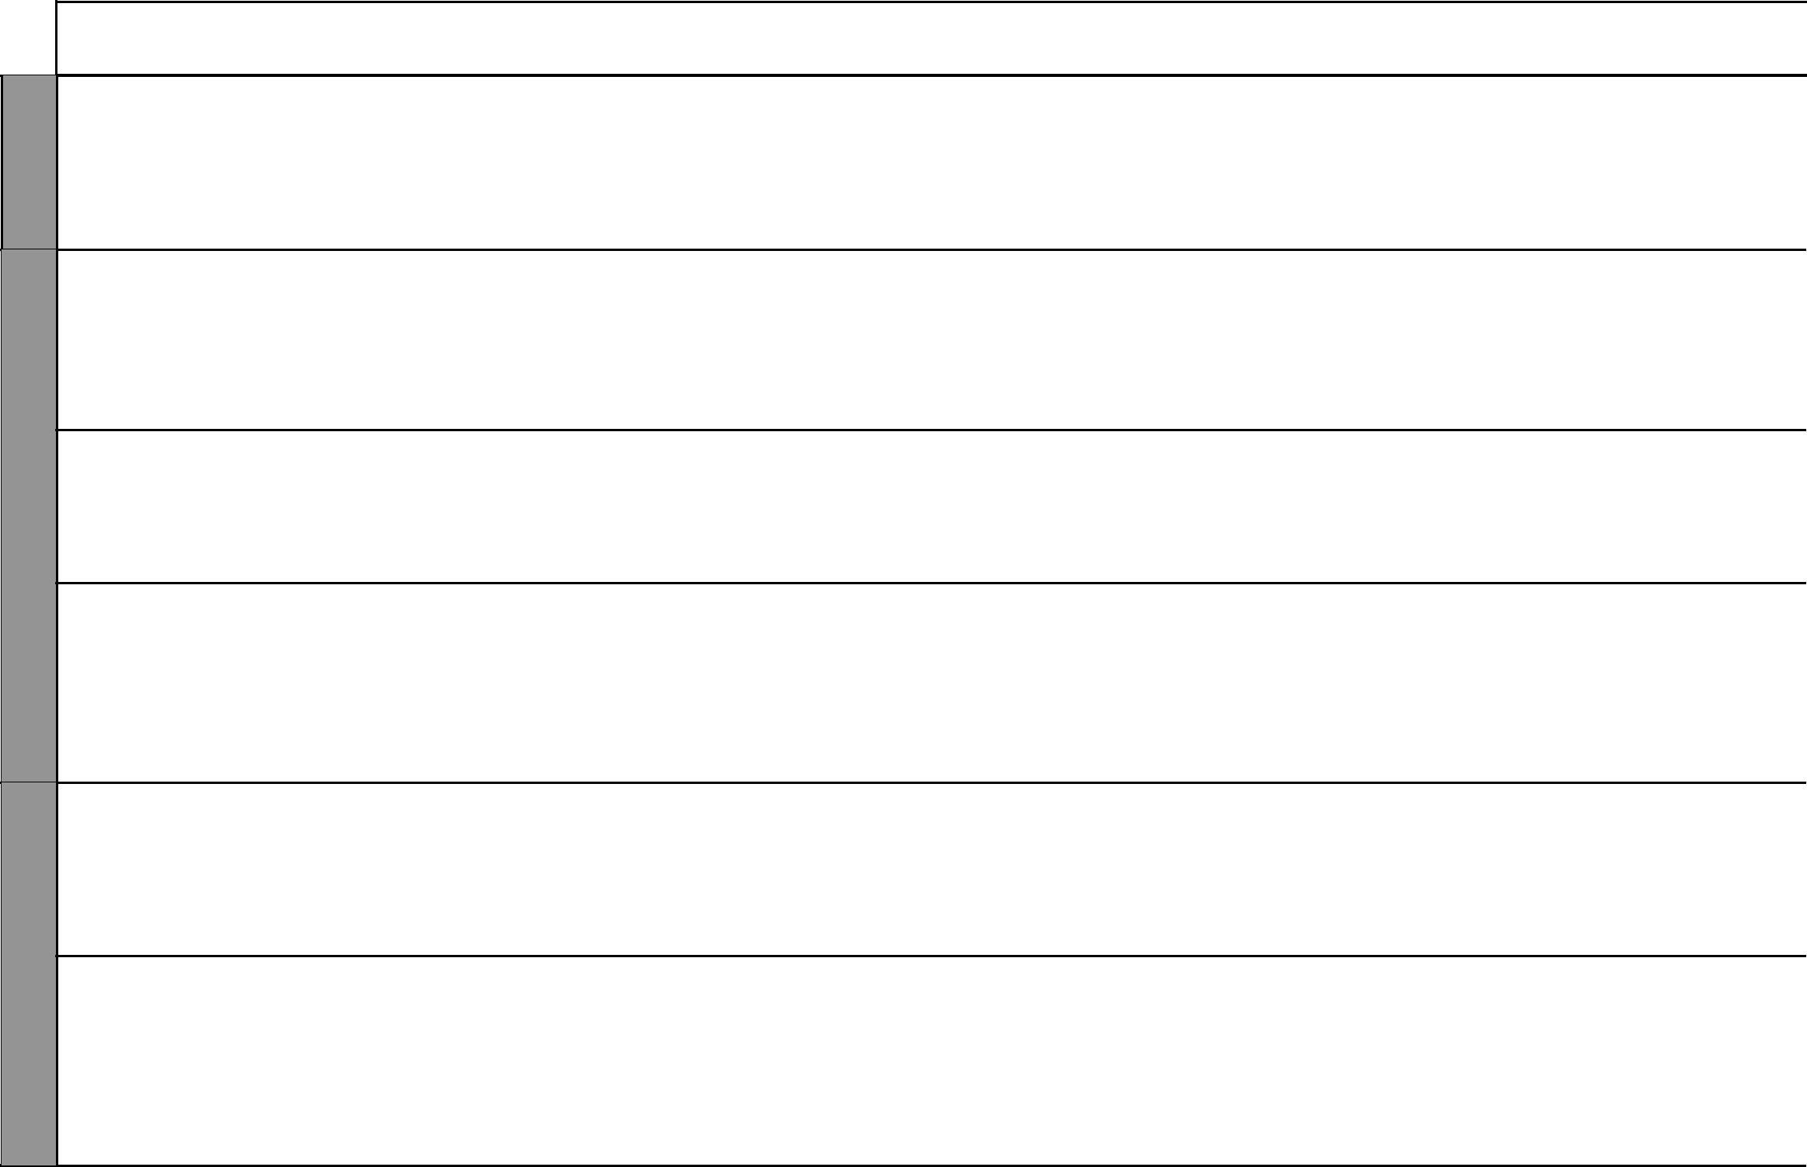

12 For use with Living in Christ Standard Six

Living in Christ Standard Six

Schemes of Work

Term 3


WEEK 4

WEEK 5

WEEK 6

LESSONS | TOPIC | SUB-TOPIC |  | OBJECTIVES | TEACHING/LEARNING |  | TEACHING/LEARNING |  |  | REFERENCES | REMARKS
 |  |  |  |  |  | ACTIVITIES |  | RESOURCES
3 |  | Forms of Child | By the end of the lesson the |  | • | Scripture reading | • The Good News Bible: |  | • | Pupil’s Book 6
 |  | labour | learner should be able to: |  | • | Discussion |  | 2 Kings 5:2 |  | pages 74-75
 |  |  | 1. | describe various forms of | • | Role play | • Film/video on child labour |  | • | Teacher’s Guide
 |  |  |  | child labour | • | Watching film/video | • | Chalkboard |  | pages 91-92
 |  |  | 2. | work willingly | • | Note taking
 |  |  |  |  | • | Questions and answers
1 |  | Effects of child | By the end of the lesson the |  | • | Scripture reading | • The Good News Bible: |  | • | Pupil’s Book 6
1 |  | labour | learner should be able to: |  | • | Explanation |  | Acts 16:16 |  | pages 75-76
 |  |  | 1. | describe the effects of | • | Watching video/film on | • | Chalkboard | • | Teacher’s Guide
 |  |  |  | child labour |  | effects of child labour | • | Film/video, posters, |  | pages 92-93
 |  |  | 2. | appreciate being in school | • | Discussion |  | showing effects of child
 |  |  |  |  | • | Brainstorming |  | labour
 |  |  |  |  | • | Note taking
2 |  | Working for the | By the end of the lesson the |  | • | Scripture reading | • The Good News Bible: |  | • | Pupil’s Book 6
 |  | community and | learner should be able to: |  | • | Questions and answers |  | 2 Thessalonians 3:6-13, |  | pages 76-77
 |  | the nation | 1. | describe how people work in | • | Note taking |  | Romans 13:6-8 | • | Teacher’s Guide
 |  |  |  | the community and for the | • | Discussion | • | Chalkboard |  | pages 93-94
 |  |  |  | nation | • | Role play | • | Posters showing various
 |  |  | 2. | appreciate various types of | • | Reciting poems |  | kinds of work in the
 |  |  |  | work done by people |  |  |  | community
3 |  | Dignity of | By the end of the lesson the |  | • | Scripture reading | • The Good News Bible: |  | • | Pupil’s Book 6
3 |  | manual work | learner should be able to: |  | • | Questions and answers |  | 2 Thessalonians 3: 7-8 |  | pages 79-80
 |  |  | 1. | explain the importance of | • | Field trip or role play | • | Chalkboard | • | Teacher’s Guide
 |  |  |  | manual work | • | Note taking |  |  |  | pages 95-96
 |  |  | 2. | appreciate various types of | • | Explanation
 |  |  |  | work done by people
1 |  | Attitudes to- | By the end of the lesson the |  | • | Scripture reading | • The Good News Bible:
1 |  | wards work | learner should be able to: |  | • | Discussion |  | Luke 18:9-14 | • | Pupil’s Book 6
 |  |  | 1. | describe how people work | • | Narration/story telling | • | Chalkboard |  | pages 80-82
 |  |  |  | in the community and for | • | Explanation | • | Charts | • | Teacher’s Guide
 |  |  |  | the nation | • | Note taking |  |  |  | pages 96-97
 |  |  | 2. | develop positive attitudes | • | Reciting and memorizing
 |  |  |  | towards work |  | scripture

13 For use with Living in Christ Standard Six

WEEK 6

WEEK 7

WEEK 8

 |  |  |  |  |  |  |  |  |  |  |  |  |  | Living in Christ Standard Six
 |  |  |  |  |  |  |  |  |  |  |  |  |  | Schemes of Work
 |  |  |  |  |  |  |  |  |  |  |  |  |  |  |  | Term 3
LESSONS |  | TOPIC |  | SUB-TOPIC |  | OBJECTIVES |  | TEACHING/LEARNING |  |  | TEACHING/LEARNING |  |  | REFERENCES |  | REMARKS
 |  |  |  |  |  |  |  |  | ACTIVITIES |  |  | RESOURCES
2 |  |  |  | What it means | By | the end of the lesson the |  | • | Scripture reading |  | • The Good News Bible: |  | • | Pupil’s Book 6
 |  |  |  | to work for | learner should be able to: |  |  | • | Discussion |  |  | Romans 16:1-2,6 |  | pages 82-83
 |  |  |  | God | 1. | state what it means to work |  | • | Note taking |  | • | Chalkboard | • | Teacher’s Guide
 |  |  |  |  |  | for God |  | • | Explanation |  |  |  |  | pages 97-98
 |  |  |  |  | 2. | work willingly |  | • | Questions and answers
3 |  | 10. The |  | Our hopes | By the end of the lesson the |  |  | • | Scripture reading |  | • The Good News Bible: |  | • | Pupil’s Book 6
 |  | Hope of |  | after primary | learner should be able to: |  |  | • | Note taking |  |  | Romans 8:23-25, 28 |  | pages 84-85
 |  | the world |  | School | 1. | explain what his/her |  | • | Buzz groups |  | • | Chalkboard | • | Teacher’s Guide
 |  |  |  |  |  | hopes are |  | • | Discussion |  |  |  |  | pages 100-101
 |  |  |  |  | 2. | develop Christian hope |  | • | Explanation
1 |  |  |  | Our hopes for | By the end of the lesson the |  |  | • | Scripture reading |  | • The Good News Bible: |  | • | Pupil’s Book 6
 |  |  |  | adult life | learner should be able to: |  |  | • | Discussion |  |  | Psalms 138:7-8, |  | pages 85-86
 |  |  |  |  | 1. | explain what his/her future |  | • | Explanation |  |  | Jeremiah 29:10-14 | • | Teacher’s Guide
 |  |  |  |  |  | hopes are |  | • | Note taking |  | • | Chalkboard |  | pages 101-102
 |  |  |  |  | 2. | develop Christian hope |  | • | Questions and answers
2 |  |  |  | How we over- | By the end of the lesson the |  |  | • | Scripture reading |  | • The Good News Bible: |  | • | Pupil’s Book 6
 |  |  |  | come disap- | learner should be able to: |  |  | • | Discussion |  |  | Isaiah 41:10 |  | pages 86-87
 |  |  |  | pointment | 1. | state how he/she overcomes |  | • | Explanation |  | • | Chalkboard | • | Teacher’s Guide
 |  |  |  |  |  | disappointment |  | • | Note taking |  |  |  |  | pages 102-103
 |  |  |  |  | 2. | seek God’s purpose for his/her |  | • | Recitation
 |  |  |  |  |  | life
3 |  |  |  | What the | By the end of the lesson the |  |  | • | Scripture reading |  | • The Good News Bible: |  | • | Pupil’s Book 6
 |  |  |  | church hopes | learner should be able to: |  |  | • | Discussion |  |  | Romans 15:12-13 |  | page 88
 |  |  |  | for | 1. | describe what a Christian |  | • | Explanation |  | • | Charts | • | Teacher’s Guide
 |  |  |  |  |  | hopes for |  | • | Note taking |  | • | Chalkboard |  | pages 103-104
 |  |  |  |  | 2. | develop a sure hope in Jesus |  | • | Questions and answers
 |  |  |  |  |  | Christ |  | • | Recitation and
 |  |  |  |  |  |  |  |  | memorization of scripture
1 |  |  |  | Wise men | By the end of the lesson the |  |  | • | Scripture reading |  | • The Good News Bible: |  | • | Pupil’s Book 6
 |  |  |  | hope for the | learner should be able to: |  |  | • | Discussion |  |  | Matthew 2:1-23 |  | page 89
 |  |  |  | King | 1. | state the hopes of the wise |  | • | Note taking |  | • | Chalkboard | • | Teacher’s Guide
 |  |  |  |  |  | men |  | • | Questions and answers |  |  |  |  | pages 104-105
 |  |  |  |  | 2. | develop a sure hope in Jesus |  | • | Dramatization
 |  |  |  |  |  |  |  | • | Explanation
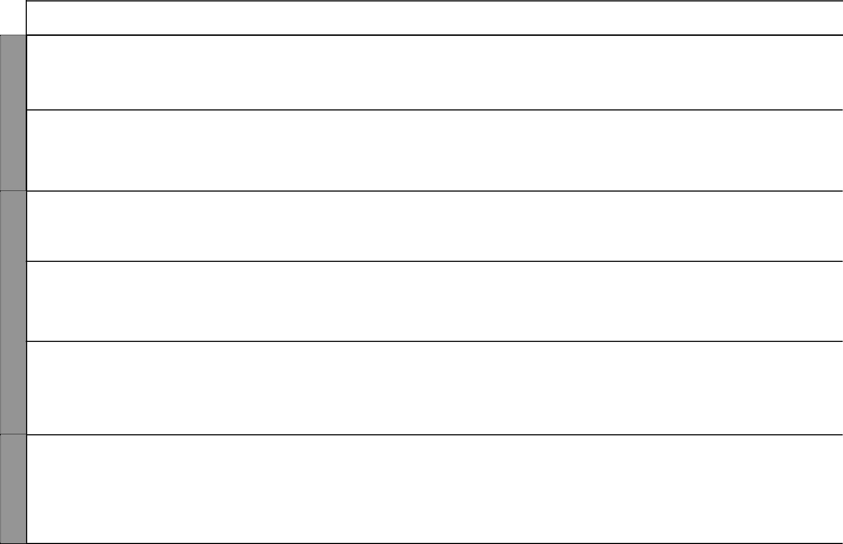

14 For use with Living in Christ Standard Six

Living in Christ Standard Six

Schemes of Work

Term 3


WEEK 8

WEEK 9

LESSONS | TOPIC | SUB-TOPIC |  | OBJECTIVES | TEACHING/LEARNING |  | TEACHING/LEARNING |  | REFERENCES |  | REMARKS
 |  |  |  |  |  | ACTIVITIES |  | RESOURCES
2 |  | Jesus Christ a | By the end of the lesson the |  | • | Scripture reading | • | The Good News Bible: | • | Pupil’s Book 6
 |  | sure hope for | learner should be able to: |  | • | Explanation |  | Matthew 1:18-22, Romans |  | page 90
 |  | humankind | 1. | explain how God is a sure | • | Discussion |  | 15:12, John 17:25-26 | • | Teacher’s Guide
 |  |  |  | hope for humankind | • | Brainstorming | • Chalkboard |  |  | pages 103-104
 |  |  | 2. | develop a sure hope in Jesus | • | Note taking
 |  |  |  | Christ
3 |  | Our ambitions | By the end of the lesson the |  | • | Scripture reading | • | The Good News Bible: | • | Pupil’s Book 6
3 |  | in life | learner should be able to: |  | • | Discussion |  | Micah 6: 6-8 |  | pages 90-91
 |  |  | 1. | state the purpose God the | • | Explanation | • | Chalkboard | • | Teacher’s Guide
 |  |  |  | father has for his/ her life | • | Note taking | • | Resource person: career |  | pages 105-106
 |  |  | 2. | seek God’s purpose for his/ | • | Quizzes |  | counsellor
 |  |  |  | her life | • | Questions and answers
1 |  | Jesus Christ: | By the end of the lesson the |  | • | Scripture reading | • | The Good News Bible: | • | Pupil’s Book 6
1 |  | Hope for eter- | learner should be able to: |  | • | Discussion |  | John 3:16, 3:36 |  | pages 91-92
 |  | nal life | 1. | give the meaning of | • | Explanation | • | Chalkboard | • | Teacher’s Guide
 |  |  |  | eternal life | • | Note taking |  |  |  | pages 106-107
 |  |  | 2. | desire to live a holy life in | • | Questions and answers
 |  |  |  | hope of eternal life
2 |  | Eternal life: | By the end of the lesson the |  | • | Scripture reading | • | The Good News Bible: | • | Pupil’s Book 6
2 |  | How it is re- | learner should be able to: |  | • | Discussion |  | 1 Corinthians 15:12, 21,35, |  | page 92
 |  | ceived | 1. | give the meaning of | • | Recitation |  | 42-44 | • | Teacher’s Guide
 |  |  |  | eternal life | • | Explanation | • | Chalkboard |  | pages 107-108
 |  |  | 2. | desire to live a holy life in | • | Note taking
 |  |  |  | hope of eternal life | • | Questions and answers
 |  | Life after death | By the end of the lesson the |  | • | Explanation | • | The Good News Bible: | • | Pupil’s Book 6
 |  |  | learner should be able to: |  | • | Scripture reading |  | John 14:1-30 |  | page 93
 |  |  | 1. | describe what Christians | • | Recitation and memorization | • | Chalkboard | • | Teacher’s Guide
 |  |  |  | hope for | • | Dramatization |  |  |  | page 108
 |  |  | 2. | develop sure hope in Jesus | • | Questions and answers
 |  |  |  | Christ | • | Note taking

15 For use with Living in Christ Standard Six

