CRE SCHEME OF WORK CLASS 2
Compiled By
Schools Net Kenya Consultancy
P.O. Box 8076 – 00200 Nairobi, Kenya | Tel: +254202319748
E-mail: infosnkenya@gmail.com | www.schoolsnetkenya.com

Living in Christ Standard Two Schemes of Work: Term One
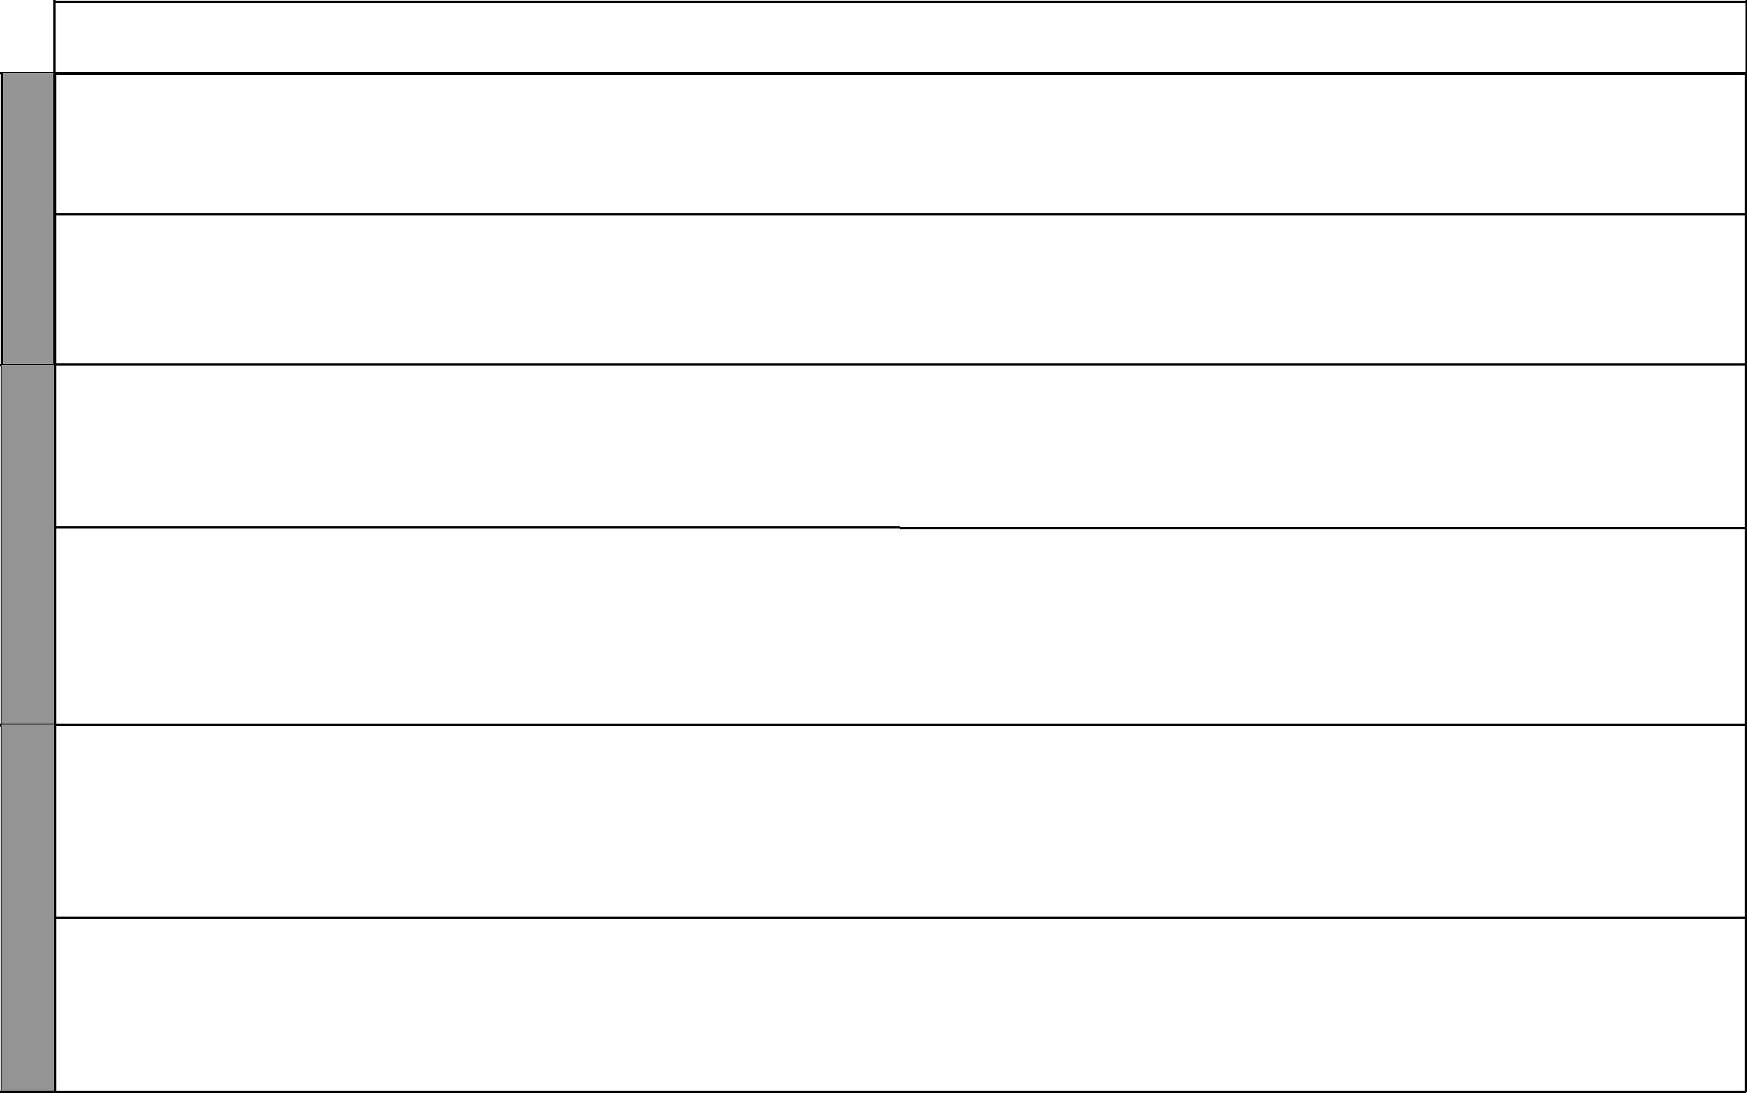

WEEK 1

WEEK 2

WEEK 3

LESSONS | TOPIC | SUB-TOPIC |  | OBJECTIVES | TEACHING/LEARNING |  | TEACHING/LEARNING |  |  | REFERENCES | REMARKS
 |  |  |  |  |  | ACTIVITIES |  | RESOURCES
1 | 1. The | Home | By the end of the lesson the |  | • | Scripture reading | • The Good News Bible: |  | • | Pupil’s Book
 | home | community | learner should be able to: |  | • | Explanation |  | Psalms 127:3-5; |  | page 2
 | commu- |  | 1. | name members of the | • | Questions and answers |  | Proverbs 23:22 | • | Teacher’s Guide
 | nity |  |  | extended family | • | Quizzes | • | Chalkboard |  | pages 1-2
 |  |  | 2. | appreciate his/her relatives | • | Singing
2 |  | Relatives | By the end of the lesson the |  | • | Scripture reading | • The Good News Bible: |  | • | Pupil’s Book
 |  |  | learner should be able to: |  | • | Explanation |  | 1 John 3:17, Ruth 1:1-22 |  | page 6
 |  |  | 1. | state what his/her relatives | • | Singing | • | Charts | • | Teacher’s Guide
 |  |  |  | do for him/her | • | Quizzes | • | Chalkboard |  | pages 4-5
 |  |  | 2. | appreciate his/her relatives | • | Narration
1 |  | Neighbours | By the end of the lesson the |  | • | Scripture reading | • The Good News Bible: |  | • | Pupil’s Book
 |  |  | learner should be able to: |  | • | Explanation |  | Romans 12:10, 1 Peter 3:8 |  | page 7
 |  |  | 1. | identify his/her neighbours | • | Questions and answers |  | Mark 12:31, Luke 10:27, | • | Teacher’s Guide
 |  |  | 2. | love his/her neighbours | • | Singing |  | Proverbs 3:28 |  | pages 6-7
 |  |  |  |  | • | Recitation | • | Charts
 |  |  |  |  | • | Memorization | • | Chalkboard
2 | 1. The | My Teachers | By the end of the lesson the |  | • | Scripture reading | • The Good News Bible: |  | • | Pupil’s Book
 | school |  | learner should be able to: |  | • | Explanation |  | Proverbs 16: 20; 2:1-6 |  | page 8
 | commu- |  | 1. | name his/her teachers | • | Memorization | • | Chalkboard | • | Teacher’s Guide
 | nity |  | 2. | state what teachers do for | • | Recitation |  |  |  | pages 7-8
 |  |  |  | him/her | • | Questions and answers
 |  |  | 3. | respect his/her teachers | • | Role play
 |  |  |  |  | • | Quizzes
1 |  | My | By the end of the lesson the |  | • | Scripture reading | • The Good News Bible: |  | • | Pupil’s Book
 |  | schoolmates | leaner should be able to: |  | • | Explanation |  | Psalms 133:1 |  | page 9
 |  |  | 1. | mention the things that he/ | • | Narration | • | Chalkboard | • | Teacher’s Guide
 |  |  |  | she does with schoolmates | • | Singing | • | Charts |  | pages 8-9
 |  |  | 2. | appreciate his/her | • | Recitation | • | Posters
 |  |  |  | schoolmates and others | • | Memorization
2 |  | Responsibili- | By the end of the lesson the |  | • | Scripture reading | • The Good News Bible: |  | • | Pupil’s Book
 |  | ties of children | learner should be able to: |  | • | Explanation |  | 1 Samuel 2:26; |  | pages 10-12
 |  |  | 1. | state responsibilities of | • | Questions and answers |  | Ephesians 6:1 | • | Teacher’s Guide
 |  |  |  | children | • | Story telling | • | Flashcards |  | pages 9-10
 |  |  | 2. | practise values that he/she | • | Memorization | • | Charts
 |  |  |  | learns at school |  |  | • | Chalkboard

1 For use with Living in Christ Standard Two

WEEK 4

WEEK 5

WEEK 6

 |  |  |  |  |  |  |  |  |  |  |  |  |  |  | Living in Christ Standard Two
 |  |  |  |  |  |  |  |  |  |  |  |  |  |  | Schemes of Work
 |  |  |  |  |  |  |  |  |  |  |  |  |  |  |  |  | Term 1
LESSONS |  | TOPIC |  | SUB-TOPIC |  | OBJECTIVES |  | TEACHING/LEARNING |  |  | TEACHING/LEARNING |  |  | REFERENCES |  |  | REMARKS
 |  |  |  |  |  |  |  |  | ACTIVITIES |  |  | RESOURCES
1 |  |  |  | Attitudes and | By the end of the lesson the |  |  | • | Scripture reading |  | • The Good News Bible: |  |  | • | Pupil’s Book
 |  |  |  | values learnt at | learner should be able to: |  |  | • | Explanation |  |  | Proverbs 9:10-12; 21:11 |  |  | page 13
 |  |  |  | school | 1. | state values and attitudes |  | • | Questions and answers |  | • | Chalkboard |  | • | Teacher’s Guide
 |  |  |  |  |  | he/she learns in school |  | • | Discussion |  |  |  |  |  | pages 10-11
 |  |  |  |  | 2. | practise values he/she learns |  | • | Demonstration
 |  |  |  |  |  | in school
2 |  | 3. The |  | Plants, animals | By the end of the lesson the |  |  | • | Scripture reading |  | • The Good News Bible: |  |  | • | Pupil’s Book
 |  | environ- |  | and birds | learner should be able to: |  |  | • | Explanation |  |  | Genesis 1:11-12; 20-25 |  |  | pages 14-19
 |  | ment |  |  | 1. | name some plants, insects, |  | • | Questions and answers |  | • | Chalkboard |  | • | Teacher’s Guide
 |  |  |  |  |  | animals and birds found in |  | • | Field trip |  | • | Real objects: plants, insects, |  |  | pages 12-19
 |  |  |  |  |  | his/her area |  | • | Practical work: planting a |  |  | seeds, soils, etc.
 |  |  |  |  | 2. | appreciate plants, insects |  |  | seed bed
 |  |  |  |  |  | animals and birds as God’s |  | • | Quizzes
 |  |  |  |  |  | creation |  | • | Drawing
1 |  | 4. Com- |  | Composition | By the end of the lesson the |  |  | • | Scripture reading |  | • The Good News Bible: |  |  | • | Pupil’s Book
 |  | position |  | of the Bible | learner should be able to: |  |  | • | Explanation |  |  | 2 Timothy 3:16-17, |  |  | page 20
 |  | of the |  |  | 1. | name some parts of the Bible |  | • | Singing |  |  | Hebrews 4:12 |  | • | Teacher’s Guide
 |  | Bible |  |  | 2. | desire to read the Bible |  | • | Demonstration |  | • | Chalkboard |  |  | pages 20-21
 |  |  |  |  |  |  |  | • | Narration
2 |  |  |  | Need to read | By the end of the lesson the |  |  | • | Scripture reading |  | • The Good News Bible: |  |  | • | Pupil’s Book
 |  |  |  | the Bible | learner should be able to: |  |  | • | Explanation |  |  | Hebrews 4:12; Romans 15:4 |  |  | page 22
 |  |  |  |  | 1. | give reasons why he/she reads |  | • | Discussion |  | • | Poster |  | • | Teacher’s Guide
 |  |  |  |  |  | the bible |  | • | Questions and answers |  | • | Chalkboard |  |  | pages 22-23
 |  |  |  |  | 2. | desire to read the bible |  | • | Singing
1 |  |  |  | The Old | By the end of the lesson the |  |  | • | Scripture reading |  | • The Good News Bible: |  |  | • | Pupil’s Book
 |  |  |  | Testament | learner should be able to: |  |  | • | Explanation |  |  | 2 Timothy 3:16-17 |  |  | page 21
 |  |  |  |  | 1. | name some books of the Old |  | • | Questions and answers |  | • | Chalkboard |  | • | Teacher’s Guide
 |  |  |  |  |  | Testament |  | • | Demonstration |  | • | Posters |  |  | pages 21-22
 |  |  |  |  | 2. | desire to read the bible |  | • | Singing
 |  |  |  |  |  |  |  | • | Written exercises
2 |  |  |  | The New | By the end of the lesson the |  |  | • | Scripture reading |  | • The Good News Bible: |  |  | • | Pupil’s Book
 |  |  |  | Testament | learner should be able to: |  |  | • | Explanation |  |  | Romans 15:4 |  |  | page 22
 |  |  |  |  | 1. | name some books of the New |  | • | Questions and answers |  | • | Chalkboard |  | • | Teacher’s Guide
 |  |  |  |  |  | Testament |  | • | Demonstration |  |  |  |  |  | pages 22-23
 |  |  |  |  | 2. | desire to read the bible |  | • | Quizzes
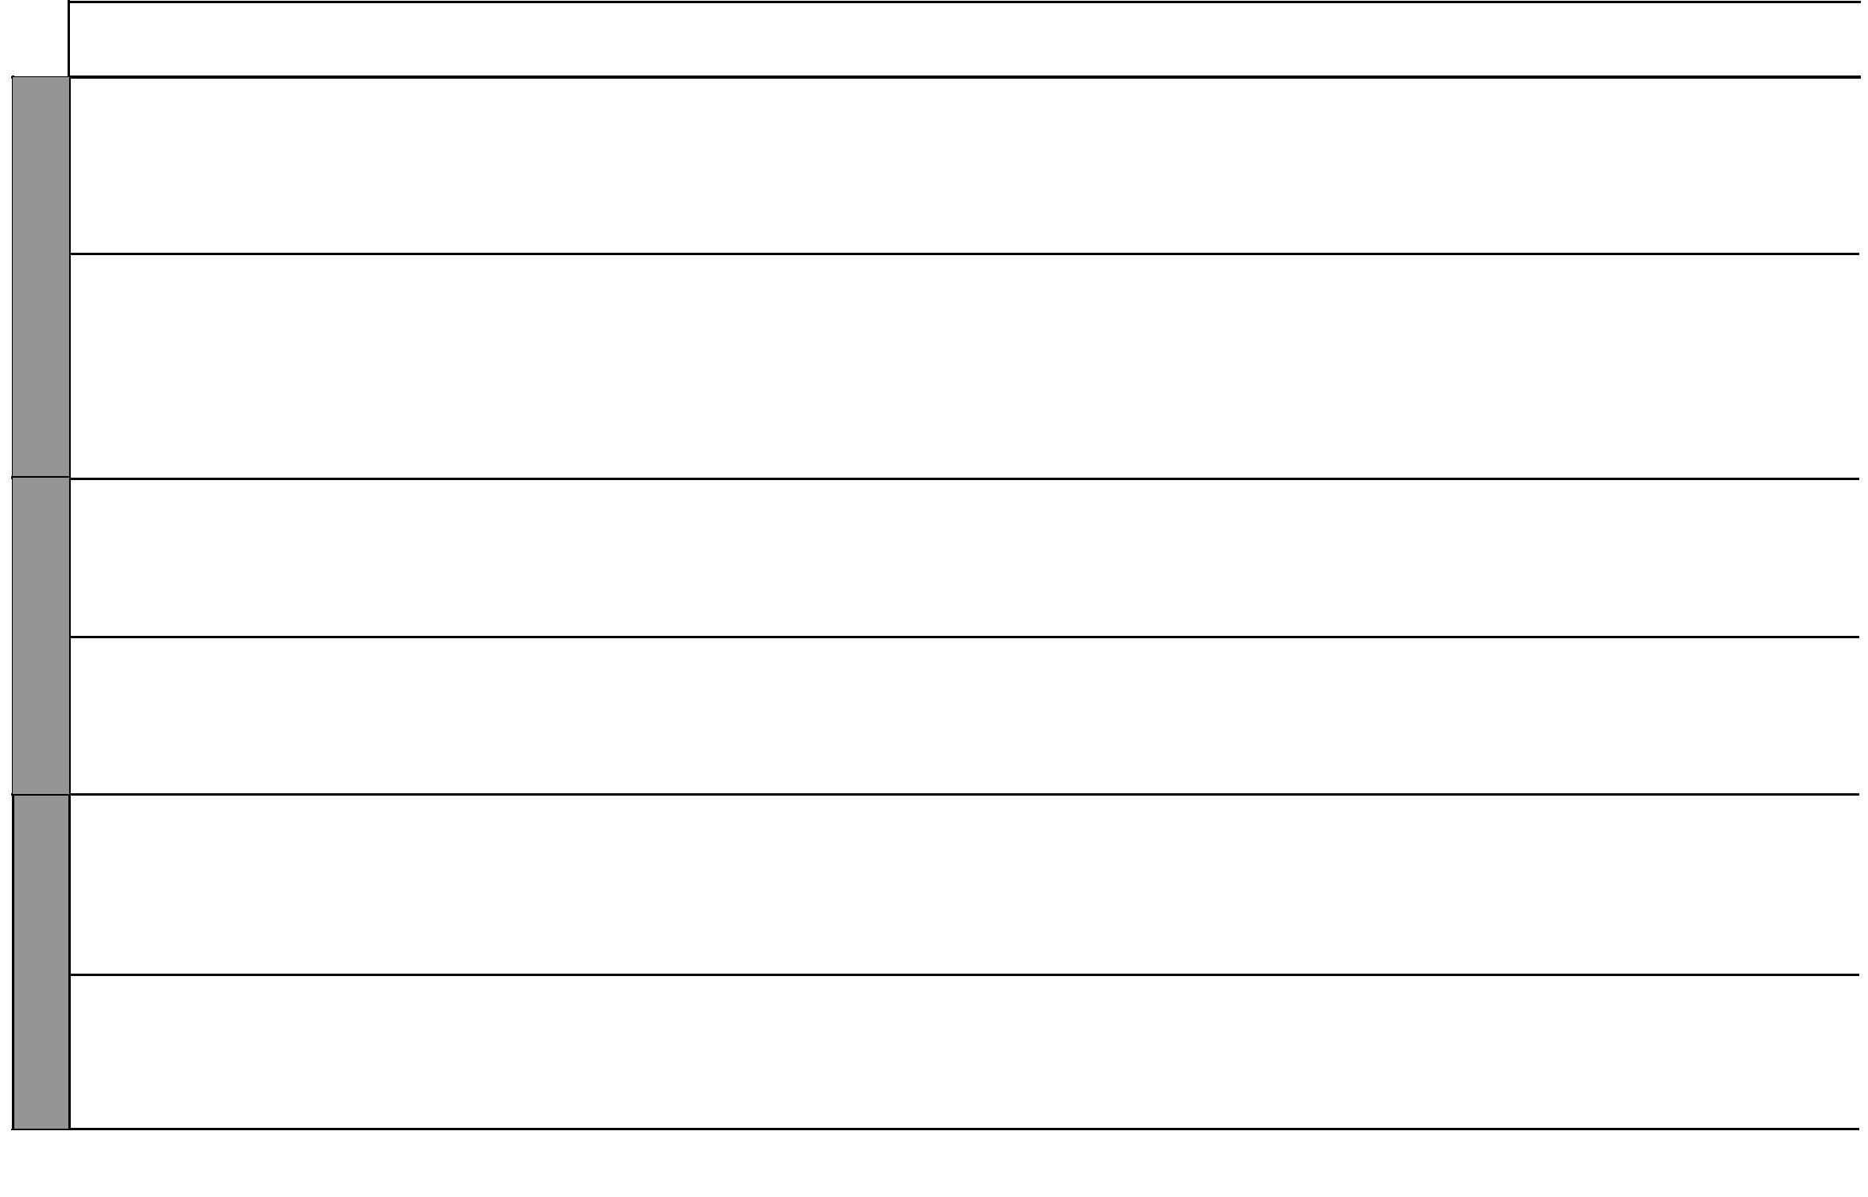

2 For use with Living in Christ Standard Two

Living in Christ Standard Two

Schemes of Work

Term 1


LESSONS

1

7
WEEK | 2
 | 1
8
WEEK | 2
 | 1
WEEK 9 | 1
 | 1
WEEK 1 | 1

TOPIC | SUB-TOPIC |  | OBJECTIVES | TEACHING/LEARNING |  | TEACHING/LEARNING |  |  | REFERENCES | REMARKS
 |  |  |  |  | ACTIVITIES |  | RESOURCES
5. Jesus’ | How we | By the end of the lesson the |  | • | Scripture reading | • | The Good News Bible: | • | Pupil’s Book
love and | celebrate our | learner should be able to: |  | • | Questions and answers |  | Luke 2:1-7 |  | page 24
care | birthdays | 1. | name the things that he/she | • | Narration | • | Chalkboard | • | Teacher’s Guide
 |  |  | does on her birthday | • | Explanation | • | Drawings |  | pages 24-25
 |  | 2. | appreciate Jesus Christ as a | • | Demonstration
 |  |  | gift from God
 | The birth of | By the end of the lesson the |  | • | Scripture reading | • | The Good News Bible: | • | Pupil’s Book
 | Jesus Christ | learner should be able to: |  | • | Explanation |  | Isaiah 9:6-7, Luke 2:1-7 |  | pages 25-26
 |  | 1. | tell the story of the birth of | • | Questions and answers | • | Chalkboard | • | Teacher’s Guide
 |  |  | Jesus | • | Narration | • | Charts |  | pages 28-29
 |  | 2. | appreciate Jesus as a gift from | • | Singing
 |  |  | God | • | Quizzes
 | Visitors who | By the end of the lesson the |  | • | Scripture reading | • | The Good News Bible: | • | Pupil’s Book
 | came to see | learner should be able to: |  | • | Explanation |  | Matthew 2:1-12 |  | page 27
 | Jesus | 1. | narrate the story of how the | • | Questions and answers | • | Chalkboard | • | Teacher’s Guide
 |  |  | shepherds visited Jesus | • | Narration | • | Drawings |  | pages 29-30
 |  | 2. | appreciate Jesus Christ as a | • | Group work
 |  |  | gift from God | • | Singing
 | Prophecy on | By the end of the lesson the |  | • | Scripture reading | • | The Good News Bible: | • | Pupil’s Book
 | the birth of | learner should be able to: |  | • | Questions and answers |  | Isaiah: 9:6-7 |  | page 25
 | Jesus | 1. | mention what the prophet | • | Narration | • | Chalkboard | • | Teacher’s Guide
 |  |  | Isaiah said about the birth | • | Miming |  |  |  | pages 26-29
 |  |  | of Jesus | • | Explanation
 |  | 2. | appreciate Jesus as a gift from
 |  |  | God
 | How we | By the end of the lesson the |  | • | Scripture reading | • | The Good News Bible: | • | Pupil’s Book
 | celebrate the | learner should be able to: |  | • | Explanation | • | Chalkboard |  | pages 28-29
 | birth of Jesus | 1. | mention how the birthday of | • | Questions and answers |  |  | • | Teacher’s Guide
 | today |  | Jesus is celebrated today | • | Role play |  |  |  | pages 30-31
 |  | 2. | appreciate Jesus as a gift from | • | Quizzes
 |  |  | God
6. Thank- | Giving thanks | By the end of the lesson the |  | • | Scripture reading | • | The Good News Bible: | • | Pupil’s Book
fulness | at home | learner should be able to: |  | • | Explanation |  | Luke 17:11-19 |  | page 30
 |  | 1. state ways in which he/she |  | • | Questions and answers | • | Chalkboard | • | Teacher’s Guide
 |  |  | can give thanks at home | • | Narration |  |  |  | pages 32-33
 |  | 2. be thankful at all times |  | • | Written exercise
 |  |  |  |  | 3
 |  |  |  |  | 3 |  |  | For use with Living in Christ Standard Two

Living in Christ Standard Two Schemes of Work: Term Two
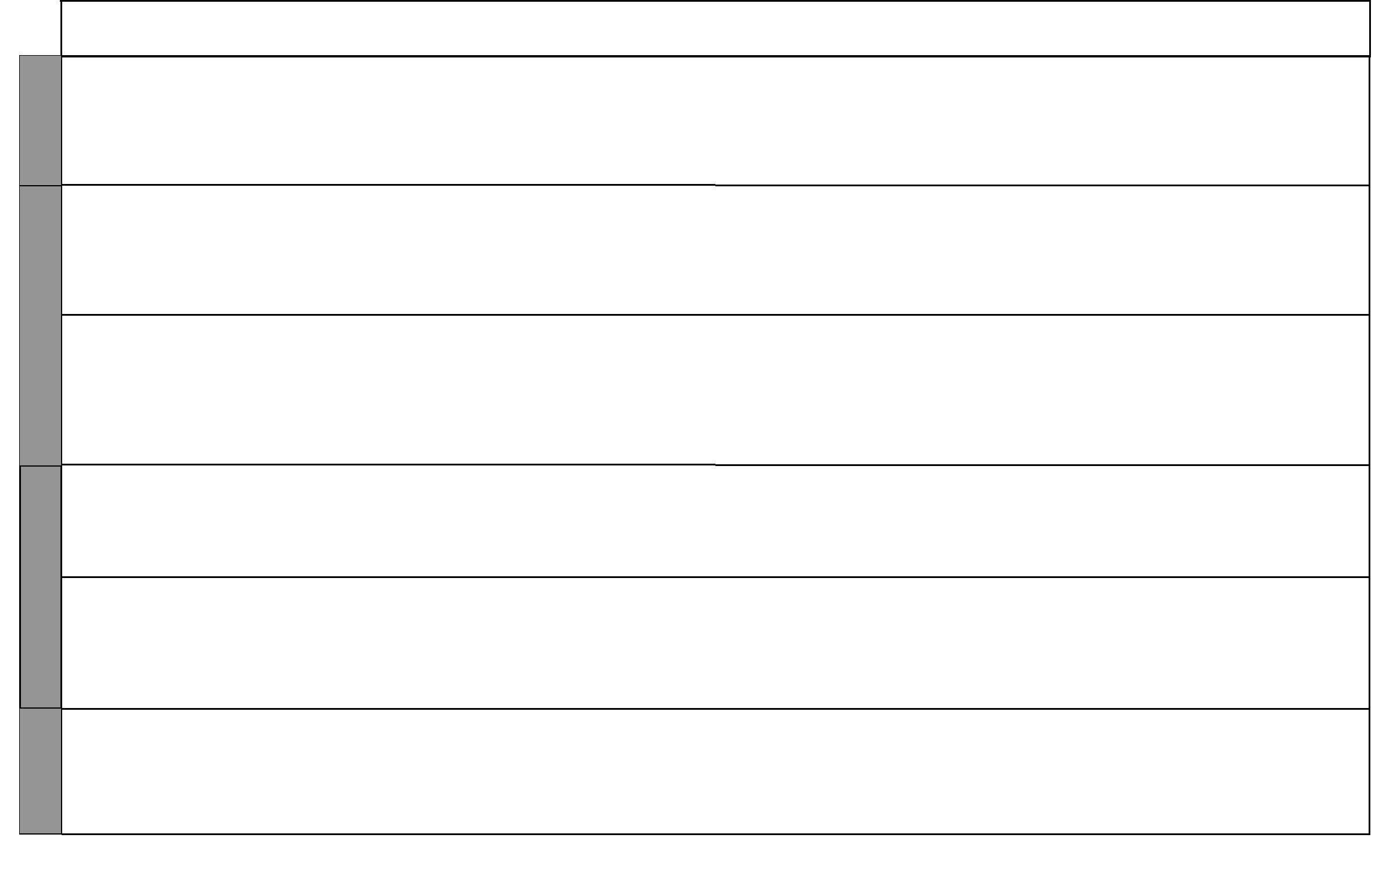

WEEK 1

WEEK 2

WEEK 3

WEEK 4

LESSONS | TOPIC | SUB-TOPIC |  | OBJECTIVES | TEACHING/LEARNING |  | TEACHING/LEARNING |  |  | REFERENCES | REMARKS
 |  |  |  |  |  | ACTIVITIES |  | RESOURCES
2 |  | Giving thanks | By the end of the lesson the |  | • | Scripture reading | • The Good News Bible: |  | • | Pupil’s Book
 |  | at school and | learner should be able to: |  | • | Explanation |  | Ephesians:5:20; Thess 5:18; | • | Teacher’s Guide
 |  | in the com- | 1. | state ways in which he/she | • | Questions and answers |  | 2 Cor 9:7; Psalms 8:1-9;
 |  | munity |  | can give thanks in school and | • | Recitation |  | Philipians 1:3-5
 |  |  |  | in the community | • | Singing | • | Chalkboard
 |  |  | 2. | be thankful at all times | • | Role play
1 | 7. Prayer | How we | By the end of the lesson the |  | • | Scripture reading | • The Good News Bible: |  | • | Pupil’s Book
 | and | worship God | learner should be able to: |  | • | Explanation |  | Psalms 92:1; 117 |  | page 34
 | worship |  | 1. | mention ways of praising | • | Questions and answers | • | Chalkboard | • | Teacher’s Guide
 |  |  |  | God | • | Singing | • | Real objects: music |  | pages 35-36
 |  |  | 2. | desire to worship God | • | Prayer |  | instruments
2 |  | Different ways | By the end of the lesson the |  | • | Scripture reading | • The Good News Bible: |  | • | Pupil’s Book
 |  | of worshipping | learner should be able to: |  | • | Explanation |  | 1 Samuel 1:1-5 |  | page 34
 |  | God | 1. | list ways of worshipping God | • | Discussion | • | Chalkboard | • | Teacher’s Guide
 |  |  | 2. | rejoice when worshipping | • | Role play |  |  |  | pages 36-37
 |  |  |  | God | • | Narration
 |  |  |  |  | • | Singing
 |  |  |  |  | • | Prayer
1 |  | Prayer | By the end of the lesson the |  | • | Scripture reading | • The Good News Bible: |  | • | Pupil’s Book
 |  |  | learner should be able to: |  | • | Explanation |  | Mark 11:24, |  | page 36
 |  |  | 1. | mention the times we pray | • | Questions and answers |  | Matthew 6:7-13; | • | Teacher’s Guide
 |  |  | 2. | desire to pray for him/herself | • | Prayer |  | Ephesians 1:15-19 |  | pages 38-39
 |  |  |  |  |  |  | • | Chalkboard
2 |  | Praying for | By the end of the lesson the |  | • | Scripture reading | • The Good News Bible |  | • | Pupil’s Book
 |  | ourselves | learner should be able to: |  | • | Explanation |  | Luke 22:41, Philippians 4:6 |  | page 36
 |  |  | 1. | recite a prayer for his/her | • | Questions and answers | • | Chalkboard | • | Teacher’s Guide
 |  |  |  | needs | • | Memorization |  |  |  | pages 38-39
 |  |  | 2. | desire to pray for him/herself | • | Recitation
 |  |  |  |  | • | Prayer
1 |  | Praying for our | By the end of the lesson the |  | • | Scripture reading | • The Good News Bible |  | • | Pupil’s Book
 |  | country | learner should be able to: |  | • | Explanation | • | Chalkboard |  | page 37
 |  |  | 1. | state how he/she prays for | • | Questions and answers | • | Map of Kenya | • | Teacher’s Guide
 |  |  |  | the country | • | Singing | • | National flag |  | pages 39-41
 |  |  | 2. | desire to pray for the country | • | Prayer | • | Posters

4 For use with Living in Christ Standard Two

Living in Christ Standard Two

Schemes of Work

Term 2


LESSONS

WEEK 4 | 2
 | 1
5
WEEK | 2

1

6
WEEK | 2
 | 1
WEEK 7

TOPIC | SUB-TOPIC | OBJECTIVES | TEACHING/LEARNING |  | TEACHING/LEARNING |  |  | REFERENCES | REMARKS
 |  |  |  | ACTIVITIES |  | RESOURCES
8. Trust | Trust at home | By the end of the lesson the | • | Scripture reading | • The Good News Bible: |  | • | Pupil’s Book
and obe- |  | learner should be able to: | • | Explanation |  | Matthew 21:28-31a |  | page 38
dience |  | 1. give reasons why he/she trusts | • | Questions and answers | • | Charts | • | Teacher’s Guide
 |  | his/her parents | • | Narration | • | Chalkboard |  | pages 41-42
 |  | 2. trust and obey his/her parents | • | Singing
 |  |  | • | Drawing
 | Trusting God | By the end of the lesson the | • | Scripture reading | • The Good News Bible: |  | • | Pupil’s Book
 |  | learner should be able to: | • | Explanation |  | 1 Samuel 1:9-11;20;27;28; |  | page 39
 |  | 1. identify ways in which God is | • | Questions and answers |  | 2:11; | • | Teacher’s Guide
 |  | kind to us | • | Narration |  | Matthew 6:26 |  | pages 42-43
 |  | 2. desire to please God | • | Singing | • | Chalkboard
 |  |  | • | Quizzes | • | Pictures
 | Obedience at | By the end of the lesson the | • | Scripture reading | • The Good News Bible: |  | • | Pupil’s Book
 | home | learner should be able to: | • | Explanation |  | Ephesians 6:1,2 |  | page 40
 |  | 1. state ways he/she can please | • | Questions and answers | • | Chalkboard | • | Teacher’s Guide
 |  | his/her parents | • | Singing |  |  |  | pages 43-44
 |  | 2. trust and obey his/her parents | • | Dramatization
 | Obeying God | By the end of the lesson the | • | Scripture reading | • The Good News Bible: |  | • | Pupil’s Book
 |  | learner should be able to: | • | Explanation |  | Psalms 112:1, |  | page 41
 |  | 1. identify ways in which God is | • | Questions and answers |  | Genesis 12:1-9 | • | Teacher’s Guide
 |  | kind to us | • | Story telling | • | Chalkboard |  | pages 45-46
 |  | 2. desire to please God | • | Recitation
 |  |  | • | Memorization
9. Help- | Wedding at | By the end of the lesson the | • | Scripture reading | • The Good News Bible: |  | • | Pupil’s Book
ing oth- | Cana | learner should be able to: | • | Explanation |  | John 2:1-11 |  | page 42
ers |  | 1. tell the story of Jesus at the | • | Story telling | • | Chalkboard | • | Teacher’s Guide
 |  | wedding in Cana | • | Dramatization |  |  |  | page 46
 |  | 2. desire to help the needy | • | Quizzes
 |  |  | • | Questions and answers
 | Helping the | By the end of the lesson the | • | Scripture reading | • The Good News Bible: |  | • | Pupil’s Book
 | needy | learner should be able to: | • | Explanation |  | Mark 1:29-31, 7:31-35; |  | page 43
 |  | 1. identify ways of helping the | • | Questions and answers |  | Luke 5:17-20, | • | Teacher’s Guide
 |  | needy | • | Story telling |  | John 5:1-10, 14-18 |  | pages 49-50
 |  | 2. desire to help the needy | • | Dramatisation | • | Chalkboard
 |  |  | • | Recitation
 |  |  | • | Memorization
 |  |  |  | 5
 |  |  |  | 5 |  |  | For use with Living in Christ Standard Two

 |  |  |  |  |  |  |  |  |  | Living in Christ Standard Two
 |  |  |  |  |  |  |  |  |  | Schemes of Work
 |  |  |  |  |  |  |  |  |  |  | Term 2
 | LESSONS | TOPIC | SUB-TOPIC | OBJECTIVES | TEACHING/LEARNING |  | TEACHING/LEARNING |  |  | REFERENCES | REMARKS
 |  |  |  |  |  | ACTIVITIES |  | RESOURCES
7 | 2 |  | Helping others | By the end of the lesson the | • | Scripture reading | • The Good News Bible: |  | • | Pupil’s Book
7 |  |  |  | learner should be able to: | • | Explanation |  | Romans 12:16 |  | page 44
WEEK |  |  |  | learner should be able to: | • | Explanation |  | Romans 12:16 |  | page 44
WEEK |  |  |  | 1. identify ways of helping oth- | • | Questions and answers | • | Chalkboard | • | Teacher’s Guide
WEEK |  |  |  | ers | • | Story telling |  |  |  | pages 48-49
WEEK |  |  |  |  | • | Prayer
WEEK |  |  |  | 2. desire to help the others
 | 1 | 10. Pen- | Knowing Jesus | By the end of the lesson the | • | Scripture reading | • The Good News Bible: |  | • | Pupil’s Book
 |  | tecost | Christ | learner should be able to: | • | Explanation |  | Luke 18:35-43; |  | page 46
 |  |  |  | 1. mention ways in which he/she | • | Questions and answers |  | Luke 8:26-31,35-39 | • | Teacher’s Guide
8 |  |  |  | can respond to Jesus Christ | • | Singing | • | Chalkboard |  | pages 50-51
8 |  |  |  | 2. desire to make the right | • | Prayer | • | Chart
WEEK
WEEK |  |  |  | response to Jesus Christ
WEEK | 2 |  | Responding to | By the end of the lesson the | • | Scripture reading | • The Good News Bible: |  | • | Pupil’s Book
WEEK |  |  | Jesus Christ | learner should be able to: | • | Explanation |  | Luke 18:35-44 |  | page 51
 |  |  |  | 1. mention how he/she can | • | Questions and answers | • | Chalkboard | • | Teacher’s Guide
 |  |  |  | respond to Jesus Christ | • | Prayer |  |  |  | pages 55-56
 |  |  |  | 2. desire to make the right | • | Story telling
 |  |  |  | response to Jesus Christ
 |  |  | A walk to | By the end of the lesson the | • | Scripture reading | • The Good News Bible: |  | • | Pupil’s Book
 | 1 |  | Emmaus | learner should be able to: | • | Explanation |  | Luke 24:13-35 |  | page 49
 |  |  |  | 1. tell the story of the walk to | • | Questions and answers | • | Chalkboard | • | Teacher’s Guide
 |  |  |  | Emmaus | • | Story telling |  |  |  | pages 53-54
9 |  |  |  | 2. desire to make the right | • | Miming
9 |  |  |  | response to Jesus Christ | • | Singing
WEEK |  |  |  | response to Jesus Christ | • | Singing
WEEK | 2 |  | Zaccheaus | By the end of the lesson the | • | Scripture reading | • The Good News Bible: |  | • | Pupil’s Book
WEEK |  |  |  | learner should be able to: | • | Explanation |  | Luke 19:1-9 |  | page 48
WEEK |  |  |  | 1. tell the story of Zaccheaus | • | Questions and answers | • | Chalkboard | • | Teacher’s Guide
 |  |  |  | 2. desire to make the right | • | Story telling |  |  |  | pages 52-53
 |  |  |  | response to Jesus Christ | • | Dramatization
 |  |  |  |  | • | Drawing
 |  |  |  |  | • | Singing
 | 1 |  | Disciples | By the end of the lesson the | • | Scripture reading | • The Good News Bible: |  | • | Pupil’s Book
10 | 1
10 |  |  | response to | learner should be able to: | • | Explanation |  | John 1:43-49; |  | page 47
WEEK |  |  | Jesus | 1. state how the disciples | • | Questions and answers |  | Mark 8:27-29 | • | Teacher’s Guide
WEEK |  |  |  | responded to Jesus Christ | • | Story telling | • | Chalkboard |  | pages 51-52
WEEK |  |  |  | 2. desire to make the right | • | Singing
WEEK |  |  |  | response to Jesus Christ
 |  |  |  |  |  | 6 |  |  | For use with Living in Christ Standard Two

Living in Christ Standard Two Schemes of Work: Term Three

 | LESSONS | TOPIC | SUB-TOPIC |  | OBJECTIVES | TEACHING/LEARNING |  | TEACHING/LEARNING |  |  | REFERENCES | REMARKS
 |  |  |  |  |  |  | ACTIVITIES |  | RESOURCES
10 | 2 |  | Response of | By the end of the lesson the |  | • | Scripture reading | • The Good News Bible: |  | • | Pupil’s Book
10 |  |  | others | learner should be able to: |  | • | Explanation |  | John 6:1-2, 24 |  | page 50
WEEK |  |  |  |  |  |  |  |  | John 6:1-2, 24 |  | page 50
WEEK |  |  |  | 1. | state how different people | • | Questions and answers | • | Chalkboard | • | Teacher’s Guide
WEEK |  |  |  |  | responded to Jesus Christ | • | Story telling |  |  |  | pages 54-55
WEEK |  |  |  | 2. | desire to make the right | • | Singing
WEEK |  |  |  |  | response to Jesus Christ | • | Miming
 | 1 | 11.Chris- | God keeps his | By the end of the lesson the |  | • | Scripture reading | • The Good News Bible: |  | • | Pupil’s Book
 |  | tian | promises | learner should be able to: |  | • | Explanation |  | Matthew 5:33-37, |  | page 52
 |  | virtues |  | 1. Give examples of occasions |  | • | Discussion |  | Genesis 18: 1-15, 21:1-8 | • | Teacher’s Guide
1 |  |  |  |  | when God kept his promises | • | Role play | • | Chalkboard |  | pages 57-58
WEEK |  |  |  | 2. | desire to keep promises | • | Questions and answers
WEEK | 2 |  | Acceptance | By the end of the lesson the |  | • | Scripture reading | • The Good News Bible: |  | • | Pupil’s Book
WEEK |  |  |  | learner should be able to: |  | • | Explanation |  | John 13:20, Luke 15:11-24 |  | page 54
 |  |  |  | 1. | give reasons why acceptance | • | Questions and answers | • | Chalkboard | • | Teacher’s Guide
 |  |  |  |  | is an important Christian | • | Drawing | • | Charts |  | pages 60-61
 |  |  |  |  | virtue | • | Prayer
 |  |  |  | 2. | rejoice in God’s love
 | 1 |  | Trust | By the end of the lesson the |  | • | Scripture reading | • The Good News Bible: |  | • | Pupil’s Book
 |  |  |  | learner should be able to: |  | • | Explanation |  | Matthew 21:28-31a |  | pages 52-53
 |  |  |  | 1. | give reasons why he/she | • | Questions and answers | • | Chalkboard | • | Teacher’s Guide
 |  |  |  |  | should be trusted at home | • | Singing | • | Charts |  | pages 59-60
 |  |  |  |  | school and in community | • | Quizzes
2 |  |  |  | 2. | thank God for loving him/her
WEEK | 2 |  | Honesty | By the end of the lesson the |  | • | Questions and answers | • The Good News Bible: |  | • | Pupil’s Book
WEEK |  |  |  | learner should be able to: |  | • | Scripture reading |  | Ephesians 4:15, |  | pages 55-56
WEEK |  |  |  | 1. | give reasons why he/she | • | Explanation |  | Exodus 20:16, Acts 5:1 | • | Teacher’s Guide
 |  |  |  |  | should be honest at school, | • | Role play | • | Chalkboard |  | pages 62-64
 |  |  |  |  | home and community | • | Recitation
 |  |  |  | 2. | be honest | • | Memorization
 | 1 |  | Fairness | By the end of the lesson the |  | • | Scripture reading | • The Good News Bible: |  | • | Pupil’s Book
3 | 1
3 |  |  |  | learner should be able to: |  | • | Explanation |  | Genesis 37: 12-35 |  | page 57
WEEK |  |  |  |  |  | • | Explanation |  | Genesis 37: 12-35 |  | page 57
WEEK |  |  |  | 1. | state how he/she can be fair | • | Questions and answers | • | Chalkboard | • | Teacher’s Guide
WEEK |  |  |  |  | at home, school and in | • | Role play | • | Charts |  | pages 64-66
WEEK |  |  |  |  | community | • | Singing
WEEK |  |  |  | 2. | be fair | • | Narration
 |  |  |  |  |  |  | 7 |  |  | For use with Living in Christ Standard Two


 |  | LESSONS
3 | 2
WEEK
 | 1
4
WEEK | 2

1

5
WEEK | 2

1

WEEK 6

 |  |  |  |  |  |  |  |  |  |  |  | Living in Christ Standard Two
 |  |  |  |  |  |  |  |  |  |  |  | Schemes of Work
 |  |  |  |  |  |  |  |  |  |  |  |  |  | Term 3
TOPIC |  | SUB-TOPIC |  | OBJECTIVES |  | TEACHING/LEARNING |  |  | TEACHING/LEARNING |  |  | REFERENCES |  | REMARKS
 |  |  |  |  |  |  | ACTIVITIES |  |  | RESOURCES
12. Con- |  | Concern for | By the end of the lesson the |  |  | • | Scripture reading |  | • The Good News Bible: |  | • | Pupil’s Book
cern and |  | the needy | learner should be able to: |  |  | • | Explanation |  |  | Matthew 25:40 |  | pages 58-61
sharing |  |  | 1. | state ways in which he/she |  | • | Questions and answers |  | • | Chalkboard | • | Teacher’s Guide
 |  |  |  | can help people in need |  | • | Role play |  | • | Charts |  | pages 67-68
 |  |  | 2. | identify with the needy
 |  | The rich | By the end of the lesson the |  |  | • | Scripture reading |  | • The Good News Bible: |  | • | Pupil’s Book
 |  | woman from | learner should be able to: |  |  | • | Explanation |  |  | 2 Kings 4:8-17 |  | page 58
 |  | Shunem | 1. | tell the story of Elisha and |  | • | Questions and answers |  | • | Chalkboard | • | Teacher’s Guide
 |  |  |  | the woman from Shunem |  | • | Narration |  | • | Pictures |  | pages 68-69
 |  |  | 2. | be willing to share his/her |  | • | Singing
 |  |  |  | possessions with others
 |  | Early Chris- | By the end of the lesson the |  |  | • | Scripture reading |  | • The Good News Bible: |  | • | Pupil’s Book
 |  | tians shared | leaner should be able to: |  |  | • | Explanation |  |  | Acts 4:32-37 |  | page 59
 |  | their posses- | 1. | state how the early Christians |  | • | Questions and answers |  | • | Chalkboard | • | Teacher’s Guide
 |  | sions |  | shared their possessions |  | • | Narration |  |  |  |  | pages 69-70
 |  |  | 2. | desire to share their |  | • | Role play
 |  |  |  | possessions with others
 |  | Sharing in | By the end of the lesson the |  |  | • | Scripture reading |  | • The Good News Bible |  | • | Pupil’s Book
 |  | Traditional | learner should be able to: |  |  | • | Explanation |  | • | Chalkboard |  | page 60
 |  | African | 1. | mention how possessions |  | • | Questions and answers |  | • | Resource person | • | Teacher’s Guide
 |  | Society |  | were shared in the traditional |  | • | Memorization |  |  |  |  | pages 70-71
 |  |  |  | African society
 |  |  | 2. | be willing to share his/her
 |  |  |  | possessions with others
 |  | Voluntary | By the end of the lesson the |  |  | • | Scripture reading |  | • The Good News Bible |  | • | Pupil’s Book
 |  | agencies | learner should be able to: |  |  | • | Explanation |  | • | Chalkboard |  | page 61
 |  |  | 1. | name voluntary agencies |  | • | Questions and answers |  | • | Resource person | • | Teacher’s Guide
 |  |  |  | that care for the needy |  | • | Story telling |  |  |  |  | pages 71-72
 |  |  | 2. | appreciate the role of |  | • | Field trip
 |  |  |  | voluntary agencies
13. Jesus |  | The blind | By the end of the lesson the |  |  | • | Scripture reading |  | • The Good News Bible: |  | • | Pupil’s Book
Christ |  | man is healed | learner should be able to: |  |  | • | Explanation |  |  | Mark 10:46-52 |  | page 62
cares for |  |  | 1. | tell the story of the healing of |  | • | Narration |  | • | Chalkboard | • | Teacher’s Guide
the needy |  |  |  | the blind man |  | • | Dramatization |  |  |  |  | pages 72-73
 |  |  | 2. | be willing to care for others |  | • | Questions and answers

1438 For use with Living in Christ Standard Two
Living in Christ Standard Two

Schemes of Work

Term 3


WEEK 6

WEEK 7

WEEK 8

LESSONS | TOPIC | SUB-TOPIC |  | OBJECTIVES | TEACHING/LEARNING |  | TEACHING/LEARNING |  |  | REFERENCES | REMARKS
 |  |  |  |  |  | ACTIVITIES |  | RESOURCES
2 |  | Healing of the | By the end of the lesson the |  | • | Scripture reading | • The Good News Bible: |  | • | Pupil’s Book
 |  | ten lepers | learner should be able to: |  | • | Explanation |  | Luke 17:12-19 |  | page 63
 |  |  | 1. | tell the story of the healing of | • | Questions and answers | • | Chalkboard | • | Teacher’s Guide
 |  |  |  | the lepers | • | Role play |  |  |  | pages 73-74
 |  |  | 2. | be willing to care for others | • | Drawing
1 |  | Healing of | By the end of the lesson the |  | • | Scripture reading | • The Good News Bible: |  | • | Pupil’s Book
 |  | Jairus’ daugh- | learner should be able to: |  | • | Explanation |  | Luke 8:40-56 |  | page 64
 |  | ter | 1. | tell the story of the raising of | • | Questions and answers | • | Chalkboard | • | Teacher’s Guide
 |  |  |  | Jairus’ daughter | • | Role play | • | Real objects: clothes, |  | pages 74-75
 |  |  | 2. | be willing to care for others | • | Drawing and colouring |  | food etc
 |  |  |  |  | • | Singing
2 |  | Raising the | By the end of the lesson the |  | • | Scripture reading | • The Good News Bible: |  | • | Pupil’s Book
 |  | widow’s son | learner should be able to: |  | • | Explanation |  | Luke 7:11-15 |  | page 65
 |  |  | 1. | tell the story of the raising of | • | Questions and answers | • | Chalkboard | • | Teacher’s Guide
 |  |  |  | the son of the widow of Nain | • | Miming | • | Charts |  | page 76
 |  |  | 2. | be willing to care for others | • | Prayer
 |  |  |  |  | • | Singing
1 |  | Our readiness | By the end of the lesson the |  | • | Scripture reading | • The Good News Bible: |  | • | Pupil’s Book
 |  | to care for | learner should be able to: |  | • | Explanation |  | Acts 3:1-6 |  | page 66
 |  | others | 1. | identify people who need | • | Questions and answers | • | Chalkboard | • | Teacher’s Guide
 |  |  |  | help | • | Story telling |  |  |  | page 77
 |  |  | 2. | be willing to care for the | • | Dramatization
 |  |  |  | needy | • | Singing


9 For use with Living in Christ Standard Two

