CRE SCHEME OF WORK CLASS 1
Compiled By
Schools Net Kenya Consultancy
P.O. Box 8076 – 00200 Nairobi, Kenya | Tel: +254202319748
E-mail: infosnkenya@gmail.com | www.schoolsnetkenya.com

Living in Christ Standard One Schemes of Work: Term One
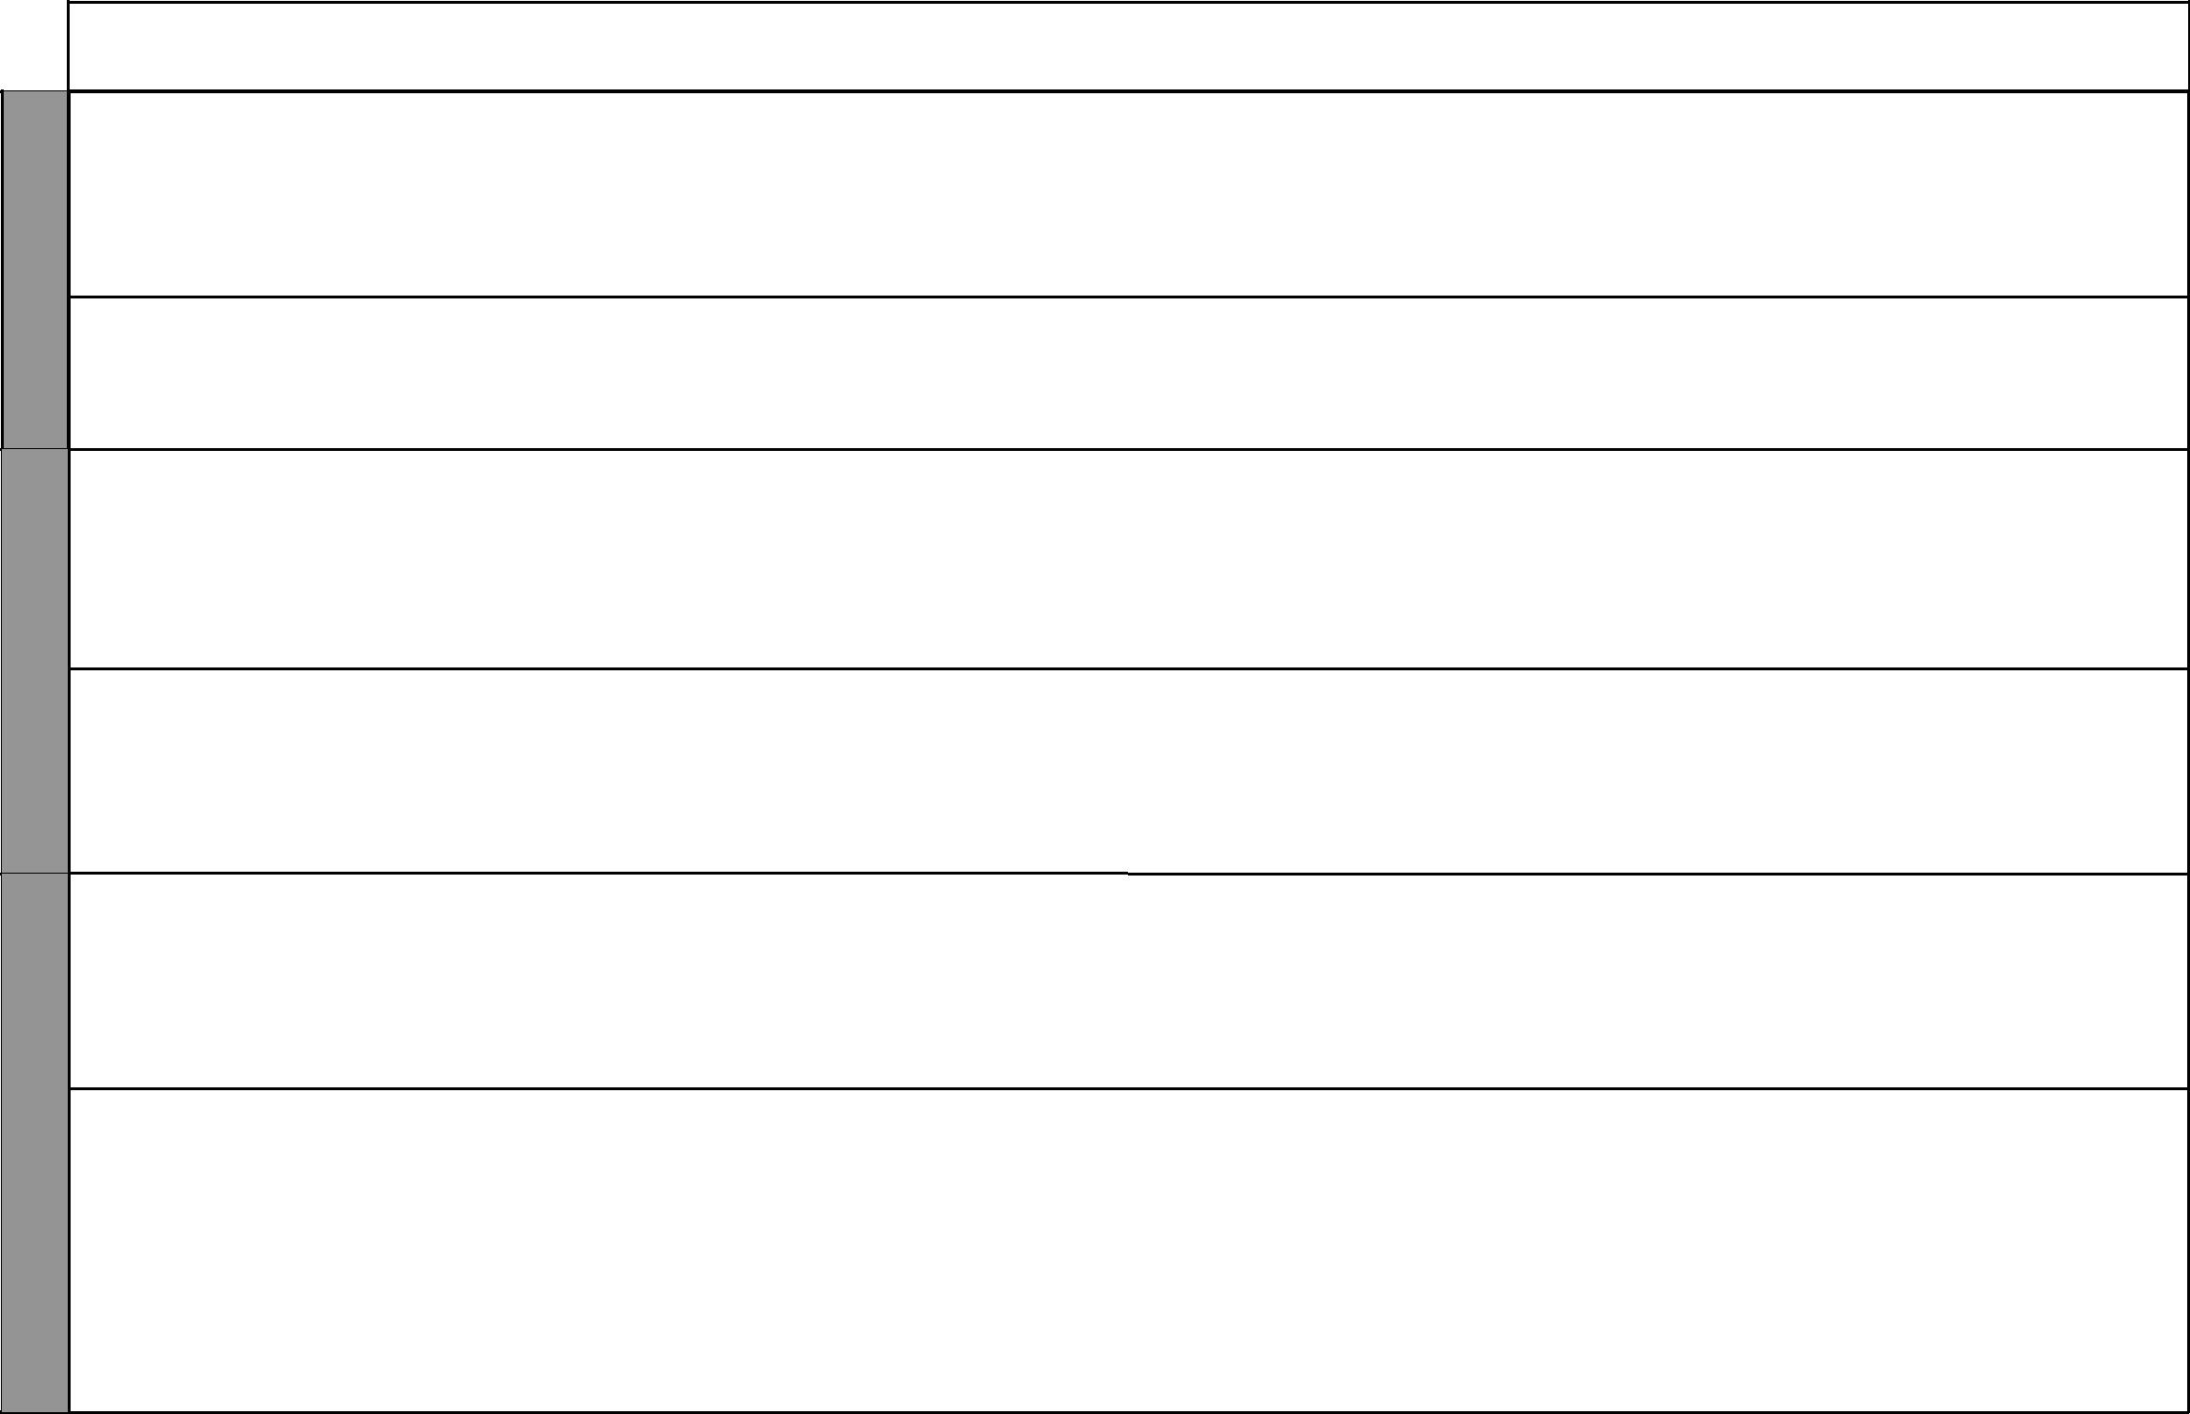

WEEK 1

WEEK 2

WEEK 3

LESSONS | TOPIC | SUB-TOPIC |  | OBJECTIVES | TEACHING/LEARNING |  | TEACHING/LEARNING |  |  | REFERENCES | REMARKS
 |  |  |  |  |  | ACTIVITIES |  | RESOURCES
1 | 1. Myself | My name | By the end of the lesson the |  | • | Scripture reading | • | The Good News Bible: | • | Pupil’s Book
 |  |  | learner should be able to: |  | • | Explanation |  | 1 Samuel 3:1-21 |  | page 2
 |  |  | 1. | tell his/her name | • | Story telling | • | Chalkboard | • | Teacher’s Guide
 |  |  | 2. | thank God for creating | • | Demonstration | • | Chart |  | page 1
 |  |  |  | him/her | • | Dramatization
 |  |  |  |  | • | Questions and answers
2 |  | Parts of the | By the end of the lesson the |  | • | Questions and answers | • | The Good News Bible: | • | Pupil’s Book
 |  | body | learner should be able to: |  | • | Scripture reading |  | 1 Corinthians 12:12-26 |  | page 3
 |  |  | 1. | mention parts of his/her body | • | Explanation | • | Chalkboard | • | Teacher’s Guide
 |  |  | 2. appreciate parts of his/her body |  | • | Demonstration |  |  |  | pages 2-3
 |  | Functions of | By the end of the lesson the |  | • | Scripture reading | • | The Good News Bible: | • | Pupil’s Book
1 |  | the parts of | learner should be able to: |  | • | Explanation |  | James 3:6-10 |  | page 4
 |  | the body | 1. | mention parts of his/her body | • | Demonstration | • | Chalkboard | • | Teacher’s Guide
 |  | the body | 1. | mention parts of his/her body | • | Singing
 |  |  |  | and their functions | • | Role play | • | Charts |  | pages 3-4
 |  |  | 2. | appreciate parts of his/her | • | Role play
 |  |  | 2. | appreciate parts of his/her | • | Drawing
 |  |  |  | body | • | Drawing
 |  |  |  | body | • | Questions and answers
 |  | Care of parts | By the end of the lesson the |  | • | Scripture reading | • | The Good News Bible: | • | Pupil’s Book
2 |  | of the body | learner should be able to: |  | • | Explanation |  | Matthew 9:27-33; |  | page 6
 |  |  | 1. | state how he/she cares for the | • | Questions and answers |  | Mark 1:29-31; Acts 3:1-10 | • | Teacher’s Guide
 |  |  | 1. | state how he/she cares for the | • | Role play |  | Mark 1:29-31; Acts 3:1-10 | • | Teacher’s Guide
 |  |  |  | parts of the body | • | Role play | • | Chalkboard |  | pages 5-6
 |  |  |  | parts of the body | • | Memorization | • | Chalkboard |  | pages 5-6
 |  |  | 2. | appreciate parts of his/her | • | Memorization | • | Charts
 |  |  |  | body
1 |  | My thoughts | By the end of the lesson the |  | • | Scripture reading | • | The Good News Bible: | • | Pupil’s Book
 |  | and feelings | learner should be able to: |  | • | Explanation |  | Psalms 35:28; 94:9-11 |  | page 7
 |  |  | 1. | describe an occasion he/she | • | Questions and answers | • | Chalkboard | • | Teacher’s Guide
 |  |  | 1. | describe an occasion he/she | • | Singing
 |  |  |  | was very happy | • | Singing | • | Charts |  | pages 7-8
 |  |  | 2. | thank God for creating
 |  |  |  | him/her
2 | 2. My | Members of | By the end of the lesson the |  | • | Scripture reading | • | The Good News Bible: | • | Pupil’s Book
 | family | my family | learner should be able to: |  | • | Discussion |  | Exodus 20:2; |  | pages 8-12
 |  |  | 1. | mention members of his/her | • | Explanation |  | Genesis 37:3-5; 12-14; | • | Teacher’s Guide
 |  |  | 1. | mention members of his/her | • | Questions and answers |  | Genesis 37:3-5; 12-14; | • | Teacher’s Guide
 |  |  |  | family | • | Questions and answers |  | 25-28 |  | pages 8-9
 |  |  |  | family | • | Drawing |  | 25-28 |  | pages 8-9
 |  |  | 2. | thank God for giving him/her | • | Drawing | • | Chalkboard
 |  |  | 2. | thank God for giving him/her | • | Prayer | • | Chalkboard
 |  |  |  | a family | • | Prayer | • | Charts

1 For use with Living in Christ Standard One

WEEK 4

WEEK 5

WEEK 6

 |  |  |  |  |  |  |  |  |  |  |  |  |  | Living in Christ Standard One
 |  |  |  |  |  |  |  |  |  |  |  |  |  | Schemes of Work
 |  |  |  |  |  |  |  |  |  |  |  |  |  |  |  | Term 1
LESSONS |  | TOPIC |  | SUB-TOPIC |  | OBJECTIVES |  | TEACHING/LEARNING |  |  | TEACHING/LEARNING |  |  | REFERENCES |  | REMARKS
 |  |  |  |  |  |  |  |  | ACTIVITIES |  |  | RESOURCES
1 |  |  |  | How I relate | By the end of the lesson the |  |  | • | Scripture reading |  | • | The Good News Bible: | • | Pupil’s Book
 |  |  |  | to members of | learner should be able to: |  |  | • | Explanation |  |  | 1 John 3:18; Exodus 20:12; |  | page 13
 |  |  |  | my family | 1. | state how he/she relates to |  | • | Narration |  |  | Ephesians 6:1-3; | • | Teacher’s Guide
 |  |  |  |  |  | members of his/her family |  | • | Prayer |  |  | Genesis 45:1-4; 12-15 |  | pages 11-12
 |  |  |  |  | 2. | respect members of his/her |  | • | Memorization |  | • | Chalkboard
 |  |  |  |  |  | family |  |  |  |  | • | Charts
2 |  | 3. The |  | God’s written | By the end of the lesson the |  |  | • | Scripture reading |  | • | The Good News Bible: | • | Pupil’s Book
 |  | Holy |  | message | learner should be able to: |  |  | • | Explanation |  |  | 1 Samuel 3:1-4; |  | page 14-15
 |  | Bible |  |  | 1. | identify the Bible from |  | • | Demonstration |  |  | 2 Timothy 3:16-17 | • | Teacher’s Guide
 |  |  |  |  |  | other books |  | • Drawing |  |  | • | Chalkboard |  | pages 14-15
 |  |  |  |  | 2. | respect the Bible as the word |  | • | Singing |  | • | Charts
 |  |  |  |  |  | of God
1 |  |  |  | The Bible: A | By the end of the lesson the |  |  | • | Scripture reading |  | • | The Good News Bible: | • | Pupil’s Book
 |  |  |  | guide in our | learner should be able to: |  |  | • | Explanation |  |  | Psalms 119:105; |  | page 16
 |  |  |  | lives | 1. | say a memory verse from |  | • Demonstration |  |  |  | Matthews 22:37-40 | • | Teacher’s Guide
 |  |  |  |  |  | the Bible |  | • Drawing |  |  | • | Chalkboard |  | pages 15-16
 |  |  |  |  | 2. | respect the Bible as the word |  | • | Singing |  | • | Charts
 |  |  |  |  |  | of God |  | • | Scripture reading |  | • | Real objects: torch candle,
 |  |  |  |  |  |  |  |  |  |  |  | ball of wool, matchbox,
 |  |  |  |  |  |  |  |  |  |  |  | piece of cloth
2 |  |  |  | Handling the | By the end of the lesson the |  |  | • Explanation |  |  | • | The Good News Bible: | • | Pupil’s Book
2 |  |  |  | Handling the |  |  |  |  |  |  | • | The Good News Bible: |  | page 17
 |  |  |  | Bible | learner should be able to |  |  | • | Questions and answers |  | • | Chalkboard |  | page 17
 |  |  |  | Bible |  |  |  | • | Questions and answers |  | • | Chalkboard | • | Teacher’s Guide
 |  |  |  |  | 1. | give ways of caring for the |  | • | Singing |  | • | Charts | • | Teacher’s Guide
 |  |  |  |  | 1. | give ways of caring for the |  | • | Singing |  | • | Charts |  | pages 16-17
 |  |  |  |  |  | Bible |  | • | Recitation |  |  |  |  | pages 16-17
 |  |  |  |  | 2. | handle the Bible with care |  | • | Memorization
1 |  |  |  | Jesus as God’s | By the end of the lesson the |  |  | • | Scripture reading |  | • | The Good News Bible: | • | Pupil’s Book
1 |  |  |  | Jesus as God’s |  |  |  | • | Scripture reading |  | • | The Good News Bible: |  | page 18
 |  | 4. God’s |  | greatest gift | learner should be able to: |  |  | • | Explanation |  |  | John 3:16; Isaiah 9:6-7; |  | page 18
 |  | 4. God’s |  | greatest gift |  |  |  | • | Explanation |  |  | Matthew 1:18-24 | • | Teacher’s Guide
 |  | love for |  |  | 1. | mention gifts he/she receives |  | • | Narration |  |  | Matthew 1:18-24 | • | Teacher’s Guide
 |  | love for |  |  | 1. | mention gifts he/she receives |  | • | Narration |  | • | Chalkboard |  | pages 17-18
 |  | us |  |  |  | from God |  | • Questions and answers |  |  | • | Chalkboard |  | pages 17-18
 |  | us |  |  |  | from God |  |  |  |  | • | Charts
 |  |  |  |  | 2. | thank God for the gifts He |  | • | Drawing |  | • | Charts
 |  |  |  |  |  | has given him/her |  | • | Prayer
 |  |  |  | Giving gifts to | By the end of the lesson the |  |  | • | Scripture reading |  | • | The Good News Bible: | • | Pupil’s Book
2 |  |  |  | others | learner should be able to: |  |  | • | Explanation |  |  | Ephesians 4:31-32; |  | page 19
2 |  |  |  | others |  |  |  | • | Explanation |  |  | Ephesians 4:31-32; | • | Teacher’s Guide
 |  |  |  |  | 1. | name the gifts he/she gives to |  | • | Questions and answers |  |  | 2 Corinthians 9: 7; | • | Teacher’s Guide
 |  |  |  |  |  | others |  | • | Demonstration |  |  | James 3:6-10 |  | pages 18-19
 |  |  |  |  |  | others |  | • | Demonstration |  | • | Chalkboard
 |  |  |  |  | 2. | share gifts with others |  | • | Role play |  | • | Chalkboard
 |  |  |  |  | 2. | share gifts with others |  | • | Role play |  | • | Charts
 |  |  |  |  |  |  |  | • | Prayer |  | • | Charts
 |  |  |  |  |  |  |  | • | Prayer |  | • | Real objects: gifts
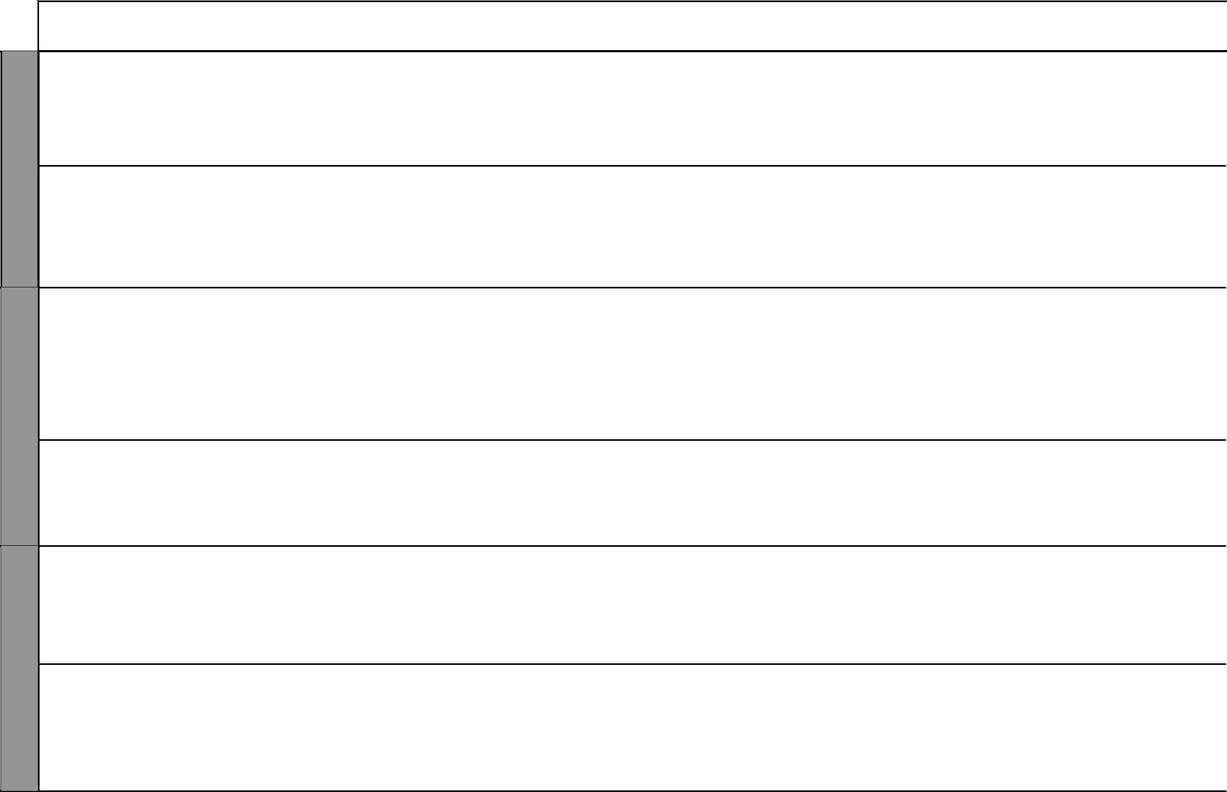

2 For use with Living in Christ Standard One

Living in Christ Standard One

Schemes of Work

Term 1
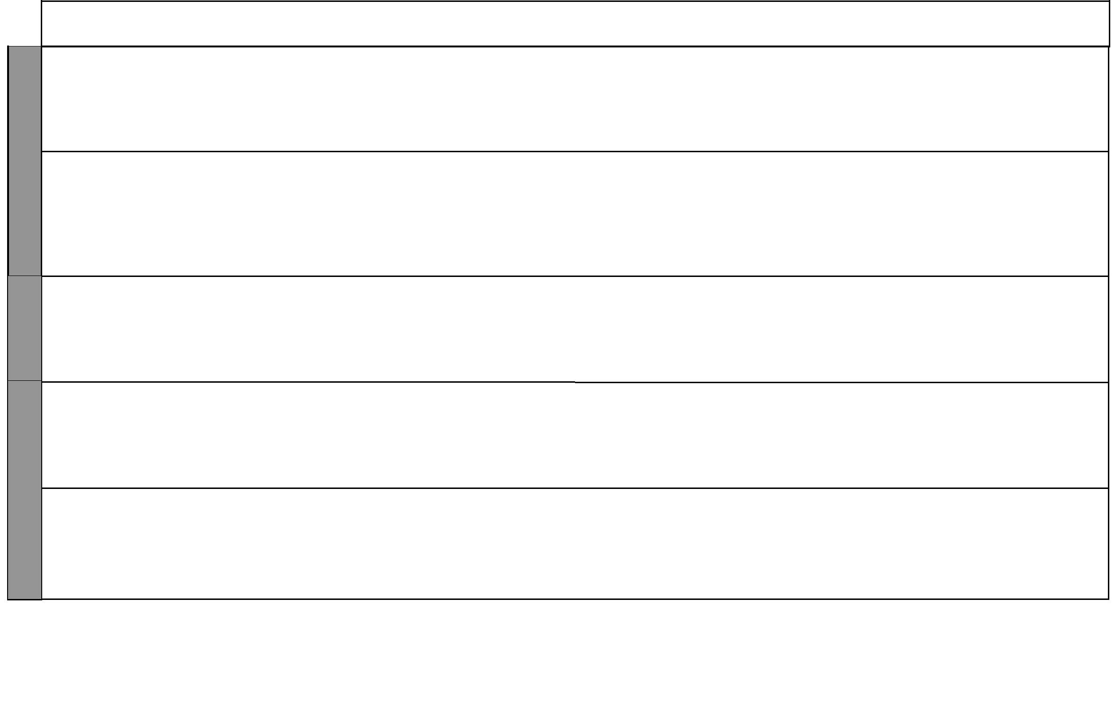

WEEK 7

WEEK 8

WEEK 1

LESSONS | TOPIC | SUB-TOPIC |  | OBJECTIVES | TEACHING/LEARNING |  | TEACHING/LEARNING |  |  | REFERENCES | REMARKS
 |  |  |  |  |  | ACTIVITIES |  | RESOURCES
1 |  | Importance of | By the end of the lesson the |  | • | Scripture reading | • | The Good News Bible: | • | Pupil’s Book
 |  | Christmas | learner should be able to: |  | • | Explanation |  | Luke 1:26-28; 2:1-20 |  | page 21
 |  |  | 1. | state the importance of | • | Questions and answers | • | Chalkboard | • | Teacher’s Guide
 |  |  |  | Christmas | • | Role play | • | Charts |  | page 21
 |  |  | 2. | thank God for the gift of | • | Singing
 |  |  |  | Jesus Christ | • | Prayer
 |  | Visit of the | By the end of the lesson the |  | • | Scripture reading | • | The Good News Bible: | • | Pupil’s Book
 |  | wise men | learner should be able to: |  | • | Explanation |  | Matthew 2:1-12 |  | page 22
2 |  |  | 1. | tell the story of the visit of | • | Questions and answers | • | Chalkboard | • | Teacher’s Guide
 |  |  |  | the wise men to the baby | • | Narration | • | Charts |  | pages 22-23
 |  |  |  | Jesus Christ | • | Role play | • | Real objects: gifts
 |  |  | 2. | desire to worship God like | • | Singing
 |  |  |  | the wise men
1 |  | Accepting gifts | By the end of the lesson the |  | • | Scripture reading | • | The Good News Bible: | • | Pupil’s Book
 |  | from others | learner should be able to: |  | • | Explanation |  | Psalms 112:9 |  | page 20
 |  |  | 1. | mention ways of accepting | • | Questions and answers | • | Chalkboard | • | Teacher’s Guide
 |  |  |  | gifts from others | • | Demonstration | • | Charts |  | pages 19-20
 |  |  | 2. | exercise caution when | • | Singing
 |  |  |  | receiving gifts from others
1 | 5. Thank- | The holidays | By the end of the lesson the |  | • | Scripture reading | • | The Good News Bible: | • | Pupil’s Book
 | fulness |  | learner should be able to: |  | • | Explanation | • | Chalkboard |  | page 24
 |  |  | 1. | describe how he/she spent | • | Questions and answers |  |  | • | Teacher’s Guide
 |  |  |  | the holidays | • | Singing |  |  |  | page 23-24
 |  |  | 2. | appreciate the importance | • | Memorization
 |  |  |  | of holidays
2 |  | Hannah shows | By the end of the lesson the |  | • Scripture reading |  | • | The Good News Bible: | • | Pupil’s Book
 |  | gratitude | learner should be able to: |  | • | Explanation |  | 1 Samuel 2:18-21, 26 |  | page 25
 |  |  | 1. | state how Hannah showed | • | Story telling | • | Chalkboard | • | Teacher’s Guide
 |  |  |  | gratitude to God | • | Role play |  |  |  | pages 24-25
 |  |  | 2. | thank God for His gifts | • | Singing

3 For use with Living in Christ Standard One

Living in Christ Standard One Schemes of Work: Term Two
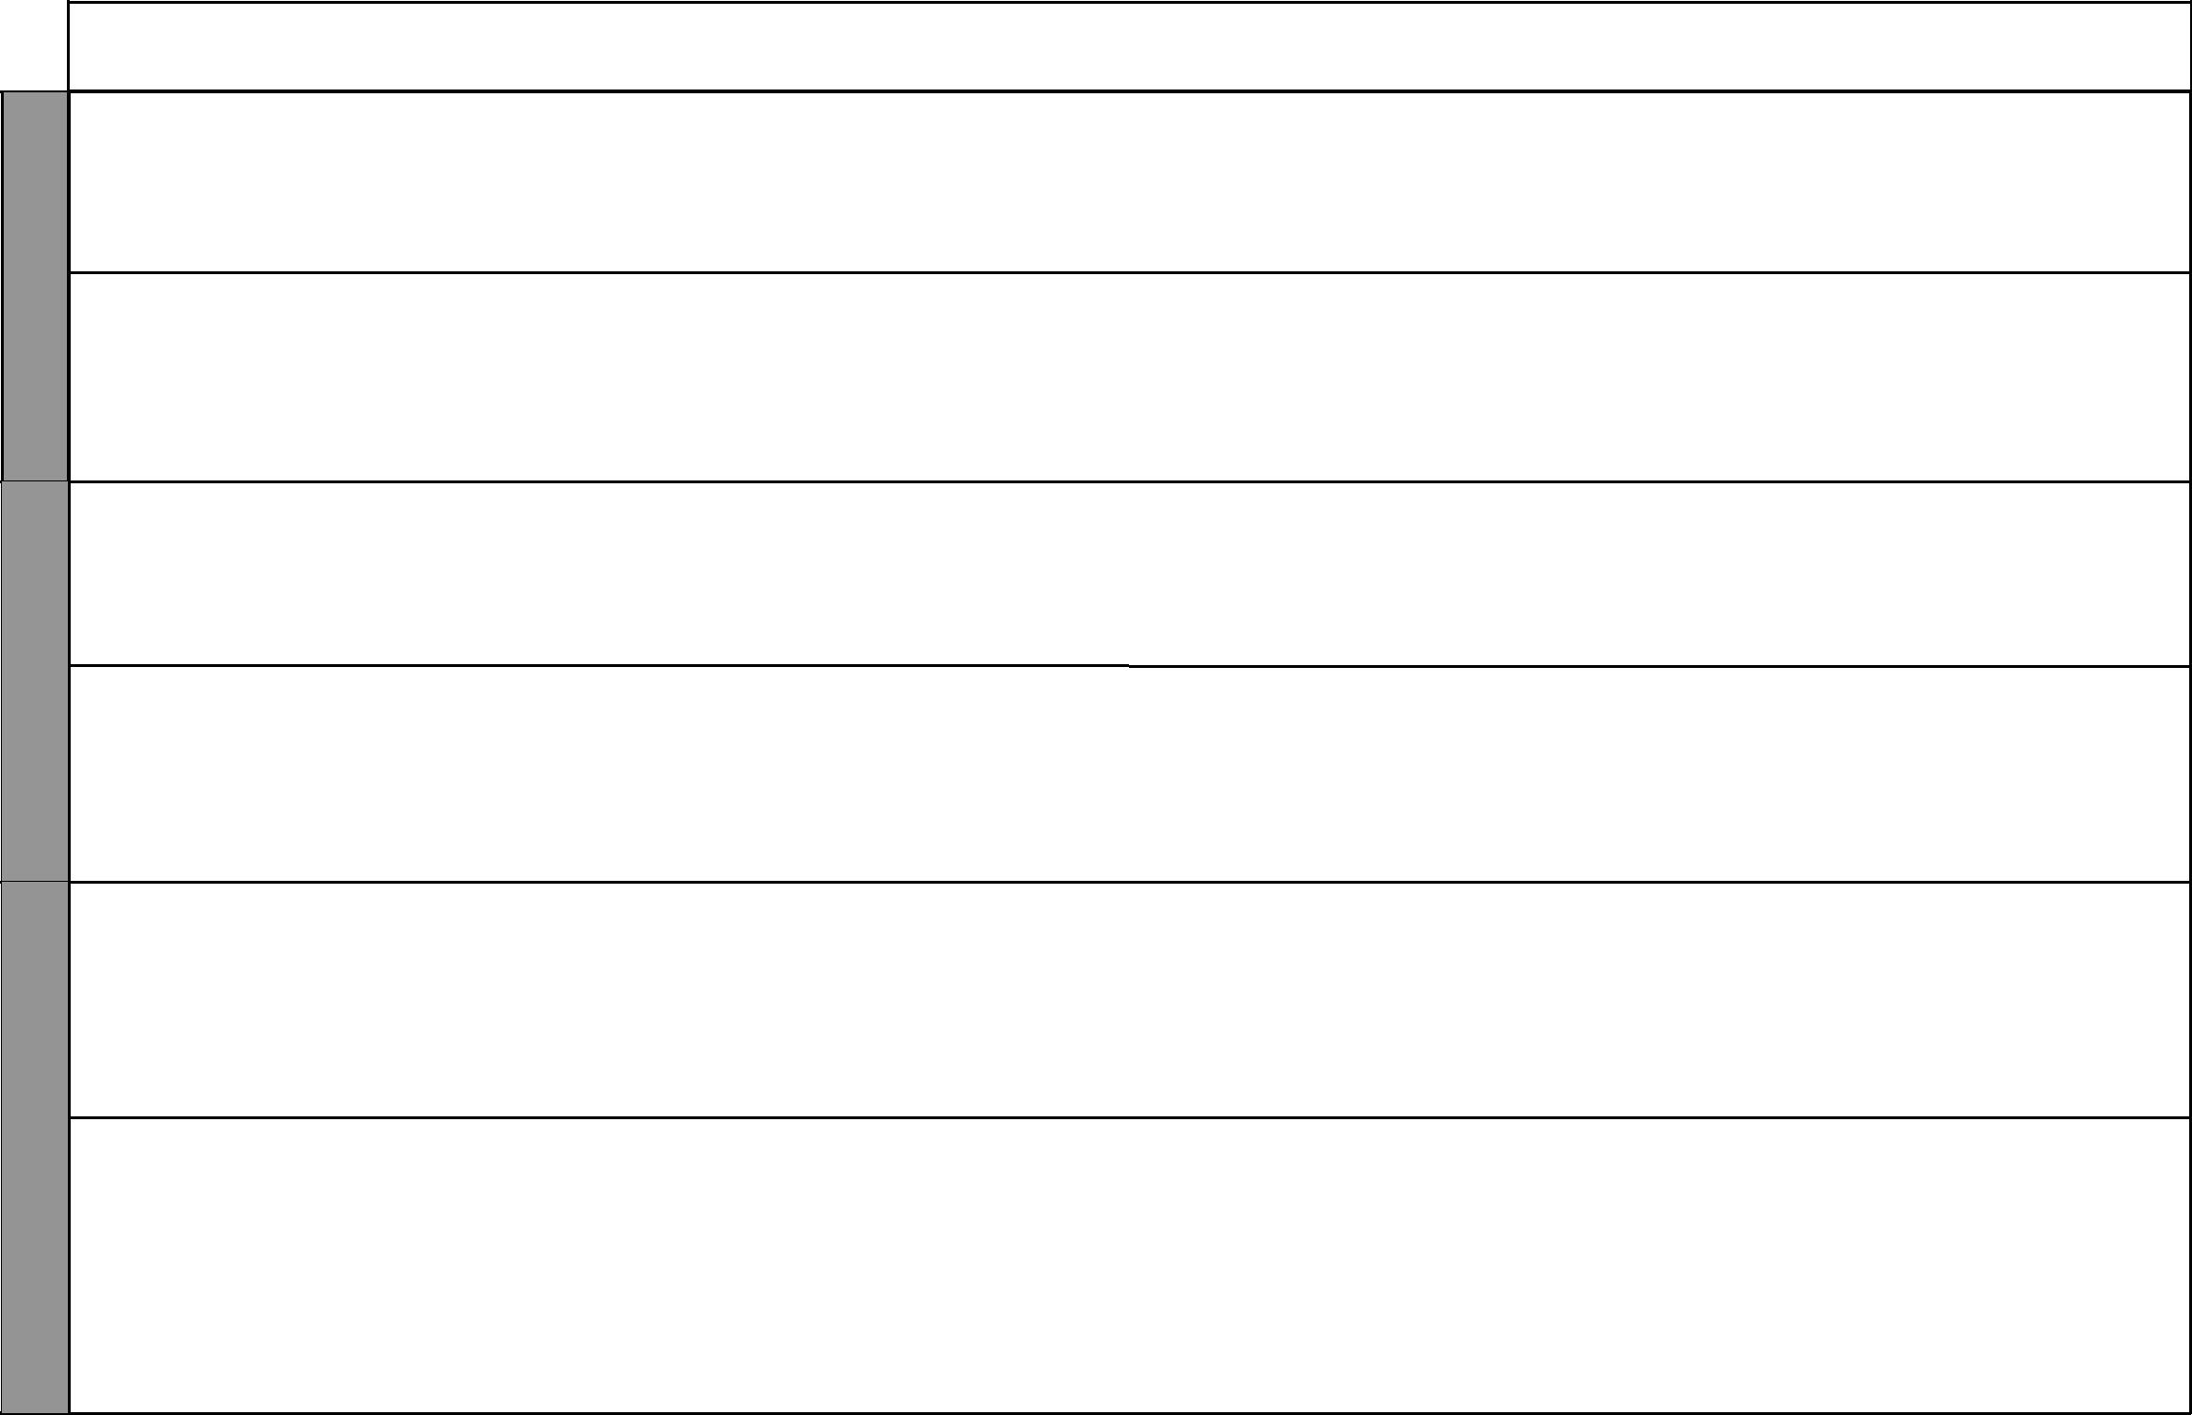

WEEK 2

WEEK 3

WEEK 4

LESSONS | TOPIC | SUB-TOPIC |  | OBJECTIVES | TEACHING/LEARNING |  | TEACHING/LEARNING |  |  | REFERENCES | REMARKS
 |  |  |  |  |  | ACTIVITIES |  | RESOURCES
1 |  | Showing | By the end of the lesson the |  | • | Scripture reading | • The Good News Bible: |  | • | Pupil’s Book
 |  | gratitude for | learner should be able to: |  | • | Explanation |  | Ephesians 5:20; | • | Teacher’s Guide
 |  | God’s gift | 1. | state how Hannah showed | • Questions and answers |  |  | 2 Corinthians 9:15
 |  |  |  | gratitude to God | • | Storytelling | • | Chalkboard
 |  |  | 2. | thank God for His gifts | • | Memorization
2 | 6. Prayer | The Lord’s | By the end of the lesson the |  | • | Scripture reading | • The Good News Bible: |  | • | Pupil’s Book
 |  | prayer | learner should be able to: |  | • | Explanation |  | Matthew 6:9-13; 7:7-11; |  | page 26
 |  |  | 1. | recite the Lord’s prayer | • | Prayer |  | Psalms 32:8; 34:4; 1 | • | Teacher’s Guide
 |  |  | 2. | desire to say the Lord’s | • | Recitation |  | Thess 5:16-17 |  | pages 25-26
 |  |  |  | prayer always | • | Memorization |  | 1 John 3:22; Luke 18:1
 |  |  |  |  |  |  | • | Chalkboard
1 | 7. Obedi- | Meaning of | By the end of the lesson the |  | • | Scripture reading | • The Good News Bible: |  | • | Pupil’s Book
 | ence | obedience | learner should be able to: |  | • | Explanation |  | 1 Samuel 16:19-22, |  | page 30
 |  |  | 1. | state the meaning of | • | Questions and answers |  | Psalms 128:1 | • | Teacher’s Guide
 |  |  |  | obedience | • Demonstration |  | • | Chalkboard |  | pages 29-30
 |  |  | 2. | obey rules | • | Memorization
2 |  | Jesus Christ | By the end of the lesson the |  | • | Scripture reading | • The Good News Bible: |  | • | Pupil’s Book
 |  | obeyed | learner should be able to: |  | • | Explanation |  | John 4:34; |  | page 31
 |  |  | 1. | state occasions when Jesus | • | Story telling |  | Luke 2:51-52; | • | Teacher’s Guide
 |  |  |  | Christ obeyed his parents | • | Drawing |  | Hebrews 5:8-9 |  | pages 30-31
 |  |  | 2. | be ready to obey his/her | • | Singing | • | Chalkboard
 |  |  |  | parents | • | Demonstration | • | Charts
1 |  | Honouring | By the end of the lesson the |  | • | Scripture reading | • The Good News Bible: |  | • | Pupil’s Book
 |  | parents | learner should be able to: |  | • | Explanation |  | Exodus 20:12; |  | page 32
 |  |  | 1. | mention occasions when | • | Questions and answers |  | Ephesians 6:1-3; | • | Teacher’s Guide
 |  |  |  | he/she has obeyed and | • | Singing |  | Colossians 3:20 |  | pages 31-32
 |  |  |  | disobeyed his/her parents | • | Role play | • | Chalkboard
 |  |  | 2. | be ready to obey his/her | • | Recitation
 |  |  |  | parents
2 |  | Rules at home | By the end of the lesson the |  | • | Scripture reading | • The Good News Bible: |  | • | Pupil’s Book
 |  |  | learner should be able to: |  | • | Explanation |  | Romans 13:1 |  | page 33
 |  |  | 1. | state the rules at home | • | Recitation | • | Chalkboard | • | Teacher’s Guide
 |  |  | 2. | obey rules at home | • | Role play |  |  |  | pages 32-33
 |  |  |  |  | • | Singing

4 For use with Living in Christ Standard One

Living in Christ Standard One

Schemes of Work

Term 2
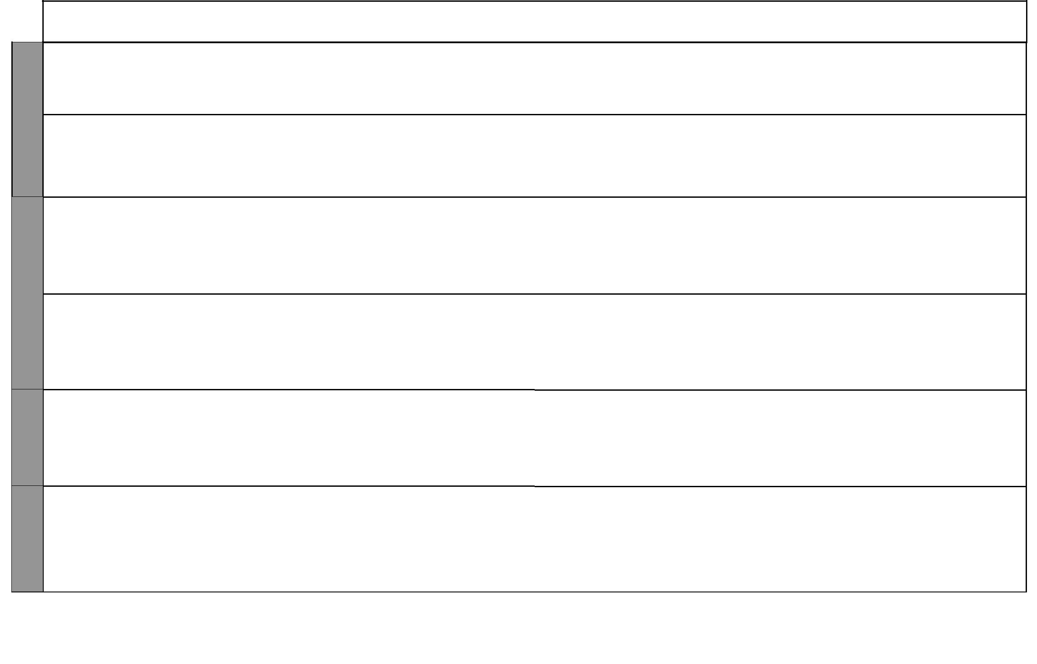

WEEK 5

WEEK 6

WEEK 8 WEEK 7

LESSONS | TOPIC | SUB-TOPIC |  | OBJECTIVES | TEACHING/LEARNING |  | TEACHING/LEARNING |  |  | REFERENCES | REMARKS
 |  |  |  |  |  | ACTIVITIES |  | RESOURCES
1 |  | Rules at school | By the end of the lesson the |  | • | Scripture reading | • The Good News Bible: |  | • | Pupil’s Book
 |  |  | learner should be able to: |  | • | Explanation |  | Romans 13:1 |  | page 33
 |  |  | 1. | state the rules at school | • | Questions and answers | • | Chalkboard | • | Teacher’s Guide
 |  |  | 2. | obey rules at school | • | Prayer |  |  |  | pages 33-34
 |  | Obedience at | By the end of the lesson the |  | • | Scripture reading | • The Good News Bible: |  | • | Pupil’s Book
2 |  | school | learner should be able to: |  | • | Explanation |  | Titus 3:1, Proverbs 23:12 |  | page 33
 |  |  | 1. | state the rules at school | • | Questions and answers | • | Chalkboard | • | Teacher’s Guide
 |  |  | 2. | obey rules at school | • | Prayer |  |  |  | pages 33-34
 |  |  |  |  | • | Recitation
 | 8. Work | Activities of | By the end of the lesson the |  | • | Scripture reading | • The Good News Bible: |  | • | Pupil’s Book
1 |  | Jesus Christ | learner should be able to: |  | • | Explanation |  | John 5:17; 17:4; |  | page 34
 |  |  | 1. | state some activities that | • | Questions and answers |  | Matthew 5:13:53-58 | • | Teacher’s Guide
 |  |  |  | Jesus carried out | • | Drawing | • | Chalkboard |  | pages 34-35
 |  |  | 2. | desire to follow the example | • | Miming | • | Charts
 |  |  |  | of Jesus as a worker
2 |  | Duties of a | By the end of the lesson the |  | • | Scripture reading | • The Good News Bible: |  | • | Pupil’s Book
 |  | child at home | learner should be able to: |  | • | Explanation |  | Exodus 2:16-19; |  | page 35
 |  |  | 1. | mention duties a child can | • | Questions and answers |  | Genesis 37:12-14 | • | Teacher’s Guide
 |  |  |  | do at home | • | Role play | • | Real objects |  | page 36
 |  |  | 2. | enjoy working | • | Memorization | • | Chalkboard
 |  |  |  |  |  |  | • | Charts
1 |  | Duties of a | By the end of the lesson the |  | • | Scripture reading | • The Good News Bible: |  | • | Pupil’s Book
 |  | child at school | learner should be able to: |  | • | Explanation |  | Daniel 1:3-4, |  | page 36
 |  |  | 1. | mention some duties a | • | Questions and answers |  | Proverbs 23:12, Acts 7:22 | • | Teacher’s Guide
 |  |  |  | child does at school | • | Working outside the class | • | Chalkboard |  | pages 37-38
 |  |  | 2. | enjoy working | • | Singing
1 |  | Being a | By the end of the lesson the |  | • | Scripture reading | • The Good News Bible: |  | • | Pupil’s Book
 |  | faithful | learner should be able to: |  | • | Explanation |  | Matthew 25:14-30 |  | page 37
 |  | servant | 1. | list the things that the | • | Questions and answers | • | Chalkboard | • | Teacher’s Guide
 |  |  |  | faithful servant did | • | Role play |  |  |  | pages 38-39
 |  |  | 2. | desire to follow the example | • | Singing
 |  |  |  | of Christ as a worker

5 For use with Living in Christ Standard One

WEEK 8

WEEK 9

WEEK 10

WEEK 11

 |  |  |  |  |  |  |  |  |  |  |  |  |  | Living in Christ Standard One
 |  |  |  |  |  |  |  |  |  |  |  |  |  | Schemes of Work
 |  |  |  |  |  |  |  |  |  |  |  |  |  |  |  | Term 2
LESSONS |  | TOPIC |  | SUB-TOPIC |  | OBJECTIVES |  | TEACHING/LEARNING |  |  | TEACHING/LEARNING |  |  | REFERENCES |  | REMARKS
 |  |  |  |  |  |  |  |  | ACTIVITIES |  |  | RESOURCES
2 |  | 9. Jesus |  | The early life | By the end of the lesson the |  |  | • | Scripture reading |  | • The Good News Bible: |  | • | Pupil’s Book
 |  | Christ |  | of Jesus Christ | learner should be able to: |  |  | • | Questions and answers |  |  | Luke 4:38-40 |  | page 38
 |  | the son |  |  | 1. | state the activities Jesus did |  | • | Explanation |  | • | Chalkboard | • | Teacher’s Guide
 |  | of God |  |  |  | at home |  | • | Miming |  |  |  |  | pages 39-40
 |  |  |  |  | 2. | desire to be a follower of |  | • | Prayer
 |  |  |  |  |  | Christ
1 |  |  |  | Jesus at the | By the end of the lesson the |  |  | • | Scripture reading |  | • The Good News Bible: |  | • | Pupil’s Book
 |  |  |  | temple | learner should be able to: |  |  | • | Questions and answers |  |  | Luke 2:41-51 |  | page 38
 |  |  |  |  | 1. | state what happened when |  | • | Explanation |  | • | Chalkboard | • | Teacher’s Guide
 |  |  |  |  |  | Jesus visited the temple |  | • | Miming |  |  |  |  | pages 39-40
 |  |  |  |  | 2. | desire to be a follower of |  | • | Prayer
 |  |  |  |  |  | Christ |  | • | Drawing
2 |  |  |  | Public min- | By the end of the lesson the |  |  | • | Scripture reading |  | • The Good News Bible: |  | • | Pupil’s Book
 |  |  |  | istry of Jesus | learner should be able to: |  |  | • | Explanation |  |  | Matthew 3:13-17, |  | page 39
 |  |  |  | Christ | 1. | name the first four followers |  | • | Questions and answers |  |  | John 1:35-42, | • | Teacher’s Guide
 |  |  |  |  |  | of Jesus Christ |  | • | Prayer |  |  | Matthew 4:18-22, |  | pages 40-41
 |  |  |  |  | 2. | desire to be a follower of |  |  |  |  |  | Luke 5:1-11
 |  |  |  |  |  | Christ |  |  |  |  | • | Chalkboard
1 |  |  |  | Choosing the | By the end of the lesson the |  |  | • | Scripture reading |  | • The Good News Bible: |  | • | Pupil’s Book
 |  |  |  | twelve | learner should be able to: |  |  | • | Explanation |  |  | Mark 3:13; Matthew 9:9-13; |  | pages 40-41
 |  |  |  |  | 1. | mention why Jesus chose the |  | • | Questions and answers |  |  | John 1:43-50; Luke 6:12-13 | • | Teacher’s Guide
 |  |  |  |  |  | twelve disciples |  | • | Role play |  | • | Chalkboard |  | pages 41-43
 |  |  |  |  | 2. | desire to be a follower of |  | • | Storytelling |  | • | Pictures of friends
 |  |  |  |  |  | Christ |  | • | Singing
2 |  |  |  | Jesus visits a | By the end of the lesson the |  |  | • | Scripture reading |  | • The Good News Bible: |  | • | Pupil’s Book
 |  |  |  | home | learner should be able to: |  |  | • | Questions and answers |  |  | Luke 4:38-40 |  | page 42
 |  |  |  |  | 1. | tell the story of how Jesus |  | • | Miming |  | • | Charts | • | Teacher’s Guide
 |  |  |  |  |  | Christ visited the home of |  | • | Explanation |  | • | Chalkboard |  | pages 43-44
 |  |  |  |  |  | Simon Peter’s mother in law |  | • | Singing
 |  |  |  |  | 2. | desire to be a follower of
 |  |  |  |  |  | Christ
1 |  |  |  | Jesus Christ | By the end of the lesson the |  |  | • | Questions and answers |  | • The Good News Bible: |  | • | Pupil’s Book
 |  |  |  | prays | learner should be able to: |  |  | • | Scripture reading |  |  | Mark 1:35-39; |  | page 43
 |  |  |  |  | 1. | mention an occasion when |  | • | Explanation |  |  | Luke 22:39-46 | • | Teacher’s Guide
 |  |  |  |  |  | Jesus prayed |  | • | Role play |  | • | Chalkboard |  | pages 44-45
 |  |  |  |  | 2. | desire to be a follower of |  | • | Drawing
 |  |  |  |  |  | Jesus Christ |  | • | Prayer
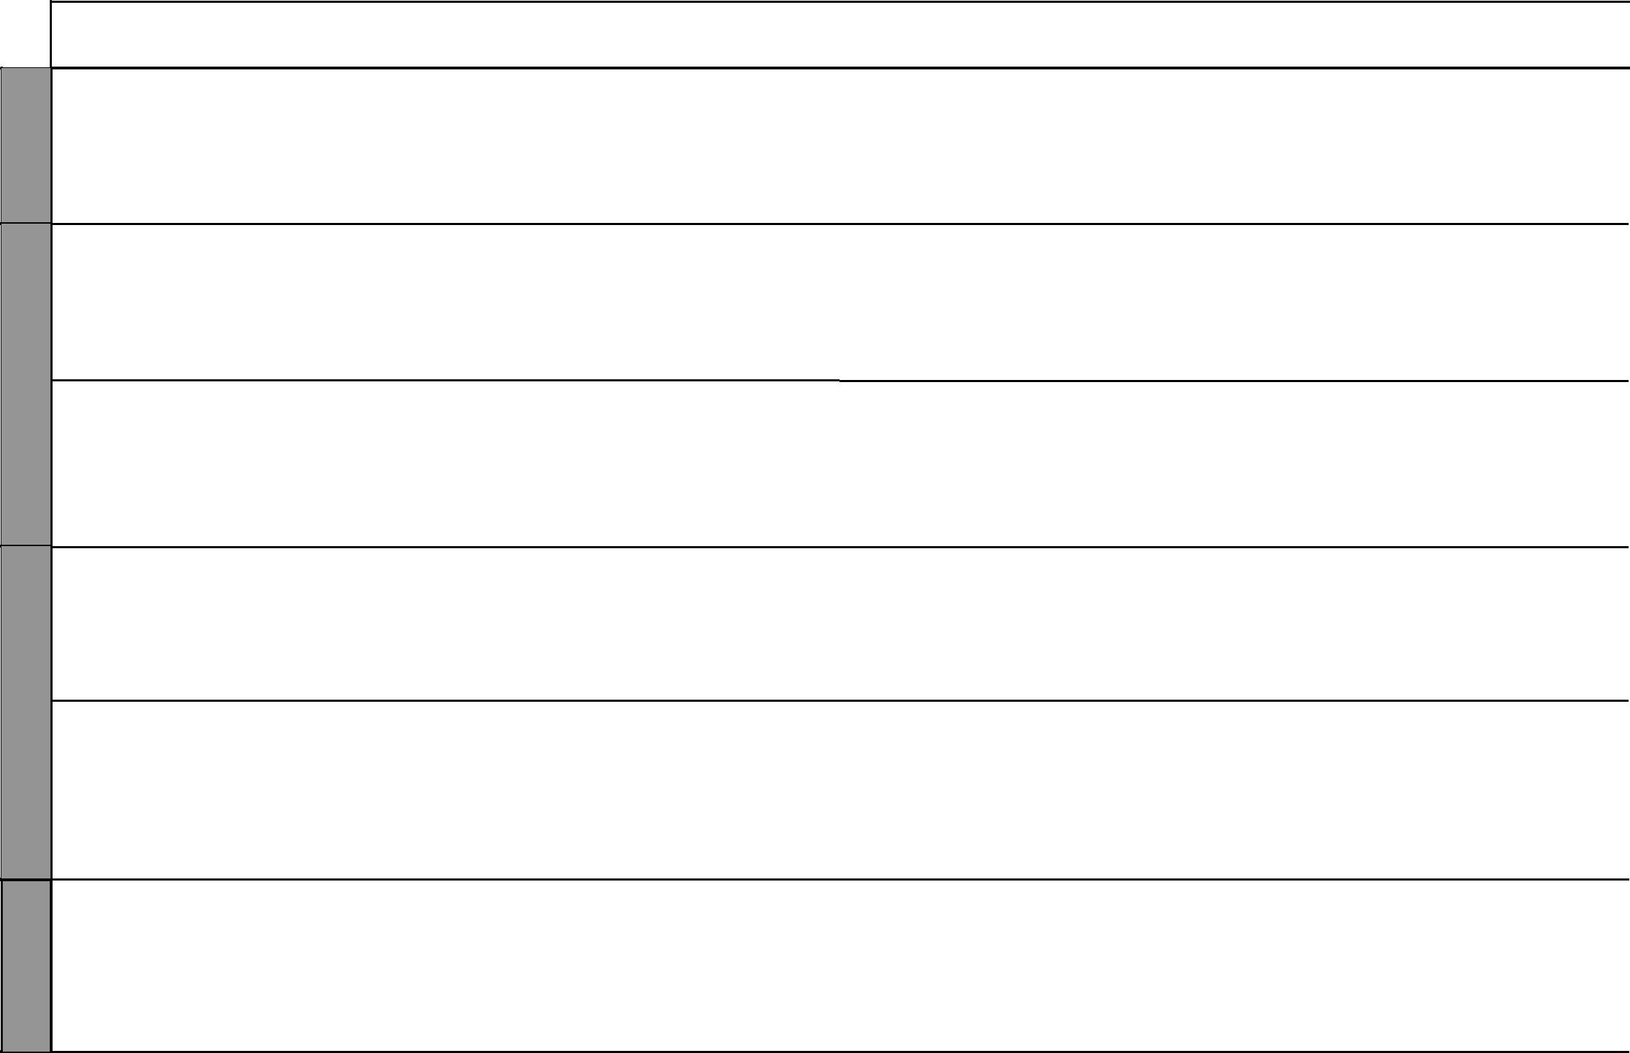

6 For use with Living in Christ Standard One

Living in Christ Standard One Schemes of Work: Term Three
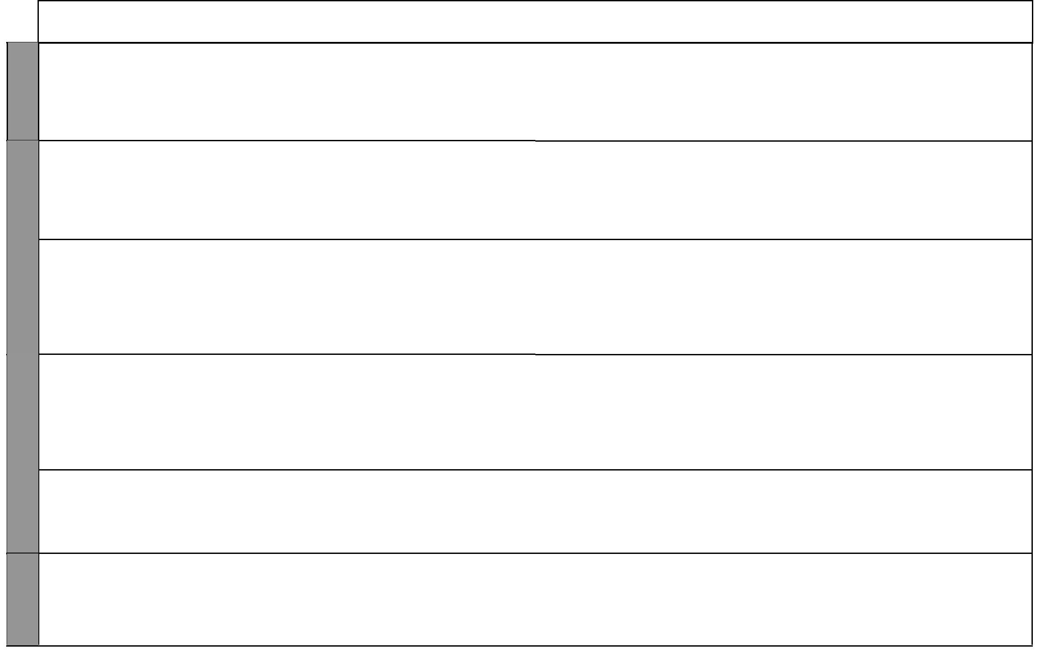

WEEK 11

WEEK 1

WEEK 2

WEEK 3

LESSONS | TOPIC | SUB-TOPIC |  | OBJECTIVES | TEACHING/LEARNING |  | TEACHING/LEARNING |  |  | REFERENCES | REMARKS
 |  |  |  |  |  | ACTIVITIES |  | RESOURCES
2 |  | Jesus Christ | By the end of the lesson the |  | • | Scripture reading | • The Good News Bible: |  | • | Pupil’s Book
 |  | forgives | learner should be able to: |  | • | Explanation |  | Mark 2:1-12, Matthew 6:12 | • | Teachers Guide
 |  |  | 1. | tell the story of Jesus healing | • | Discussion | • | Chalkboard
 |  |  |  | a paralysed man | • | Storytelling
 |  |  | 2. | desire to be a follower of | • | Miming
 |  |  |  | Christ | • | Prayer
1 | 10. Accep- | Visitors to our | By the end of the lesson the |  | • | Scripture reading | • The Good News Bible: |  | • | Pupil’s Book
 | tance and | home | learner should be able to: |  | • | Explanation |  | Hebrews 13:1-2 |  | pages 44-45
 | trust |  | 1. | name the people who visit | • | Questions and answers | • | Chalkboard | • | Teacher’s Guide
 |  |  |  | his/her home | • | Role play | • | Charts |  | pages 45-46
 |  |  | 2. | be ready to welcome visitors
2 |  | Differences | By the end of the lesson the |  | • | Scripture reading | • The Good News Bible: |  | • | Pupil’s Book
 |  | and similari- | learner should be able to: |  | • | Explanation |  | 1 Corinthians 12:4-26, |  | page 46
 |  | ties in family | 1. | state the similarities and | • | Questions and answers |  | Philippians 2:1-5; | • | Teacher’s Guide
 |  | members |  | differences of family | • | Drawing |  | Matthew 7:12 |  | page 47
 |  |  |  | members | • | Singing | • | Chalkboard
 |  |  | 2. | accept all members of his/her
 |  |  |  | family
1 |  | Accepting | By the end of the lesson the |  | • | Scripture reading | • The Good News Bible |  | • | Pupil’s Book
 |  | members of | learner should be able to: |  | • | Explanation |  | Philippians 4:13 |  | page 47
 |  | my family | 1. | state why he/she trusts | • | Questions and answers | • | Chalkboard | • | Teacher’s Guide
 |  |  |  | his/her family members | • | Drawing |  |  |  | page 48
 |  |  | 2. | desire to be trusted by his/her | • | Singing
 |  |  |  | family members | • | Prayer
2 |  | Being trusted | By the end of the lesson the |  | • | Scripture reading | • The Good News Bible: |  | • | Pupil’s Book
 |  | by others | learner should be able to: |  | • | Explanation |  | Deuteronomy 10:20 |  | page 48
 |  |  | 1. | say who he/she trusts at | • | Questions and answers | • | Chalkboard | • | Teacher’s Guide
 |  |  |  | home and at school | • | Narration |  |  |  | pages 49-50
 |  |  | 2. | desire to be trusted by others | • | Singing
1 |  | Trusting God | By the end of the lesson the |  | • | Scripture reading | • The Good News Bible: |  | • | Pupil’s Book
 |  |  | learner should be able to: |  | • | Explanation |  | 2 Corinthians 1:9b; |  | page 49
 |  |  | 1. | give reasons why he/she | • | Questions and answers |  | Psalms 40:3-5, 118:8-9 | • | Teacher’s Guide
 |  |  |  | trusts God | • | Memorization | • | Chalkboard |  | pages 50-51
 |  |  | 2. | trust in God | • | Prayer

7 For use with Living in Christ Standard One

WEEK 3

WEEK 4

WEEK 5

WEEK 6

 |  |  |  |  |  |  |  |  |  |  |  |  |  | Living in Christ Standard One
 |  |  |  |  |  |  |  |  |  |  |  |  |  | Schemes of Work
 |  |  |  |  |  |  |  |  |  |  |  |  |  |  |  | Term 3
LESSONS |  | TOPIC |  | SUB-TOPIC |  | OBJECTIVES |  | TEACHING/LEARNING |  |  | TEACHING/LEARNING |  |  | REFERENCES |  | REMARKS
 |  |  |  |  |  |  |  |  | ACTIVITIES |  |  | RESOURCES
2 |  | 11. Con- |  | Sharing | By the end of the lesson the |  |  | • | Scripture reading |  | • The Good News Bible: |  | • | Pupil’s Book
 |  | cern and |  |  | learner should be able to: |  |  | • | Explanation |  |  | Acts 4:32-35, 20:35; |  | page 50
 |  | sharing |  |  | 1. | mention things that he/she |  | • | Questions and answers |  |  | James 2:14-17 | • | Teacher’s Guide
 |  |  |  |  |  | can share |  | • | Singing |  | • | Chalkboard |  | pages 51-52
 |  |  |  |  | 2. | share with others willingly
1 |  |  |  | The little boy | By the end of the lesson the |  |  | • | Scripture reading |  | • The Good News Bible: |  | • | Pupil’s Book
 |  |  |  | who shared his | learner should be able to: |  |  | • | Explanation |  |  | John 6:8-13 |  | page 51
 |  |  |  | food | 1. | state how the little boy |  | • | Questions and answers |  | • | Real objects e.g. bread, | • | Teacher’s Guide
 |  |  |  |  |  | shared his lunch |  | • | Narration |  |  | water |  | pages 52-53
 |  |  |  |  | 2. | share with others willingly |  | • | Miming |  | • | Chalkboard
 |  |  |  |  |  |  |  | • | Quizzes
 |  |  |  |  |  |  |  | • | Demonstration
2 |  |  |  | The story of | By the end of the lesson the |  |  | • | Scripture reading |  | • The Good News Bible: |  | • | Pupil’s Book
 |  |  |  | Tabitha | learner should be able to: |  |  | • | Explanation |  |  | Acts 9:36-42 |  | page 52
 |  |  |  |  | 1. | tell the story of Tabitha |  | • | Questions and answers |  | • | Charts | • | Teacher’s Guide
 |  |  |  |  | 2. | share with others willingly |  | • | Narration |  | • | Chalkboard |  | pages 53-54
 |  |  |  |  |  |  |  | • | Role play
1 |  |  |  | Healing of | By the end of the lesson the |  |  | • | Scripture reading |  | • The Good News Bible: |  | • | Pupil’s Book
 |  |  |  | Jairus’ | learner should be able to: |  |  | • | Explanation |  |  | Luke 8:40-42 |  | page 53
 |  |  |  | Daughter | 1. | state how Jesus responded to |  | • | Questions and answers |  | • | Chalkboard | • | Teacher’s Guide
 |  |  |  |  |  | people’s needs |  | • | Prayers |  | • | Charts |  | pages 54-55
 |  |  |  |  | 2. | imitate Jesus concern for the
 |  |  |  |  |  | needy
2 |  | 12. |  | Names of my | By the end of the lesson the |  |  | • | Scripture reading |  | • The Good News Bible: |  | • | Pupil’s Book
 |  | Friend- |  | friends | learner should be able to: |  |  | • | Explanation |  | • | Chalkboard |  | page 54
 |  | ship |  | friends |  |  |  | • | Explanation |  | • | Chalkboard |  | page 54
 |  | ship |  |  | 1. | name his/her friends |  | • | Questions and answers |  | • | Charts | • | Teacher’s Guide
 |  |  |  |  | 2. | thank God for his/her friends |  | • | Singing |  |  |  |  | pages 55-56
 |  |  |  |  |  |  |  | • | Drawing
1 |  |  |  | My friends at | By the end of the lesson the |  |  | • | Scripture reading |  | • The Good News Bible: |  | • | Pupil’s Book
 |  |  |  | school and at | learner should be able to: |  |  | • | Explanation |  |  | Luke 11:5-8, Job 6:14 |  | pages 55-56
 |  |  |  | home | 1. | list the things that he/she |  | • | Questions and answers |  | • | Chalkboard | • | Teacher’s Guide
 |  |  |  |  |  | does with friends |  | • | Prayer |  | • | Charts |  | pages 56-58
 |  |  |  |  | 2. | thank God for his/her friends |  | • | Role play
 |  |  |  |  |  |  |  | • | Narration
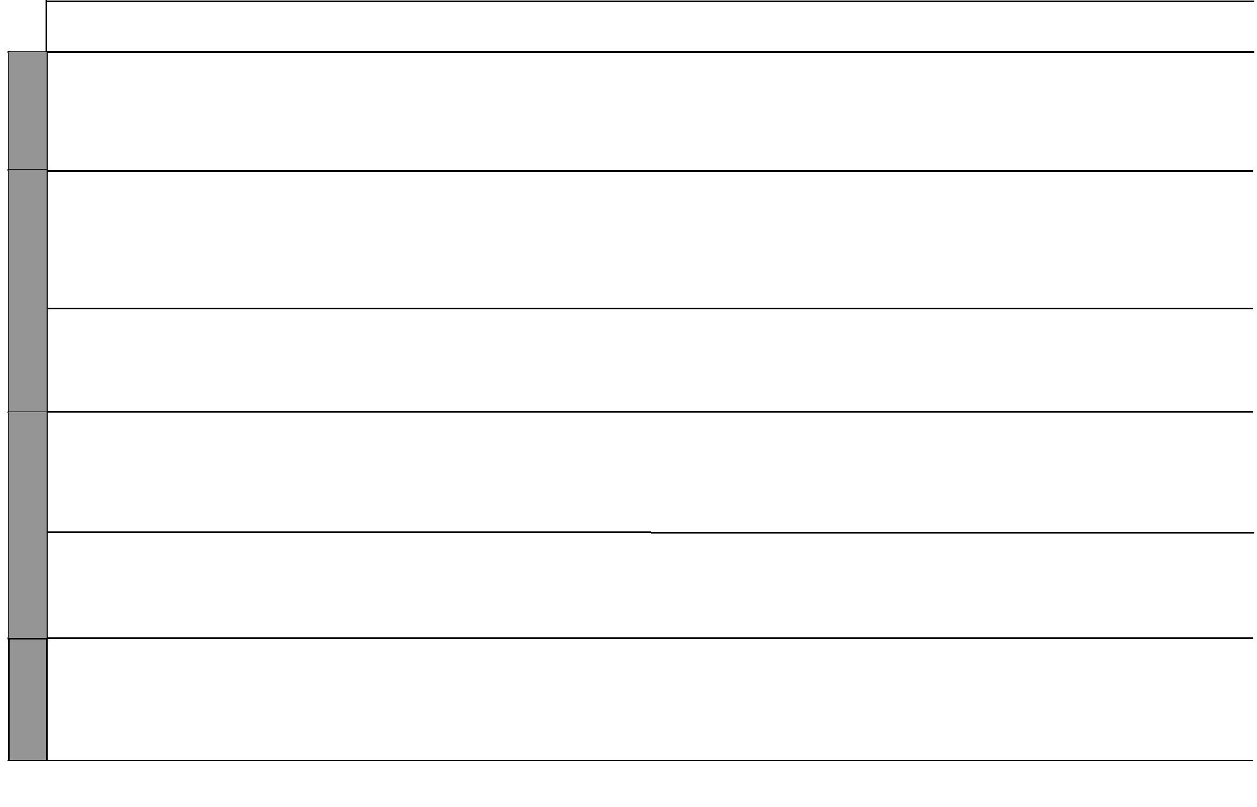

8 For use with Living in Christ Standard One

Living in Christ Standard One

Schemes of Work

Term 3
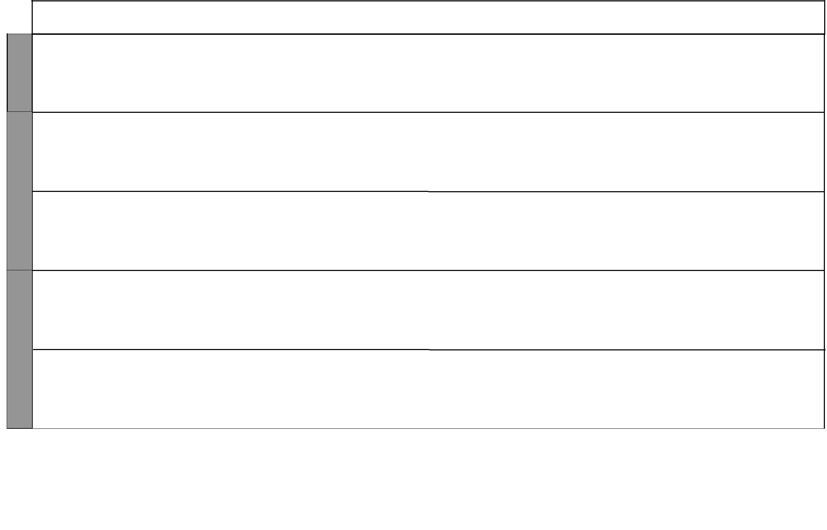

WEEK 6

WEEK 7

WEEK 8

LESSONS | TOPIC | SUB-TOPIC |  | OBJECTIVES | TEACHING/LEARNING |  | TEACHING/LEARNING |  |  | REFERENCES | REMARKS
 |  |  |  |  |  | ACTIVITIES |  | RESOURCES
2 |  | People at | By the end of the lesson the |  | • | Scripture reading | • The Good News Bible: |  | • | Pupil’s Book
 |  | home as | learner should be able to: |  | • | Explanation |  | Genesis 45: 1-15 |  | page 56
 |  | friends | 1. | mention people at home who | • | Questions and answers | • | Chalkboard | • | Teacher’s Guide
 |  |  |  | are his/her friends | • | Narration | • | Charts |  | pages 57-58
 |  |  | 2. | thank God for his/her friends | • | Prayer
 |  |  |  |  | • | Miming
1 |  | God as our | By the end of the lesson the |  | • | Scripture reading | • The Good News Bible: |  | • | Pupil’s Book
 |  | friend | learner should be able to: |  | • | Explanation |  | James 2:23b John 15:13-15, |  | page 57
 |  |  | 1. | mention ways in which she/ | • | Questions and answers |  | 1 John 5:1-5, | • | Teacher’s Guide
 |  |  |  | he can become friends | • | Singing |  | Psalms 25:14 |  | pages 58-59
 |  |  |  | with God | • | Role play | • | Chalkboard
 |  |  | 2. | rejoice in God’s friendship |  |  | • | Charts
2 | 13. Jesus | Meaning of | By the end of the lesson the |  | • | Scripture reading | • The Good News Bible: |  | • | Pupil’s Book
 | Christ | Easter | learner should be able to: |  | • | Explanation |  | Luke 22:14-20 |  | page 58
 | the Son |  | 1. | state the meaning of Easter | • | Questions and answers | • | Chalkboard | • | Teacher’s Guide
 | of God |  | 2. | recite the memory verse | • | Quizzes | • | Charts |  | pages 59-60
 |  |  |  | ‘Jesus died for us’ | • | Singing
 |  |  |  |  | • | Recitation
1 |  | Jesus Christ | By the end of the lesson the |  | • | Scripture reading | • The Good News Bible: |  | • | Pupil’s Book
 |  | a friend of | learner should be able to: |  | • | Explanation |  | Matthew 19:13-15, |  | page 59
 |  | children | 1. | identify Jesus Christ as a | • | Questions and answers |  | John 15:14 | • | Teacher’s Guide
 |  |  |  | friend of little children | • | Memorization | • | Chalkboard |  | pages 59-60
 |  |  | 2. | desire to be a friend of Jesus | • | Narration | • | Charts
 |  |  |  | Christ
2 |  | Death and | By the end of the lesson the |  | • | Scripture reading | • The Good News Bible: |  | • | Pupil’s Book
 |  | resurrection of | learner should be able to: |  | • | Explanation |  | Mark 15:33-47; 16:1-8 |  | pages 60-61
 |  | Jesus | 1. | repeat the memory verse | • | Questions and answers | • | Chalkboard | • | Teacher’s Guide
 |  |  |  | ‘Jesus died for us’ | • | Drawing | • | Charts |  | pages 62-63
 |  |  | 2. | desire to be a friend of Jesus | • | Recitation
 |  |  |  |  | • | Memorization

10 For use with Living in Christ Standard One

