UNIT 1 : PHYSICAL ENVIRONMENT
What is Environment?
The things around us or in our surrounding make up the environment.
Examples
(i) Trees (ii) Animals ` (iii) Water etc.
(vi) Grass (v) Rivers
(vi) Buildings (vii) Birds
Types of environment
(i) Natural environment
(ii) Human environment
(iii) Physical environment
Natural environment
These were things that were made by God. E.g Mountains ,Lakes, Rivers, Vegetation etc.
Human environment
These are things made through man`s efforts e.g Dams, buildings, roads, etc.
Physical environment
The non – living part of the environment which consists of Soils, air, rocks, water, hills, mountains, rivers and lakes form the physical environment.
Map reading and interpretation .
A map is a drawing on a flat surface that represents a whole part of the earth.
Elements of a map
Elements of a map helps a reader to understand the information on a given map.
The main element of a map are:
(i) Title (ii) Key (iii) Compress
(iv) Frame (v) Scales
Uses of elements of a map
ELEMENT | USE(S)
Title | It is the name of the area represented by the map and the information it contains.
Frame | It shows the extent of the area represented by a map. It is also known as the borderline of a map.
Key | It contains the signs or the symbols which represents various features represented in a map.
Compass Direction | Helps to find direction of a position or features in relation to others
Scale | Helps the map reader to know the actual distance on the earth`s surface as reprtesented on the map

Map reading
This is the ability to read, understand, and interpret information given on a map.
Symbols of a map contained in the key should be fully understood and interpreted correctly.
Features that can be interpreted from a map
- Relief and drainage patterns in the area.
- Human and economic activities in the area.
- Types of climate experienced in the area.
- Transport facilities in the area.
- Vegetation found in the area.
- Human settlement pattern in the area.
- Administrative boundaries in the area.
- Social activities (services) found in the area.

Human activities commonly found in a map
Economic activities are the objectives that people carry out in order to get income (money).

Examples
Economic activity | Evidence
Crop farming | Crops e.g coffee, tea, sisal, sugarcane, cotton, pyrethrum, wheat and cotton ginneries, factories, plantations, mills.
Forestry | Presence of saw mill, timber yard, forest guard, posts.
Livestock farming | Presence of cattle dips, butcheries, slaughter houses, cattle boma, dairy farms, creamery, veterinary offices, ranches, beef factories, trough.
Tourism | Presence of national parks, game reserves, camping sites, picnic sites, hotels, lodges, museums, pre-historic sites.  Evidence
Fishing | Presence of fish ponds, fishing villages, a fish factory, fish traps, fisheries departments.
Mining | Presence of quarry, symbols of mines, name of the mine like Salt mining works.
Trade | Presence of markets, shops, trade license office, trading centers, warehouses, stores, towns, custom offices
Industry | Manufacturing factories, bakeries, refineries, rolling mills, ginneries, saw mill.
Transport and communication | Roads, railway lines, airports, airstrips, ports, post offices, telephone lines.

Social activities on a map
(i) Religious activities : Churches, mosques, temples, shrines.
(ii) Medical services : Clinics, dispensaries, health centers, district hospital, provincial hospitals and National hospitals.
(iii) Education: Schools, colleges, polytechnics, universities.
(iv) Recreation : Cinema halls, Social halls, play grounds, theatres.
Features on a map that represents administration
(i) Government offices e.g. Assistant chief`s offices or chief`s camp.
(ii) Police post.
(iii) Administrative boundaries.
Features that show drainage systems on a map
Drainage features | Interpretation
Boreholes and wells | Areas of low and unreliable rainfall.
Permanent rivers | Areas that receive high rainfall.
Seasonal rivers | Areas of low rainfall.
Waterfall | Areas of hard and soft rocks.
Many swamps | Clay soils, poorly drained areas.
Tributaries | Direction of the flow of the river

Human settlement on the map
Settlement is the pattern of population distribution in an area shown by dots and black shades.
Types of settlement
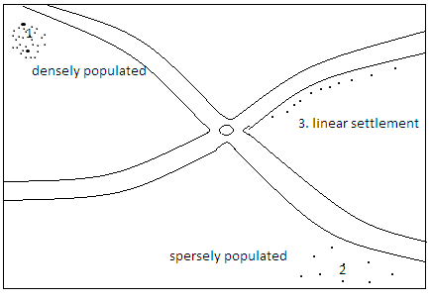
How to identify the functions of a town on a map
Functions of the urban centre | Identification symbol
Administrative centre | Government offices, chief`s camp, law courts, police posts, prisons, administrative boundaries.
Commercial centers | Shops, markets, road functions, trading centers, towns, cities, warehouses, stores, trade licensing offices.
Social center | Schools, colleges, mosque, churches, theatres, sports, grounds, hospitals, cinema halls.
Mining centers | Mining works, quarries, named mines.
Agricultural center | Food stores, Large estates, or plantations, processing factories, dairy, creameries, cattle ranches, cattle dips, dairy farm.

PHYSICAL FEATURES
These are things we see on the surface of the earth. They include natural physical features and man-made(human)
Natural features: Mountains, plateaus, hills, plains, valleys, rivers, lakes, etc.
Man-made: dams, lakes etc.
The effects of physical features on human activities
Physical features | Human activities
Lakes, oceans, rivers | Fishing-( food income)  Electricity production  Supply of water
Ocean, lakes | Transport-income  Sporting activities
Snow capped mountains  Rift valley  Beautiful water falls  Sond beaches  Hot springs | Tourism
Homa hills(limestone)  Lake Magadi(Soda ash)  Indian ocean(salt) | Minerals  Mining Income  Creation of employment
Negative effects:
- Flooding.
- Water borne diseases e.g. Malaria and Bilharzia.

CLIMATE
Traditional methods of observing weather
(i) Observing the sky
Thick grey clouds: rain.
Certain stars arranged in a particular manner: dry spell.
(ii) Phases of the moon
New moon: rain.
Full moon: It would rarely rain.
(iii) Appearance of the rainbow
Some communities believed that it would not rain if the rainbow appears in the sky when it was about to ran
(iv) Condition of the environment
Very hot and humid: Coming of the rain.
(v) Blowing of wind
Strong winds blowing after a dry weather: Showed the coming of the rains
Wind blowing during the rainy season: Meant chasing away of the rain to give way to a dry spell.
(vi) Behavior of birds: Happy and playful birds in the sky would signify the coming of rains.
(vii) Trial of ants: Signified the coming of rains.
(viii) Croaking of frogs: Signified the coming of the rain.
(ix) Appearance of toads: Signified the coming of the rains.
(x) Behavior of cattle: Coming of the rains(showing happiness by jumping up and down)
(xi) Shedding of leaves after a rainy season: This Signified a dry spell.
Observation, measurement and recording of weather elements
What is meteorology?
It is the science of observing and measuring weather elements.
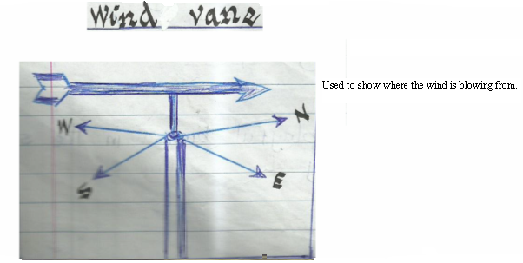

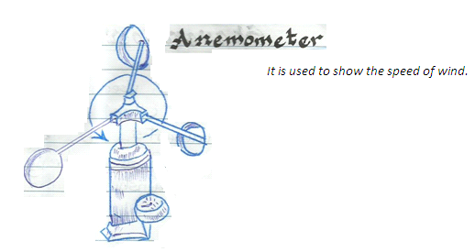

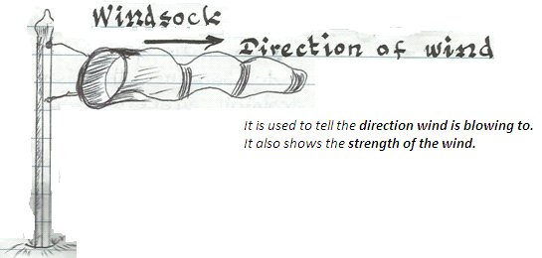
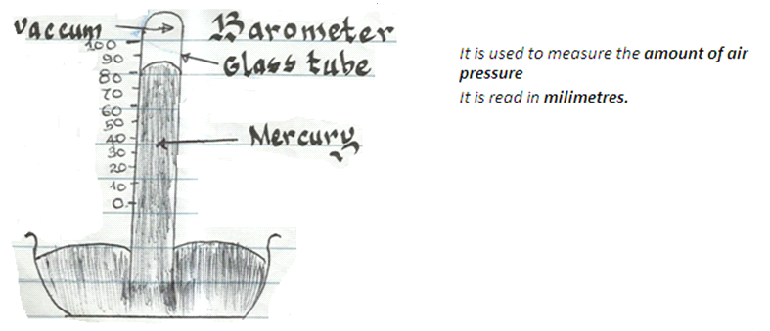
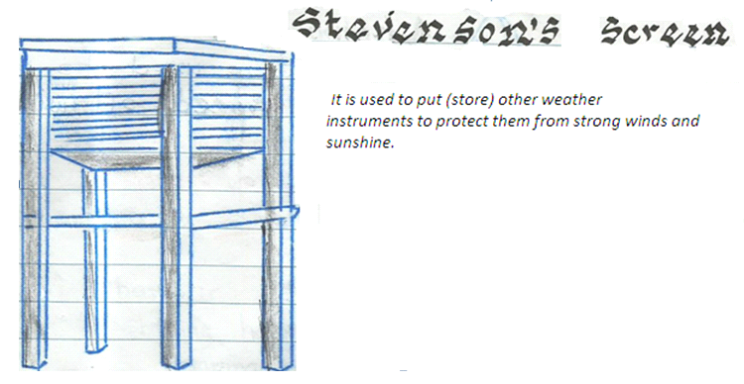
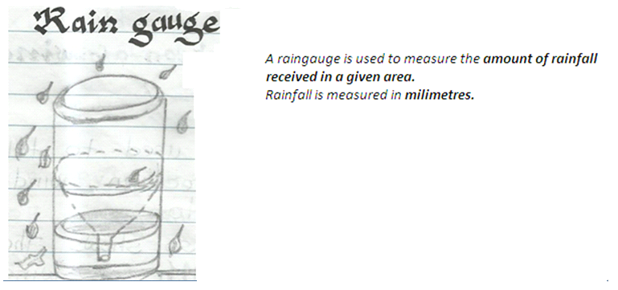
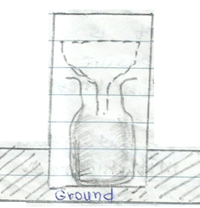
The raingauge is dug into the ground as shown above.
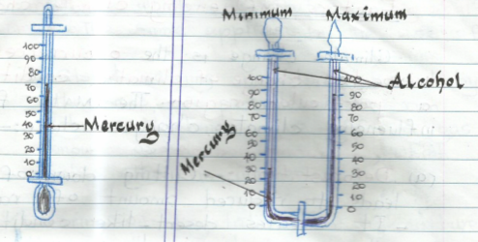
Minimum and maximum thermometer
- Used to measure temperature for the day.
- It is U-shaped.
- Minimum records coldest temperature.
- Maximum records warmest temperatures.
Single-tube thermometer
- Used to measure coldness and / or hotness of the air.
- It is marked in º Celsius.
- It may contain alcohol or mercury.
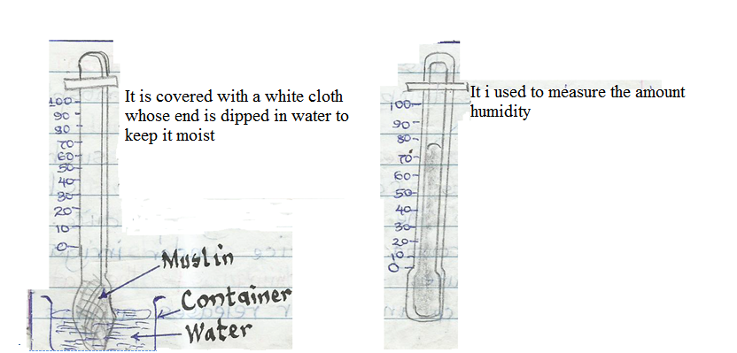
Factors influencing climate change
Climate change is the occurrence of unexpected change of climatic condition in a particular region. The main factors influencing climate change include:-
Deforestation
- Cutting down of trees leads to reduced amount of rainfall.
- It creates desert – like conditions in the areas previously occupied by forests.
- It contributes to increased carbon dioxide in the atmosphere.

Afforestration and re-afforestration
- Planting of more trees will increase the amount of rainfall.
- Both afforestration and re-afforestration reduce soil erosion and evaporation, hence protecting water catchment areas.
Industrialization
Heat and smoke from industries cause pollution and increase temperature in the atmosphere.
Excess use of chemicals
Such as fertilizers causes atmospheric change due to the gasses they produce.
The growing of rice under irrigation contributes to warming of the atmosphere. The rice in water release a gas known as methane, which contributes to global warming. The same applies to the use of fertilizers.
Global warming is also caused by the use of petroleum to run vehicles .Machines give off a gas known as carbon monoxide, which makes the air warmer.
Clearing of vegetation for agriculture
This exposes the soil to agents of soil erosion.
Building of dams
Human-made lakes which form behind the dam modify the climate.
Ocean currents
These leads to temperature change along the coastal areas.
Impact of climate change on human activities
Positive effects | Negative effects
Increase in food production due to increased amount of rainfall | Low agricultural production due to lack of rains.
Increased generation of hidro-electric power due to high rainfall | Displacement of people due to floods.
Promotion of fishing due to adequate water in rivers. | Global warming as a result of general increase in temperature worldwide.
 | Increase of water-borne diseases such as malaria and bilharzias due to increased rains.
 | Darmage of transport systems e.g. roads.
 | Migration of people migration of people to favourable climate.
 | Death of human beings.

SOILS
Soil is formed through a process called weathering. Soil contains:
- Organic matter
- Rock particles
- Humus
- Air
- Minerals
- Water
- Living organisms
Major soil types in Kenya
(i) Volcanic soils.
(ii) Clay (black cotton) soil.
(iii) Sandy soil.
(iv) Loamy soil.
(v) Alluvial (young) soil.
Characteristics of types of soil
Volcanic soil
- Red in colour.
- Deep fertile and well-drained.
- Occur in layers.
- Medium – sized soil particles.
- Mainly found in the highlands.

Clay( black cotton) soil
- Small – sized particles.
- Dark in colour
- Deep and fertile
- Poorly drained.
- Muddy and sticky during the rainy season.
- Big cracks during dry seasons.

Sandy soil
- Large soil particles.
- Shallow and dry.
- Contains a lot of air.
- Water seeps through them fast.
- Low water retention capacity.
- Loose nutrients mainly through leaching.

Loamy soil
- It has a mixture of small, medium and large soil particles.
- It retains a reasonable amount of water fertile, deep and well drained.
- Appears in different colours e.g. light grey, dark brown and dark grey.

Alluvial (young) soil
- They are found in river valleys and flood plains.
- They are made of slits.
- Soil particles are of medium size.
- Have a smooth texture.
- They are deep and fertile.

Major causes of soil erosion
Soil erosion is the natural displacement of soil from the original place of formation to another by agents of erosion like wind, water and human beings.
The major causes of soil erosion are as follows:
Deforestation- Cutting down of trees which exposes the soil to agents of soil erosion.
Overstocking- Keeping large herds of livestock beyond the capacity of land leading to overgrazing
Overgrazing-Livestock grazing on all pasture (vegetation) leaving the ground bare.
Monocropping-Growing of one type of crop on the same peace of land year after year exhausts soil fertility.
Over-cropping-Growing of many different types of crops which compete for nutrients. The soil finally becomes loose and infertile
Up-the-slope (hill) cultivation-This promotes gulley ersion.
Mining and quarrying-Results to displacement of soil.
Effects of soil erosion on human activities
- Destocking (reducing the number of livestock on the farm)
- Application of fertilizers to the soil in order to increase its fertility.
- Introduction of afforestration and re-afforestrationprogrammes
- Promotion of agriculture in the flood plain where fertile soil (alluvial) is deposited.
- Adoption of good farming methods to reduce soil erosion.
- Additional expense to the government in building dams, dykes and canals.

Soil conservation measures
Afforestration : Planting of trees.
Re- afforestration: Planting of trees where they had been cut down.
Agro-forestry: Planting of trees together with crops.
Crop rotation:- Growing of different crops on the same peace of land in alternate planting seasons.
Mulching: The covering of the bare ground with grass to prevent moisture loss.
Cover cropping: Planting of perennial crops like coffee and bananas together with food crops likepotatoes, beans and maize.
Construction of gabions: Pilling up of stones in iron cages to prevent further movement of soil downhill.
Terracing: Making of horizontal steps on sides of hilly areas.
Fallowing: Leaving the land idle for some time in order to retain its fertility.
Creation of cut-off- drainage: This is the digging of trenches to divert water from hill tops
Controlled grazing: This is done by subdividing land into paddocks.
Use of fertilizers and manure: This helps the soil to regain its fertility.
Contour ploughing: This is ploughing of farm across the land guarded by the contours.

UNIT 2 : PEOPLE AND POPULATION
Theories of human origin
(i) Mythical theory
(ii) Theory of creation
(iii) Theory of evolution
Mythical theory
It is based on folktales told by various communities on how they originated.
Examples
Luo - Claim to be descendants of their ancestor Ramogiwho lived on Ramogi hill.
Kalenjin - Claim to be descendants of the first Orkoiyot ( medicine man) called Miot.
Wagiriama - Claim their ancestors lived at a place called Muyeye in Malindi.They dispersed from Muyeye and formed the nine (9) sub tribes as they migrated.
Agikuyu - Claim to have descended from Gikuyuand Mumbi Who lived at MukurwewaNagathanga.
Baganda - Claim to be descendants of Kintu who lived on Mt Elgon.
The theory of creation
It is based on Religious beliefs.
It explains that all human beings and other creatures were created by a super natural creator, God among the Christians and Allah among theMuslims.
The evolution theory
This is a scientific view which explains that human beings developed slowly ( evolved ) from primitive ape – like creature to what they are today. This view was first suggested by a scientist called Charles Darwin.
Archaeology - Is the study of human evolution.
To understand the evolution of man archaeologists study:-
(i) tods
(ii) Plants and animal remains (Fossils) of early creatures.
Study of human evolution
The earliest known human-like creature was called Australopithecus.
- The period between the timeof Homo habillis and the time of Homo Sapiens is referred to as the stone age because the creatures mainly used stone tools.
- These creatures practiced the following activities:-
(i) Hunting and fishing.
(ii) Gathering roots and wild berries for food.
(iii) Painting and making ornaments.
Note
Stone age is divided into three stages:-
(a) Early stoneage.
(b) Middle stone age.
(c) Late stone age.

Where the fossils of early man was discovered
Stone age. | Where they were found.
Homo habilis | Olduvai Gorge.  Near Lake Turkana.
Homo erectus | Olorgesaille in Kenya  Hadar in Ethiopia  North West shores of Lake Turkana  Isimilia in Tanzania.
Homo sapiens | Ngaloba in Tanzania.  Eliye springs west of Lake Turkana.  Bodo in Ethiopia.  Kanjera in Kenya.  Omo valley in Ethiopia.

Australopithecus

Homo habilis(able human beings)
- Was able to use stone to makesome tools

Homo erectus (upright human being)
- learnt how to use fire andcommunicate through speech.

Homo Sapiens (intelligent human beings)
- Carried out various economic activities e.g. hunting and gathering.

Homo sapiens sapiens (modern human beings)
- Able to think, plan and make accurate forecast.

Migration
Migration is the movement of people from one place to another.
Migration within a country is called Internal migration.
Migration from one country to another is known as external migration.
Types of Modern migration
The four main types of Migration taking place in Kenya are:-
(i) Rural – urban migration.
(ii) Urban – Rural migration.
(iii) Rural – Rural migration
(iv) Urban – Urban migration
Rural – Urban migration
This is the movement of people from rural areas to urban areas.
Reason:
- Search for employment.
- Shortage of farming land in some rural areas.
- Opportunity to engage actively in trading activities.
- Availability of better recreational facilities and good infrastructure.

Urban – Rural migration
This is the movement of people from urban centers to rural centers.
Reasons
- Retirement from employment.
- Overcrowding and high cost of living.
- Difficulties experienced in towns.

Rural – Rural migration
This is the movement of people from one rural area to another.
Note: Most rural – rural migrations are permanent especially in cases of movement to settlement schemes.
Reasons
- Resettlement of people displaced by the construction of big dams which form lakes.
- Establishment of settlement schemes (irrigation schemes) which attract many people from other densely populated rural areas.
- Settlement of landless people by government .
- Seasonal migrations by nomadic pastoralists in search of pasture and water.
- Search of employment in large plantations.
- Mining activities which may force people to move away from their original homes.
- Government actions which may force people to move away from areas where they had settled in order to conserve the environment e.g. Mau water catchment forest.
- Political unrest which may cause people to relocate from one place to another (IDPs Internally displaced persons)
- Natural disasters e.g Floods which may force people to move temporarily to safer higher grounds.
Urban – Urban migrations
This is the movement of people from one urban center to another.
Note: These migrations occur in a small scale .
Reasons
- Job transfers from one town to another.
- Opportunities for business people to expand their businesses in bigger towns.
- Religious pilgrimages which may result in people settling down in the towns they visit.
Effects of Migration
Effects on urban areas
(i) Unemployment.
(ii) Increase in crime.
(iii) Increase in Immorality. Eg. - prostitution - HIV / AIDS and STIs
(iv) Development of poor housing - slums (shanties)
(v) Competition (strains) for social amenities eg. Hospitals , schools etc.
(vi) Overcrowding
(vii) Environmental problems e.g. air pollution and water pollution.
(viii) Increase in labour supply.
Effects on rural areas:
(i) Reduced pressure on land.
(ii) Shortage of labour (negatively affecting agriculture).
(iii) Improved economic conditions (reduction in production).
(iv) Reversal of roles.
(v) Improved agricultural production (introduction of new farming methods).

NOTE:
Immigration: Is the migration of people from one country into another.
Emigration: Is the migration of people out of a country.
Positive effects of immigration
- Foreign investments which offer employment opportunities.
Negative effects of immigration
- Influx of people from war-torn countries encourages the movement of illegal arms into the countries which are used by criminals
- Refugees in our country affects the environment as they clear forests for firewood.
- The foreign cultures of these people end up affecting our cultures negatively.
Reasons for the establishment of settlement schemes in Kenya
- To settle the landless people.
- To ease congestion in the already populated areas.
- To make land ownership in Kenya fair.
- To encourage people to practice commercial farming in areas that had been occupied by settler farmers.
- To increase food production in Kenya.
- To speed up land ownership in Kenya.
- To open up areas which had not been settled in.
Benefits of settlement schemes
- Increased food and cash production in the country.
- Provision of of land to the landless (squatters)
- It has reduced congestion on land that had high population densities.
- It has helped to raise the living standards of the people.
- Agricultural exports from various settlement schemes has helped to boost the economy of our country.
- It has helped to open up the areas that had not be settled in.
Problems facing settlement schemes in Kenya
- Lack of adequate capital to invest in improved farming practices.
- Congestion in some parts of the settlement schemes due to population increase.
- Reduction in the size of land due to land fragmentation.
- People cut down trees to create room for crop growing and settlement (De-forest ration)
- Over cultivation in densely populated schemes has led to loss of soil fertility
- Poor transport network in the settlement schemes.
- Lack of adequate markets for the farm produce.
Irrigation schemes in Kenya
Irrigation refers to the application water to crops through artificial means in order to facilitate their growth.
Example
MweaTebere | Perkera
Rice (main) | Seed Maize
French beans | Onions
Tomatoes | Paw paws
Maize | Chilies
Soya beans | Water melons
Vegetables | Cucumbers

MweaTebere
- Established ii 1954. (It is the oldest in the county)
- Mainly started to settle the landless who lost their lands to the white settlers.
- Located in Kirinyagacounty.
- It is the largest irrigation scheme in Kenya.
- Main crop grown is Rice.
- Sources of water for irrigation are:-
River Nyamindi,River Thiba: Both are tributaries of R. Tana.
- Methods of irrigation used is Basin irrigation which involves flooding the rice plot(rice paddies)
- Canals are used to direct water from the rivers to the shallow basins
- Water flows into the basin through gravitational flow.

Perkera irrigation scheme
- Located in Marigat, Baringo county.
- Mainly started to put more land under cultivation.
- Sources of water include:-
River Perkera
Lake Baringo
- Methods of irrigation used isFurrow method.
- Furrows carry water from main canal to the crops which grow on the ridges
- Sluice gates are used to control or regulate the flow of water into the farm.
Contributions of the scheme to the economy
MweaTebere | Perkera
Produces 80% of Kenya`s rice | Income generation
Offering employment | Increse in economic activity
Has increased food production | Creation of employment
Has led to improvement of infrastructure and growth of towns egWanguru town. | Led to growth of Marigat town.
Has raised people`s living standards | Note: Main problem is reduction of water into the plot during the dry season.

Problems facing irrigation farming in Kenya
- Shortage of water during dry season.
- Siltation of the canals which reduces the amount of water that can flow to them.
- Late and irregular payments to the farmers from the irrigation board.
- Presence of weed.
- Some irrigation schemes are affected by floods during rainy seasons in places like Bunyala.
- Stagnant water is a health hazard eg. Spread of malariaand bilharzias.
- Lack of adequate capital.
- Mismanagement of finances and resources.
- Some irrigation schemes are far from the market which increases transport costs.
- Competition from imported, cheap farm produce.
- Presence of crop diseases and pests.

Horticultural Farming
Horticulture - Is the growing of vegetables, fruits and flowers for sale.
Viticulture - Growing of fruits only.
Floriculture - Growing of flowers only.
Horticultural Crops Development Authority (HCDA) is a body established by the government to promote horticulture (market gardening)
The HCDA :-
(a) Advices the farmers.
(b) Provides storage facilities.
(c) Searches for external marks for products.

Crops grown in horticulture farming
Flowers | Carnations , roses , lilies , orchids.
Fruits | Oranges, lemons, apricot, paw paws, grapes, limes, avocados, tangerines, passion fruits, peaches, apples, pears, plums, loquats, bananas, watermelons, strawberries.
Vegetables | Cabbages, spinach, lentils, spruce, sprouts, broccoli, peas, French beans, cauliflower, carrots, turnips, groundnuts, tomatoes, cucumber, green peas, chilies, onion, lettuce.

Contribution of horticultural farming to the economy of Kenya
- Earning of foreign exchange.
- Creation of employment opportunities.
- Farmers earn regular income.
- Development of infrastructure.
- Availability of food.
- Crops provide raw materials for fruit and vegetable canning.
- Better use of land.

Problems facing horticultural farming in Kenya
- Bad weather.
- Poor infrastructure.
- High fees charged to farmers who export their farm produce (high tarrifs)
- High transport costs.
- High cost of farm inputs e.g. fertilizers, insecticides and pesticides.
- Lack of storage.
- Restrictions by importance
- Competition from other producers e.g. Netherlands.
- Inadequate capital to purchase farm equipment and inputs.
- Lack of co-operatives.
- Low export demand
- Poor marketing.
Horticultural farming in Kenya and Netherlands
KENYA | NETHERLANDS
Most farmers are located near towns | Most farms are established on reclaimed land.
Most farms are small scale apart from the flower farms | Almost all the horticultural farms are large scale.
Poor means of infrastructure | Modernized infrastructure
Kenya is far from European market | Netherlands is centrally located in Europe.
Lack of adequate capital to promote horticultural farming | Adequate capital to scientifically manage the horticultural farms.
Fertile volcanic soils that are favorable for crop growing. | Sandy coastal soils are used as they drain well.
Little mechanization in the farms | Highly mechanized farms.
Labor intensive. | Capital intensive.
Horticultural technology is relatively new | World`s most successful horticultural producing country.

Fishing in Kenya
Fishing is the practice of removing or harvesting fish from water.
Fishing is a major economic activity for those people living next to rivers , lakes or oceans which have fish.
Major fishing grounds in Kenya
Fishing grounds are places where fish are caught.
Groups of fishing grounds
- Inland fishing grounds.
- Marine / sea fishing grounds.
INLAND FISHING GROUNDS | MARINE FISHING GROUNDS
Lake Turkana | Lamu
L. Baringo | Kiunga
L. Victoria | Malindi
L. Naivasha | Mombasa
L. Jipe | Kilifi
L. Chala | Ukunda
L. Masinga | Shimoni
Kiambere dam | Kipini

Note:
Inland fishing is also carried out in big rivers such as:-
R. Tana,R.Sondu-Miriu,R. Yala,R.Nzoia,R. Nyando,R.Kuja.
Fish farming is the raring of fish in fish ponds and dams.
Areas where fish farming is carried out.
Sagana,Borabu,Bamburi near Mombasa,Aruba dam,Kiboswa
Types of fish caught
Inland waters | Marine waters
- Tilapia  - Nile perch  - Trout  - Lung fish  - Shell fish  - Cat fish  - Black bass  - Mud fish  - Dagaa (Omena)  - Salmon  - Snappers | - Kingfish  - Sardines  - Tuna  - Bonito  - Black Skin  - Queen fish  - Mullet  - Sail fish  - Parrot fish  - Sharks  - Crustaceans egcrubs,oysters,shrimps,lobsters.

Problems facing fish farming
- Presence of predators e.g. snakes, birds, cats.
- Insufficient supply of water in ponds especially during the dry season.
- Limited market
- Presence of unwanted weeds e.g. water hyacinth in L. Victoria.
- Lack of adequate funds for most farmers.
- Use of traditional methods of harvesting.
- Inadequate refrigeration facilities.

Comparison of fish farming between Kenya and Japan
Kenya | Japan
Lack of adequate capital. | There is adequate capital.
Most farmers use traditional methods of fishing and harvesting. | Fish farming is highly mechanized.
Limited market for the fish products | There is a large market for fish which encourages the industry
Insufficient supply of water e.g. during the dry season | Enough supply of water through out the year.
Fish is mainly consumed locally | Fishing is done mainly for export.

MINING
Mining is the removal (extraction) of a mineral from where it has naturally been formed.
The main minerals in Kenya include
- Soda ash
- Gemstones
- Diatomite
- Flourspar
- Sand
- Salt
- Limestone
- Marble

Mineral | Where mined | Uses
Fluorspar  Method of mining:Open cast(Quarrying) | - Kimwarer in Kerio Valley. | - Strengthening steel and aluminum.  - Making tooth paste.  - Used in refineries.  - Making cans, sufurias and cooking pans  - Making sulphuric acid.
Limestone.  Method of mining: Opencast (quarrying) | - Bamburi in Mombasa  - Athgi river  - Bissil in Kajiado  - Koru – Kisumu county  - West pokot  - Homa hills – Homa bay county | - Used in cement making.  - Lime extracted from Homa hills and Koru are used as animal feed.
Diatomite.  Method of mining: Open cast (quarrying) | - Kariandusi near gilgil.  - Gicheru on the floor of Nyandarua ranges. | - Making chalk.  - Lining hot furnaces  - Act as sound proof material.  - Making plaster used in hiospitals.  - Used in dry cleaning clothes.
Gemstone.  Method of mining: Open cast method. | - Mainly mined at Voi and Mwatate at the Coast. | - Used mainly in the making of ornaments.
Marble.  Method of mining: Open cast (quarrying) | - Athiriver.  - Kerio Valley | - Used to decorate flours and walls of the building.
Salt. | - Shores of Lake Magadi.  - Ngomeni  - Fundisa near Malindi. | - Adding flavor to food  - It is a food preservative  - Soap making  - Glass making

Contribution of minerals to the economy of Kenya
- Mineral exports earn Kenya foreign exchange.
- Mining is a source of employment to many people.
- It has led to the growth of towns e.g. Magadi.
- It has led to the establishment of industries that use minerals as their raw materials.
- Availability of minerals saves the country`s foreign exchange that could have been used to import them.
- Mining has led to the development of social services like schools , hospitals and sports facilities in the mining areas.
- Mining is a source of revenue to the government since the mining companies pay taxes to the government.
- It has led to the development of transport links of infrastructure.
- Mining has led to the improvement of the standards of living of people working in the mines and mineral – related industries.

Effects of mining on the environment
- Pollution of the environment.
- Land degradation.
- Destruction of vegetation during the mining process.
- Clearing of vegetation during mining leads to soil erosion.
- Open pits filled with water are a health hazards to people and animals.
- Release of harmful gases in the air may result to global warming.
- Walls of mines sometimes collapse and cause accidents to miners.

FORESTRY
Forstry is the practice of establishing forests and caring for trees.
It also involves paper harvesting and good use of trees.
Types of forests in Kenya
There are two main types of forests found in Kenya. These are:
(a) Natural forests.
(b) Planted forests.
Natural forests
This are forests which have grown on their own.
They are divided as follows:
(i) Highland rain forests.
- They grow in the high rainfall areas e.g.
Slopes of mountains
Hills and highlands

Examples
Kakamega,Nyambane,Ndare,Kaimosi,Mt.Kenya,Timboroa,Nyandarua,Mau,Malava,Mt.Marsabit,Ngong hills,Mt. Elgon,Ndaragwa.
(ii) Lowland rain forest.
Found in high rainfall areas of the coast.
Examples:
Witu,Jilore,Gongeni,Boni,Arabuko – Sokoke
(iii) Mangrove forest
They grow in salty waters of the Indian ocean.
They grow along the coast in: Kwale,Kilifi,Lamu,Malindi

Planted forest
They have been established through efforts of human beings.
They are found in high rainfall areas where afforestration programs are being carried out.
These forests are found in the following areas:
- Slopes of Mt. Kenya around Meru and Embu.
- Cherengani hills
- Limuru
- Elburgon
- Timboroa
- Molo
- Turbo
- Slopes of Mt Elgon
- Lari
- Njabini
- Kaptagat
- Londiani
- Moi`s bridge
- Nandi hills
Types of trees found in planted and natural forests
Natural forest | Planted forest
Mvule  Camphor  Elgon teak  Mahogany  Meru Oak  - They are mainly hardwood  - They grow in natural forests  - They take long to mature | They are mainly softwood  Example:  Cypress  Cedar  Eucalyptus  Pine  They mature quickly  They have straight trunks.

Problems facing forests in Kenya
- Attacks by pests and diseases which affects their rate of growth.
- Outbreaks of fires especially during the dry season.
- Deforestration due to increased demand for land for farming and settlement.
- Increased demand for forest product e.g. timber and pulp.
- Need for charcoal and firewood.
- Poor reafforestration programs.
Effects of deforestration in Kenya
Deforestration is the cutting down of forest trees faster than they are replaced through reafforestration.
Effects
- Deforestration affects the sources of water leading to reduced water supply.
- Cutting down of trees leads to spread of the desert.
- Reduction in forest production.
- Increase soil erosion.
- Loss of the species
- Rural communities are affected since some of them use forest products for their survival.
- Change in climate.
Forest conservation measures in Kenya
Forest conservation is the careful harvesting and good use of trees found in the forest.
Conservation measures includes:
- Establishment of tree nurseries.
- Gazzetement of forest reserves by the government to protect the forests.
- Organizing and supporting tree planting activities (afforestration).
- Encouragement by the government for the public to undertake replanting activities.
- Discouraging the use of charcoal.
- Growing of trees alongside crops in the farm (Agro-forestry).
- Informing the public on the importance of trees and the and the need to plant more trees on their farms (awareness campaigns).
- Establishment of environmental clubs in schools.
- Banning tree activities.

WILDLIFE AND TOURISM
Wildlife refers to plants , birds and animals in their natural environment. (habitat).
Tourism is the travelling to other places of interest for pleasure.

Importance of wildlife
- Earns the country foreign exchange from tourists who visit the country.
- Creates jobs for many people who work in game parks, game researves , and tourist hotels.
- Leads to economic growth of the areas they are found.
- Promotes development of local industries e.g. stone and wood curving which are mainly bought by tourists.
- Wildlife is an important national heritage.

Tourists attraction in Kenya and Switzerland
Similarities
- Both countries have beautiful sceneries.
- Both countries have a rich cultural heritage which is a major tourist attraction.
- Both have good accommodation facilities for the tourists e.g. hotels.
- Both countries enjoy relative peace.
- Both countries have game parks.

Differences between Kenya and Switzerland
- Wildlife is the main tourist attraction in Kenya while Beautiful scenery is the main tourist attraction in Switzerland.
- Tourists are attracted by the warm climate ion Kenya while in Switzerland tourists are attracted by the summer and winter seasons.
- Transport and communication is highly developed in Switzerland and thus attracts tourists. In Kenya, The transport and communication is NOT highly developed.

INDUSTRIES
An industry is a place where raw materials are changed from one form to nother ,processed and assembled.

Types of industries
- Processing industries.
- Manufacturing industry
- Assembly industries
- Service industries.
Processing industries
- They are also called primary industries.
- Involved in the first stage of changing raw materials from one form to another.
- Examples in Kenya : Maize, milk, fish processing etc.
Manufacturing industries
- They are also known as Secondary industries.
- They use raw materials to make final products.
Examples:
Sugar from a processing industry taken to another factory to make sweets, bread or soft drinks.
- Steel rolling milk
- Glass making industry
- Insecticide industry
- Medicine making
- Cement factories
- Textile industry
- Shoe factories
- Oil refineries.

Assembly industries
- They are also known as secondary industry.
- They put together parts that have been produced elsewhere to make new products.
- Examples include:-
Vehicles
Radios
Bicycles
Televisions etc.
Service industry
- They are also known as tertiary industries.
- They provide services that other people and other industries need.
- Examples includes:
Transport and communication.
Banking
Insurance
Repair work
Printing etc.
Factors influencing location of industries
- Availability of raw materials.
- Availability of capital(money to start a business).
- Availability of good means of transport and communication.
- Availability of power (electricity).
- Availability of regular water supply.
- Availability of ready market.
- Government policy of location of industry.
- Availability of land.
- Personal consideration.
- Security.
- Presence of other industries.
Jua kali industries
- These industries are also known as cottage or fabrication industries
- It involves making simple items in the open air or under simple shade.
- They use scrap metals to fabricate different types of cheap products.
- Items made include:
- Jikos
- Jembes
- Pans
- Wheelbarrows.
- Boxes etc.
Reasons for establishment for Juakali industries in Kenya
- To create self employment opportunities.
- Products from Jua kali industries are cheap as compared to those made in manufacturing industries.
- The sale of the jua kali products earns the people income
- Jua kali industries require little space to house workers.
- Some Jua kali industries do not require electricity.
- Jua kali industries help in cleaning up the environment as they use heap of scrap metals.
Benefits of Jua kali industries
- Creation of employment opportunities.
- Use of waste iron materials helps in recycling wastes.
- They produce many goods that are widely used in homes and schools.
- Jua kali products are cheap and long lasting.
- Jua kali helps in improving the living standards of people working in the Jua kali industry (sector)
- Jua kali is foreign exchange earner.
- The use of recycled materials helps in controlling environmental pollution.
- Jua kali reduces rural – urban migration as youths in the rural areas get employment in their rural areas.
Problems facing jua kali industries
- Inadequate space: This leads to interruption of their work.
- Competition from manufactured goods.
- Inadequate capital (cash to start and maintain the business)
- High cost of raw materials.
- Poor working conditions.
- Inadequate supply of water and electricity.
- Limited market for the products.
Contribution of industries to the economy of Kenya
- Creation of jobs(employment opportunities)
- Earning of income by the people.
- Earning of foreign exchange.
- Making use of local resources(raw materials)
- Saving on foreign exchange.
- Making it possible to have increased trade locally and with other countries.
- Promotion of agriculture due to increased demand of raw materials.
- Availability of goods.
- Growth of urban centers.
- Development of infrastructure e.g. roads.
- Increased skills by the people employed in industries.
- Encourages countries to join regional blocks.This enhances international relations.
- Self sufficiency.

UNIT 3: SOCIAL RELATIONS AND CALTURAL ACTIVITIES
The school: A school is a centre where learning takes place both formally and informally.
It is also a place where the learners acquire knowledge.
School management
The public schools are run by the government through the ministry of education.
At the district level, the schools are managed by the District Education Board. (D.E.B)
The chairman of the district education board is the district commissioner.
The secretary of the District education board is the district education officer (D.E.O)
The D.E.O is in charge of all the education matters in the district.
He/She:-
- Ensures there are teachers in the school.
- Inspects schools to ensure standards are set and maintained.
- Organizes co-curriculum activities.
- Assigns teachers responsibilities by posting and transferring them.
The teacher
- He/She is the secretary to the school committee.
- He/She signs duties and responsibilities to all the teachers in the school
- Receive information from the ministry and pass them on to teachers.
- Ensures that the school is stable and runs smoothly.
- He supervises the work of teachers, pupils and school workers.
- He ensures that good academic standards are made and maintained.
- He writes minutes during school committee meetings.
- He maintains discipline among pupils.
The Deputy head teacher
- He is the principal assistant of the head teacher.
- He attends to lessons by planning and teaching.
- He acts in the absence of head teacher.
- He is in charge of discipline.
The senior teacher
- Ensures all lessons are attended to.
- Acts in the absence of head teacher and the Deputy head teacher.
- Plans and teaches the pupils.
Head prefects (head boy and head girl)
- They co-ordinate the activities of other prefects.
- Ensures the pupils are orderly.
- Prefects act as the eyes of teachers on other pupils.
Importance of school administration.
- It promotes high academic standards.
- It promotes high standards of discipline.
- It helps in maintaining school facilities like chairs tables and desks.
- It co-ordinates the daily academic activities in the school.
- It maintains proper school records.
- It organizes and promotes co-curricular activities in the schools e.g. games, music, athletics, drama.
- It acts as the link between the community in school.
- It ensures that the school maintains cleanliness.
- It acts as a link between the school and the government education agents like:
Assistant education officers (AEO)
District Education Officers
Provincial director of education
- It allocates teachers their teaching subjects and other duties.
The school motto
- It is a phrase that expresses the beliefs of a school.
- It describes the goals that a school intends the school learners to achieve by the time they leave the school.
- School routine is the program of activities in the school either on daily or weekly basis.
- The school timetable forms a major part of the school routine.
The family
- Family is a group of people who are related by blood or marriage.
Main types of family
- Nuclear family - father, mother and child/children
- Extended family - nuclear and other relatives.
- Single parent family - One parent and child/children
Needs of family members
- Needs are requirements that are necessary for people to live.
Types of needs
- Basic needs - things we cannot do without.
- Secondary needs - Things that add comfort to our lives but we can do without them.
Basic needs | Secondary needs
Food | Education
Shelter | Motto vehicle
Clothing | Television set
Water | Radios
 | Mobile phones
 | Sofa sets
 | Friends
Responsibilities of family members
- Roles and duties in a family are well defined.
EXAMPLES:
Responsibilities of parents
- Providing basic needs for the family.
- Providing security in the family.
- Providing medical care for the family.
- Installing good morals in the children.
- Providing financial assistance.
- Teaching religious values.
- Providing love for the family members.
Marriage
- Marriage is a permanent union between adults.
- Marriage systems recognized in Kenya are:
Religious marriage.
Customary marriage.
Civil marriage.
Religious marriage
- It is usually conducted in a church , mosque , or a temple.
- A wedding ceremony is conducted.
- Christians and Asian marriages are monogamous (one man and one wife)while Muslim marriages are polygamous (more than one wife).
- Couple exchange marriage vows.
- A marriage certificate is issued.
Customary marriage
- Conducted according to the African customs and beliefs.
- Polygamy is allowed.
- Bride wealth is given before the wedding ceremony.
- It is usually conducted by the clan elders.
Civil marriage
- It is presided over by a magistrate or an authorized government officer.
- A couple intending to marry must issue a 21 day notice to the district commissioner or the district registrar of marriage.
- The marriage partners pay a marriage fee.
- A marriage certificate is issued.
- Divorce or separation is granted by a court of law.

Importance of marriage
- It provides companionship.
- It ensures the continuity of the family name and culture.
- It unites different families hence promotes unity and harmony in the society.
- It ensures good upbringing of the children.
- It provides security and legal rights to the children, wife, and the husband.
- It helps to regulate social behavior of the couple.
- It helps to enrich culture especially when man and wife are responsible.
Rights and responsibilities of spouses in marriage
- To be loyal and faithful to each other.
- To stand by each other as a source of comfort and strength.
- To love one another.
- To give each other emotional and physical security and protection.
- To earn an income to support the family.
- To promote the family’s standard of living.
- To discuss the decisions regarding the family matters.
- They should be caring to the children.
Succession and inheritance
- Succession means taking over property after the owner dies or give up ownership.
- Inheritance is receiving property left behind when the owner dies.
- People succeed or inherit the estate (belonging of the deceased ) through:
a) customary laws
b) written wills
c) parliamentary acts (law of succession).
- The property of the diseased is called an estate.
- A written document that shows how the property of the deceased should be shared out is known as the will.
- The person who inherits the estates of the deceased is known as an heir.
- The distribution of the estate of the deceased is done by:
(i) Court of law.
(ii) The public trustee.
(iii) The bearer of the letter of administration or the grant of probate.
- The authority to manage the estate is granted by a court of law.
- The following are entitled to the estate of the deceased :
(i) wife or wives
(ii) former wife ( in case of a divorce in a court of law).
(iii) sons
(iv) daughters
(v) parents
(vi) Any other person with proof that they depend on the deceased.
- Where both the parents have died, the adult first born child should apply to get a letter of administration, if the parent did not leave a will or a grant of probate, if the parent left a will.
NB: daughters of the deceased whether married or not have the right to benefit from the property of the deceased.
Resources and economic activities.
- Resources are the things that are useful to human beings
e.g. Soil, water, money, land, forest, mineral, wildlife, domestic animals.
- Economic activities are the different ways that we use the resources to earn income.
The main economic activities in Kenya include:
- Transport and communication.
- Livestock keeping.
- Wildlife and tourism.
- Fishing.
- Mining.
- Crop farming.
- Forestry.
- Manufacturing.
Settler farming in Kenya
- Europeans settler farming was practiced in the white highlands(crown lands)
Examples:

Region | Area covered.
Central highlands | Kiambu, thika, muranga, nyandarua, nyeri, kirinyaga.
Western highlands. | Kericho, bureti, sotik, nyamira, uasingishu, kisii.
Central rift valley | Nakuru, laikipia, narok, kajiado, molo, naivasha, koibate(eldamaravine).
Eastern | Meru , konza, embu, machakos.

- NB: The colonial government took away large areas of African land and allocated it to the white settlers.
Europeans settler farming in Kenya.
- The European settlers farming took African land.
- They mostly practiced large scale farming.
- They introduced cash crop farming and new livestock breed.
- Their farming methods were mechanized: they used commercial fertilizers and applied pesticides to crops.
- Africans were used as the source of labour on the settlers farms.
- rotation on their farms and divided ranching area into paddocks which helped They practiced crop to control grazing.
What the settlers farmers were engaged in
- Mixed farming (growing of crops and keeping of livestocks).
- Plantation farming (growing crops in a large scale farm). i.e. sisal, tea, coffee, wheat, maize, pyrethrum, cotton, sugarcane.
- Dairy farming, animal kept were: hare ford, Aberdeen angus, chorales, Galloway.
- Horticulture.
- Fruits grown : oranges, limes, lemons, pineapples.
- Vegetables grown:onions, carrots, tomatoes, legumes,cabbages.
- Poultry farming-chicken breed kept were; rhode island red, white leghorn light Sussex among others.
NB; The settlers farmers also kept pigs sheep and rabbits.

Effects of settler farming in Kenya
Positive effects | Negative effects
Introduction of new crops. | Loss of fertile lands by the Africans.
Introduction of new livestock. | High poverty levels among the Africans.
Improved infrastructures. | Most Africans become squatters.
Establishment of processing industries. | Forced labour among the Africans.
Introduction of agricultural co-operatives. | Racism; Europeans looked down upon the Africans because of their skin colour.
Establishments and growth of towns. | Congestion of Africans in areas with low productivity.
Introduction of cross breeding in animals.
Introduction of modern method of farming.
Introduction of use of fertilizers and improved seeds.
Introduction of plantation (large scale) farming.

Settlement schemes in Kenya
Reasons for establishment were as follows:
- To settle the landless.
- To ease congestion in the already over-populated area.
- To make land ownership in Kenya fair.
- Encourage commercial farming in places that were ones occupied by writers.
- To increase food production in the country.
- To open up areas that had not been settled on.
Settlement schemes in Kenya.
Sotik,Endebes,Kaptagat,Matunda,Machakos,Lake,Kenyatta,Molo,Ainamoi
Kitobo,Naitiri,Cherengany,Songhor/MuhoroniEldama Ravine,Chepsiri,
Mweiga,Lesos,Ngarika,Turbo,Kinangop,Lugari,Naromoru,Masongaleni.
Benefits of settlement schemes in Kenya
- Increased food and cash crop production in the country.
- Provision of land to the landless (squaters).
- It has reduced congestion on land that had high population.
- It has helped to raise the standards of living of people.
- It has helped to promote the growth of infrastructure e.g. road.
- It has greatly reduced unemployment.
- It has led to the development of social facilities e.g. Schools, hospitals etc.

